Email:
Right before the holidays, we investigated an issue with the VT_Statewide_A23 lidar project (PTS ID 300166) which appears to have notable alignment and quality issues that could impact downstream workflows and data reliability. During the review, S1M team members observed vertical offsets ranging from 20–30 cm between the new statewide dataset and older Vermont collections, such as VT_Rutland_Lot8_2013 and VT_Western_2017. The offsets are present in all three work units of the new project. These discrepancies are not random; they appear to align with the flight lines of the new acquisition, pointing to systematic problems in contractor collection and processing rather than isolated anomalies. Such misalignments raise concerns about the integrity of seamless integration across projects, especially when combining datasets for hydrography and elevation modeling. The contractor could implement additional alignment refinements—such as TerraMatch or BayesMap Strip Align —to correct internal inconsistencies and ensure compatibility with legacy datasets. Without these refinements, the risk of propagation of errors into derivative products like DEMs and hydro-flattened surfaces remains high.
Here you can see VT_Statewide_3_A23 Minus VT_Rutland_Lot8_2013 on the north, VT_Statewide_3_A23 minus VT_Western_2017 in the south (red polygon for the VT_Western_2017 boundary) with the black flight line polygons added for VT_Statewide_3_A23. The offsets perfectly align with the new collections flight swaths. Blue areas are higher than the older datasets and red areas are lower.
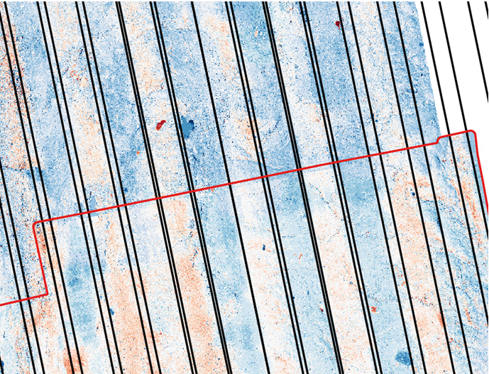

This project was collected by Sanborn Map Company as a financial assistance project.
If you recall, this is a similar to the error that we found in Kansas back in 2024.

Thanks!

https://www.mdpi.com/2072-4292/14/4/847#remotesensing-14-00847-f001
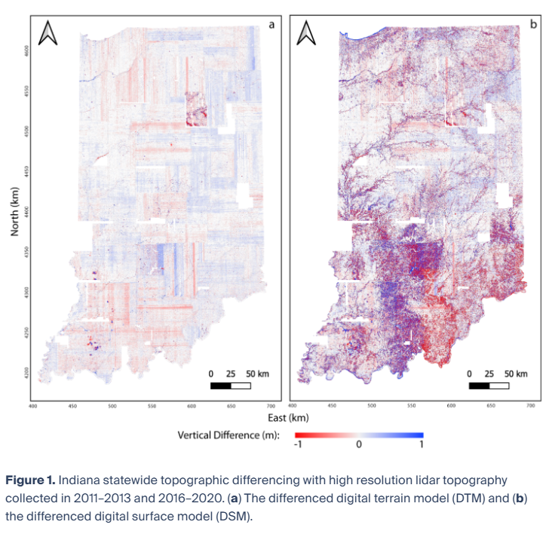
In this section, we discuss the differencing and CHM results at the statewide and site scales. The visually most dominant signal in the statewide DTM change map (Figure 1a) is the north–south- and east–west-oriented blue and red stripes. These stripes do not represent real topographic change but instead indicate misalignment between data collected along adjacent flight paths. These errors are likely from the 2011–2013 dataset because the errors correlate with the county boundaries that guided the earlier acquisition (Figure 3A). While these errors can be corrected [22,42], the correction benefits from flight trajectory data are very time-intensive and are out of scope for most large-scale studies. Topographically correlated errors vary with slope direction—for example, in Brown County in South–Central Indiana. This apparent lateral shift reflects horizontal georeferencing errors.
(5) The largest source of noise is the offset between flight-lines in the lidar data, which appear as east–west- and north–south-oriented swaths most noticeable in the differenced DTM (Figure 1a). This type of error can be corrected using additional flight trajectory information [42]. However, this process is at best very time-intensive and requires flight information that is rarely delivered with the topography data, and thus would likely be challenging to locate at the state scale. Georeferencing errors also produce topographically correlated noise. We made the explicit choice to not correct these errors because the correction is out of scope for this project and the majority of the change signals are larger than the noise amplitude. This choice was also an opportunity to explore the overall quality of these statewide datasets and to better understand their suitability for multi-temporal analyses without additional and labor-intensive adjustments. In the case of Indiana, these flight-line errors appear to be largely present in the earlier lidar dataset. This observation is consistent with the general observation that older and legacy lidar datasets have larger errors and lower resolution. Thanks to improvements in lidar technology, as well as the data quality control and review processes, these types of errors are likely to be less prevalent in future dataset collections. We expect that this topographic differencing exercise presents a common set of challenges that would face any large-scale analysis of 3DEP or similar regional to national scale topography datasets.

https://opentopography.org/blog/interpreting-errors-topographic-differencing-results
Stripes From Flight Alignment Errors
Airborne lidar surveys are typically conducted along multiple parallel and overlapping paths or flight-lines. Offsets of the topography collected along adjacent flight-lines due to georeferencing errors create apparent vertical offsets that manifest as linear, swath-to-swath artifacts in the differencing results aligned with the flight direction. The resulting stripes do not represent real topographic change. These flight-line misalignments are often on the order of a few tens of centimeters (or less) and can interfere with interpreting smaller and especially linear patterns of surface change. The example below shows fluvial activity along the Wabash River in southwestern Indiana. The north-south oriented stripes in the right panel (C) reflect flight-line errors and make it challenging to distinguish between erosion (typically red) and deposition (typically blue).
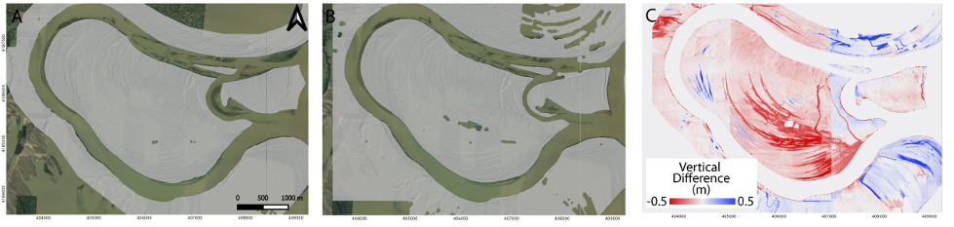
Topographic differencing results along the Wabash River, Southwestern Indiana. The north-south stripes in the right panel (C) are noise and reflect flight alignment errors, not true vertical deformation or change. See Scott et al., (2022) for additional discussion and examples.

