RockyWeb /outgoing/Z/ Full NGINX Access-Log Analysis
Generated 2026-07-12 07:42:24 local runtime time

Executive summary
The pipeline parsed 361,642,469 RockyWeb custom nginx access-log records across 141 downloaded log files. The parsed records account for 2,381,501.08 GB of response-body bytes. The parsed server-local timestamp range is 2026-02-17 07:48:33 to 2026-07-08 09:57:34. The analysis summarizes downloads by data type, project, source IP/network, user-agent class, status code, and day/week/month.
Duplicate-line suppression was not used. Event identity is source file plus line number, and exact duplicate-looking rows are retained as observed server events.
Active-log overlap filtering excluded 13 parseable rows from the primary rollup based on timestamp coverage already present in rotated logs.
Country and operator attribution uses routing/registration evidence. Team Cymru maps IP addresses to BGP origin ASN, prefix, and country code; RDAP provides WHOIS-style registration data for Internet number resources. These fields identify network operators and egress countries, not necessarily the physical location or identity of a human end user.
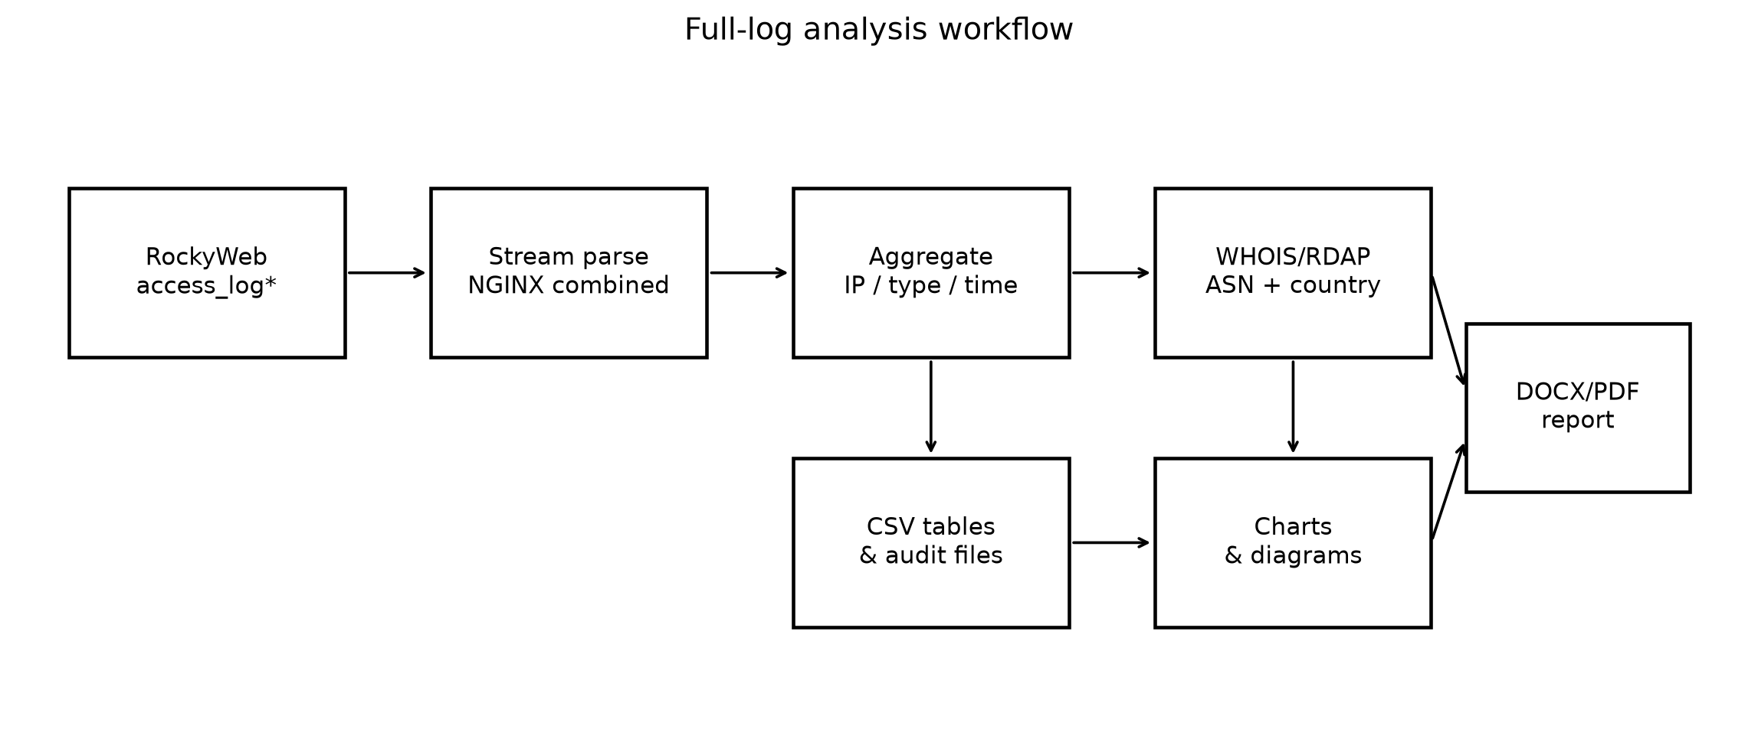
Figure 1. Full-log analysis workflow.

Methodology
The parser treats the files as a custom RockyWeb nginx HTTP access-log format: quoted remote address, remote user, local timestamp, quoted request, status, response-body bytes, then four quoted custom fields. The actual user-agent is the third quoted field after the byte count, not the second combined-log position. Each physical source_file + source_line_number is treated as an observed server event; exact duplicate-looking lines are retained because range/parallel downloaders such as aria2 can legitimately produce visually identical 206 responses in a one-second-resolution log.
The output byte count is the logged response body byte field. It is a server log measurement of response payload bytes, not necessarily total wire bytes. Status codes, byte counts, user-agent strings, automated downloader indicators, and referrer hosts are retained in summary form.
Source analysis is performed at three levels: individual IP address, normalized source network (/24 for public IPv4 and /48 for public IPv6), and ASN/operator after WHOIS/RDAP enrichment. Private and non-public addresses are explicitly labeled rather than geolocated.

Download volume over time
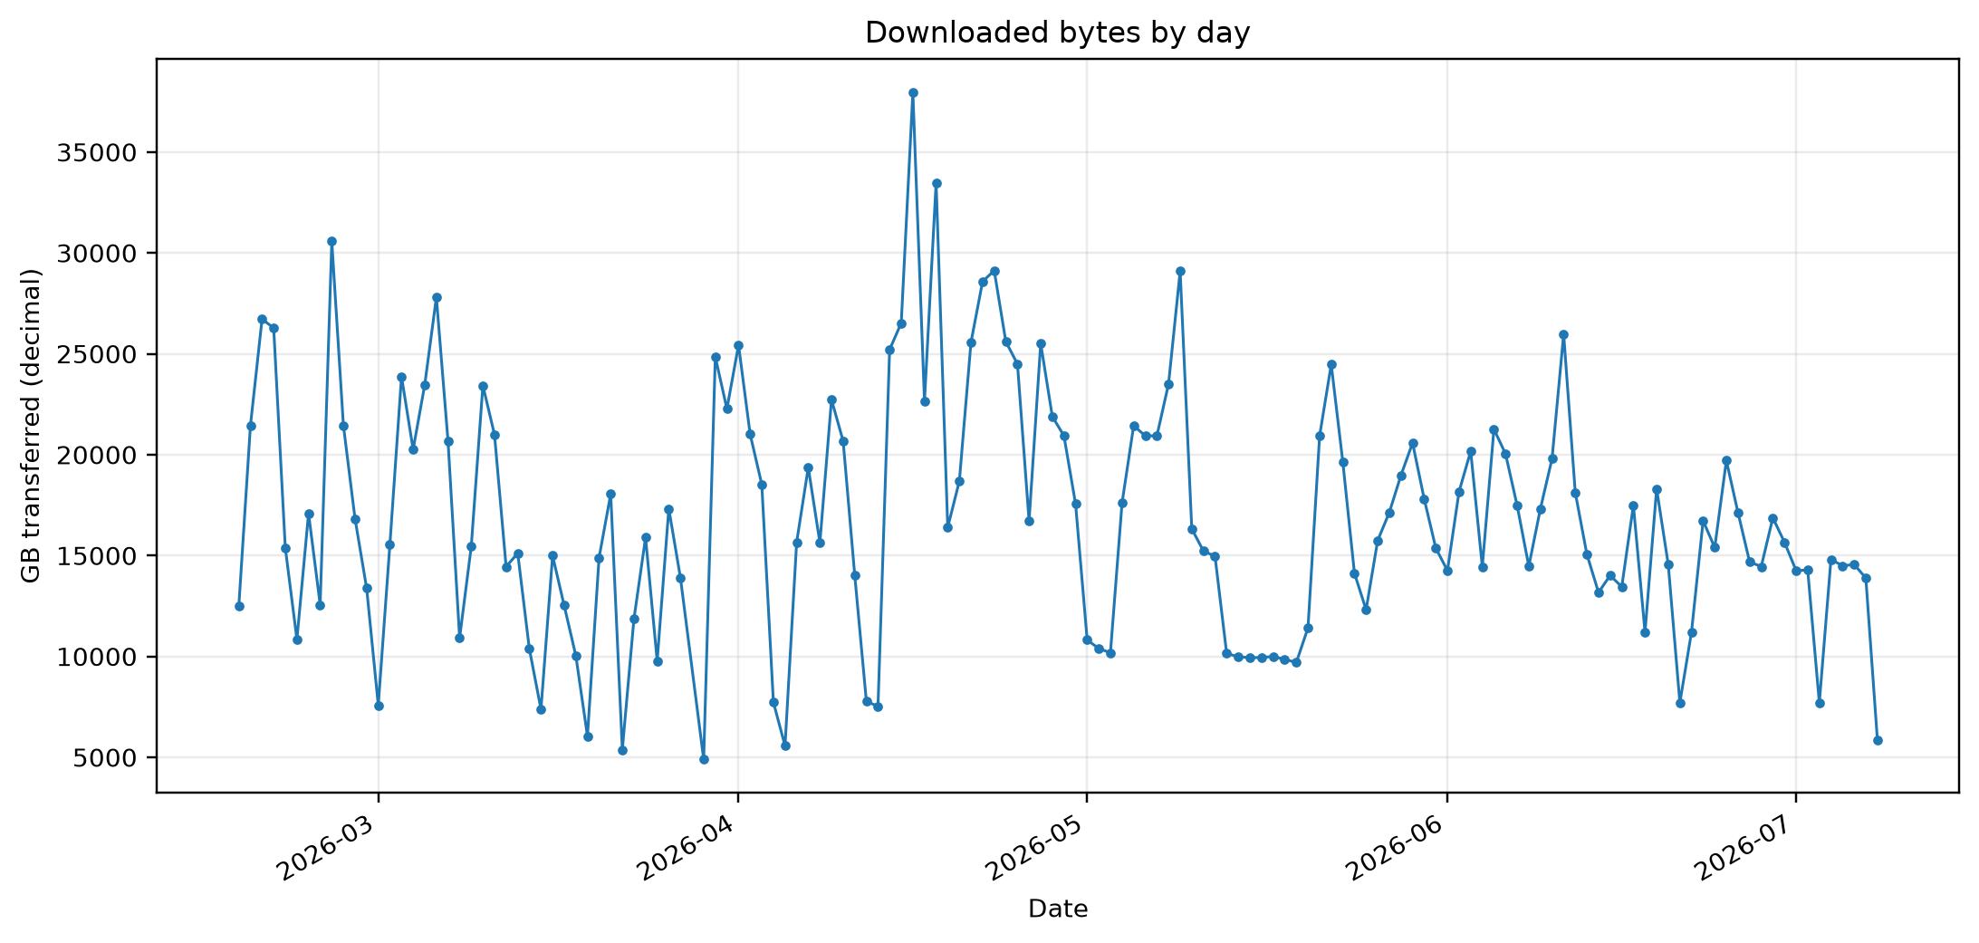
Figure 2. Parsed response-body bytes by day.
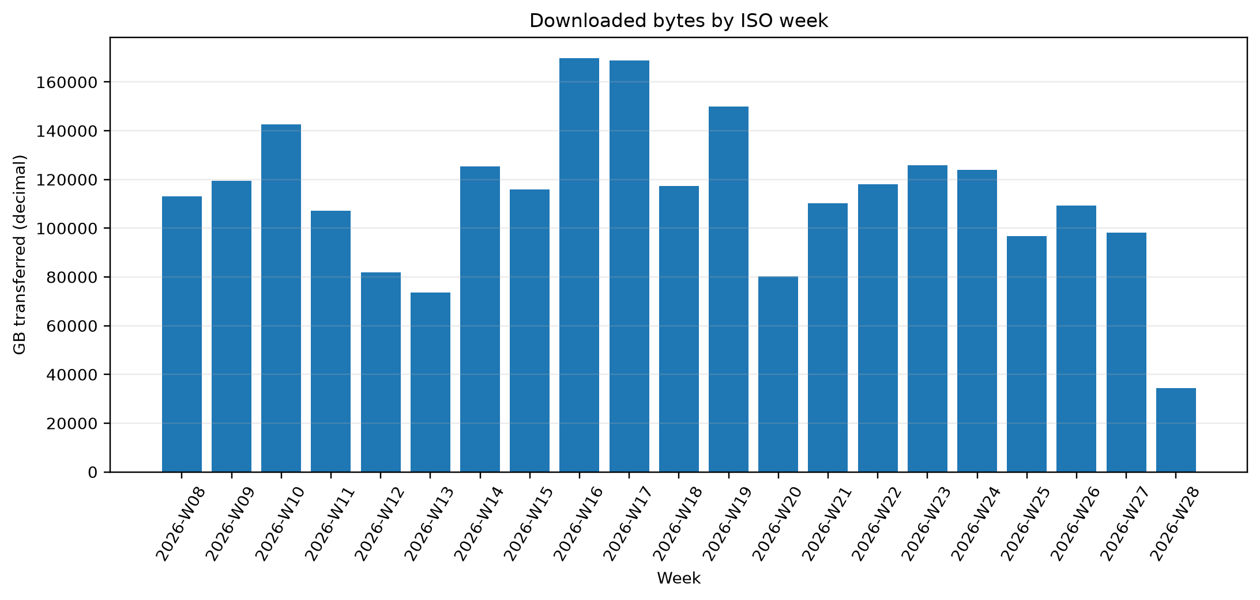
Figure 3. Parsed response-body bytes by ISO week.
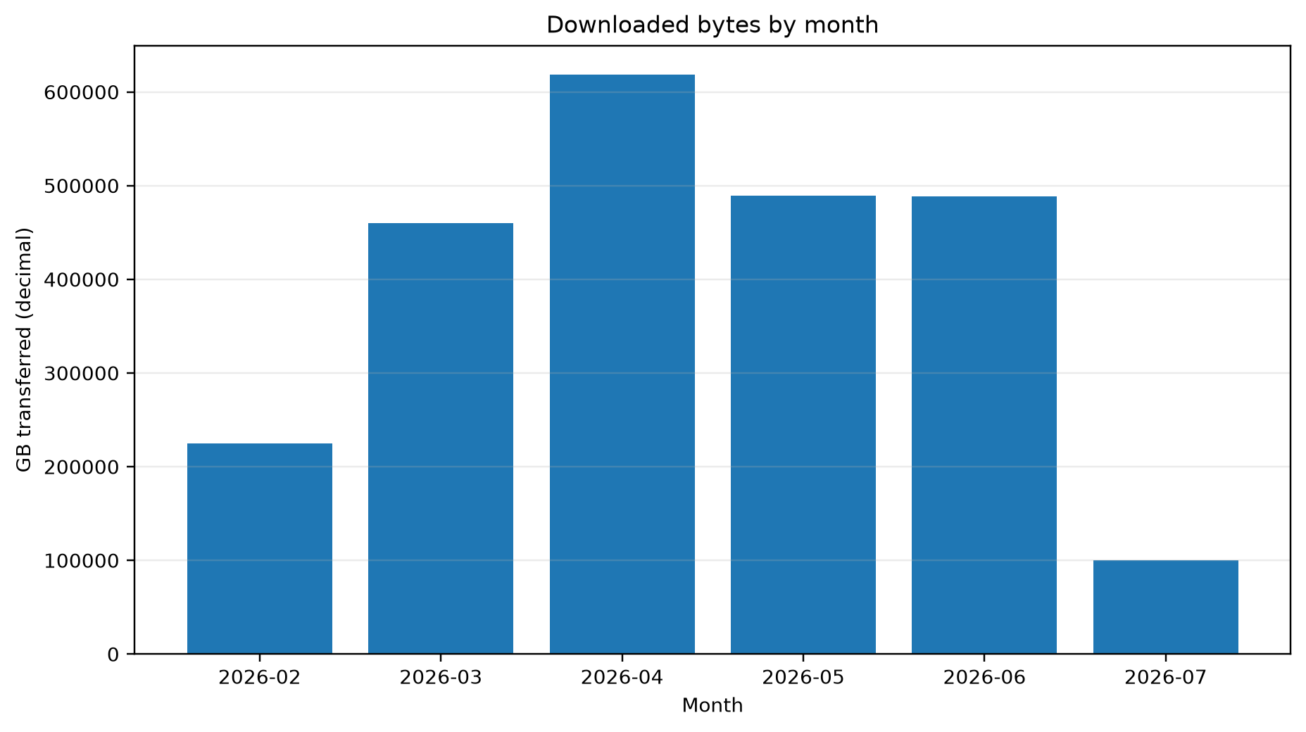
Figure 4. Parsed response-body bytes by month.
Highest-volume parsed days:
Date | Requests | GB | Unique IPs
2026-04-16 | 6,841,231 | 37,955.57 | 327,210
2026-04-18 | 6,198,037 | 33,480.58 | 153,940
2026-02-25 | 949,885 | 30,584.16 | 93,151
2026-04-23 | 1,393,862 | 29,128.66 | 56,071
2026-05-09 | 645,798 | 29,098.68 | 160,415
2026-04-22 | 1,352,229 | 28,583.37 | 14,150
2026-03-06 | 1,223,537 | 27,803.86 | 256,213
2026-02-19 | 1,167,100 | 26,723.45 | 27,872
2026-04-15 | 8,789,231 | 26,528.76 | 52,012
2026-02-20 | 1,267,578 | 26,279.80 | 32,889

What was downloaded
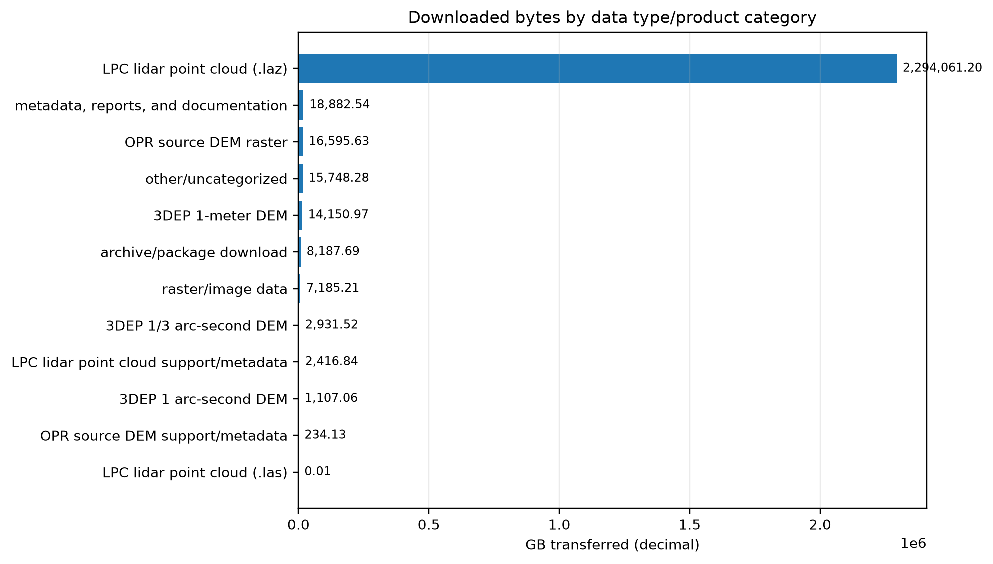
Figure 5. Response-body bytes by product/data category.
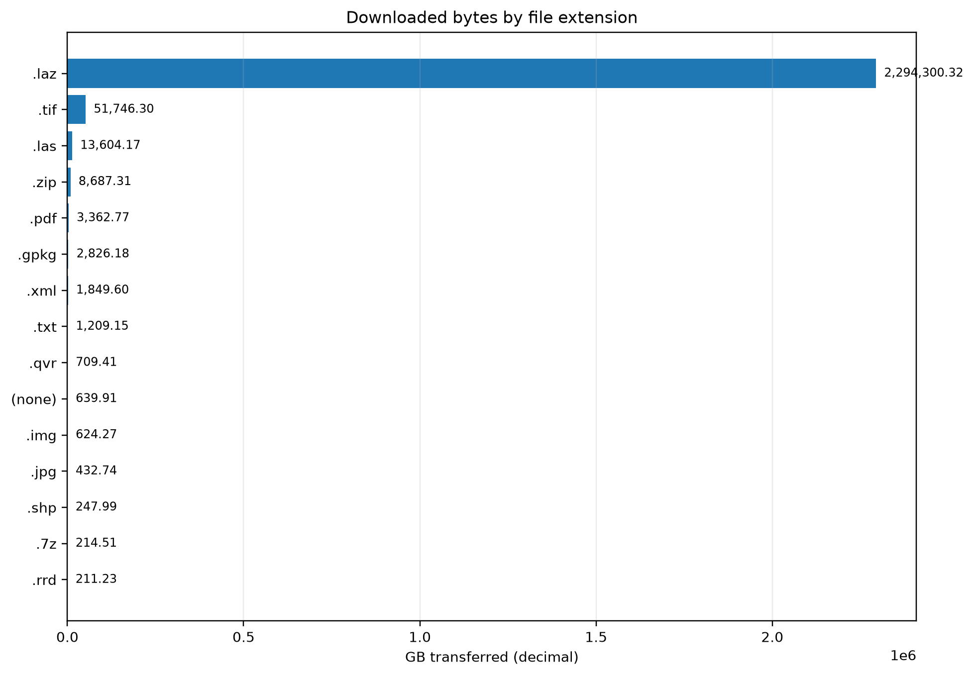
Figure 6. Response-body bytes by file extension.
Product/data category | Requests | GB
LPC lidar point cloud (.laz) | 133,505,331 | 2,294,061.20
metadata, reports, and documentation | 13,406,997 | 18,882.54
OPR source DEM raster | 3,127,437 | 16,595.63
other/uncategorized | 16,484,118 | 15,748.28
3DEP 1-meter DEM | 2,620,076 | 14,150.97
archive/package download | 419,212 | 8,187.69
raster/image data | 547,400 | 7,185.21
3DEP 1/3 arc-second DEM | 250,622 | 2,931.52
LPC lidar point cloud support/metadata | 179,362,242 | 2,416.84
3DEP 1 arc-second DEM | 406,875 | 1,107.06
OPR source DEM support/metadata | 11,502,508 | 234.13
LPC lidar point cloud (.las) | 9,651 | 0.01
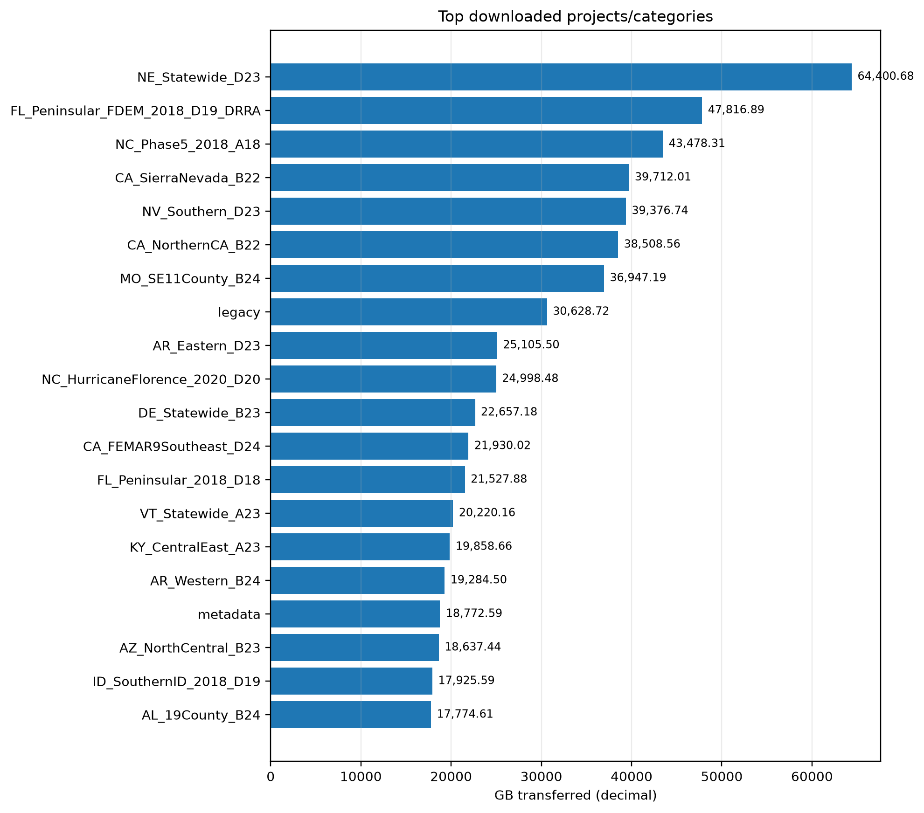
Figure 7. Top projects/categories by response-body bytes.

Who downloaded it and from where
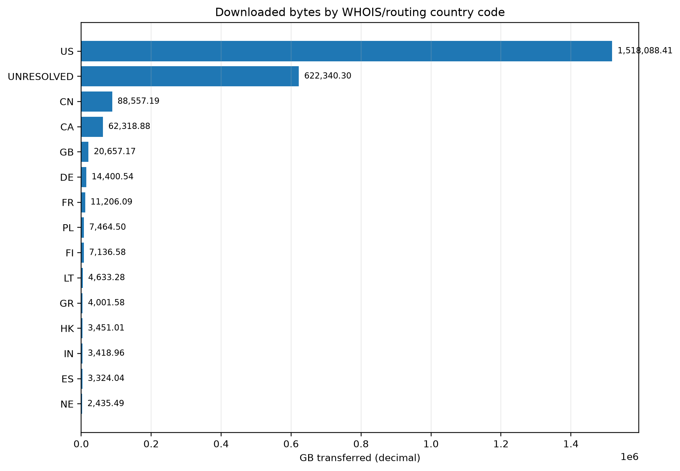
Figure 8. Response-body bytes by WHOIS/routing country code.
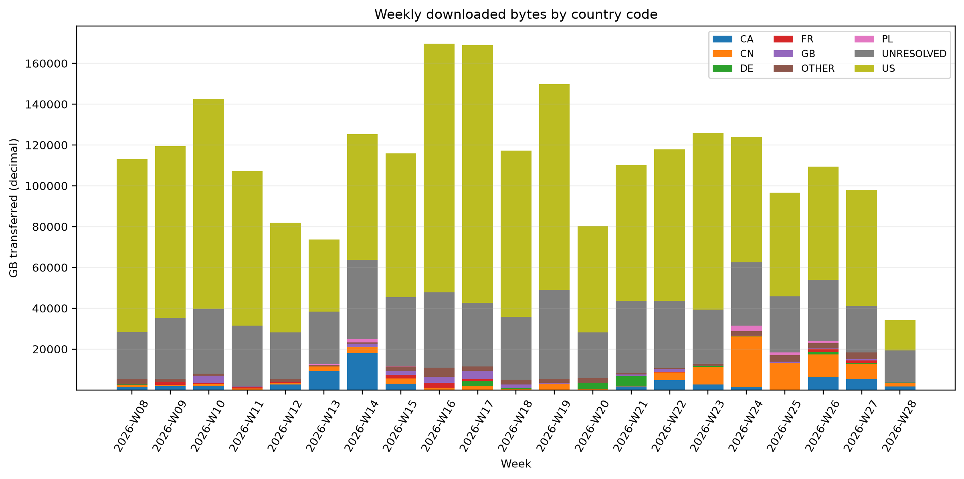
Figure 9. Weekly response-body bytes by top country codes.
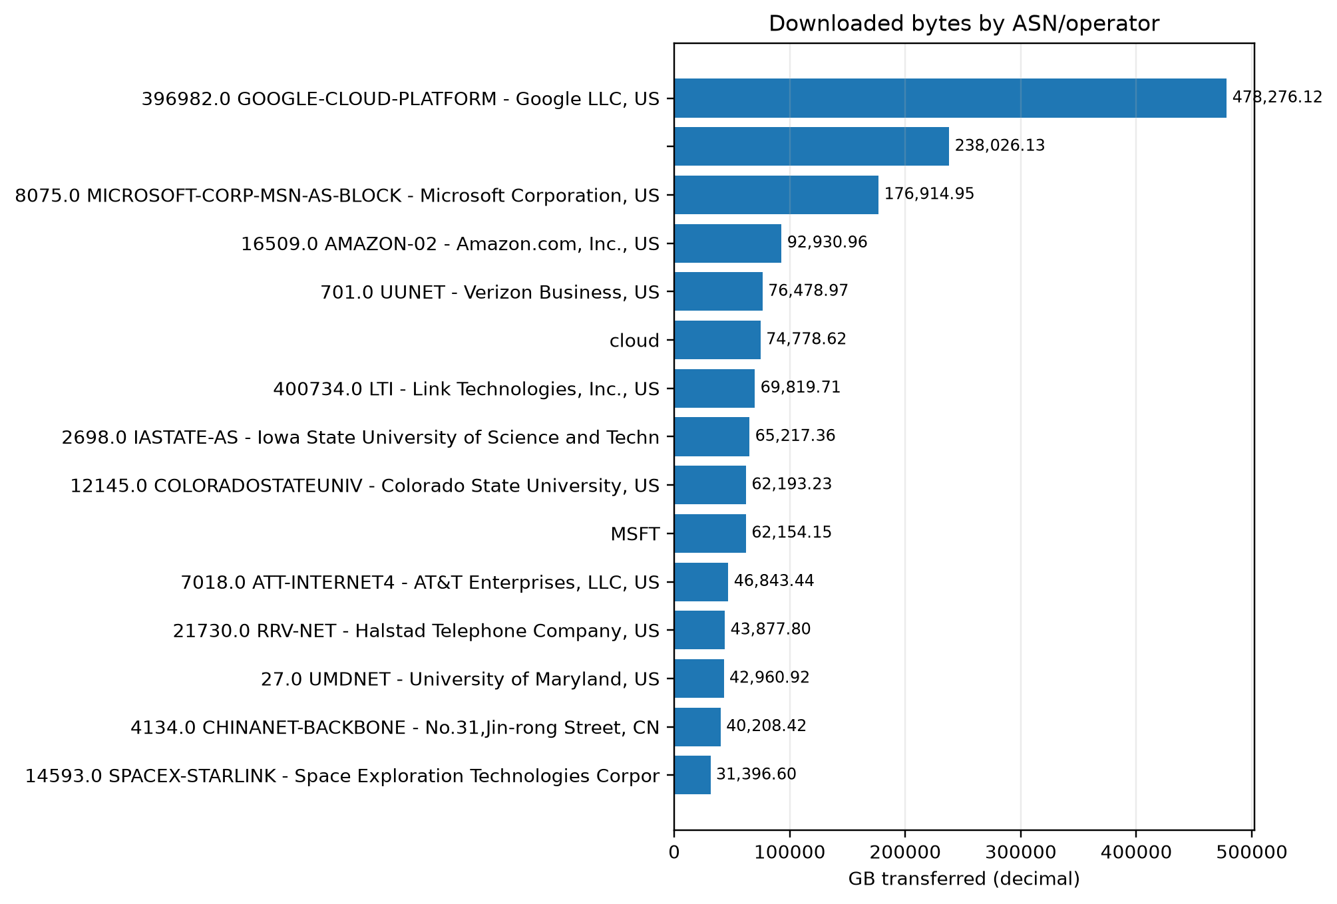
Figure 10. Response-body bytes by ASN/operator.
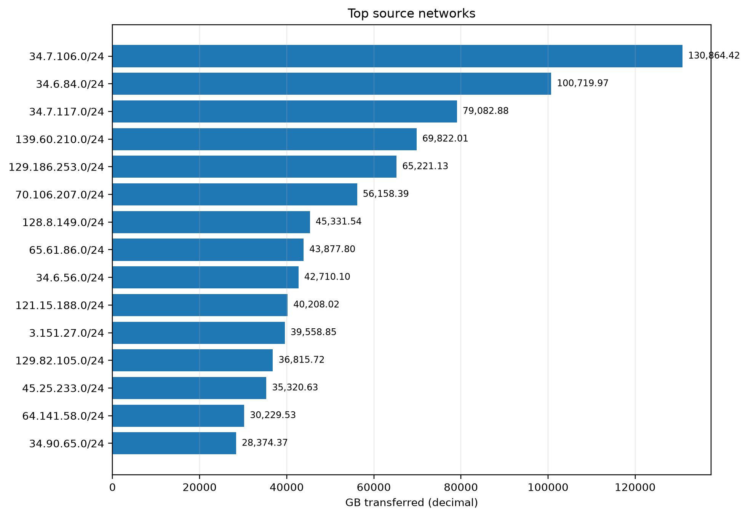
Figure 11. Top source networks by response-body bytes.
Country code | Requests | GB | Unique IPs
US | 111,669,641 | 1,518,088.41 | 12,844
UNRESOLVED | 201,812,062 | 622,340.30 | 8,160,939
CN | 7,981,677 | 88,557.19 | 1,330
CA | 1,722,093 | 62,318.88 | 838
GB | 1,741,827 | 20,657.17 | 2,641
DE | 1,991,916 | 14,400.54 | 1,126
FR | 74,803 | 11,206.09 | 1,649
PL | 312,312 | 7,464.50 | 345
FI | 226,934 | 7,136.58 | 30
LT | 242,186 | 4,633.28 | 248
GR | 79,734 | 4,001.58 | 178
HK | 452,943 | 3,451.01 | 402
IN | 1,077,337 | 3,418.96 | 4,618
ES | 46,509 | 3,324.04 | 1,272
NE | 181,876 | 2,435.49 | 2
ASN | ASN/operator | CC | GB
396,982.00 | GOOGLE-CLOUD-PLATFORM - Google LLC, US | US | 478,276.12
nan | nan | UNRESOLVED | 238,026.13
8,075.00 | MICROSOFT-CORP-MSN-AS-BLOCK - Microsoft Corporation, US | US | 176,914.95
16,509.00 | AMAZON-02 - Amazon.com, Inc., US | US | 92,930.96
701.00 | UUNET - Verizon Business, US | US | 76,478.97
nan | cloud | US | 74,778.62
400,734.00 | LTI - Link Technologies, Inc., US | US | 69,819.71
2,698.00 | IASTATE-AS - Iowa State University of Science and Technology, US | US | 65,217.36
12,145.00 | COLORADOSTATEUNIV - Colorado State University, US | US | 62,193.23
nan | MSFT | UNRESOLVED | 62,154.15
7,018.00 | ATT-INTERNET4 - AT&T Enterprises, LLC, US | US | 46,843.44
21,730.00 | RRV-NET - Halstad Telephone Company, US | US | 43,877.80
27.00 | UMDNET - University of Maryland, US | US | 42,960.92
4,134.00 | CHINANET-BACKBONE - No.31,Jin-rong Street, CN | CN | 40,208.42
14,593.00 | SPACEX-STARLINK - Space Exploration Technologies Corporation, US | US | 31,396.60

How the downloads were performed
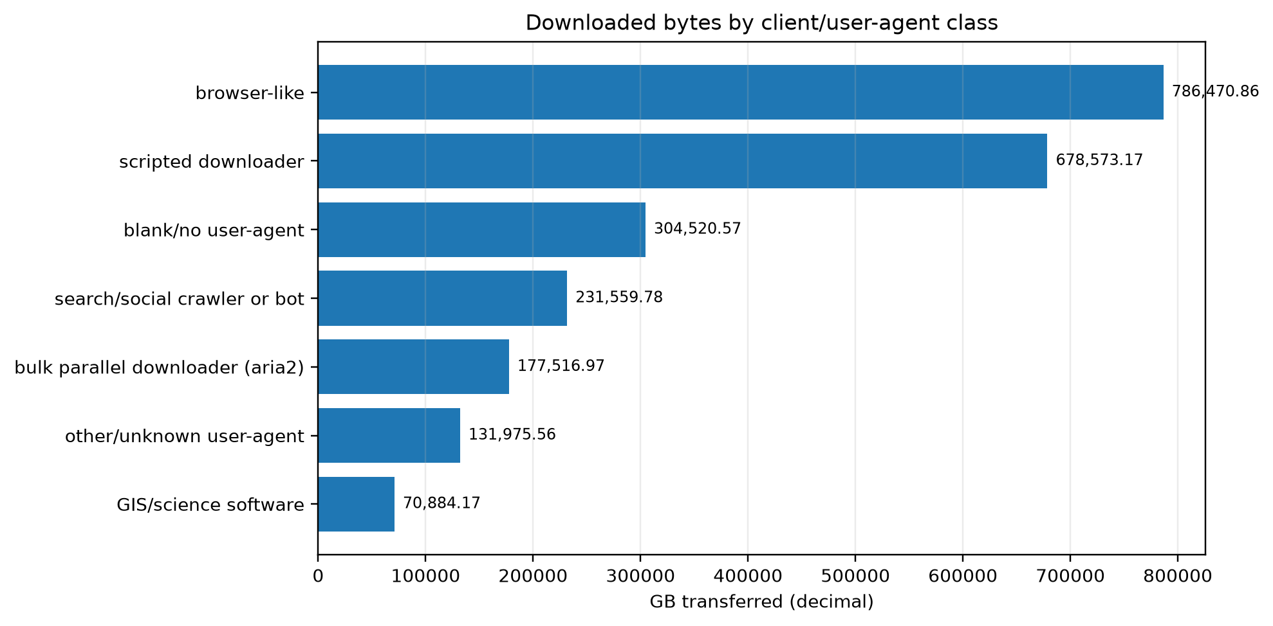
Figure 12. Response-body bytes by user-agent/client class.
Client class | Requests | GB
browser-like | 51,405,975 | 786,470.86
scripted downloader | 167,007,867 | 678,573.17
blank/no user-agent | 19,141,645 | 304,520.57
search/social crawler or bot | 47,708,635 | 231,559.78
bulk parallel downloader (aria2) | 19,151,442 | 177,516.97
other/unknown user-agent | 51,791,823 | 131,975.56
GIS/science software | 5,435,082 | 70,884.17
HTTP status-code distribution:
Status | Requests | GB
200.00 | 269,535,268.00 | 2,222,736.12
206.00 | 84,471,236.00 | 158,762.51
404.00 | 6,714,238.00 | 2.15
403.00 | 354,397.00 | 0.18
416.00 | 240,162.00 | 0.05
405.00 | 80,139.00 | 0.04
301.00 | 154,265.00 | 0.02
400.00 | 74,003.00 | 0.01
414.00 | 455.00 | 0.00
501.00 | 111.00 | 0.00
412.00 | 8.00 | 0.00
413.00 | 8.00 | 0.00

Audit files and reproducibility
The output folder retains CSV tables for all report charts. The raw logs are intentionally not included in the compact report bundle; keep them locally if audit or reprocessing is required. The most important audit tables are directory_manifest.csv, parse_summary.json, unmatched_examples.csv, source_ip_summary.csv, source_network_summary.csv, unique_public_ips.csv, cymru_ip_enrichment.csv, and rdap_network_enrichment.csv.

Limitations
Log-derived byte counts depend on the configured nginx log format and the semantics of the logged byte variable. The byte field represented here is interpreted as response-body bytes, not total TCP/TLS transfer size. Confirm the server log_format directive if the site uses a custom byte variable.
WHOIS/RDAP and BGP-origin country data should be interpreted as registration/routing evidence. Cloud regions, VPN/proxy egress, institutional gateways, NAT, crawlers, and scripted download infrastructure can make the apparent country or organization differ from the final user or beneficiary of a download.
The active access_log may overlap with rotated daily logs depending on server log rotation. This parser does not suppress exact duplicate-looking rows. When --include-active is used with the default --active-overlap-policy exclude-covered, active-log rows at or before the latest rotated-log timestamp are excluded from the primary rollup; use --active-overlap-policy include to count all active-log rows.

References
[1] U.S. Geological Survey RockyWeb directory listing, Index of /outgoing/Z/, https://rockyweb.usgs.gov/outgoing/Z/. Accessed 2026-07-08.
[2] NGINX, Module ngx_http_log_module, official documentation for access_log and log_format, https://nginx.org/en/docs/http/ngx_http_log_module.html.
[3] ARIN, Whois/Registration Data Access Protocol (RDAP), https://www.arin.net/resources/registry/whois/rdap/.
[4] Team Cymru, IP to ASN Mapping Service, https://www.team-cymru.com/ip-asn-mapping.
[5] Rekhter et al., RFC 1918: Address Allocation for Private Internets, Internet Engineering Task Force, https://datatracker.ietf.org/doc/html/rfc1918.
[6] U.S. Geological Survey, Lidar Point Cloud - USGS National Map 3DEP Downloadable Data Collection, https://data.usgs.gov/datacatalog/data/USGS%3Ab7e353d2-325f-4fc6-8d95-01254705638a.
[7] U.S. Geological Survey, Original Product Resolution Source Digital Elevation Models - USGS National Map 3DEP Downloadable Data Collection, https://data.usgs.gov/datacatalog/data/USGS%3A1004ada7-1e9f-4fcf-adfb-677868b7317c.

