Contours to reorient the profile lines

See other issue papers to get general gist of the profile tool...

* Main problem with the profiles is:
  + When the line is oriented against the contours at the point where a profile is being placed, the profile shows a downward trend, flagging an error for the profile.
  + If the profile was adjusted to be at the correct orientation with the contours, there may be fewer false positives.

1. Buffer the line features (minus the AP) by ~~20 meters~~ 25 meters (20 meters removed the edge cells too much of the time making the contours a bit too short).

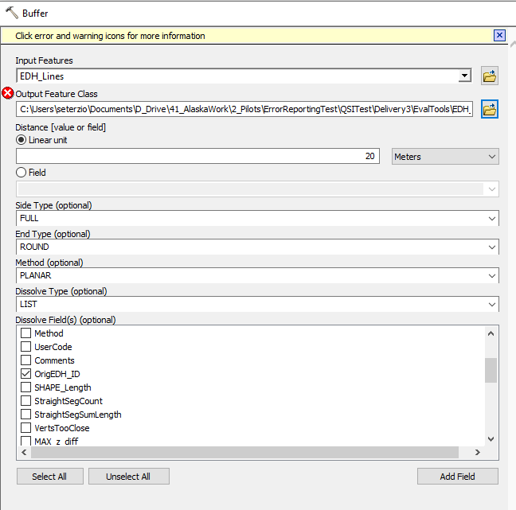

Executing: Buffer EDH_Lines C:\Users\seterzio\Documents\D_Drive\41_AlaskaWork\2_Pilots\ErrorReportingTest\QSITest\Delivery3\EvalTools\EDH_Evaluation.gdb\EDH_Lines_buffer20m "20 Meters" FULL ROUND LIST OrigEDH_ID PLANAR

Start Time: Mon Jun 15 13:09:14 2020

Succeeded at Mon Jun 15 13:10:48 2020 (Elapsed Time: 1 minutes 34 seconds)

1. Clip elevation to buffer areas and create an integer elevation dataset within the buffers.

Using the strm buff grid as a mask:

Executing: RasterCalculator Int("DTM_19050302_Area3_QSI.tif"*10) C:\Users\seterzio\Documents\D_Drive\41_AlaskaWork\2_Pilots\ErrorReportingTest\QSITest\buffelevx10

Start Time: Mon Jun 15 15:05:42 2020

Int(Raster(r"DTM_19050302_Area3_QSI.tif")*10)

Succeeded at Mon Jun 15 15:06:12 2020 (Elapsed Time: 30.03 seconds)

1. Create contour lines for the Study area

Executing: Contour buffelevx10 C:\Users\seterzio\Documents\ArcGIS\Default.gdb\Contour_buffele1 10 0 1 CONTOUR #

Start Time: Mon Jun 15 15:13:24 2020

Succeeded at Mon Jun 15 15:16:04 2020 (Elapsed Time: 2 minutes 39 seconds)

Example of profile line with overlapping contour and line created (in red) to measure the profile based on endpoints of contour:

False positive:

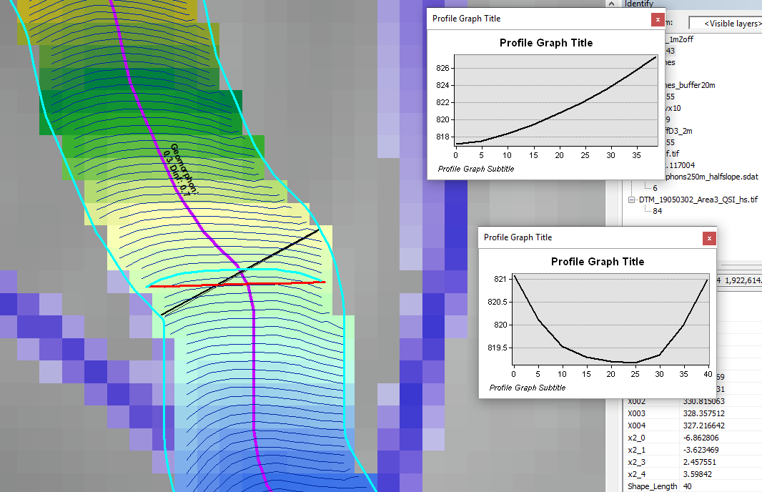

Real error - still shows a real error but not ge 2 meters:

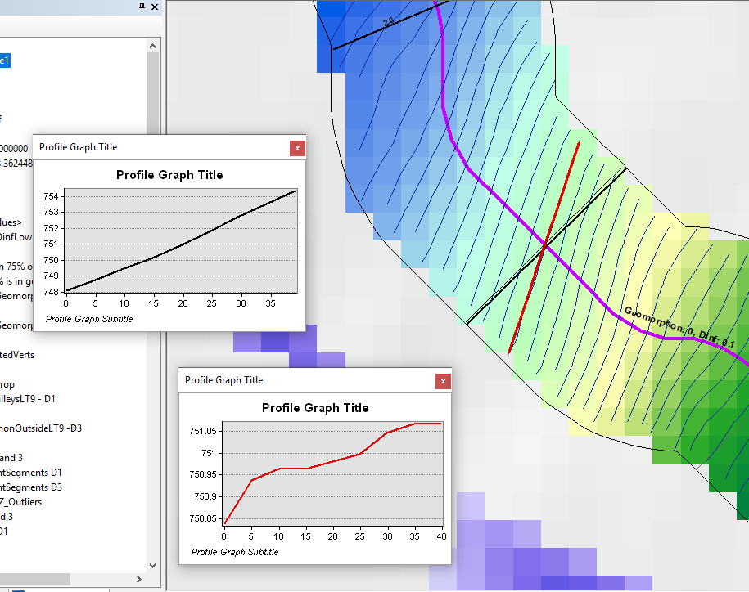

Error gt 2:

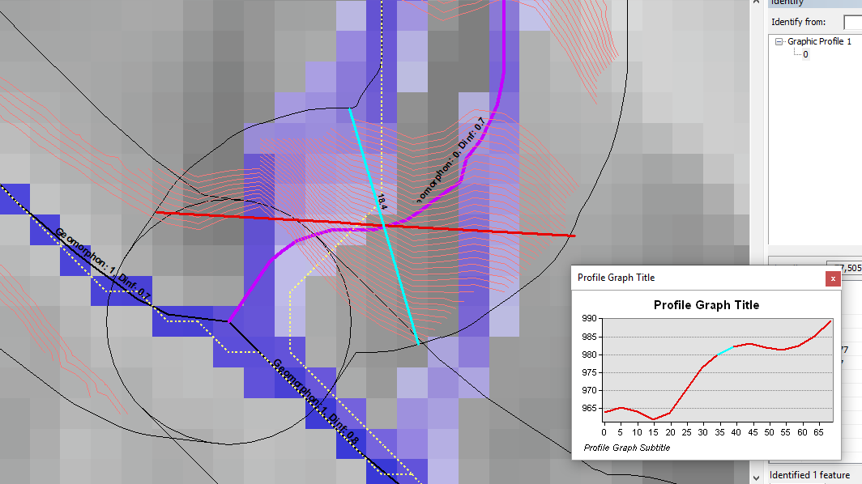

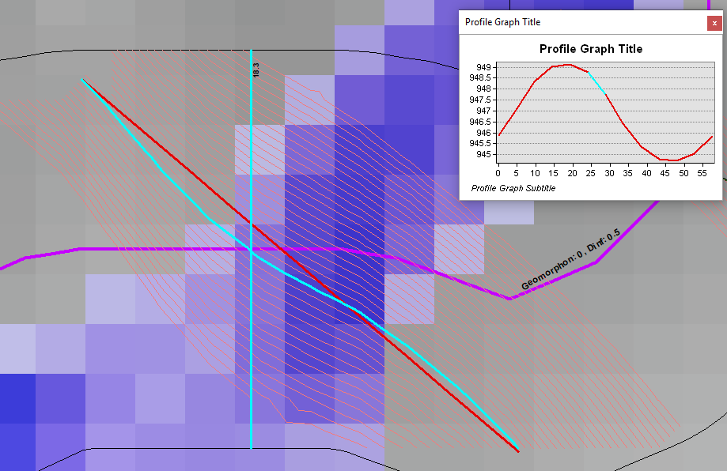

Many do not become errors – but should they be? :

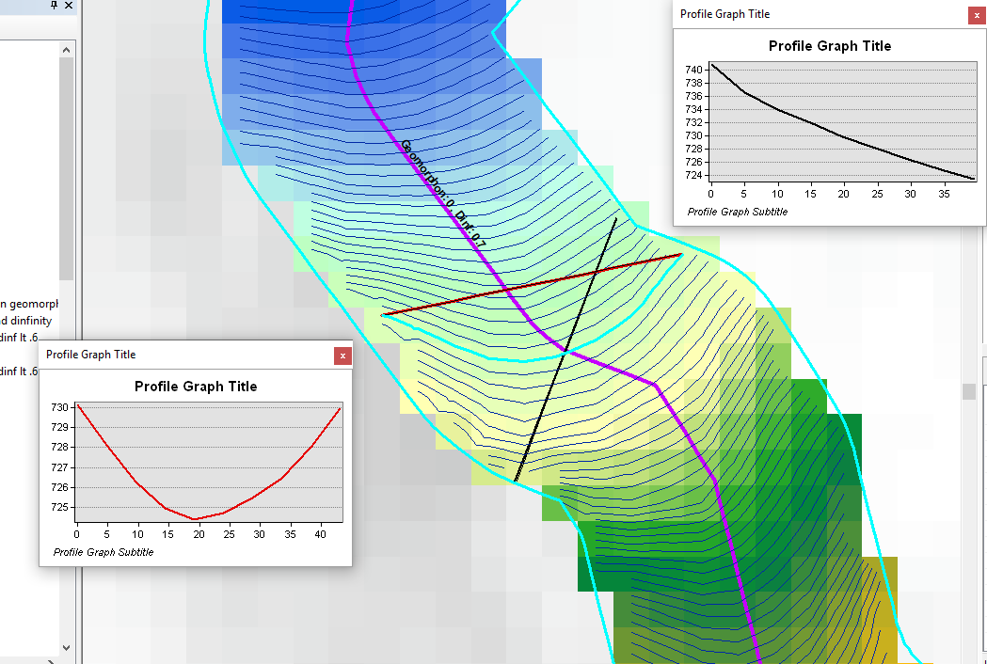

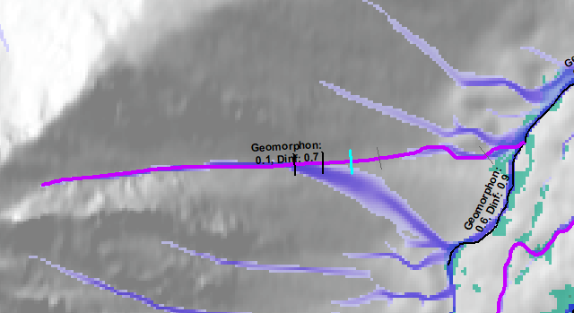

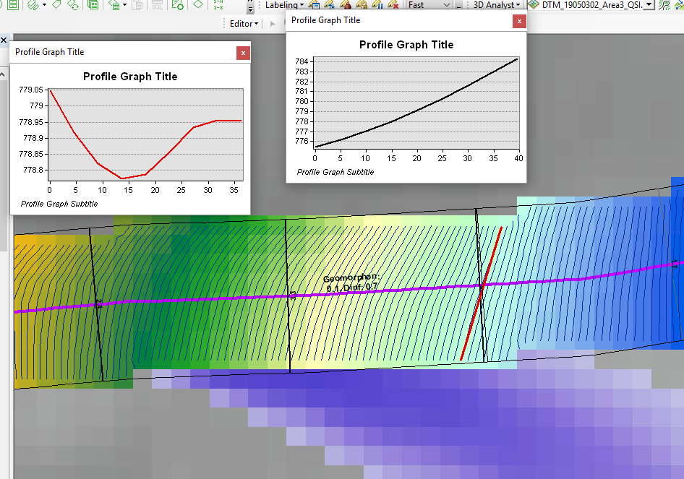

Problem with this method – should be an error, but contour is ok - this is a problem with entire method I’m afraid! Maybe we need to look at the angle of the contour lines with the profile line. Could it be avoided if need to select the contour that also passes over the EDH line (not just the profile line):

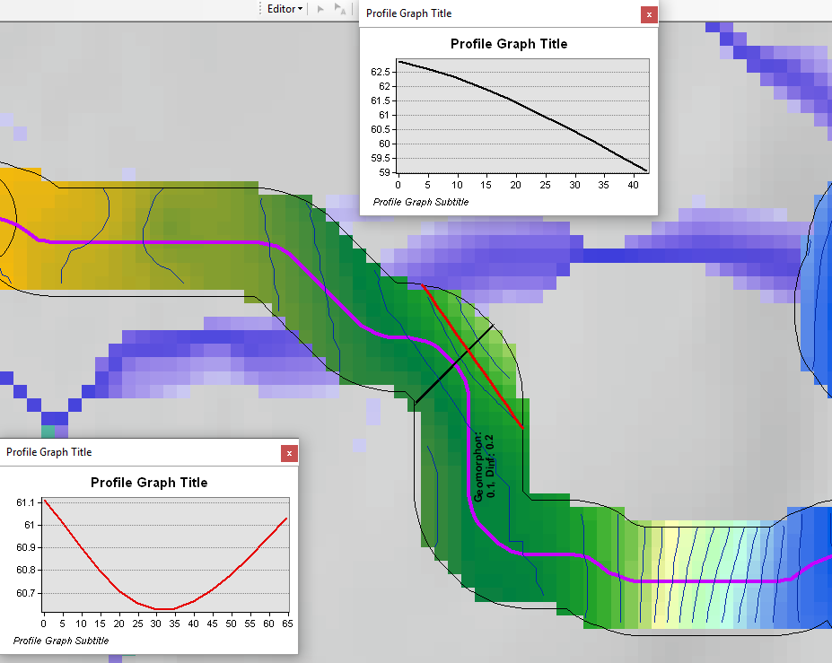

Select only the lines that overlap the Profile lines before selecting closes contour line.

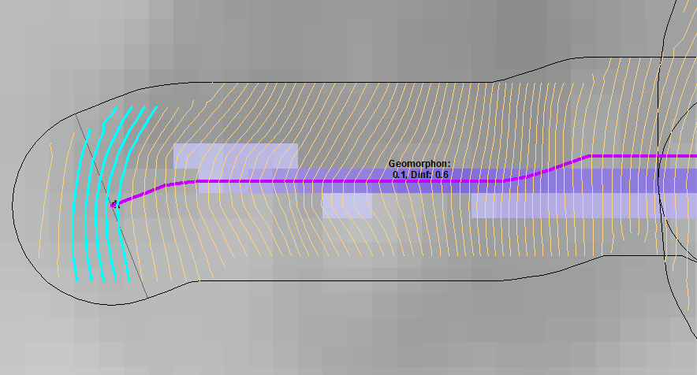

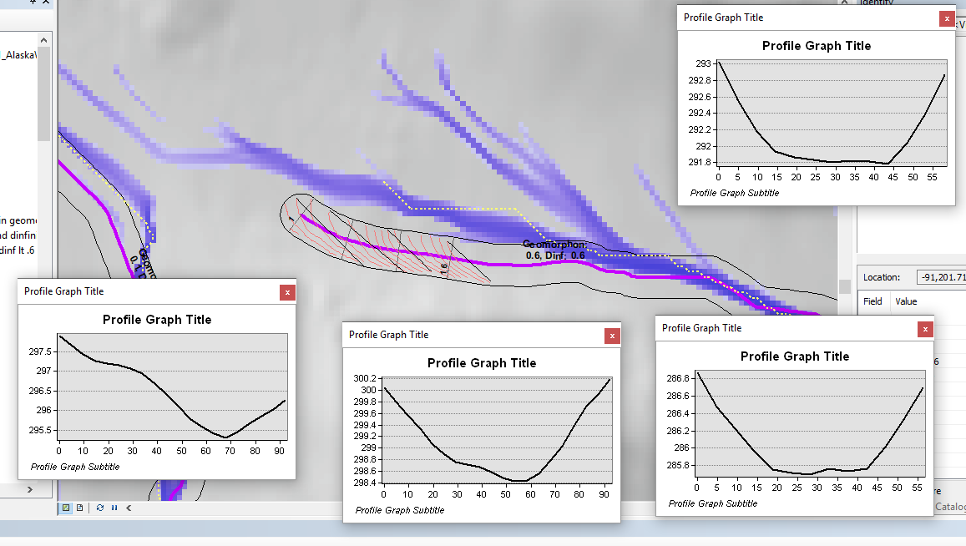

TEST BASED ON LENGTH OF CONTOURS INTERSECTING THE PROFILE LINES:

1. Join the profiles and the contours that intersect the profiles.

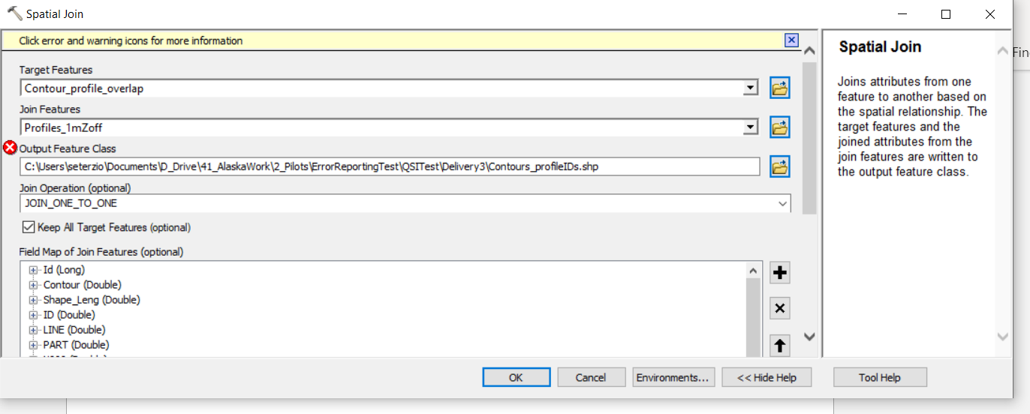

1. Do a frequency on the length of the contours, by id of the profile line.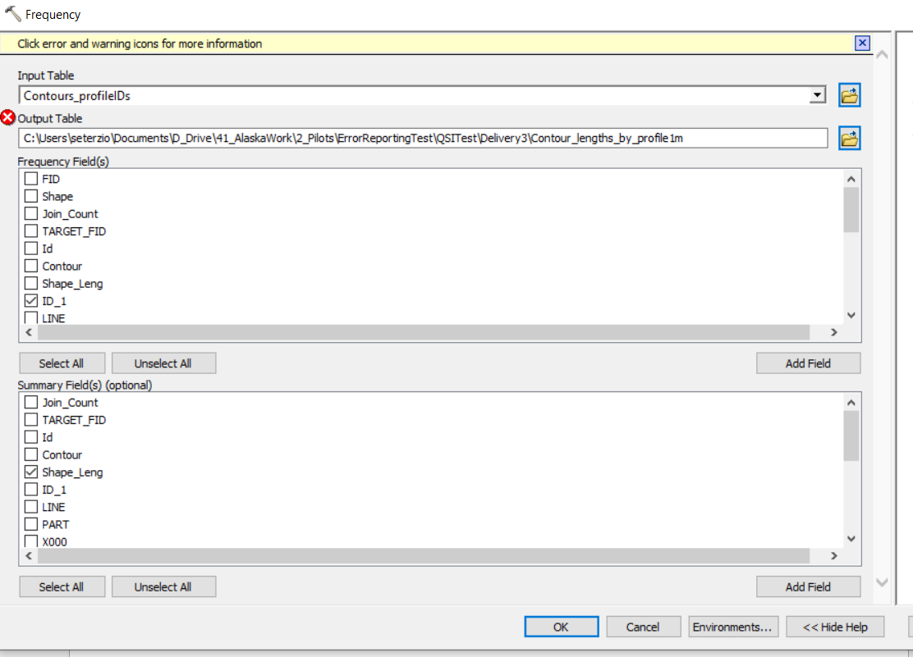
2. Join the frequency table to the profile lines and display by std to see what are much longer than normal

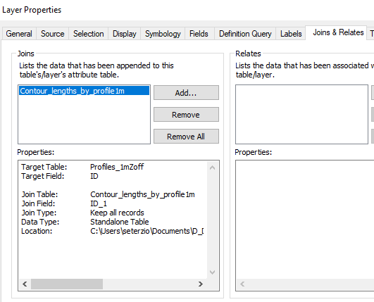

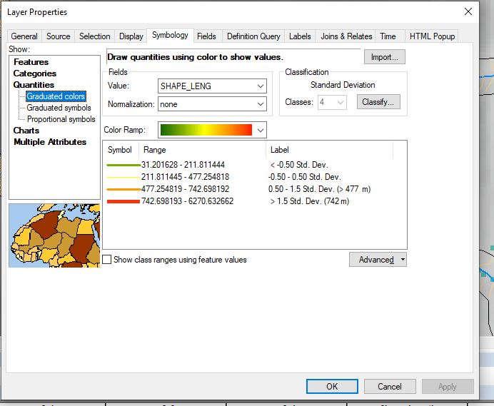

Here are some that are fairly small lengths:

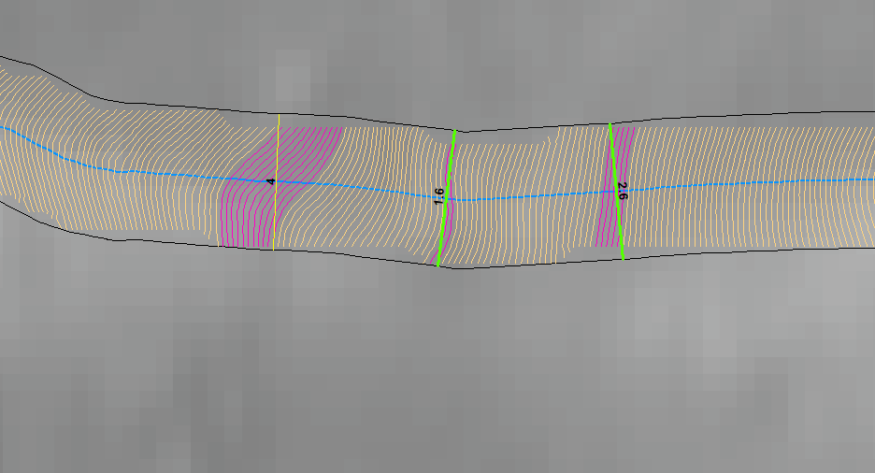

So we would trust these orientations

The Yellow is around the mean so still trust?

Here some orientation is questionable, and some ok:

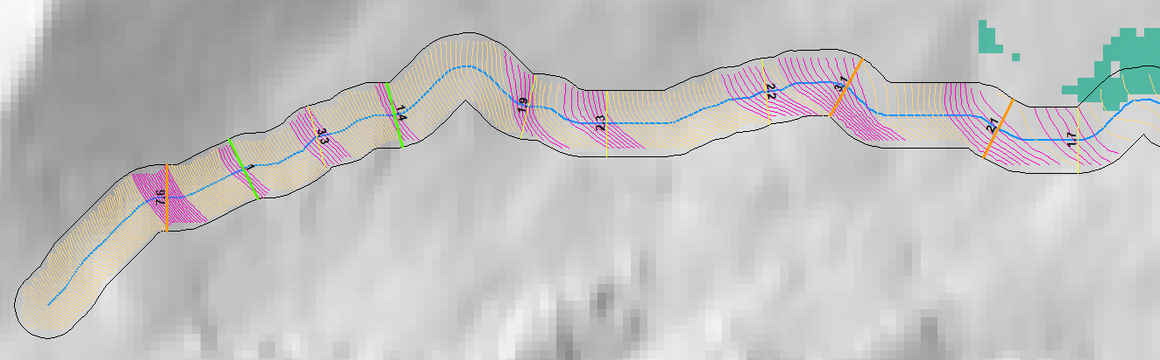

Very long lengths – also look stair steppy:

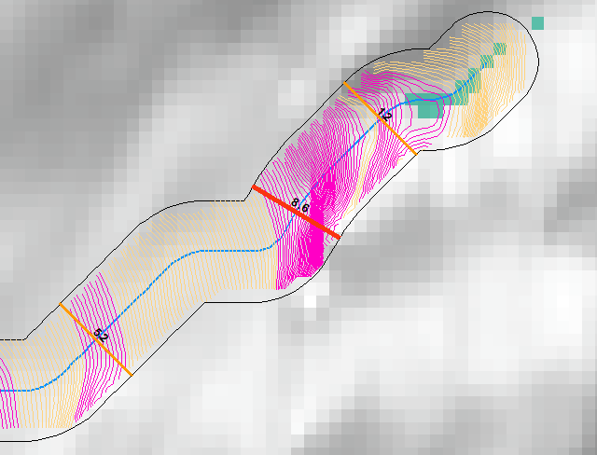

Misc

Run profile tool – extract lines with a max elevation difference of at least 2 meters

max ( !x2_0!, !x2_1!, !x2_3!, !x2_4!)

Create an intersection point with profile line and edh lines

Run near between profiles and intersection point

Extract clipped contours that are closest to the point of intersection (or can we automate contour creation at these points?)

Get endpoints of contours and connect them to form a straight line.

These are the new profiles.

Create new profile file using these contours – they should be better oriented to the contours.

Maybe choosing the start or end endpoints of the contour closest to the profile?

Here is a ‘good’ one:

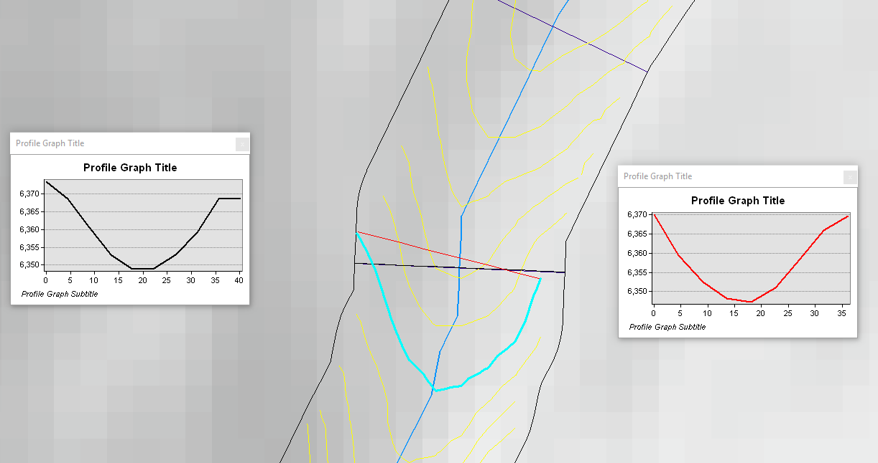

A very badly placed one:

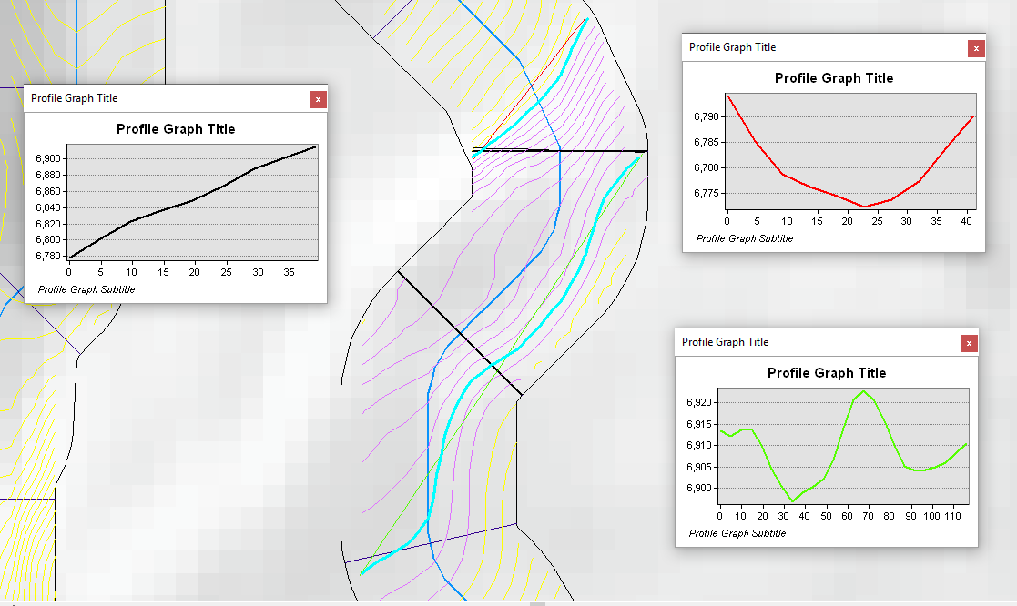

Back to the angle of the closest contour – what is that telling us:

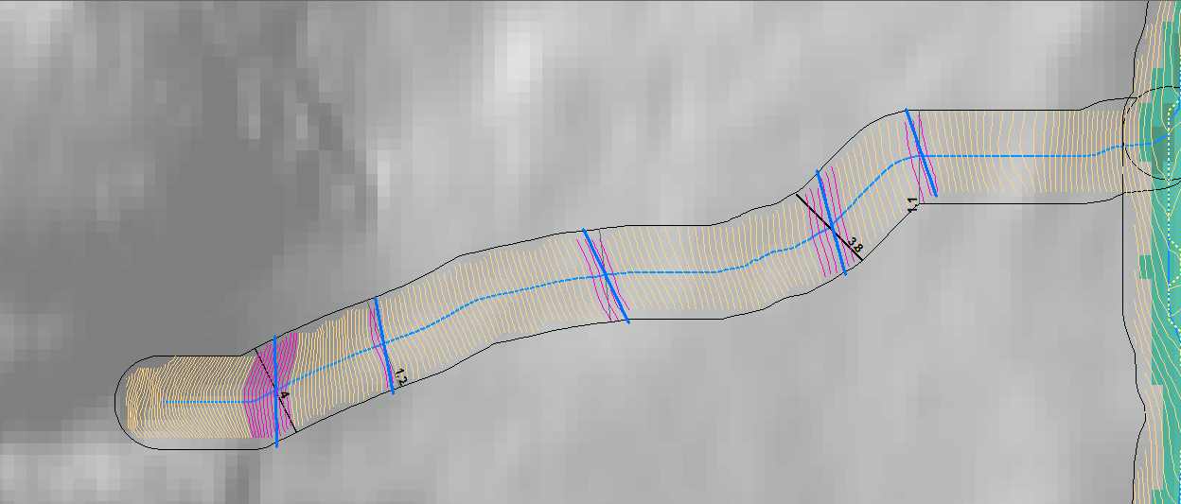

If the angle if great between the profile and contour endpoints, the stream is oriented incorrectly.

If the angle is small, the orientation is ok – so trust the profile tool?

