**Acquisition Guideline for Alaska and CONUS Elevation-Derived Hydrography**

**Geomorphic Indicators used to determine stream placement**

|  |  |  |
| --- | --- | --- |
| **Version** | **Date** | **Changes** |
| Version 1 | November 30, 2020 |  |
| Version 2 | January 19, 2022 | Added additional geomorphic derivatives that may be useful for determining stream channels. |

**Description of Issue**

These guidelines are provided to offer examples for creating a Geomorphic Index (GMI) layer for use in checking whether a hydrography network falls within a channelized area of the terrain. Elevation derivatives that identify channelization or relative low spots in the terrain can be used to predict where water would flow or pool. Combining the presence or absence of geomorphic derivatives that identify a stream channel is used to create an index from 0 to n, where 0 = no derivatives identify a channel and n = number of derivatives combined to make the index layer. Typically, a GMI is composed of 3 to 4 index layers. Comparing hydrography derived from elevation to derivatives from the same elevation source helps ensure that linework is aligned with surface features likely to represent hydrography.

**Intent for Guidelines**

This guidance document provides examples of geomorphic layers derived from a bare-earth DEM that can be used to identify landscape characteristics that typically support water features. Terrain characteristics such as slope can influence what parameters are appropriate to use in a GMI. Other features such as geology, land cover, or soil type can also greatly influence the effectiveness of geomorphic derivatives to identify areas likely to represent hydrography channels.

The GMI layer identifies probable channels that are compared to the position of vector stream channels in order to automate flagging of potential errors. Three or four parameters are typically used to create the GMI and identify the likely channel positions.

Expected Outcomes

1. Describe a set of geomorphic derivatives that can potentially identify where a hydrography feature may be present.
2. Provide methods and sources to define the geomorphic derivatives.
3. Provide a method that can be used to help verify that hydrography acquired from elevation is well integrated with the source elevation.

Supporting Information

Elevation derivatives that may be helpful in identifying hydrographic features:

## Geomorphons

1. Geomorphons – A method of identifying landforms, typically summarized to 10 landform types.

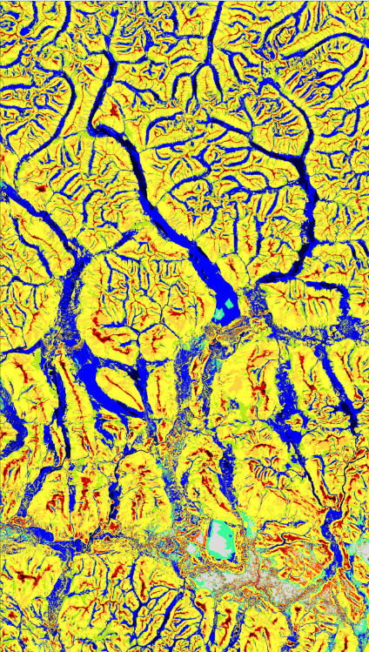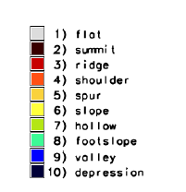

For use as an input geomorphic indicator layer, we extract **Valley and Depression** classes. The geomorphons are useful for larger flat floodplain valleys.

The software used is SAGA (or GRASS), with .5 as the slope angle and 250 meters as the radial limit. This provides a somewhat smoothed valley features, without the microfeatures a smaller radius would capture.

1. Run the **Feature Preserving Smoothing filter** using Whitebox tools on the DEM and use the smoothed surface for geomorphon extraction
   1. Whitebox Tools in ArcGIS: Whitebox Tools>Geomorphometric Analysis >Feature Preserving Smoothing
   2. Use default parameters
2. Use SAGA to create the geomorphon layer – **use a .5 degree slope (threshold angle) and 250 meters** as the search radius (radial limit) for Alaska. This distance may need to be changed if valleys are too wide or not being picked up.

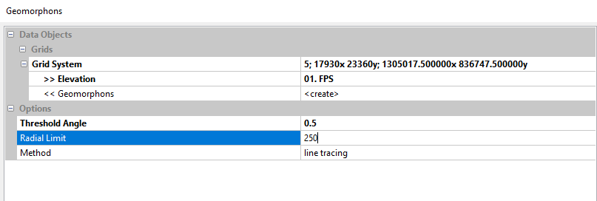

1. Output as a tiff

<http://geomorphometry.org/system/files/StepinskiJasiewicz2011geomorphometry.pdf>

## D-Infinity Flow Paths

1. D-infinity flow paths – “The D-Infinity (DINF) flow method, described by Tarboton (1997), determines flow direction as the steepest downward slope on eight triangular facets formed in a 3x3 cell window centered on the cell of interest. Flow direction output is a floating-point raster represented as a single angle in degrees going counter-clockwise from 0 (due east) to 360 (again due east). “

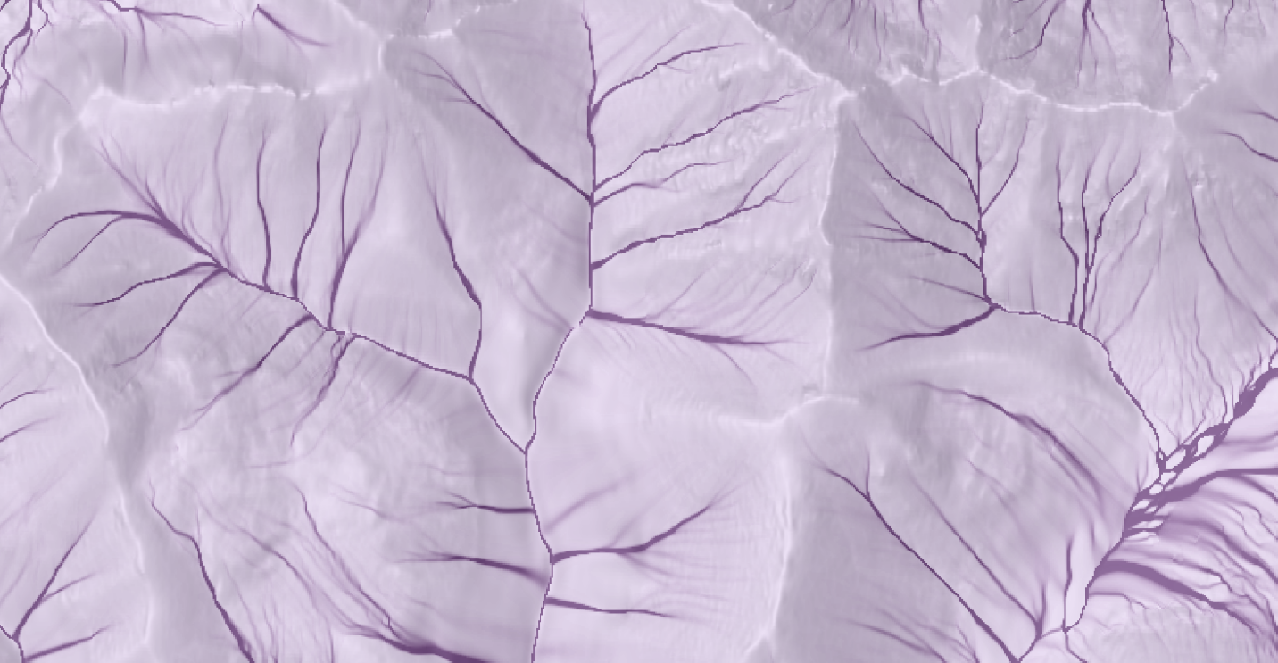

Subset used of D-infinity raster:

Run the D-infinity flowpaths on an **UNFILLED** DEM surface to produce flowpaths that would naturally flow across the surface in areas of moderate to high relief. This does not work well in flat terrain or in places with many depressions.

We use a minimum accumulation of **500** pixels to create a model of probable flow.

D-infinity flow accumulation is available in most GIS Software systems.

## Plan Curvature

1. Plan curvature – the plan curvature is perpendicular to the direction of the maximum slope.

Plan curvature is used to avoid curvature that hugs a contour line, and instead goes against the contours finding more probable channels heading downstream. Negative plan curvature indicates concave channels, and positive indicates convex channels.

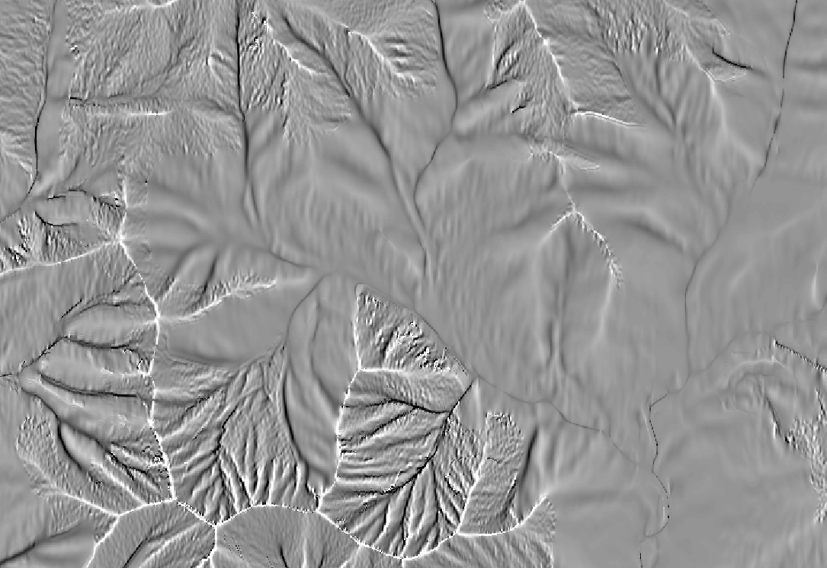

Subset used for Plan Curvature raster:

Run the **Feature Preserving Smoothing filter** using Whitebox tools on the DEM and use the smoothed surface for curvature extraction.

One or two standard deviations below the mean is used as the cut off for plan curvature, unless that value is positive. In that case -.5 is used.

This works well in the steep terrain but can also add definition in hard to discern channels in low relief areas.

Plan curvature can create a lot of ‘noise’ if there are hummocks or artifacts in the surface, and may not be an appropriate use for the index.

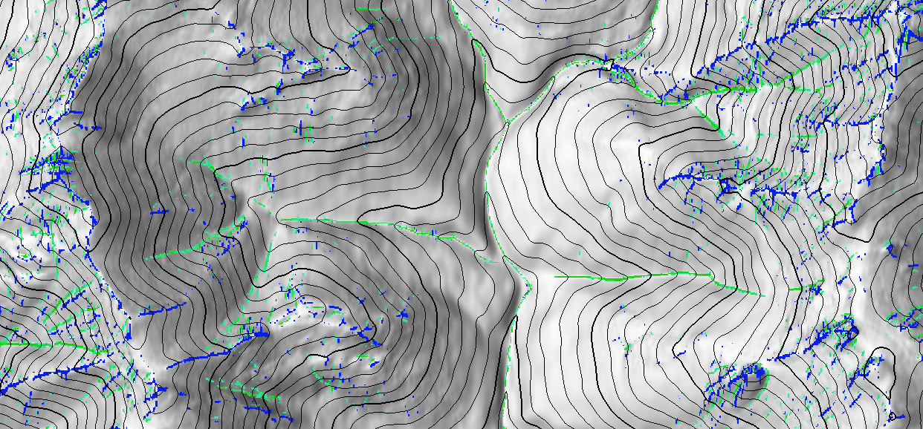

For flat areas, the mean can be used to extract curvature values.

Plan curvature is available in most GIS Software systems.

## BOTHAT

1. BOTHAT

The bothat command uses a focal min at two focal radiuses and finds overlapping cells to extract channel bottoms.

1. Run the BothHat focal analysis for 11x11 and 3x3.
2. Extract the cells from the 3x3 focal analysis that intersect the 11x11 cells.

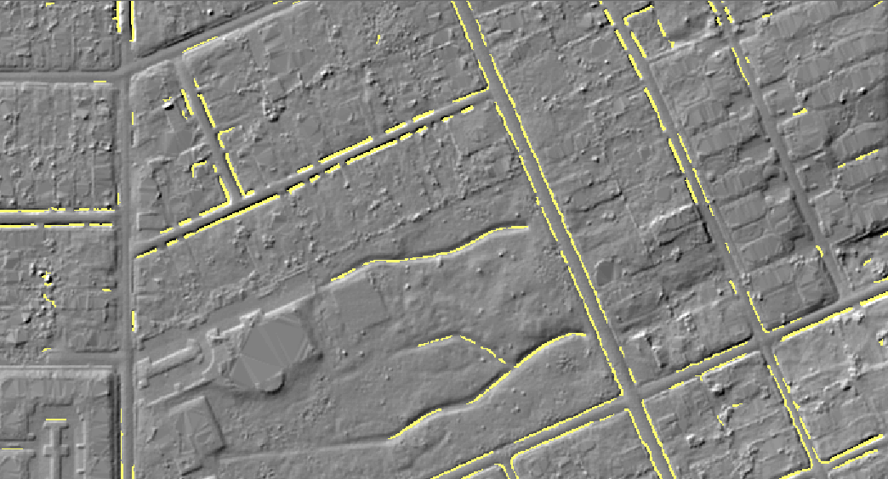

Figure 1 [The Black Top Hat function applied to a DEM: A tool to estimate recent incision in a mountainous watershed (Estibère Watershed, Central Pyrenees) - Rodriguez - 2002 - Geophysical Research Letters - Wiley Online Library](https://agupubs.onlinelibrary.wiley.com/doi/pdf/10.1029/2001GL014412)

[LiDAR at the New Hampshire Geological Survey (unh.edu)](https://wrrc.unh.edu/sites/wrrc.unh.edu/files/LR_Symposium/2014/05%20Olson%20Lamprey_Symposium.pdf)

BotHat is available within SAGA and as functions for use in a modelbuilder tool.

Multiscale Elevation Percentile

* 1. Create a Feature Preserving Smoothing DEM from the original DEM. This will also be used to create the MEP layer
     1. Run in WhiteBox tools – under Geomorphological functions
  2. Run the Multiscale Elevation Percentile function from WhiteBox tools. This creates a continuous raster, with values from 0 to 100, indicating the relative position within the terrain.
     1. Run in WhiteBox tools – under Geomorphological functions using the FPS_DEM.tif as input

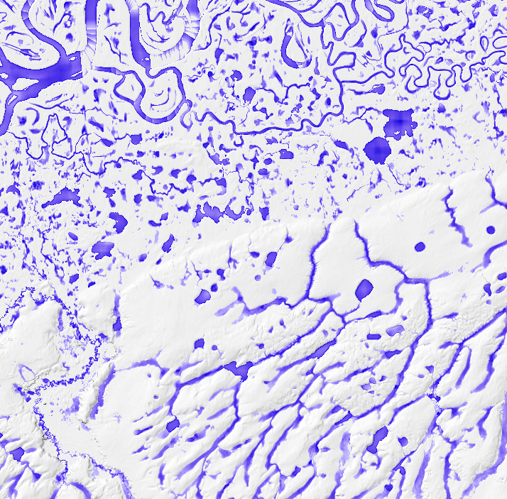

Figure 2 For Alaska, use a 1 cell search radius. This works for more non-connected areas with a lot of roughness to find probable channels.

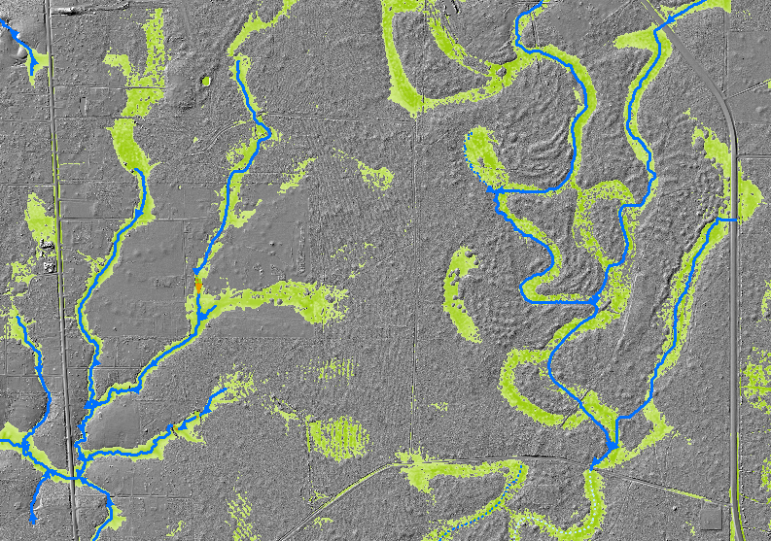

Figure 3 For CONUS with lidar data, a larger distance is used, particularly in low slope areas, in order to identify wide vegetated channels. In Southeast Texas a search radius of 250 meters was used.

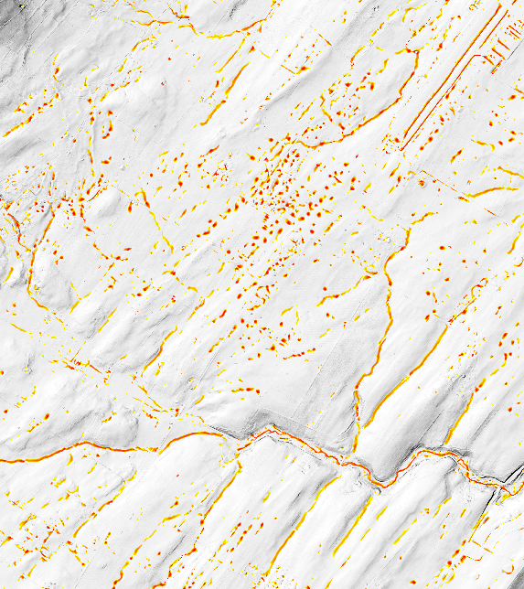

Figure 4 In Pennsylvania, a radius of 15 meters was used to identify channel. Note that many sink holes were also identified in the karst terrain.

[Geomorphometric analysis - WhiteboxTools User Manual (whiteboxgeo.com)](https://www.whiteboxgeo.com/manual/wbt_book/available_tools/geomorphometric_analysis.html#MultiscaleElevationPercentile)

Available from the Whitebox Toolset.

1. Other derivatives that may be useful include Relative Topographic Index, Wetness Index, and Openness.

The geomorphic index (GMI).

A common GMI used in Alaska is a 4-parameter combination with:

* asubsets of Geomorphon valleys (class 9) and depressions (class 10),
* D-Infinity flow accumulation greater than 500 cells,
* multiscale elevation percentile in the lowest 20th percentile,
* and plan curvature less than 1 standard deviation from the mean.

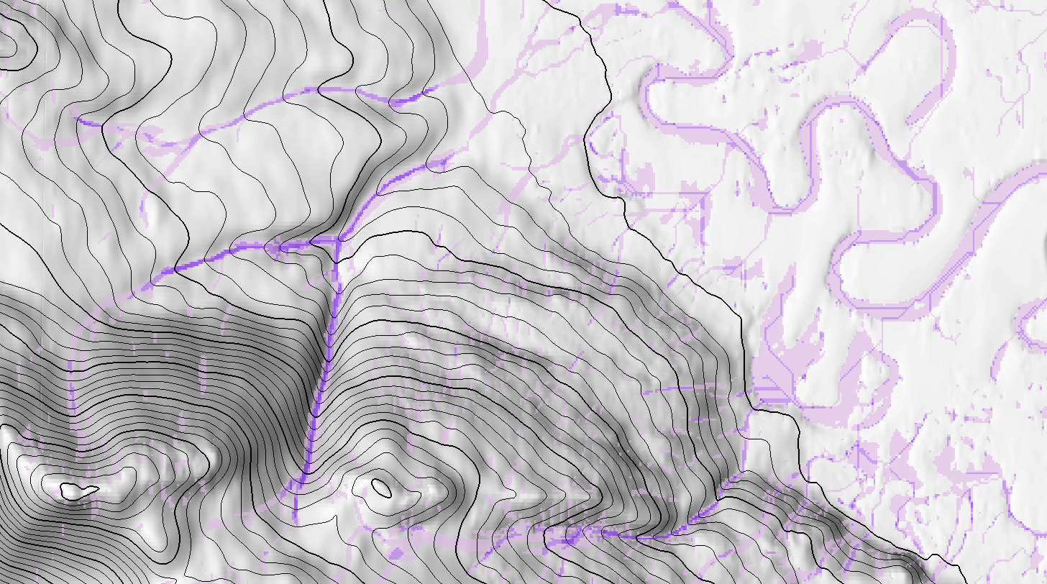

Figure 5 The geomorphic index is a composite indicator with ranges in value from 1 to 4, where the higher the indicator index, the more likely a channel would pass through it. In this example, the darkest purple colors have higher index values, indicating more index layers are positive for a channel in this location. The lighter colors have lower index values, indicating fewer indicators showing a channel for this location.

**Disclaimer**

These guidelines have not been accepted as official USGS Specifications, do not supersede existing specifications, and are provided as clarifications of existing specifications only. Please see the Alaska Specifications Roll-Up, and Elevation-Derived Hydrography Acquisition Specifications and Elevation-Derived Hydrography—Representation, Extraction, Attribution, and Delineation Rules for more information about this topic. There are additional capture conditions and specifications that must be adhered to for hydrography acquisition outside of these guidelines. These guidelines may become official published specifications in the future.

**Selected References**

Archuleta, C.M., and Terziotti, S., 2020, Elevation-Derived Hydrography—Representation, Extraction, Attribution, and Delineation Rules: U.S. Geological Survey Techniques and Methods, book 11, chap. B12, 60 p., https://doi.org/ 10.3133/ tm11B12.

Terziotti, S., and Archuleta, C.M., 2020, Elevation-Derived Hydrography Acquisition Specifications: U.S. Geological Survey Techniques and Methods, book 11, chap. B11, 74 p., https://doi.org/ 10.3133/ tm11B11.