Elevation Data TSDN Project Narrative

San Diego County, CA
September 30, 2016

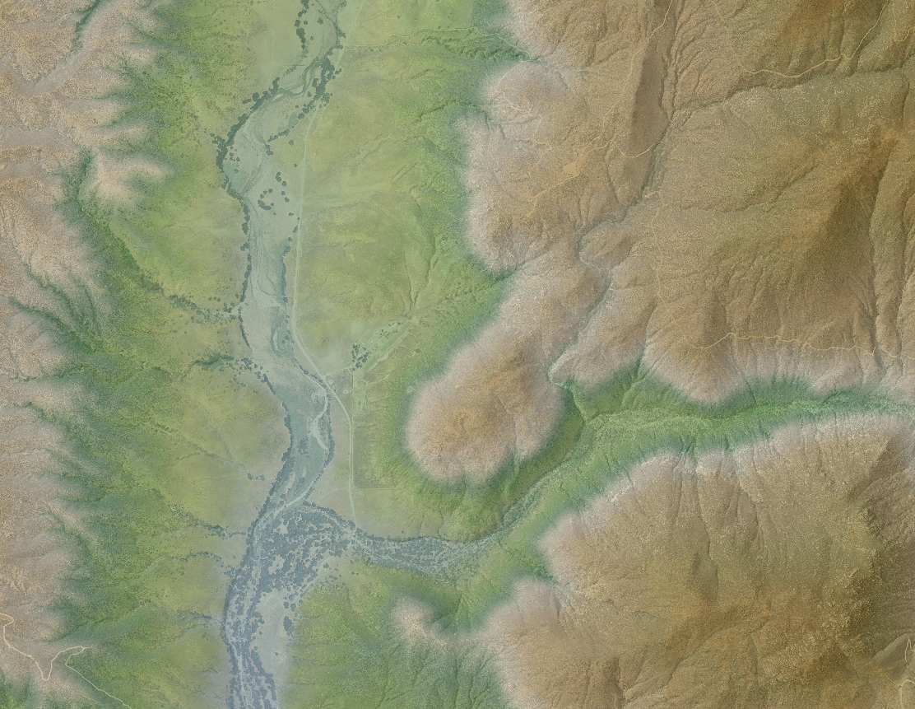

Federal Emergency Management Agency, Region IX

Department of Homeland Security
1111 Broadway, Suite 1200
Oakland, CA 94607

Table of Contents

1.0 INTRODUCTION 1
2.0 Scope of Work 3
3.0 Issues 3
4.0 Information for the Next Mapping Partner 4
4.1 Field Survey 5
4.2 LiDAR Acquisition 5
4.3 LiDAR Post Processing 6
4.4 LiDAR Derived Products 6
4.5 Quality Assurance 7

INTRODUCTION

Beginning in Fiscal Year 2010, FEMA initiated a program for Risk Mapping, Assessment, and Planning (Risk MAP). The purpose of Risk MAP is to continue to improve flood hazard information for the National Flood Insurance Program (NFIP) and increase national awareness and understanding of flood risk to support Federal, State, and local actions to reduce risk. To support these initiatives FEMA has made a commitment to acquire high-resolution LiDAR elevation data. The incorporation of more accurate topography improves the precision and reliability of flood hazard data. This, in turn, improves the quality of Flood Insurance Rate Maps and Flood Risk Assessments so communities are able to make informed decisions to protect their citizens and become more resilient to flood related hazards.

The purpose of this elevation dataset is to provide the basis for riverine hydrologic and hydraulic modeling in the San Diego County, CA area of interest. This area is located to the east of the City of San Diego and covers approximately 1617 square miles within the County.

LiDAR acquisition and post processing objectives for the San Diego County, CA project are as follows:

- Satisfy USGS 3DEP requirements for Quality Level 2 elevation data
- ASPRS LAS 1.4 format with point data record 6
- Collect raw point cloud swaths that cover the entire project area
- Obtain an Aggregate Pulse Density (ANPD) of greater than 2 pulses per square meter
- Achieve an Aggregate Point Spacing (ANPS) of less than 0.71 meters or 2.32 feet
- Provide LAS files in tiled format with the following classifications:
  - Class 1 = Processed but Unclassified
  - Class 2 = Bare Earth
  - Class 7 = Low Noise
  - Class 9 = Water
  - Class 10 = Ignored Ground (Near a Breakline)
  - Class 17 = Bridge Decks
  - Class 18 = High Noise
- Meet or exceed the Non-Vegetated Vertical Accuracy Requirements for Quality Level 2
  - Less than 10 centimeters RMSEz
  - Less than 19.6 centimeters at the 95% confidence level (AccuracyZ)
- Meet or exceed the Vegetated Vertical Accuracy Requirements for Quality Level 2
  - Less than 29.4 centimeters at the 95th percentile
- Create hydro-flattened Digital Elevation Models with Breaklines
- Create ESRI Terrain Dataset and Contours

Figure 1: San Diego County, CA Project area
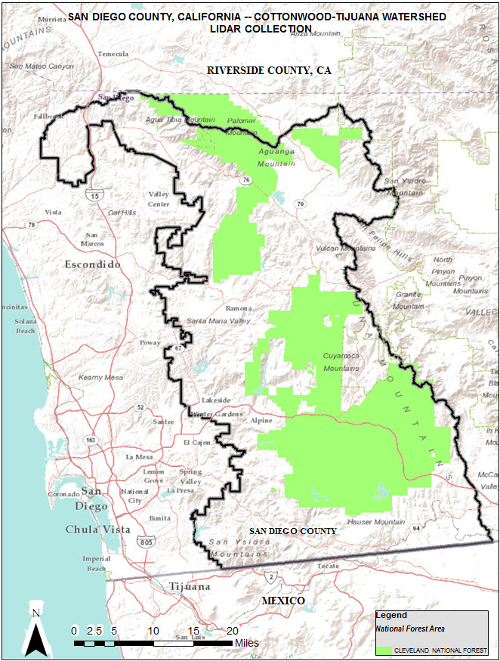

Scope of Work

Task order HSFE09-15-J-0001 requires STARR II to collect and process LiDAR data for the San Diego County, CA area of interest, the scope of work is as follows:
Acquire and process 1617 square miles of USGS defined Quality Level 2 LiDAR, collection of hydro-breaklines, and creation of derived products.
Tasks include:
- Field Survey collection of 40 ground control points
- Field Survey collection of 117 NVA and VVA vertical accuracy check points
- Aerial Acquisition of LiDAR data
- Calibration and processing LiDAR data to point cloud
- Post-processing point cloud to fully classified LAS data (including bare earth)
- Collection of breaklines for streams wider than 100 feet, lakes larger than 2 acres, top of bank/bluffs/levee tops
- Creation of hydro-flattened DEMs
- Creation of ESRI Terrain Dataset
- Creation of contours
- Independent QA/QC including vertical accuracy testing and verification
  - Visual examination of 5% for raw point cloud LiDAR swaths
  - Visual examination of 20% for classified point cloud tiles and Bare Earth DEMs

Activities completed under this task order will comply with the USGS LiDAR Base Specifications version 1.2 for quality level 2 data, ASPRS LAS version 1.4 requirements, and contemporary FEMA Technical References and Guidance documents for elevation data.

Deliverables for this task are:
- Flight reports, logs and metadata
- All field survey data including vertical accuracy reports
- LAS point cloud swaths and classified LAS point cloud tiles with indices
- Breaklines and 2.5-foot Hydro Flattened DEMs
- ESRI terrain Dataset and Contours
- FEMA FGDC compliant metadata and TSDN narrative
- Independent Quality Assurance Report

Issues
None.

Information for the Next Mapping Partner

The San Diego County, CA project consists of one continuous area that is adjacent to the City of San Diego. This project included LiDAR Acquisition, Post Processing, and LiDAR derived product development. Point cloud data is composed of LAS version 1.4 unclassified swaths and classified tiles. All data collected has the following spatial reference information:

Projection: State Plane California VI
Linear units: US Survey Feet
Horizontal Datum: North American Datum 1983 (NSRS 2011)
Vertical Datum: North American Vertical Datum of 1988 (Geoid 12B)
Vertical units: US Survey Feet
Table 1: LiDAR Data Information
Item | Data Type | Quantity
Ground Control Survey | Point Shapefile | 1
Raw Point Cloud Swaths | LAS 1.4 Point Data Format 6 | 403
NVA Checkpoints | Point Shapefile | 1
VVA Checkpoints | Point Shapefile | 1
Classified Point Cloud Tiles | LAS 1.4 Point Data Format 6 | 2045
Breaklines | ESRI File Geodatabase PolylineZ Feature Class | 1
2.5-foot Hydro-Flattened DEMs | ERDAS Imagine Format | 2045
ESRI Terrain | ESRI File Geodatabase | 1
Contours | Shapefiles | 558

CompassData, Inc. collected ground control and checkpoint surveys. LiDAR was acquired and processed by Quantum Spatial, Inc. Stantec Consulting Ltd. conducted independent quality assurance. All firms were under contract to Strategic Alliance for Risk Reduction (STARR II), a joint venture that held the FEMA Professional Technical Services contract and task order for this scope of work.

4.1 Field Survey
USGS Quality Level 2 Vertical Accuracy Requirements as published in the LiDAR Base Specifications version 1.2:
Non-Vegetated Vertical Accuracy Swath Data:
  - NVA RMSEz: <= 10.0 cm
  - NVA at 95% Confidence Level: <= 19.6 cm
Non-Vegetated Vertical Accuracy Bare Earth Surface:
- NVA RMSEz: <=10.0 cm
- NVA at 95% Confidence Level: <= 19.6 cm
Vegetated Vertical Accuracy Bare Earth Surface:
- VVA at 95th Percentile: <= 29.4 cm
This data set was tested to meet ASPRS Positional Accuracy Standards for Digital Geospatial Data (2014) for a 10cm (cm) RMSEz Vertica Accuracy Class. Actual NVA accuracy was found to be RMSEz =4.6 cm, equating to +/- 9 cm at 95% confidence level. Actual VVA accuracy was found to be +/- 18.4 cm at the 95th percentile.
Testing Results Summary:
- Swath NVA RMSEz: 4.6cm
- Swath NVA 95percentage Confidence Level: 9cm
- Bare Earth Surface NVA RMSEz: 4.6cm
- Bare Earth Surface NVA 95percentage Confidence Level: 9cm
- Bare Earth Surface VVA 95th Percentile: 18.4cm
Please see the Survey Report for more detailed information.

4.2 LiDAR Acquisition
LiDAR acquisition covers 1617 square miles and was collected from October 30, 2015 to November 23, 2015 in 23 lifts while no snow was on the ground and rivers were at or below normal levels. There were 39 calibration control points established to calibrate the LiDAR to known ground locations throughout the project area. Please refer to the post flight report for acquisition details and flight logs.

This large dataset consisting of 403 flight line swaths with over 30 billion points covers the project area with a point density of approximately 6 points per square meter. The average point spacing is approximately 0.4 meters or 1.3 feet.

4.3 LiDAR Post Processing
The calibrated and controlled LIDAR swaths are processed using automatic point classification routines in proprietary software. These routines operate against the entire collection (all swaths, all lifts), eliminating character differences between files. The bare earth surface is manually reviewed to ensure correct classification on the Class 2 (Ground) points.
All overlap data was processed through automated functionality provided by TerraScan to classify the overlapping flight line data to approved classes by USGS. Overlap points were flagged using the overlap bit, per LAS 1.4 specifications. All data was manually reviewed and any remaining artifacts removed using functionality provided by TerraScan and TerraModeler.
Global Mapper was used as a final check of the bare earth dataset. GeoCue was then used to create the deliverable industry-standard LAS files for both the All Point Cloud Data and the Bare Earth. Proprietary software was used to perform final statistical analysis of the classes in the LAS files, on a per tile level to verify final classification metrics and full LAS header information. Fully classified LAS 1.4 files were formatted to 2,045 individual 5,000-foot x 5,000-foot tiles for the project area.
Table 2: San Diego County, CA Classifications
Code | Description
1 | Processed but not classified
2 | Bare Earth
7 | Low Noise
9 | Water
10 | Ignored Ground (near a breakline)
17 | Bridge Decks
18 | High Noise

4.4 LiDAR Derived Products
Breaklines are created using the class 2 LiDAR. The bare earth surface model was then used to heads-up digitize 2D breaklines of inland streams and rivers with a 100-foot nominal width and Inland Ponds and Lakes of 2 acres or greater surface area. Elevation values were assigned to all Inland Ponds and Lakes, Inland Pond and Lake Islands, Inland Stream and River Islands, using TerraModeler functionality.

Elevation values were assigned to all Inland streams and rivers using proprietary software. A buffer of 3 feet was also used around each hydro-flattened feature. These points were moved from ground (ASPRS Class2) to Ignored Ground (ASPRS Class 10). The breakline files were then translated to Esri file-geodatabase format using Esri conversion tools.
Class 2 LiDAR in conjunction with the hydro breaklines were used to create a 2.5-foot Raster DEM. Using proprietary automated scripting routines, an ERDAS Imagine .IMG file was created for each tile. Each surface is reviewed using Global Mapper to check for any surface anomalies or incorrect elevations found within the surface.
An ESRI terrain dataset was created using the class 2 bare earth LAS points, hard and soft breaklines, and the project boundary. This dataset is stored in an ESRI 10.4.1 file geodatabase.
Contours are generated from the hydro flattened DEMs at an interval of 5 feet. Geoprocessing scripts are run to create the contour dataset and remove as much noise as possible. In order to reduce the overall number of individual files, the contours were created using a 10,000-foot by 10,000-foot tile index.

4.5 Quality Assurance
Quality assurance for all elevation data delivered for this project has been completed based on the following specifications:
- USGS Lidar Base Specification Version 1.2, November 2014
- ASPRS LAS Specification Version 1.4 – R13 July 15, 2013
- ASPRS Positional Accuracy Standards for Digital Geospatial Data (Edition 1, Version 1.0. –November, 2014)
- FEMA Data Capture Standards format for terrain deliverables November 2015

LiDAR elevation data created during this project are checked for compliance to the aforementioned guidance and specifications before submittal to FEMA. Quality assurance results are incorporated into the Elevation Data QA/QC Report – San Diego County, California included with this submission.

Figure 2: Quality Assurance Workflow
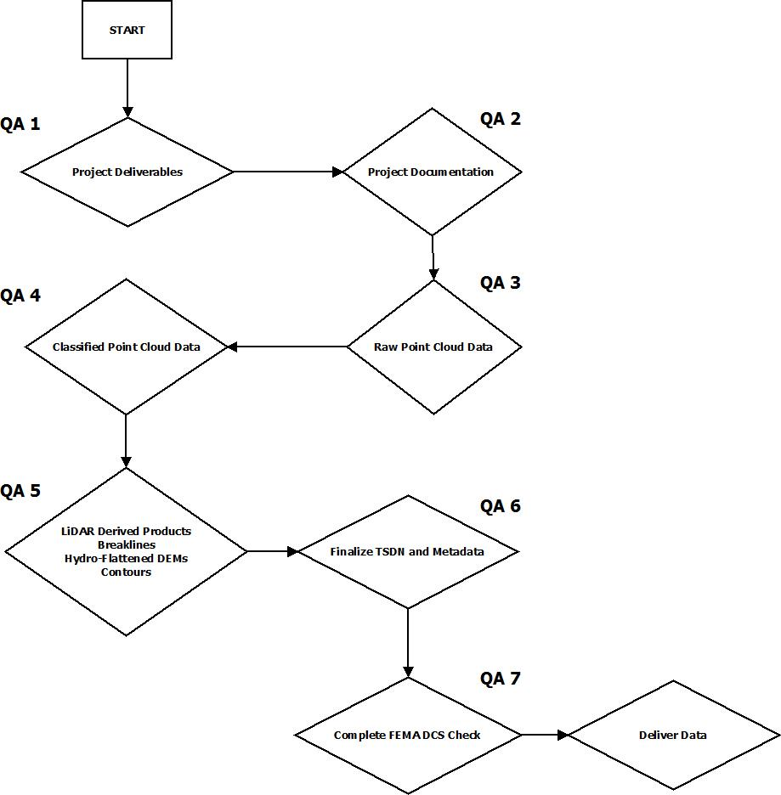
Table 3: FEMA DCS Checklist
FEMA DCS Deliverable General
Terrain Metadata
☒ | XML Format
☒ | Correct case number
☒ | Bounding coordinates match LAS tile index
☒ | Correct FEMA-CID
☒ | Correct contact information
☒ | Attribute accuracy includes classifications
☒ | Correct vertical accuracy reported
☒ | Lineage includes all items in the deliverable
☒ | Correct spatial reference
Project Narrative
☒ | MS Word Format
☒ | Purpose (includes Map of project area and project summary)
☒ | Scope of work
☒ | Brief description of each step (acquisition, classification, and product generation)
☒ | Vertical accuracy results
☒ | MIP location
Additional Required Documents
☒ | Certification LiDAR signed and sealed with correct project information
☒ | Certification Survey signed and sealed with correct project information
☒ | Flight Reports and flight logs
☒ | Independent QA/QC report
FEMA DCS Deliverable Spatial Files
☒ | S_Submittal_Info shapefile
☒ | L_Source_Cit dbf table
Source (readme files for the mip and full datasets for the library)
☒ | Raw_Point_Cloud_Data (Swaths with index)
☐ | Classified_Point_Cloud_Data (Tiles with index)
☐ | Breaklines (index if applicable)
☐ | Bare_Earth_DEM (DEMs with Index)
☐ | Contours (Individual shapefiles or file geodatabase with index)
☐ | TINs (Individual TINs with Index or ESRI terrain if applicable)
Final (readme files for the mip and full datasets for the library)
☐ | Raw_Point_Cloud_Data (Swaths with index)
☒ | Classified_Point_Cloud_Data (Tiles with index)
☒ | Breaklines (index if applicable)
☒ | Bare_Earth_DEM (DEMs with Index)
☒ | Contours (Individual shapefiles or file geodatabase with index)
☒ | TINs (Individual TINs with Index or ESRI terrain if applicable)

STARR II will provide deliverables to the FEMA Engineering Library via external hard drive. To the extent possible, datasets that do not exceed the MIP file size limitation will be loaded to the MIP at this location:

- J:/R09/CALIFORNIA_06/SAN_DIEGO_06073/SAN_DIEGO_073C/16-09-0637S/SubmissionUpload/Terrain/2182786

