Survey of LIDAR Ground Control and Checkpoints for the Denver Area USGS AOI.

SURVEY REPORT

Field Measurement by: Steven A. Wood

For: Sanborn Mapping

Field Measurement Date; May 28 thru June 05, 2020

PROJECT LOCATION MAP

We were provided proposed locations selected to obtain LIDAR GCP gps truthing NVA and VVA x,y,z locations, GCP, and 2020_GCP locations for survey control for the Denver Area AOIs. The schematic is as below. As we completed the measurements the locations were adjusted as necessary based on our ability to access each and the SV conditions at each.

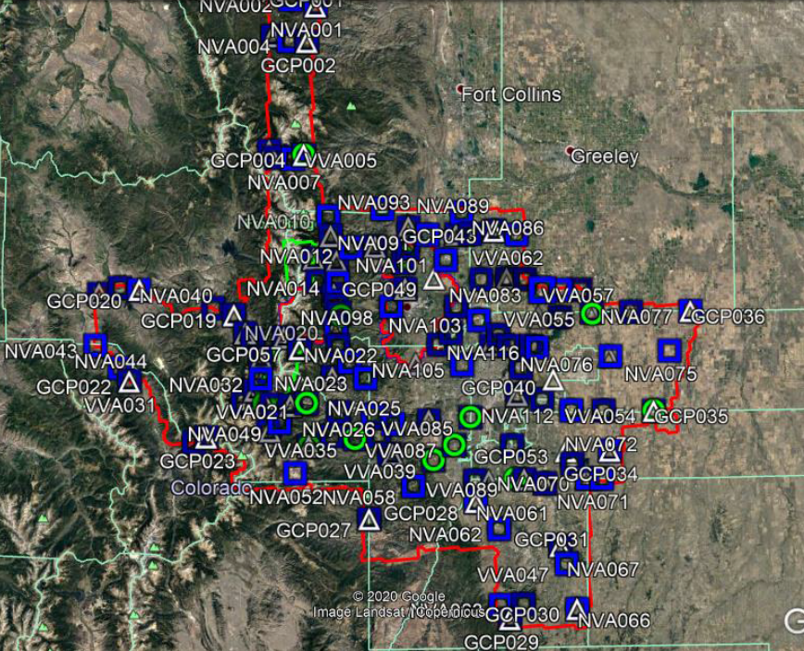

Project Kick off and Control Staging

Survey crews arrived on site May 27, 2020. Two additional crews were added to the survey team over the ensuing days. Each day following they set out to measure GCP locations and the process was a combination of using the using a fully static gps measured network tied to the local NGS CORS station and temporary bases throughout the AOI and working mostly within the confines of public access areas or where and when we had access to private property. The weather was favorable for the most part during the survey. Initial field work was completed on the evening of June 05, 2020.

LOCATION METHODS, MEASUREMENTS AND EQUIPMENT

The equipment configuration for this project consists of industry standard gps surveying equipment. The gps equipment used was a combination of Topcon dual frequency(L1/L2) receivers. The Topcon receivers are the Hiper GD, Hiper Plus and HIPER SR models. Topcon Tools gps processing software was used to post process all observed gps data. Each gps observation was logged for site id, receiver type, height of antenna, start time and date. Length of vector, time of day, SV configuration and site obstructions determined the length of observation at each site. Data was downloaded to the PC after each day’s sessions. Initial processing was performed to verify we had good vector solutions between sites.

There are NGS CORS station located in or within close proximity to the AOI. A secondary CORs type base from Leica Smartnet RTN was also used.

The coordinate datum is as described below:

Horizontal and Vertical Control:
Data shall be referenced to NAD83(2011) Colorado State Plane Central (FIPS 0502) and Colorado State Plane North (FIPS 0501) in US Foot units, and NAVD88 orthometric heights in US Foot units based on GEOID 18 model from National Geodetic Survey.

The Topcon Tools processing software reports on static observations the horizontal and vertical precision of every vector measured and summarizes the standard deviation in x, y and z position for each individual control point.

Three field crews were utilized to obtain the GCP data. Typically a base station was running and the crews performed with a rover tying the primary vector back to the base. When multiple bases were running simultaneously the rover vector could be processed to both bases, and therefore the network triangle strength was heightened significantly with all the redundant data.

The Topcon Tools processing software summarizes the observed vectors, the raw vector horizontal and vertical RMSE components and the corresponding Residual in northing easting and elevation. Upon final adjustment each point in the network has its corresponding RMSE standard deviation in all 3 directions. We included all points in each daily report.

The points were preselected in the office and grouped into 3 categories. GCP for control check calibration points, NVA for non vegetation area points and VVA for vegetation area points.

The survey used several NGS CORS and Leica Smartnet CORS type base stations for the control datum origin monuments. They are summarized in the listing herein. All of them fit together great with one major exception. NGS CORS station ZDV1 located near north central Denver data sheet has its published values per NGS. The horizontal position fits with all the other CORS in the area BUT the vertical values published does not fit by 1.3 feet
A small network in the coords listing is included in the coordinate summary. In the network we held NGS points and Leica Smartnet points and tried checking into ZDV1 and also another NGS CORS station in Fort Collins. ZDV1 does not fit vertically yet COFC in Fort Collins does.
Consequently NGS CORS ZDV1 was not used in final adjustment of our gps survey.

The full Topcon Adjust Report is included herewith in one composite spreadsheet containing each days worth of gps observations. This spreadsheet is included separately from this report.

A composite coordinate summary spreadsheet is also included herewith to facilitate data retrieval and formatting for the all control and LIDAR QC processing.
We took pictures of the survey points and they are labeled by their unique GCP number and then a post script designation such as _1, _2 or _3 on some PID points

Final documents were completed and are as shown in the composite summary spreadsheet attached separately. It lists all survey points on CO SPCS Central Zone and on CO SPCS North.

COORDINATE SUMMARY
Denver Area USGS LIDAR QC Swood |  |  | 6/21/2020
NGS and Smartnet LEICA CORS Network Discrepancy
CO SPCS Central Zone, NAD83, 2011, NAVD88, Geoid 18, USFoot
Name | Grid Northing (USft) | Grid Easting (USft) | Elevation (USft)
ZDV1 | 1857590.331 | 3104167.501 | 5114.218 | NGS CORS
P041 | 1770881.433 | 3085725.381 | 5728.278 | NGS CORS
CODN | 1726484.795 | 3233651.836 | 5433.529 | Leica CORS
ARVA | 1717707.416 | 3115821.463 | 5393.687 | Leica CORS
COFC | 2005515.310 | 3094330.634 | 5285.932 | NGS CORS
CO SPCS North Zone, NAD83, 2011, NAVD88, Geoid 18, USFoot
Name | Grid Northing (USft) | Grid Easting (USft) | Elevation (USft)
ZDV1 | 1311294.229 | 3104150.987 | 5114.218 | NGS CORS
P041 | 1224593.760 | 3085718.945 | 5728.278 | NGS CORS
CODN | 1180222.174 | 3233644.327 | 5433.529 | Leica CORS
ARVA | 1171425.282 | 3115818.687 | 5393.687 | Leica CORS
COFC | 1459184.257 | 3094302.182 | 5285.932 | NGS CORS
CO SPCS Central Zone, NAD83, 2011, NAVD88, Geoid 18, USFoot
LIDAR QC Points Central Zone CO SPCS
Name | Grid Northing (USft) | Grid Easting (USft) | Elevation (USft)
ARVA | 1717707.416 | 3115821.463 | 5393.687 | Leica CORS
Base89 | 1936495.173 | 2966981.767 | 8524.724
COBK | 1618281.584 | 2845519.498 | 9279.283 | Leica CORS
COCC | 1570995.184 | 3178187.574 | 6132.761 | Leica CORS
CODN | 1726484.795 | 3233651.836 | 5433.529 | Leica CORS
COFC | 2005515.284 | 3094330.640 | 5286.040 | NGS CORS
COGW | 1647693.251 | 3172752.186 | 5718.178 | Leica CORS
COWI | 1759086.460 | 2919743.169 | 8844.098 | Leica CORS
CTMC | 1687841.270 | 3086394.060 | 6022.264 | Leica CORS
GCP001 | 2077977.093 | 2977334.145 | 8275.460
GCP002 | 2043054.237 | 2969286.138 | 7297.961
GCP002X | 2043061.895 | 2969541.259 | 7292.199
GCP003 | 2048077.021 | 2937171.799 | 7726.856
GCP004 | 1936565.943 | 2967028.163 | 8529.676
GCP005 | 1939620.929 | 2934896.868 | 12092.804
GCP006 | 1860638.301 | 2992480.541 | 8523.461
GCP007 | 1837019.633 | 2998009.726 | 8565.036
GCP008 | 1805840.649 | 2995422.878 | 9290.013
GCP009 | 1774901.566 | 2997196.737 | 8231.691
GCP010 | 1728007.431 | 2994236.992 | 8905.167
GCP011 | 1695162.704 | 2997640.718 | 7502.686
GCP012 | 1701745.339 | 2955324.968 | 8283.249
GCP013 | 1703148.849 | 2932278.031 | 9122.107
GCP013X | 1703160.897 | 2932235.347 | 9124.085
GCP014 | 1707710.873 | 2917761.262 | 9650.808
GCP015 | 1715657.327 | 2922119.344 | 11311.621
GCP016 | 1745891.569 | 2927946.456 | 9208.770
GCP017R | 1752376.276 | 2930817.726 | 9987.467
GCP018 | 1769248.275 | 2912307.934 | 8571.443
GCP019 | 1786646.513 | 2900986.108 | 8365.492
GCP020 | 1810034.426 | 2811253.667 | 7600.602
GCP021 | 1806112.364 | 2772669.158 | 7372.986
GCP022 | 1723688.431 | 2802774.042 | 8061.337
GCP023 | 1672221.164 | 2877019.844 | 11148.688
GCP024 | 1678190.997 | 2936475.139 | 9118.988
GCP025 | 1663953.142 | 2972995.108 | 10677.358
GCP026 | 1656885.524 | 3051820.036 | 7025.254
GCP027 | 1595053.468 | 3029124.707 | 8447.944
GCP028 | 1609861.895 | 3130155.946 | 5612.582
GCP029A | 1499794.068 | 3162764.749 | 6862.802
GCP030 | 1508816.856 | 3226796.752 | 6829.522
GCP031 | 1568125.060 | 3210954.507 | 6142.088
GCP032 | 1627807.923 | 3196104.526 | 5793.880
GCP033 | 1632309.399 | 3235659.538 | 6159.138
GCP034 | 1658599.235 | 3258180.486 | 5985.874
GCP035 | 1696473.147 | 3300047.355 | 5517.125
GCP036 | 1791559.431 | 3335539.063 | 4945.046
GCP036B | 1771244.177 | 3336022.346 | 4999.151
GCP037 | 1790881.089 | 3277732.341 | 5069.518
GCP038 | 1790344.003 | 3240765.806 | 5137.603
GCP038B | 1790443.554 | 3240836.371 | 5134.648
GCP039 | 1748363.634 | 3257334.500 | 5327.655
GCP040 | 1726121.824 | 3204232.535 | 5321.152
GCP041 | 1785412.380 | 3189902.951 | 4973.876
GCP042 | 1821968.510 | 3159527.708 | 5040.686
GCP044 | 1863779.932 | 3111270.777 | 5071.749
GCP044A | 1867396.337 | 3147526.824 | 4967.966
GCP045 | 1870039.819 | 3065564.695 | 5323.472
GCP046 | 1851401.270 | 3033959.332 | 6761.810
GCP047 | 1811861.640 | 3062638.755 | 5519.646
GCP048 | 1740448.720 | 3072837.675 | 6245.114
GCP049 | 1821958.268 | 3090113.120 | 5124.368
GCP050R | 1687172.262 | 3085515.024 | 5991.441
GCP051 | 1629678.316 | 3142849.358 | 5581.181
GCP052 | 1631342.329 | 3176463.426 | 5859.856
GCP053 | 1657622.308 | 3215508.269 | 5804.844
GCP054 | 1711341.697 | 3169738.889 | 5238.966
GCP055 | 1758392.584 | 3144757.998 | 5372.707
GCP056R | 1836290.674 | 2993912.192 | 8669.528
GCP057R | 1763386.499 | 2928799.713 | 9477.212
NVA001 | 2077947.074 | 2977353.164 | 8273.911
NVA002 | 2081558.302 | 2957561.493 | 8943.443
NVA003 | 2043130.234 | 2969317.355 | 7300.262
NVA004 | 2043938.847 | 2952175.092 | 7593.037
NVA005 | 2047837.677 | 2937309.470 | 7722.440
NVA006 | 1936571.413 | 2966895.762 | 8532.645
NVA007 | 1932639.181 | 2956785.613 | 9390.821
NVA008 | 1933285.801 | 2941115.370 | 11729.320
NVA009 | 1939576.345 | 2934952.744 | 12094.706
NVA010 | 1879271.040 | 2990036.291 | 8634.983
NVA010X | 1879281.183 | 2990081.343 | 8637.710
NVA011 | 1860723.616 | 2992294.032 | 8533.662
NVA012 | 1850036.869 | 3010780.479 | 8146.217
NVA013 | 1837040.073 | 2998000.736 | 8564.789
NVA014 | 1816700.696 | 2999206.382 | 9269.737
NVA015 | 1818345.307 | 2990466.560 | 10062.069
NVA016 | 1805790.401 | 2995453.315 | 9291.741
NVA017R | 1836220.905 | 2994140.950 | 8660.334
NVA018 | 1795636.882 | 2997420.071 | 9037.761
NVA019 | 1788272.400 | 3000546.556 | 8511.977
NVA020 | 1774837.420 | 2997293.549 | 8233.750
NVA021 | 1757437.113 | 2999992.885 | 8434.307
NVA022 | 1742511.607 | 3010277.049 | 8999.743
NVA023 | 1726294.439 | 3025291.307 | 8307.090
NVA024 | 1728065.522 | 2994223.538 | 8908.083
NVA025 | 1692919.278 | 3032448.847 | 6831.607
NVA026 | 1684271.161 | 3051414.860 | 7662.193
NVA027 | 1703540.431 | 2971355.618 | 7948.181
NVA028 | 1701425.441 | 2954927.988 | 8269.381
NVA029 | 1702872.428 | 2938097.859 | 8785.672
NVA030R | 1706198.457 | 2909354.143 | 10027.923
NVA031 | 1715614.228 | 2922112.581 | 11310.128
NVA032 | 1726464.521 | 2927289.661 | 9761.964
NVA033 | 1745664.785 | 2928493.862 | 9207.902
NVA034R | 1752089.988 | 2931166.276 | 10005.712
NVA035 | 1763022.000 | 2919234.019 | 8712.512
NVA036 | 1769202.188 | 2912297.799 | 8573.356
NVA037R | 1763323.516 | 2928733.056 | 9478.490
NVA037R2 | 1763338.980 | 2928707.415 | 9477.799
NVA038 | 1786790.161 | 2901371.942 | 8335.066
NVA039 | 1792722.099 | 2881982.867 | 8600.890
NVA040 | 1809857.559 | 2810774.494 | 7585.038
NVA042 | 1806090.703 | 2772676.246 | 7373.752
NVA043 | 1757210.651 | 2769482.522 | 7840.229
NVA044 | 1736721.573 | 2792822.267 | 7996.108
NVA045 | 1723583.389 | 2803222.660 | 8065.959
NVA046 | 1667413.532 | 2865317.762 | 10292.519
NVA047 | 1672183.214 | 2877035.646 | 11147.458
NVA048 | 1678195.852 | 2934288.084 | 9149.801
NVA049 | 1686160.986 | 2945041.524 | 8487.143
NVA050 | 1695157.041 | 2999942.974 | 7485.750
NVA051 | 1663889.035 | 2973020.117 | 10681.356
NVA052 | 1667397.539 | 2971239.455 | 10474.531
NVA053 | 1673459.962 | 2994498.532 | 10683.216
NVA054 | 1670455.176 | 3015640.645 | 9198.665
NVA055 | 1673520.134 | 3038011.356 | 7749.424
NVA056 | 1656962.203 | 3051905.662 | 7019.156
NVA057 | 1595166.741 | 3029150.095 | 8446.129
NVA058 | 1625981.211 | 3070589.384 | 7921.059
NVA059 | 1649787.435 | 3089838.277 | 6087.653
NVA060 | 1629782.725 | 3130213.693 | 5408.715
NVA061 | 1609889.097 | 3130182.913 | 5612.507
NVA062 | 1584471.712 | 3152175.683 | 5833.960
NVA063 | 1512929.544 | 3153891.803 | 6443.566
NVA064 | 1499788.380 | 3162707.464 | 6861.676
NVA065 | 1513767.364 | 3175584.764 | 6618.639
NVA066 | 1508764.904 | 3226800.902 | 6830.588
NVA067 | 1551459.898 | 3216745.321 | 6615.068
NVA068 | 1568124.113 | 3210902.774 | 6140.667
NVA069 | 1627541.235 | 3196267.705 | 5786.679
NVA070 | 1632321.286 | 3236335.431 | 6173.999
NVA071 | 1632214.613 | 3250282.947 | 5952.881
NVA072 | 1658599.845 | 3258118.838 | 5985.916
NVA073 | 1697439.687 | 3252689.872 | 5528.374
NVA074 | 1696563.046 | 3300047.259 | 5516.284
NVA075 | 1753788.021 | 3315238.314 | 5178.984
NVA076 | 1748392.718 | 3258581.726 | 5336.627
NVA077 | 1791569.591 | 3335591.220 | 4943.534
NVA078 | 1790905.016 | 3278457.153 | 5060.114
NVA079 | 1789897.325 | 3240809.290 | 5142.636
NVA080 | 1785414.330 | 3210200.631 | 5102.306
NVA081 | 1811562.110 | 3229946.529 | 4940.925
NVA082 | 1811433.749 | 3210825.397 | 5142.962
NVA083 | 1811143.369 | 3193300.725 | 4933.116
NVA084 | 1821430.533 | 3177007.528 | 4946.423
NVA085 | 1822016.537 | 3159536.208 | 5040.694
NVA086 | 1863764.531 | 3168791.629 | 4793.592
NVA087 | 1867396.588 | 3147551.804 | 4967.953
NVA088 | 1864343.096 | 3124376.136 | 4994.121
NVA089 | 1884705.670 | 3116309.555 | 5128.213
NVA090 | 1863822.942 | 3111279.332 | 5071.908
NVA091 | 1863338.178 | 3083984.755 | 5183.907
NVA092 | 1870008.442 | 3065527.410 | 5322.103
NVA093 | 1887250.381 | 3040828.453 | 6777.769
NVA094 | 1851362.038 | 3033959.903 | 6760.459
NVA095 | 1850075.248 | 3065156.163 | 5639.562
NVA096 | 1836146.225 | 3061185.687 | 5559.893
NVA097 | 1811895.186 | 3062761.071 | 5516.752
NVA098 | 1794920.201 | 3049402.148 | 5771.547
NVA099 | 1759227.548 | 3094727.753 | 5654.191
NVA100 | 1795526.165 | 3111082.286 | 5248.345
NVA100X | 1795477.485 | 3110995.451 | 5249.801
NVA101 | 1839478.223 | 3101229.706 | 5032.710
NVA102 | 1821193.423 | 3134992.922 | 5004.847
NVA103 | 1782465.214 | 3132896.196 | 5347.532
NVA104 | 1770268.614 | 3106011.213 | 5336.157
NVA105 | 1739778.709 | 3116907.893 | 5432.246
NVA106 | 1690319.776 | 3125474.711 | 5320.613
NVA106X | 1690023.792 | 3125019.783 | 5332.380
NVA107 | 1687087.564 | 3085357.234 | 5993.590
NVA108 | 1663600.318 | 3109724.539 | 5514.584
NVA109 | 1663448.599 | 3164847.279 | 5569.765
NVA110 | 1631277.502 | 3176546.183 | 5860.856
NVA111 | 1646230.600 | 3222092.738 | 6030.494
NVA112 | 1696806.312 | 3221195.043 | 5510.991
NVA113 | 1707180.399 | 3193509.535 | 5381.232
NVA114 | 1711368.632 | 3169781.061 | 5239.600
NVA115 | 1737360.427 | 3173142.024 | 5133.376
NVA116 | 1756427.394 | 3188505.677 | 5087.794
NVA117 | 1758092.579 | 3183145.895 | 5063.951
NVA118 | 1758072.588 | 3161571.257 | 5221.680
NVA119 | 1768313.462 | 3151603.710 | 5229.181
NVA120 | 1758455.623 | 3144777.915 | 5372.140
P041 | 1770881.433 | 3085725.381 | 5728.278 | NGS CORS
TMGO | 1836949.511 | 3074751.795 | 5543.897 | NGS CORS
VVA001 | 2077924.139 | 2977322.222 | 8273.685
VVA002 | 2081533.905 | 2957618.277 | 8941.294
VVA003 | 2043146.025 | 2969388.558 | 7300.994
VVA004 | 2047857.318 | 2937355.416 | 7721.875
VVA005 | 1936502.373 | 2966958.753 | 8525.991
VVA006 | 1879395.556 | 2990047.670 | 8646.606
VVA007 | 1860702.680 | 2992548.599 | 8530.479
VVA008 | 1849981.517 | 3010785.252 | 8155.379
VVA009 | 1837049.659 | 2997954.714 | 8566.099
VVA010 | 1818433.616 | 2990438.581 | 10063.273
VVA011 | 1795641.842 | 2997480.787 | 9044.567
VVA012 | 1785830.588 | 3002368.331 | 8285.236
VVA013 | 1774959.615 | 2997967.281 | 8208.278
VVA014 | 1757407.326 | 3000012.171 | 8442.397
VVA015 | 1742550.288 | 3010293.485 | 9005.288
VVA016 | 1726341.428 | 3025296.332 | 8305.832
VVA017 | 1727989.634 | 2994176.184 | 8903.497
VVA018 | 1692909.200 | 3032479.533 | 6830.503
VVA019 | 1684300.659 | 3051457.820 | 7659.176
VVA020R | 1695257.529 | 2997748.550 | 7500.625
VVA021 | 1703538.479 | 2971396.623 | 7947.785
VVA022 | 1701638.677 | 2954872.777 | 8296.801
VVA023R | 1706278.518 | 2909413.246 | 10036.107
VVA024 | 1726437.571 | 2927231.343 | 9764.010
VVA025 | 1745721.305 | 2928506.998 | 9210.149
VVA026 | 1763115.787 | 2919235.772 | 8710.815
VVA027 | 1769160.532 | 2912323.341 | 8575.375
VVA028R | 1763379.090 | 2928739.024 | 9476.855
VVA029 | 1786897.309 | 2901367.043 | 8335.371
VVA030 | 1812876.385 | 2792057.724 | 7422.103
VVA031 | 1723830.304 | 2802343.907 | 8054.108
VVA032 | 1678204.773 | 2934128.517 | 9154.412
VVA033 | 1686198.041 | 2945077.001 | 8485.558
VVA034 | 1663906.911 | 2972977.672 | 10680.879
VVA034X | 1752134.694 | 2931111.963 | 10002.804
VVA035 | 1670523.202 | 3015654.951 | 9196.775
VVA036 | 1673511.862 | 3037982.998 | 7751.660
VVA037 | 1656975.379 | 3051956.123 | 7018.927
VVA038 | 1595081.675 | 3029225.779 | 8444.050
VVA039 | 1649723.753 | 3089899.504 | 6090.927
VVA040 | 1629745.145 | 3130197.456 | 5409.771
VVA041 | 1609861.495 | 3130130.239 | 5612.744
VVA042 | 1584442.769 | 3152161.422 | 5832.590
VVA043 | 1512963.707 | 3153861.208 | 6442.823
VVA044A | 1499762.781 | 3162639.940 | 6862.207
VVA045 | 1513792.023 | 3175610.686 | 6617.822
VVA046 | 1508693.460 | 3226731.717 | 6828.742
VVA047 | 1551584.219 | 3216737.053 | 6613.318
VVA048 | 1568137.979 | 3210540.355 | 6126.717
VVA049 | 1627962.710 | 3195861.796 | 5805.719
VVA050 | 1646226.130 | 3222058.931 | 6032.845
VVA051 | 1632180.857 | 3250310.634 | 5952.366
VVA052 | 1696807.048 | 3221134.575 | 5509.100
VVA053 | 1697411.244 | 3252715.984 | 5528.776
VVA054 | 1696676.340 | 3300225.446 | 5517.764
VVA055 | 1788952.038 | 3240820.649 | 5154.415
VVA056 | 1785345.516 | 3210243.643 | 5102.648
VVA057 | 1811210.641 | 3193328.436 | 4932.061
VVA058 | 1821612.985 | 3177059.458 | 4945.172
VVA059 | 1821993.654 | 3159357.668 | 5039.500
VVA060 | 1821221.871 | 3135037.690 | 5005.062
VVA061 | 1839449.901 | 3101259.955 | 5033.229
VVA062 | 1863891.928 | 3168719.671 | 4792.716
VVA063 | 1867393.013 | 3147480.714 | 4970.465
VVA064R | 1863724.517 | 3123375.303 | 5016.369
VVA065 | 1863823.635 | 3111220.228 | 5072.582
VVA066 | 1884644.714 | 3116283.438 | 5127.588
VVA067 | 1863375.720 | 3083982.193 | 5182.728
VVA068 | 1870061.320 | 3065541.787 | 5324.566
VVA069 | 1887195.697 | 3040821.576 | 6775.351
VVA070 | 1849990.228 | 3065132.586 | 5643.896
VVA071 | 1841992.144 | 3060835.125 | 5651.935
VVA072 | 1811799.343 | 3062611.929 | 5520.632
VVA073 | 1794849.058 | 3049485.056 | 5764.370
VVA074 | 1759196.214 | 3094768.472 | 5655.105
VVA075 | 1795406.258 | 3111067.933 | 5252.108
VVA075X | 1795503.722 | 3110977.675 | 5248.684
VVA076 | 1770260.445 | 3105965.519 | 5337.418
VVA077 | 1782370.334 | 3132960.631 | 5357.957
VVA078 | 1767886.110 | 3151658.929 | 5233.302
VVA078X | 1768134.068 | 3151569.605 | 5229.405
VVA079 | 1758010.808 | 3161516.566 | 5220.589
VVA080 | 1757846.928 | 3183185.836 | 5061.574
VVA081 | 1756539.107 | 3188505.755 | 5089.141
VVA082 | 1737138.086 | 3172864.228 | 5131.666
VVA083 | 1711325.657 | 3169785.995 | 5239.947
VVA084 | 1707140.328 | 3193540.006 | 5380.945
VVA085 | 1690413.052 | 3125562.591 | 5317.520
VVA085X | 1690037.120 | 3125232.415 | 5331.470
VVA086 | 1686998.761 | 3085305.644 | 6010.471
VVA087 | 1663557.462 | 3109732.495 | 5515.629
VVA088 | 1663353.046 | 3164731.604 | 5575.484
VVA089 | 1631334.302 | 3176528.732 | 5862.477
VVA090 | 1631800.618 | 3168050.268 | 5765.033
VVA091 | 1625981.703 | 3070663.148 | 7912.077
VVA092 | 1703513.283 | 2931297.205 | 9182.451
ZDV1 | 1857590.292 | 3104167.534 | 5114.215 | NGS CORS
CO SPCS North Zone, NAD83, 2011, NAVD88, Geoid 18, USFoot
LIDAR QC Points North Zone CO SPCS
Name | Grid Northing (USft) | Grid Easting (USft) | Elevation (USft)
ARVA | 1171425.282 | 3115818.687 | 5393.687 | NGS CORS
Base89 | 1390178.846 | 2966989.520 | 8524.724
COBK | 1072002.074 | 2845508.484 | 9279.283 | Leica CORS
COCC | 1024714.983 | 3178208.332 | 6132.761 | Leica CORS
CODN | 1180222.174 | 3233644.327 | 5433.529 | Leica CORS
COFC | 1459184.231 | 3094302.188 | 5286.040 | NGS CORS
COGW | 1101418.293 | 3172759.650 | 5718.178 | Leica CORS
COWI | 1212799.169 | 2919748.284 | 8844.098 | Leica CORS
CTMC | 1141556.568 | 3086394.460 | 6022.264 | NGS CORS
GCP001 | 1531617.565 | 2977342.578 | 8275.460
GCP002 | 1496707.318 | 2969296.523 | 7297.961
GCP002X | 1496714.965 | 2969551.558 | 7292.199
GCP003 | 1501729.850 | 2937193.348 | 7726.856
GCP004 | 1390249.598 | 2967035.907 | 8529.676
GCP005 | 1393305.386 | 2934912.351 | 12092.804
GCP006 | 1314336.506 | 2992481.756 | 8523.461
GCP007 | 1290721.358 | 2998010.002 | 8565.036
GCP008 | 1259546.241 | 2995423.376 | 9290.013
GCP009 | 1228610.055 | 2997196.958 | 8231.691
GCP010 | 1181718.579 | 2994237.187 | 8905.167
GCP011 | 1148874.437 | 2997640.723 | 7502.686
GCP012 | 1155457.988 | 2955325.358 | 8283.249
GCP013 | 1156862.727 | 2932278.712 | 9122.107
GCP013X | 1156874.778 | 2932236.030 | 9124.085
GCP014 | 1161425.740 | 2917762.447 | 9650.808
GCP015 | 1169371.715 | 2922121.061 | 11311.621
GCP016 | 1199604.434 | 2927950.135 | 9208.770
GCP017R | 1206088.596 | 2930821.690 | 9987.467
GCP018 | 1222960.887 | 2912314.379 | 8571.443
GCP019 | 1240358.719 | 2900995.040 | 8365.492
GCP020 | 1263756.692 | 2811274.912 | 7600.602
GCP021 | 1259842.789 | 2772693.864 | 7372.986
GCP022 | 1177418.363 | 2802779.870 | 8061.337
GCP023 | 1125939.939 | 2877017.428 | 11148.688
GCP024 | 1131904.562 | 2936474.259 | 9118.988
GCP025 | 1117664.830 | 2972994.366 | 10677.358
GCP026 | 1110597.930 | 3051821.811 | 7025.254
GCP027 | 1048761.049 | 3029127.425 | 8447.944
GCP028 | 1063578.441 | 3130166.267 | 5612.582
GCP029A | 953500.627 | 3162794.746 | 6862.802
GCP030 | 962536.913 | 3226836.637 | 6829.522
GCP031 | 1021850.600 | 3210979.677 | 6142.088
GCP032 | 1081536.027 | 3196116.740 | 5793.880
GCP033 | 1086045.941 | 3235673.225 | 6159.138
GCP034 | 1112342.314 | 3258189.006 | 5985.874
GCP035 | 1150228.021 | 3300046.414 | 5517.125
GCP036 | 1245320.623 | 3335507.420 | 4945.046
GCP036B | 1225007.215 | 3335997.222 | 4999.151
GCP037 | 1244625.292 | 3277706.270 | 5069.518
GCP038 | 1244079.037 | 3240743.301 | 5137.603
GCP038B | 1244178.595 | 3240813.837 | 5134.648
GCP039 | 1202105.678 | 3257320.844 | 5327.655
GCP040 | 1179853.032 | 3204226.027 | 5321.152
GCP041 | 1239137.326 | 3189886.076 | 4973.876
GCP042 | 1275684.468 | 3159507.909 | 5040.686
GCP044 | 1317483.569 | 3111252.473 | 5071.749
GCP044A | 1321103.900 | 3147502.051 | 4967.966
GCP045 | 1323738.508 | 3065553.511 | 5323.472
GCP046 | 1305101.454 | 3033954.149 | 6761.810
GCP047 | 1265568.438 | 3062631.582 | 5519.646
GCP048 | 1194161.903 | 3072834.336 | 6245.114
GCP049 | 1275665.883 | 3090101.928 | 5124.368
GCP050R | 1140887.484 | 3085515.475 | 5991.441
GCP051 | 1083397.907 | 3142857.984 | 5581.181
GCP052 | 1085067.150 | 3176473.812 | 5859.856
GCP053 | 1111355.680 | 3215515.555 | 5804.844
GCP054 | 1165067.078 | 3169735.874 | 5238.966
GCP055 | 1212112.309 | 3144748.882 | 5372.707
GCP056R | 1289992.516 | 2993913.033 | 8669.528
GCP057R | 1217098.266 | 2928804.546 | 9477.212
NVA001 | 1531587.557 | 2977361.590 | 8273.911
NVA002 | 1535198.061 | 2957577.430 | 8943.443
NVA003 | 1496783.289 | 2969327.731 | 7300.262
NVA004 | 1497592.282 | 2952191.303 | 7593.037
NVA005 | 1501490.581 | 2937330.957 | 7722.440
NVA006 | 1390255.070 | 2966903.538 | 8532.645
NVA007 | 1386324.127 | 2956795.599 | 9390.821
NVA008 | 1386971.372 | 2941129.014 | 11729.320
NVA009 | 1393260.809 | 2934968.210 | 12094.706
NVA010 | 1332966.087 | 2990038.079 | 8634.983
NVA010X | 1332976.228 | 2990083.124 | 8637.710
NVA011 | 1314421.807 | 2992295.278 | 8533.662
NVA012 | 1303736.760 | 3010778.848 | 8146.217
NVA013 | 1290741.795 | 2998001.014 | 8564.789
NVA014 | 1270405.041 | 2999206.477 | 9269.737
NVA015 | 1272049.498 | 2990467.712 | 10062.069
NVA016 | 1259495.998 | 2995453.810 | 9291.741
NVA017R | 1289922.756 | 2994141.759 | 8660.334
NVA018 | 1249343.526 | 2997420.326 | 9037.761
NVA019 | 1241979.744 | 3000546.506 | 8511.977
NVA020 | 1228545.915 | 2997293.763 | 8233.750
NVA021 | 1211146.831 | 2999992.886 | 8434.307
NVA022 | 1196222.197 | 3010276.557 | 8999.743
NVA023 | 1180005.935 | 3025290.490 | 8307.090
NVA024 | 1181776.669 | 2994223.734 | 8908.083
NVA025 | 1146631.516 | 3032448.838 | 6831.607
NVA026 | 1137984.126 | 3051415.273 | 7662.193
NVA027 | 1157252.500 | 2971355.918 | 7948.181
NVA028 | 1155138.110 | 2954928.368 | 8269.381
NVA029 | 1156585.947 | 2938098.465 | 8785.672
NVA030R | 1159914.041 | 2909355.317 | 10027.923
NVA031 | 1169328.617 | 2922114.294 | 11310.128
NVA032 | 1180178.241 | 2927292.018 | 9761.964
NVA033 | 1199377.625 | 2928497.498 | 9207.902
NVA034R | 1205802.301 | 2931170.201 | 10005.712
NVA035 | 1216734.490 | 2919239.472 | 8712.512
NVA036 | 1222914.804 | 2912304.240 | 8573.356
NVA037R | 1217035.292 | 2928737.889 | 9478.490
NVA037R2 | 1217050.756 | 2928712.251 | 9477.799
NVA038 | 1240502.318 | 2901380.853 | 8335.066
NVA039 | 1246435.724 | 2881994.201 | 8600.890
NVA040 | 1263579.932 | 2810795.760 | 7585.038
NVA042 | 1259821.129 | 2772700.948 | 7373.752
NVA043 | 1210945.911 | 2769496.732 | 7840.229
NVA044 | 1190452.977 | 2792830.975 | 7996.108
NVA045 | 1177313.240 | 2803228.455 | 8065.959
NVA046 | 1121133.644 | 2865314.494 | 10292.519
NVA047 | 1125901.986 | 2877033.226 | 11147.458
NVA048 | 1131909.553 | 2934287.174 | 9149.801
NVA049 | 1139874.145 | 2945041.182 | 8487.143
NVA050 | 1148868.771 | 2999942.975 | 7485.750
NVA051 | 1117600.720 | 2973019.374 | 10681.356
NVA052 | 1121109.363 | 2971238.760 | 10474.531
NVA053 | 1127171.534 | 2994498.431 | 10683.216
NVA054 | 1124166.790 | 3015640.977 | 9198.665
NVA055 | 1127232.384 | 3038012.052 | 7749.424
NVA056 | 1110674.616 | 3051907.436 | 7019.156
NVA057 | 1048874.333 | 3029152.813 | 8446.129
NVA058 | 1079693.198 | 3070593.889 | 7921.059
NVA059 | 1103502.150 | 3089841.968 | 6087.653
NVA060 | 1083500.673 | 3130221.540 | 5408.715
NVA061 | 1063605.648 | 3130193.234 | 5612.507
NVA062 | 1038188.898 | 3152191.446 | 5833.960
NVA063 | 966637.109 | 3153918.239 | 6443.566
NVA064 | 953494.930 | 3162737.451 | 6861.676
NVA065 | 967478.474 | 3175614.794 | 6618.639
NVA066 | 962484.952 | 3226840.799 | 6830.588
NVA067 | 1005184.489 | 3216774.629 | 6615.068
NVA068 | 1021849.643 | 3210927.938 | 6140.667
NVA069 | 1081269.352 | 3196279.979 | 5786.679
NVA070 | 1086057.981 | 3236349.156 | 6173.999
NVA071 | 1085954.547 | 3250297.518 | 5952.881
NVA072 | 1112342.909 | 3258127.355 | 5985.916
NVA073 | 1151182.013 | 3252688.805 | 5528.374
NVA074 | 1150317.919 | 3300046.292 | 5516.284
NVA075 | 1207545.691 | 3315220.006 | 5178.984
NVA076 | 1202135.069 | 3258567.997 | 5336.627
NVA077 | 1245330.799 | 3335559.569 | 4943.534
NVA078 | 1244649.411 | 3278431.009 | 5060.114
NVA079 | 1243632.411 | 3240786.885 | 5142.636
NVA080 | 1239143.181 | 3210181.962 | 5102.306
NVA081 | 1265292.508 | 3229920.333 | 4940.925
NVA082 | 1265160.104 | 3210801.394 | 5142.962
NVA083 | 1264866.347 | 3193278.763 | 4933.116
NVA084 | 1275149.391 | 3176985.658 | 4946.423
NVA085 | 1275732.491 | 3159516.401 | 5040.694
NVA086 | 1317475.941 | 3168763.883 | 4793.592
NVA087 | 1321104.154 | 3147527.026 | 4967.953
NVA088 | 1318048.130 | 3124355.611 | 4994.121
NVA089 | 1338406.210 | 3116288.075 | 5128.213
NVA090 | 1317526.573 | 3111261.023 | 5071.908
NVA091 | 1317039.317 | 3083970.973 | 5183.907
NVA092 | 1323707.135 | 3065516.234 | 5322.103
NVA093 | 1340944.722 | 3040820.810 | 6777.769
NVA094 | 1305062.228 | 3033954.721 | 6760.459
NVA095 | 1303777.124 | 3065146.303 | 5639.562
NVA096 | 1289849.873 | 3061177.249 | 5559.893
NVA097 | 1265601.988 | 3062753.882 | 5516.752
NVA098 | 1248628.087 | 3049397.296 | 5771.547
NVA099 | 1212941.464 | 3094721.705 | 5654.191
NVA100 | 1249238.753 | 3111071.319 | 5248.345
NVA100X | 1249190.070 | 3110984.497 | 5249.801
NVA101 | 1293184.541 | 3101215.425 | 5032.710
NVA102 | 1274905.998 | 3134976.263 | 5004.847
NVA103 | 1236181.568 | 3132884.749 | 5347.532
NVA104 | 1223982.857 | 3106003.320 | 5336.157
NVA105 | 1193495.937 | 3116902.615 | 5432.246
NVA106 | 1144039.050 | 3125475.001 | 5320.613
NVA106X | 1143743.011 | 3125020.107 | 5332.380
NVA107 | 1140802.773 | 3085357.691 | 5993.590
NVA108 | 1117317.410 | 3109727.598 | 5514.584
NVA109 | 1117172.932 | 3164851.914 | 5569.765
NVA110 | 1085002.334 | 3176556.586 | 5860.856
NVA111 | 1099964.897 | 3222102.672 | 6030.494
NVA112 | 1150541.486 | 3221194.224 | 5510.991
NVA113 | 1160909.985 | 3193506.880 | 5381.232
NVA114 | 1165094.019 | 3169778.041 | 5239.600
NVA115 | 1191085.590 | 3173134.626 | 5133.376
NVA116 | 1210154.245 | 3188494.178 | 5087.794
NVA117 | 1211818.371 | 3183134.427 | 5063.951
NVA118 | 1211794.808 | 3161561.136 | 5221.680
NVA119 | 1222033.493 | 3151592.718 | 5229.181
NVA120 | 1212175.347 | 3144768.788 | 5372.140
P041 | 1224593.760 | 3085718.945 | 5728.278 | NGS CORS
TMGO | 1290653.936 | 3074741.430 | 5543.897 | NGS CORS
VVA001 | 1531564.630 | 2977330.659 | 8273.685
VVA002 | 1535173.672 | 2957634.192 | 8941.294
VVA003 | 1496799.072 | 2969398.911 | 7300.994
VVA004 | 1501510.212 | 2937376.888 | 7721.875
VVA005 | 1390186.045 | 2966966.511 | 8525.991
VVA006 | 1333090.581 | 2990049.458 | 8646.606
VVA007 | 1314400.873 | 2992549.803 | 8530.479
VVA008 | 1303681.417 | 3010783.621 | 8155.379
VVA009 | 1290751.380 | 2997954.998 | 8566.099
VVA010 | 1272137.796 | 2990439.737 | 10063.273
VVA011 | 1249348.486 | 2997481.036 | 9044.567
VVA012 | 1239538.156 | 3002368.120 | 8285.236
VVA013 | 1228668.098 | 2997967.442 | 8208.278
VVA014 | 1211117.047 | 3000012.170 | 8442.397
VVA015 | 1196260.876 | 3010292.992 | 9005.288
VVA016 | 1180052.922 | 3025295.514 | 8305.832
VVA017 | 1181700.783 | 2994176.382 | 8903.497
VVA018 | 1146621.438 | 3032479.525 | 6830.503
VVA019 | 1138013.627 | 3051458.232 | 7659.176
VVA020R | 1148969.261 | 2997748.555 | 7500.625
VVA021 | 1157250.547 | 2971396.922 | 7947.785
VVA022 | 1155351.347 | 2954873.167 | 8296.801
VVA023R | 1159994.096 | 2909414.427 | 10036.107
VVA024 | 1180151.296 | 2927233.700 | 9764.010
VVA025 | 1199434.140 | 2928510.637 | 9210.149
VVA026 | 1216828.271 | 2919241.232 | 8710.815
VVA027 | 1222873.150 | 2912329.777 | 8575.375
VVA028R | 1217090.862 | 2928743.861 | 9476.855
VVA029 | 1240609.457 | 2901375.964 | 8335.371
VVA030 | 1266601.994 | 2792081.688 | 7422.103
VVA031 | 1177560.313 | 2802349.774 | 8054.108
VVA032 | 1131918.484 | 2934127.605 | 9154.412
VVA033 | 1139911.199 | 2945076.662 | 8485.558
VVA034 | 1117618.598 | 2972976.928 | 10680.879
VVA034X | 1205847.008 | 2931115.894 | 10002.804
VVA035 | 1124234.818 | 3015655.282 | 9196.775
VVA036 | 1127224.111 | 3037983.694 | 7751.660
VVA037 | 1110687.794 | 3051957.898 | 7018.927
VVA038 | 1048789.261 | 3029228.506 | 8444.050
VVA039 | 1103438.471 | 3089903.202 | 6090.927
VVA040 | 1083463.088 | 3130205.307 | 5409.771
VVA041 | 1063578.038 | 3130140.559 | 5612.744
VVA042 | 1038159.950 | 3152177.188 | 5832.590
VVA043 | 966671.274 | 3153887.633 | 6442.823
VVA044A | 953469.315 | 3162669.919 | 6862.207
VVA045 | 967503.142 | 3175640.716 | 6617.822
VVA046 | 962413.480 | 3226771.617 | 6828.742
VVA047 | 1005308.825 | 3216766.335 | 6613.318
VVA048 | 1021863.438 | 3210565.473 | 6126.717
VVA049 | 1081690.778 | 3195873.966 | 5805.719
VVA050 | 1099960.419 | 3222068.865 | 6032.845
VVA051 | 1085920.795 | 3250325.214 | 5952.366
VVA052 | 1150542.209 | 3221133.755 | 5509.100
VVA053 | 1151153.576 | 3252714.924 | 5528.776
VVA054 | 1150431.264 | 3300224.446 | 5517.764
VVA055 | 1242687.213 | 3240798.461 | 5154.415
VVA056 | 1239074.382 | 3210224.984 | 5102.648
VVA057 | 1264933.617 | 3193306.459 | 4932.061
VVA058 | 1275331.830 | 3177037.550 | 4945.172
VVA059 | 1275709.584 | 3159337.886 | 5039.500
VVA060 | 1274934.447 | 3135021.022 | 5005.062
VVA061 | 1293156.225 | 3101245.672 | 5033.229
VVA062 | 1317603.305 | 3168691.916 | 4792.716
VVA063 | 1321100.570 | 3147455.948 | 4970.465
VVA064R | 1317429.533 | 3123355.017 | 5016.369
VVA065 | 1317527.259 | 3111201.928 | 5072.582
VVA066 | 1338345.263 | 3116261.969 | 5127.588
VVA067 | 1317076.853 | 3083968.408 | 5182.728
VVA068 | 1323760.004 | 3065530.605 | 5324.566
VVA069 | 1340890.048 | 3040813.936 | 6775.351
VVA070 | 1303692.116 | 3065122.735 | 5643.896
VVA071 | 1295694.950 | 3060826.393 | 5651.935
VVA072 | 1265506.147 | 3062604.763 | 5520.632
VVA073 | 1248556.955 | 3049480.199 | 5764.370
VVA074 | 1212910.136 | 3094762.423 | 5655.105
VVA075 | 1249118.857 | 3111056.980 | 5252.108
VVA075X | 1249216.301 | 3110966.719 | 5248.684
VVA076 | 1223974.684 | 3105957.631 | 5337.418
VVA077 | 1236086.704 | 3132949.190 | 5357.957
VVA078 | 1221606.180 | 3151647.996 | 5233.302
VVA078X | 1221854.107 | 3151558.642 | 5229.405
VVA079 | 1211733.023 | 3161506.458 | 5220.589
VVA080 | 1211572.742 | 3183174.409 | 5061.574
VVA081 | 1210265.951 | 3188494.235 | 5089.141
VVA082 | 1190863.213 | 3172856.880 | 5131.666
VVA083 | 1165051.046 | 3169782.982 | 5239.947
VVA084 | 1160869.919 | 3193537.357 | 5380.945
VVA085 | 1144132.337 | 3125562.870 | 5317.520
VVA085X | 1143756.364 | 3125232.738 | 5331.470
VVA086 | 1140713.965 | 3085306.108 | 6010.471
VVA087 | 1117274.554 | 3109735.559 | 5515.629
VVA088 | 1117077.357 | 3164736.251 | 5575.484
VVA089 | 1085059.134 | 3176539.124 | 5862.477
VVA090 | 1085524.081 | 3168060.083 | 5765.033
VVA091 | 1079693.695 | 3070667.658 | 7912.077
VVA092 | 1157227.222 | 2931297.919 | 9182.451
ZDV1 | 1311294.190 | 3104151.020 | 5114.215 | NGS CORS

The NGS Data Sheet

See file dsdata.pdf for more information about the datasheet.
PROGRAM = datasheet95, VERSION = 8.12.5.8
Starting Datasheet Retrieval...
1 National Geodetic Survey, Retrieval Date = JUNE 20, 2020
DM5962 ***********************************************************************
DM5962 CORS - This is a GPS Continuously Operating Reference Station.
DM5962 DESIGNATION - CDOT GOLDEN CORS ARP
DM5962 CORS_ID - CTMC
DM5962 PID - DM5962
DM5962 STATE/COUNTY- CO/JEFFERSON
DM5962 COUNTRY - US
DM5962 USGS QUAD - MORRISON (2019)
DM5962
DM5962 *CURRENT SURVEY CONTROL
DM5962 ______________________________________________________________________
DM5962* NAD 83(2011) POSITION- 39 43 17.49312(N) 105 11 34.33565(W) ADJUSTED
DM5962* NAD 83(2011) ELLIP HT- 1819.842 (meters) (06/??/19) ADJUSTED
DM5962* NAD 83(2011) EPOCH - 2010.00
DM5962 ______________________________________________________________________
DM5962 GEOID HEIGHT - -15.748 (meters) GEOID18
DM5962 NAD 83(2011) X - -1,287,787.771 (meters) COMP
DM5962 NAD 83(2011) Y - -4,742,178.369 (meters) COMP
DM5962 NAD 83(2011) Z - 4,055,414.617 (meters) COMP
DM5962
DM5962 Network accuracy estimates per FGDC Geospatial Positioning Accuracy
DM5962 Standards:
DM5962 FGDC (95% conf, cm) Standard deviation (cm) CorrNE
DM5962 Horiz Ellip SD_N SD_E SD_h (unitless)
DM5962 -------------------------------------------------------------------
DM5962 NETWORK 0.17 0.41 0.06 0.07 0.21 0.23305400
DM5962 -------------------------------------------------------------------
DM5962
DM5962
DM5962.The coordinates were established by GPS observations
DM5962.and adjusted by the National Geodetic Survey in June 2019.
DM5962
DM5962.NAD 83(2011) refers to NAD 83 coordinates where the reference frame has
DM5962.been affixed to the stable North American Tectonic Plate.
DM5962
DM5962.The coordinates are valid at the epoch date displayed above
DM5962.which is a decimal equivalence of Year/Month/Day.
DM5962
DM5962.Due to the release of the International GNSS Service (IGS) 2014
DM5962.realization of the International Terrestrial Reference Frame of 2014
DM5962.(ITRF2014), NGS reprocessed all NOAA CORS Network and some IGS stations
DM5962.using data collected between 1/1/1996 and 1/30/2017. The resulting ITRF2014
DM5962.epoch 2010.00 coordinates, referred to as Multi-Year CORS Solution 2
DM5962.(MYCS2), were transformed to NAD 83 (2011/PA11/MA11) maintaining the
DM5962.currently published epoch of 2010.00.
DM5962
DM5962.Additional information on MYCS2 is available at
DM5962.https://geodesy.noaa.gov/CORS/coords.shtml
DM5962
DM5962.Significant digits in the geoid height do not necessarily reflect accuracy.
DM5962.GEOID18 height accuracy estimate available here.
DM5962
DM5962.The PID for the CORS L1 Phase Center is DM5963.
DM5962
DM5962.Click photographs - Photos may exist for this station.
DM5962
DM5962.The XYZ, and position/ellipsoidal ht. are equivalent.
DM5962
DM5962.The ellipsoidal height was determined by GPS observations
DM5962.and is referenced to NAD 83.
DM5962
DM5962. The following values were computed from the NAD 83(2011) position.
DM5962
DM5962; North East Units Scale Factor Converg.
DM5962;SPC CO C - 514,455.048 940,734.790 MT 0.99999449 +0 11 37.3
DM5962;SPC CO C - 1,687,841.27 3,086,394.06 sFT 0.99999449 +0 11 37.3
DM5962;UTM 13 - 4,396,867.838 483,469.900 MT 0.99960336 -0 07 23.7
DM5962
DM5962! - Elev Factor x Scale Factor = Combined Factor
DM5962!SPC CO C - 0.99971458 x 0.99999449 = 0.99970907
DM5962!UTM 13 - 0.99971458 x 0.99960336 = 0.99931805
DM5962
DM5962_U.S. NATIONAL GRID SPATIAL ADDRESS: 13SDD8346996867(NAD 83)
DM5962
DM5962 SUPERSEDED SURVEY CONTROL
DM5962
DM5962 NAD 83(2011)- 39 43 17.49315(N) 105 11 34.33560(W) AD(2010.00) c
DM5962 ELLIP H (08/??/11) 1819.836 (m) GP(2010.00) c c
DM5962 NAD 83(CORS)- 39 43 17.49312(N) 105 11 34.33640(W) AD(2002.00) c
DM5962 ELLIP H (03/??/11) 1819.837 (m) GP(2002.00) c c
DM5962
DM5962.Superseded values are not recommended for survey control.
DM5962
DM5962.NGS no longer adjusts projects to the NAD 27 or NGVD 29 datums.
DM5962.See file dsdata.pdf to determine how the superseded data were derived.
DM5962
DM5962_MARKER: STATION IS THE ANTENNA REFERENCE POINT OF THE GPS ANTENNA
DM5962
DM5962 STATION DESCRIPTION
DM5962
DM5962'DESCRIBED BY NATIONAL GEODETIC SURVEY 2019
DM5962'STATION IS A GPS CORS. LATEST INFORMATION INCLUDING POSITIONS AND
DM5962'VELOCITIES ARE AVAILABLE IN THE COORDINATE AND LOG FILES ACCESSIBLE
DM5962'BY ANONYMOUS FTP OR THE WORLDWIDE WEB.
DM5962' ftp://cors.ngs.noaa.gov/cors/README.txt
DM5962' ftp://cors.ngs.noaa.gov/cors/coord/coord_14
DM5962' ftp://cors.ngs.noaa.gov/cors/station_log
DM5962' https://geodesy.noaa.gov/CORS

*** retrieval complete.
Elapsed Time = 00:00:02

The NGS Data Sheet

See file dsdata.pdf for more information about the datasheet.
PROGRAM = datasheet95, VERSION = 8.12.5.8
Starting Datasheet Retrieval...
1 National Geodetic Survey, Retrieval Date = JUNE 20, 2020
DF9219 ***********************************************************************
DF9219 CORS - This is a GPS Continuously Operating Reference Station.
DF9219 DESIGNATION - DENVER WAAS 1 CORS ARP
DF9219 CORS_ID - ZDV1
DF9219 PID - DF9219
DF9219 STATE/COUNTY- CO/BOULDER
DF9219 COUNTRY - US
DF9219 USGS QUAD - HYGIENE (2019)
DF9219
DF9219 *CURRENT SURVEY CONTROL
DF9219 ______________________________________________________________________
DF9219* NAD 83(2011) POSITION- 40 11 14.27201(N) 105 07 37.95983(W) ADJUSTED
DF9219* NAD 83(2011) ELLIP HT- 1541.784 (meters) (06/??/19) ADJUSTED
DF9219* NAD 83(2011) EPOCH - 2010.00
DF9219 ______________________________________________________________________
DF9219 GEOID HEIGHT - -16.642 (meters) GEOID18
DF9219 NAD 83(2011) X - -1,273,627.707 (meters) COMP
DF9219 NAD 83(2011) Y - -4,711,376.566 (meters) COMP
DF9219 NAD 83(2011) Z - 4,094,889.922 (meters) COMP
DF9219
DF9219 Network accuracy estimates per FGDC Geospatial Positioning Accuracy
DF9219 Standards:
DF9219 FGDC (95% conf, cm) Standard deviation (cm) CorrNE
DF9219 Horiz Ellip SD_N SD_E SD_h (unitless)
DF9219 -------------------------------------------------------------------
DF9219 NETWORK 0.18 0.45 0.07 0.08 0.23 0.19623100
DF9219 -------------------------------------------------------------------
DF9219
DF9219
DF9219.The coordinates were established by GPS observations
DF9219.and adjusted by the National Geodetic Survey in June 2019.
DF9219
DF9219.NAD 83(2011) refers to NAD 83 coordinates where the reference frame has
DF9219.been affixed to the stable North American Tectonic Plate.
DF9219
DF9219.The coordinates are valid at the epoch date displayed above
DF9219.which is a decimal equivalence of Year/Month/Day.
DF9219
DF9219.Due to the release of the International GNSS Service (IGS) 2014
DF9219.realization of the International Terrestrial Reference Frame of 2014
DF9219.(ITRF2014), NGS reprocessed all NOAA CORS Network and some IGS stations
DF9219.using data collected between 1/1/1996 and 1/30/2017. The resulting ITRF2014
DF9219.epoch 2010.00 coordinates, referred to as Multi-Year CORS Solution 2
DF9219.(MYCS2), were transformed to NAD 83 (2011/PA11/MA11) maintaining the
DF9219.currently published epoch of 2010.00.
DF9219
DF9219.Additional information on MYCS2 is available at
DF9219.https://geodesy.noaa.gov/CORS/coords.shtml
DF9219
DF9219.Significant digits in the geoid height do not necessarily reflect accuracy.
DF9219.GEOID18 height accuracy estimate available here.
DF9219
DF9219.The PID for the CORS L1 Phase Center is DI6103.
DF9219
DF9219.Click photographs - Photos may exist for this station.
DF9219
DF9219.The XYZ, and position/ellipsoidal ht. are equivalent.
DF9219
DF9219.The ellipsoidal height was determined by GPS observations
DF9219.and is referenced to NAD 83.
DF9219
DF9219. The following values were computed from the NAD 83(2011) position.
DF9219
DF9219; North East Units Scale Factor Converg.
DF9219;SPC CO N - 399,683.267 946,147.123 MT 0.99995746 +0 14 27.1
DF9219;SPC CO N - 1,311,294.19 3,104,151.02 sFT 0.99995746 +0 14 27.1
DF9219;UTM 13 - 4,448,553.535 489,171.026 MT 0.99960144 -0 04 55.5
DF9219
DF9219! - Elev Factor x Scale Factor = Combined Factor
DF9219!SPC CO N - 0.99975819 x 0.99995746 = 0.99971566
DF9219!UTM 13 - 0.99975819 x 0.99960144 = 0.99935973
DF9219
DF9219_U.S. NATIONAL GRID SPATIAL ADDRESS: 13TDE8917148553(NAD 83)
DF9219
DF9219 SUPERSEDED SURVEY CONTROL
DF9219
DF9219 ELLIP H (06/27/12) 1541.773 (m) GP(2010.00) 0 0
DF9219 NAD 83(2011)- 40 11 14.27248(N) 105 07 37.95969(W) AD(2010.00) c
DF9219 NAD 83(2011)- 40 11 14.27200(N) 105 07 37.95976(W) AD(2010.00) c
DF9219 ELLIP H (08/??/11) 1541.784 (m) GP(2010.00) c c
DF9219 ELLIP H (02/10/07) 1541.783 (m) GP(2002.00)
DF9219 NAD 83(2007)- 40 11 14.27224(N) 105 07 37.96036(W) AD(2002.00) c
DF9219 NAD 83(CORS)- 40 11 14.27224(N) 105 07 37.96036(W) AD(2002.00) c
DF9219 ELLIP H (12/??/03) 1541.783 (m) GP(2002.00) c c
DF9219
DF9219.Superseded values are not recommended for survey control.
DF9219
DF9219.NGS no longer adjusts projects to the NAD 27 or NGVD 29 datums.
DF9219.See file dsdata.pdf to determine how the superseded data were derived.
DF9219
DF9219_MARKER: STATION IS THE ANTENNA REFERENCE POINT OF THE GPS ANTENNA
DF9219
DF9219 STATION DESCRIPTION
DF9219
DF9219'DESCRIBED BY NATIONAL GEODETIC SURVEY 2019
DF9219'STATION IS A GPS CORS. LATEST INFORMATION INCLUDING POSITIONS AND
DF9219'VELOCITIES ARE AVAILABLE IN THE COORDINATE AND LOG FILES ACCESSIBLE
DF9219'BY ANONYMOUS FTP OR THE WORLDWIDE WEB.
DF9219' ftp://cors.ngs.noaa.gov/cors/README.txt
DF9219' ftp://cors.ngs.noaa.gov/cors/coord/coord_14
DF9219' ftp://cors.ngs.noaa.gov/cors/station_log
DF9219' https://geodesy.noaa.gov/CORS

*** retrieval complete.
Elapsed Time = 00:00:02

The NGS Data Sheet

See file dsdata.pdf for more information about the datasheet.
PROGRAM = datasheet95, VERSION = 8.12.5.8
Starting Datasheet Retrieval...
1 National Geodetic Survey, Retrieval Date = JUNE 20, 2020
DG7429 ***********************************************************************
DG7429 CORS - This is a GPS Continuously Operating Reference Station.
DG7429 DESIGNATION - MARSHALL FIELD CORS ARP
DG7429 CORS_ID - P041
DG7429 PID - DG7429
DG7429 STATE/COUNTY- CO/BOULDER
DG7429 COUNTRY - US
DG7429 USGS QUAD - LOUISVILLE (2019)
DG7429
DG7429 *CURRENT SURVEY CONTROL
DG7429 ______________________________________________________________________
DG7429* NAD 83(2011) POSITION- 39 56 58.15001(N) 105 11 39.31658(W) ADJUSTED
DG7429* NAD 83(2011) ELLIP HT- 1729.724 (meters) (06/??/19) ADJUSTED
DG7429* NAD 83(2011) EPOCH - 2010.00
DG7429 ______________________________________________________________________
DG7429 GEOID HEIGHT - -16.258 (meters) GEOID18
DG7429 NAD 83(2011) X - -1,283,633.475 (meters) COMP
DG7429 NAD 83(2011) Y - -4,726,429.207 (meters) COMP
DG7429 NAD 83(2011) Z - 4,074,798.095 (meters) COMP
DG7429
DG7429 Network accuracy estimates per FGDC Geospatial Positioning Accuracy
DG7429 Standards:
DG7429 FGDC (95% conf, cm) Standard deviation (cm) CorrNE
DG7429 Horiz Ellip SD_N SD_E SD_h (unitless)
DG7429 -------------------------------------------------------------------
DG7429 NETWORK 0.14 0.34 0.05 0.06 0.17 0.26471700
DG7429 -------------------------------------------------------------------
DG7429
DG7429
DG7429.The coordinates were established by GPS observations
DG7429.and adjusted by the National Geodetic Survey in June 2019.
DG7429
DG7429.NAD 83(2011) refers to NAD 83 coordinates where the reference frame has
DG7429.been affixed to the stable North American Tectonic Plate.
DG7429
DG7429.The coordinates are valid at the epoch date displayed above
DG7429.which is a decimal equivalence of Year/Month/Day.
DG7429
DG7429.Due to the release of the International GNSS Service (IGS) 2014
DG7429.realization of the International Terrestrial Reference Frame of 2014
DG7429.(ITRF2014), NGS reprocessed all NOAA CORS Network and some IGS stations
DG7429.using data collected between 1/1/1996 and 1/30/2017. The resulting ITRF2014
DG7429.epoch 2010.00 coordinates, referred to as Multi-Year CORS Solution 2
DG7429.(MYCS2), were transformed to NAD 83 (2011/PA11/MA11) maintaining the
DG7429.currently published epoch of 2010.00.
DG7429
DG7429.Additional information on MYCS2 is available at
DG7429.https://geodesy.noaa.gov/CORS/coords.shtml
DG7429
DG7429.Significant digits in the geoid height do not necessarily reflect accuracy.
DG7429.GEOID18 height accuracy estimate available here.
DG7429
DG7429.The PID for the CORS L1 Phase Center is DP7042.
DG7429
DG7429.Click photographs - Photos may exist for this station.
DG7429
DG7429.The XYZ, and position/ellipsoidal ht. are equivalent.
DG7429
DG7429.The ellipsoidal height was determined by GPS observations
DG7429.and is referenced to NAD 83.
DG7429
DG7429. The following values were computed from the NAD 83(2011) position.
DG7429
DG7429; North East Units Scale Factor Converg.
DG7429;SPC CO N - 373,256.925 940,529.016 MT 0.99997059 +0 11 51.2
DG7429;SPC CO N - 1,224,593.76 3,085,718.95 sFT 0.99997059 +0 11 51.2
DG7429;UTM 13 - 4,422,168.758 483,406.268 MT 0.99960339 -0 07 29.0
DG7429
DG7429! - Elev Factor x Scale Factor = Combined Factor
DG7429!SPC CO N - 0.99972872 x 0.99997059 = 0.99969931
DG7429!UTM 13 - 0.99972872 x 0.99960339 = 0.99933221
DG7429
DG7429_U.S. NATIONAL GRID SPATIAL ADDRESS: 13SDE8340622168(NAD 83)
DG7429
DG7429 SUPERSEDED SURVEY CONTROL
DG7429
DG7429 ELLIP H (06/27/12) 1729.679 (m) GP(2010.00) 0 0
DG7429 NAD 83(2011)- 39 56 58.15008(N) 105 11 39.31661(W) AD(2010.00) c
DG7429 NAD 83(2011)- 39 56 58.15018(N) 105 11 39.31657(W) AD(2010.00) c
DG7429 ELLIP H (08/??/11) 1729.713 (m) GP(2010.00) c c
DG7429 NAD 83(CORS)- 39 56 58.15000(N) 105 11 39.31685(W) AD(2002.00) c
DG7429 ELLIP H (10/??/04) 1729.708 (m) GP(2002.00) c c
DG7429
DG7429.Superseded values are not recommended for survey control.
DG7429
DG7429.NGS no longer adjusts projects to the NAD 27 or NGVD 29 datums.
DG7429.See file dsdata.pdf to determine how the superseded data were derived.
DG7429
DG7429_MARKER: STATION IS THE ANTENNA REFERENCE POINT OF THE GPS ANTENNA
DG7429
DG7429 STATION DESCRIPTION
DG7429
DG7429'DESCRIBED BY NATIONAL GEODETIC SURVEY 2019
DG7429'STATION IS A GPS CORS. LATEST INFORMATION INCLUDING POSITIONS AND
DG7429'VELOCITIES ARE AVAILABLE IN THE COORDINATE AND LOG FILES ACCESSIBLE
DG7429'BY ANONYMOUS FTP OR THE WORLDWIDE WEB.
DG7429' ftp://cors.ngs.noaa.gov/cors/README.txt
DG7429' ftp://cors.ngs.noaa.gov/cors/coord/coord_14
DG7429' ftp://cors.ngs.noaa.gov/cors/station_log
DG7429' https://geodesy.noaa.gov/CORS
1 National Geodetic Survey, Retrieval Date = JUNE 20, 2020

The NGS Data Sheet

See file dsdata.pdf for more information about the datasheet.
PROGRAM = datasheet95, VERSION = 8.12.5.8
Starting Datasheet Retrieval...
1 National Geodetic Survey, Retrieval Date = JUNE 20, 2020
AF9516 ***********************************************************************
AF9516 HT_MOD - This is a Height Modernization Survey Station.
AF9516 CORS - This is a GPS Continuously Operating Reference Station.
AF9516 DESIGNATION - TABLE MOUNTAIN CORS ARP
AF9516 CORS_ID - TMGO
AF9516 PID - AF9516
AF9516 STATE/COUNTY- CO/BOULDER
AF9516 COUNTRY - US
AF9516 USGS QUAD - HYGIENE (2019)
AF9516
AF9516 *CURRENT SURVEY CONTROL
AF9516 ______________________________________________________________________
AF9516* NAD 83(2011) POSITION- 40 07 51.34537(N) 105 13 57.71669(W) ADJUSTED
AF9516* NAD 83(2011) ELLIP HT- 1673.858 (meters) (06/??/19) ADJUSTED
AF9516* NAD 83(2011) EPOCH - 2010.00
AF9516* NAVD 88 ORTHO HEIGHT - 1689.78 (meters) 5543.9 (feet) GPS OBS
AF9516 ______________________________________________________________________
AF9516 NAVD 88 orthometric height was determined with geoid model GEOID99
AF9516 GEOID HEIGHT - -15.862 (meters) GEOID99
AF9516 GEOID HEIGHT - -15.925 (meters) GEOID18
AF9516 NAD 83(2011) X - -1,283,387.066 (meters) COMP
AF9516 NAD 83(2011) Y - -4,713,016.775 (meters) COMP
AF9516 NAD 83(2011) Z - 4,090,190.386 (meters) COMP
AF9516
AF9516 Network accuracy estimates per FGDC Geospatial Positioning Accuracy
AF9516 Standards:
AF9516 FGDC (95% conf, cm) Standard deviation (cm) CorrNE
AF9516 Horiz Ellip SD_N SD_E SD_h (unitless)
AF9516 -------------------------------------------------------------------
AF9516 NETWORK 0.17 0.48 0.07 0.07 0.24 0.12649200
AF9516 -------------------------------------------------------------------
AF9516
AF9516
AF9516.The coordinates were established by GPS observations
AF9516.and adjusted by the National Geodetic Survey in June 2019.
AF9516
AF9516.NAD 83(2011) refers to NAD 83 coordinates where the reference frame has
AF9516.been affixed to the stable North American Tectonic Plate.
AF9516
AF9516.The coordinates are valid at the epoch date displayed above
AF9516.which is a decimal equivalence of Year/Month/Day.
AF9516
AF9516.Due to the release of the International GNSS Service (IGS) 2014
AF9516.realization of the International Terrestrial Reference Frame of 2014
AF9516.(ITRF2014), NGS reprocessed all NOAA CORS Network and some IGS stations
AF9516.using data collected between 1/1/1996 and 1/30/2017. The resulting ITRF2014
AF9516.epoch 2010.00 coordinates, referred to as Multi-Year CORS Solution 2
AF9516.(MYCS2), were transformed to NAD 83 (2011/PA11/MA11) maintaining the
AF9516.currently published epoch of 2010.00.
AF9516
AF9516.Additional information on MYCS2 is available at
AF9516.https://geodesy.noaa.gov/CORS/coords.shtml
AF9516
AF9516.The orthometric height was determined by GPS observations and a
AF9516.high-resolution geoid model using precise GPS observation and
AF9516.processing techniques.
AF9516
AF9516.Significant digits in the geoid height do not necessarily reflect accuracy.
AF9516.GEOID18 height accuracy estimate available here.
AF9516
AF9516.The PID for the CORS L1 Phase Center is DH5957.
AF9516
AF9516.Click photographs - Photos may exist for this station.
AF9516
AF9516.The XYZ, and position/ellipsoidal ht. are equivalent.
AF9516
AF9516.The ellipsoidal height was determined by GPS observations
AF9516.and is referenced to NAD 83.
AF9516
AF9516. The following values were computed from the NAD 83(2011) position.
AF9516
AF9516; North East Units Scale Factor Converg.
AF9516;SPC CO N - 393,392.107 937,183.062 MT 0.99995902 +0 10 21.8
AF9516;SPC CO N - 1,290,653.94 3,074,741.43 sFT 0.99995902 +0 10 21.8
AF9516;UTM 13 - 4,442,315.200 480,174.856 MT 0.99960484 -0 08 59.9
AF9516
AF9516! - Elev Factor x Scale Factor = Combined Factor
AF9516!SPC CO N - 0.99973748 x 0.99995902 = 0.99969651
AF9516!UTM 13 - 0.99973748 x 0.99960484 = 0.99934242
AF9516
AF9516_U.S. NATIONAL GRID SPATIAL ADDRESS: 13TDE8017442315(NAD 83)
AF9516
AF9516 SUPERSEDED SURVEY CONTROL
AF9516
AF9516 ELLIP H (06/27/12) 1673.830 (m) GP(2010.00) 0 0
AF9516 NAD 83(2011)- 40 07 51.34521(N) 105 13 57.71682(W) AD(2010.00) c
AF9516 NAD 83(2011)- 40 07 51.34543(N) 105 13 57.71653(W) AD(2010.00) c
AF9516 ELLIP H (08/??/11) 1673.853 (m) GP(2010.00) c c
AF9516 ELLIP H (02/10/07) 1673.858 (m) GP(2002.00)
AF9516 NAD 83(2007)- 40 07 51.34512(N) 105 13 57.71720(W) AD(2002.00) c
AF9516 NAD 83(CORS)- 40 07 51.34512(N) 105 13 57.71720(W) AD(2002.00) c
AF9516 ELLIP H (03/??/02) 1673.858 (m) GP(2002.00) c c
AF9516 NAD 83(CORS)- 40 07 51.34493(N) 105 13 57.71724(W) AD(1997.00) c
AF9516 ELLIP H (04/??/96) 1673.871 (m) GP(1997.00) c c
AF9516 NAD 83(CORS)- 40 07 51.34493(N) 105 13 57.71724(W) AD(1996.00) c
AF9516 ELLIP H (04/??/96) 1673.871 (m) GP(1996.00) c c
AF9516 NAVD 88 (01/06/00) 1689.79 (m) UNKNOWN model used GPS OBS
AF9516
AF9516.Superseded values are not recommended for survey control.
AF9516
AF9516.NGS no longer adjusts projects to the NAD 27 or NGVD 29 datums.
AF9516.See file dsdata.pdf to determine how the superseded data were derived.
AF9516
AF9516_MARKER: STATION IS THE ANTENNA REFERENCE POINT OF THE GPS ANTENNA
AF9516
AF9516 STATION DESCRIPTION
AF9516
AF9516'DESCRIBED BY NATIONAL GEODETIC SURVEY 2019
AF9516'STATION IS A GPS CORS. LATEST INFORMATION INCLUDING POSITIONS AND
AF9516'VELOCITIES ARE AVAILABLE IN THE COORDINATE AND LOG FILES ACCESSIBLE
AF9516'BY ANONYMOUS FTP OR THE WORLDWIDE WEB.
AF9516' ftp://cors.ngs.noaa.gov/cors/README.txt
AF9516' ftp://cors.ngs.noaa.gov/cors/coord/coord_14
AF9516' ftp://cors.ngs.noaa.gov/cors/station_log
AF9516' https://geodesy.noaa.gov/CORS

*** retrieval complete.

The NGS Data Sheet

See file dsdata.pdf for more information about the datasheet.
PROGRAM = datasheet95, VERSION = 8.12.5.8
Starting Datasheet Retrieval...
1 National Geodetic Survey, Retrieval Date = JUNE 20, 2020
DL2742 ***********************************************************************
DL2742 CORS - This is a GPS Continuously Operating Reference Station.
DL2742 DESIGNATION - FORT COLLINS CORS ARP
DL2742 CORS_ID - COFC
DL2742 PID - DL2742
DL2742 STATE/COUNTY- CO/LARIMER
DL2742 COUNTRY - US
DL2742 USGS QUAD - HORSETOOTH RESERVOIR (2019)
DL2742
DL2742 *CURRENT SURVEY CONTROL
DL2742 ______________________________________________________________________
DL2742* NAD 83(2011) POSITION- 40 35 36.10799(N) 105 09 37.56860(W) ADJUSTED
DL2742* NAD 83(2011) ELLIP HT- 1595.986 (meters) (06/??/19) ADJUSTED
DL2742* NAD 83(2011) EPOCH - 2010.00
DL2742 ______________________________________________________________________
DL2742 GEOID HEIGHT - -15.203 (meters) GEOID18
DL2742 NAD 83(2011) X - -1,268,727.233 (meters) COMP
DL2742 NAD 83(2011) Y - -4,682,468.860 (meters) COMP
DL2742 NAD 83(2011) Z - 4,129,276.430 (meters) COMP
DL2742
DL2742 Network accuracy estimates per FGDC Geospatial Positioning Accuracy
DL2742 Standards:
DL2742 FGDC (95% conf, cm) Standard deviation (cm) CorrNE
DL2742 Horiz Ellip SD_N SD_E SD_h (unitless)
DL2742 -------------------------------------------------------------------
DL2742 NETWORK 0.16 0.39 0.06 0.07 0.20 0.23408900
DL2742 -------------------------------------------------------------------
DL2742
DL2742
DL2742.The coordinates were established by GPS observations
DL2742.and adjusted by the National Geodetic Survey in June 2019.
DL2742
DL2742.NAD 83(2011) refers to NAD 83 coordinates where the reference frame has
DL2742.been affixed to the stable North American Tectonic Plate.
DL2742
DL2742.The coordinates are valid at the epoch date displayed above
DL2742.which is a decimal equivalence of Year/Month/Day.
DL2742
DL2742.Due to the release of the International GNSS Service (IGS) 2014
DL2742.realization of the International Terrestrial Reference Frame of 2014
DL2742.(ITRF2014), NGS reprocessed all NOAA CORS Network and some IGS stations
DL2742.using data collected between 1/1/1996 and 1/30/2017. The resulting ITRF2014
DL2742.epoch 2010.00 coordinates, referred to as Multi-Year CORS Solution 2
DL2742.(MYCS2), were transformed to NAD 83 (2011/PA11/MA11) maintaining the
DL2742.currently published epoch of 2010.00.
DL2742
DL2742.Additional information on MYCS2 is available at
DL2742.https://geodesy.noaa.gov/CORS/coords.shtml
DL2742
DL2742.Significant digits in the geoid height do not necessarily reflect accuracy.
DL2742.GEOID18 height accuracy estimate available here.
DL2742
DL2742.The PID for the CORS L1 Phase Center is DL2743.
DL2742
DL2742.Click photographs - Photos may exist for this station.
DL2742
DL2742.The XYZ, and position/ellipsoidal ht. are equivalent.
DL2742
DL2742.The ellipsoidal height was determined by GPS observations
DL2742.and is referenced to NAD 83.
DL2742
DL2742. The following values were computed from the NAD 83(2011) position.
DL2742
DL2742; North East Units Scale Factor Converg.
DL2742;SPC CO N - 444,760.243 943,145.193 MT 0.99997469 +0 13 09.9
DL2742;SPC CO N - 1,459,184.23 3,094,302.19 sFT 0.99997469 +0 13 09.9
DL2742;UTM 13 - 4,493,630.498 486,424.524 MT 0.99960227 -0 06 15.8
DL2742
DL2742! - Elev Factor x Scale Factor = Combined Factor
DL2742!SPC CO N - 0.99974970 x 0.99997469 = 0.99972440
DL2742!UTM 13 - 0.99974970 x 0.99960227 = 0.99935207
DL2742
DL2742_U.S. NATIONAL GRID SPATIAL ADDRESS: 13TDE8642493630(NAD 83)
DL2742
DL2742 SUPERSEDED SURVEY CONTROL
DL2742
DL2742 NAD 83(2011)- 40 35 36.10801(N) 105 09 37.56853(W) AD(2010.00) c
DL2742 ELLIP H (08/??/11) 1595.981 (m) GP(2010.00) c c
DL2742 NAD 83(CORS)- 40 35 36.10790(N) 105 09 37.56921(W) AD(2002.00) c
DL2742 ELLIP H (05/??/09) 1595.974 (m) GP(2002.00) c c
DL2742
DL2742.Superseded values are not recommended for survey control.
DL2742
DL2742.NGS no longer adjusts projects to the NAD 27 or NGVD 29 datums.
DL2742.See file dsdata.pdf to determine how the superseded data were derived.
DL2742
DL2742_MARKER: STATION IS THE ANTENNA REFERENCE POINT OF THE GPS ANTENNA
DL2742
DL2742 STATION DESCRIPTION
DL2742
DL2742'DESCRIBED BY NATIONAL GEODETIC SURVEY 2019
DL2742'STATION IS A GPS CORS. LATEST INFORMATION INCLUDING POSITIONS AND
DL2742'VELOCITIES ARE AVAILABLE IN THE COORDINATE AND LOG FILES ACCESSIBLE
DL2742'BY ANONYMOUS FTP OR THE WORLDWIDE WEB.
DL2742' ftp://cors.ngs.noaa.gov/cors/README.txt
DL2742' ftp://cors.ngs.noaa.gov/cors/coord/coord_14
DL2742' ftp://cors.ngs.noaa.gov/cors/station_log
DL2742' https://geodesy.noaa.gov/CORS

*** retrieval complete.
Elapsed Time = 00:00:01

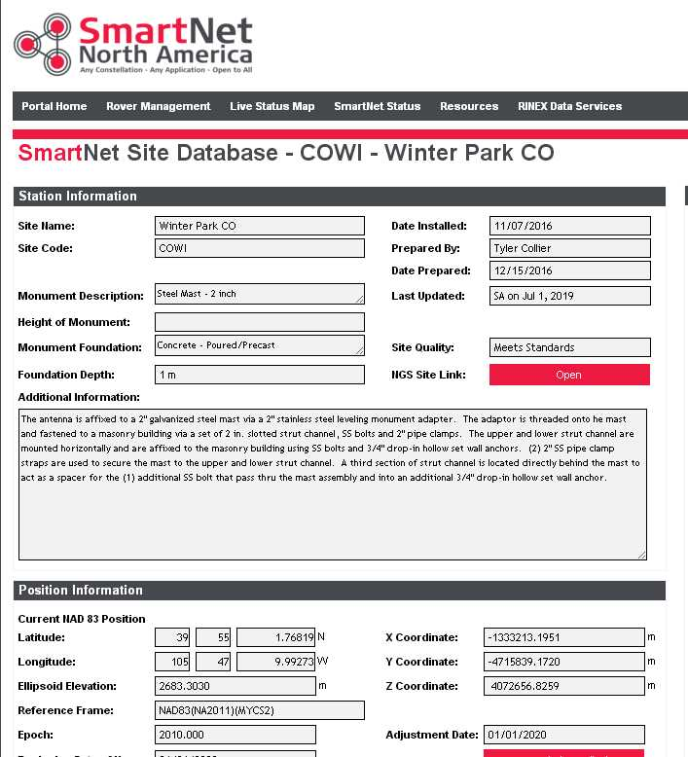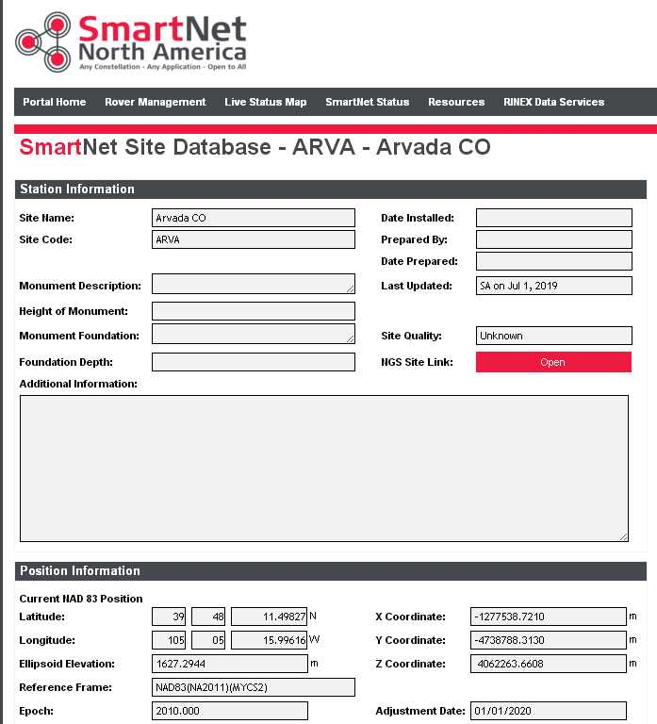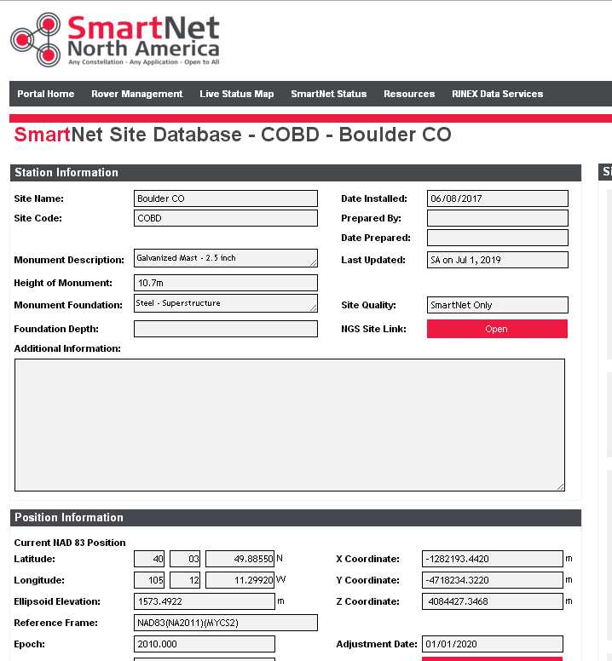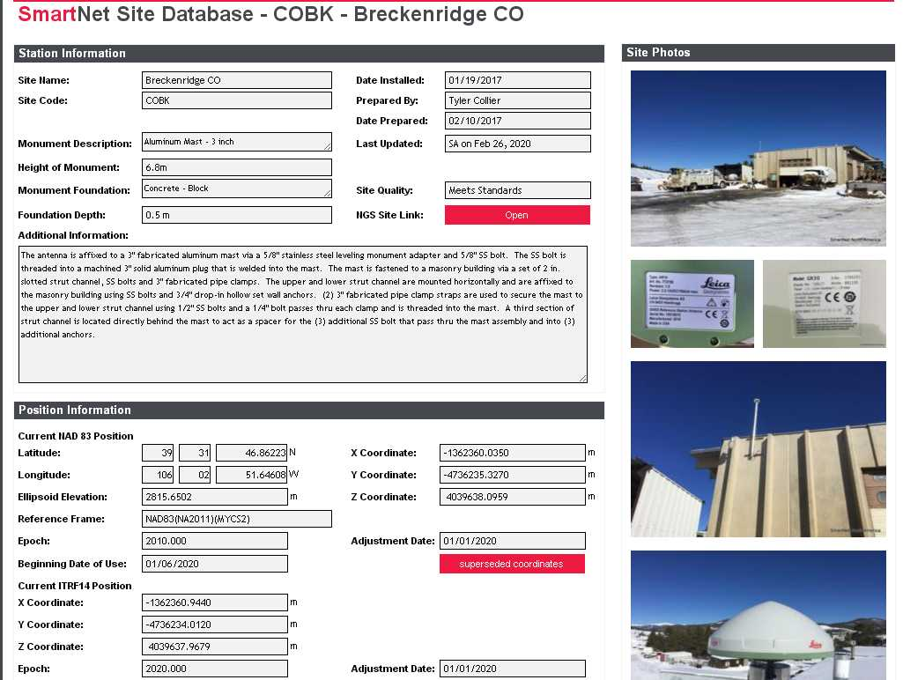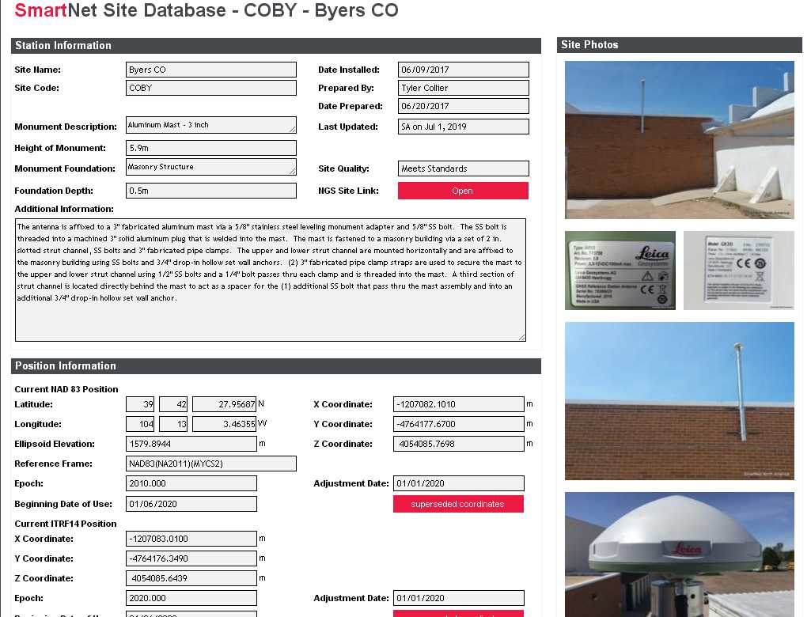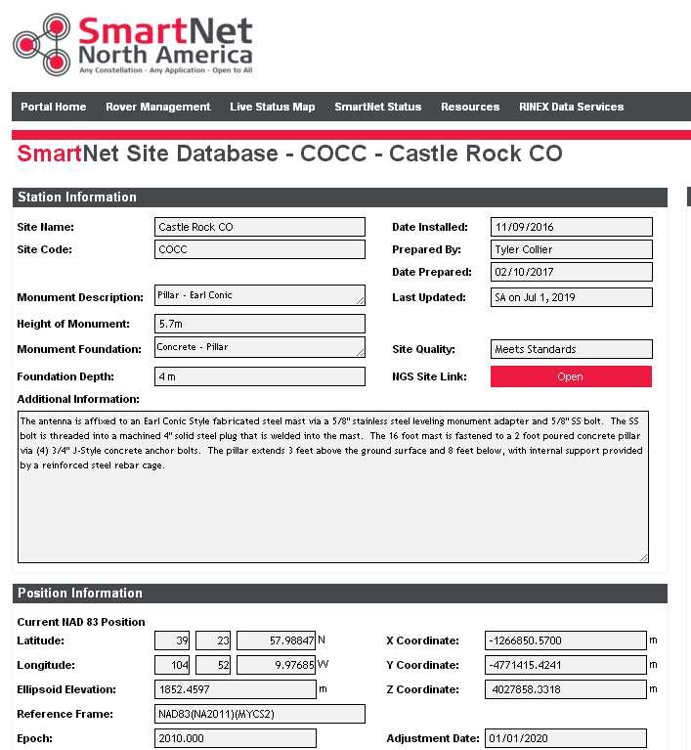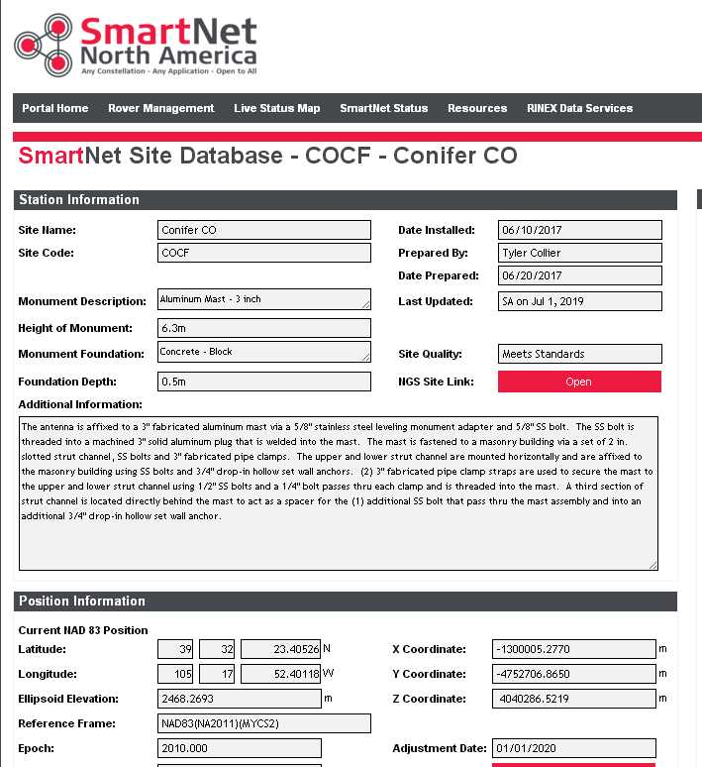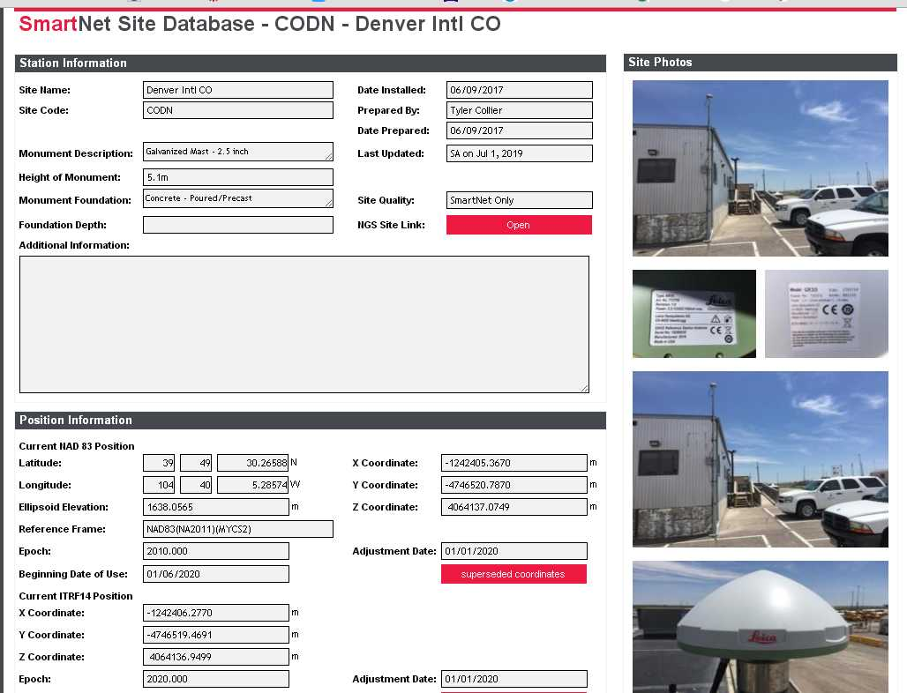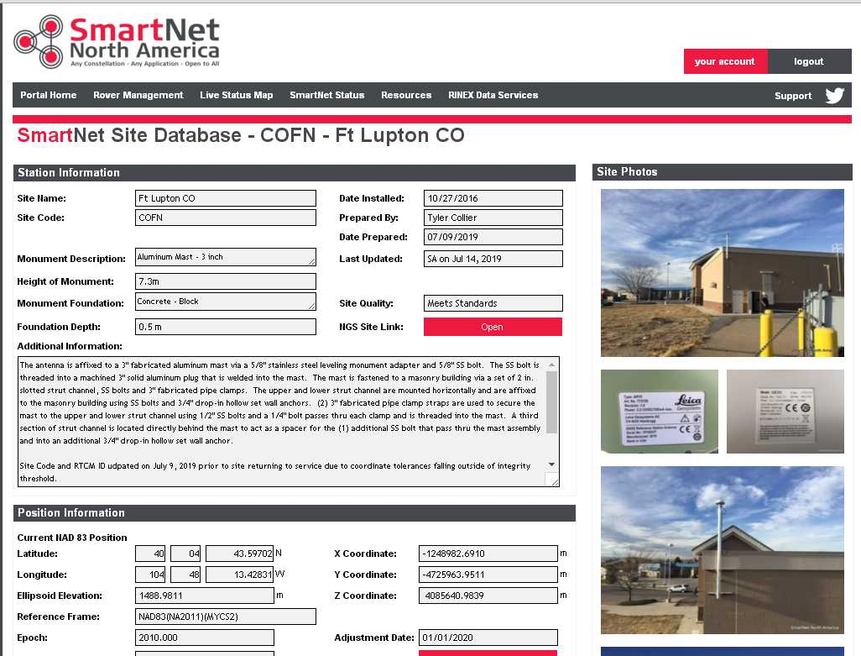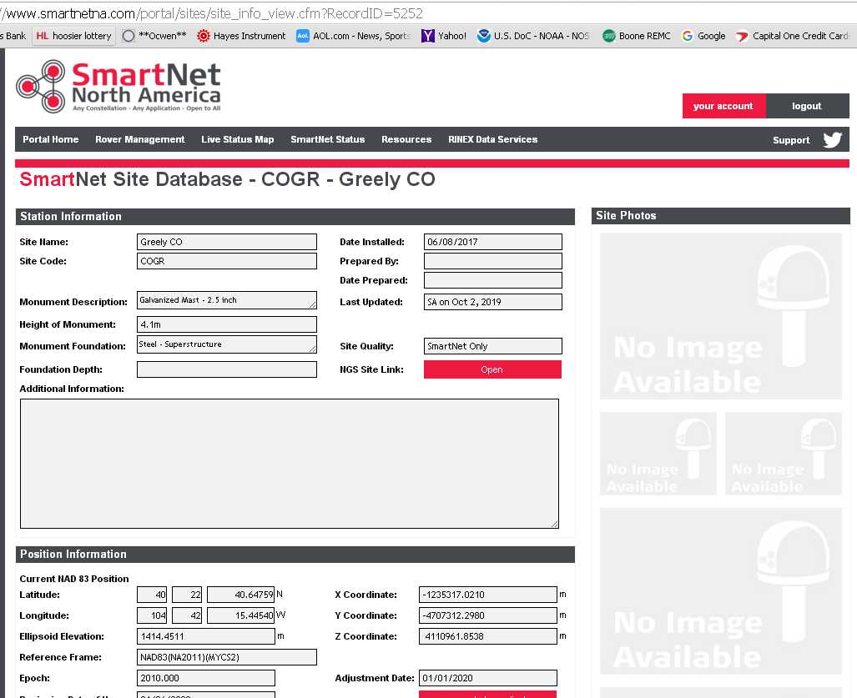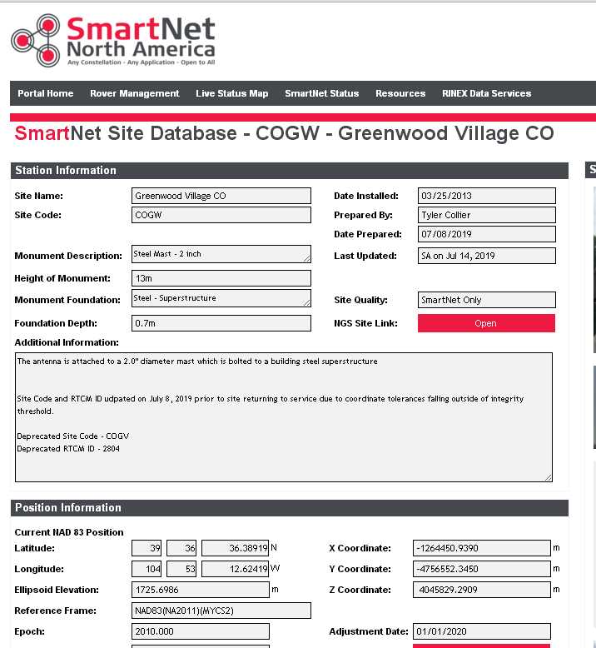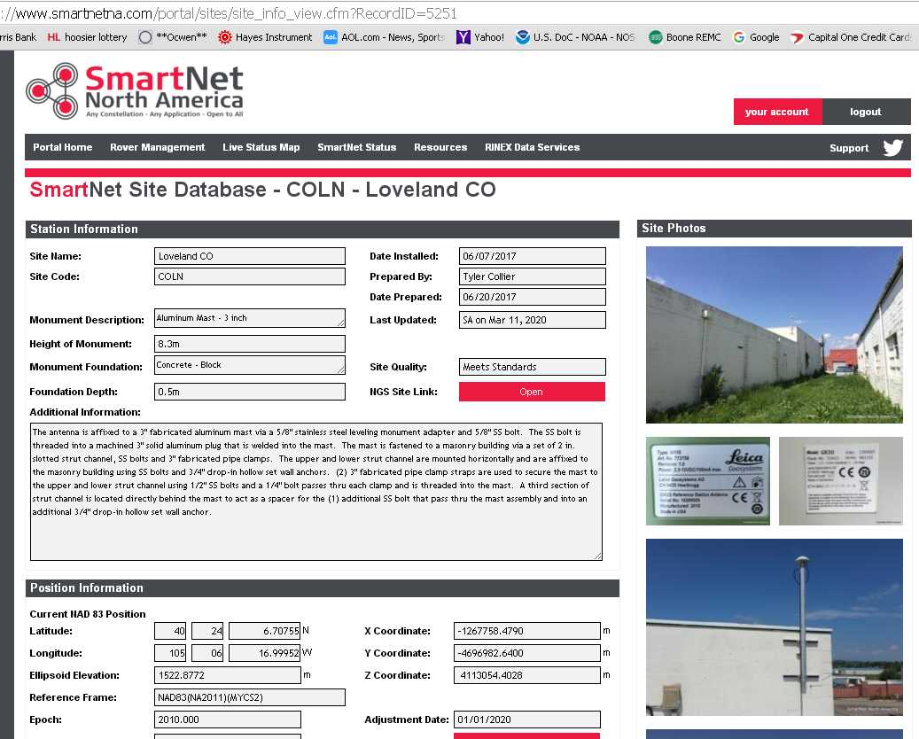

PROJECT SURVEYOR Steven A. Wood


