October 29, 2015
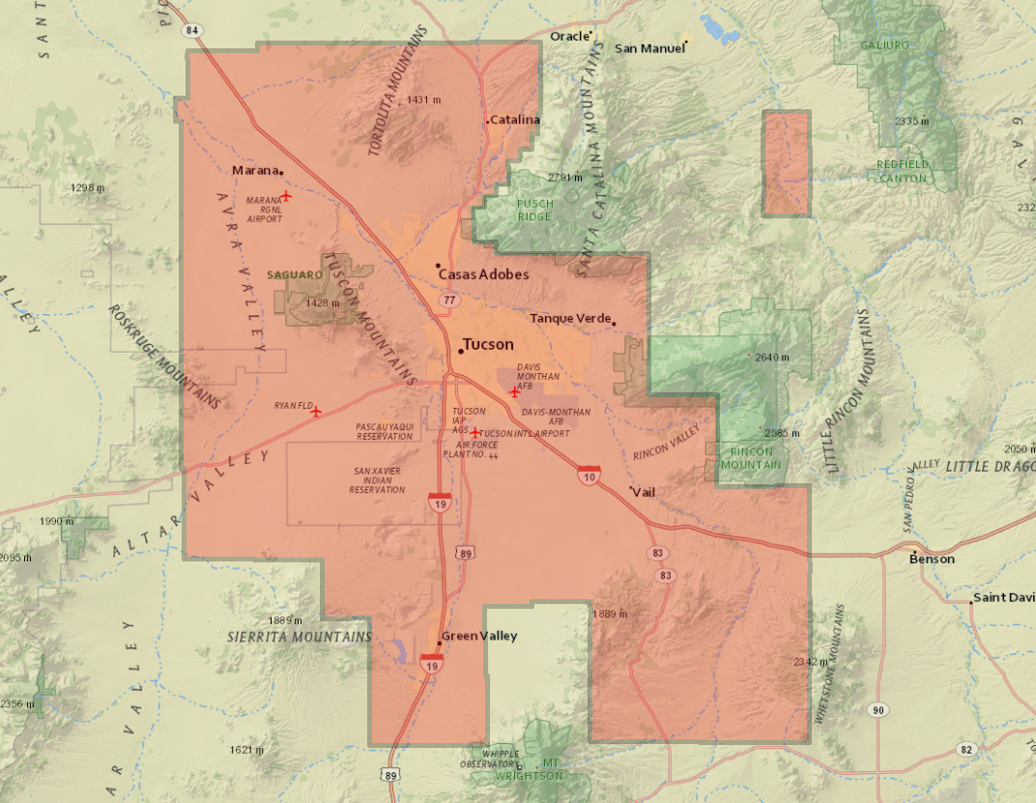

Contents
EXECUTIVE SUMMARY 3
1 INTRODUCTION 4
1.1 Purpose of the Survey 5
1.2 Duration/Time Period 6
1.3 Personnel 6
1.4 Equipment 6
1.5 Field Procedures 6
1.6 Contact 7
1.7 Accuracy requirements 7
1.8 GPS Network, PID and Lidar Calibration Diagrams 8
2 PROJECT AREA SCOPE AND DETAILS 11
2.1 Monuments and Station Naming 11
3 CONDITIONS AFFECTING PROGRESS 11
4 POST PROCESSING 12
4.1 Baseline Processing 12
5 Final Coordinates and Elevations 12
APPENDIX A 13
APPENDIX B 14
APPENDIX C 15
APPENDIX D 16
APPENDIX E 17
APPENDIX F 18

EXECUTIVE SUMMARY

Sanborn Map Company is contracted with the Pima Association of Governments (PAG) to acquire new six-inch resolution color digital Orthophotography and LiDAR data of the project area totaling 2239 square miles in the viscinity of Tucson AZ.
The purpose of this survey was to establish the locations of ground control points (GCP) for the 2015 PAG Orthophotography and LiDAR calibration processes. Twenty four (24) photo identifiable points and thirty two (32) calibration points were identified throughout project area. All points were surveyed by “Fast Static” GPS methods.
Final horizontal coordinates are provided in either State Plane Arizona Central coordinates based on the North American Datum of 1983. Orthometric elevations were based on the GEOID 12A and are provided on the North American Vertical Datum of 1988 (NAVD88). All units are provided in international feet.
The survey’s field observations began on February 19 2015 and ended on May 15 2015. GPS baselines were measured with a minimum of 30 minutes for shorter lines and were extended accordingly for longer baselines. The final adjustment was constrained to HARN network of NGS monuments and CORS stations found throughout the project area, with quality control checks made by submitting the GPS data to the NGS “Online Positioning User Service” (OPUS).

1 INTRODUCTION

This report contains the technical write-up of the differential GPS surveys performed for the ground control photo control and LiDAR calibration points in support of orthophotography collection and high-resolution digital elevation model developed from LiDAR data for the 2015 PAG project.
Sanborn was responsible for the preparation of this report, all fieldwork including reconnaissance of existing control points, establishment of additional control points, LiDAR calibration points, GPS surveys, all GPS data processing and reductions.
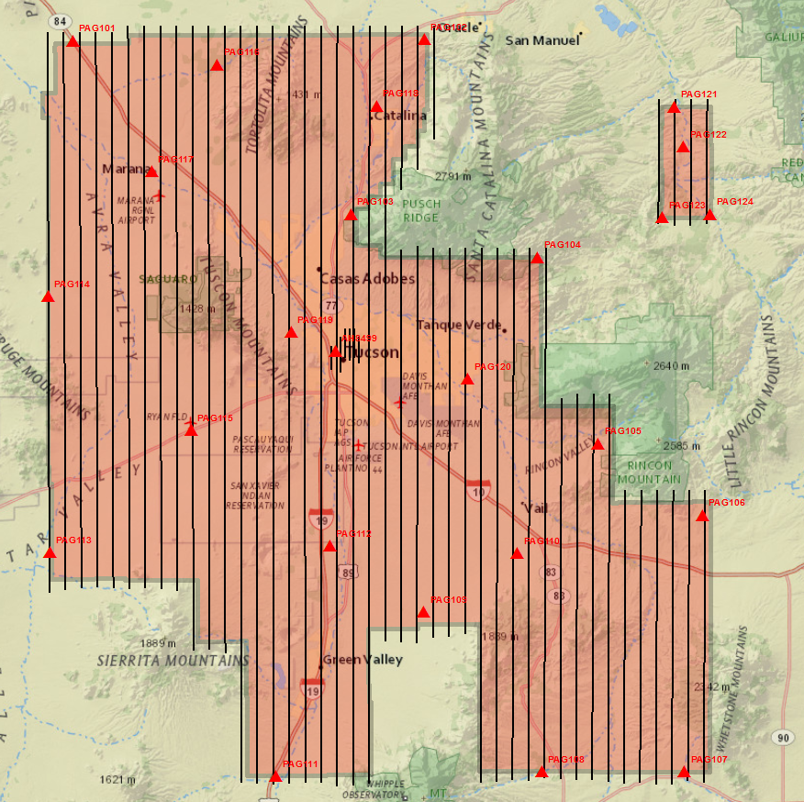
Figure 1: Project Layout with PID Control Points.
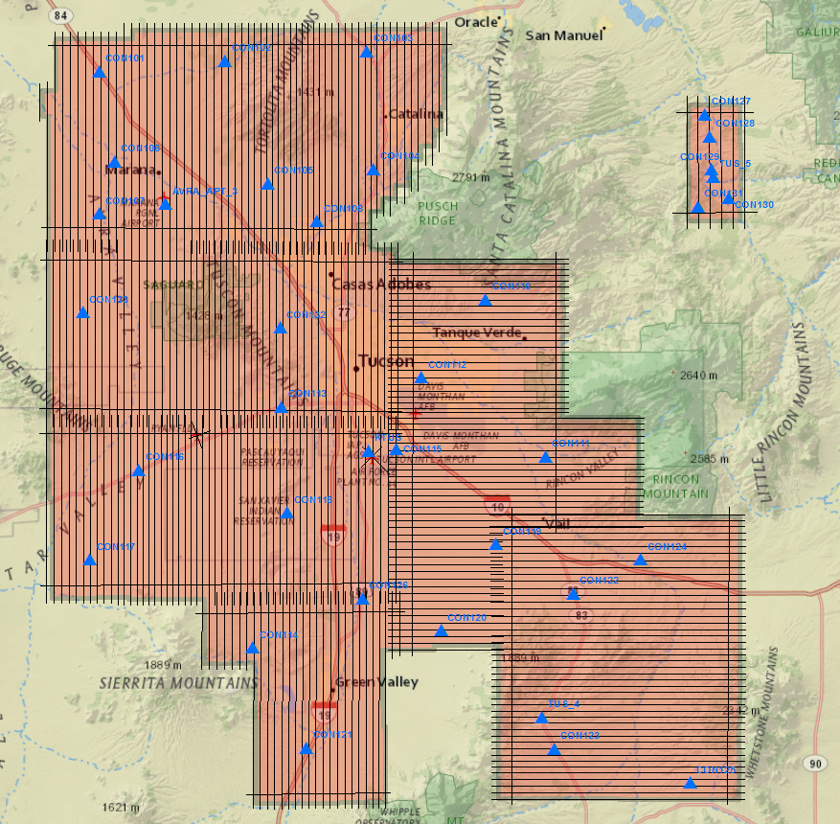
Figure 2: Project Layout with LiDAR Calibration Points.

Purpose of the Survey

The GPS Network surveys were designed to provide ground control for photo aerial collection and high-accuracy LiDAR data collection of the PAG mapping project. The 2015 PAG network consists of sixty three (63) control stations. The network includes two (2) NGS monuments: AH8499 and CH0209, five (5) ABGPS base station points: KTUS_APT_1, KRYN_APT_2, AVRA_APT_3, TUS_4 and TUS_5, twenty four (24) photo ID control points and thirty two (32) LiDAR calibration points, see APPENDIX A for adjusted coordinates and APPENDIX C for points pictures and sketches. The horizontal and vertical datum of the local GPS network is based on HARN network and published values of the above listed NGS monuments.
Photo identifiable control points were strategically placed throughout the project area to serve in aerial triangulation (AT) process to build final orthophotography product. See APPENDIX C1 for point pictures and sketches.
The LiDAR calibration points were established throughout project area to serve in LiDAR data processing and adjustments. One (1) class of calibration points was surveyed throughout the project area: Bare Earth class. Calibration points were positioned with the intent of accomplishing even and random point distribution over the area of interest. See APPENDIX C2 for point pictures and sketches.

Duration/Time Period
The acquisition of ground control and calibration points control was completed between February 19, 2015 (Julian day 050) and May 15, 2015 (Julian day 135).

Personnel
Sanborn field data acquisition technicians are cross-trained as Survey Technicians as well as Airborne Sensor Operators to maximize their utility.

Field Survey Personnel
Name Function
Mario Hernandez | Sensor Operator/ Survey Technician
Richard Wetherill | Sensor Operator/ Survey Technician

Equipment
The ground control survey was performed using survey grade L1/L2 GPS antennaes attached to adjustable height tripods with tribrach and fixed height tripods. The antennas include:
Novatel DL4 plus receivers with 702 Pinwheel Antenna
Trimble 5700 receivers with Zephyr/Zephyr Geodetic Antenna

1.5 Field Procedures
A careful reconnaissance was undertaken prior to the monumentation and subsequent GPS survey. Most of the points in the network have good satellite visibility. The satellite window provided 24–hour coverage, and GPS observation sessions were scheduled between 7:00 am and 7:00 PM, local time, each day. No difficulties were experienced with solar storm activity. All baseline processing, analysis, and preliminary reductions were performed on a daily basis, thus allowing for continuous quality control.
The GPS control survey was set up as a fast static at 0.5s logging rate. Field crew members followed a session schedule established by office personnel to facilitate observation location and duration, which were at least 30 minutes per session for LiDAR calibration point surveys. Personnel navigated to points using hand-held GPS receivers, USGS Quadrangle maps and state road maps. The hand-held GPS receivers had approximate geodetic coordinates loaded for the required observation points. Upon arriving at the desired location, the field personnel initiated a search for an adequate calibration point location that was in a GPS “friendly” spot. The receiver was set on the tripod and leveled over the point. The following information was recorded: control point name and code, stamping if available, date, Julian date, observer name, receiver model & serial number, antenna type, where the antenna height was measured to, antenna height, start time, end time, site sketch with ties. The data file name is also included on this sheet. The file name convention is SSSSJJJf.dat, where “SSSS” is the last four digits of the receiver serial number, “JJJ” is the Julian date, and “f” is the data file number for that day’s work. “f” = 0 for the first file, 1 for the second and so on. See APPENDIX F with field logs for details.
Digital photographs or sketches were taken at each point showing the calibration point surveyed and its relationship to its surroundings.

1.6 Contact
Questions regarding the technical aspects of this report should be addressed to:
Sanborn
1935 Jamboree Drive, Suite 100
Colorado Springs, Colorado, 80920
Attention: Sanchit Agarwal Project Manager
Karol Szczubelek Geodetic Engineer
Telephone: (719) 593-0093
FAX: (719) 528-5093

1.7 Accuracy requirements
The final horizontal datum NAD 83 HARN yielded 2 sigma (95%) station confidence levels of less than 0.10 international ft horizontally (X, Y) and vertical datum NAVD88 of less than 0.20 international ft vertically (Z).

1.8 GPS Network, PID and Lidar Calibration Diagrams

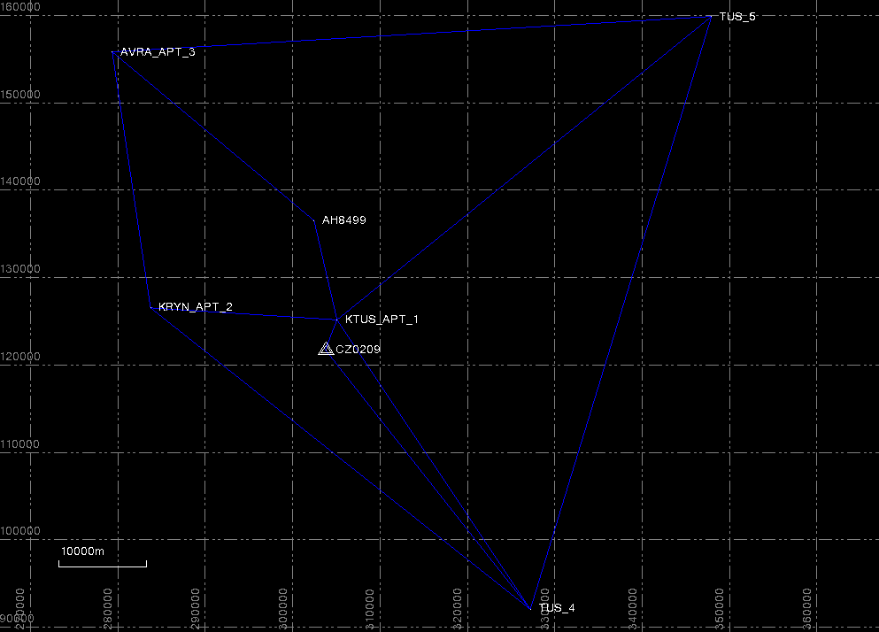
Figure 3: Network Diagram

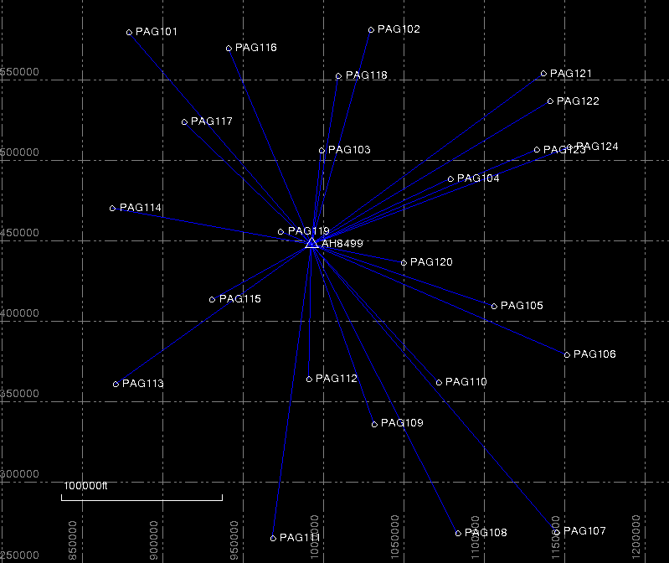
Figure 4: Photo PID Control Diagram
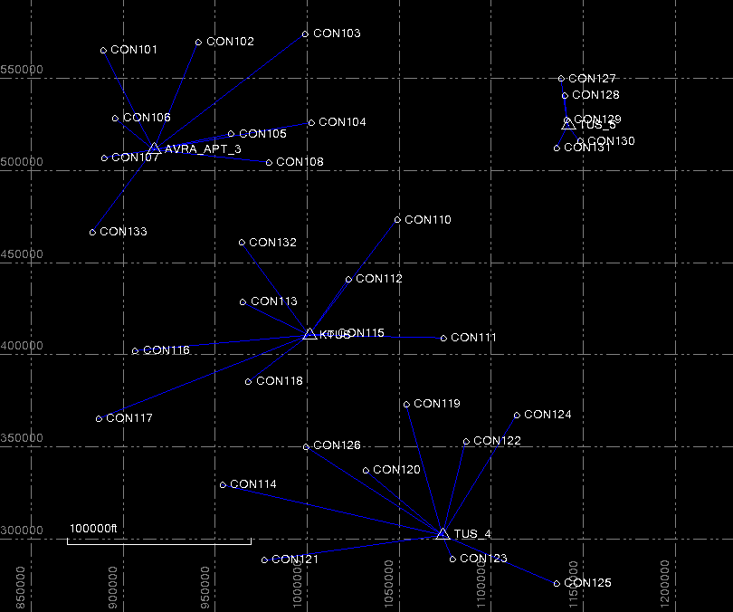
Figure 5: LiDAR Calibration Points Diagram

2 PROJECT AREA SCOPE AND DETAILS

Sanborn Map Company is contracted with the Pima Association of Governments (PAG) to acquire new six-inch resolution color digital Orthophotography and LiDAR data of the project area totaling 2239 square miles over Tucson AZ and vicinity.
The purpose of this survey was to establish the location of ground control points (GCP) for the 2015 PAG Orthophotography and LiDAR calibration process. Twenty four (24) photo identifiable points and thirty two (32) calibration points were identified throughout project areas. All points were surveyed by “Fast Static” GPS methods.

Monuments and Station Naming

The GPS Network surveys were designed to provide ground control for photo aerial collection and high-accuracy LiDAR data collection of the PAG mapping project. The 2015 PAG network consists of sixty three (63) control stations. The network includes two (2) NGS monuments: AH8499 and CH0209, five (5) ABGPS base station points: KTUS_APT_1, KRYN_APT_2, AVRA_APT_3, TUS_4 and TUS_5, twenty four (24) photo ID control points and thirty two (32) LiDAR calibration points, see APPENDIX A for adjusted coordinates and APPENDIX C for points pictures and sketches. The horizontal and vertical datum of the local GPS network is based on HARN network and published values of the below listed NGS monuments. See APPENDIX C for pictures and sketches.

CONDITIONS AFFECTING PROGRESS

A careful reconnaissance was undertaken prior to calibration point control selection and subsequent GPS surveys. Most of the points in the network have good satellite visibility. The satellite window provided 24–hour coverage, and GPS observation sessions were scheduled between 7:00 am and 7:00 PM, local time, each day. No difficulties were experienced with solar storm activity.

4 POST PROCESSING

4.1 Baseline Processing

All static baselines and vectors for PAG project were processed using Trimble Business Center (Ver. 3.10) (TBC) software. Fixed solutions were adopted for all baselines using the precise ephemeris. GEOID12A was incorporated into the reductions, thereby allowing rigorous interpolation of the geoidal undulation values (N) at each point in the network. This provides a useful method of estimating the elevations at all points in the network. For baseline processing reports and adjustments, see APPENDIX B.

Table 1. Adjustment Constraints

Horizontal

Station Name PID Order
COT1 B AH8499 0
XAVIER CZ0209 0

Vertical
Station Name PID Order
COT1 B AH8499 1
XAVIER CZ0209 1

Final Coordinates and Elevations

The final NAD83 State Plane Coordinates Arizona Central zone 0202, are presented in international feet in APPENDIX A. Final orthometric elevations, referenced to the North American Vertical Datum of 1988 (NAVD88) in international feet, are also presented in the above given APPENDIX. All final coordinates are derived from the constrained adjustments shown in APPENDIX B.

APPENDIX A

Adjusted Coordinates List

(Electronically Attached)

APPENDIX B

Network Adjustments Reports
(Electronically Attached)

APPENDIX C

Ground Control Pictures & Sketches
(Electronically Attached)

APPENDIX D

NGS Sheets
(Electronically Attached)

APPENDIX E

OPUS SOLUTIONS
(Electronically Attached)

APPENDIX F

LOGS
(Electronically Attached)

