Eastern Shore Virginia QL2 LiDAR BAA
Report Produced for U.S. Geological Survey
USGS Contract: G10PC00013 Task Order: G15PD00284 Report Date: 02/11/2016

SUBMITTED BY:
Dewberry
1000 North Ashley Drive Suite 801
Tampa, FL 33602
813.225.1325

SUBMITTED TO:
U.S. Geological Survey 1400 Independence Road Rolla, MO 65401 573.308.3810

Table of Contents

Executive Summary 4
The Project Team 4
Survey Area 4
Date of Survey 4
Coordinate Reference System 4
LiDAR Vertical Accuracy 5
Project Deliverables 5
Project Tiling Footprint 6
LiDAR Acquisition Report 7
LiDAR Acquisition Details 7
LiDAR System parameters 7
Acquisition Status Report and Flightlines 8
LiDAR Control 9
Airborn GPS Kinematic 10
Generation and Calibration of Laser Points (raw data) 10
Boresight and Relative accuracy 11
Preliminary Vertical Accuracy Assessment 12
LiDAR Processing & Qualitative Assessment 13
Initial Processing 13
Final Swath Vertical Accuracy Assessment 13
Inter-Swath (Between Swath) Relative Accuracy 15
Intra-Swath (Within a Single Swath) Relative Accuracy 16
Horizontal Alignment 17
Point Density and Spatial Distribution 17
Data Classification and Editing 18
LiDAR Qualitative Assessment 19
Visual Review 20
Data Voids 20
Bridge Removal Artifacts 20
Culverts 22
Dirt Mounds 23
Elevation Changes within Tidal Water Bodies 24
Flightline Ridges 25
Temporal Changes 25
Formatting 28
LiDAR Positional Accuracy 29
Background 29
Survey Vertical Accuracy Checkpoints 30
Vertical Accuracy Test Procedures 33
NVA 33
VVA 34
Vertical Accuracy Results 34
Horizontal Accuracy Test Procedures 37
Horizontal Accuracy Results 38
Breakline Production & Qualitative Assessment Report 38
Breakline Production Methodology 38
Breakline Qualitative Assessment 39
Breakline Checklist 40
Data Dictionary 41
Horizontal and Vertical Datum 41
Coordinate System and Projection 41
Inland Ponds and Lakes 41
Tidal Waters 43
DEM Production & Qualitative Assessment 44
DEM Production Methodology 44
DEM Qualitative Assessment 46
DEM Vertical Accuracy Results 47
DEM Checklist 48
Appendix A: Survey Report 49
Appendix B: Complete List of Delivered Tiles 63
Appendix C: List of Water Tiles 72
Appendix D: GPS Processing 73

Executive Summary
The primary purpose of this project was to develop a consistent and accurate surface elevation dataset derived from high-accuracy Light Detection and Ranging (LiDAR) technology for the USGS Eastern Shore, Virginia Project Area.

The LiDAR data were processed and classified according to project specifications. Detailed breaklines and bare-earth Digital Elevation Models (DEMs) were produced for the project area. Data were formatted according to tiles with each tile covering an area of 5,000 ft by 5,000 ft. A total of 1375 LAS tiles and 1310 DEMs were produced for the project encompassing an area of approximately 994 sq. miles. Sixty-five tiles are water tiles where no topographic ground is present. DEMs were not produced for all water tiles.

THE PROJECT TEAM
Dewberry served as the prime contractor for the project. In addition to project management, Dewberry was responsible for LAS classification, all LiDAR products, breakline production, Digital Elevation Model (DEM) production, and quality assurance.

Dewberry’s Gary Simpson completed ground surveying for the project and delivered surveyed checkpoints. His task was to acquire surveyed checkpoints for the project to use in independent testing of the vertical accuracy of the LiDAR-derived surface model. He also verified the GPS base station coordinates used during LiDAR data acquisition to ensure that the base station coordinates were accurate. Please see Appendix A to view the separate Survey Report that was created for this portion of the project.

Leading Edge Geomatics completed LiDAR data acquisition and data calibration for the project area.
SURVEY AREA
The project area addressed by this report falls within the Virginia counties of Northampton and Accomack.
DATE OF SURVEY
The LiDAR aerial acquisition was conducted from April 11, 2015 to April 24, 2015.
COORDINATE REFERENCE SYSTEM
Data produced for the project were delivered in the following reference system.
Horizontal Datum: The horizontal datum for the project is North American Datum of 1983 with the 2011 Adjustment (NAD 83 (2011))
Vertical Datum: The Vertical datum for the project is North American Vertical Datum of 1988 (NAVD88)
Coordinate System: Virginia State Plane South
Units: Horizontal units are in US Survey feet, Vertical units are in US Survey feet. Geiod Model: Geoid12A (Geoid 12A was used to convert ellipsoid heights to orthometric heights).

LIDAR VERTICAL ACCURACY
For the Eastern Shore Virginia LiDAR Project, the tested RMSEz of the classified LiDAR data for checkpoints in non-vegetated terrain equaled 6.4 cm (0.21 ft) compared with the 10 cm (0.33 ft) specification; and the NVA of the classified LiDAR data computed using RMSEz x 1.9600 was equal to 12.5 cm (0.41 ft), compared with the 19.6 cm (0.64 ft) specification.

For the Eastern Shore LiDAR Project, the tested VVA of the classified LiDAR data computed using the 95th percentile was equal to 17.7 cm (0.58 ft), compared with the 29.4 cm (0.96 ft) specification.

Additional accuracy information and statistics for the classified LiDAR data, raw swath data, and bare earth DEM data are found in the following sections of this report.
PROJECT DELIVERABLES
The deliverables for the project are listed below.

- Raw Point Cloud Data (Swaths)
- Classified Point Cloud Data (Tiled)
- Bare Earth Surface (Raster DEM – IMG Format)
- Intensity Images (8-bit gray scale, tiled, GeoTIFF format)
- Breakline Data (File GDB)
- Independent Survey Checkpoint Data (Report, Photos, & Points)
- Calibration Points
- Metadata
- Project Report (Acquisition, Processing, QC)
- Project Extents, Including a shapefile derived from the LiDAR Deliverable
- Other Ancillary Data (Areas identified as temporally changed)

PROJECT TILING FOOTPRINT
One thousand three hundred seventy-five (1375) LAS tiles and one thousand three hundred ten (1310) DEM tiles were delivered for the project. Sixty five (65) tiles contained all water and were removed from DEM processing as these tiles do not contain any topographic data. Dewberry extended the client provided boundary where tiles had ground to include thirty four (34) extra tiles. Each tile’s extent is 5,000 feet by 5,000 feet (see Appendix B for a complete listing of delivered tiles and Appendix C for a list of water tiles that were not included in the DEM).

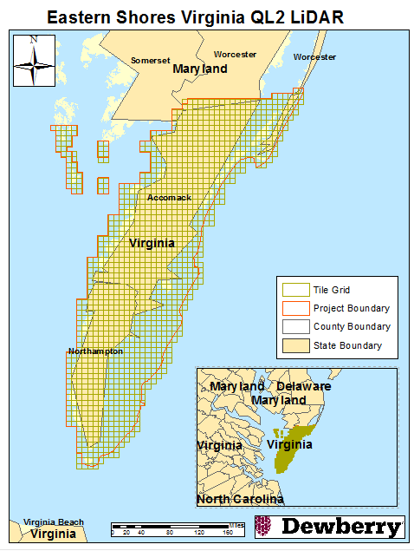
Figure 1 - Project Map

LiDAR Acquisition Report

Dewberry elected to subcontract the LiDAR Acquisition and Calibration activities to Leading Edge Geomatics (LEG). LEG was responsible for providing LiDAR acquisition, calibration and delivery of LiDAR data files to Dewberry.

Dewberry received calibrated swath data from LEG on August 31, 2015.
LIDAR ACQUISITION DETAILS
Leading Edge Geomatics planned 181 passes total for the entire project area and a series of parallel flight lines with cross flightlines for the purposes of quality control. The flight plan included zigzag flight line collection as a result of the inherent IMU drift associated with all IMU systems. In order to reduce any margin for error in the flight plan, Leading Edge Geomatics followed FEMA’s Appendix A “guidelines” for flight planning and, at a minimum, includes the following criteria:
  - A digital flight line layout using Track Air flight design software for direct integration into the aircraft flight navigation system.
  - Planned flight lines; flight line numbers; and coverage area.
  - LiDAR coverage extended by a predetermined margin beyond all project borders to ensure necessary over-edge coverage appropriate for specific task order deliverables.
  - Local restrictions related to air space and any controlled areas have been investigated so that required permissions can be obtained in a timely manner with respect to schedule. Additionally, LEG will file our flight plans as required by local Air Traffic Control (ATC) prior to each mission.
LEG monitored weather and atmospheric conditions and conducted LiDAR missions only when no conditions exist below the sensor that will affect the collection of data. These conditions include leaf-off for hardwoods, no snow, rain, fog, smoke, mist and low clouds. LiDAR systems are active sensors, not requiring light, thus missions may be conducted during night hours when weather restrictions do not prevent collection. LEG accesses reliable weather sites and indicators (webcams) to establish the highest probability for successful collection in order to position our sensor to maximize successful data acquisition.
Within 72-hours prior to the planned day(s) of acquisition, LEG closely monitored the weather, checking all sources for forecasts at least twice daily. As soon as weather conditions were conducive to acquisition, our aircraft mobilized to the project site to begin data collection. Once on site, the acquisition team took responsibility for weather analysis.
Leading Edge Geomatics’ LiDAR sensors are calibrated at a designated site located in downtown Fredericton, New Brunswick and are periodically checked and adjusted to minimize corrections at project sites. Both systems were calibrated before departing for the project area.
LIDAR SYSTEM PARAMETERS
Leading Edge Geomatics operated two Cessna 172 (Tail # C-FMNB and C-GUNB) each outfitted with a Riegl 680i LiDAR system during the collection of the entire project. Table 1 illustrates LEG’s system parameters for LiDAR acquisition on this project.

Item | Parameter
System | Riegl 680i
Altitude (AGL meters) | 1000
Approx. Flight Speed (knots) | 100
Scanner Pulse Rate (kHz) | 200
Scan Frequency (hz) | 78
Pulse Duration of the Scanner (nanoseconds) | 5
Pulse Width of the Scanner (m) | 0.8994
Swath width (m) | 1155
Central Wavelength of the Sensor Laser (nanometers) | 1064
Did the Sensor Operate with Multiple Pulses in The Air? (yes/no) | No
Beam Divergence (milliradians) | 5.0
Nominal Swath Width on the Ground (m) | 1155
Swath Overlap (%) | 50
Total Sensor Scan Angle (degree) | 60
Computed Down Track spacing (m) per beam | 0.66
Computed Cross Track Spacing (m) per beam | 0.66
Nominal Pulse Spacing (single swath), (m) | 0.66
Nominal Pulse Density (single swath) (ppsm), (m) | 2.25
Aggregate NPS (m) (if ANPS was designed to be met through single coverage, ANPS and NPS will be equal) | 0.53
Aggregate NPD (m) (if ANPD was designed to be met through single coverage, ANPD and NPD will be equal) | 3.45
Maximum Number of Returns per Pulse | 7
Table 1: LEG’s LiDAR System Parameters

ACQUISITION STATUS REPORT AND FLIGHTLINES
Upon notification to proceed, the flight crew loaded the flight plans and validated the flight parameters. The Acquisition Manager contacted air traffic control and coordinated flight pattern requirements. LiDAR acquisition began immediately upon notification that control base stations were in place. During flight operations, the flight crew monitored weather and atmospheric conditions. LiDAR missions were flown only when no condition existed below the sensor that would affect the collection of data. The pilot constantly monitored the aircraft course, position, pitch, roll, and yaw of the aircraft. The sensor operator monitored the sensor, the status of PDOPs, and performed the first Q/C review during acquisition. The flight crew constantly reviewed weather and cloud locations. Any flight lines impacted by unfavorable conditions were marked as invalid and re-flown immediately or at an optimal time.

Figure 2 shows the combined trajectory of the flightlines.

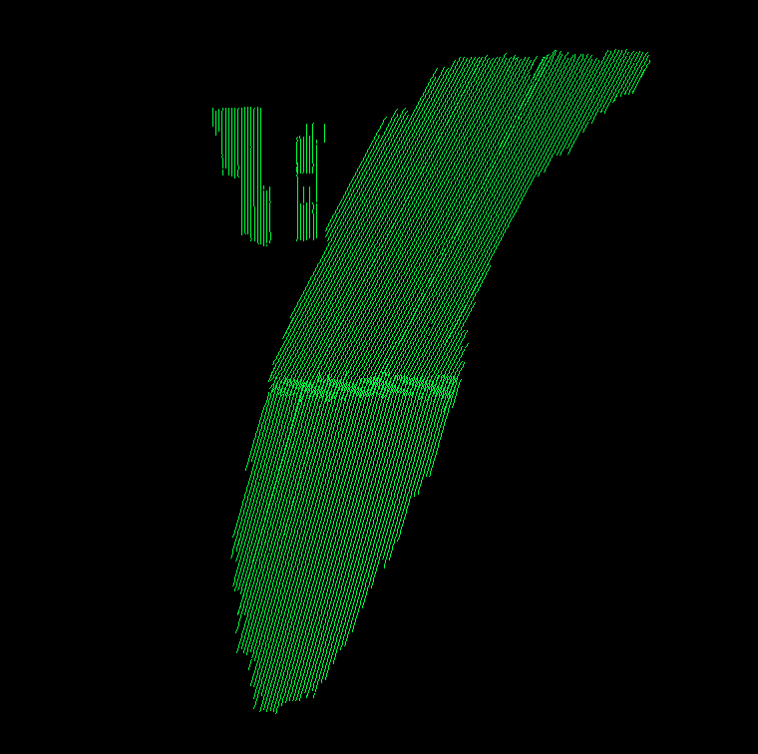

LIDAR CONTROL
Figure 2: Trajectories as flown by LEG

Seven active base stations from Leica Smartnet were employed as well as three existing NGS monuments and one newly established base station were used to control the LiDAR acquisition for the Eastern Shore VA LiDAR project area. The coordinates of all used base stations are provided in the table below. All control and calibration points are also provided in shapefile format as part of the final deliverables.

Name | NAD83(2011) State Plane VA South |  | Ellipsoid Ht (meters) | Orthometric Ht (NAVD88, Geoid12A,  ft)
 | Easting X (ft) | Northing Y (ft)
LOYG | 12173127.9778 | 4179657.87 | -21.772 | 91.9320

12007914.0974 3629210.1275 2.198 117.9719
LOYM | 12018715.5239 | 4006085.1738 | 6.099 | 117.2294
LOYW | 12251869.1056 | 3726623.3987 | -22.492 | 97.7099
LOYX

LS03 | 12226769.4158 | 3456648.5533 | -22.006 | 102.4152
LS09 | 12390532.8985 | 3982774.1816 | -17.442 | 101.1909
VAHP | 12094608.6656 | 3552986.7166 | -22.683 | 97.0186

Accomac Reset | 12300004.0789 | 3796950.0510 | -23.118 | 96.8955
Jerry McCready | 12245554.5854 | 3889314.6319 | -35.442 | 83.0352
Nelson | 12335638.4318 | 3901413.8731 | -26.809 | 92.5438
REBAR1 | 12229779.9442 | 3642235.0442 | -27.753 | 93.4894
Table 2 – Base Stations used to control LiDAR acquisition

AIRBORN GPS KINEMATIC
Airborne GPS data was processed using the PosPac kinematic On-The-Fly (OTF) software suite using Applanix Smartbase processing. Flights were flown with a minimum of 6 satellites in view (13° above the horizon) and with a PDOP of better than 4.

For all flights, the GPS data can be classified as excellent, with GPS residuals of 3cm average or better but no larger than 10cm being recorded.

GENERATION AND CALIBRATION OF LASER POINTS (RAW DATA)
The initial step of calibration is to verify availability and status of all needed GPS and laser data against field notes and compile any data if not complete.

Subsequently the mission points are output using Riegl’s RiProcess application. System calibration was conducted prior to the aircraft departing for the project and the initial calibration values are used to position the point cloud. If a calibration error greater than specification is observed within the mission, the roll, pitch and yaw corrections that need to be applied are calculated. The missions with the new calibration values are regenerated and validated internally once again to ensure quality.

Data collected by the LiDAR unit is reviewed for completeness, acceptable density and to make sure all data is captured without errors or corrupted values. In addition, all GPS, aircraft trajectory, mission information, and ground control files are reviewed and logged into a database.

On a project level, a supplementary coverage check is carried out to ensure no data voids unreported by Field Operations are present.

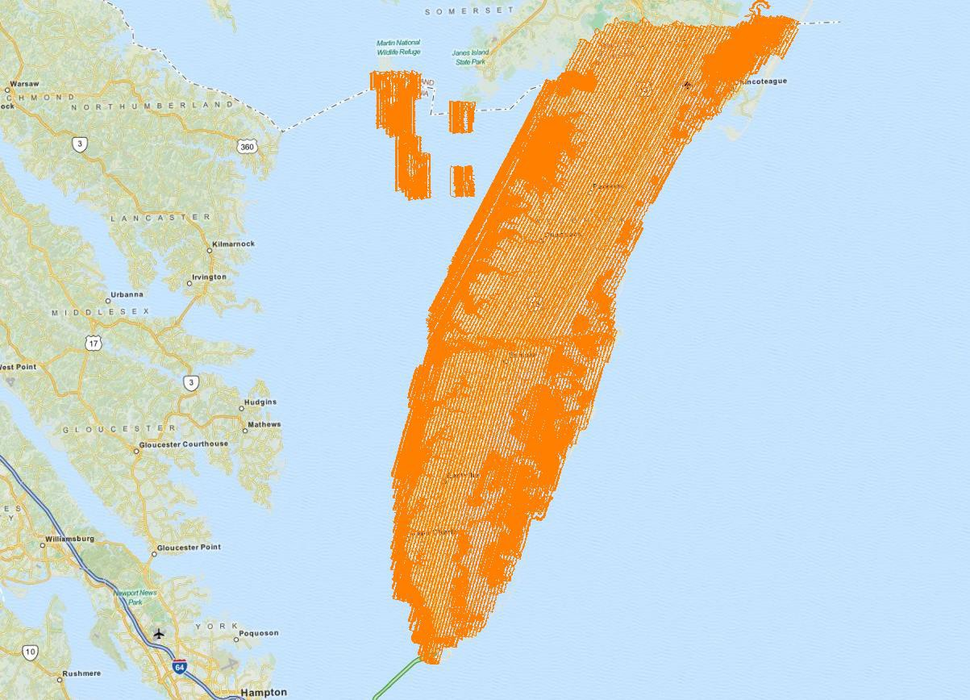
Figure 3 – LiDAR Swath output showing complete coverage.

BORESIGHT AND RELATIVE ACCURACY
The initial points for each mission calibration are inspected for flight line errors, flight line overlap, slivers or gaps in the data, point data minimums, or issues with the LiDAR unit or GPS. Roll, pitch and yaw are optimized during the calibration process until the relative accuracy is met.

Relative accuracy and internal quality are checked using at least 3 regularly spaced QC blocks in which points from all lines are loaded and inspected. Vertical differences between ground surfaces of each line are displayed. Color scale is adjusted so that errors greater than the specifications are flagged. Cross sections are visually inspected across each block to validate point to point, flight line to flight line and mission to mission agreement.

For this project the specifications used are as follow:
Relative accuracy <= 6 cm maximum difference within individual swaths and <=8 cm RMSDz within swath overlap (between adjacent swaths).

Figure 4 – Profile view colored by flightline showing correct roll and pitch adjustments.

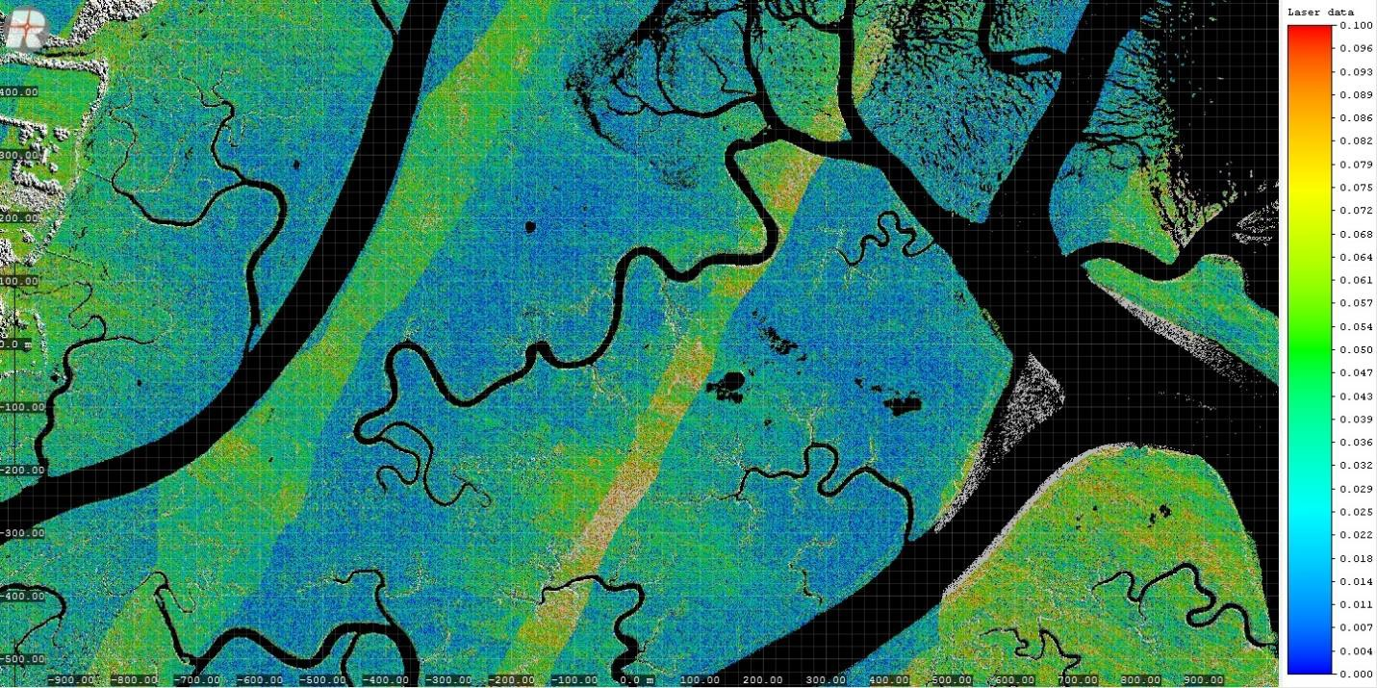
Figure 5 – QC block colored by elevation differences to ensure accuracy at swath edges.
A different set of QC blocks are generated for final review after all transformations have been applied.
PRELIMINARY VERTICAL ACCURACY ASSESSMENT
A preliminary RMSEz error check is performed by Leading Edge Geomatics at this stage of the project life cycle in the raw LiDAR dataset against GPS static and kinematic data and compared to RMSEz project specifications. The LiDAR data is examined in open, flat areas away from breaks. Ground control points are collected by RTK survey and compared against the LiDAR ground points and statistics are generated. 23% of the flight lines flown for the project were directly tested against independently collected RTK control.

Prior to delivery to Dewberry, the elevation data was verified internally to ensure it met fundamental accuracy requirements (vertical accuracy NSSDA RMSEz = 10 cm (NSSDA Accuracyz 95% = 19.6 cm) or better in open, non-vegetated terrain) when compared to static and kinematic GPS checkpoints. Below is a summary for the test:

The calibrated Virginia LiDAR dataset was tested to 0.133 m (0.438 ft) vertical accuracy at 95% confidence level based on consolidated RMSEz (0.068m x 1.9600) when compared to 287 RTK collected static check points.

The following are the final statistics for the GPS static checkpoints used by LEG to internally verify vertical accuracy.

Average dz +0.055 m Root mean square 0.068 m Std deviation 0.0402 m

Overall the calibrated LiDAR data products collected by LEG meet or exceed the requirements set out in the Statement of Work. The quality control requirements of LEG quality management program were adhered to throughout the acquisition stage for this project to ensure product quality.

LiDAR Processing & Qualitative Assessment
INITIAL PROCESSING
Once Dewberry receives the calibrated swath data from the acquisition provider, Dewberry performs several validations on the dataset prior to starting full-scale production on the project. These validations include vertical accuracy of the swath data, inter-swath (between swath) relative accuracy validation, intra-swath (within a single swath) relative accuracy validation, verification of horizontal alignment between swaths, and confirmation of point density and spatial distribution. This initial assessment allows Dewberry to determine if the data are suitable for full-scale production. Addressing issues at this stage allows the data to be corrected while imposing the least disruption possible on the overall production workflow and overall schedule.

Final Swath Vertical Accuracy Assessment
Once Dewberry received the calibrated swath data from LEG, Dewberry tested the vertical accuracy of the non-vegetated terrain swath data prior to additional processing. Dewberry tested the vertical accuracy of the swath data using the fifty-nine (59) non-vegetated (open terrain and urban) independent survey check points. The vertical accuracy is tested by comparing survey checkpoints in non-vegetated terrain to a triangulated irregular network (TIN) that is created from the raw swath points. Only checkpoints in non-vegetated terrain can be tested against raw swath data because the data has not undergone classification techniques to remove vegetation, buildings, and other artifacts from the ground surface. Checkpoints are always compared to interpolated surfaces from the LiDAR point cloud because it is unlikely that a survey checkpoint will be located at the location of a discrete LiDAR point. Project specifications require a NVA of
19.6 cm (0.64 ft) based on the RMSEz (10 cm/0.33 ft) x 1.96. The dataset for the Eastern Shore VA LiDAR Project satisfies this criteria. This raw LiDAR swath data set was tested to meet ASPRS Positional Accuracy Standards for Digital Geospatial Data (2014) for a 0.33 ft (10 cm)

RMSEz Vertical Accuracy Class. Actual NVA accuracy was found to be RMSEz = 0.20 ft (6.1 cm), equating to +/- 0.39 ft (11.9 cm) at 95% confidence level. The table below shows all calculated statistics for the raw swath data.

100 % of Totals | # of Points | RMSEz NVA  Spec=0.33 ft | NVA –Non-  vegetated Vertical Accuracy (RMSEz x 1.9600)  Spec=0.64 ft | Mean (ft) | Median (ft) | Skew | Std Dev (ft) | Min (ft) | Max (ft) | Kurtosis
Non- Vegetated Terrain | 59 | 0.20 | 0.39 | 0.00 | 0.03 | -0.22 | 0.20 | -0.48 | 0.44 | -0.20

Table 3: NVA at 95% Confidence Level for Raw Swaths
One checkpoint (NVA-54) was removed from the raw swath vertical accuracy testing due to its location underneath a power line. Only non-vegetated terrain checkpoints are used to test the raw swath data because the raw swath data has not been classified to remove vegetation, structures, and other above ground features from the ground classification. While NVA-54 is located in urban terrain, the overhead power lines are modeled by the LiDAR point cloud. These high points caused erroneous high values during the swath vertical accuracy testing so this point was removed from the raw swath accuracy calculations. Once the data underwent the classification process, the power lines were removed from the final ground classification and this point could be used in the final vertical accuracy testing for the fully classified LiDAR data. Table 4, below, provides the coordinates for this checkpoint. Table 5, below, provides the usable vertical accuracy results of this checkpoint from the fully classified LiDAR. Figure 6, below, shows a 3D model of the LiDAR point cloud and the location of the checkpoint beneath a power line.

D88 d 12A)
Point ID | NAD83(2011) State Plane VA South NAV  (Geoi
 | Easting X (ft) | Northing Y (ft) Survey Z (ft)
NVA-54 | 12226073.01 | 3628990.53 | 32.54

Table 4: Checkpoint removed from raw swath vertical accuracy testing.

Point ID | NAD83 (2011) VA State Plane South |  | NAVD88 (Geoid 12A) |  | DeltaZ | AbsDeltaZ
 | Easting X (ft) | Northing Y (ft) | Z-Survey (ft) | Z-LiDAR  (ft)
NVA-54 | 12226073.01 | 3628990.53 | 32.54 | 32.26 | -0.28 | 0.28
Table 5: Final tested vertical accuracy for NVA-54 after ground classification.

Figure 6 – Urban Terrain checkpoint NVA-54, shown as blue dot, is located underneath power line features. This point was removed from raw swath vertical accuracy testing because above ground features, including power lines, have not yet been classified separately from the ground.

Inter-Swath (Between Swath) Relative Accuracy
Dewberry verified inter-swath or between swath relative accuracy of the dataset by creating Delta-Z (DZ) orthos. According to the SOW, USGS LiDAR Base Specifications v1.2, and ASPRS Positional Accuracy Standards for Digital Geospatial Data, 10 cm Vertical Accuracy Class or QL2 data must meet inter-swath relative accuracy of 8 cm RMSDz or less with maximum differences less than 16 cm. These measurements are to be taken in non-vegetated and flat open terrain using single or only returns from all classes. Measurements are calculated in the DZ orthos on
- meter pixels or cell sizes. Areas in the dataset where overlapping flight lines are within 8 cm of each other within each pixel are colored green, areas in the dataset where overlapping flight lines have elevation differences in each pixel between 8 cm -12 cm are colored yellow, and areas in the dataset where overlapping flight lines have elevation differences in each pixel greater than 12 cm are colored red. Pixels that do not contain points from overlapping flight lines are colored according to their intensity values. Areas of vegetation and steep slopes (slopes with 12 cm or more of valid elevation change across 1 linear meter) are expected to appear yellow or red in the DZ orthos. If the project area is heavily vegetated, Dewberry may also create DZ Orthos from the initial ground classification only, while keeping all other parameters consistent. This allows Dewberry to review the ground classification relative accuracy beneath vegetation and to ensure flight line ridges or other issues do not exist in the final classified data.

Flat, open areas are expected to be green in the DZ orthos. Large or continuous sections of yellow or red pixels can indicate the data was not calibrated correctly or that there were issues during acquisition that could affect the usability of the data, especially when these yellow/red sections follow the flight lines and not the terrain or areas of vegetation. The DZ orthos for Eastern Shore Virginia are shown in the figure below; this project meets inter-swath relative accuracy specifications.

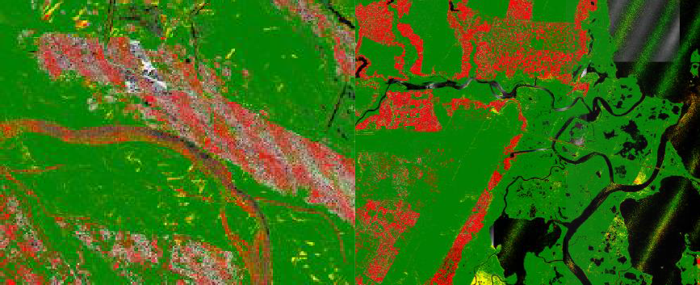
Figure 7– Single return DZ Orthos for the Eastern Shore Virginia Lidar Project. Inter-swath relative accuracy passes specifications.

Intra-Swath (Within a Single Swath) Relative Accuracy
Dewberry verifies the intra-swath or within swath relative accuracy by using Quick Terrain Modeler (QTM) scripting and visual reviews. QTM scripting is used to calculate the RMSDz of all points within each 1-meter pixel/cell size of each swath. Dewberry analysts then identify planar surfaces acceptable for repeatability testing and analysts review the QTM results in those areas. According to the SOW, USGS LiDAR Base Specifications v1.2, and ASPRS Positional Accuracy Standards for Digital Geospatial Data, 10 cm Vertical Accuracy Class or QL2 data must meet intra-swath relative accuracy of 6 cm RMSDz or less. The image below shows two examples of the intra-swath relative accuracy of Eastern Shore Virginia; this project meets intra-swath relative accuracy specifications.

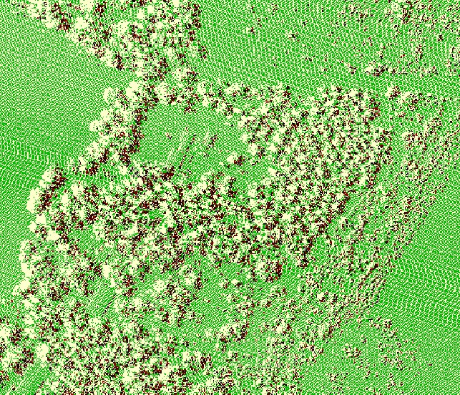
Figure 8–Intra-swath relative accuracy. The left image shows a portion of the dataset; flat, open areas are colored green as they are within 6 cm RMSDz whereas sloped terrain is colored red because it exceeds 6 cm RMSDz, as expected, due to actual slope/terrain change. The right image is a close- up of a flat area. With the exception of f trees (shown in red as the RMSDz in vegetated areas will

exceed 6 cm) this open flat area is acceptable for repeatability testing. Intra-swath relative accuracy passes specifications.

Horizontal Alignment
To ensure horizontal alignment between adjacent or overlapping flight lines, Dewberry uses QTM scripting and visual reviews. QTM scripting is used to create files similar to DZ orthos for each swath but this process highlights planar surfaces, such as roof tops. In particular, horizontal shifts or misalignments between swaths on roof tops and other elevated planar surfaces are highlighted. Visual reviews of these features, including additional profile verifications, are used to confirm the results of this process. The image below shows an example of the horizontal alignment between swaths for Eastern Shore Virginia; no horizontal alignment issues were identified.

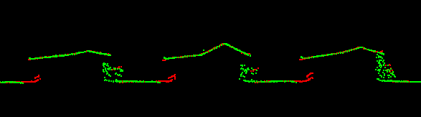
Figure 9– Horizontal Alignment. Two separate flight lines differentiated by color (Red/Green) are shown in this profile. There is no visible offset between these two flight lines. No horizontal alignment issues were identified.

Point Density and Spatial Distribution
The required Aggregate Nominal Point Spacing (ANPS) for this project is no greater than 0.71 meters, which equates to an Aggregate Nominal Point Density (ANPD) of 2 points per square meter or greater. Density calculations were performed using first return data only located in the geometrically usable center portion (typically ~90%) of each swath. By utilizing statistics, the project area was determined to have an ANPS of 0.53 meters or an ANPD of 3.45 points per square meter which satisfies the project requirements.

The spatial distribution of points must be uniform and free of clustering. This specification is tested by creating a grid with cell sizes equal to the design NPS*2. QTM scripting is then used to calculate the number of first return points of each swath within each grid cell. At least 90% of the cells must contain 1 LiDAR point, excluding acceptable void areas such as water or low NIR reflectivity features, i.e. some asphalt and roof composition materials. This project passes spatial distribution requirements, as shown in the image below.

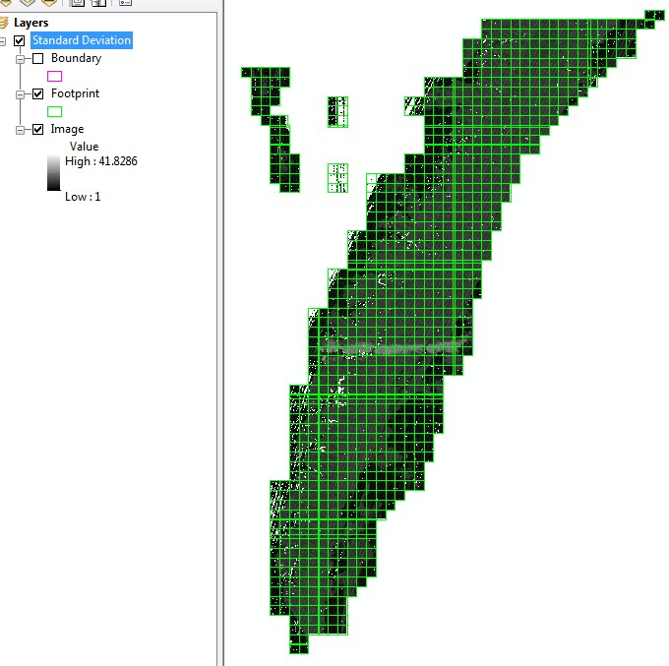

Figure 10– Spatial Distribution. The 2*NPS grid shows all tiles contain at least one LiDAR point. All no data pixels are within water bodies and are acceptable data voids.

DATA CLASSIFICATION AND EDITING
Once the calibration, absolute swath vertical accuracy, and relative accuracy of the data was confirmed, Dewberry utilized a variety of software suites for data processing. The data was processed using GeoCue and TerraScan software. The initial step is the setup of the GeoCue project, which is done by importing a project defined tile boundary index encompassing the entire project area. The acquired 3D laser point clouds, in LAS binary format, were imported into the GeoCue project and tiled according to the project tile grid. Once tiled, the laser points were classified using a proprietary routine in TerraScan. This routine classifies any obvious low outliers in the dataset to class 7 and high outliers in the dataset to class 18. Points along flight line edges that are geometrically unusable are identified as withheld and classified to a separate class so that they will not be used in the initial ground algorithm. After points that could negatively affect the ground are removed from class 1, the ground layer is extracted from this remaining point cloud. The ground extraction process encompassed in this routine takes place by building an iterative surface model.

This surface model is generated using three main parameters: building size, iteration angle and iteration distance. The initial model is based on low points being selected by a "roaming window" with the assumption that these are the ground points. The size of this roaming window is determined by the building size parameter. The low points are triangulated and the remaining

points are evaluated and subsequently added to the model if they meet the iteration angle and distance constraints. This process is repeated until no additional points are added within iterations. A second critical parameter is the maximum terrain angle constraint, which determines the maximum terrain angle allowed within the classification model.

Each tile was then imported into Terrascan and a surface model was created to examine the ground classification. Dewberry analysts visually reviewed the ground surface model and corrected errors in the ground classification such as vegetation, buildings, and bridges that were present following the initial processing conducted by Dewberry. Dewberry analysts employ 3D visualization techniques to view the point cloud at multiple angles and in profile to ensure that non-ground points are removed from the ground classification. Bridge decks are classified to class 17 using bridge breaklines compiled by Dewberry. After the ground classification corrections were completed, the dataset was processed through a water classification routine that utilizes breaklines compiled by Dewberry to automatically classify hydro features. The water classification routine selects ground points within the breakline polygons and automatically classifies them as class 9, water. During this water classification routine, points that are within 1x NPS or less of the hydrographic features are moved to class 10, an ignored ground due to breakline proximity. Overage points are then identified in Terrascan and GeoCue is used to set the overlap bit for the overage points and the withheld bit is set on the withheld points previously identified in Terrascan before the ground classification routine was performed.

The LiDAR tiles were classified to the following classification schema:
  - Class 1 = Unclassified, used for all other features that do not fit into the Classes 2, 7, 9, 10, 17, or 18, including vegetation, buildings, etc.
  - Class 2 = Bare-Earth Ground (bare earth points identified as Model Key Points are flagged with the Model Key Point bit)
  - Class 7 = Low Noise
  - Class 9 = Water, points located within collected breaklines
  - Class 10 = Ignored Ground due to breakline proximity
  - Class 17 = Bridge Decks
  - Class 18 = High Noise

After manual classification, the LAS tiles were peer reviewed and then underwent a final QA/QC. After the final QA/QC and corrections, the LAS files were then converted from LAS v1.2 to LAS v1.4 using GeoCue software. At this time, all headers, appropriate point data records, and variable length records, including spatial reference information, are updated in GeoCue software and then verified using proprietary Dewberry tools.

LiDAR Qualitative Assessment
Dewberry’s qualitative assessment utilizes a combination of statistical analysis and interpretative methodology or visualization to assess the quality of the data for a bare-earth digital terrain model (DTM). This includes creating pseudo image products such as LiDAR orthos produced from the intensity returns, Triangular Irregular Network (TIN)’s, Digital Elevation Models (DEM) and 3- dimensional models as well as reviewing the actual point cloud data. This process looks for

anomalies in the data, areas where man-made structures or vegetation points may not have been classified properly to produce a bare-earth model, and other classification errors. This report will present representative examples where the LiDAR and post processing had issues as well as examples of where the LiDAR performed well.
VISUAL REVIEW
The following sections describe common types of issues identified in LiDAR data and the results of the visual review for Eastern Shore VA LiDAR project.

Data Voids
The LAS files are used to produce density grids using the commercial software package QT Modeler (QTM) which creates a 3-dimensional data model derived from Class 2 (ground) points in the LAS files. Grid spacing is based on the project density deliverable requirement for un- obscured areas. Acceptable voids (areas with no LiDAR returns in the LAS files) that are present in the majority of LiDAR projects include voids caused by bodies of water. No unacceptable voids are present in the Eastern Shore Virginia LiDAR project.

Bridge Removal Artifacts
The DEM surface models are created from TINs or Terrains. TIN and Terrain models create continuous surfaces from the inputs. Because a continuous surface is being created, the TIN or Terrain will use interpolation to continue the surface beneath the bridge where no LiDAR data was acquired. Locations where bridges were removed will generally contain less detail in the bare-earth surface because these areas are interpolated.

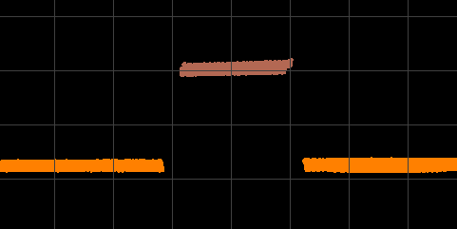

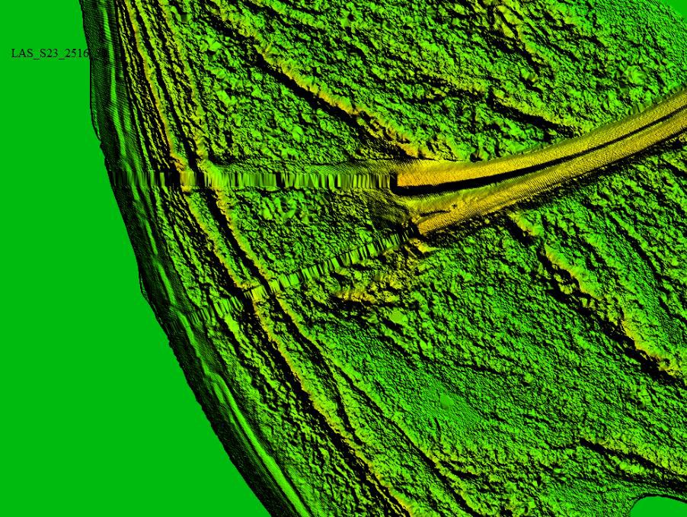

Figure 11 – Tile number DEM_S23_2516_30. The DEM in the bottom view shows an area where a bridge has been removed from ground. The surface model must make a continuous model and in order to do so, points are connected through interpolation. This results in less detail where the surface must be interpolated. The profile in the top view shows the LiDAR points of this particular feature colored by class. All bridge points have been removed from ground (orange) and are bridge deck (brown).

Culverts
Bridges have been removed from the bare earth surface while culverts remain in the bare earth surface. In instances where it is difficult to determine if the feature is a culvert or bridge, such as with some small bridges, Dewberry erred on assuming they would be culverts especially if they are on secondary or tertiary roads. Below is an example of a culvert that has been left in the ground surface.

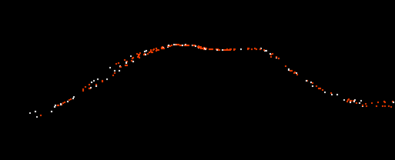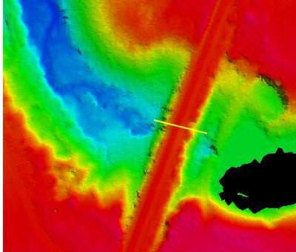
Figure 12– Tile number DEM_S23_2426_20. Profile with points colored by class (class 1=white, class 2=orange, model key point=red) is shown in the top view and the DEM is shown in the bottom view. This culvert remains in the bare earth surface. Bridges have been removed from the bare earth surface and classified to class 17.

Dirt Mounds
Irregularities in the natural ground exist and may be misinterpreted as artifacts that should be removed. Hills and dirt mounds are present throughout the project area. These features are correctly included in the ground.

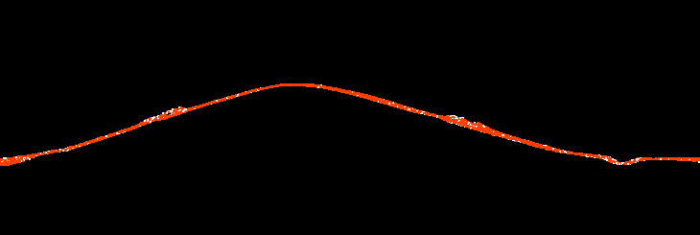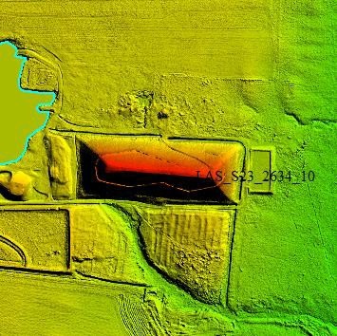

Figure 13 - Tile LAS_S23_2634_10. Profile with the points colored by class (unclassified points are white, ground points are orange) is shown in the top view and a DEM of the surface is shown in the bottom view. These features are correctly included in the ground classification.

Elevation Changes within Tidal Water Bodies
While water bodies are flattened in the final DEMs, tidal areas can have changes in elevation due to tidal fluctuations. Dewberry has reviewed the DEMs to ensure that these changes in elevation due to tidal fluctuations are shown from bank to bank. These changes are often shown as steps to reduce the presence of artifacts. An example is shown below.

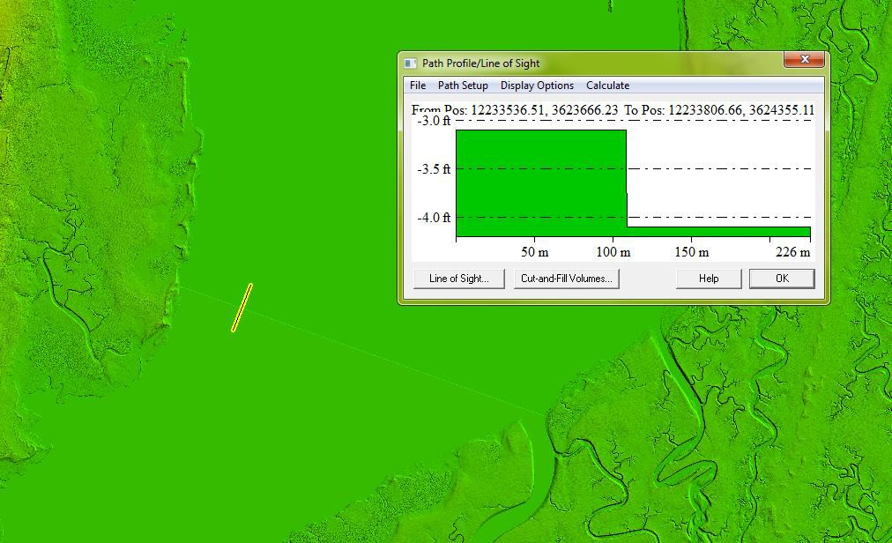
Figure 14 – Tiles DEM_S23_2632_10 and DEM_S23_2632_40. Elevation change in a tidal water body due to tidal fluctuations has been stair stepped. The steps are flat from bank to bank.

Flightline Ridges
Ridges occur when there is a difference between the elevations of adjoining flight lines or swaths. Some flightline ridges are visible in the final DEMs but they do not exceed the project specifications and the overall relative accuracy requirements for the project area have been met. An example of a visible ridge that is within tolerance is shown below.

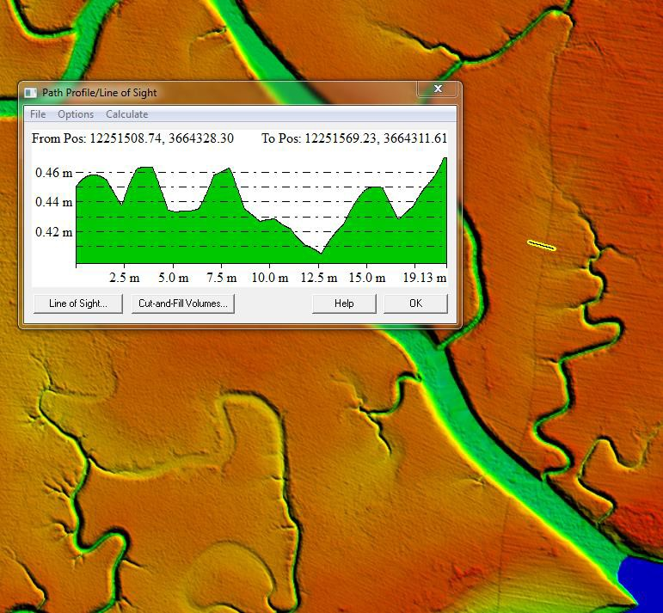
Figure 15– Tile number DEM_S23_2656_10. The flight line ridge is less than 8 cm. Overall, the Eastern Shore Virginia LiDAR data meets the project specifications for 8 cm RMSDz relative accuracy requirement.

Temporal Changes
Because the Eastern Shore Virginia LiDAR project includes data from the Sandy Topobathy project, there are some temporal differences between the areas collected at different times. The majority of temporal differences are found along water or hydrographic features, but some changes were noted on terrestrial features as well. The most common temporal changes observed were along hydrographic features, most notably along the eastern coastal side that included the Sandy data. In that area, adjoining flight lines were from different collection time windows and individual flight lines may have been flown at different tide stages.

The temporal differences between the Sandy data and the data collected by LEG also appear in many water bodies that were too small for the Eastern Shore hydro flattening requirements. . In these small water features, Sandy topobathy data that was classified as bathy bottom was reclassified to ground in order to match this project’s classification schema (per USGS guidance). . Sandy was collected using a green sensor which can penetrate the water surface

and reach the bottom of water bodies, where LEG used a NIR sensor which generally cannot penetrate the water surface. Overlapping bathy bottom (now ground) points from the Sandy data and points classified as ground along the water surface from LEG data give these areas a rough texture in the DEMs.

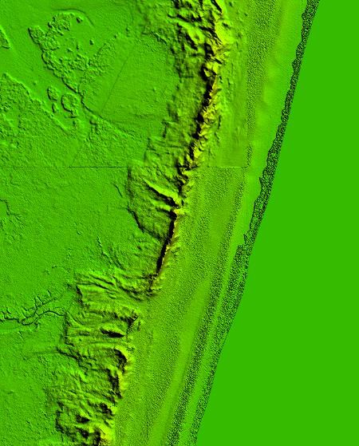
Figure 16- Tile number DEM_S23_3729_40 shows a temporal ridge due to temporal changes between the Sandy/LEG datasets and textured tidal areas due to different overlapping grounds in the Sandy/LEG datasets caused by LIDAR sensor differences.

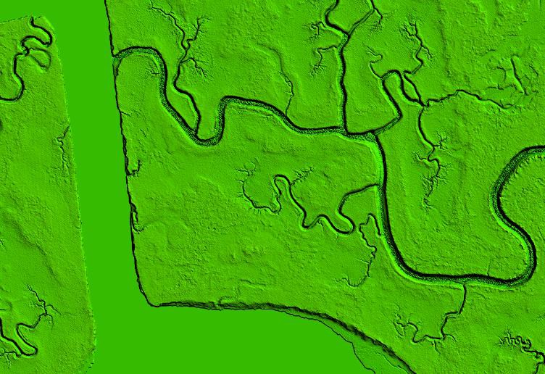
Figure 17- This image is an example from DEM_S23_3728_10 showing textured ground in a river smaller than the minimum project requirements for hydro flattening. This textured ground is caused by overlapping bathy bottom (now ground due to reclassification of Sandy data to meet the Eastern Shore classification schema) points mixed in with the LEG NIR points that are along the water surface.

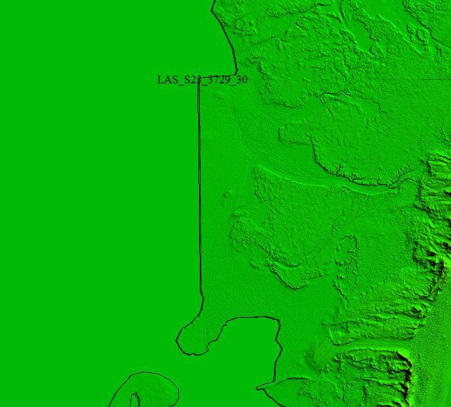

Figure 18- Tile DEM_S23_3729_30 shows a temporal difference where the Eastern Shore LEG data meets the Sandy data. The straight vertical line between the hydro flattened area and the terrestrial area is the dividing line between the Sandy topobathy data and the data collected by LEG. This area was submerged in the area collected by LEG and was not submerged in the Sandy data.

FORMATTING
After the final QA/QC is performed and all corrections have been applied to the dataset, all LiDAR files are updated to the final format requirements and the final formatting, header information, point data records, and variable length records are verified using Dewberry proprietary tools. The table below lists some of the main LiDAR header fields that are updated and verified.

Classified LiDAR Formatting
Validation | Requirement | Pass/Fail
LAS Version | 1.4 | Pass

Point Data Format | Format 6 | Pass
Coordinate Reference System | NAD83 (2011) State Plane Virginia South, US Survey feet and NAVD88 (Geoid 12A), US Survey feet | Pass
Global Encoder Bit | Should be set to 17 for Adjusted GPS Time | Pass
Time Stamp | Adjusted GPS Time (unique timestamps) | Pass
System ID | Should be set to the processing system/software and is set to NIIRS10 for GeoCue software | Pass
Multiple Returns | The sensor shall be able to collect multiple returns per pulse and the return numbers are recorded | Pass
Intensity | 16 bit intensity values are recorded for each pulse | Pass
Classification | Required Classes include: Class 1: Unclassified  Class 2: Ground (includes model key point bit) Class 7: Low Noise  Class 9: Water  Class 10: Ignored Ground Class 17: Bridge Decks Class 18: High Noise | Pass
Overlap and Withheld Points | Overlap (Overage) and Withheld points are set to the Overlap and Withheld bits | Pass
Scan Angle | Recorded for each pulse | Pass
XYZ Coordinates | Unique Easting, Northing, and Elevation coordinates are recorded for each pulse | Pass

LiDAR Positional Accuracy
BACKGROUND
Dewberry quantitatively tested the dataset by testing the vertical accuracy of the LiDAR. The vertical accuracy is tested by comparing the discreet measurement of the survey checkpoints to that of the interpolated value within the three closest LiDAR points that constitute the vertices of a three-dimensional triangular face of the TIN. Therefore, the end result is that only a small sample of the LiDAR data is actually tested. However there is an increased level of confidence with LiDAR data due to the relative accuracy. This relative accuracy in turn is based on how well one LiDAR point "fits" in comparison to the next contiguous LiDAR measurement, and is verified as

part of the initial processing. If the relative accuracy of a dataset is within specifications and the dataset passes vertical accuracy requirements at the location of survey checkpoints, the vertical accuracy results can be applied to the whole dataset with high confidence due to the passing relative accuracy.

Dewberry also tests the horizontal accuracy of LiDAR datasets when checkpoints are photo- identifiable in the intensity imagery. Photo-identifiable checkpoints in intensity imagery typically include checkpoints located at the ends of paint stripes on concrete or asphalt surfaces or checkpoints located at 90 degree corners of different reflectivity, e.g. a sidewalk corner adjoining a grass surface. The XY coordinates of checkpoints, as defined in the intensity imagery, are compared to surveyed XY coordinates for each photo-identifiable checkpoint. These differences are used to compute the tested horizontal accuracy of the LiDAR. As not all projects contain photo-identifiable checkpoints, the horizontal accuracy of the LiDAR cannot always be tested.
SURVEY VERTICAL ACCURACY CHECKPOINTS
For the vertical accuracy assessment, one hundred thirteen (113) check points were surveyed for the project and are located within bare earth/open terrain, grass/weeds/crops, brush/low trees, and forested/fully grown land cover categories. Please see appendix A to view the survey report which details and validates how the survey was completed for this project.

Checkpoints were evenly distributed throughout the project area so as to cover as many flight lines as possible using the “dispersed method” of placement.

All checkpoints surveyed for vertical accuracy testing purposes are listed in the following table.

oid 12A)
Point ID | NAD83(2011) State Plane VA South NAVD88 (Ge
 | Easting X (ft) | Northing Y (ft) Elevation (ft)
NVA-1 | 12196414.01 | 3884364.651 1.339
NVA-2 | 12207349.4 | 3834754.755 3.4
NVA-10 | 12307410.12 | 3856666.261 1.986
NVA-12 | 12336260.66 | 3830310.758 15.68 | 3
NVA-14 | 12277689.67 | 3814839.19 3.29
NVA-15 | 12311495.71 | 3817405.053 41.106
NVA-16 | 12320051.31 | 3795915.182 4.25
NVA-17 | 12302530.6 | 3809832.272 38.89 | 8
NVA-18 | 12277752.73 | 3794462.14 13.76 | 7
NVA-19 | 12268180.43 | 3799251.427 4.438
NVA-21 | 12306616.78 | 3786617.331 18.90 | 5
NVA-22 | 12304276.41 | 3770432.922 8.151
NVA-24 | 12265368.17 | 3782487.624 9.538
NVA-26 | 12242395.7 | 3770064.715 3.58
NVA-29 | 12280088.9 | 3742835.676 8.541
NVA-30 | 12266728.44 | 3742757.88 32.97 | 7
NVA-31 | 12246774.66 | 3747788.886 22.63 | 9
NVA-32 | 12229848.1 | 3739447.722 2.877
NVA-34 | 12258548.61 | 3715952.41 28.94 | 3
NVA-36 | 12230736.5 | 3730286.178 4.388

NVA-37 | 12243200.41 | 3723008.043 | 23.504
NVA-41 | 12228145.56 | 3712527.147 | 18.859
NVA-44 | 12241632.84 | 3676363.976 | 28.837
NVA-45 | 12216293.66 | 3688645.459 | 10.567
NVA-46 | 12221336.04 | 3678925.913 | 17.969
NVA-49 | 12224380.96 | 3659206.754 | 28.065
NVA-53 | 12210752.83 | 3615608.025 | 7.971
NVA-55 | 12216133.33 | 3603594.973 | 34.74
NVA-56 | 12223934.22 | 3601143.623 | 26.158
NVA-60 | 12281896.39 | 3870410.577 | 5.572
NVA-3 | 12334426.97 | 3906508.754 | 20.499
NVA-4 | 12369437.32 | 3906210.864 | 31.448
NVA-5 | 12373394.91 | 3878728.478 | 4.061
NVA-6 | 12353618.26 | 3876879.63 | 32.149
NVA-7 | 12314423.94 | 3882489.387 | 6.346
NVA-8 | 12345098.85 | 3862707.771 | 32.21
NVA-9 | 12346680.11 | 3852015.627 | 16.79
NVA-11 | 12331979.08 | 3853514.729 | 46.074
NVA-13 | 12315462.53 | 3841739.518 | 22.503
NVA-20 | 12290033.72 | 3791572.158 | 42.809
NVA-23 | 12283996.66 | 3777497.908 | 49.834
NVA-25 | 12255263.66 | 3774938.485 | 5.846
NVA-27 | 12275043.71 | 3759251.252 | 41.386
NVA-28 | 12296139.1 | 3754969.311 | 7.603
NVA-33 | 12258997.98 | 3728527.241 | 36.707
NVA-35 | 12243354.19 | 3734016.408 | 3.685
NVA-38 | 12247956.65 | 3707433.084 | 34.406
NVA-39 | 12250334.48 | 3698943.637 | 31.473
NVA-40 | 12238260.51 | 3703313.748 | 20.839
NVA-42 | 12228154.32 | 3697406.637 | 17.692
NVA-43 | 12240646.92 | 3689370.087 | 38.612
NVA-47 | 12231449.38 | 3659656.001 | 33.422
NVA-48 | 12208510.7 | 3652516.165 | 7.497
NVA-50 | 12223921.46 | 3645687.163 | 37.852
NVA-51 | 12221305.89 | 3638302.328 | 34.492
NVA-52 | 12205446.95 | 3629616.668 | 6.562
NVA-54 | 12226073.01 | 3628990.534 | 32.537
NVA-57 | 12214970.71 | 3594092.821 | 8.201
NVA-58 | 12226011.25 | 3580164.399 | 4.476
NVA-59 | 12220288.01 | 3567530.256 | 11.877
VVA-1 | 12210869.02 | 3837260.505 | 4.135
VVA-2 | 12236321.16 | 3824165.676 | 3.116
VVA-3 | 12233408.01 | 3859989.622 | 1.099
VVA-4 | 12338668.43 | 3894495.05 | 20.771
VVA-7 | 12377291.99 | 3879672.008 | 0.6
VVA-9 | 12312473.53 | 3903657.646 | 2.338
VVA-14 | 12297561.5 | 3843886.826 | 3.343
VVA-18 | 12305072.33 | 3830869.906 | 10.257
VVA-22 | 12321485.89 | 3808493.47 | 16.842
VVA-23 | 12291371.66 | 3803110.679 | 28.619
VVA-25 | 12269736.36 | 3805351.042 | 2.027
VVA-28 | 12292884.15 | 3782116.367 | 39.068
VVA-31 | 12241977.85 | 3766097.419 | 1.751

VVA-32 | 12274513.98 | 3770795.67 | 44.902
VVA-37 | 12236722.14 | 3740061.662 | 9.355
VVA-39 | 12259551.45 | 3719746.021 | 35.052
VVA-42 | 12222679.06 | 3708229.622 | 13.831
VVA-45 | 12220150.12 | 3669478.605 | 14.623
VVA-47 | 12218067.08 | 3633610.889 | 19.259
VVA-49 | 12221502.61 | 3593117.253 | 29.833
VVA-50 | 12220156.54 | 3567729.962 | 8.009
VVA-5 | 12322375.94 | 3880672.953 | 12.56
VVA-8 | 12358846.02 | 3900342.753 | 34.53
VVA-11 | 12318748.36 | 3870457.619 | 8.074
VVA-12 | 12335835.7 | 3866204.032 | 38.718
VVA-13 | 12313785.22 | 3856334.676 | 2.943
VVA-15 | 12343159.59 | 3854836.177 | 36.85
VVA-16 | 12327955.78 | 3830528.774 | 38.172
VVA-17 | 12319036.17 | 3842443.411 | 34.005
VVA-19 | 12288047.43 | 3818747.39 | 4.534
VVA-20 | 12303792.13 | 3820309.494 | 33.22
VVA-29 | 12266605.35 | 3791388.973 | 7.142
VVA-34 | 12280632.57 | 3753003.122 | 14.68
VVA-35 | 12262785.3 | 3755704.689 | 38.762
VVA-40 | 12247952.03 | 3729283.816 | 27.815
VVA-43 | 12250914.5 | 3700751.503 | 29.751
VVA-46 | 12226217.62 | 3651851.475 | 36.3
VVA-6 | 12301163.36 | 3873369.638 | 3.217
VVA-10 | 12284958.32 | 3874257.928 | 2.035
VVA-21 | 12319528.03 | 3819093.11 | 39.17
VVA-24 | 12274428.18 | 3812682.652 | 1.626
VVA-26 | 12315572.41 | 3791983.98 | 13.646
VVA-27 | 12304941.06 | 3774212.276 | 6.103
VVA-30 | 12257694.47 | 3784904.872 | 4.161
VVA-33 | 12294155.26 | 3758794.49 | 7.203
VVA-36 | 12239523.07 | 3749853.325 | 6.545
VVA-38 | 12273452.75 | 3731273.35 | 4.065
VVA-41 | 12226095.56 | 3721904.738 | 14.083
VVA-44 | 12231685.78 | 3692139.913 | 18.025
VVA-48 | 12225556.14 | 3616330.009 | 31.776
BLT34 | 12219946.44 | 3567822.742 | 3.471
TWC34 | 12220365.83 | 3567544.088 | 4.321
OT34 | 12220092.62 | 3567671.947 | 5.515
Table 6: Eastern Shore VA LiDAR surveyed accuracy checkpoints

The figure below shows the location of the QA/QC checkpoints used to test the positional accuracy of the dataset.
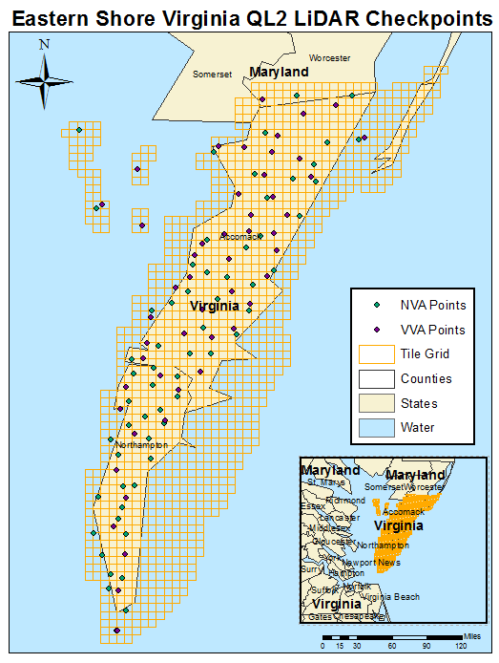

Figure 19 – Location of QA/QC Checkpoints

VERTICAL ACCURACY TEST PROCEDURES
NVA (Non-vegetated Vertical Accuracy) is determined with check points located only in non- vegetated terrain, including open terrain (grass, dirt, sand, and/or rocks) and urban areas, where

there is a very high probability that the LiDAR sensor will have detected the bare-earth ground surface and where random errors are expected to follow a normal error distribution. The NVA determines how well the calibrated LiDAR sensor performed. With a normal error distribution, the vertical accuracy at the 95% confidence level is computed as the vertical root mean square error (RMSEz) of the checkpoints x 1.9600. For the Eastern Shore LiDAR project, vertical accuracy must be 0.64 ft (19.6 cm) or less based on an RMSEz of 0.33 ft (10 cm) x 1.9600.

VVA (Vegetated Vertical Accuracy) is determined with all checkpoints in vegetated land cover categories, including tall grass, weeds, crops, brush and low trees, and fully forested areas, where there is a possibility that the LiDAR sensor and post-processing may yield elevation errors that do not follow a normal error distribution. VVA at the 95% confidence level equals the 95th percentile error for all checkpoints in all vegetated land cover categories combined. The Eastern Shore VA LiDAR Project VVA standard is 0.96 ft (29.4 cm) based on the 95th percentile. The VVA is accompanied by a listing of the 5% outliers that are larger than the 95th percentile used to compute the VVA; these are always the largest outliers that may depart from a normal error distribution. Here, Accuracyz differs from VVA because Accuracyz assumes elevation errors follow a normal error distribution where RMSE procedures are valid, whereas VVA assumes LiDAR errors may not follow a normal error distribution in vegetated categories, making the RMSE process invalid.

The relevant testing criteria are summarized in Table 7.

Quantitative Criteria | Measure of Acceptability
Non-Vegetated Vertical Accuracy (NVA) in open terrain and urban land cover categories using RMSEz *1.9600 | 0.64 ft (based on RMSEz (0.33 ft cm) * 1.9600)
Vegetated Vertical Accuracy (VVA) in all vegetated land cover categories combined at the 95% confidence level | 0.96 ft (based on combined 95th percentile)

Table 7 ― Acceptance Criteria
The primary QA/QC vertical accuracy testing steps used by Dewberry are summarized as follows:

- Dewberry’s team surveyed QA/QC vertical checkpoints in accordance with the project’s specifications.
- Next, Dewberry interpolated the bare-earth LiDAR DTM to provide the z-value for every checkpoint.
- Dewberry then computed the associated z-value differences between the interpolated z-value from the LiDAR data and the ground truth survey checkpoints and computed NVA, VVA, and other statistics.
- The data were analyzed by Dewberry to assess the accuracy of the data. The review process examined the various accuracy parameters as defined by the scope of work. The overall descriptive statistics of each dataset were computed to assess any trends or anomalies. This report provides tables, graphs and figures to summarize and illustrate data quality.

VERTICAL ACCURACY RESULTS
The table below summarizes the tested vertical accuracy resulting from a comparison of the surveyed checkpoints to the elevation values present within the fully classified LiDAR LAS files.

 | 61.00 0.41
NVA
VVA | 52.00 |  | 0.58

Table 8 ― Tested NVA and VVA
Land Cover  Category # of Points | NVA ― Non- vegetated Vertical Accuracy (RMSEz x 1.9600) Spec=0.64  ft | VVA ― Vegetated Vertical Accuracy (95th Percentile) Spec=0.96 ft

This LiDAR dataset was tested to meet ASPRS Positional Accuracy Standards for Digital Geospatial Data (2014) for a 0.33 ft (10 cm) RMSEz Vertical Accuracy Class. Actual NVA accuracy was found to be RMSEz =0.21 ft (6. 40 cm), equating to +/- 0.41 ft (12.5 cm) at 95% confidence level. Actual VVA accuracy was found to be +/- 0.58 ft (17.7 cm) at the 95th percentile.
The figure below illustrates the magnitude of the differences between the QA/QC checkpoints and LiDAR data. This shows that the majority of LiDAR elevations were within +/- 0.20 ft of the checkpoints elevations, but there were some outliers where LiDAR and checkpoint elevations differed by up to +88 cm.

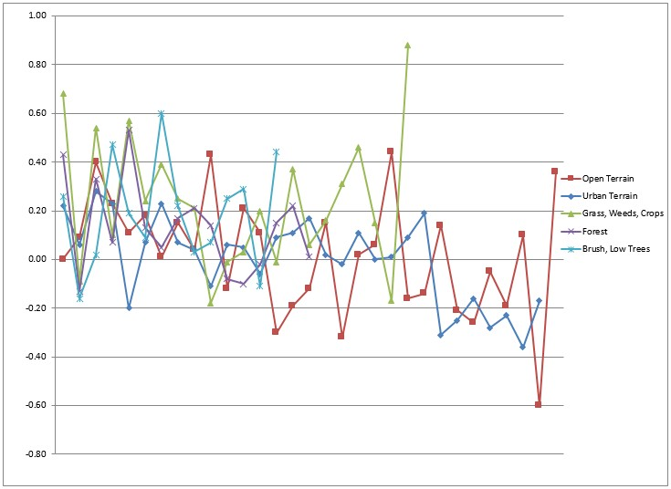
Figure 20 – Magnitude of elevation discrepancies per land cover category

Table 9 lists the 5% outliers that are larger than the VVA 95th percentile.

bsDeltaZ
Point ID | NAD83 (2011) VA State Plane South |  |  | DeltaZ A
 | Easting X (ft) | Northing Y (ft) | Z-Survey (ft) Z-LiDAR (f | t)
VVA-1 | 12210869.02 | 3837260.51 | 4.14 4.82 | 0.69 |  |  | 0.69
VVA-30 | 12257694.47 | 3784904.87 | 4.16 4.76 | 0.60 |  |  | 0.60
TWC34 | 12220365.83 | 3567544.09 | 4.32 5.20 | 0.88 |  |  | 0.88

Table 9 ― 5% Outliers
Table 10 provides overall descriptive statistics.

Skew Std Dev
(ft)
Kurtosis Min (ft)
Max
(ft)

-0.27 0.24 0.23 -0.60 0.44
 |  | RMSEz (ft)
100 % of | # of | NVA | Mean | Median
Totals | Points | Spec=0.33 | (ft) | (ft)
 |  | ft
Open Terrain | 31 | 0.24 | 0.02 | 0.04

Urban | 30 | 0.17 | 0.00 | 0.04 | -0.45 | 0.18 | -0.70 | -0.36 | 0.28
NVA | 61 | 0.21 | 0.01 | 0.04 | -0.28 | 0.21 | 0.19 | -0.60 | 0.44
Tall Weeds and Crops | 22 | N/A | 0.23 | 0.21 | 0.58 | 0.27 | 0.04 | -0.18 | 0.88
Brush Lands and
Trees 14 N/A 0.19 0.21 0.23 0.22 -0.43 -0.16 0.60

Forested and Fully Grown | 16 | N/A | 0.13 | 0.13 | 0.62 | 0.19 | 0.06 | -0.13 | 0.53
VVA | 52 | N/A | 0.19 | 0.17 | 0.66 | 0.24 | 0.28 | -0.18 | 0.88

Table 10 ― Overall Descriptive Statistics

The figure below illustrates a histogram of the associated elevation discrepancies between the QA/QC checkpoints and elevations interpolated from the LiDAR triangulated irregular network (TIN). The frequency shows the number of discrepancies within each band of elevation differences. Although the discrepancies vary between a low of -0.60 feet and a high of +0.88 feet, the histogram shows that the majority of the discrepancies are skewed on the positive side. The vast majority of points are within the ranges of -0.25 feet to +0.25 feet.

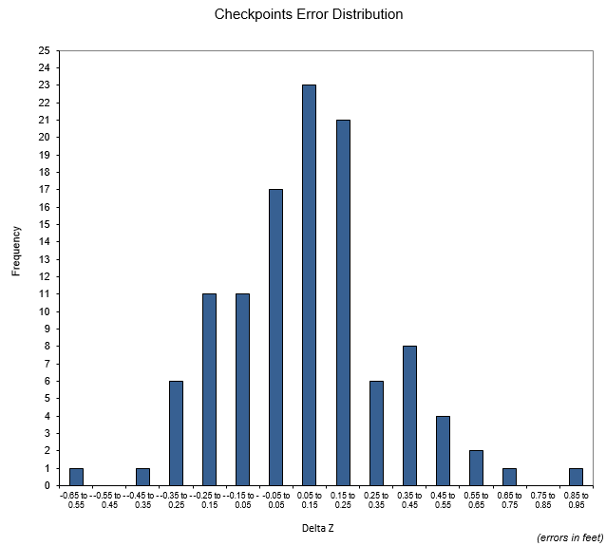
Figure 21 ― Histogram of Elevation Discrepancies with errors in feet
Based on the vertical accuracy testing conducted by Dewberry, the LiDAR dataset for the Eastern Shore VA LiDAR Project satisfies the project’s pre-defined vertical accuracy criteria.
HORIZONTAL ACCURACY TEST PROCEDURES
Horizontal accuracy testing requires well-defined checkpoints that can be identified in the dataset. Elevation datasets, including LiDAR datasets, do not always contain well-defined checkpoints suitable for horizontal accuracy assessment. However, the ASPRS Positional Accuracy Standards for Digital Geospatial Data (2014) recommends at least half of the NVA vertical check points should be located at the ends of paint stripes or other point features visible on the LiDAR intensity image, allowing them to double as horizontal check points.

Dewberry reviews all NVA checkpoints to determine which, if any, of these checkpoints are located on photo-identifiable features in the intensity imagery. This subset of checkpoints are then used for horizontal accuracy testing.

The primary QA/QC horizontal accuracy testing steps used by Dewberry are summarized as follows:

- Dewberry’s team surveyed QA/QC vertical checkpoints in accordance with the project’s specifications and tried to locate half of the NVA checkpoints on features photo-identifiable in the intensity imagery.
- Next, Dewberry identified the well-defined features in the intensity imagery.
- Dewberry then computed the associated xy-value differences between the coordinates of the well-defined feature in the LiDAR intensity imagery and the ground truth survey checkpoints.
- The data were analyzed by Dewberry to assess the accuracy of the data. Horizontal accuracy was assessed using NSSDA methodology where horizontal accuracy is calculated at the 95% confidence level. This report provides the results of the horizontal accuracy testing.
HORIZONTAL ACCURACY RESULTS
Seventeen checkpoints were determined to be photo-identifiable in the intensity imagery and were used to test the horizontal accuracy of the LiDAR dataset. As only seventeen (17) checkpoints were photo-identifiable, the results are not statistically significant enough to report as a final tested value, but the results of the testing are still shown in the table below.

Using NSSDA methodology (endorsed by the ASPRS Positional Accuracy Standards for Digital Geospatial Data (2014)), horizontal accuracy at the 95% confidence level (called ACCURACYr) is computed by the formula RMSEr * 1.7308 or RMSExy * 2.448.

No horizontal accuracy requirements or thresholds were provided for this project. However, LiDAR datasets are generally calibrated by methods designed to ensure a horizontal accuracy of 1 meter or less.

# of Points | RMSEx (Spec=1.34 ft) | RMSEy  (Spec=1.34 ft) | RMSEr  (Spec=1.9 ft) | ACCURACYr (RMSEr x 1.7308)  Spec=3.28 ft
17 | 0.83 | 0.91 | 1.23 | 2.13
Table 11-Tested horizontal accuracy at the 95% confidence level

Actual positional accuracy of this dataset was found to be RMSEx = 0.83 ft (25.3 cm) and RMSEy = 0.91 ft (27.7 cm) which equates to +/- 2.13 ft (64.9 cm) at 95% confidence level.

Breakline Production & Qualitative Assessment Report
BREAKLINE PRODUCTION METHODOLOGY
Dewberry used GeoCue software to develop LiDAR stereo models of the Eastern Shore VA LiDAR Project area so the LiDAR derived data could be viewed in 3-D stereo using Socet Set softcopy

photogrammetric software. Using LiDARgrammetry procedures with LiDAR intensity imagery, Dewberry used the stereo models developed by Dewberry to stereo-compile the two types of hard breaklines in accordance with the project’s Data Dictionary.

Water bodies are reviewed in stereo and the lowest elevation is applied to the entire water body. Tidal breaklines may show tidal fluctuations but as much ground as possible is modeled in the dataset.

BREAKLINE QUALITATIVE ASSESSMENT
Dewberry completed breakline qualitative assessments according to a defined workflow. The following workflow diagram represents the steps taken by Dewberry to provide a thorough qualitative assessment of the breakline data.

Completeness and horizontal placement is verified through visual reviews against LiDAR intensity imagery. Automated checks are applied on all breakline features to validate topology, including the 3D connectivity of features, enforced monotonicity on linear hydrographic breaklines, and flatness on water bodies.

The next step is to compare the elevation of the breakline vertices against the ground elevation extracted from the ESRI Terrain built from the LiDAR ground points, keeping in mind that a discrepancy is expected because of the hydro-enforcement applied to the breaklines and because of the interpolated imagery used to acquire the breaklines. A given tolerance is used to validate if the elevations differ too much from the LiDAR.

After all corrections and edits to the breakline features, the breaklines are imported into the final GDB and verified for correct formatting.

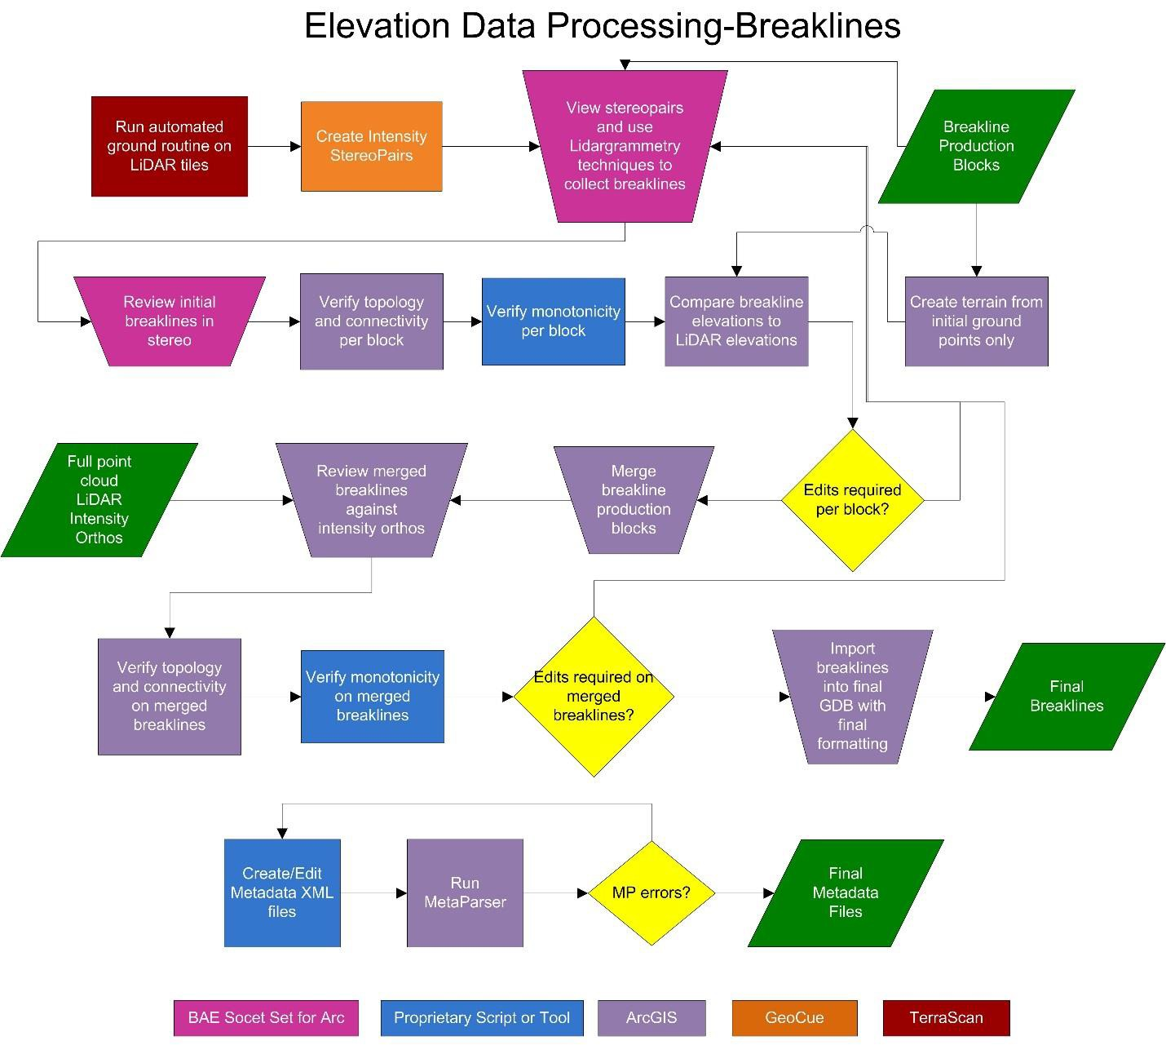

Figure 22- Breakline QA/QC workflow

BREAKLINE CHECKLIST
The following table represents a portion of the high-level steps in Dewberry’s Production and QA/QC checklist that were performed for this project.

Pass/Fail | Validation Step
Pass | Use intensity imagery, stereo pairs, and terrains to collect breaklines according to project specifications.
Pass | In areas of heavy vegetation or where the exact shoreline is hard to delineate, it is better to err on placing the breakline slightly inside or seaward of the shoreline (breakline can be inside shoreline by 1x-2x NPS).

Pass | After each producer finishes breakline collection for a block, each producer must perform a completeness check, breakline variance check, and all automated checks on their block before calling that block complete and ready for the final merge and QC
Pass | After breaklines are completed for production blocks, all production blocks should be merged together and all checks-completeness, breakline variance, and automated checks- should be performed on the final, merged GDB. Ensure correct snapping-horizontal (x,y) and vertical (z)-between all production blocks.
Pass | Check entire dataset for missing features that were not captured, but should be to meet baseline specifications or for consistency. Features should be collected consistently across tile bounds. Check that the horizontal placement of breaklines is correct. Breaklines should be compared to full point cloud intensity imagery and terrains
Pass | Breaklines are correctly edge-matched to adjoining datasets in completion, coding, and horizontal placement.
Pass | Using a terrain created from LiDAR ground (all ground including 2, 8, and 10) and water points (class 9), compare breakline Z values to interpolated LiDAR elevations.
Pass | Perform all Topology and Data Integrity Checks
Pass | Perform hydro-flattening and hydro-enforcement checks including monotonicity and flatness from bank to bank on linear hydrographic features and flatness of water bodies. Tidal waters should preserve as much ground as possible and can include variations or be non-monotonic.
Table 12-A subset of the high-level steps from Dewberry’s Production and QA/QC checklist performed for this project.

DATA DICTIONARY
The following data dictionary was used for this project.

Horizontal and Vertical Datum
The horizontal datum shall be North American Datum of 1983 (2011), Units in US Survey feet. The vertical datum shall be referenced to the North American Vertical Datum of 1988 (NAVD 88), Units in US Survey feet Geoid12a shall be used to convert ellipsoidal heights to orthometric heights.

Coordinate System and Projection
All data shall be projected to State Plane Virginia South, Horizontal Units in US Survey feet and Vertical Units in US Survey feet.

Inland Ponds and Lakes
Feature Dataset: BREAKLINES Feature Class: PONDS_AND_LAKES
Feature Type: Polygon Contains M Values: No
Contains Z Values: Yes Annotation Subclass: None
XY Resolution: Accept Default Setting Z Resolution: Accept Default Setting
XY Tolerance: 0.003 Z Tolerance: 0.001

Description
This polygon feature class will depict closed water body features that are at a constant elevation.

Table Definition
Field Name Data Type | Allow Null Values | Default Value | Domain | Precision | Scale | Length | Responsibility

OBJECTID | Object ID |  |  |  |  |  |  | Assigned by Software
SHAPE | Geometry |  |  |  |  |  |  | Assigned by Software
SHAPE_LENGTH | Double | Yes |  |  | 0 | 0 |  | Calculated by Software
SHAPE_AREA | Double | Yes |  |  | 0 | 0 |  | Calculated by Software

Feature Definition
Description | Definition | Capture Rules
Ponds and Lakes | Land/Water boundaries of constant elevation water bodies such as lakes, reservoirs, ponds, etc. Features shall be defined as closed polygons and contain an elevation value that reflects the best estimate of the water elevation at the time of data capture. Water body features will be captured for features 2 acres in size or greater.  “Donuts” will exist where there are islands within a closed water body feature. | Water bodies shall be captured as closed polygons with the water feature to the right. The compiler shall take care to ensure that the z-value remains consistent for all vertices placed on the water body.  Breaklines must be captured at or just below the elevations of the immediately surrounding terrain. Under no circumstances should a feature be elevated above the surrounding LiDAR points. Acceptable variance in the negative direction will be defined for each project individually.  An Island within a Closed Water Body Feature that is 1 acre in size or greater will also have a “donut polygon” compiled.  These instructions are only for docks or piers that follow the coastline or water’s edge, not for docks or piers that extend perpendicular from the land into the water. If it can be reasonably determined where the edge of water most probably falls, beneath the dock or pier, then the edge of water will be collected at the elevation of the water where it can be directly measured. If there is a clearly- indicated headwall or bulkhead adjacent to the dock or pier and it is evident that the waterline is most probably adjacent to the headwall or bulkhead, then the water line will follow the headwall or bulkhead at the elevation of the water where it can be directly measured. If there is no clear indication of the location of the water’s edge beneath the dock or pier, then the edge of water will follow the outer edge of the dock or pier as it is adjacent to the water, at the measured elevation of the water.

Tidal Waters
Feature Dataset: BREAKLINES Feature Class: TIDAL_WATERS
Feature Type: Polygon Contains M Values: No
Contains Z Values: Yes Annotation Subclass: None
XY Resolution: Accept Default Setting Z Resolution: Accept Default Setting
XY Tolerance: 0.003 Z Tolerance: 0.001

Description
This polygon feature class will outline the land / water interface at the time of LiDAR acquisition.

Table Definition

Field Name Data Type | Allow Null Values | Default Value | Domain | Precision | Scale | Length | Responsibility
Object ID Assigned by
OBJECTID
SHAPE | Geometry |  |  |  |  |  |  | Assigned by Software
SHAPE_LENGTH | Double | Yes |  | 0 |  | 0 |  | Calculated by Software
SHAPE_AREA | Double | Yes |  |  | 0 | 0 |  | Calculated by Software

Software

Feature Definition
Description | Definition | Capture Rules
TIDAL_WATERS | The coastal breakline will delineate the land water interface using LiDAR data as reference. In flight line boundary areas with tidal variation the coastal shoreline may show stair stepping as no feathering is allowed. Stair stepping is allowed to show as much ground as the collected data permits. | The feature shall be extracted at the apparent land/water interface, as determined by the LiDAR intensity data, to the extent of the tile boundaries. Differences caused by tidal variation are acceptable and breaklines delineated should reflect that change with no feathering.  Breaklines must be captured at or just below the elevations of the immediately surrounding terrain. Under no circumstances should a feature be elevated above the surrounding LiDAR points. Acceptable variance in the negative direction will be defined for each project individually.  If it can be reasonably determined where the edge of water most probably falls, beneath the dock or pier, then the edge of water will be collected at the elevation of the water where it can be directly measured. If there is a clearly-indicated headwall or bulkhead adjacent to the dock or pier and it is evident that the waterline is most probably adjacent to the headwall or bulkhead, then the water line will follow the headwall or bulkhead at the elevation of the water where it can be directly measured. If there is no clear indication of the location of the water’s edge beneath the dock or pier, then the edge of water will follow the outer edge of the dock or pier as it is adjacent to the water, at the measured elevation of the water.  Breaklines shall snap and merge seamlessly with linear hydrographic features.

DEM Production & Qualitative Assessment
DEM PRODUCTION METHODOLOGY
Dewberry utilized ESRI software and Global Mapper for the DEM production and QC process. ArcGIS software is used to generate the products and the QC is performed in both ArcGIS and Global Mapper. The figure below shows the entire process necessary for bare earth DEM production, starting from the LiDAR swath processing.

The final bare-earth LiDAR points are used to create a terrain. The final 3D breaklines collected for the project are also enforced in the terrain. The terrain is then converted to raster format using linear interpolation. For most projects, a single terrain/DEM can be created for the whole project. For very large projects, multiple terrains/DEMs may be created. The DEM(s) is reviewed for any issues requiring corrections, including remaining LiDAR mis-classifications, erroneous breakline elevations, poor hydro-flattening or hydro-enforcement, and processing artifacts. After corrections are applied, the DEM(s) is then split into individual tiles following the project tiling scheme. The tiles are verified for final formatting and then loaded into Global Mapper to ensure no missing or corrupt tiles and to ensure seamlessness across tile boundaries.

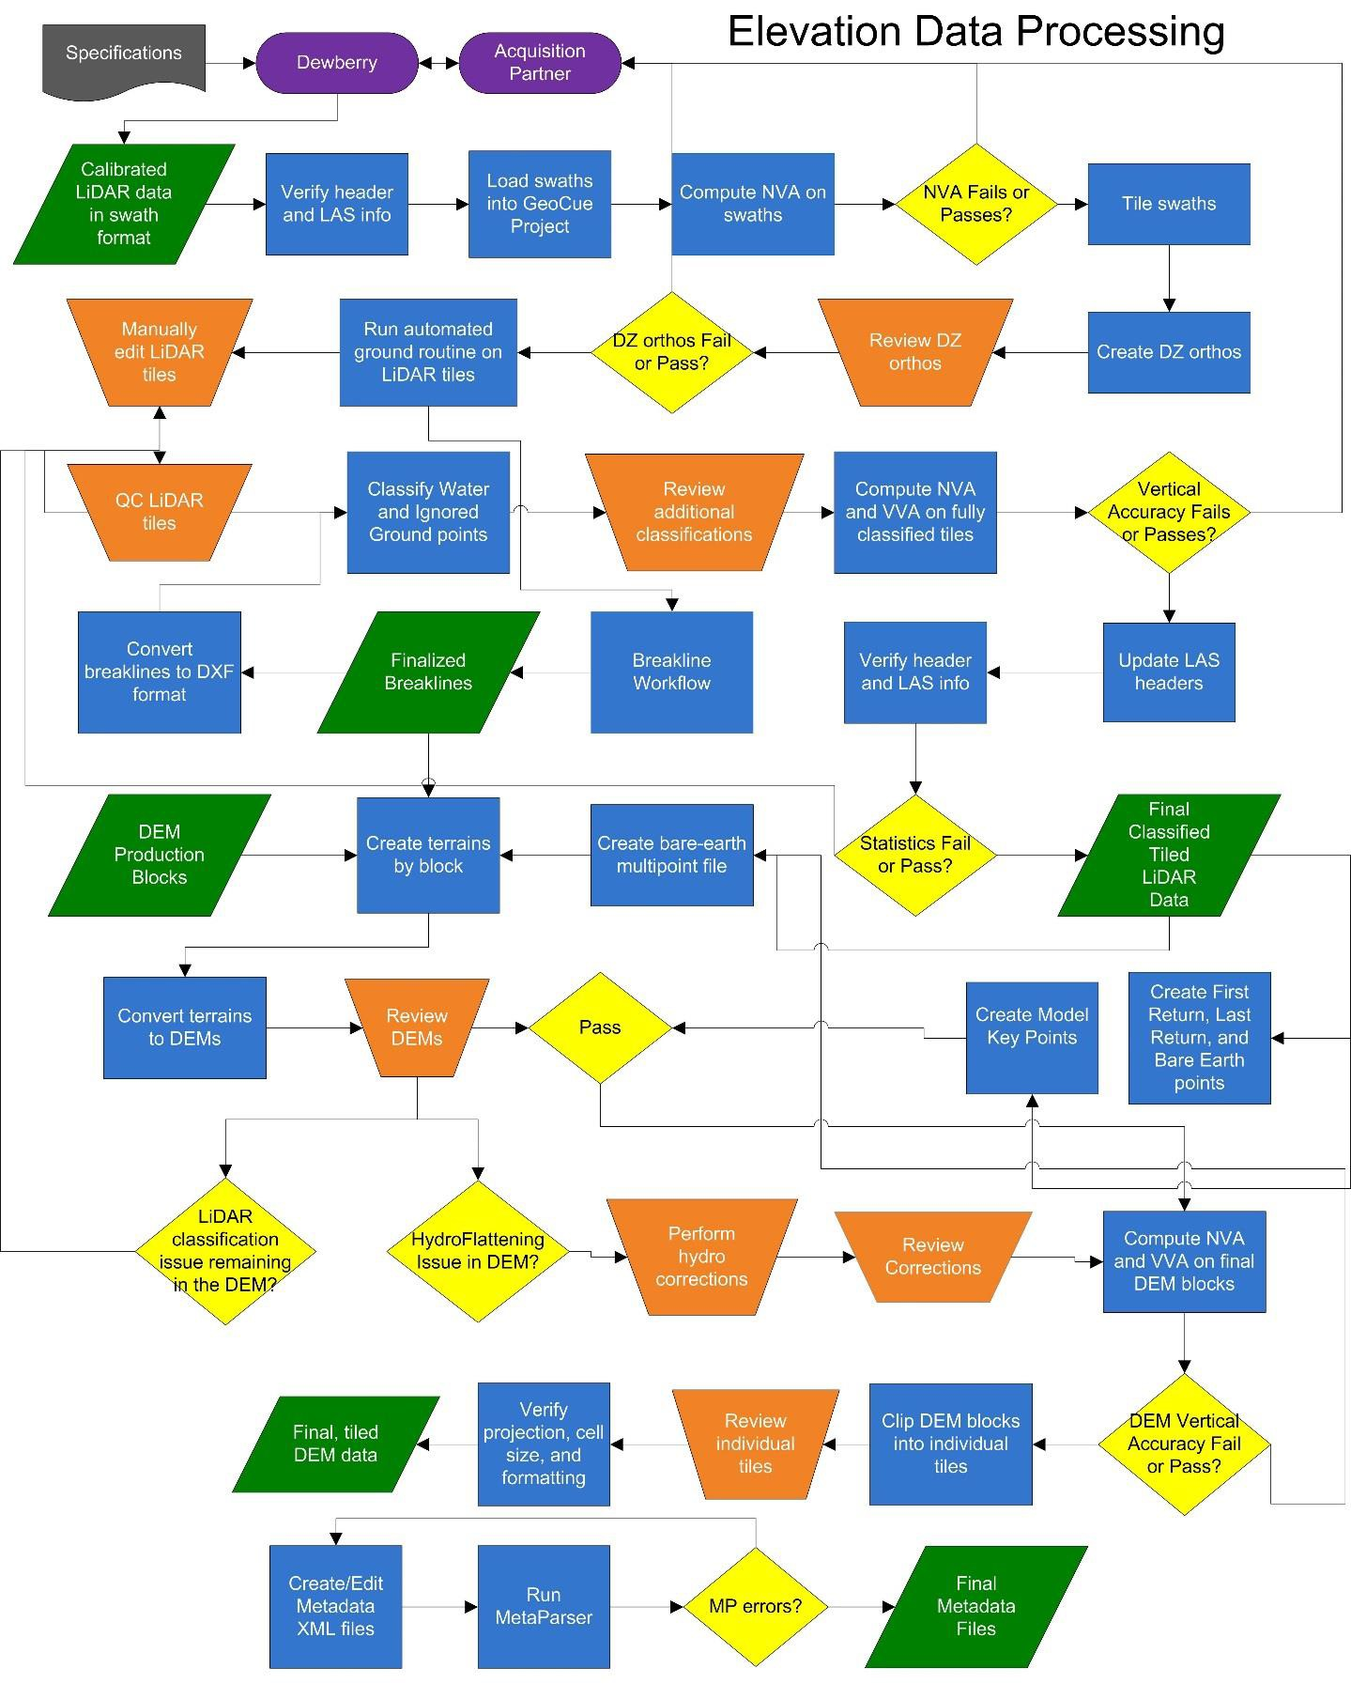

Figure 23-DEM Production Workflow

DEM QUALITATIVE ASSESSMENT
Dewberry performed a comprehensive qualitative assessment of the bare earth DEM deliverables to ensure that all tiled DEM products were delivered with the proper extents, were free of processing artifacts, and contained the proper referencing information. This process was performed in ArcGIS software with the use of a tool set Dewberry has developed to verify that the raster extents match those of the tile grid and contain the correct projection information. The DEM data was reviewed at a scale of 1:5000 to review for artifacts caused by the DEM generation process and to review the hydro-flattened features. To perform this review Dewberry creates HillShade models and overlays a partially transparent colorized elevation model to review for these issues. All corrections are completed using Dewberry’s proprietary correction workflow. Upon completion of the corrections, the DEM data is loaded into Global Mapper for its second review and to verify corrections. Once the DEMs are tiled out, the final tiles are again loaded into Global Mapper to ensure coverage, extents, and that the final tiles are seamless.

The image below show an example of a bare earth DEM.

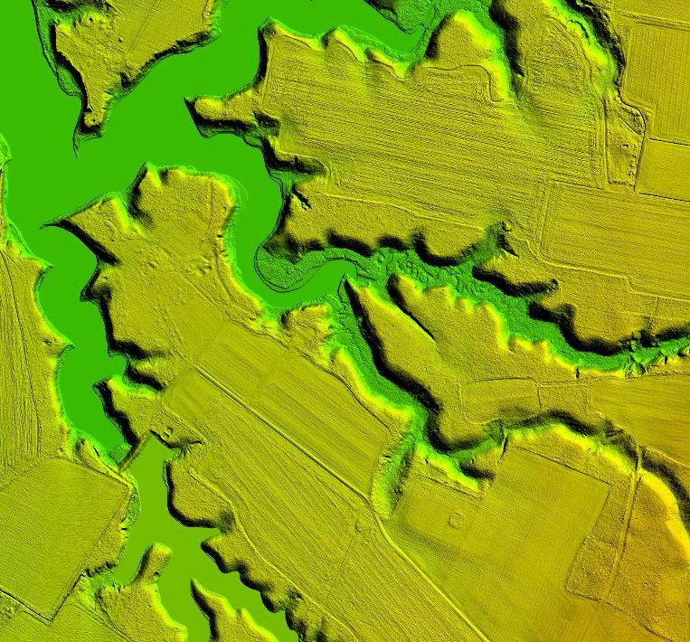
Figure 24-Tile DEM_S23_2627_40. The bare earth DEM

DEM VERTICAL ACCURACY RESULTS
The same 113 checkpoints that were used to test the vertical accuracy of the LiDAR were used to validate the vertical accuracy of the final DEM products as well. Accuracy results may vary between the source LiDAR and final DEM deliverable. DEMs are created by averaging several LiDAR points within each pixel which may result in slightly different elevation values at each survey checkpoint when compared to the source LAS, which does not average several LiDAR points together but may interpolate (linearly) between two or three points to derive an elevation value. The vertical accuracy of the DEM is tested by extracting the elevation of the pixel that contains the x/y coordinates of the checkpoint and comparing these DEM elevations to the surveyed elevations.

Table 13 summarizes the tested vertical accuracy results from a comparison of the surveyed checkpoints to the elevation values present within the final DEM dataset.
Land Cover # of Points Category | NVA ― Non- vegetated Vertical Accuracy (RMSEz x 1.9600) Spec=0.64  ft | VVA ― Vegetated Vertical Accuracy (95th Percentile) Spec=0.96 ft

 | 61.00 0.40
NVA
VVA | 52.00 |  | 0.60

Table 13 ― DEM tested NVA and VVA
This DEM dataset was tested to meet ASPRS Positional Accuracy Standards for Digital Geospatial Data (2014) for a 0.33 ft (10 cm) RMSEz Vertical Accuracy Class. Actual NVA accuracy was found to be RMSEz =0.20 ft (6.10 cm), equating to +/- 0.40 ft (12.19 cm) at 95% confidence level. Actual VVA accuracy was found to be +/- 0.60 ft (18.28 cm) at the 95th percentile.
Table 14 lists the 5% outliers that are larger than the VVA 95th percentile.
Point ID | NAD83 (2011) VA State Plane NAVD88 (Geoid 12A) South | DeltaZ AbsDeltaZ
Z-LiDAR
Easting X (ft) Northing Y (ft) Z-Survey (ft) (ft)
VVA-1 | 12210869.02 3837260.51 4.14 4.83 0.700 0.700
VVA-7 | 12377291.990 3879672.010 0.600 1.220 0.620 0.620
TWC34 | 12220365.83 3567544.09 4.32 5.19 0.870 0.870

Table 14 ― 5% Outliers
Table 15 provides overall descriptive statistics.

100 % of Totals | # of Points | RMSEz (ft) NVA  Spec=0.33 ft | Mean (ft) | Median (ft) | Skew | Std Dev (ft) | Kurtosis | Min (ft) | Max (ft)
Open Terrain | 31 | 0.23 | 0.01 | 0.03 | -0.33 | 0.23 | 0.14 | -0.58 | 0.41
Urban | 30 | 0.17 | -0.01 | 0.04 | -0.55 | 0.18 | -0.58 | -0.38 | 0.28
NVA | 61 | 0.20 | 0.00 | 0.045 | -0.35 | 0.20 | 0.06 | -0.58 | 0.41
Tall Weeds/Crops | 22 | N/A | 0.24 | 0.22 | 0.36 | 0.29 | -0.11 | -0.29 | 0.87
Brush Lands and Trees | 14 | N/A | 0.18 | 0.20 | 0.03 | 0.21 | -0.70 | -0.15 | 0.53

Forested and Fully Grown | 16 | N/A | 0.13 | 0.12 | 0.59 | 0.19 | 0.43 | -0.16 | 0.56
VVA | 52 | N/A | 0.19 | 0.18 | 0.52 | 0.24 | 0.24 | -0.29 | 0.87

Table 15 ― Overall Descriptive Statistics
Based on the vertical accuracy testing conducted by Dewberry, the DEM dataset for the Eastern Shore VA LiDAR Project satisfies the project’s pre-defined vertical accuracy criteria.
DEM CHECKLIST
The following table represents a portion of the high-level steps in Dewberry’s bare earth DEM Production and QA/QC checklist that were performed for this project.

Pass/Fai l | Validation Step
Pass | Masspoints (LAS to multipoint) are created from ground points only (class 2 and class 8 if model key points created, but no class 10 ignored ground points or class 9 water points
Pass | Create a terrain for each production block using the final bare earth LiDAR points and final breaklines.
Pass | Convert terrains to rasters using project specifications for grid type, formatting, and cell size
Pass | Create hillshades for all DEMs
Pass | Manually review bare-earth DEMs in ArcMap with hillshades to check for issues
Pass | DEMs should be hydro-flattened or hydro-enforced as required by project specifications
Pass | DEMs should be seamless across tile boundaries
Pass | Water should be flowing downhill without excessive water artifacts present
Pass | Water features should NOT be floating above surrounding
Pass | Bridges should NOT be present in bare-earth DEMs.
Pass | Any remaining bridge saddles where below bridge breaklines were not used need to be fixed by adding below bridge breaklines and re-processing.
Pass | All qualitative issues present in the DEMs as a result of LiDAR processing and editing issues must be marked for corrections in the LiDAR These DEMs will need to be recreated after the LiDAR has been corrected.
Pass | Calculate DEM Vertical Accuracy including NVA, VVA, and other statistics
Pass | Split the DEMs into tiles according to the project tiling scheme
Pass | Verify all properties of the tiled DEMs, including coordinate reference system information, cell size, cell extents, and that compression has not been applied to the tiled DEMs
Pass | Load all tiled DEMs into Global Mapper to verify complete coverage to the (buffered) project boundary and that no tiles are corrupt.
Table 16-A subset of the high-level steps from Dewberry’s bare earth DEM Production and QA/QC checklist performed for this project.

Appendix A: Survey Report
- INTRODUCTION
  - Project Summary

Dewberry Consultants LLC is under contract to the United States Geological Survey to provide 110 Check Points in the State of Virginia. Under the above referenced USGS Task Order, Dewberry is tasked to complete the quality assurance of LiDAR products. As part of this work Dewberry staff will complete Check Point surveys that will be used to evaluate vertical and horizontal accuracy. The ground survey was conducted May 11 to May 15, 2015.
Existing NGS Control Points were located and surveyed to check the accuracy of the RTK/GPS survey equipment with the results shown in Section 2.4 of this Report.
As an internal QA/QC procedure and to verify that the Check Points meet the 95% confidence level approximately 50% of the points were re-observed and are shown in Section 5 of this report.
Final horizontal coordinates are referenced to UTM Zone 18, NAD83 in feet. Final Vertical elevations are referenced to NAVD88 in feet using Geoid model 2012A (Geoid12A).

Points of Contact

Questions regarding the technical aspects of this report should be addressed to:

Dewberry Consultants LLC
Gary D. Simpson, L.S. Senior Associate
10003 Derekwood Lane
Suite 204
Lanham, Maryland 20706
(301) 364-1855 direct (301) 731-0188 fax

Project Area

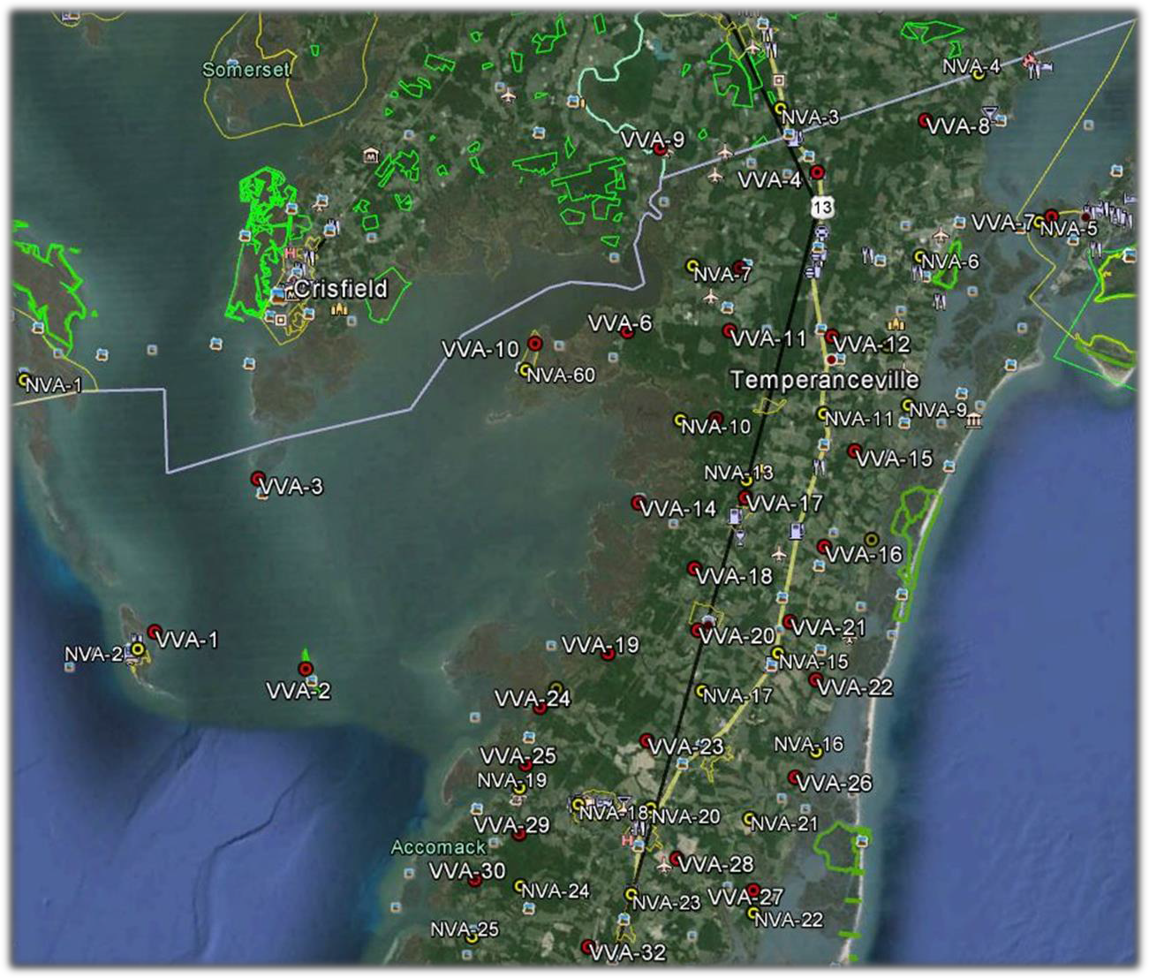

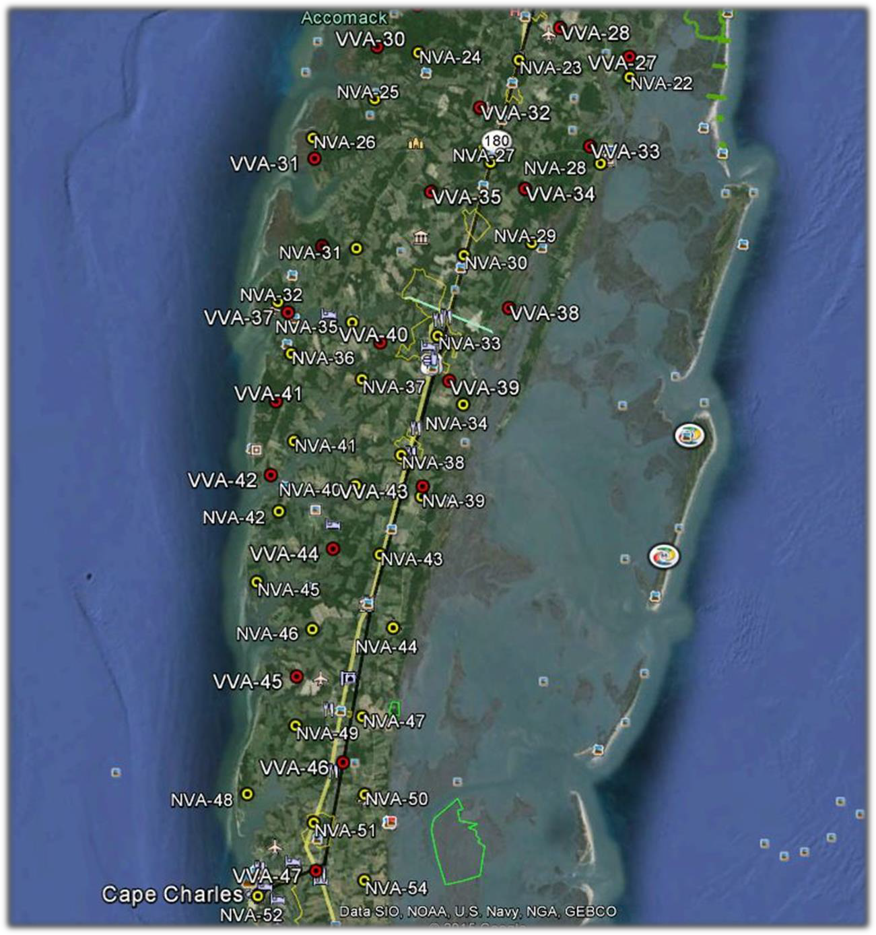

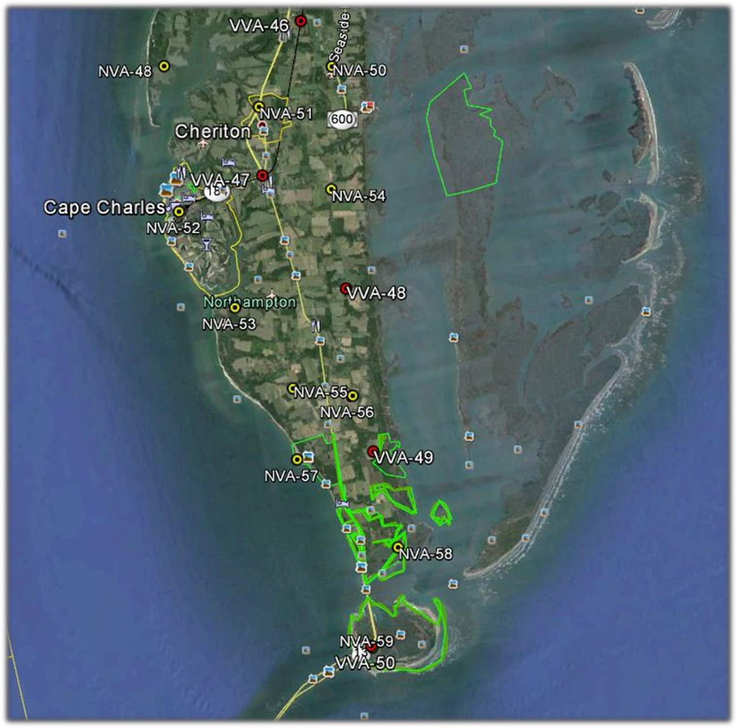
- PROJECT DETAILS

Survey Equipment

In performing the GPS observations Trimble R-10 GNSS receiver/antenna attached to a two meter fixed height pole with a Trimble TSC3 Data Collector to collect GPS raw data were used to perform the field surveys.

Survey Point Detail

The 110 LiDAR Check Points were well distributed throughout the project area.

A sketch was made for each location and a nail was set at the point where possible or at an identifiable point. The Check Point locations are detailed on the “Control Point Documentation Report” sheets attached to this report.

Network Design

The GPS survey performed by Dewberry Consultants LLC office located in Lanham, MD was tied to a Real Time Network (RTN) managed by KEYNET GPS, Inc. The network is a series of “real-time” continuously operating, high precision GPS reference stations. All of the reference stations have been linked together using Trimble GPSNet software, creating a Virtual Reference Station System (VRS).
The Trimble NetR5 Reference Station is a multi-channel, multi-frequency GNSS (Global Navigation Satellite System) receiver designed for use as a stand-alone reference station or as part of a GNSS infrastructure solution. Trimble R-Track technology in the NetR5 receiver supports the modernized GPS L2C and L5 signals as well as GLONASS L1/L2 signals.

Field Survey Procedures and Analysis

Dewberry field surveyors used Trimble R-10 GNSS receivers, which is a geodetic quality dual frequency GPS receiver, to collect data at each surveyed location.
All locations were occupied once with approximately 50% of the locations being re- observed. All re-observations matched the initially derived station positions within the allowable tolerance of ± 5cm or within the 95% confidence level. Each occupation which utilized the VRS network was occupied for approximately three (3) minutes in duration and measured to 180 epochs.
Each occupation which utilized OPUS (if used) was occupied between 18 and 20 minutes. Field GPS observations are detailed on the “Ground Control Point Documentation
Reports” submitted as part of this report.
There (3) existing NGS monuments listed in the NSRS database and one (1) aerial acquisition firm control point were located as an additional QA/QC method to check the accuracy of the VRS network as well as being the primary project control monuments designated as W 420, NELSON, ACCOMAC RESET and REBAR 1. The results are as follows:

NGS PT. ID | As Surveyed (ft) |  |  | Published (ft) |  |  | Differences (ft)
 | Northing(ft) | Easting(ft) | Elev.(ft) | Northing(ft) | Easting(ft) | Elev.(ft) | ∆ N | ∆ E | ∆ Elev.
W420 | N/A | N/A | 3.08 | N/A | N/A | 3.13 | N/A | N/A | 0.05
NELSON | 13799401.38 | 1484775.42 | 31.28 | 13799401.40 | 1484775.50 | 31.27 | 0.02 | 0.07 | 0.01
ACCOMAC RESET | 13696368.85 | 1445299.97 | N/A | 13696368.85 | 1445299.92 | 44.25 | 0.01 | 0.05 | N/A
REBAR 1 | 13544408.85 | 1369407.22 | 30.46 | 13544408.79 | 1369407.28 | N/A | 0.06 | 0.06 | N/A

The above results indicate that the VRS network is providing positional values within the 5cm parameters for this survey.

Adjustment

The survey data was collected using Virtual Reference Stations (VRS) methodology within a Virtual Reference System (VRS).
The system is designed to provide a true Network RTK performance, the RTKNet software enables high-accuracy positioning in real time across a geographic region. The RTKNet software package uses real-time data streams from the KEYNET system user and generates correction models for high-accuracy RTK GPS corrections throughout the network. Therefore, corrections were applied to the points as they were being collected, thus negating the need for a post process adjustment.

Data Processing Procedures

After field data is collected the information is downloaded from the data collectors into the office software. The Software program used is called TBC or Trimble Business Center.
Downloaded data is run through the TBC program to obtain the following reports; points report, point comparison report and a point detail report. The reports are reviewed for point accuracy and precision.
After review of the point data an “ASCII” or “txt” file which is the industry standard is created. Point files are loaded into our CADD program (Carlson Survey 2014) to make a visual check of the point data (Pt. #, Coordinates, Elev. and Description). The data can now be imported into the final product.

- FINAL COORDINATES

POINT # | NORTHING (ft) | EASTING (ft) | ELEV. (ft)
NVA CHECK POINTS
NVA-1 | 13787544.72 | 1345061.37 | 1.34
NVA-2 | 13737576.97 | 1354141.25 | 3.40
NVA-3 | 13804535.78 | 1483754.54 | 20.50
NVA-4 | 13802938.37 | 1518716.14 | 31.45
NVA-5 | 13775338.62 | 1521649.52 | 4.06
NVA-6 | 13774225.72 | 1501825.31 | 32.15
NVA-7 | 13781284.79 | 1462880.68 | 6.35
NVA-8 | 13760385.06 | 1492788.87 | 32.21
NVA-9 | 13749645.45 | 1493971.62 | 16.79
NVA-10 | 13755749.08 | 1454915.20 | 1.99
NVA-11 | 13751688.65 | 1479341.61 | 46.07
NVA-12 | 13728349.88 | 1482757.49 | 15.68
NVA-13 | 13740538.80 | 1462405.07 | 22.50

NVA-14 | 13715068.25 | 1423672.01 | 3.29
NVA-15 | 13716376.57 | 1457539.03 | 41.11
NVA-16 | 13694591.10 | 1465288.41 | 4.25
NVA-17 | 13709144.25 | 1448301.98 | 38.90
NVA-18 | 13694709.28 | 1422978.56 | 13.77
NVA-19 | 13699849.12 | 1413593.59 | 4.44
NVA-20 | 13691366.38 | 1435139.99 | 42.81
NVA-21 | 13685801.16 | 1451522.49 | 18.91
NVA-22 | 13669719.87 | 1448584.00 | 8.15
NVA-23 | 13677530.24 | 1428586.66 | 49.83
NVA-24 | 13683206.34 | 1410161.85 | 9.54
NVA-25 | 13676039.67 | 1399787.10 | 5.85
NVA-26 | 13671648.26 | 1386750.83 | 3.58
NVA-27 | 13659633.88 | 1418965.56 | 41.39
NVA-28 | 13654573.59 | 1439881.17 | 7.60
NVA-29 | 13643047.34 | 1423396.80 | 8.54
NVA-30 | 13643465.21 | 1410046.59 | 32.98
NVA-31 | 13649231.57 | 1390298.90 | 22.64
NVA-32 | 13641526.45 | 1373079.19 | 2.88
NVA-33 | 13629535.20 | 1401795.83 | 36.71
NVA-34 | 13616989.25 | 1400880.55 | 28.94
NVA-35 | 13635649.31 | 1386370.80 | 3.69
NVA-36 | 13632340.72 | 1373626.86 | 4.39
NVA-37 | 13624607.26 | 1385808.85 | 23.50
NVA-38 | 13608870.92 | 1389982.92 | 34.41
NVA-39 | 13600301.49 | 1392043.70 | 31.47
NVA-40 | 13605115.06 | 1380143.36 | 20.84
NVA-41 | 13614694.74 | 1370379.71 | 18.86
NVA-42 | 13599588.29 | 1369827.79 | 17.69
NVA-43 | 13591096.27 | 1382010.54 | 38.61
NVA-44 | 13578066.06 | 1382513.43 | 28.84
NVA-45 | 13591275.12 | 1357653.54 | 10.57
NVA-46 | 13581277.83 | 1362330.87 | 17.97
NVA-47 | 13561751.38 | 1371720.52 | 33.42
NVA-48 | 13555468.16 | 1348538.92 | 7.50
NVA-49 | 13561564.46 | 1364642.16 | 28.07
NVA-50 | 13548074.67 | 1363682.22 | 37.85
NVA-51 | 13540793.69 | 1360795.58 | 34.49

NVA-52 | 13532703.53 | 1344629.83 | 6.56
NVA-53 | 13518511.52 | 1349412.03 | 7.97
NVA-54 | 13531314.14 | 1365213.32 | 32.54
NVA-55 | 13506310.57 | 1354342.76 | 34.74
NVA-56 | 13503572.78 | 1362045.54 | 26.16
NVA-57 | 13496860.40 | 1352829.53 | 8.20
NVA-58 | 13482536.60 | 1363344.19 | 4.48
NVA-59 | 13470126.21 | 1357158.95 | 11.88
NVA-60 | 13770426.82 | 1429938.34 | 5.57
VVA CHECK POINTS
VVA-1 | 13739949.46 | 1357750.56 | 4.14
VVA-2 | 13725921.77 | 1382691.12 | 3.12
VVA-3 | 13761818.33 | 1381112.05 | 1.10
VVA-4 | 13792377.41 | 1487545.35 | 20.77
VVA-5 | 13779174.95 | 1470756.86 | 12.56
VVA-6 | 13772667.10 | 1449295.26 | 3.22
VVA-7 | 13776136.53 | 1525577.46 | 0.60
VVA-8 | 13797469.73 | 1507918.44 | 34.53
VVA-9 | 13802503.13 | 1461718.62 | 2.34
VVA-10 | 13774156.44 | 1433140.04 | 2.04
VVA-11 | 13769105.05 | 1466753.75 | 8.07
VVA-12 | 13764221.50 | 1483665.24 | 38.72
VVA-13 | 13755181.12 | 1461271.37 | 2.94
VVA-14 | 13743348.53 | 1444602.19 | 3.34
VVA-15 | 13752593.71 | 1490559.47 | 36.85
VVA-16 | 13728875.89 | 1474469.29 | 38.17
VVA-17 | 13741109.30 | 1466001.15 | 34.01
VVA-18 | 13730066.09 | 1451622.03 | 10.26
VVA-19 | 13718587.96 | 1434164.42 | 4.53
VVA-20 | 13719563.99 | 1449951.12 | 33.22
VVA-21 | 13717764.78 | 1465625.79 | 39.17
VVA-22 | 13707103.33 | 1467188.27 | 16.84
VVA-23 | 13702843.64 | 1436904.84 | 28.62
VVA-24 | 13713034.97 | 1420333.73 | 1.63
VVA-25 | 13705884.89 | 1415374.41 | 2.03
VVA-26 | 13690830.08 | 1460668.19 | 13.65
VVA-27 | 13673470.77 | 1449388.20 | 6.10
VVA-28 | 13681814.29 | 1437636.66 | 39.07

VVA-29 | 13692053.05 | 1411728.08 | 7.14
VVA-30 | 13685906.03 | 1402585.45 | 4.16
VVA-31 | 13667700.33 | 1386186.14 | 1.75
VVA-32 | 13671186.54 | 1418864.70 | 44.90
VVA-33 | 13658468.55 | 1438041.21 | 7.20
VVA-34 | 13653184.58 | 1424317.10 | 14.68
VVA-35 | 13656545.62 | 1406587.62 | 38.76
VVA-36 | 13651563.07 | 1383130.93 | 6.55
VVA-37 | 13641884.77 | 1379969.41 | 9.36
VVA-38 | 13631742.52 | 1416338.33 | 4.07
VVA-39 | 13620741.99 | 1402023.09 | 35.05
VVA-40 | 13630700.74 | 1390788.65 | 27.82
VVA-41 | 13624139.43 | 1368679.46 | 14.08
VVA-42 | 13610604.02 | 1364759.03 | 13.83
VVA-43 | 13602086.11 | 1392690.19 | 29.75
VVA-44 | 13594195.65 | 1373160.63 | 18.03
VVA-45 | 13571983.39 | 1360795.94 | 14.62
VVA-46 | 13554148.09 | 1366204.57 | 36.30
VVA-47 | 13536226.63 | 1357386.05 | 19.26
VVA-48 | 13518684.74 | 1364228.13 | 31.78
VVA-49 | 13495644.01 | 1359319.15 | 29.83
VVA-50 | 13470330.59 | 1357035.00 | 8.01

- GPS OBSERVATIONS

VIRGINIA EASTERN SHORE LiDAR QA
POINT ID | OBSERV. DATE | JULIAN DATE | TIME OF DAY (PST) | RE-OBSERV. DATE | RE-OBSERV. TIME
NVA-1 | 5/12/2015 | 132 | 17:12 | N/A | N/A
NVA-2 | 5/12/2015 | 132 | 10:10 | N/A | N/A
NVA-3 | 5/11/2015 | 131 | 6:40 | 5/11/2015 | 17:29
NVA-4 | 5/11/2015 | 131 | 16:20 | N/A | N/A
NVA-5 | 5/13/2015 | 133 | 12:27 | N/A | N/A
NVA-6 | 5/13/2015 | 133 | 12:46 | N/A | N/A
NVA-7 | 5/11/2015 | 131 | 7:35 | N/A | N/A
NVA-8 | 5/13/2015 | 133 | 14:34 | N/A | N/A
NVA-9 | 5/13/2015 | 133 | 15:13 | N/A | N/A
NVA-10 | 5/11/2015 | 131 | 8:35 | 5/11/2015 | 19:26

NVA-11 | 5/11/2015 | 131 | 9:15 | 5/11/2015 | 20:51
NVA-12 | 5/13/2015 | 133 | 17:12 | 5/14/2015 | 7:09
NVA-13 | 5/11/2015 | 131 | 10:45 | 5/14/2015 | 20:19
NVA-14 | 5/14/2015 | 134 | 10:39 | N/A | N/A
NVA-15 | 5/11/2015 | 131 | 10:15 | N/A | N/A
NVA-16 | 5/13/2015 | 133 | 18:31 | 5/14/2015 | 19:56
NVA-17 | 5/11/2015 | 131 | 12:20 | 5/14/2015 | 5:08
NVA-18 | 5/14/2015 | 134 | 12:03 | N/A | N/A
NVA-19 | 5/14/2015 | 134 | 11:41 | N/A | N/A
NVA-20 | 5/13/2015 | 133 | 20:06 | 5/14/2015 | 18:58
NVA-21 | 5/13/2015 | 133 | 19:10 | 5/14/2015 | 19:16
NVA-22 | 5/13/2015 | 133 | 19:40 | N/A | N/A
NVA-23 | 5/14/2015 | 134 | 16:06 | 5/14/2015 | 18:10
NVA-24 | 5/14/2015 | 134 | 13:12 | 5/14/2015 | 18:33
NVA-25 | 5/14/2015 | 134 | 13:38 | N/A | N/A
NVA-26 | 5/14/2015 | 134 | 14:19 | 5/15/2015 | 6:12
NVA-27 | 5/14/2015 | 134 | 15:29 | 5/15/2015 | 6:49
NVA-28 | 5/14/2015 | 134 | 17:01 | N/A | N/A
NVA-29 | 5/14/2015 | 134 | 15:12 | 5/15/2015 | 7:51
NVA-30 | 5/14/2015 | 134 | 14:44 | 5/15/2015 | 7:19
NVA-31 | 5/13/2015 | 133 | 12:25 | 5/13/2015 | 20:29
NVA-32 | 5/13/2015 | 133 | 13:09 | 5/13/2015 | 20:51
NVA-33 | 5/13/2015 | 133 | 16:30 | N/A | N/A
NVA-34 | 5/13/2015 | 133 | 17:25 | 5/14/2015 | 5:21
NVA-35 | 5/13/2015 | 133 | 14:22 | 5/13/2015 | 21:09
NVA-36 | 5/13/2015 | 133 | 14:55 | 5/13/2015 | 21:23
NVA-37 | 5/13/2015 | 133 | 14:39 | N/A | N/A
NVA-38 | 5/13/2015 | 133 | 17:44 | 5/14/2015 | 5:41
NVA-39 | 5/13/2015 | 133 | 19:42 | 5/14/2015 | 6:28
NVA-40 | 5/13/2015 | 133 | 18:28 | N/A | N/A
NVA-41 | 5/13/2015 | 133 | 15:43 | 5/13/2015 | 22:10
NVA-42 | 5/13/2015 | 133 | 18:45 | 5/14/2015 | 7:01
NVA-43 | 5/13/2015 | 133 | 19:28 | 5/14/2015 | 22:15
NVA-44 | 5/14/2015 | 134 | 7:45 | N/A | N/A
NVA-45 | 5/13/2015 | 133 | 19:00 | N/A | N/A
NVA-46 | 5/14/2015 | 134 | 8:18 | 5/14/2015 | 21:59
NVA-47 | 5/14/2015 | 134 | 9:24 | 5/14/2015 | 20:49
NVA-48 | 5/14/2015 | 134 | 10:25 | N/A | N/A

NVA-49 | 5/14/2015 | 134 | 9:52 | 5/14/2015 | 21:10
NVA-50 | 5/14/2015 | 134 | 11:26 | 5/14/2015 | 20:07
NVA-51 | 5/14/2015 | 134 | 12:19 | 5/14/2015 | 19:49
NVA-52 | 5/14/2015 | 134 | 12:50 | 5/14/2015 | 19:33
NVA-53 | 5/14/2015 | 134 | 15:12 | N/A | N/A
NVA-54 | 5/14/2015 | 134 | 14:05 | 5/14/2015 | 18:51
NVA-55 | 5/14/2015 | 134 | 15:40 | N/A | N/A
NVA-56 | 5/14/2015 | 134 | 16:05 | N/A | N/A
NVA-57 | 5/14/2015 | 134 | 16:36 | N/A | N/A
NVA-58 | 5/14/2015 | 134 | 17:30 | N/A | N/A
NVA-59 | 5/14/2015 | 134 | 18:23 | N/A | N/A
NVA-60 | 5/11/2015 | 131 | 13:45 | 5/11/2015 | 18:51
VVA-1 | 5/12/2015 | 132 | 9:50 | N/A | N/A
VVA-2 | 5/12/2015 | 132 | 11:35 | N/A | N/A
VVA-3 | 5/12/2015 | 132 | 14:10 | N/A | N/A
VVA-4 | 5/11/2015 | 131 | 6:56 | 5/11/2015 | 17:11
VVA-5 | 5/11/2015 | 131 | 7:22 | N/A | N/A
VVA-6 | 5/11/2015 | 131 | 7:50 | 5/11/2015 | 18:15
VVA-7 | 5/13/2015 | 133 | 12:13 | N/A | N/A
VVA-8 | 5/11/2015 | 131 | 16:45 | N/A | N/A
VVA-9 | 5/11/2015 | 131 | 14:20 | 5/11/2015 | 17:43
VVA-10 | 5/11/2015 | 131 | 13:30 | 5/11/2015 | 18:39
VVA-11 | 5/11/2015 | 131 | 13:10 | N/A | N/A
VVA-12 | 5/13/2015 | 133 | 14:19 | 5/14/2015 | 7:59
VVA-13 | 5/11/2015 | 131 | 12:55 | N/A | N/A
VVA-14 | 5/14/2015 | 134 | 8:49 | N/A | N/A
VVA-15 | 5/13/2015 | 133 | 15:27 | 5/14/2015 | 7:29
VVA-16 | 5/13/2015 | 133 | 15:54 | 5/14/2015 | 6:42
VVA-17 | 5/11/2015 | 131 | 12:45 | 5/11/2015 | 20:10
VVA-18 | 5/14/2015 | 134 | 9:37 | N/A | N/A
VVA-19 | 5/14/2015 | 134 | 10:00 | N/A | N/A
VVA-20 | 5/13/2015 | 133 | 17:02 | 5/14/2015 | 5:33
VVA-21 | 5/13/2015 | 133 | 16:37 | 5/14/2015 | 5:49
VVA-22 | 5/13/2015 | 133 | 17:25 | 5/14/2015 | 6:09
VVA-23 | 5/13/2015 | 133 | 17:46 | N/A | N/A
VVA-24 | 5/14/2015 | 134 | 11:00 | N/A | N/A
VVA-25 | 5/14/2015 | 134 | 11:24 | N/A | N/A
VVA-26 | 5/13/2015 | 133 | 18:51 | 5/14/2015 | 19:31

VVA-27 | 5/13/2015 | 133 | 19:27 | N/A | N/A
VVA-28 | 5/13/2015 | 133 | 16:31 | 5/14/2015 | 18:59
VVA-29 | 5/14/2015 | 134 | 12:26 | N/A | N/A
VVA-30 | 5/14/2015 | 134 | 12:54 | N/A | N/A
VVA-31 | 5/14/2015 | 134 | 13:58 | 5/15/2015 | 6:31
VVA-32 | 5/14/2015 | 134 | 15:49 | 5/14/2015 | 17:46
VVA-33 | 5/13/2015 | 133 | 10:48 | N/A | N/A
VVA-34 | 5/13/2015 | 133 | 11:13 | N/A | N/A
VVA-35 | 5/13/2015 | 133 | 11:50 | N/A | N/A
VVA-36 | 5/13/2015 | 133 | 12:52 | 5/13/2015 | 20:10
VVA-37 | 5/13/2015 | 133 | 13:20 | N/A | N/A
VVA-38 | 5/13/2015 | 133 | 16:56 | N/A | N/A
VVA-39 | 5/13/2015 | 133 | 17:14 | N/A | N/A
VVA-40 | 5/13/2015 | 133 | 13:54 | N/A | N/A
VVA-41 | 5/13/2015 | 133 | 15:24 | 5/13/2015 | 21:46
VVA-42 | 5/13/2015 | 133 | 16:03 | 5/14/2015 | 6:10
VVA-43 | 5/13/2015 | 133 | 18:10 | N/A | N/A
VVA-44 | 5/13/2015 | 133 | 19:16 | N/A | N/A
VVA-45 | 5/14/2015 | 134 | 8:52 | 5/14/2015 | 21:29
VVA-46 | 5/14/2015 | 134 | 10:57 | 5/14/2015 | 20:31
VVA-47 | 5/14/2015 | 134 | 13:36 | 5/14/2015 | 19:13
VVA-48 | 5/14/2015 | 134 | 14:32 | N/A | N/A
VVA-49 | 5/14/2015 | 134 | 17:01 | N/A | N/A
VVA-50 | 5/14/2015 | 134 | 17:59 | N/A | N/A

- POINT COMPARISON

LiDAR QA
POINT ID | POINT CK | DELTA NORTH (ft) | DELTA EAST (ft) | VERT. DIFF (ft)
NVA-3 | NVA-3CK | 0.00 | 0.01 | 0.00
NVA-10 | NVA-10CK | 0.02 | 0.03 | 0.10
NVA-11 | NVA-11CK | 0.02 | 0.00 | 0.03
NVA-12 | NVA-12CK | 0.01 | 0.01 | 0.04
NVA-13 | NVA-13CK | 0.01 | 0.01 | 0.01
NVA-16 | NVA-16CK | 0.03 | 0.01 | 0.01
NVA-17 | NVA-17CK | 0.01 | 0.03 | 0.04
NVA-20 | NVA-20CK | 0.02 | 0.00 | 0.00
NVA-21 | NVA-21CK | 0.01 | 0.00 | 0.05
NVA-23 | NVA-23CK | 0.02 | 0.02 | 0.04

NVA-24 | NVA-24CK | 0.01 | 0.01 | 0.01
NVA-26 | NVA-26CK | 0.01 | 0.01 | 0.03
NVA-27 | NVA-27CK | 0.02 | 0.04 | 0.02
NVA-29 | NVA-29CK | 0.01 | 0.00 | 0.03
NVA-30 | NVA-30CK | 0.01 | 0.03 | 0.01
NVA-31 | NVA-31CK | 0.01 | 0.01 | 0.03
NVA-32 | NVA-32CK | 0.02 | 0.00 | 0.01
NVA-34 | NVA-34CK | 0.01 | 0.01 | 0.03
NVA-35 | NVA-35CK | 0.00 | 0.00 | 0.00
NVA-36 | NVA-36CK | 0.03 | 0.03 | 0.01
NVA-38 | NVA-38CK | 0.02 | 0.02 | 0.04
NVA-39 | NVA-39CK | 0.01 | 0.00 | 0.05
NVA-41 | NVA-41CK | 0.00 | 0.00 | 0.03
NVA-42 | NVA-42CK | 0.01 | 0.03 | 0.00
NVA-43 | NVA-43CK | 0.00 | 0.02 | 0.01
NVA-46 | NVA-46CK | 0.03 | 0.04 | 0.04
NVA-47 | NVA-47CK | 0.01 | 0.03 | 0.03
NVA-49 | NVA-49CK | 0.04 | 0.04 | 0.05
NVA-50 | NVA-50CK | 0.07 | 0.06 | 0.04
NVA-51 | NVA-51CK | 0.04 | 0.05 | 0.05
NVA-52 | NVA-52CK | 0.06 | 0.04 | 0.07
NVA-54 | NVA-54CK | 0.07 | 0.07 | 0.04
NVA-60 | NVA-60CK | 0.01 | 0.00 | 0.01
VVA-4 | VVA-4CK | 0.00 | 0.01 | 0.01
VVA-6 | VVA-6CK | 0.01 | 0.01 | 0.02
VVA-9 | VVA-9CK | 0.00 | 0.02 | 0.05
VVA-10 | VVA-10CK | 0.01 | 0.00 | 0.03
VVA-12 | VVA-12CK | 0.00 | 0.00 | 0.00
VVA-15 | VVA-15CK | 0.01 | 0.02 | 0.01
VVA-16 | VVA-16CK | 0.02 | 0.03 | 0.01
VVA-17 | VVA-17CK | 0.03 | 0.03 | 0.01
VVA-20 | VVA-20CK | 0.04 | 0.01 | 0.04
VVA-21 | VVA-21CK | 0.01 | 0.01 | 0.04
VVA-22 | VVA-22CK | 0.00 | 0.01 | 0.02
VVA-26 | VVA-26CK | 0.01 | 0.01 | 0.04
VVA-28 | VVA-28CK | 0.00 | 0.01 | 0.03
VVA-31 | VVA-31CK | 0.00 | 0.03 | 0.03
VVA-32 | VVA-32CK | 0.02 | 0.02 | 0.02

VVA-36 | VVA-36CK | 0.02 | 0.02 | 0.05
VVA-41 | VVA-41CK | 0.01 | 0.04 | 0.06
VVA-42 | VVA-42CK | 0.02 | 0.03 | 0.04
VVA-45 | VVA-45CK | 0.03 | 0.05 | 0.06
VVA-46 | VVA-46CK | 0.09 | 0.08 | 0.09
VVA-47 | VVA-47CK | 0.05 | 0.09 | 0.05

Appendix B: Complete List of Delivered Tiles

LAS_S23_1888_40 | LAS_S23_3725_10 | LAS_S23_2687_20 | LAS_S23_2745_10
LAS_S23_1896_10 | LAS_S23_3725_20 | LAS_S23_2688_10 | LAS_S23_2745_20
LAS_S23_1896_20 | LAS_S23_3726_10 | LAS_S23_2688_20 | LAS_S23_2746_10
LAS_S23_1897_10 | LAS_S23_3726_20 | LAS_S23_2689_10 | LAS_S23_2746_20
LAS_S23_1897_20 | LAS_S23_3727_10 | LAS_S23_2689_20 | LAS_S23_2747_10
LAS_S23_1898_10 | LAS_S23_3727_20 | LAS_S23_2780_10 | LAS_S23_2747_20
LAS_S23_1895_30 | LAS_S23_3728_10 | LAS_S23_2780_20 | LAS_S23_2748_10
LAS_S23_1896_40 | LAS_S23_3728_20 | LAS_S23_2781_10 | LAS_S23_2748_20
LAS_S23_1896_30 | LAS_S23_3729_10 | LAS_S23_2781_20 | LAS_S23_2749_10
LAS_S23_1897_40 | LAS_S23_3729_20 | LAS_S23_2782_10 | LAS_S23_2749_20
LAS_S23_1897_30 | LAS_S23_3820_10 | LAS_S23_2782_20 | LAS_S23_2547_30
LAS_S23_1898_40 | LAS_S23_3820_20 | LAS_S23_2783_10 | LAS_S23_2548_40
LAS_S23_2600_10 | LAS_S23_3821_10 | LAS_S23_2783_20 | LAS_S23_2548_30
LAS_S23_2600_20 | LAS_S23_3821_20 | LAS_S23_2784_10 | LAS_S23_2549_40
LAS_S23_2601_10 | LAS_S23_3822_10 | LAS_S23_2784_20 | LAS_S23_2549_30
LAS_S23_2601_20 | LAS_S23_3822_20 | LAS_S23_2785_10 | LAS_S23_2640_40
LAS_S23_2602_10 | LAS_S23_3823_10 | LAS_S23_2785_20 | LAS_S23_2640_30
LAS_S23_2602_20 | LAS_S23_3823_20 | LAS_S23_2786_10 | LAS_S23_2641_40
LAS_S23_2603_10 | LAS_S23_3824_10 | LAS_S23_2786_20 | LAS_S23_2641_30
LAS_S23_2603_20 | LAS_S23_3824_20 | LAS_S23_2787_10 | LAS_S23_2642_40
LAS_S23_2604_10 | LAS_S23_3825_10 | LAS_S23_2787_20 | LAS_S23_2642_30
LAS_S23_2604_20 | LAS_S23_3825_20 | LAS_S23_2788_10 | LAS_S23_2643_40
LAS_S23_2605_10 | LAS_S23_3826_10 | LAS_S23_2788_20 | LAS_S23_2643_30
LAS_S23_2605_20 | LAS_S23_3826_20 | LAS_S23_2789_10 | LAS_S23_2644_40
LAS_S23_2606_10 | LAS_S23_3827_10 | LAS_S23_2789_20 | LAS_S23_2644_30
LAS_S23_2606_20 | LAS_S23_3827_20 | LAS_S23_2880_10 | LAS_S23_2645_40
LAS_S23_2802_20 | LAS_S23_3828_10 | LAS_S23_2880_20 | LAS_S23_2645_30
LAS_S23_2803_10 | LAS_S23_3828_20 | LAS_S23_2881_10 | LAS_S23_2646_40
LAS_S23_2803_20 | LAS_S23_3829_10 | LAS_S23_2881_20 | LAS_S23_2646_30
LAS_S23_2804_10 | LAS_S23_3829_20 | LAS_S23_2882_10 | LAS_S23_2647_40
LAS_S23_2804_20 | LAS_S23_3920_10 | LAS_S23_2882_20 | LAS_S23_2647_30
LAS_S23_2805_10 | LAS_S23_3920_20 | LAS_S23_2883_10 | LAS_S23_2648_40
LAS_S23_2805_20 | LAS_S23_3723_30 | LAS_S23_2883_20 | LAS_S23_2648_30
LAS_S23_2806_20 | LAS_S23_3724_40 | LAS_S23_2884_10 | LAS_S23_2649_40
LAS_S23_2807_10 | LAS_S23_3724_30 | LAS_S23_2884_20 | LAS_S23_2649_30
LAS_S23_2807_20 | LAS_S23_3725_40 | LAS_S23_2885_10 | LAS_S23_2740_40
LAS_S23_2808_10 | LAS_S23_3726_30 | LAS_S23_2885_20 | LAS_S23_2740_30
LAS_S23_2600_40 | LAS_S23_3727_40 | LAS_S23_2886_10 | LAS_S23_2741_40
LAS_S23_2600_30 | LAS_S23_3727_30 | LAS_S23_2886_20 | LAS_S23_2741_30
LAS_S23_2601_40 | LAS_S23_3728_40 | LAS_S23_2887_10 | LAS_S23_2742_40

LAS_S23_2601_30 | LAS_S23_3728_30 | LAS_S23_2887_20 | LAS_S23_2742_30
LAS_S23_2602_40 | LAS_S23_3729_40 | LAS_S23_2684_30 | LAS_S23_2743_40
LAS_S23_2602_30 | LAS_S23_3729_30 | LAS_S23_2685_40 | LAS_S23_2743_30
LAS_S23_2603_40 | LAS_S23_3820_40 | LAS_S23_2685_30 | LAS_S23_2744_40
LAS_S23_2603_30 | LAS_S23_3820_30 | LAS_S23_2686_40 | LAS_S23_2744_30
LAS_S23_2604_40 | LAS_S23_3821_40 | LAS_S23_2686_30 | LAS_S23_2745_40
LAS_S23_2604_30 | LAS_S23_3821_30 | LAS_S23_2687_40 | LAS_S23_2745_30
LAS_S23_2605_40 | LAS_S23_3822_40 | LAS_S23_2687_30 | LAS_S23_2746_40
LAS_S23_2605_30 | LAS_S23_3822_30 | LAS_S23_2688_40 | LAS_S23_2746_30
LAS_S23_2606_40 | LAS_S23_3823_40 | LAS_S23_2688_30 | LAS_S23_2747_40
LAS_S23_2606_30 | LAS_S23_3823_30 | LAS_S23_2689_40 | LAS_S23_2747_30
LAS_S23_2802_40 | LAS_S23_3824_40 | LAS_S23_2689_30 | LAS_S23_2748_40
LAS_S23_2802_30 | LAS_S23_3824_30 | LAS_S23_2780_40 | LAS_S23_2748_30
LAS_S23_2803_40 | LAS_S23_3825_40 | LAS_S23_2780_30 | LAS_S23_2749_40
LAS_S23_2803_30 | LAS_S23_3825_30 | LAS_S23_2781_40 | LAS_S23_2749_30
LAS_S23_2804_40 | LAS_S23_3826_40 | LAS_S23_2781_30 | LAS_S23_2558_10
LAS_S23_2804_30 | LAS_S23_3826_30 | LAS_S23_2782_40 | LAS_S23_2558_20
LAS_S23_2805_40 | LAS_S23_3827_40 | LAS_S23_2782_30 | LAS_S23_2559_10
LAS_S23_2805_30 | LAS_S23_3827_30 | LAS_S23_2783_40 | LAS_S23_2559_20
LAS_S23_2807_30 | LAS_S23_3828_40 | LAS_S23_2783_30 | LAS_S23_2650_10
LAS_S23_2808_40 | LAS_S23_3828_30 | LAS_S23_2784_40 | LAS_S23_2650_20
LAS_S23_2516_10 | LAS_S23_3829_40 | LAS_S23_2784_30 | LAS_S23_2651_10
LAS_S23_2516_20 | LAS_S23_3829_30 | LAS_S23_2785_40 | LAS_S23_2651_20
LAS_S23_2517_10 | LAS_S23_3920_40 | LAS_S23_2785_30 | LAS_S23_2652_10
LAS_S23_2517_20 | LAS_S23_3920_30 | LAS_S23_2786_40 | LAS_S23_2652_20
LAS_S23_2518_10 | LAS_S23_3739_10 | LAS_S23_2786_30 | LAS_S23_2653_10
LAS_S23_2518_20 | LAS_S23_3739_20 | LAS_S23_2787_40 | LAS_S23_2653_20
LAS_S23_2519_10 | LAS_S23_3830_10 | LAS_S23_2787_30 | LAS_S23_2654_10
LAS_S23_2519_20 | LAS_S23_3830_20 | LAS_S23_2788_40 | LAS_S23_2654_20
LAS_S23_2610_10 | LAS_S23_3831_10 | LAS_S23_2788_30 | LAS_S23_2655_10
LAS_S23_2610_20 | LAS_S23_3831_20 | LAS_S23_2789_40 | LAS_S23_2655_20
LAS_S23_2611_10 | LAS_S23_3832_10 | LAS_S23_2789_30 | LAS_S23_2656_10
LAS_S23_2611_20 | LAS_S23_3832_20 | LAS_S23_2880_40 | LAS_S23_2656_20
LAS_S23_2612_10 | LAS_S23_3833_10 | LAS_S23_2880_30 | LAS_S23_2657_10
LAS_S23_2612_20 | LAS_S23_3833_20 | LAS_S23_2881_40 | LAS_S23_2657_20
LAS_S23_2613_10 | LAS_S23_3834_10 | LAS_S23_2881_30 | LAS_S23_2658_10
LAS_S23_2613_20 | LAS_S23_3834_20 | LAS_S23_2882_40 | LAS_S23_2658_20
LAS_S23_2614_10 | LAS_S23_3835_10 | LAS_S23_2882_30 | LAS_S23_2659_10
LAS_S23_2614_20 | LAS_S23_3835_20 | LAS_S23_2883_40 | LAS_S23_2659_20
LAS_S23_2615_10 | LAS_S23_3836_10 | LAS_S23_2883_30 | LAS_S23_2750_10
LAS_S23_2615_20 | LAS_S23_3836_20 | LAS_S23_2884_40 | LAS_S23_2750_20
LAS_S23_2616_10 | LAS_S23_3837_10 | LAS_S23_2884_30 | LAS_S23_2751_10

LAS_S23_2616_20 | LAS_S23_3837_20 | LAS_S23_2885_40 | LAS_S23_2751_20
LAS_S23_2617_10 | LAS_S23_3838_10 | LAS_S23_2885_30 | LAS_S23_2752_10
LAS_S23_2617_20 | LAS_S23_3838_20 | LAS_S23_2886_40 | LAS_S23_2752_20
LAS_S23_2618_10 | LAS_S23_3839_10 | LAS_S23_2886_30 | LAS_S23_2753_10
LAS_S23_2618_20 | LAS_S23_3839_20 | LAS_S23_2887_40 | LAS_S23_2753_20
LAS_S23_2619_10 | LAS_S23_3930_10 | LAS_S23_2887_30 | LAS_S23_2754_10
LAS_S23_2619_20 | LAS_S23_3930_20 | LAS_S23_2695_20 | LAS_S23_2754_20
LAS_S23_2710_10 | LAS_S23_3830_40 | LAS_S23_2696_10 | LAS_S23_2755_10
LAS_S23_2710_20 | LAS_S23_3830_30 | LAS_S23_2696_20 | LAS_S23_2755_20
LAS_S23_2711_10 | LAS_S23_3831_40 | LAS_S23_2697_10 | LAS_S23_2756_10
LAS_S23_2711_20 | LAS_S23_3831_30 | LAS_S23_2697_20 | LAS_S23_2756_20
LAS_S23_2812_10 | LAS_S23_3832_40 | LAS_S23_2698_10 | LAS_S23_2757_10
LAS_S23_2812_20 | LAS_S23_3832_30 | LAS_S23_2698_20 | LAS_S23_2757_20
LAS_S23_2813_10 | LAS_S23_3833_40 | LAS_S23_2699_10 | LAS_S23_2758_10
LAS_S23_2813_20 | LAS_S23_3833_30 | LAS_S23_2699_20 | LAS_S23_2758_20
LAS_S23_2516_40 | LAS_S23_3834_40 | LAS_S23_2790_10 | LAS_S23_2759_10
LAS_S23_2516_30 | LAS_S23_3834_30 | LAS_S23_2790_20 | LAS_S23_2759_20
LAS_S23_2517_40 | LAS_S23_3835_40 | LAS_S23_2791_10 | LAS_S23_2850_10
LAS_S23_2517_30 | LAS_S23_3835_30 | LAS_S23_2791_20 | LAS_S23_2850_20
LAS_S23_2518_40 | LAS_S23_3836_40 | LAS_S23_2792_10 | LAS_S23_2851_10
LAS_S23_2518_30 | LAS_S23_3836_30 | LAS_S23_2792_20 | LAS_S23_2851_20
LAS_S23_2519_40 | LAS_S23_3837_40 | LAS_S23_2793_10 | LAS_S23_2852_10
LAS_S23_2519_30 | LAS_S23_3837_30 | LAS_S23_2793_20 | LAS_S23_2852_20
LAS_S23_2610_40 | LAS_S23_3838_40 | LAS_S23_2794_10 | LAS_S23_2558_30
LAS_S23_2610_30 | LAS_S23_3838_30 | LAS_S23_2794_20 | LAS_S23_2559_40
LAS_S23_2611_40 | LAS_S23_3839_40 | LAS_S23_2795_10 | LAS_S23_2559_30
LAS_S23_2611_30 | LAS_S23_3839_30 | LAS_S23_2795_20 | LAS_S23_2650_40
LAS_S23_2612_40 | LAS_S23_3930_40 | LAS_S23_2796_10 | LAS_S23_2650_30
LAS_S23_2612_30 | LAS_S23_3930_30 | LAS_S23_2796_20 | LAS_S23_2651_40
LAS_S23_2613_40 | LAS_S23_3841_10 | LAS_S23_2797_10 | LAS_S23_2651_30
LAS_S23_2613_30 | LAS_S23_3841_20 | LAS_S23_2797_20 | LAS_S23_2652_40
LAS_S23_2614_40 | LAS_S23_3842_10 | LAS_S23_2798_10 | LAS_S23_2652_30
LAS_S23_2614_30 | LAS_S23_3842_20 | LAS_S23_2798_20 | LAS_S23_2653_40
LAS_S23_2615_40 | LAS_S23_3843_10 | LAS_S23_2799_10 | LAS_S23_2653_30
LAS_S23_2615_30 | LAS_S23_3843_20 | LAS_S23_2799_20 | LAS_S23_2654_40
LAS_S23_2616_40 | LAS_S23_3844_10 | LAS_S23_2890_10 | LAS_S23_2654_30
LAS_S23_2616_30 | LAS_S23_3844_20 | LAS_S23_2890_20 | LAS_S23_2655_40
LAS_S23_2617_40 | LAS_S23_3845_10 | LAS_S23_2891_10 | LAS_S23_2655_30
LAS_S23_2617_30 | LAS_S23_3845_20 | LAS_S23_2891_20 | LAS_S23_2656_40
LAS_S23_2618_40 | LAS_S23_3846_10 | LAS_S23_2892_10 | LAS_S23_2656_30
LAS_S23_2618_30 | LAS_S23_3846_20 | LAS_S23_2892_20 | LAS_S23_2657_40
LAS_S23_2619_40 | LAS_S23_3847_10 | LAS_S23_2893_10 | LAS_S23_2657_30

LAS_S23_2619_30 | LAS_S23_3847_20 | LAS_S23_2893_20 | LAS_S23_2658_40
LAS_S23_2710_40 | LAS_S23_3848_10 | LAS_S23_2894_10 | LAS_S23_2658_30
LAS_S23_2710_30 | LAS_S23_3848_20 | LAS_S23_2894_20 | LAS_S23_2659_40
LAS_S23_2711_40 | LAS_S23_3849_10 | LAS_S23_2895_10 | LAS_S23_2659_30
LAS_S23_2711_30 | LAS_S23_3849_20 | LAS_S23_2895_20 | LAS_S23_2750_40
LAS_S23_2526_10 | LAS_S23_3940_10 | LAS_S23_2896_10 | LAS_S23_2750_30
LAS_S23_2526_20 | LAS_S23_3940_20 | LAS_S23_2896_20 | LAS_S23_2751_40
LAS_S23_2527_10 | LAS_S23_3842_40 | LAS_S23_2897_10 | LAS_S23_2751_30
LAS_S23_2527_20 | LAS_S23_3842_30 | LAS_S23_2897_20 | LAS_S23_2752_40
LAS_S23_2528_10 | LAS_S23_3843_40 | LAS_S23_2697_40 | LAS_S23_2752_30
LAS_S23_2528_20 | LAS_S23_3843_30 | LAS_S23_2697_30 | LAS_S23_2753_40
LAS_S23_2529_10 | LAS_S23_3844_40 | LAS_S23_2698_40 | LAS_S23_2753_30
LAS_S23_2529_20 | LAS_S23_3844_30 | LAS_S23_2698_30 | LAS_S23_2754_40
LAS_S23_2620_10 | LAS_S23_3845_40 | LAS_S23_2699_40 | LAS_S23_2754_30
LAS_S23_2620_20 | LAS_S23_3845_30 | LAS_S23_2699_30 | LAS_S23_2755_40
LAS_S23_2621_10 | LAS_S23_3846_40 | LAS_S23_2790_40 | LAS_S23_2755_30
LAS_S23_2621_20 | LAS_S23_3846_30 | LAS_S23_2790_30 | LAS_S23_2756_40
LAS_S23_2622_10 | LAS_S23_3847_40 | LAS_S23_2791_40 | LAS_S23_2756_30
LAS_S23_2622_20 | LAS_S23_3847_30 | LAS_S23_2791_30 | LAS_S23_2757_40
LAS_S23_2623_10 | LAS_S23_3848_40 | LAS_S23_2792_40 | LAS_S23_2757_30
LAS_S23_2623_20 | LAS_S23_3848_30 | LAS_S23_2792_30 | LAS_S23_2758_40
LAS_S23_2624_10 | LAS_S23_3849_40 | LAS_S23_2793_40 | LAS_S23_2758_30
LAS_S23_2624_20 | LAS_S23_3849_30 | LAS_S23_2793_30 | LAS_S23_2759_40
LAS_S23_2625_10 | LAS_S23_3940_40 | LAS_S23_2794_40 | LAS_S23_2759_30
LAS_S23_2625_20 | LAS_S23_3940_30 | LAS_S23_2794_30 | LAS_S23_2850_40
LAS_S23_2626_10 | LAS_S23_3853_10 | LAS_S23_2795_40 | LAS_S23_2850_30
LAS_S23_2626_20 | LAS_S23_3853_20 | LAS_S23_2795_30 | LAS_S23_2851_40
LAS_S23_2627_10 | LAS_S23_3854_10 | LAS_S23_2796_40 | LAS_S23_2851_30
LAS_S23_2627_20 | LAS_S23_3854_20 | LAS_S23_2796_30 | LAS_S23_2852_40
LAS_S23_2628_10 | LAS_S23_3855_10 | LAS_S23_2797_40 | LAS_S23_2852_30
LAS_S23_2628_20 | LAS_S23_3855_20 | LAS_S23_2797_30 | LAS_S23_2569_10
LAS_S23_2629_10 | LAS_S23_3856_10 | LAS_S23_2798_40 | LAS_S23_2569_20
LAS_S23_2629_20 | LAS_S23_3856_20 | LAS_S23_2798_30 | LAS_S23_2660_10
LAS_S23_2720_10 | LAS_S23_3857_10 | LAS_S23_2799_40 | LAS_S23_2660_20
LAS_S23_2720_20 | LAS_S23_3857_20 | LAS_S23_2799_30 | LAS_S23_2661_10
LAS_S23_2721_10 | LAS_S23_3858_10 | LAS_S23_2890_40 | LAS_S23_2661_20
LAS_S23_2721_20 | LAS_S23_3858_20 | LAS_S23_2890_30 | LAS_S23_2662_10
LAS_S23_2722_10 | LAS_S23_3859_10 | LAS_S23_2891_40 | LAS_S23_2662_20
LAS_S23_2722_20 | LAS_S23_3859_20 | LAS_S23_2891_30 | LAS_S23_2663_10
LAS_S23_2723_10 | LAS_S23_3950_10 | LAS_S23_2892_40 | LAS_S23_2663_20
LAS_S23_2723_20 | LAS_S23_3950_20 | LAS_S23_2892_30 | LAS_S23_2664_10
LAS_S23_2724_10 | LAS_S23_3853_30 | LAS_S23_2893_40 | LAS_S23_2664_20

LAS_S23_2724_20 | LAS_S23_3854_40 | LAS_S23_2893_30 | LAS_S23_2665_10
LAS_S23_2725_10 | LAS_S23_3854_30 | LAS_S23_2894_40 | LAS_S23_2665_20
LAS_S23_2725_20 | LAS_S23_3855_40 | LAS_S23_2894_30 | LAS_S23_2666_10
LAS_S23_2526_40 | LAS_S23_3855_30 | LAS_S23_2895_40 | LAS_S23_2666_20
LAS_S23_2526_30 | LAS_S23_3856_40 | LAS_S23_2895_30 | LAS_S23_2667_10
LAS_S23_2527_40 | LAS_S23_3856_30 | LAS_S23_2896_40 | LAS_S23_2667_20
LAS_S23_2527_30 | LAS_S23_3857_40 | LAS_S23_2896_30 | LAS_S23_2668_10
LAS_S23_2528_40 | LAS_S23_3857_30 | LAS_S23_2897_40 | LAS_S23_2668_20
LAS_S23_2528_30 | LAS_S23_3858_40 | LAS_S23_2897_30 | LAS_S23_2669_10
LAS_S23_2529_40 | LAS_S23_3858_30 | LAS_S23_3608_10 | LAS_S23_2669_20
LAS_S23_2529_30 | LAS_S23_3859_40 | LAS_S23_3608_20 | LAS_S23_2760_10
LAS_S23_2620_40 | LAS_S23_3859_30 | LAS_S23_3609_10 | LAS_S23_2760_20
LAS_S23_2620_30 | LAS_S23_3950_40 | LAS_S23_3609_20 | LAS_S23_2761_10
LAS_S23_2621_40 | LAS_S23_3950_30 | LAS_S23_3700_10 | LAS_S23_2761_20
LAS_S23_2621_30 | LAS_S23_3864_10 | LAS_S23_3700_20 | LAS_S23_2762_10
LAS_S23_2622_40 | LAS_S23_3864_20 | LAS_S23_3701_10 | LAS_S23_2762_20
LAS_S23_2622_30 | LAS_S23_3865_10 | LAS_S23_3701_20 | LAS_S23_2763_10
LAS_S23_2623_40 | LAS_S23_3865_20 | LAS_S23_3702_10 | LAS_S23_2763_20
LAS_S23_2623_30 | LAS_S23_3866_10 | LAS_S23_3702_20 | LAS_S23_2764_10
LAS_S23_2624_40 | LAS_S23_3866_20 | LAS_S23_3703_10 | LAS_S23_2764_20
LAS_S23_2624_30 | LAS_S23_3867_10 | LAS_S23_3703_20 | LAS_S23_2765_10
LAS_S23_2625_40 | LAS_S23_3867_20 | LAS_S23_3704_10 | LAS_S23_2765_20
LAS_S23_2625_30 | LAS_S23_3868_10 | LAS_S23_3704_20 | LAS_S23_2766_10
LAS_S23_2626_40 | LAS_S23_3868_20 | LAS_S23_3705_10 | LAS_S23_2766_20
LAS_S23_2626_30 | LAS_S23_3869_10 | LAS_S23_3705_20 | LAS_S23_2767_10
LAS_S23_2627_40 | LAS_S23_3869_20 | LAS_S23_3706_10 | LAS_S23_2767_20
LAS_S23_2627_30 | LAS_S23_3960_10 | LAS_S23_3706_20 | LAS_S23_2768_10
LAS_S23_2628_40 | LAS_S23_3960_20 | LAS_S23_3707_10 | LAS_S23_2768_20
LAS_S23_2628_30 | LAS_S23_3864_30 | LAS_S23_3707_20 | LAS_S23_2769_10
LAS_S23_2629_40 | LAS_S23_3865_40 | LAS_S23_3708_10 | LAS_S23_2769_20
LAS_S23_2629_30 | LAS_S23_3865_30 | LAS_S23_3708_20 | LAS_S23_2860_10
LAS_S23_2720_40 | LAS_S23_3866_40 | LAS_S23_3709_10 | LAS_S23_2860_20
LAS_S23_2720_30 | LAS_S23_3866_30 | LAS_S23_3709_20 | LAS_S23_2861_10
LAS_S23_2721_40 | LAS_S23_3867_40 | LAS_S23_3800_10 | LAS_S23_2861_20
LAS_S23_2721_30 | LAS_S23_3867_30 | LAS_S23_3800_20 | LAS_S23_2862_10
LAS_S23_2722_40 | LAS_S23_3868_40 | LAS_S23_3801_10 | LAS_S23_2862_20
LAS_S23_2722_30 | LAS_S23_3868_30 | LAS_S23_3801_20 | LAS_S23_2660_40
LAS_S23_2723_40 | LAS_S23_3869_40 | LAS_S23_3802_10 | LAS_S23_2660_30
LAS_S23_2723_30 | LAS_S23_3869_30 | LAS_S23_3802_20 | LAS_S23_2661_40
LAS_S23_2724_40 | LAS_S23_3960_40 | LAS_S23_3803_10 | LAS_S23_2661_30
LAS_S23_2724_30 | LAS_S23_3960_30 | LAS_S23_3803_20 | LAS_S23_2662_40
LAS_S23_2725_40 | LAS_S23_3875_10 | LAS_S23_3804_10 | LAS_S23_2662_30

LAS_S23_2725_30 | LAS_S23_3875_20 | LAS_S23_3804_20 | LAS_S23_2663_40
LAS_S23_2536_20 | LAS_S23_3876_10 | LAS_S23_3805_10 | LAS_S23_2663_30
LAS_S23_2537_10 | LAS_S23_3876_20 | LAS_S23_3805_20 | LAS_S23_2664_40
LAS_S23_2537_20 | LAS_S23_3877_10 | LAS_S23_3806_10 | LAS_S23_2664_30
LAS_S23_2538_10 | LAS_S23_3877_20 | LAS_S23_3806_20 | LAS_S23_2665_40
LAS_S23_2538_20 | LAS_S23_3878_10 | LAS_S23_3807_10 | LAS_S23_2665_30
LAS_S23_2539_10 | LAS_S23_3878_20 | LAS_S23_3807_20 | LAS_S23_2666_40
LAS_S23_2539_20 | LAS_S23_3879_10 | LAS_S23_3808_10 | LAS_S23_2666_30
LAS_S23_2630_10 | LAS_S23_3879_20 | LAS_S23_3808_20 | LAS_S23_2667_40
LAS_S23_2630_20 | LAS_S23_3970_10 | LAS_S23_3809_10 | LAS_S23_2667_30
LAS_S23_2631_10 | LAS_S23_3970_20 | LAS_S23_3809_20 | LAS_S23_2668_40
LAS_S23_2631_20 | LAS_S23_3875_40 | LAS_S23_3608_30 | LAS_S23_2668_30
LAS_S23_2632_10 | LAS_S23_3875_30 | LAS_S23_3609_40 | LAS_S23_2669_40
LAS_S23_2632_20 | LAS_S23_3876_40 | LAS_S23_3609_30 | LAS_S23_2669_30
LAS_S23_2633_10 | LAS_S23_3876_30 | LAS_S23_3700_40 | LAS_S23_2760_40
LAS_S23_2633_20 | LAS_S23_3877_40 | LAS_S23_3700_30 | LAS_S23_2760_30
LAS_S23_2634_10 | LAS_S23_3877_30 | LAS_S23_3701_40 | LAS_S23_2761_40
LAS_S23_2634_20 | LAS_S23_3878_40 | LAS_S23_3701_30 | LAS_S23_2761_30
LAS_S23_2635_10 | LAS_S23_3878_30 | LAS_S23_3702_40 | LAS_S23_2762_40
LAS_S23_2635_20 | LAS_S23_3879_40 | LAS_S23_3702_30 | LAS_S23_2762_30
LAS_S23_2636_10 | LAS_S23_3879_30 | LAS_S23_3703_40 | LAS_S23_2763_40
LAS_S23_2636_20 | LAS_S23_3970_40 | LAS_S23_3703_30 | LAS_S23_2763_30
LAS_S23_2637_10 | LAS_S23_3970_30 | LAS_S23_3704_40 | LAS_S23_2764_40
LAS_S23_2637_20 | LAS_S23_3884_20 | LAS_S23_3704_30 | LAS_S23_2764_30
LAS_S23_2638_10 | LAS_S23_3885_10 | LAS_S23_3705_40 | LAS_S23_2765_40
LAS_S23_2638_20 | LAS_S23_3885_20 | LAS_S23_3705_30 | LAS_S23_2765_30
LAS_S23_2639_10 | LAS_S23_3886_10 | LAS_S23_3706_40 | LAS_S23_2766_40
LAS_S23_2639_20 | LAS_S23_3886_20 | LAS_S23_3706_30 | LAS_S23_2766_30
LAS_S23_2730_10 | LAS_S23_3887_10 | LAS_S23_3707_40 | LAS_S23_2767_40
LAS_S23_2730_20 | LAS_S23_3887_20 | LAS_S23_3707_30 | LAS_S23_2767_30
LAS_S23_2731_10 | LAS_S23_3888_10 | LAS_S23_3708_40 | LAS_S23_2768_40
LAS_S23_2731_20 | LAS_S23_3888_20 | LAS_S23_3708_30 | LAS_S23_2768_30
LAS_S23_2732_10 | LAS_S23_3889_10 | LAS_S23_3709_40 | LAS_S23_2769_40
LAS_S23_2732_20 | LAS_S23_3889_20 | LAS_S23_3709_30 | LAS_S23_2769_30
LAS_S23_2733_10 | LAS_S23_3980_10 | LAS_S23_3800_40 | LAS_S23_2860_40
LAS_S23_2733_20 | LAS_S23_3980_20 | LAS_S23_3800_30 | LAS_S23_2860_30
LAS_S23_2734_10 | LAS_S23_3884_30 | LAS_S23_3801_40 | LAS_S23_2861_40
LAS_S23_2734_20 | LAS_S23_3885_40 | LAS_S23_3801_30 | LAS_S23_2861_30
LAS_S23_2735_10 | LAS_S23_3885_30 | LAS_S23_3802_40 | LAS_S23_2862_40
LAS_S23_2735_20 | LAS_S23_3886_40 | LAS_S23_3802_30 | LAS_S23_2862_30
LAS_S23_2736_10 | LAS_S23_3886_30 | LAS_S23_3803_40 | LAS_S23_2672_10
LAS_S23_2736_20 | LAS_S23_3887_40 | LAS_S23_3803_30 | LAS_S23_2672_20

LAS_S23_2737_10 | LAS_S23_3887_30 | LAS_S23_3804_40 | LAS_S23_2673_10
LAS_S23_2737_20 | LAS_S23_3888_40 | LAS_S23_3804_30 | LAS_S23_2673_20
LAS_S23_2832_10 | LAS_S23_3888_30 | LAS_S23_3805_40 | LAS_S23_2674_10
LAS_S23_2832_20 | LAS_S23_3889_40 | LAS_S23_3805_30 | LAS_S23_2674_20
LAS_S23_2833_10 | LAS_S23_3889_30 | LAS_S23_3806_40 | LAS_S23_2675_10
LAS_S23_2835_10 | LAS_S23_3980_40 | LAS_S23_3806_30 | LAS_S23_2675_20
LAS_S23_2835_20 | LAS_S23_3980_30 | LAS_S23_3807_40 | LAS_S23_2676_10
LAS_S23_2836_10 | LAS_S23_3895_10 | LAS_S23_3807_30 | LAS_S23_2676_20
LAS_S23_2836_20 | LAS_S23_3895_20 | LAS_S23_3808_40 | LAS_S23_2677_10
LAS_S23_2537_40 | LAS_S23_3896_10 | LAS_S23_3808_30 | LAS_S23_2677_20
LAS_S23_2537_30 | LAS_S23_3896_20 | LAS_S23_3809_40 | LAS_S23_2678_10
LAS_S23_2538_40 | LAS_S23_3897_10 | LAS_S23_3809_30 | LAS_S23_2678_20
LAS_S23_2538_30 | LAS_S23_3897_20 | LAS_S23_3711_10 | LAS_S23_2679_10
LAS_S23_2539_40 | LAS_S23_3898_10 | LAS_S23_3711_20 | LAS_S23_2679_20
LAS_S23_2539_30 | LAS_S23_3898_20 | LAS_S23_3712_10 | LAS_S23_2770_10
LAS_S23_2630_40 | LAS_S23_3899_10 | LAS_S23_3712_20 | LAS_S23_2770_20
LAS_S23_2630_30 | LAS_S23_3899_20 | LAS_S23_3713_10 | LAS_S23_2771_10
LAS_S23_2631_40 | LAS_S23_3990_10 | LAS_S23_3713_20 | LAS_S23_2771_20
LAS_S23_2631_30 | LAS_S23_3990_20 | LAS_S23_3714_10 | LAS_S23_2772_10
LAS_S23_2632_40 | LAS_S23_3895_30 | LAS_S23_3714_20 | LAS_S23_2772_20
LAS_S23_2632_30 | LAS_S23_3896_40 | LAS_S23_3715_10 | LAS_S23_2773_10
LAS_S23_2633_40 | LAS_S23_3896_30 | LAS_S23_3715_20 | LAS_S23_2773_20
LAS_S23_2633_30 | LAS_S23_3897_40 | LAS_S23_3716_10 | LAS_S23_2774_10
LAS_S23_2634_40 | LAS_S23_3897_30 | LAS_S23_3716_20 | LAS_S23_2774_20
LAS_S23_2634_30 | LAS_S23_3898_40 | LAS_S23_3717_10 | LAS_S23_2775_10
LAS_S23_2635_40 | LAS_S23_3898_30 | LAS_S23_3717_20 | LAS_S23_2775_20
LAS_S23_2635_30 | LAS_S23_3899_40 | LAS_S23_3718_10 | LAS_S23_2776_10
LAS_S23_2636_40 | LAS_S23_3899_30 | LAS_S23_3718_20 | LAS_S23_2776_20
LAS_S23_2636_30 | LAS_S23_3990_40 | LAS_S23_3719_10 | LAS_S23_2777_10
LAS_S23_2637_40 | LAS_S23_3990_30 | LAS_S23_3719_20 | LAS_S23_2777_20
LAS_S23_2637_30 | LAS_S23_3991_40 | LAS_S23_3810_10 | LAS_S23_2778_10
LAS_S23_2638_40 | LAS_S23_4807_10 | LAS_S23_3810_20 | LAS_S23_2778_20
LAS_S23_2638_30 | LAS_S23_4807_20 | LAS_S23_3811_10 | LAS_S23_2779_10
LAS_S23_2639_40 | LAS_S23_4808_10 | LAS_S23_3811_20 | LAS_S23_2779_20
LAS_S23_2639_30 | LAS_S23_4808_20 | LAS_S23_3812_10 | LAS_S23_2870_10
LAS_S23_2730_40 | LAS_S23_4809_10 | LAS_S23_3812_20 | LAS_S23_2870_20
LAS_S23_2730_30 | LAS_S23_4809_20 | LAS_S23_3813_10 | LAS_S23_2871_10
LAS_S23_2731_40 | LAS_S23_4900_10 | LAS_S23_3813_20 | LAS_S23_2871_20
LAS_S23_2731_30 | LAS_S23_4900_20 | LAS_S23_3814_10 | LAS_S23_2872_10
LAS_S23_2732_40 | LAS_S23_4901_10 | LAS_S23_3814_20 | LAS_S23_2872_20
LAS_S23_2732_30 | LAS_S23_4808_40 | LAS_S23_3815_10 | LAS_S23_2873_10
LAS_S23_2733_40 | LAS_S23_4808_30 | LAS_S23_3815_20 | LAS_S23_2873_20

LAS_S23_2733_30 | LAS_S23_4809_40 | LAS_S23_3816_10 | LAS_S23_2876_10
LAS_S23_2734_40 | LAS_S23_4809_30 | LAS_S23_3816_20 | LAS_S23_2876_20
LAS_S23_2734_30 | LAS_S23_4900_40 | LAS_S23_3817_10 | LAS_S23_2674_40
LAS_S23_2735_40 | LAS_S23_4900_30 | LAS_S23_3817_20 | LAS_S23_2674_30
LAS_S23_2735_30 | LAS_S23_4901_40 | LAS_S23_3818_10 | LAS_S23_2675_40
LAS_S23_2736_40 | LAS_S23_4819_10 | LAS_S23_3818_20 | LAS_S23_2675_30
LAS_S23_2736_30 | LAS_S23_4819_20 | LAS_S23_3819_10 | LAS_S23_2676_40
LAS_S23_2737_40 | LAS_S23_4910_10 | LAS_S23_3819_20 | LAS_S23_2676_30
LAS_S23_2737_30 | LAS_S23_4910_20 | LAS_S23_3910_10 | LAS_S23_2677_40
LAS_S23_2832_40 | LAS_S23_4911_10 | LAS_S23_3910_20 | LAS_S23_2677_30
LAS_S23_2832_30 | LAS_S23_4819_30 | LAS_S23_3712_40 | LAS_S23_2678_40
LAS_S23_2833_40 | LAS_S23_4910_40 | LAS_S23_3712_30 | LAS_S23_2678_30
LAS_S23_2835_40 | LAS_S23_4910_30 | LAS_S23_3713_40 | LAS_S23_2679_40
LAS_S23_2835_30 | LAS_S23_4911_40 | LAS_S23_3713_30 | LAS_S23_2679_30
LAS_S23_2836_40 | LAS_S23_4911_30 | LAS_S23_3714_40 | LAS_S23_2770_40
LAS_S23_2836_30 | LAS_S23_4920_20 | LAS_S23_3714_30 | LAS_S23_2770_30
LAS_S23_2547_10 | LAS_S23_4921_10 | LAS_S23_3715_40 | LAS_S23_2771_40
LAS_S23_2547_20 | LAS_S23_4921_20 | LAS_S23_3715_30 | LAS_S23_2771_30
LAS_S23_2548_10 | LAS_S23_3874_30x | LAS_S23_3716_40 | LAS_S23_2772_40
LAS_S23_2548_20 | LAS_S23_2846_20x | LAS_S23_3716_30 | LAS_S23_2772_30
LAS_S23_2549_10 | LAS_S23_2837_40x | LAS_S23_3717_40 | LAS_S23_2773_40
LAS_S23_2549_20 | LAS_S23_2847_10x | LAS_S23_3717_30 | LAS_S23_2773_30
LAS_S23_2640_10 | LAS_S23_1898_20x | LAS_S23_3718_40 | LAS_S23_2774_40
LAS_S23_2640_20 | LAS_S23_1898_30x | LAS_S23_3718_30 | LAS_S23_2774_30
LAS_S23_2641_10 | LAS_S23_2808_20x | LAS_S23_3719_40 | LAS_S23_2775_40
LAS_S23_2641_20 | LAS_S23_2808_30x | LAS_S23_3719_30 | LAS_S23_2775_30
LAS_S23_2642_10 | LAS_S23_3798_30x | LAS_S23_3810_40 | LAS_S23_2776_40
LAS_S23_2642_20 | LAS_S23_3799_40x | LAS_S23_3810_30 | LAS_S23_2776_30
LAS_S23_2643_10 | LAS_S23_3799_30x | LAS_S23_3811_40 | LAS_S23_2777_40
LAS_S23_2643_20 | LAS_S23_3800_40x | LAS_S23_3811_30 | LAS_S23_2777_30
LAS_S23_2644_10 | LAS_S23_3810_10x | LAS_S23_3812_40 | LAS_S23_2778_40
LAS_S23_2644_20 | LAS_S23_3810_40x | LAS_S23_3812_30 | LAS_S23_2778_30
LAS_S23_2645_10 | LAS_S23_3810_30x | LAS_S23_3813_40 | LAS_S23_2779_40
LAS_S23_2645_20 | LAS_S23_3911_10x | LAS_S23_3813_30 | LAS_S23_2779_30
LAS_S23_2646_10 | LAS_S23_3911_40x | LAS_S23_3814_40 | LAS_S23_2870_40
LAS_S23_2646_20 | LAS_S23_3921_10x | LAS_S23_3814_30 | LAS_S23_2870_30
LAS_S23_2647_10 | LAS_S23_3921_40x | LAS_S23_3815_40 | LAS_S23_2871_40
LAS_S23_2647_20 | LAS_S23_3931_10x | LAS_S23_3815_30 | LAS_S23_2871_30
LAS_S23_2648_10 | LAS_S23_3931_40x | LAS_S23_3816_40 | LAS_S23_2872_40
LAS_S23_2648_20 | LAS_S23_3941_10x | LAS_S23_3816_30 | LAS_S23_2872_30
LAS_S23_2649_10 | LAS_S23_3941_40x | LAS_S23_3817_40 | LAS_S23_2873_40
LAS_S23_2649_20 | LAS_S23_3951_10x | LAS_S23_3817_30 | LAS_S23_2873_30

LAS_S23_2740_10 | LAS_S23_3951_40x | LAS_S23_3818_40 | LAS_S23_2876_40
LAS_S23_2740_20 | LAS_S23_3961_10x | LAS_S23_3818_30 | LAS_S23_2876_30
LAS_S23_2741_10 | LAS_S23_3961_40x | LAS_S23_3819_40 | LAS_S23_2684_10
LAS_S23_2741_20 | LAS_S23_3971_10x | LAS_S23_3819_30 | LAS_S23_2684_20
LAS_S23_2742_10 | LAS_S23_3971_40x | LAS_S23_3910_40 | LAS_S23_2685_10
LAS_S23_2742_20 | LAS_S23_3981_10x | LAS_S23_3910_30 | LAS_S23_2685_20
LAS_S23_2743_10 | LAS_S23_4912_40x | LAS_S23_3723_10 | LAS_S23_2686_10
LAS_S23_2743_20 | LAS_S23_4922_10x | LAS_S23_3723_20 | LAS_S23_2686_20
LAS_S23_2744_10 | LAS_S23_4922_40x | LAS_S23_3724_10 | LAS_S23_2687_10
LAS_S23_2744_20 | LAS_S23_2671_20x | LAS_S23_3724_20

Appendix C: List of Water Tiles

LAS_S23_1888_40 | LAS_S23_2695_20 | LAS_S23_2710_20 | LAS_S23_2835_30
LAS_S23_1896_10 | LAS_S23_2696_10 | LAS_S23_2711_10 | LAS_S23_2749_10
LAS_S23_2600_10 | LAS_S23_3608_10 | LAS_S23_2711_20 | LAS_S23_2749_20
LAS_S23_2600_20 | LAS_S23_3608_30 | LAS_S23_2812_10 | LAS_S23_2749_30
LAS_S23_2601_10 | LAS_S23_3711_10 | LAS_S23_2725_10 | LAS_S23_2851_10
LAS_S23_2606_10 | LAS_S23_3723_10 | LAS_S23_2725_20 | LAS_S23_2851_20
LAS_S23_2606_20 | LAS_S23_3723_30 | LAS_S23_2736_20 | LAS_S23_2852_10
LAS_S23_2802_20 | LAS_S23_3726_30 | LAS_S23_2737_10 | LAS_S23_2852_20
LAS_S23_2806_20 | LAS_S23_3842_40 | LAS_S23_2737_20 | LAS_S23_2558_30
LAS_S23_2807_10 | LAS_S23_3853_30 | LAS_S23_2832_10 | LAS_S23_2569_10
LAS_S23_2606_30 | LAS_S23_3864_10 | LAS_S23_2832_20 | LAS_S23_2873_10
LAS_S23_2802_40 | LAS_S23_3864_30 | LAS_S23_2833_10 | LAS_S23_2873_20
LAS_S23_2805_40 | LAS_S23_4819_30 | LAS_S23_2835_10 | LAS_S23_2876_20
LAS_S23_2805_30 | LAS_S23_4922_40x | LAS_S23_2737_30 | LAS_S23_2684_10
LAS_S23_2516_10 | LAS_S23_2671_20x | LAS_S23_2833_40 | LAS_S23_2684_30
LAS_S23_2516_20 | LAS_S23_2517_20 | LAS_S23_2835_40 | LAS_S23_2518_10
LAS_S23_2517_10

Appendix D: GPS Processing

MNB15101A
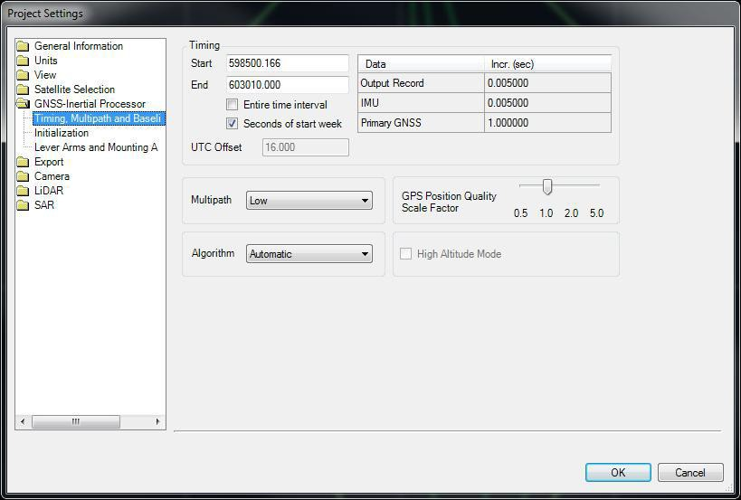

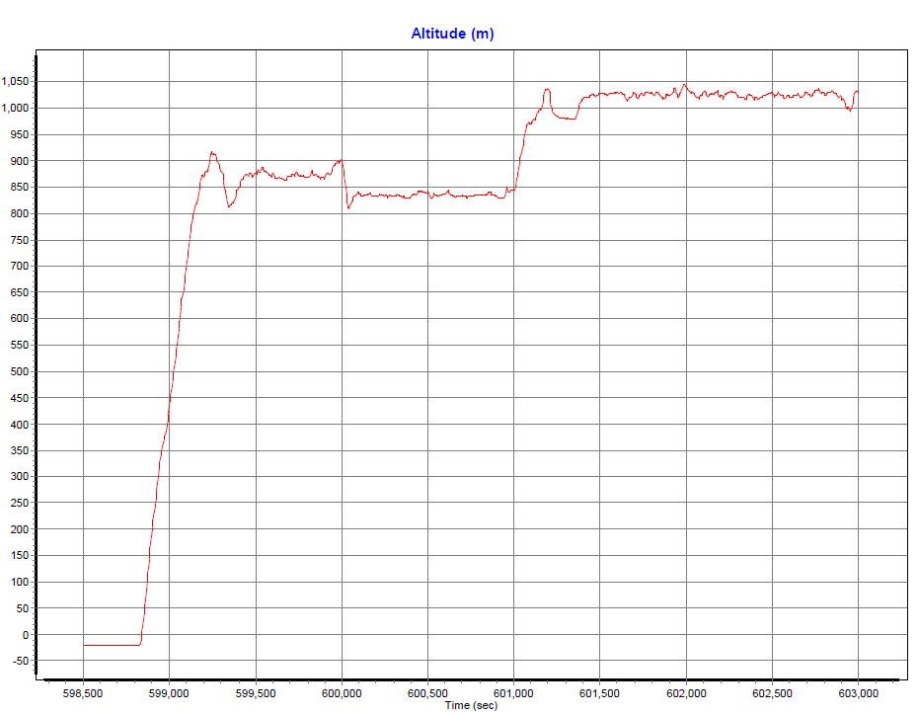

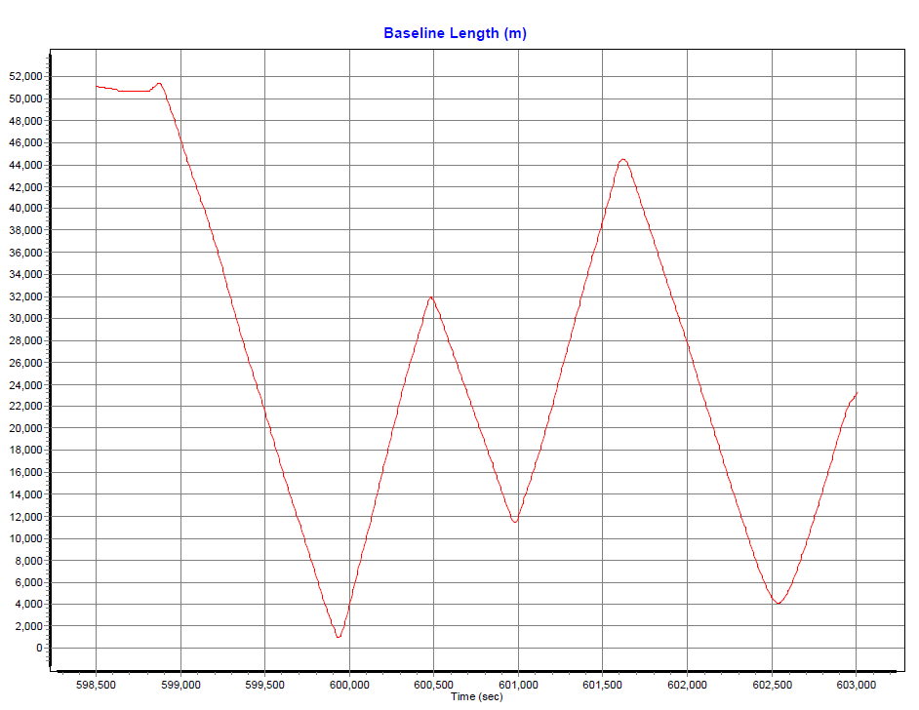

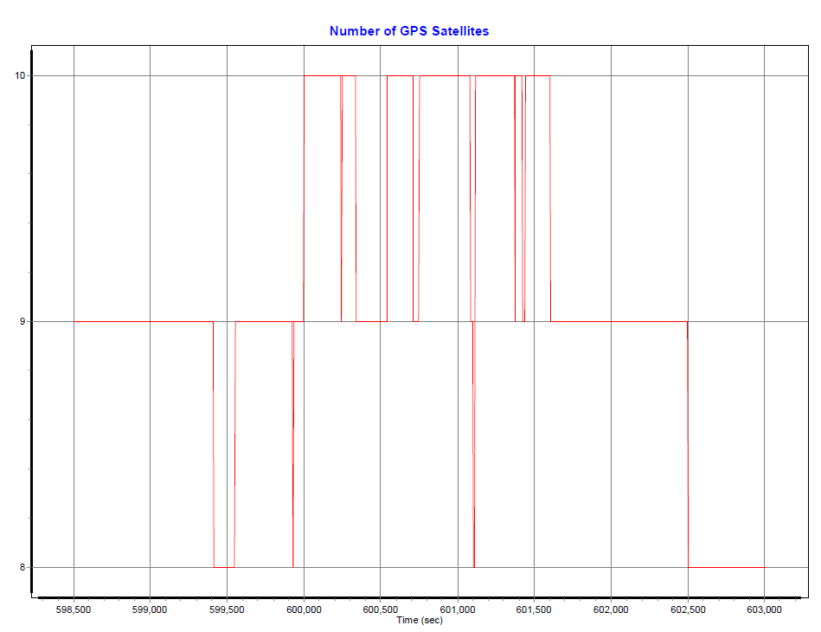

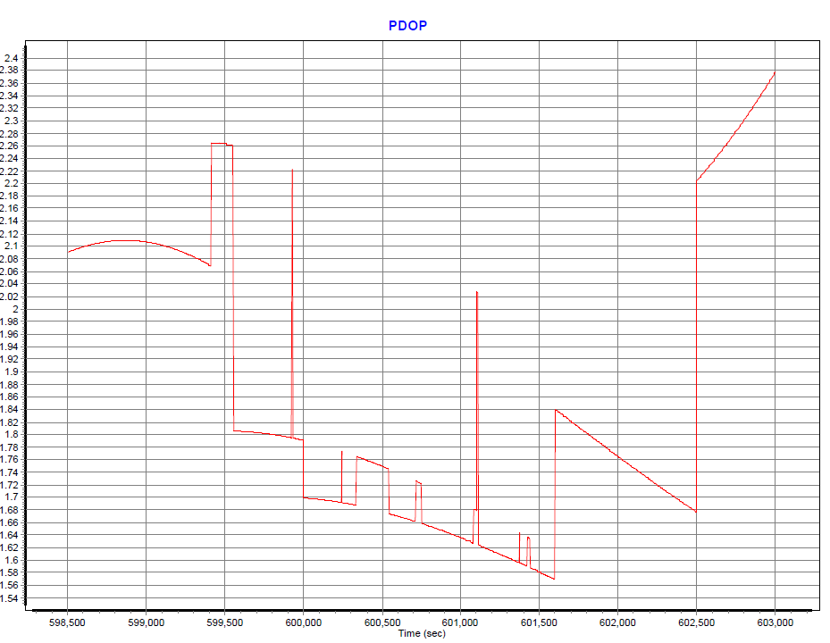

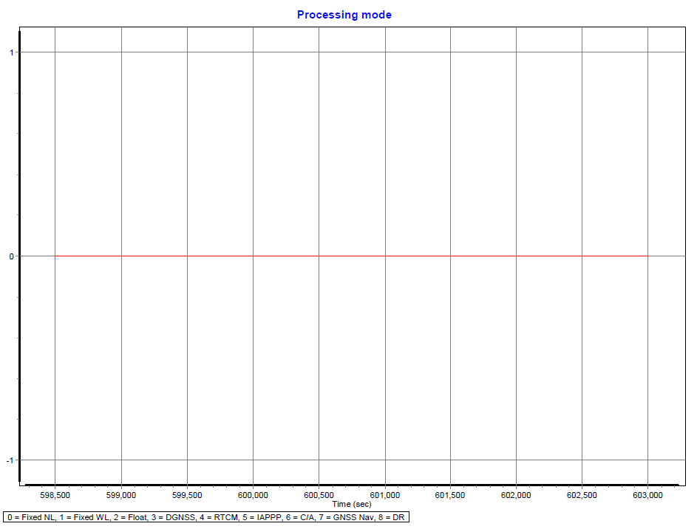

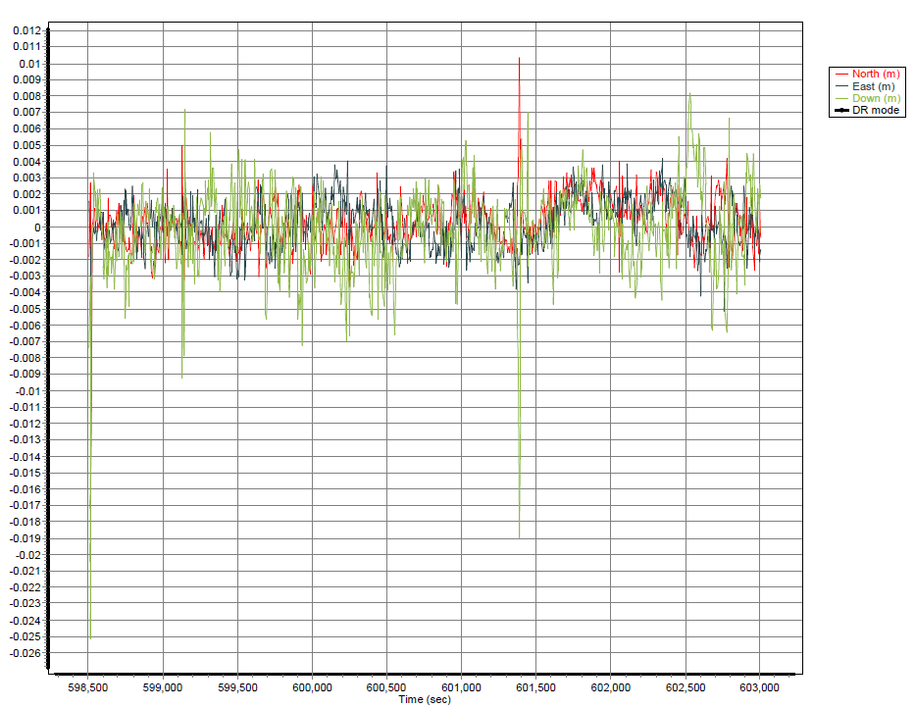

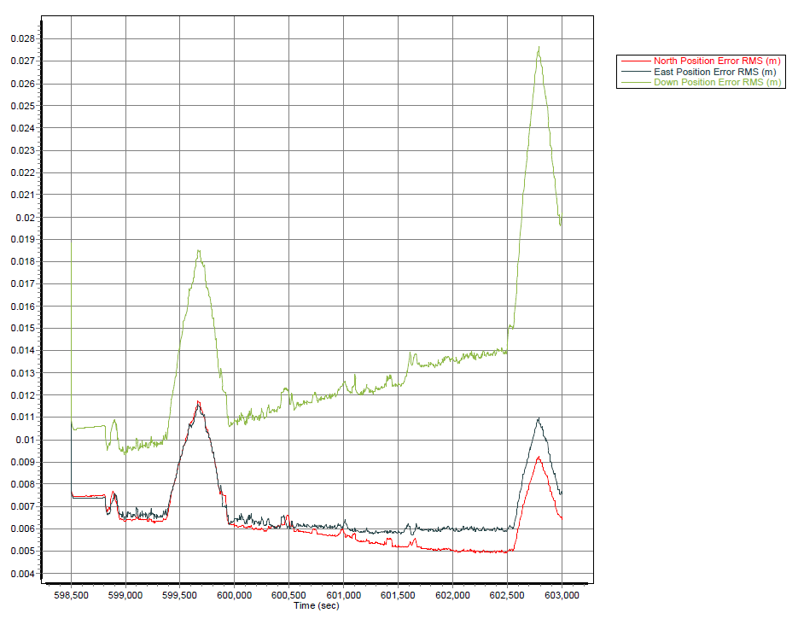

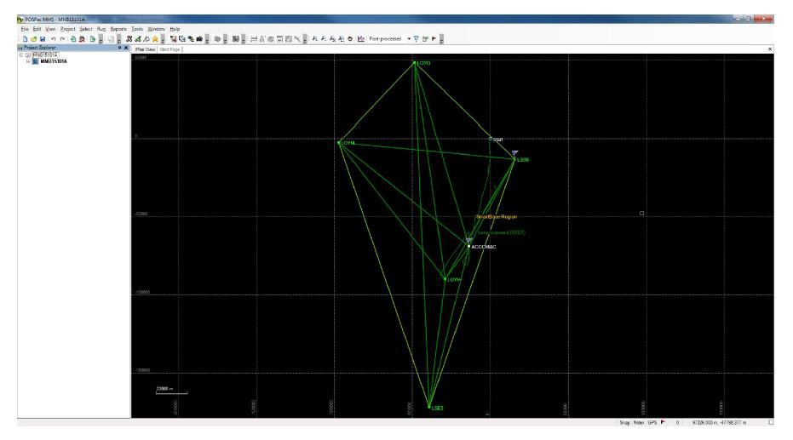
MNB15102A
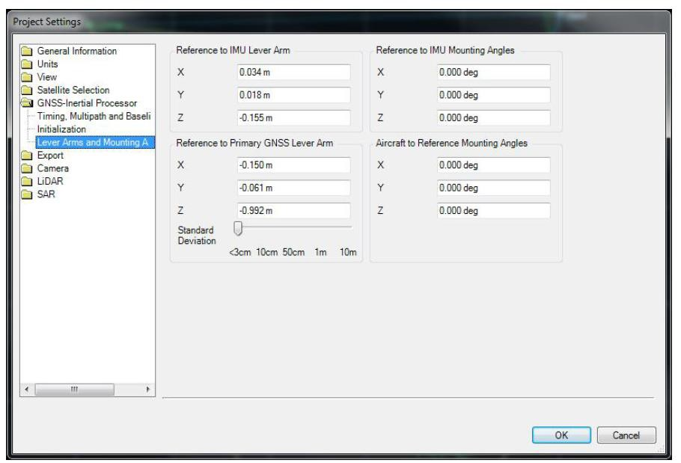

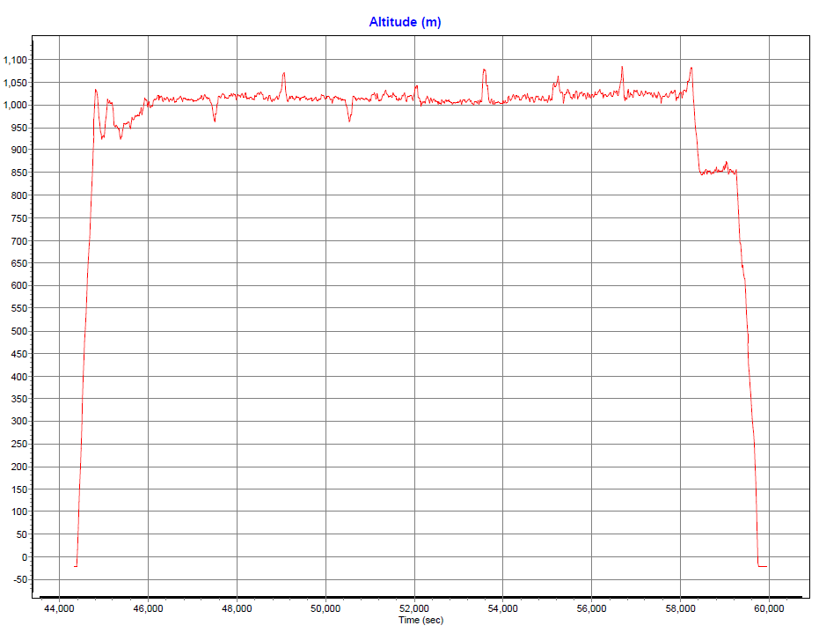

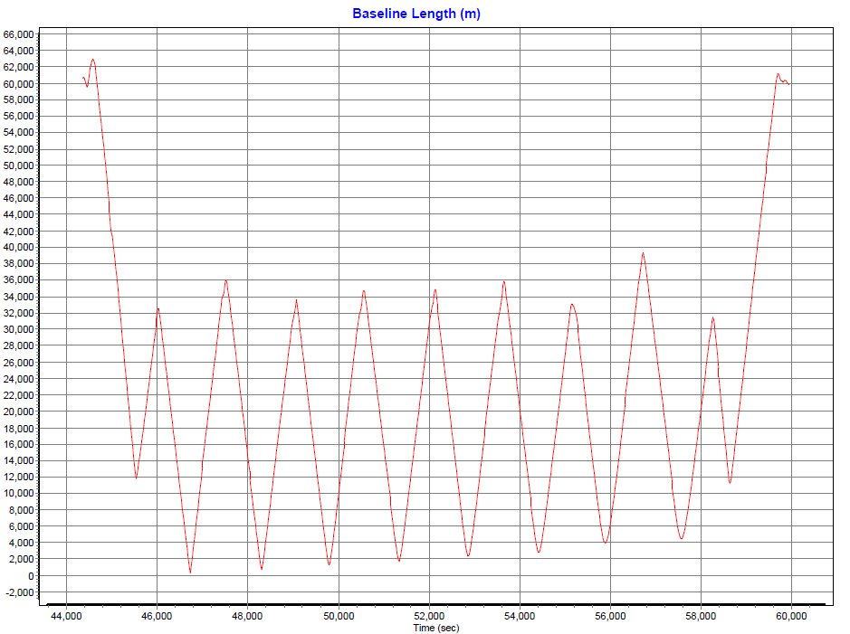

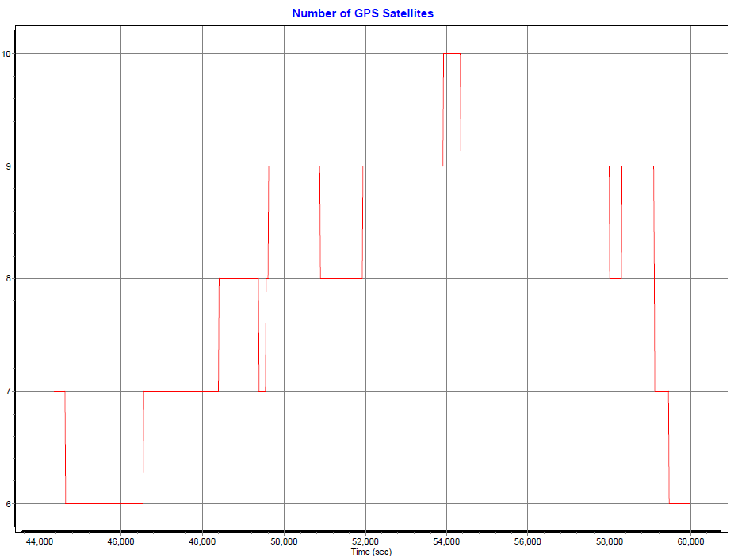

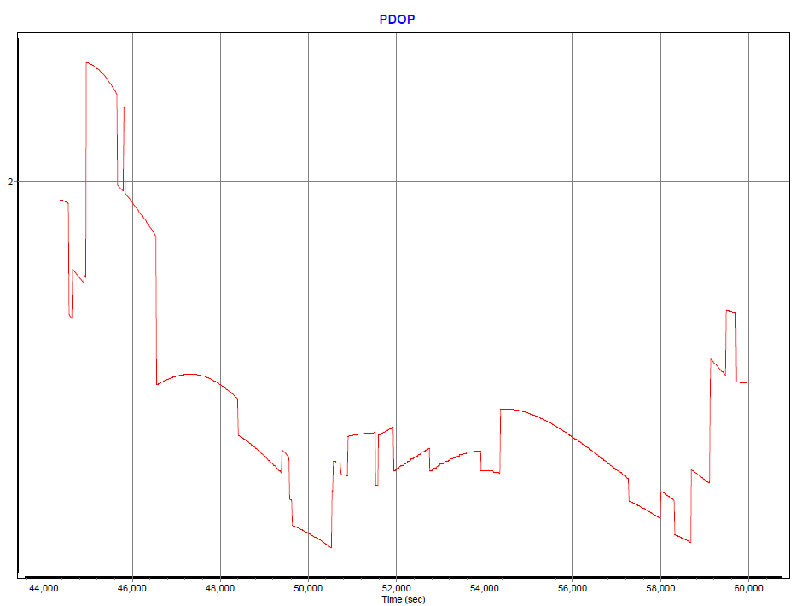

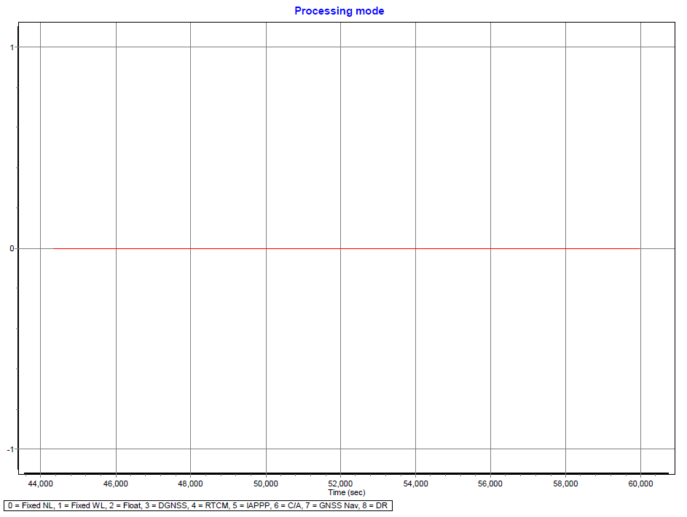

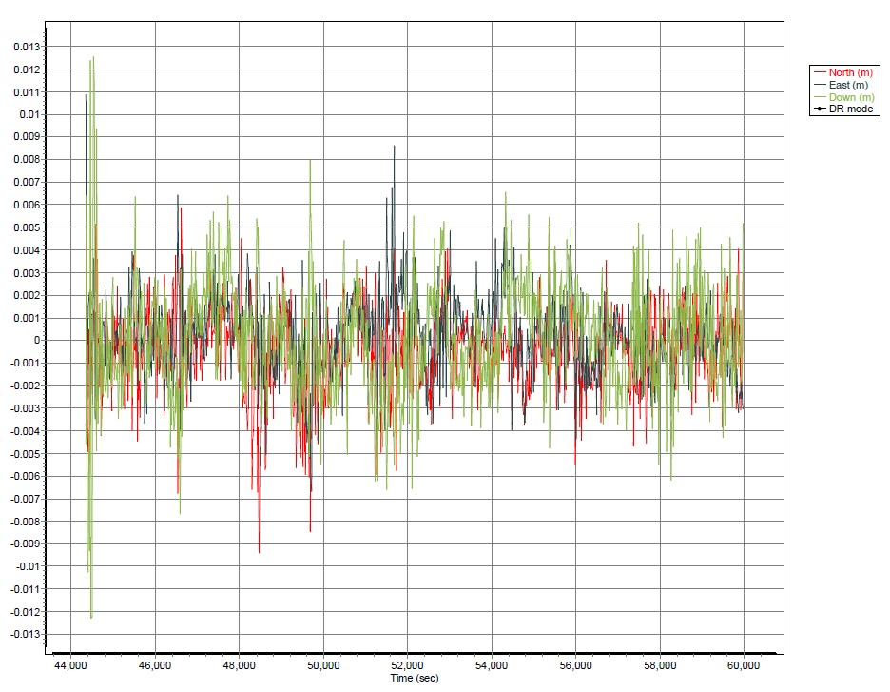

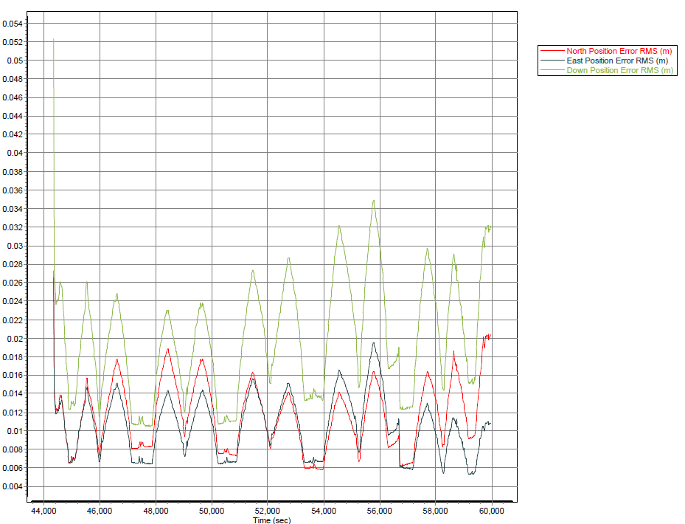

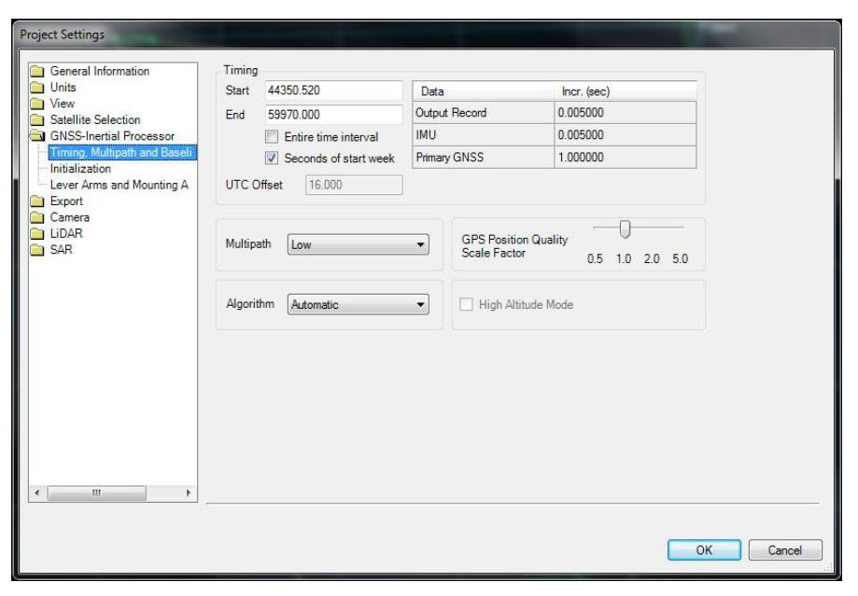

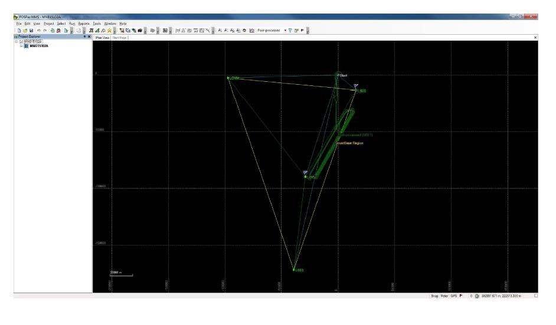

MNB15102B
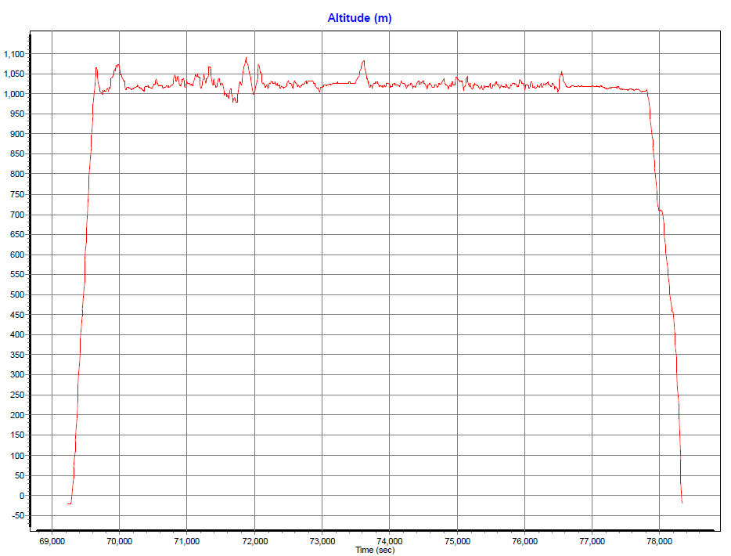

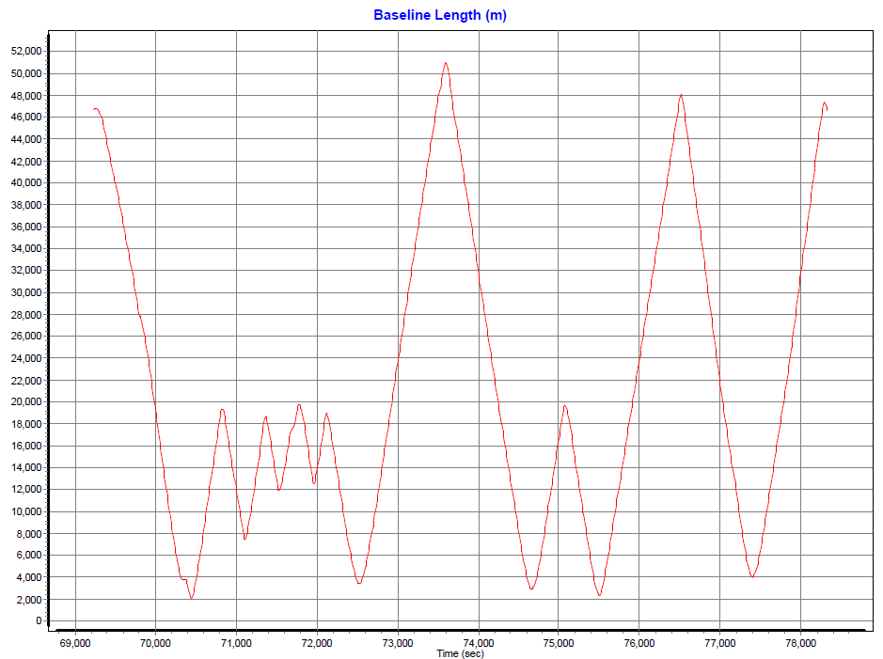

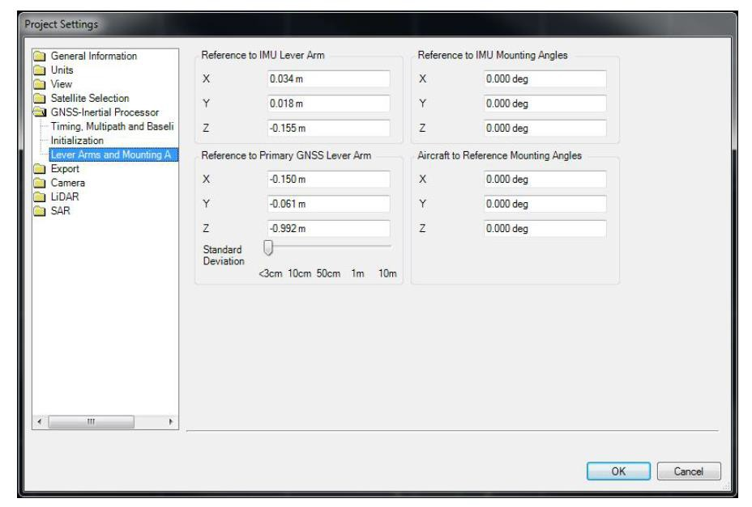

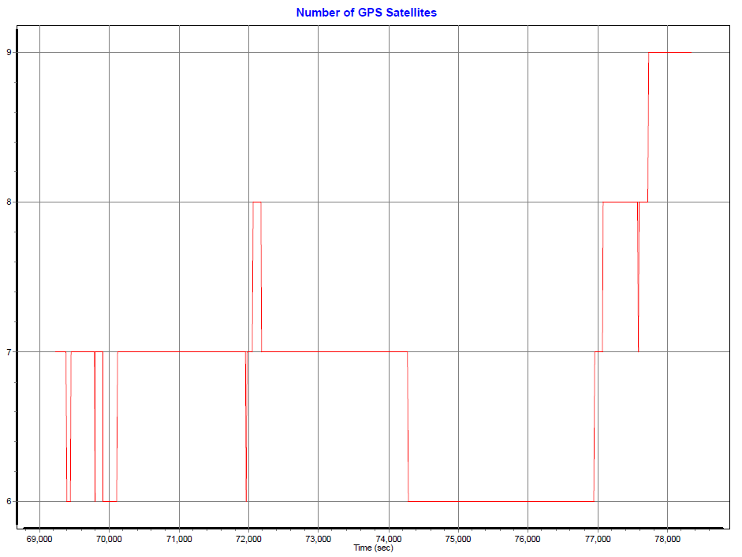

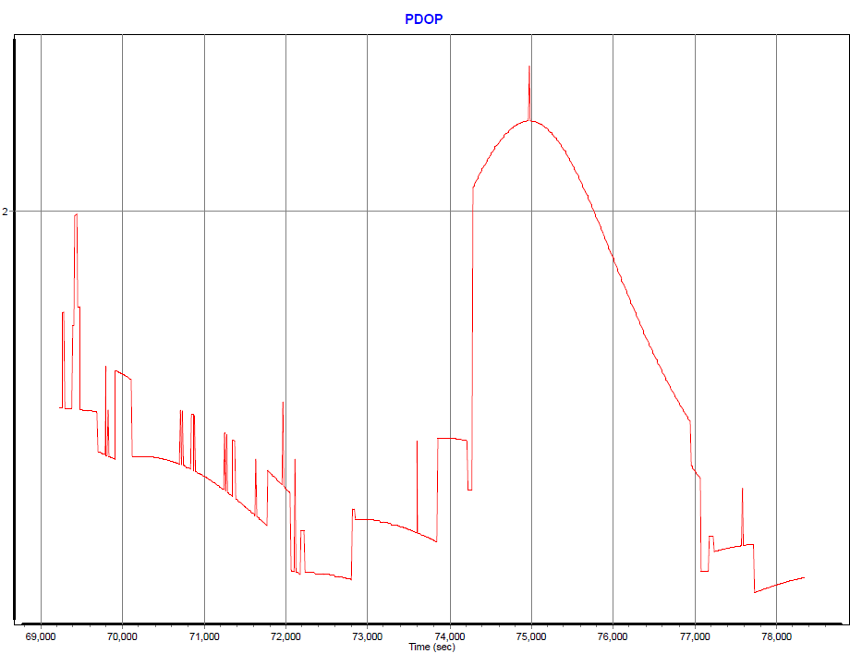

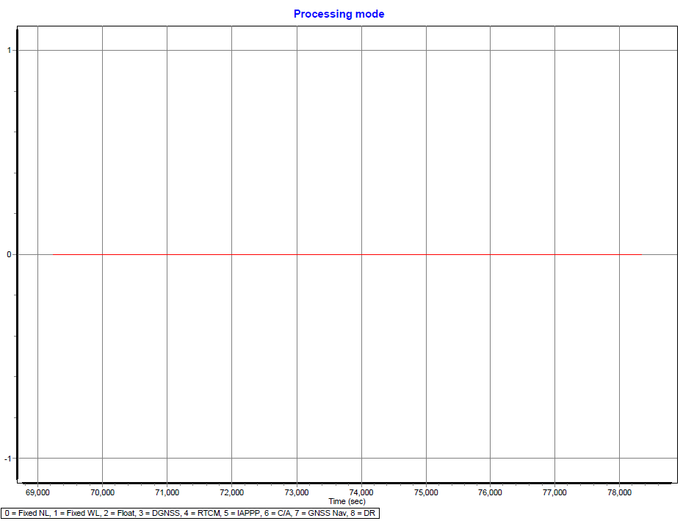

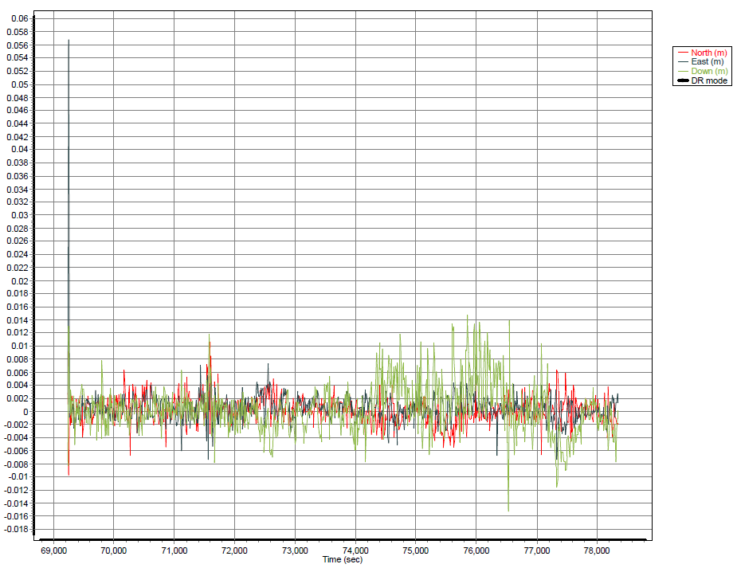

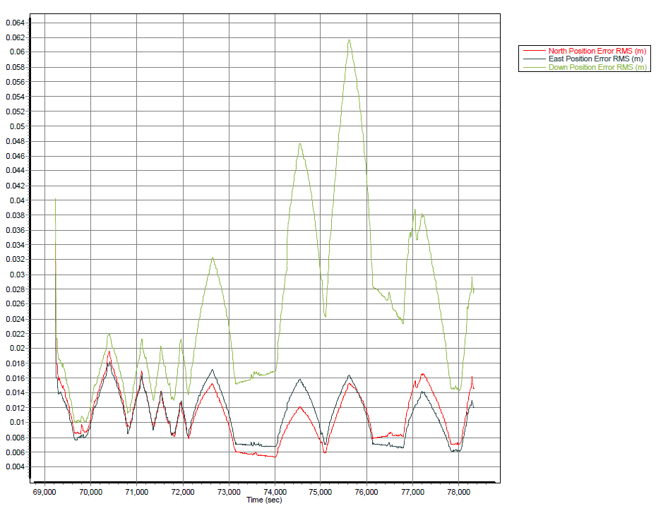

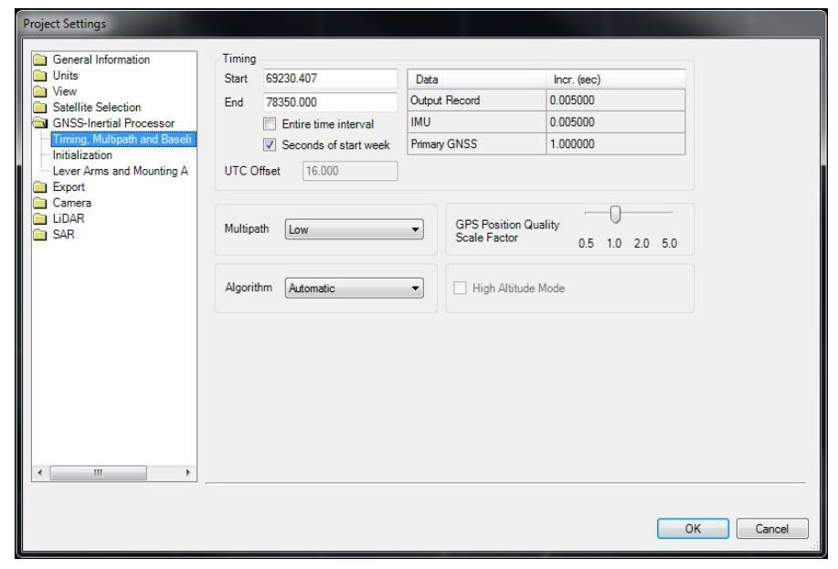

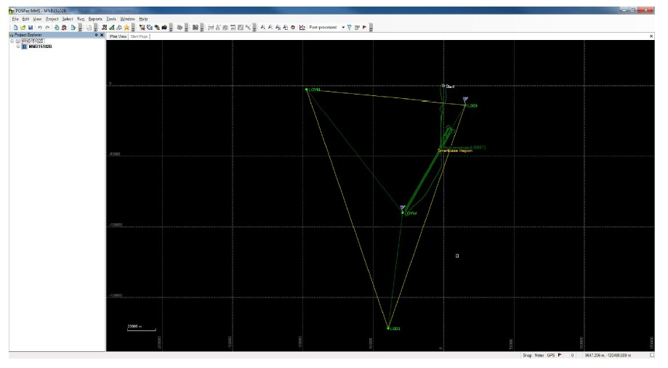

MNB15103A
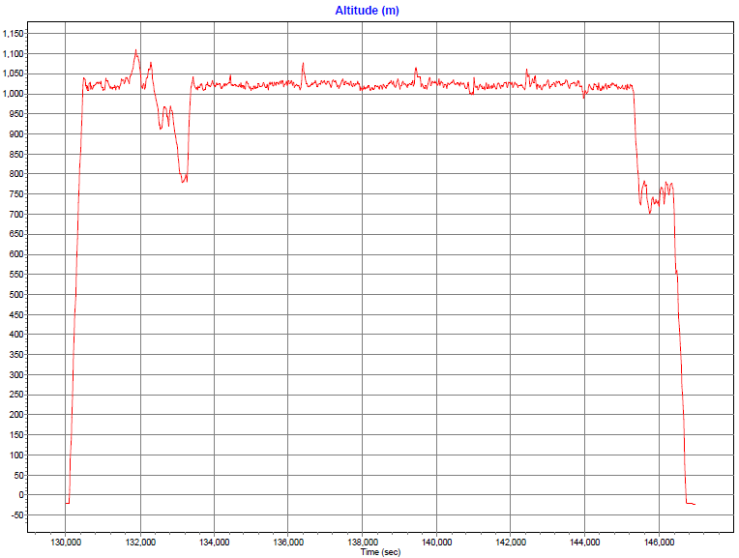

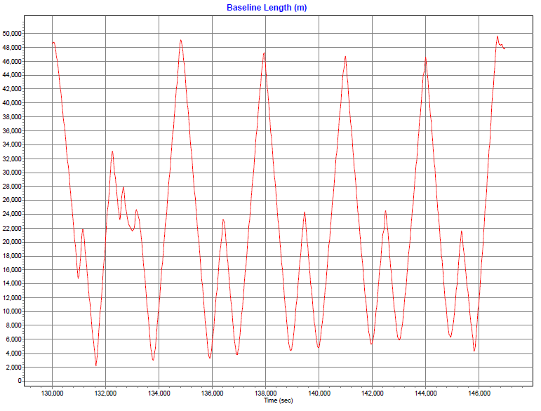

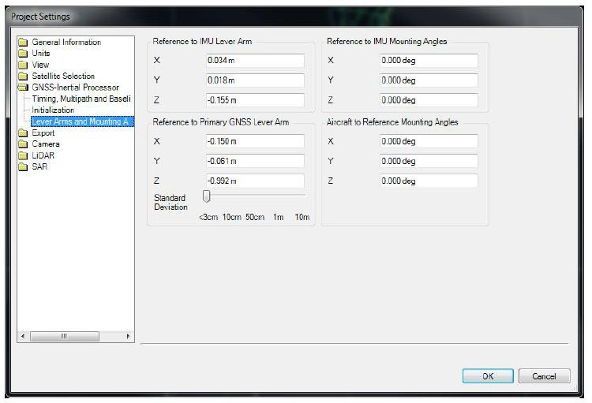

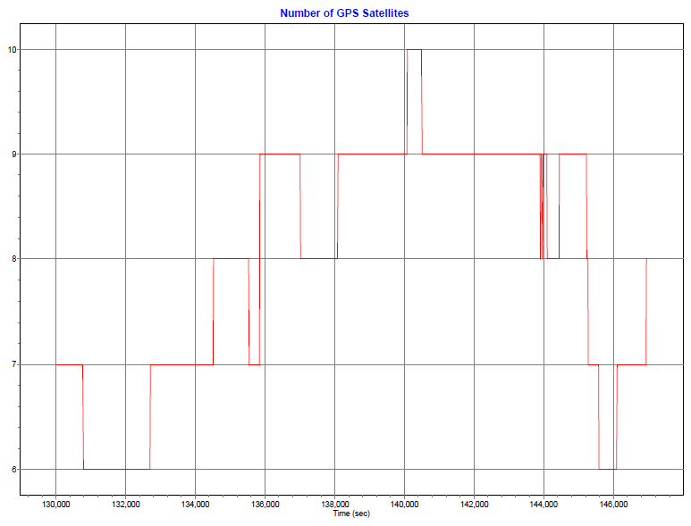

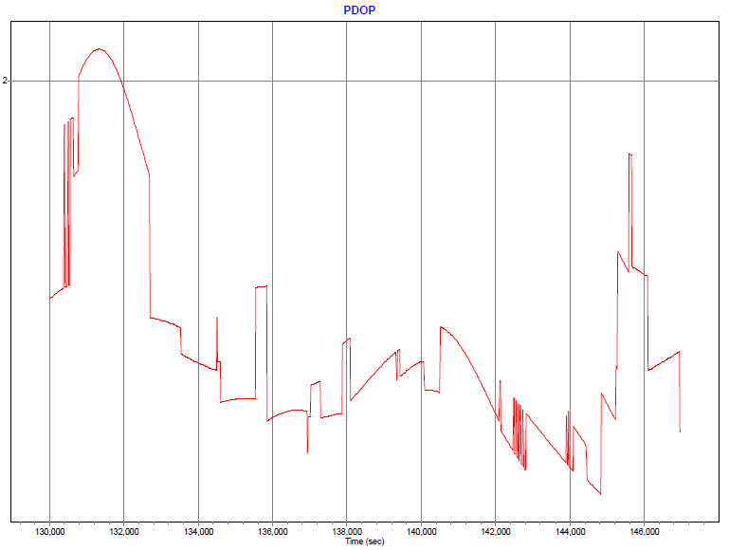

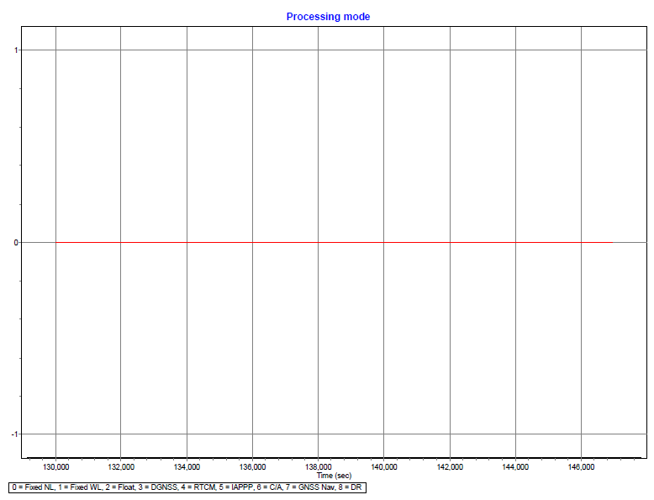

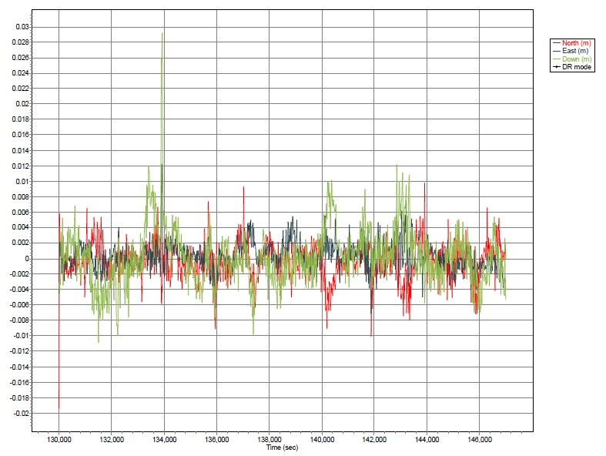

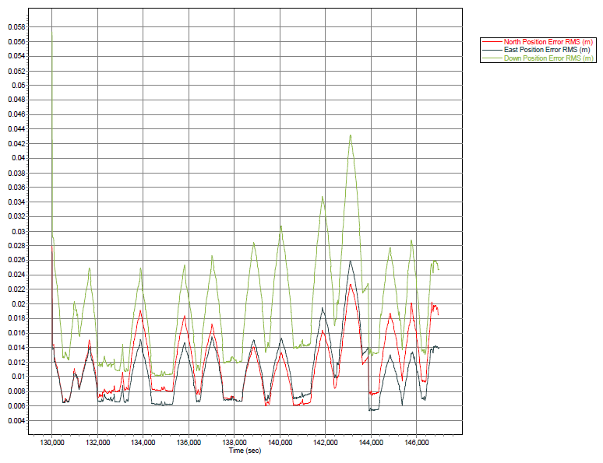

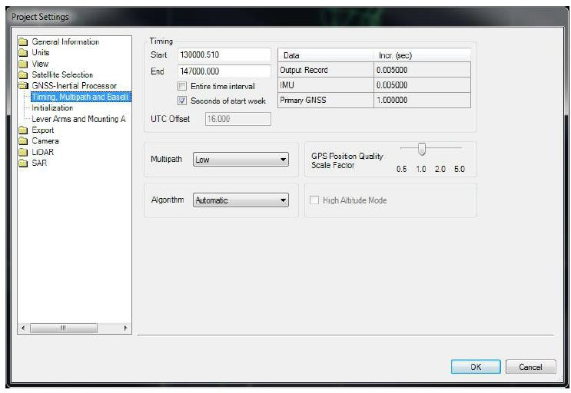

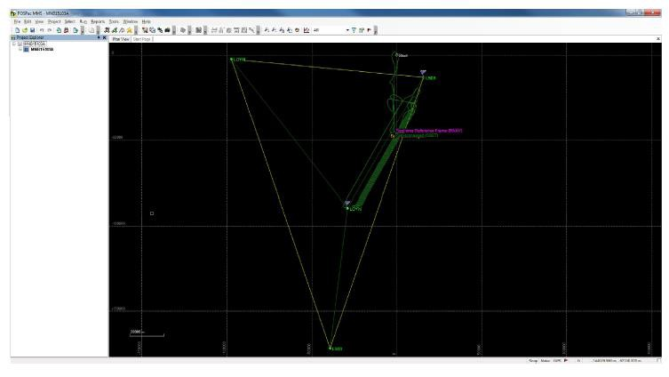

MNB15105A
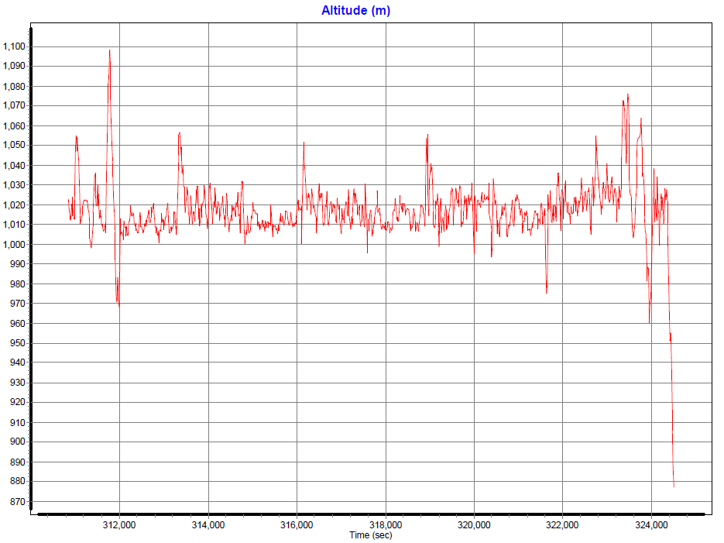

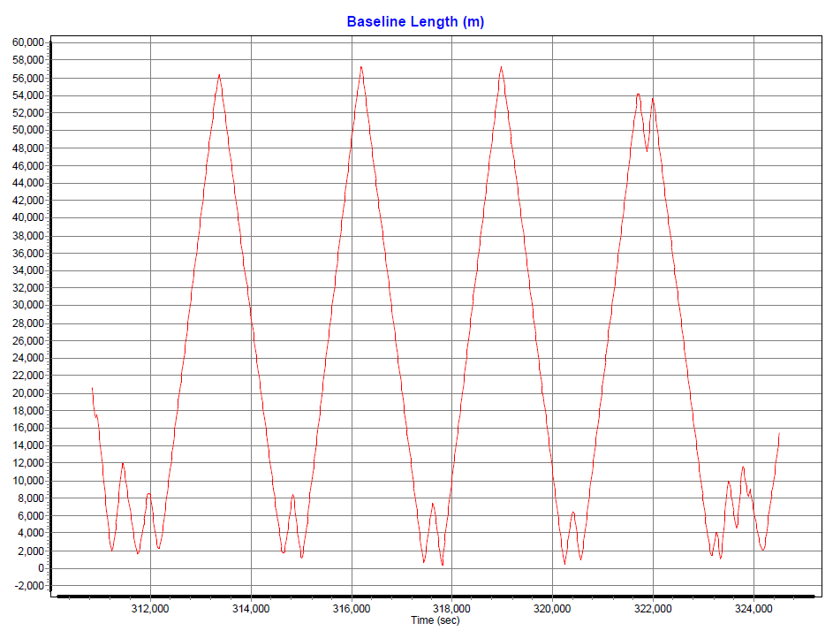

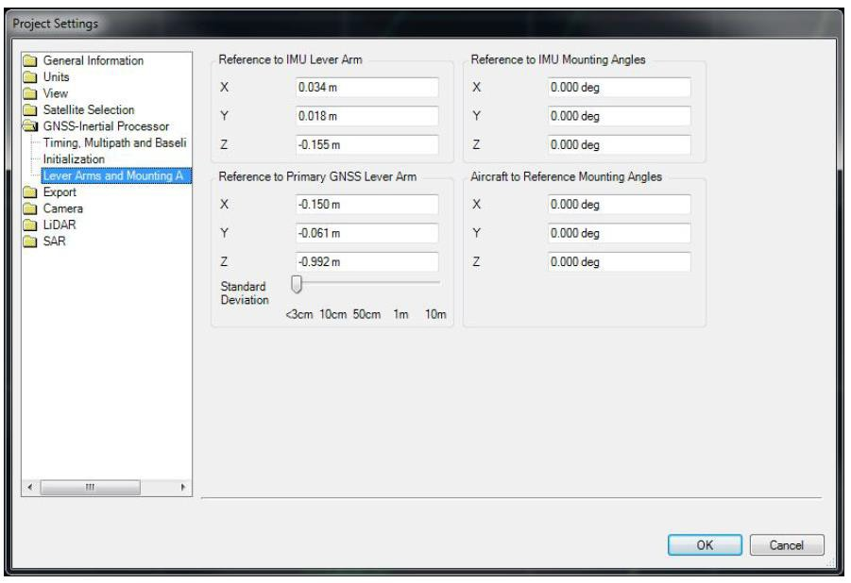

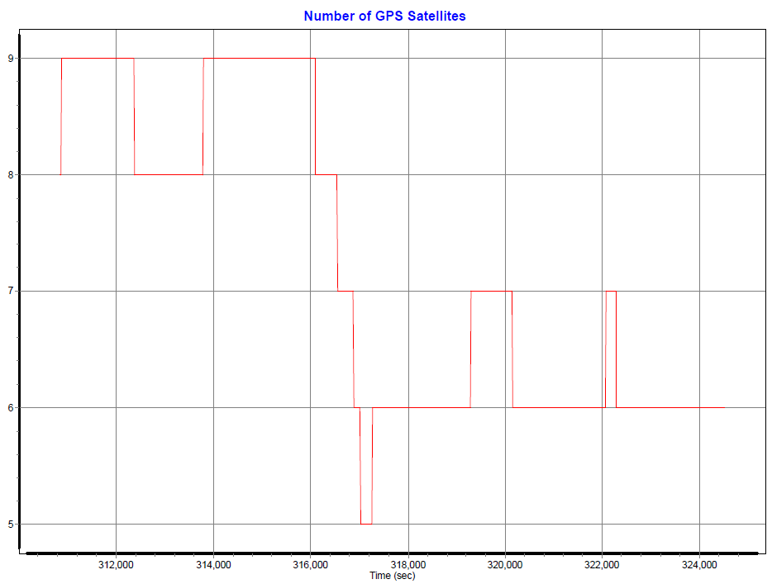

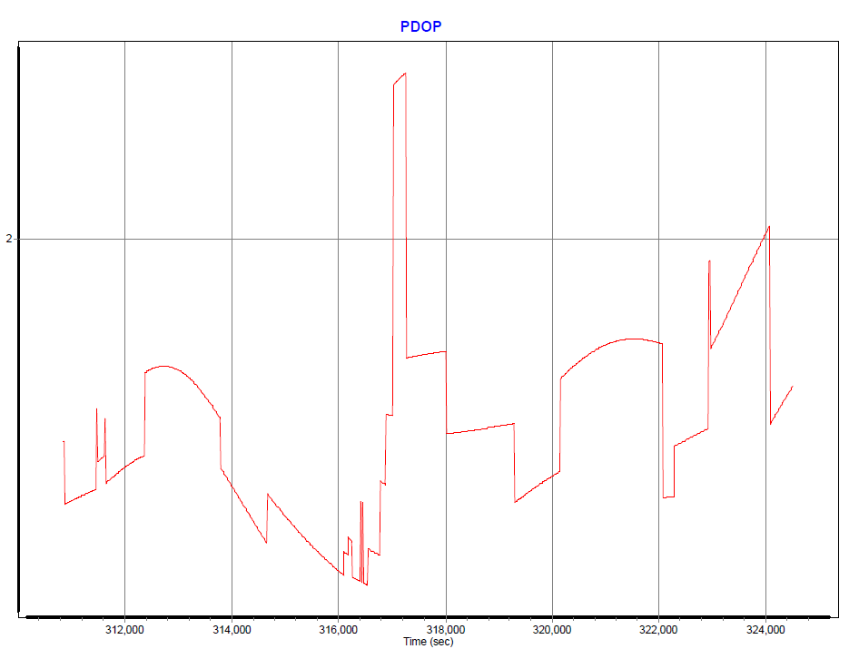

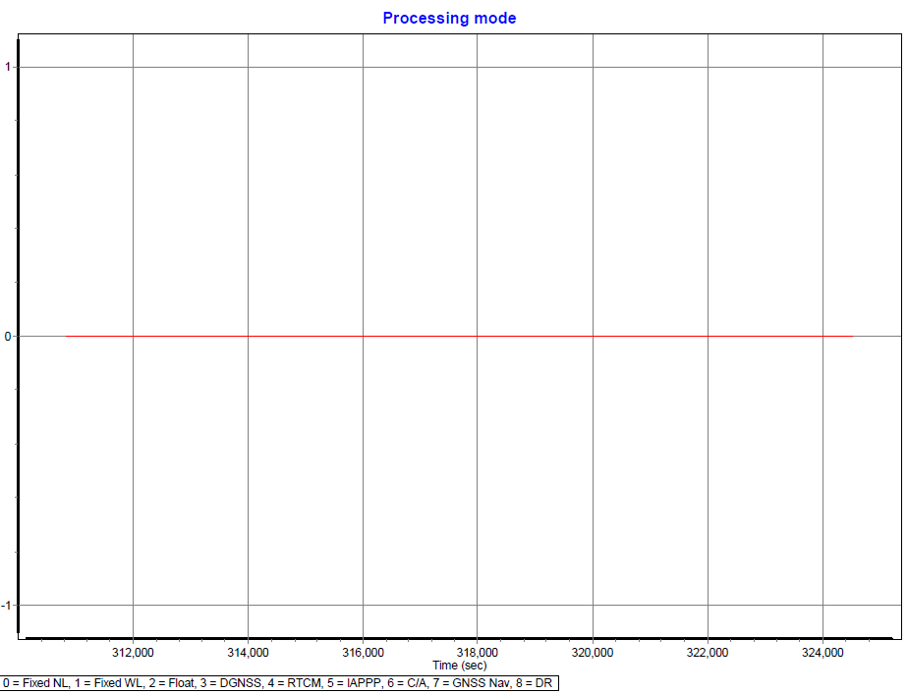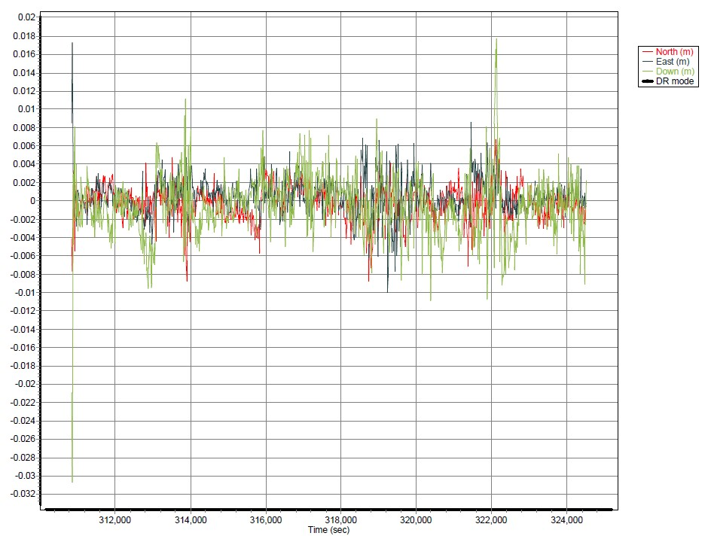

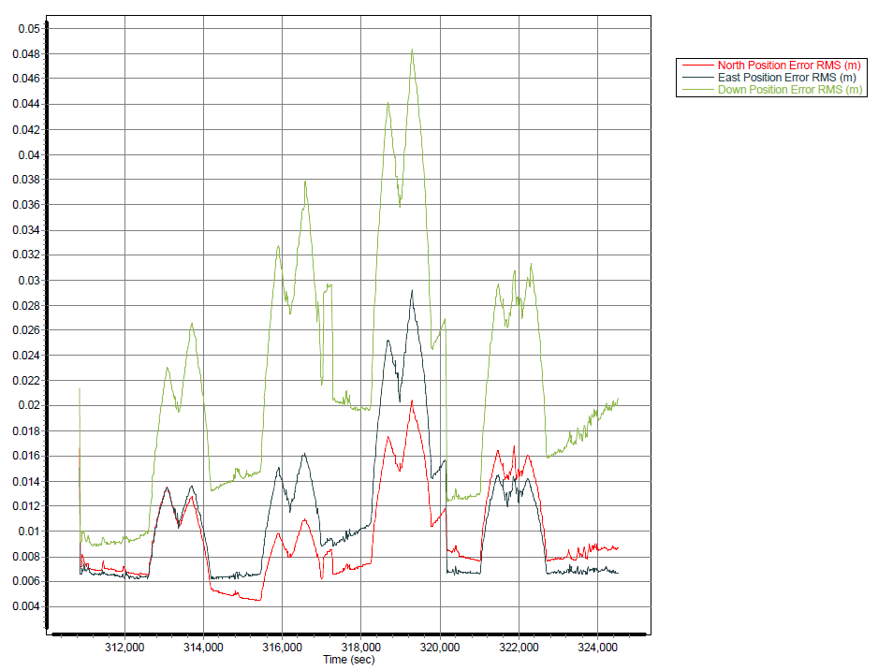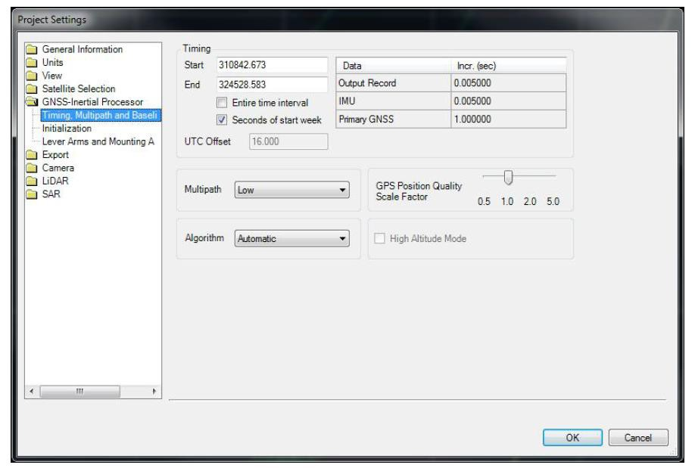

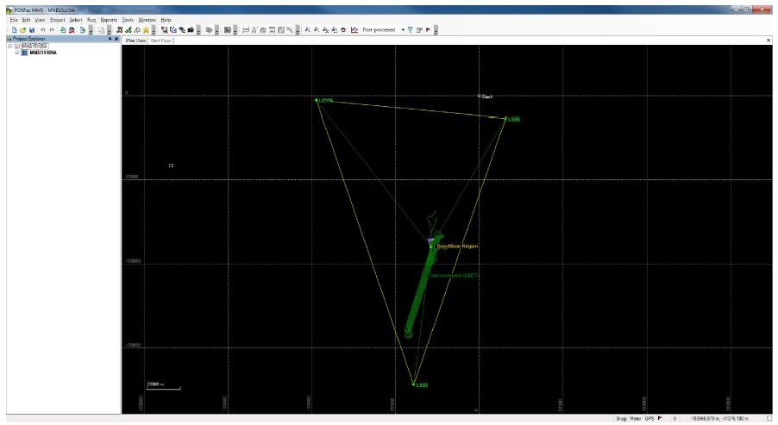

MNB15106A
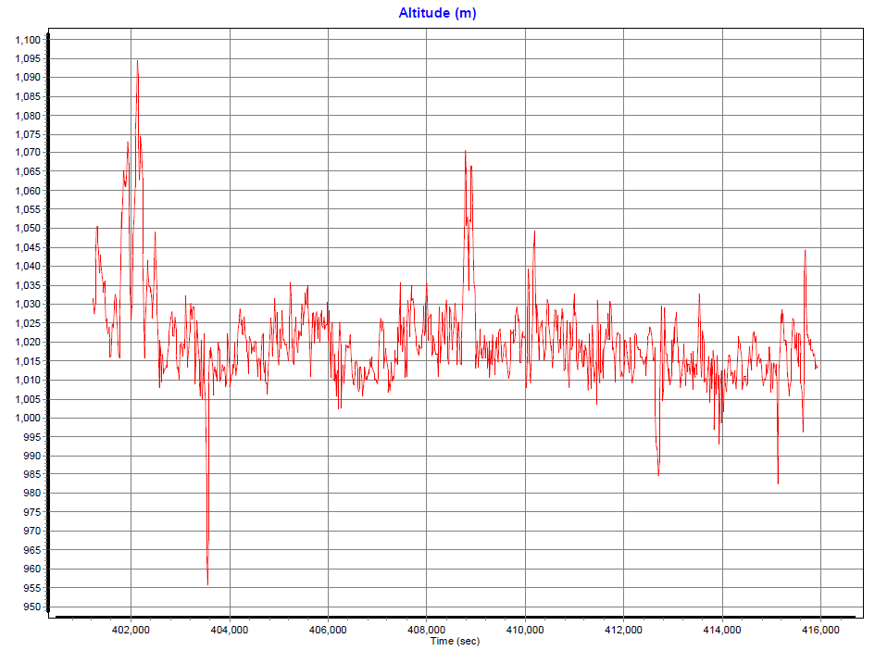

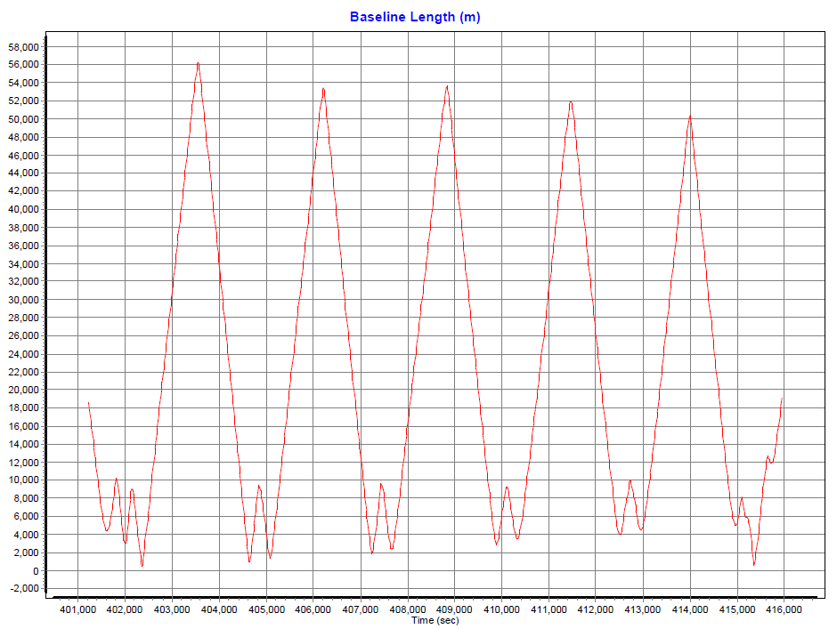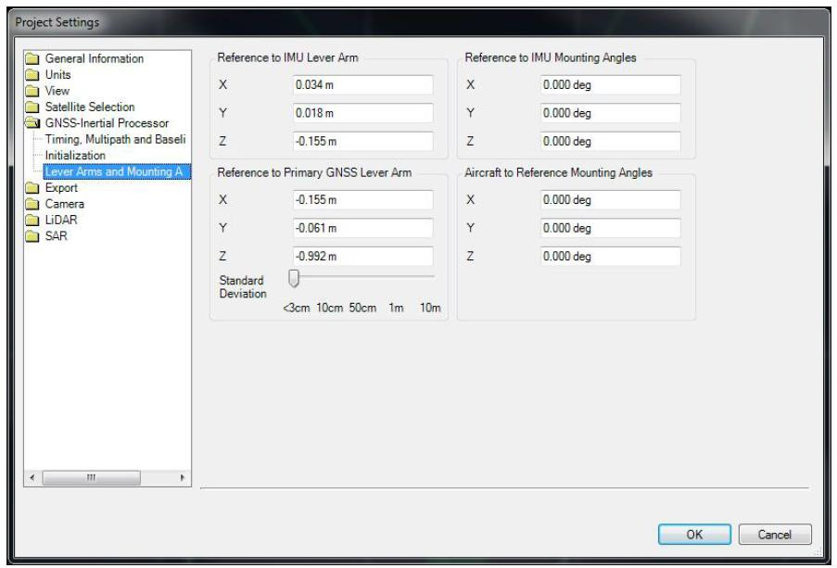

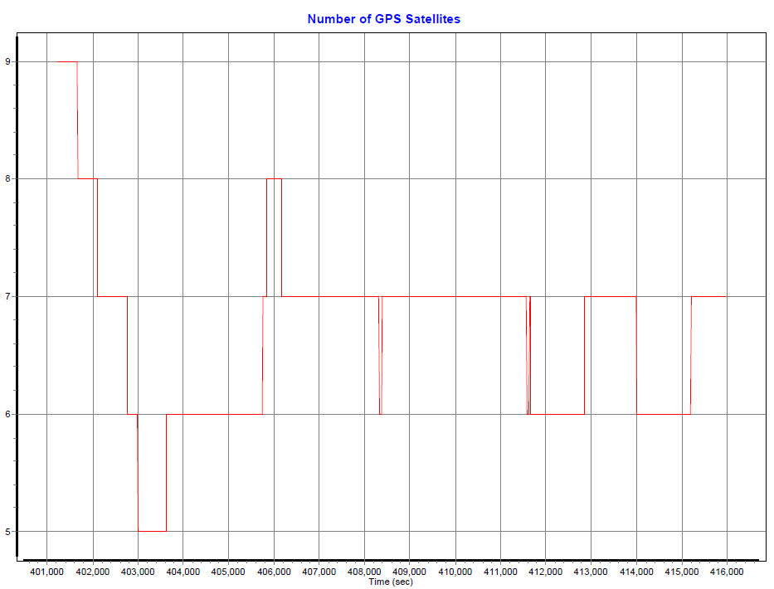

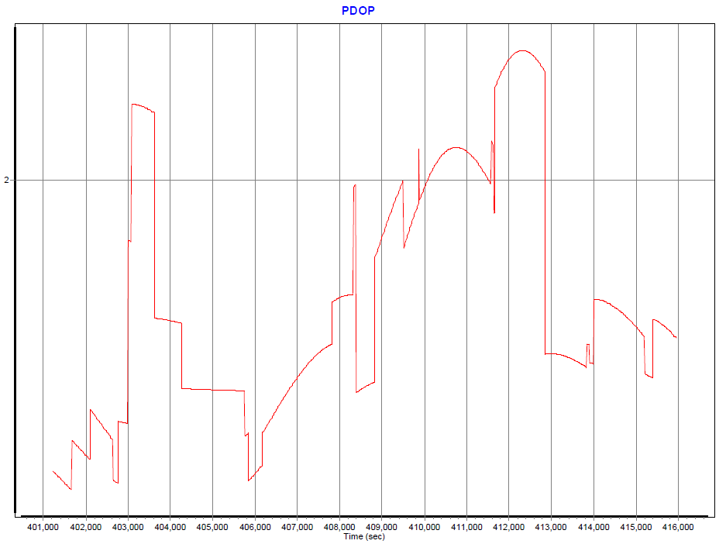

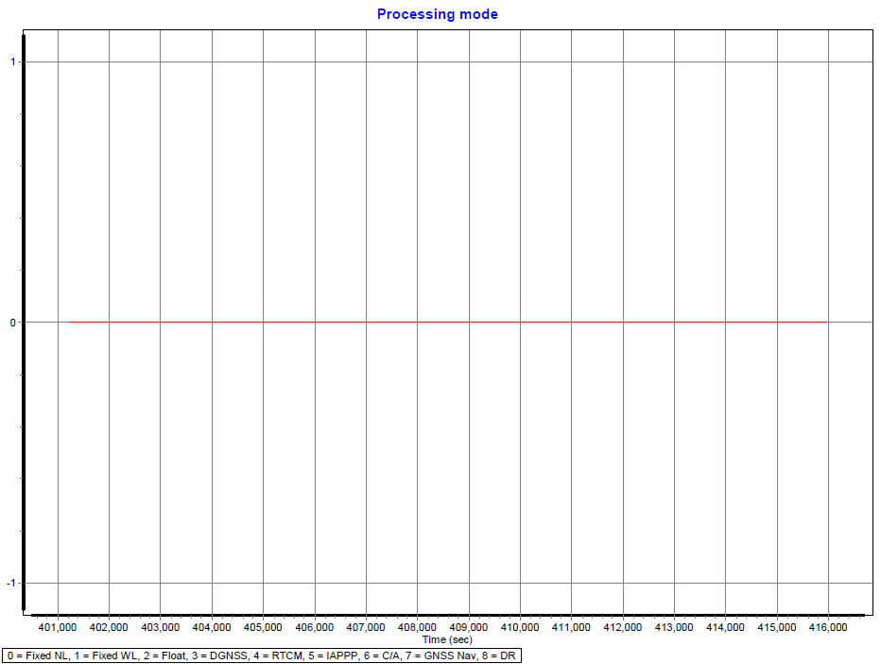

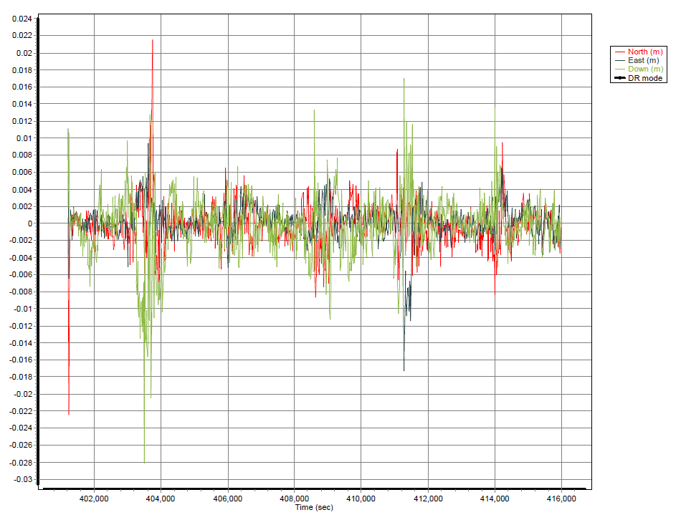

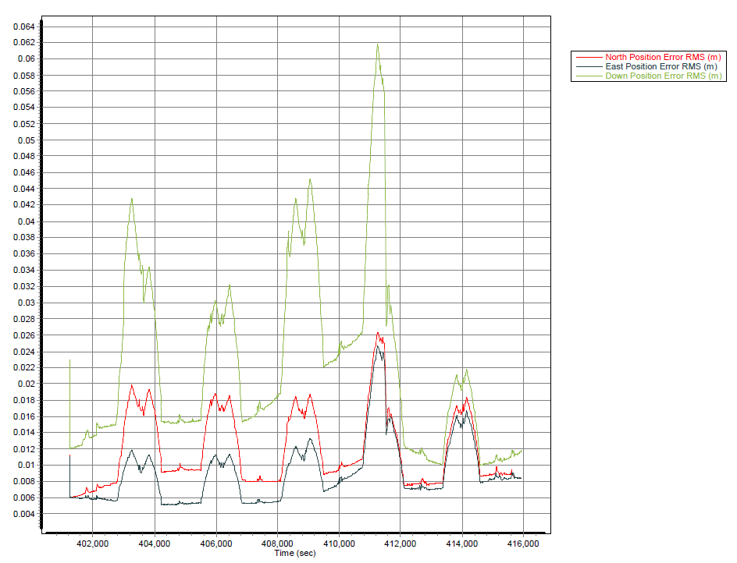

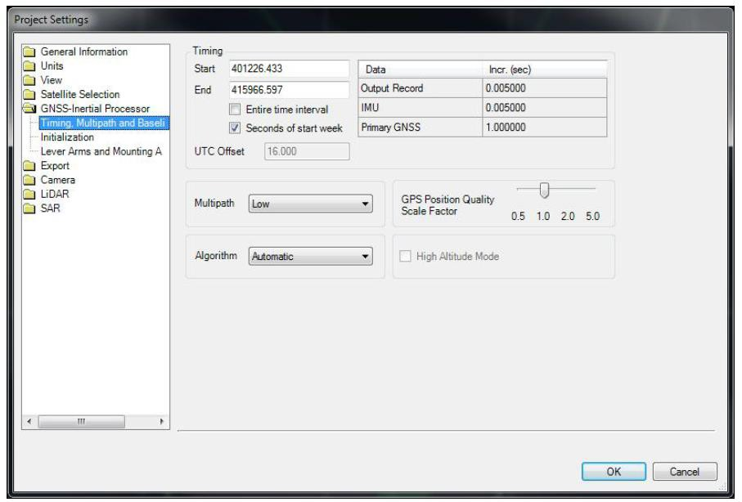

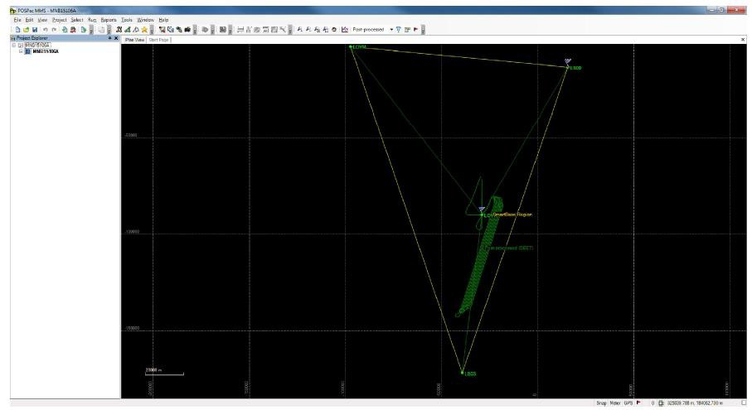

MNB15108A
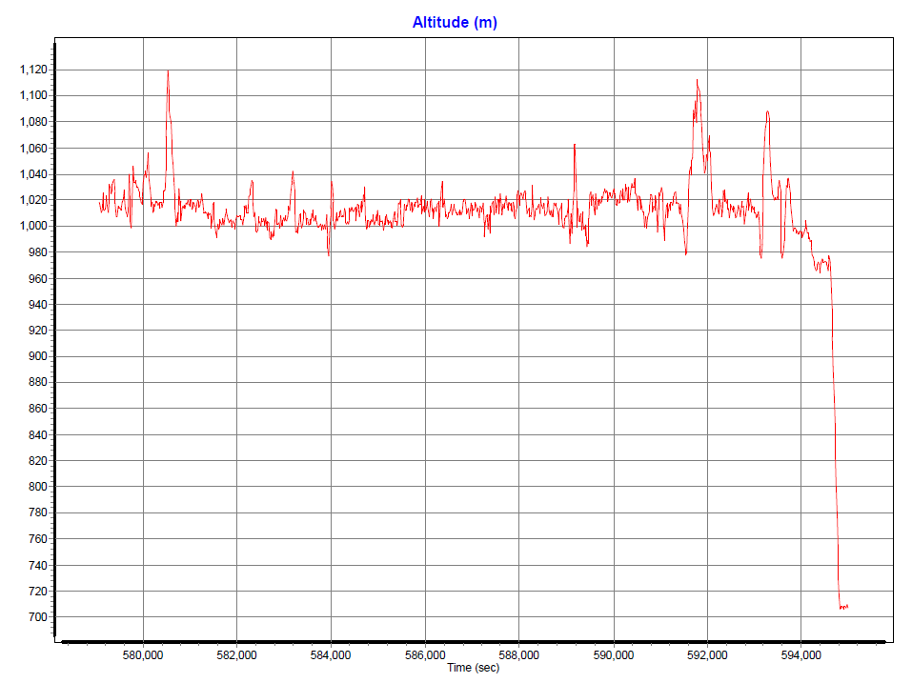

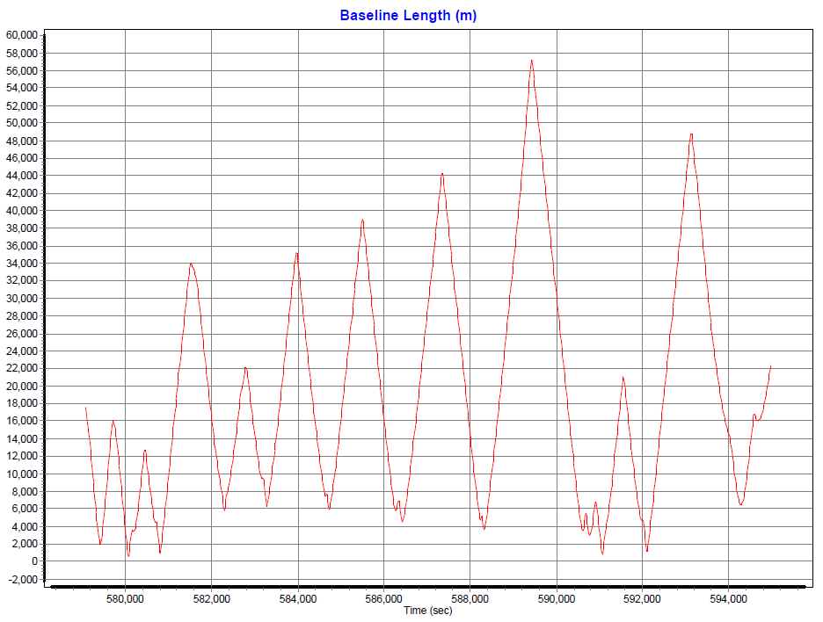

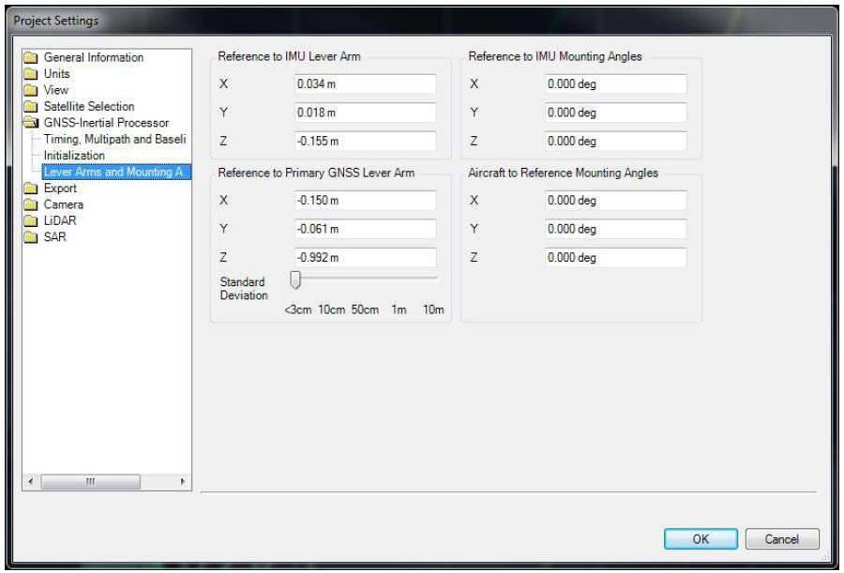

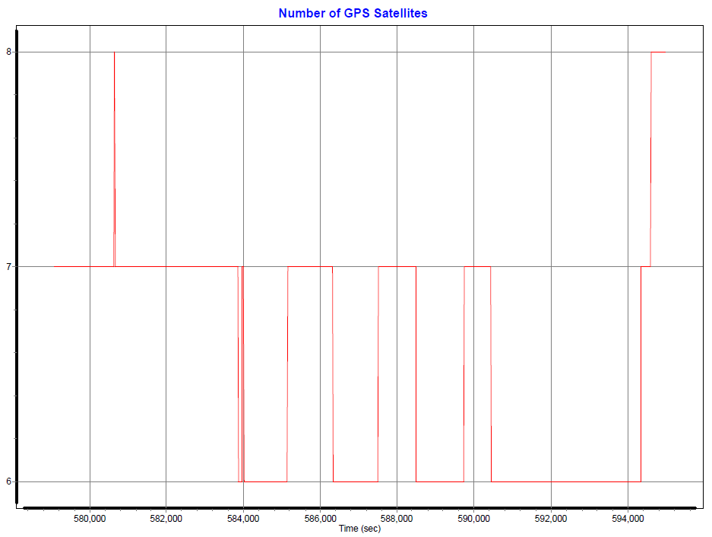

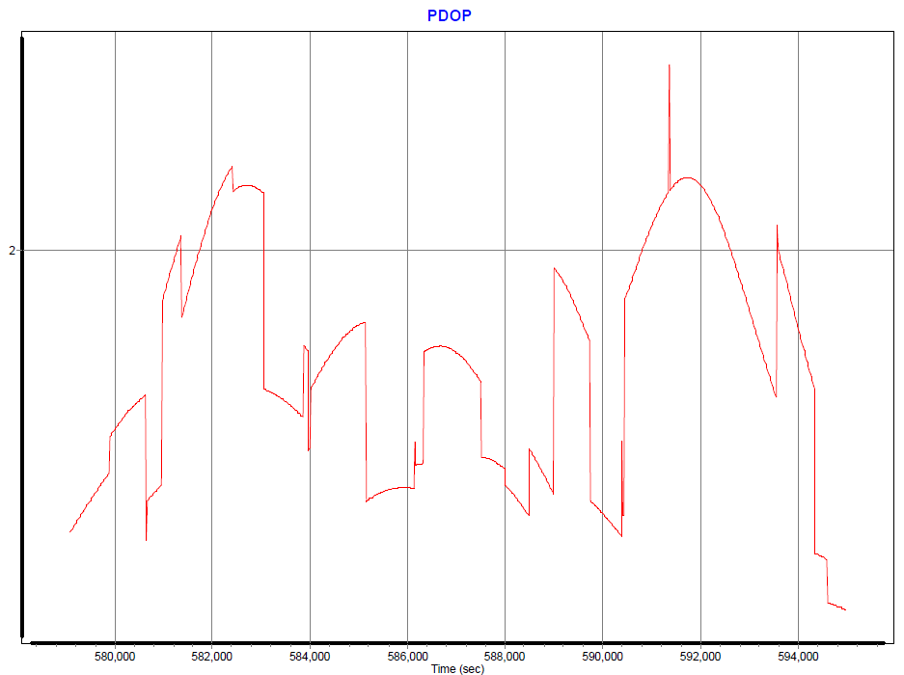

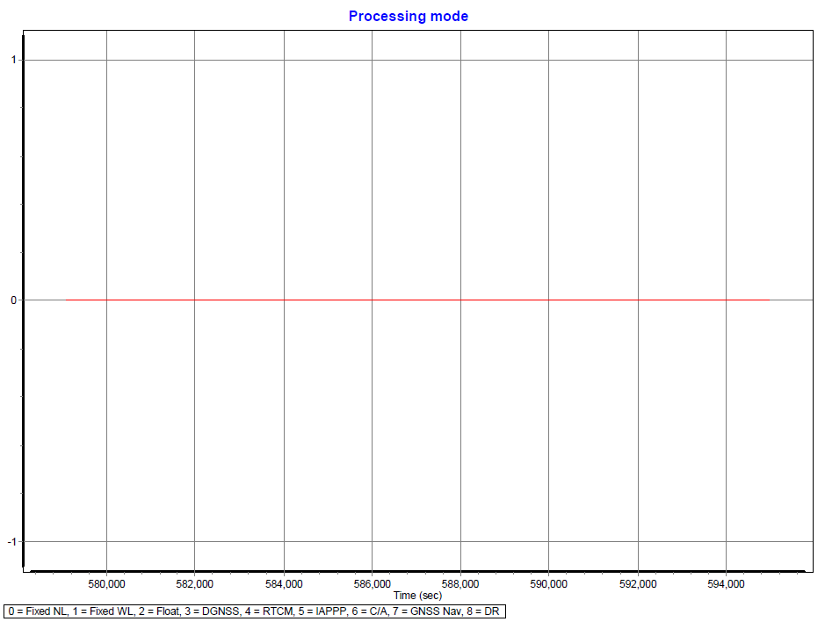

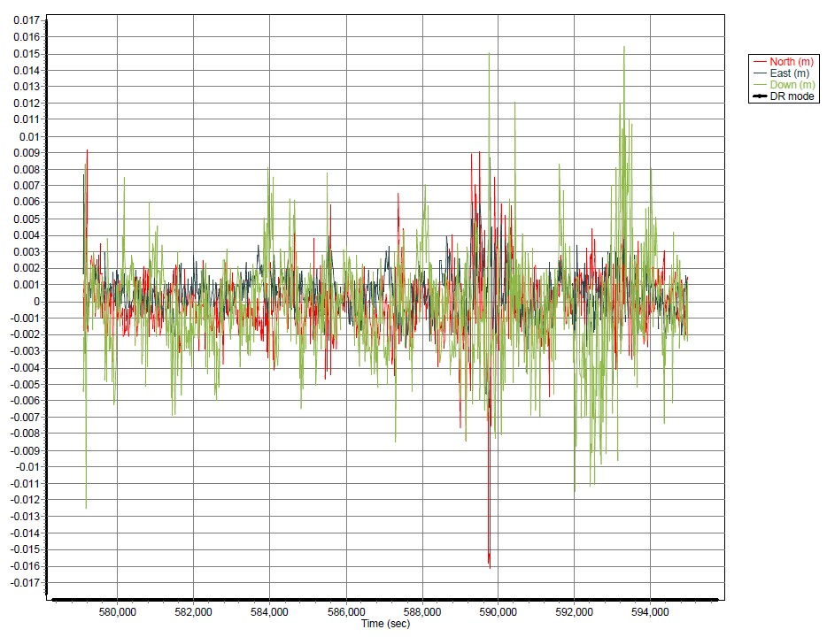

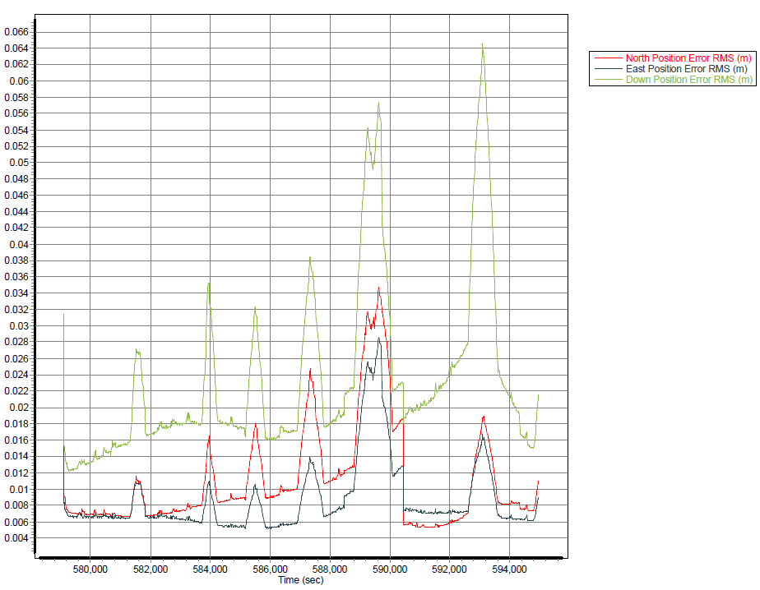

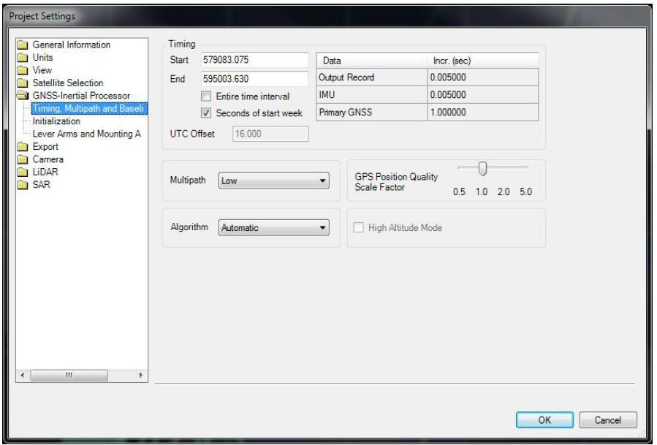

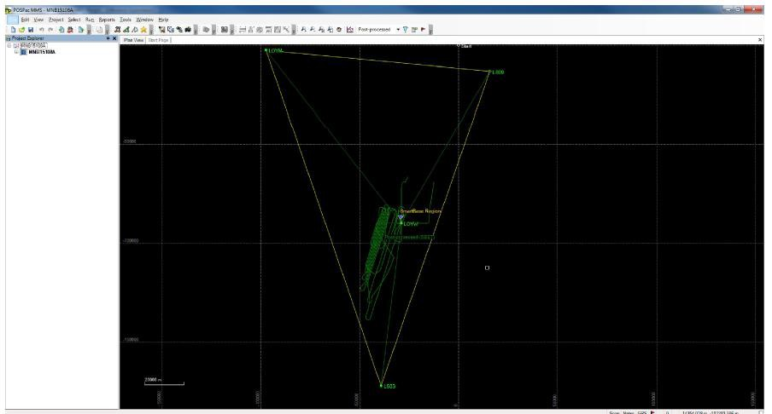

MNB15111A
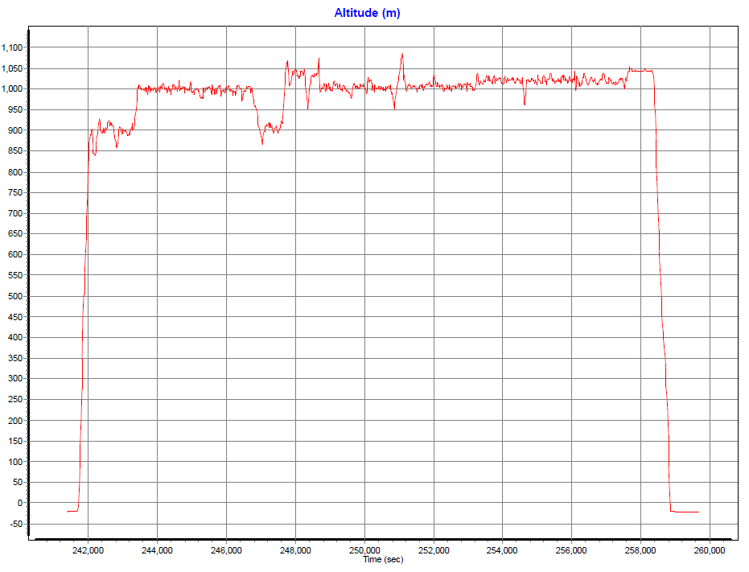

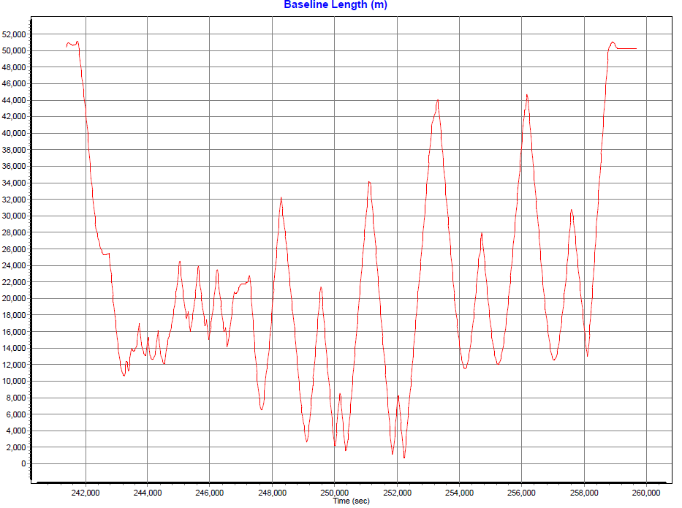

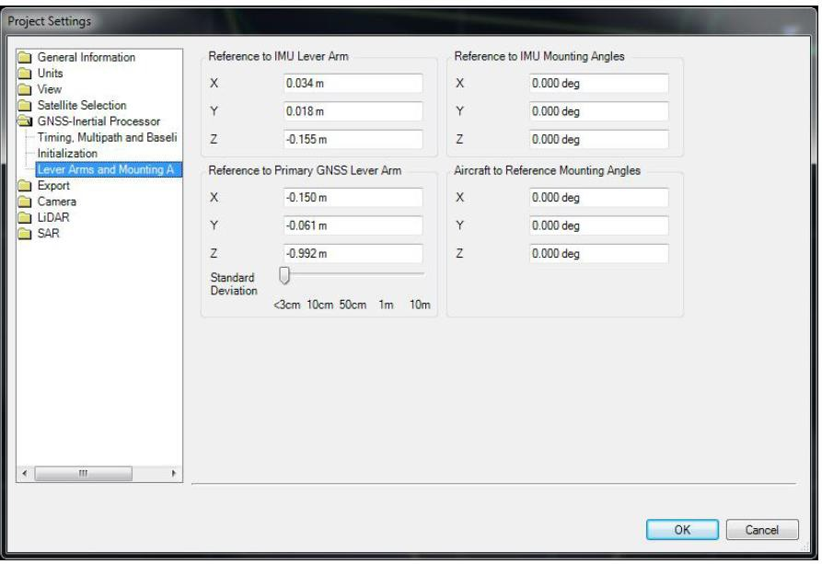

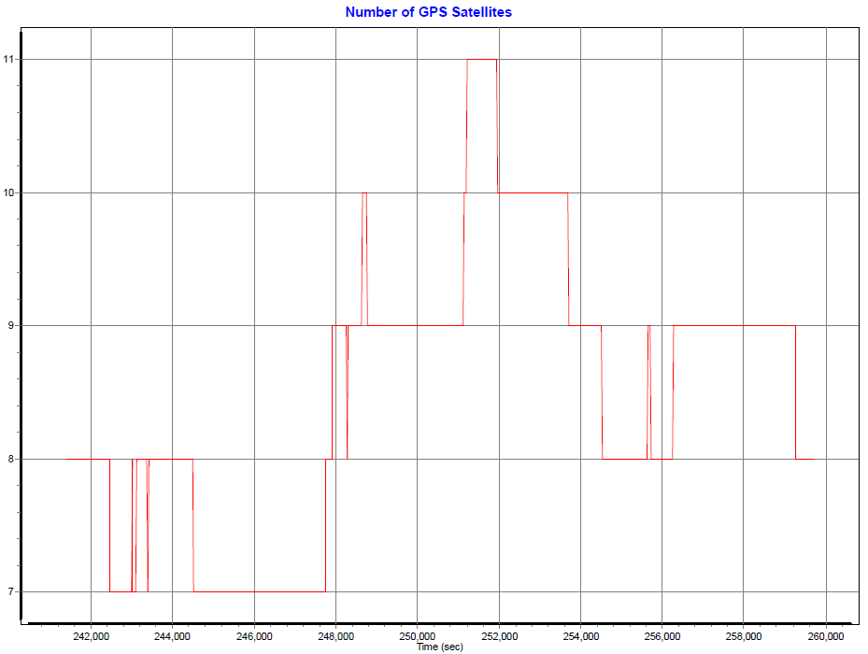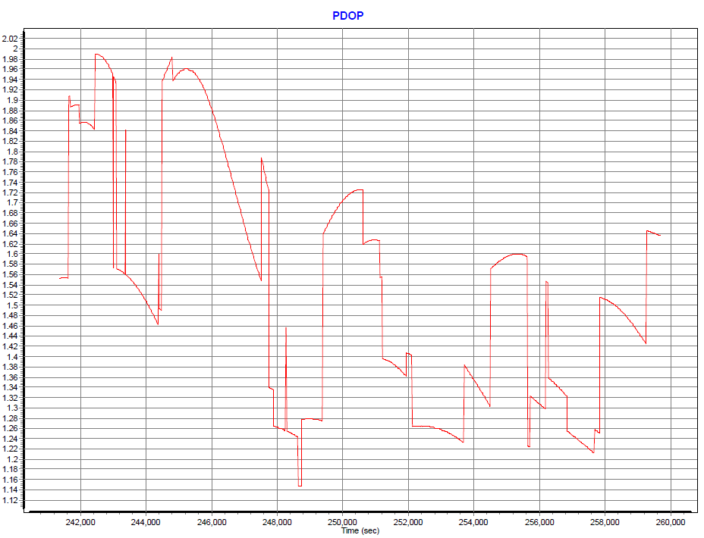

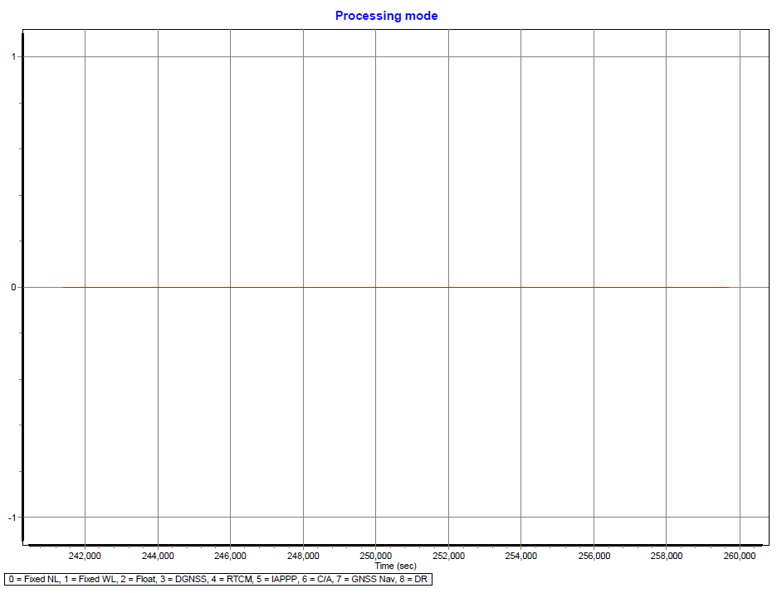

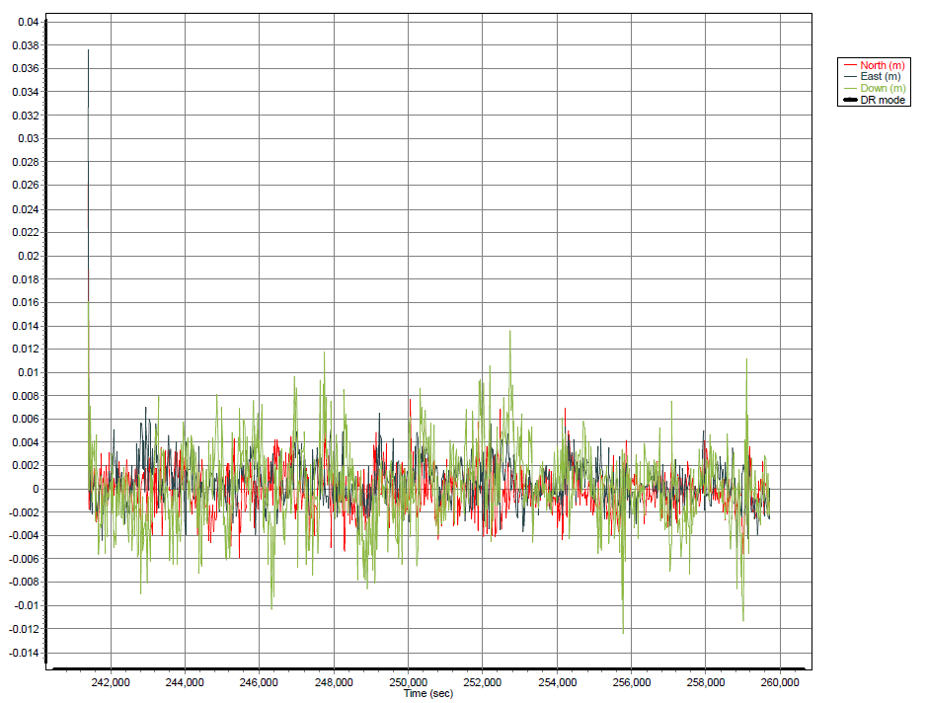

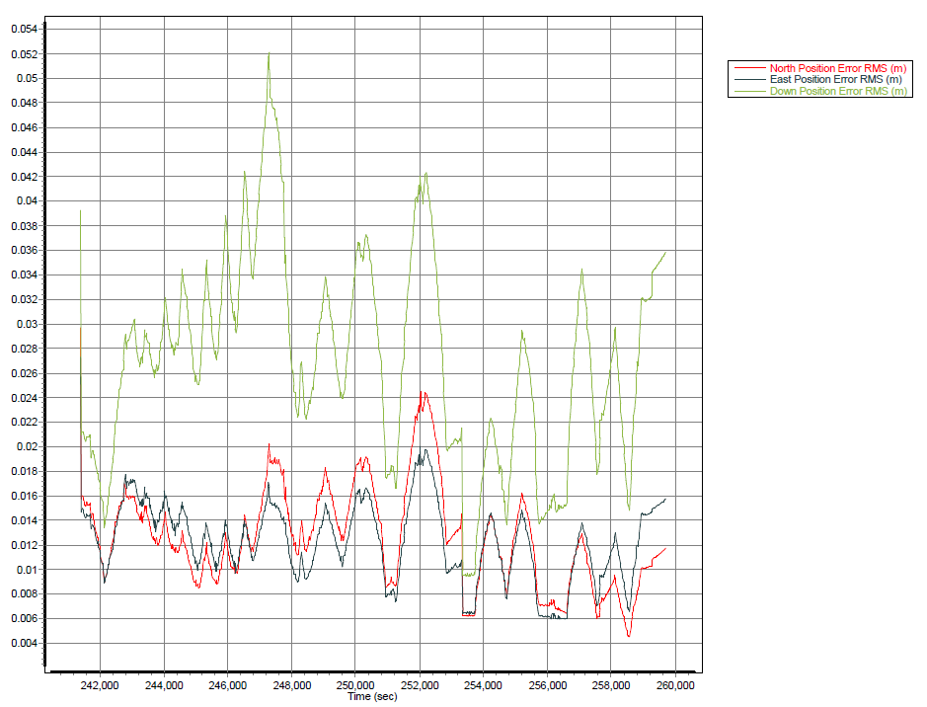

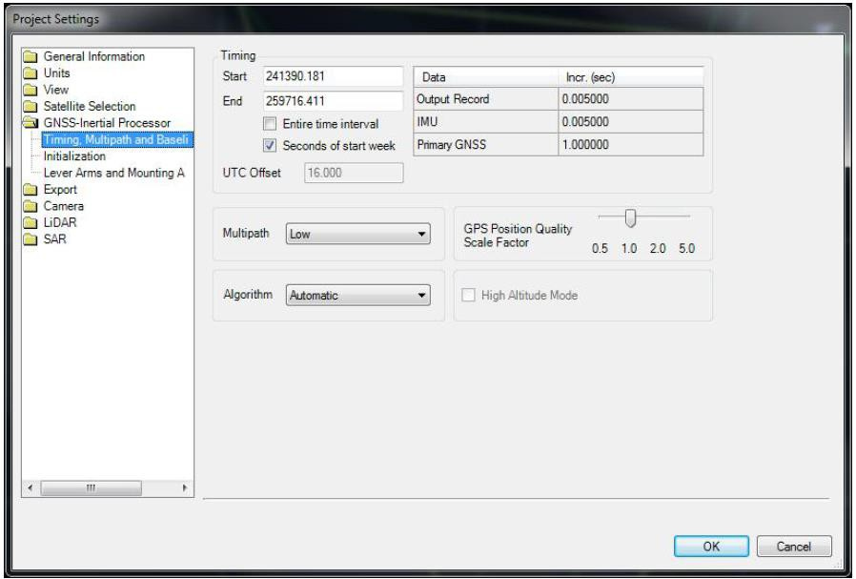

MNB15113A
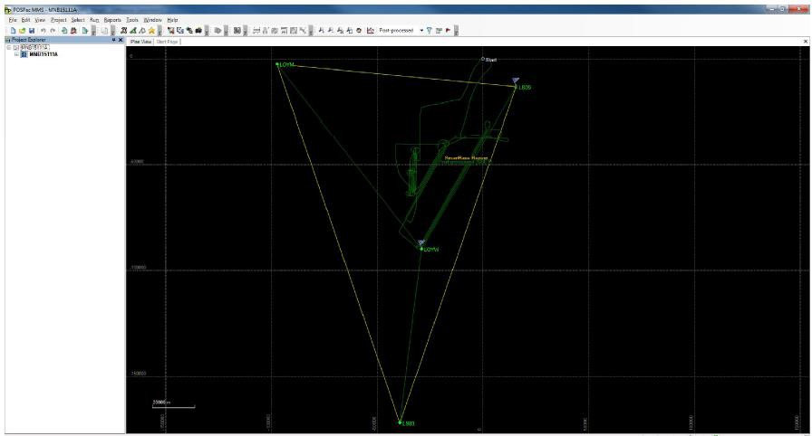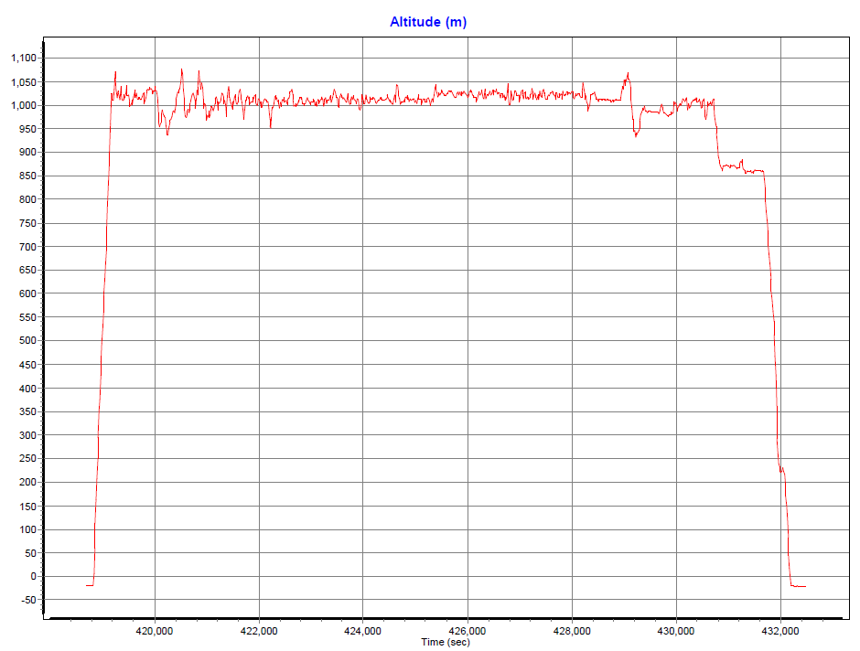

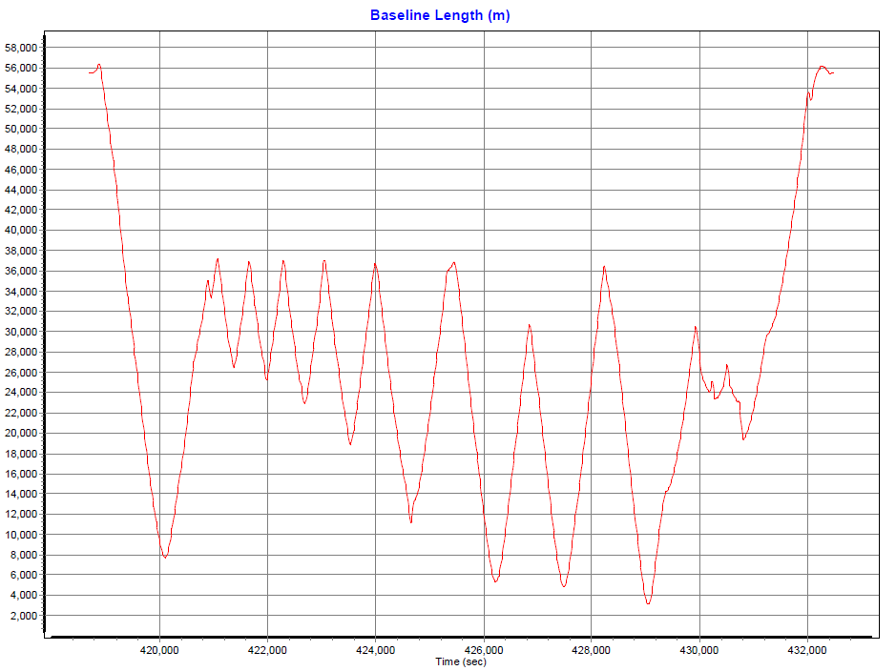

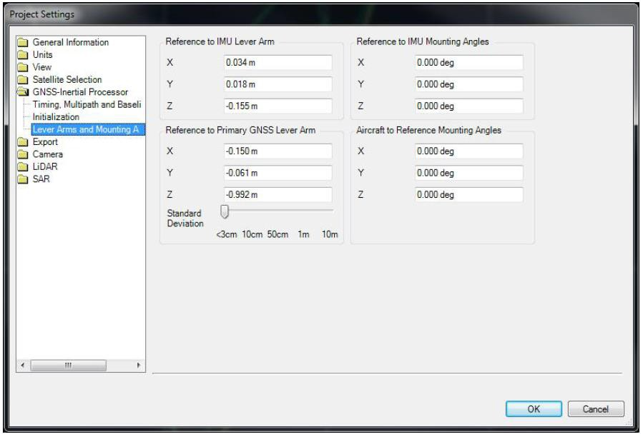

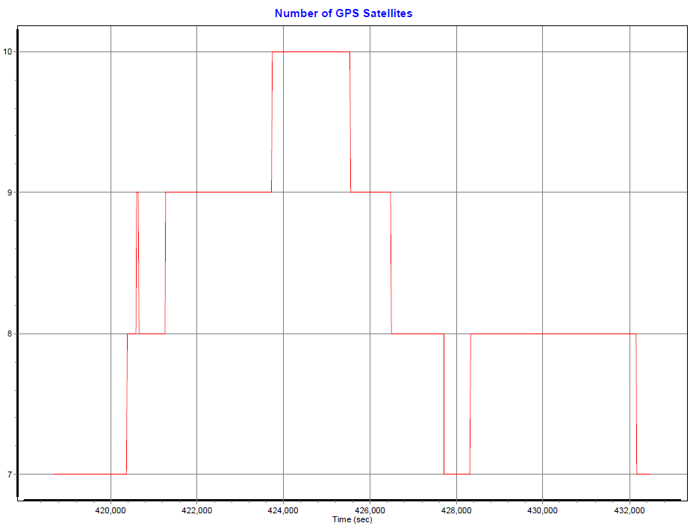

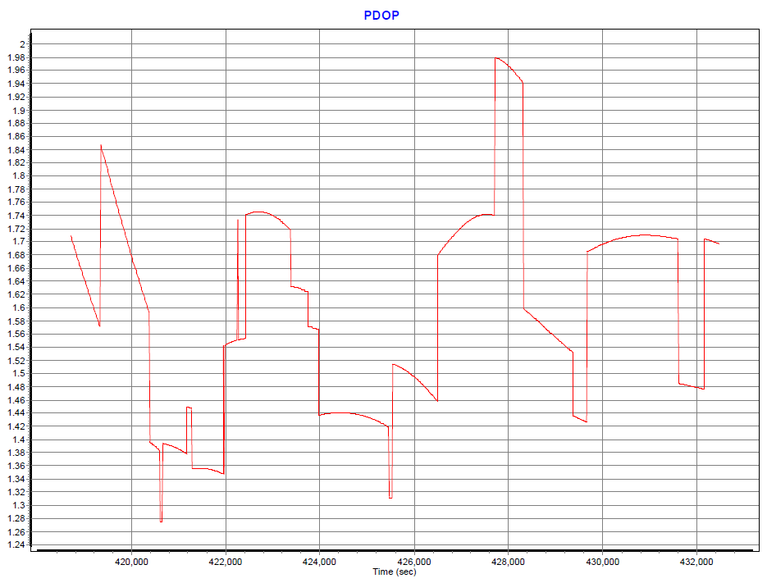

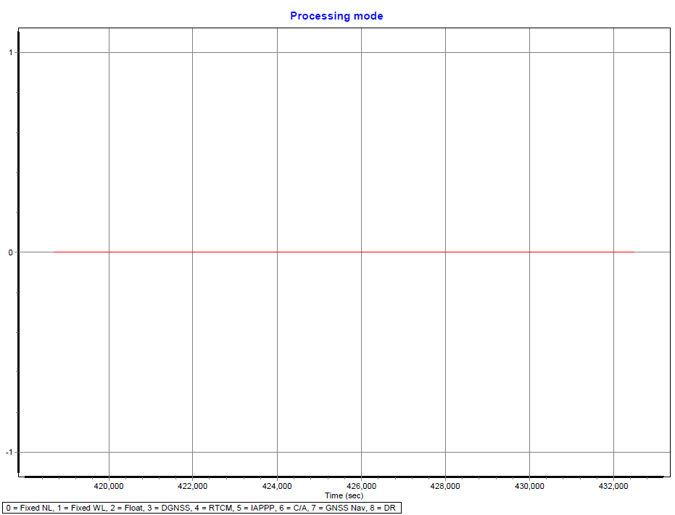

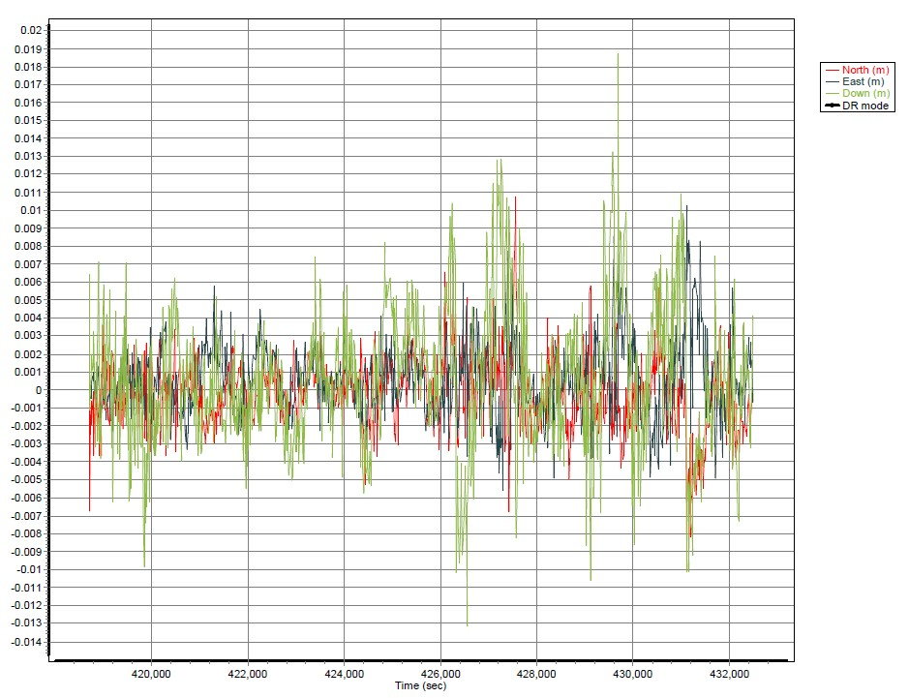

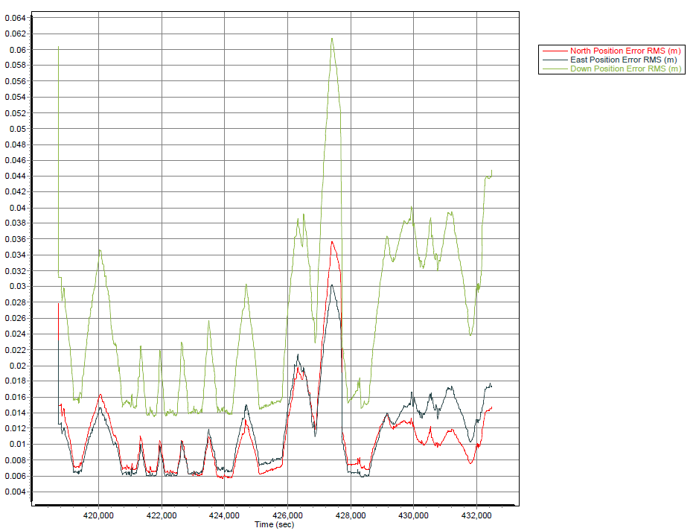

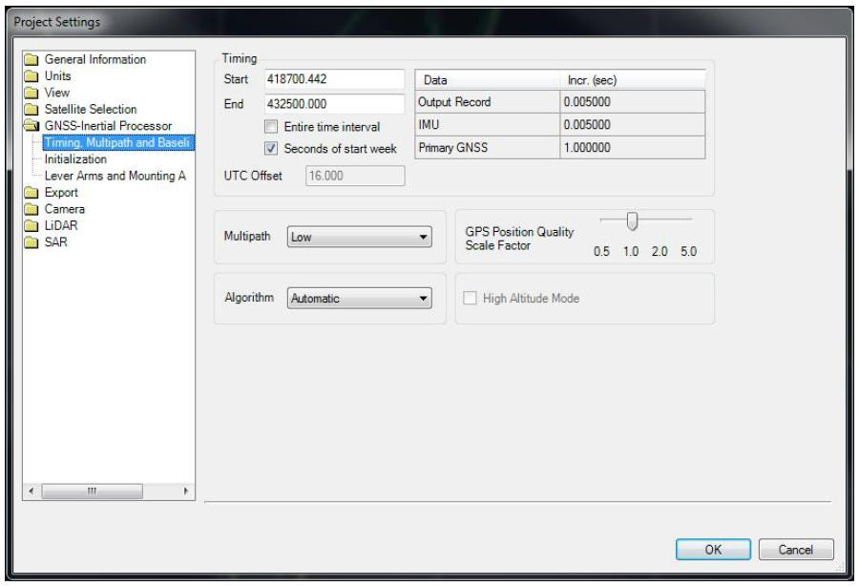

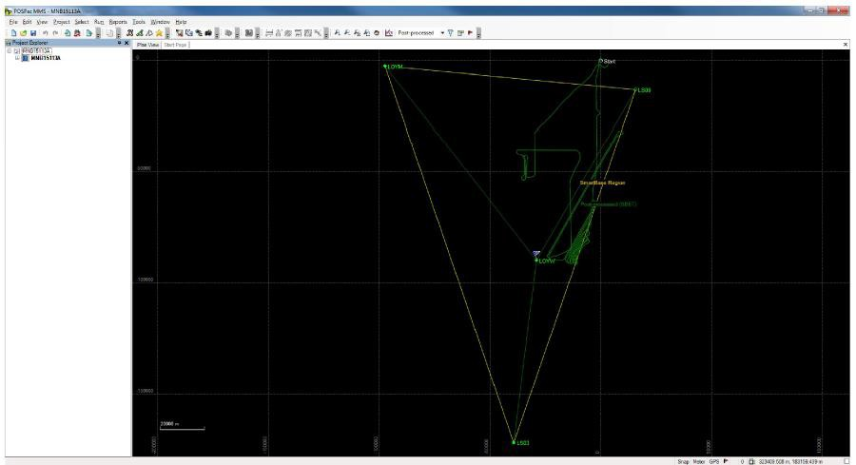

MNB15114A
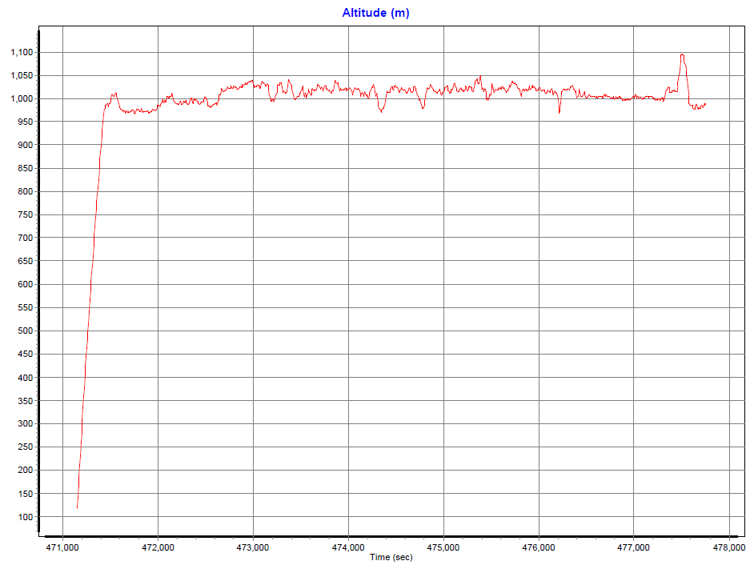

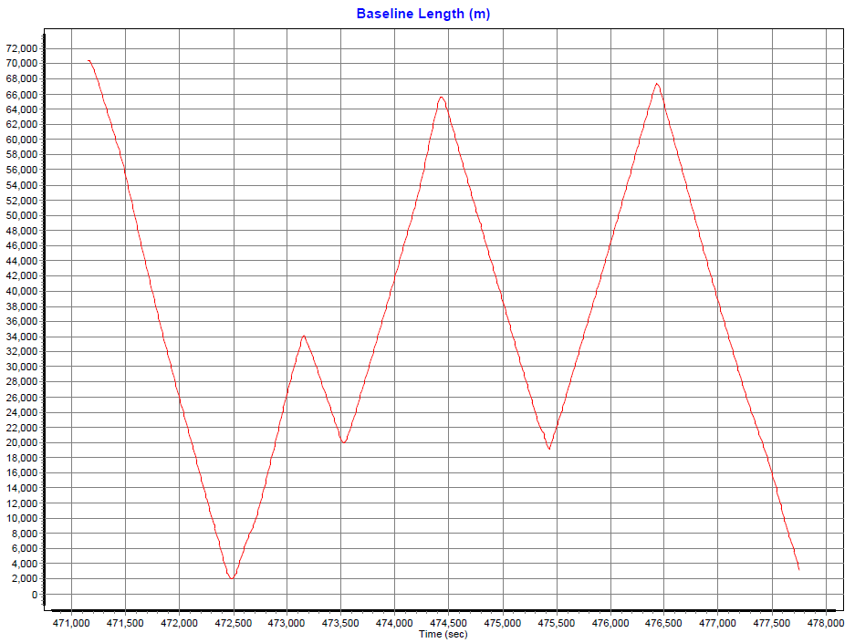

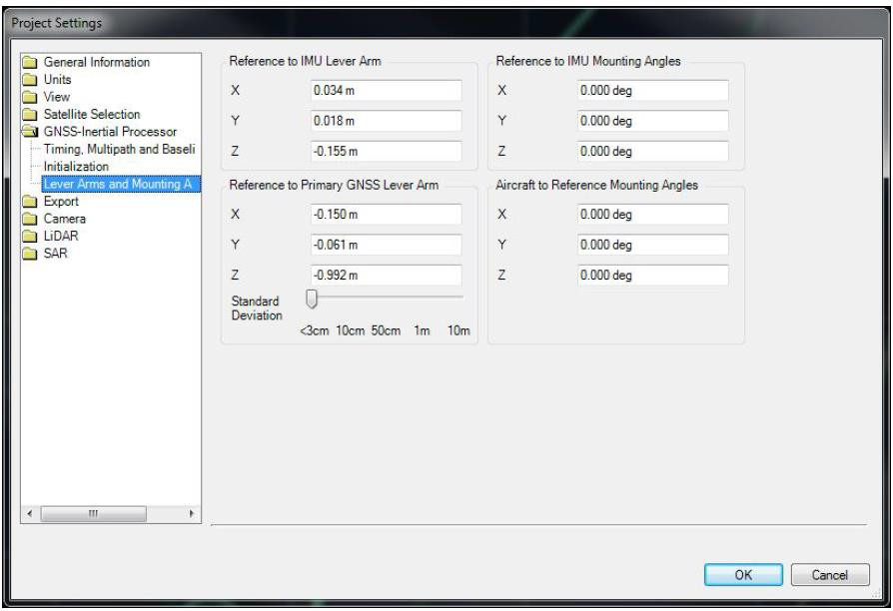

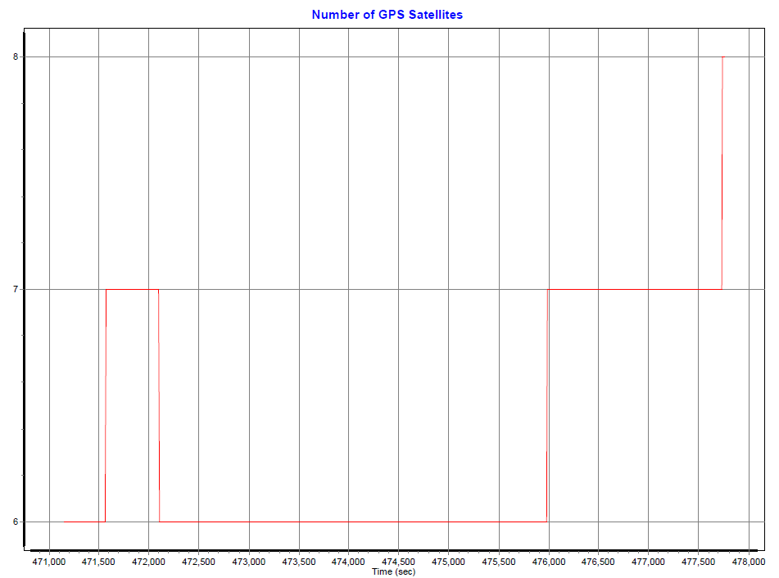

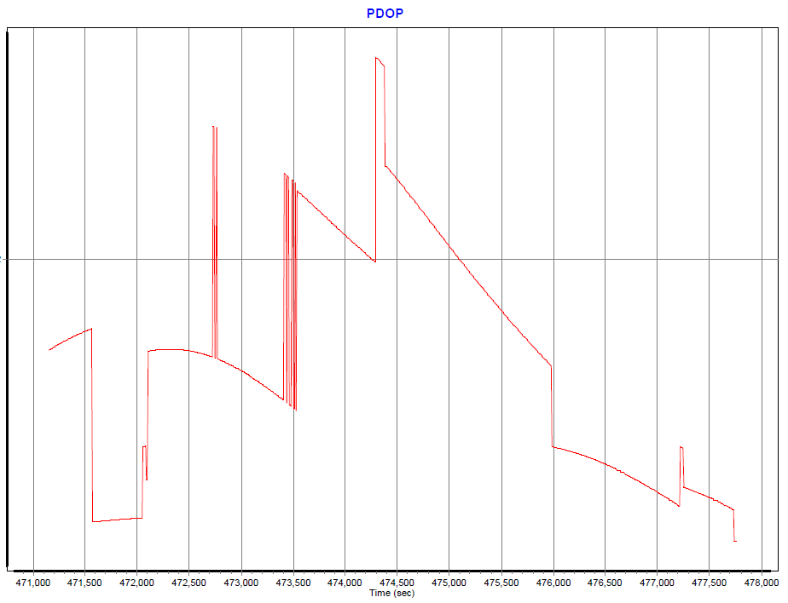

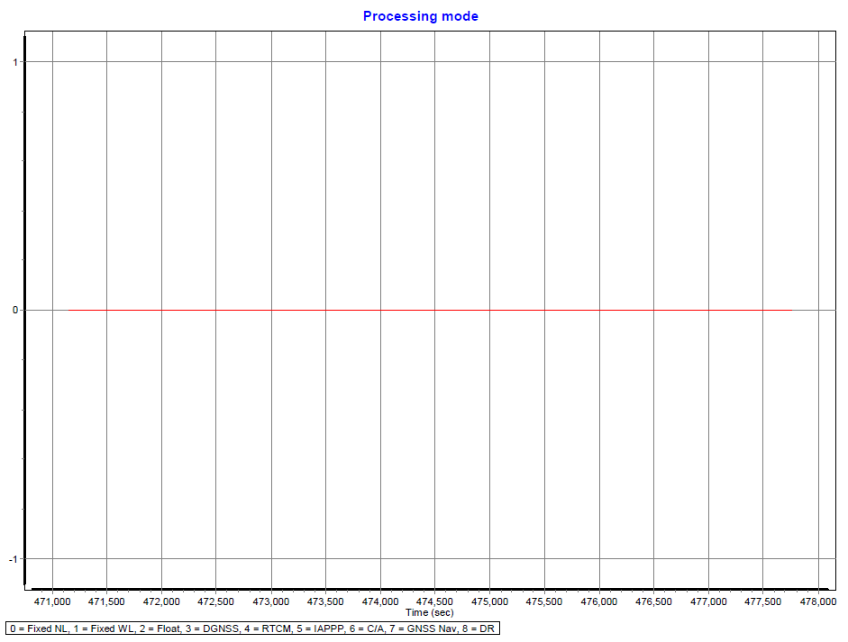

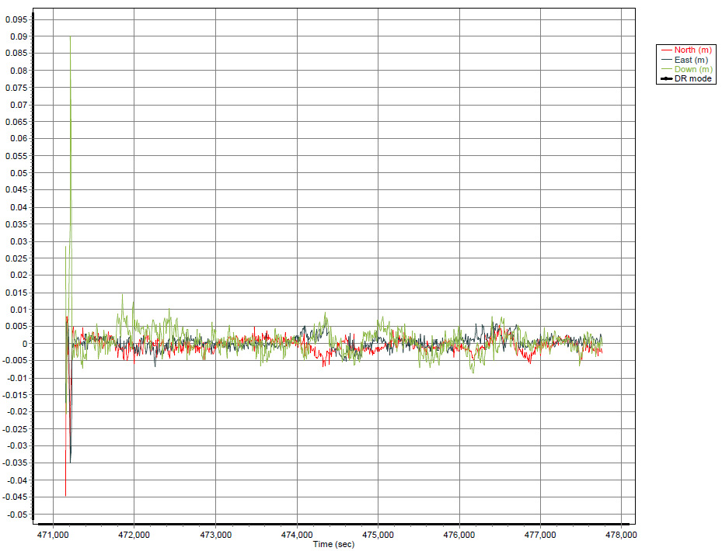

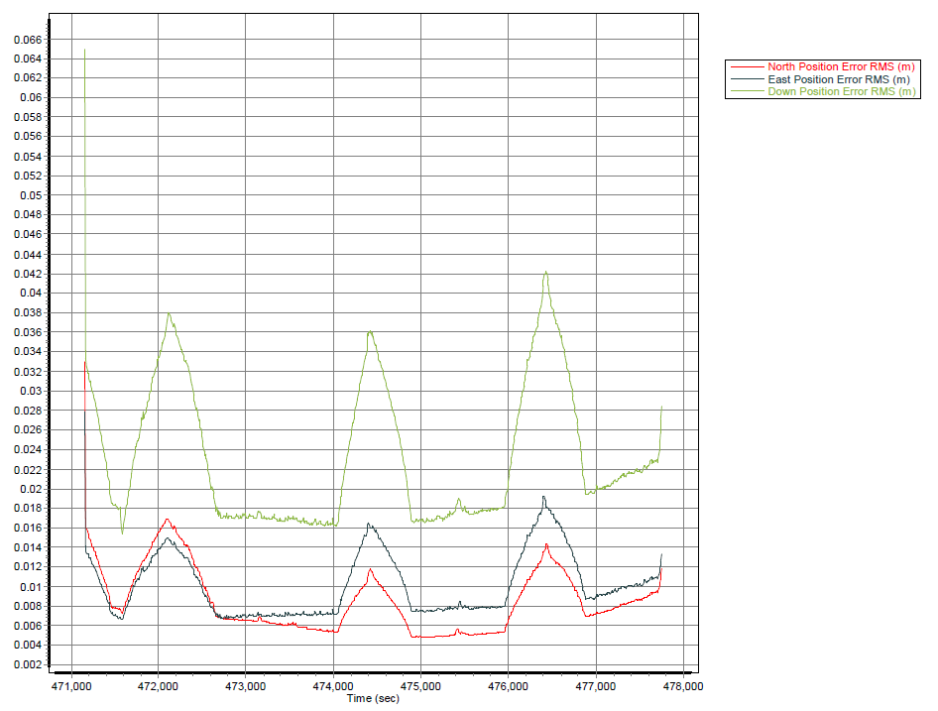

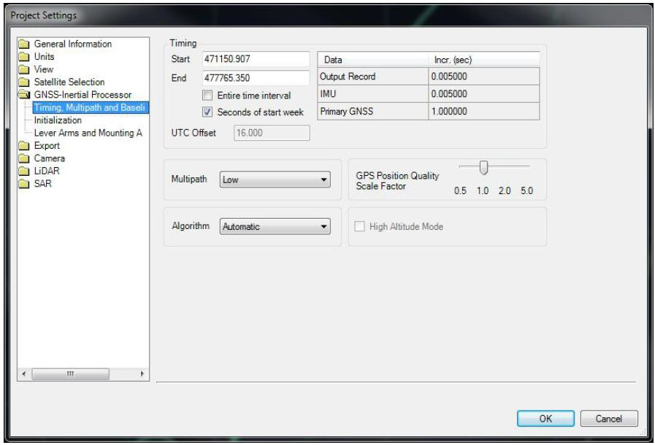

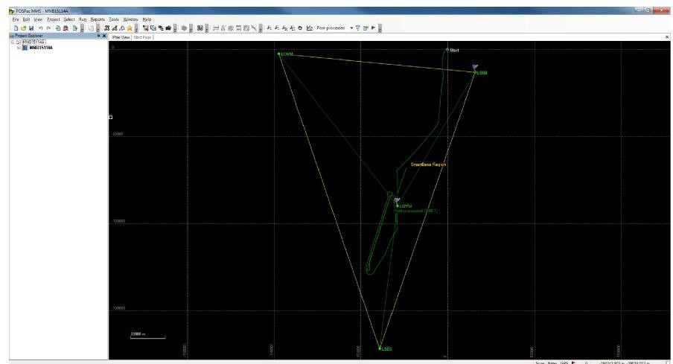

UNB15105A
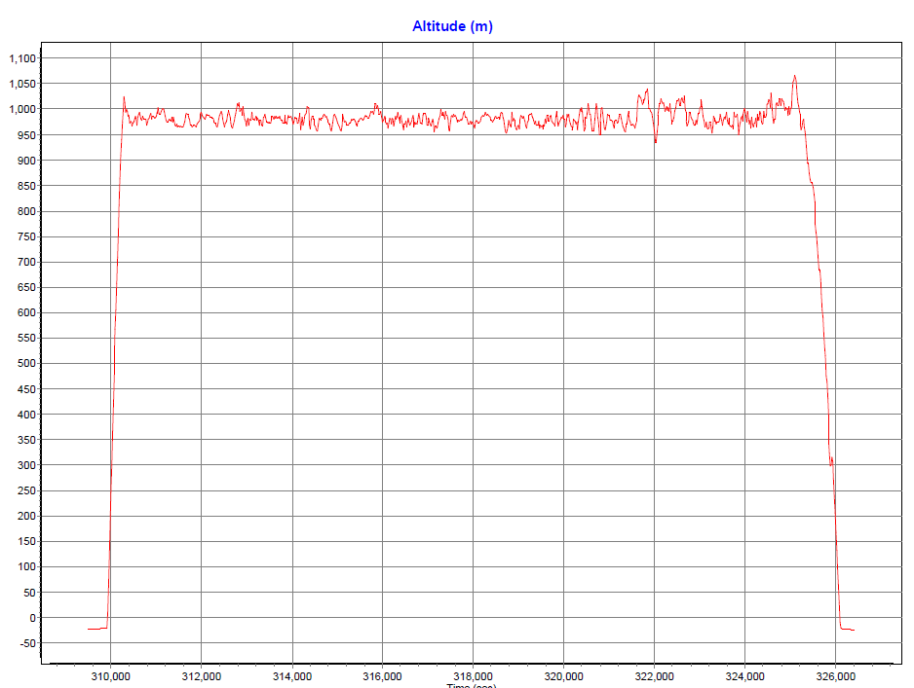

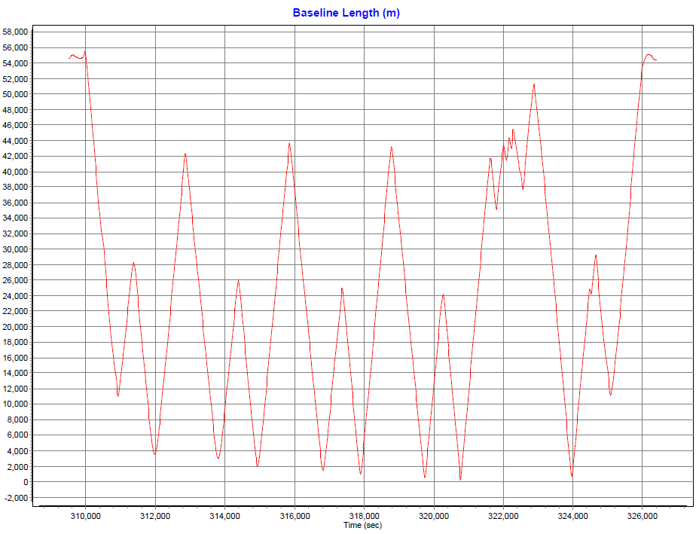

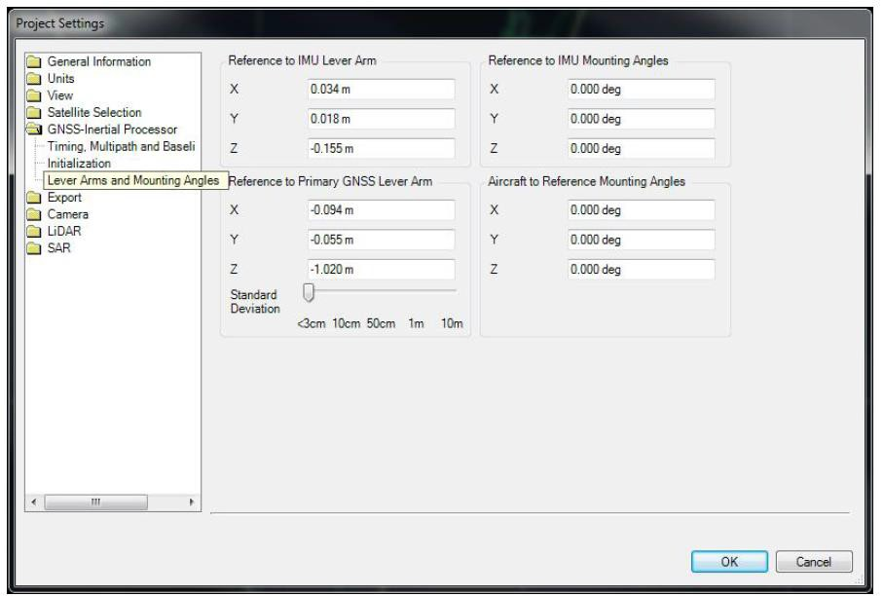

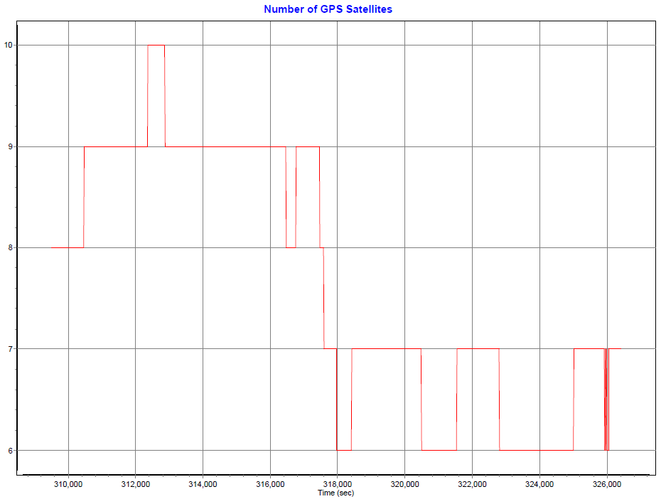

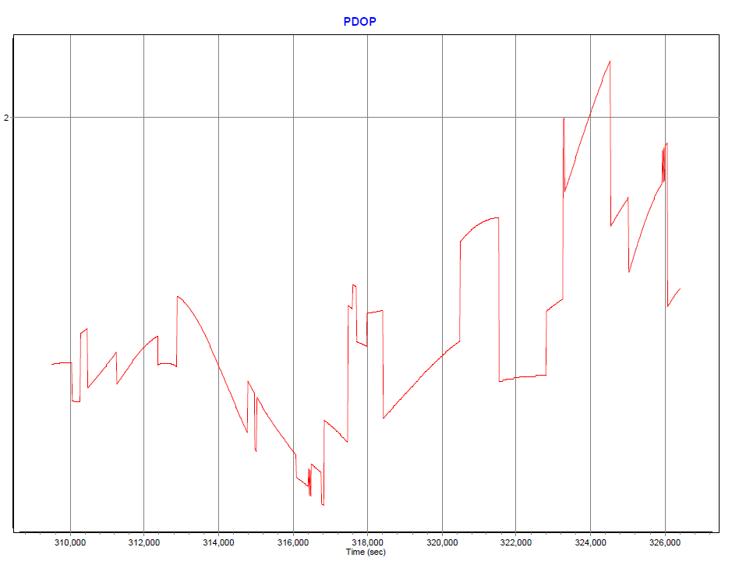

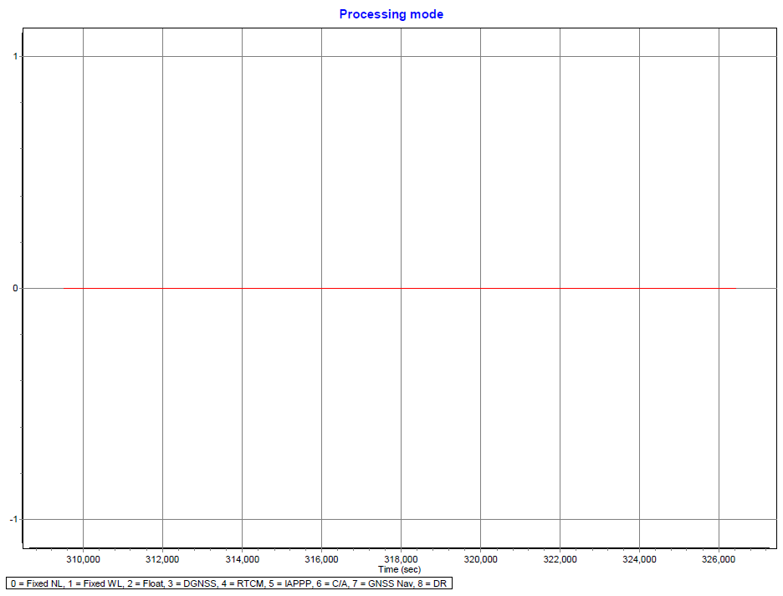

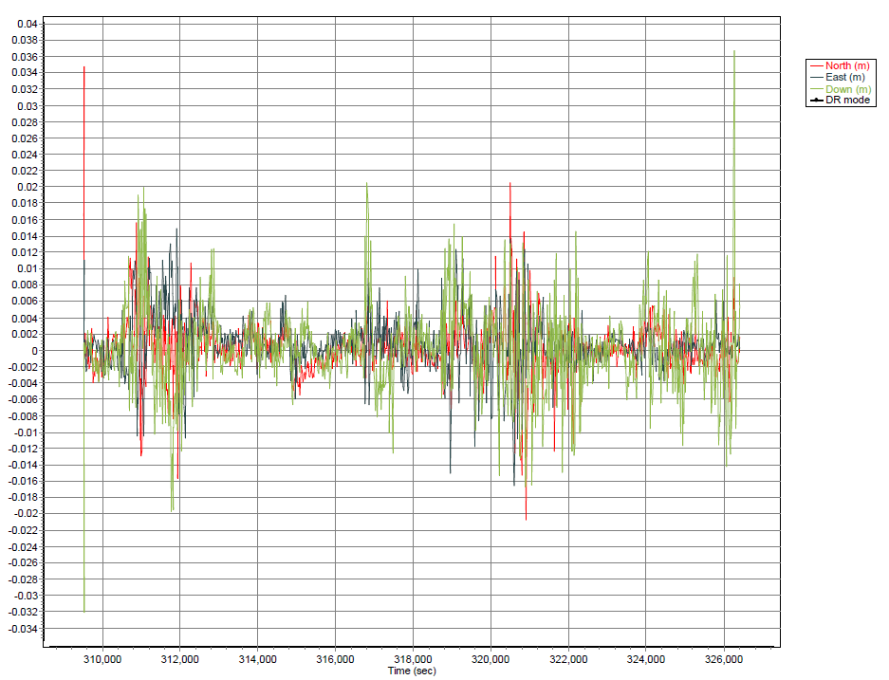

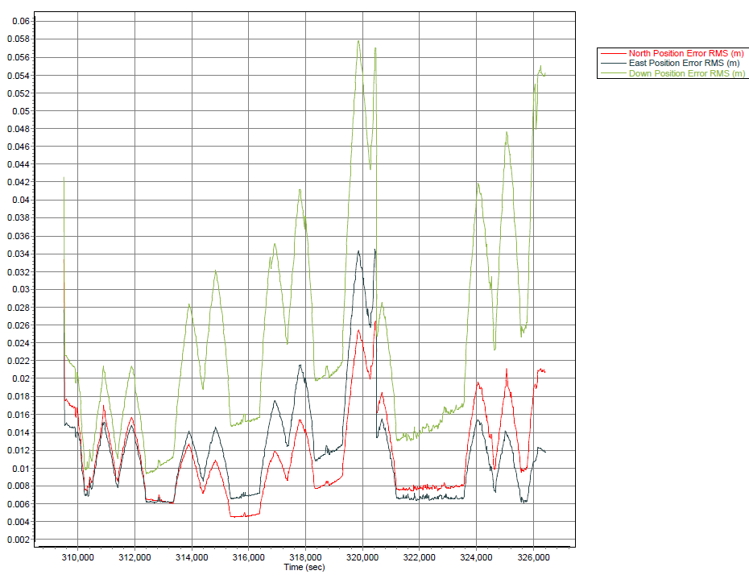

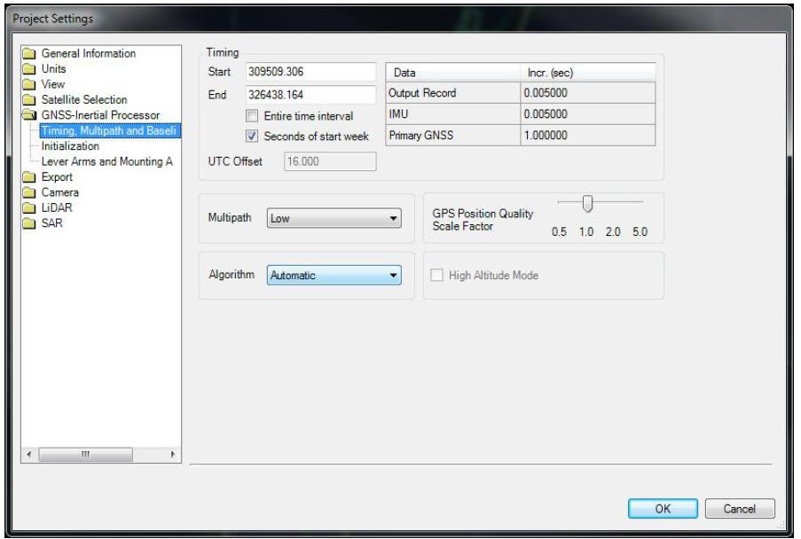

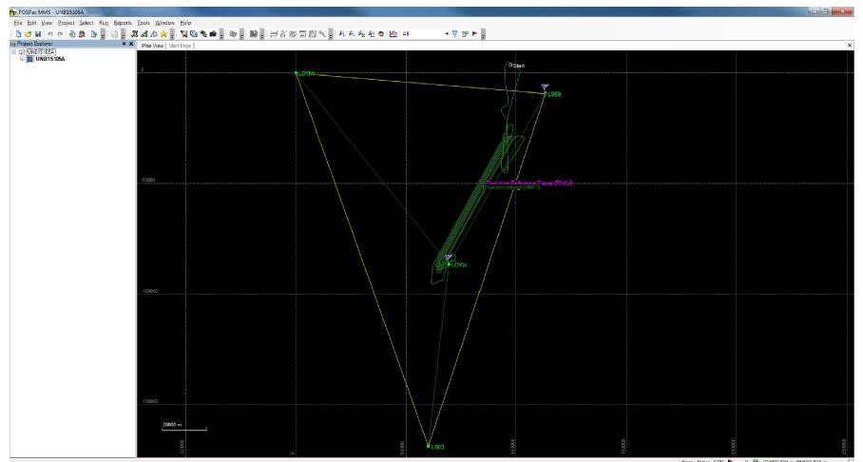

UNB15106A
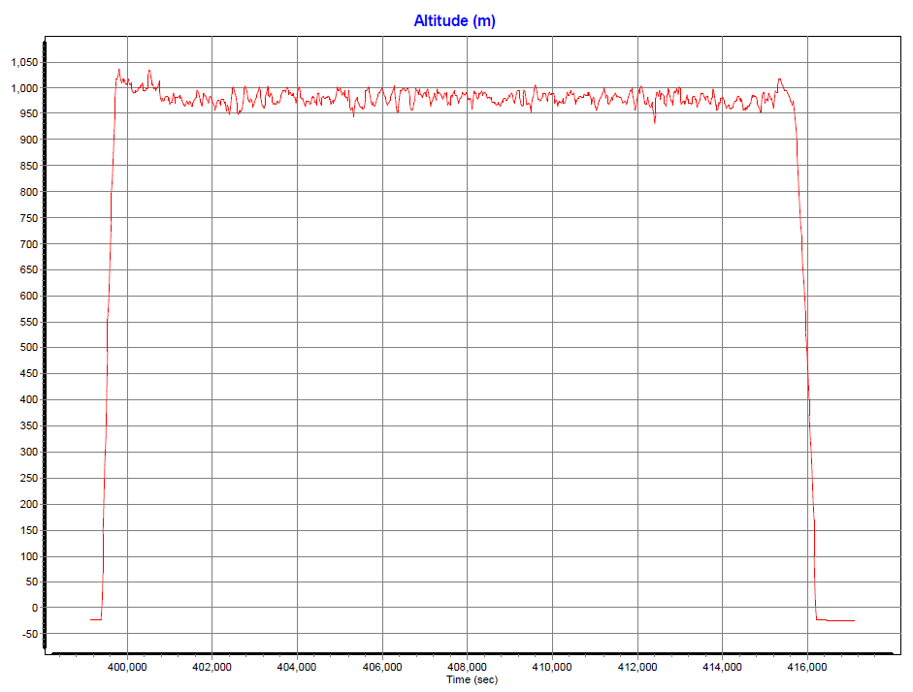

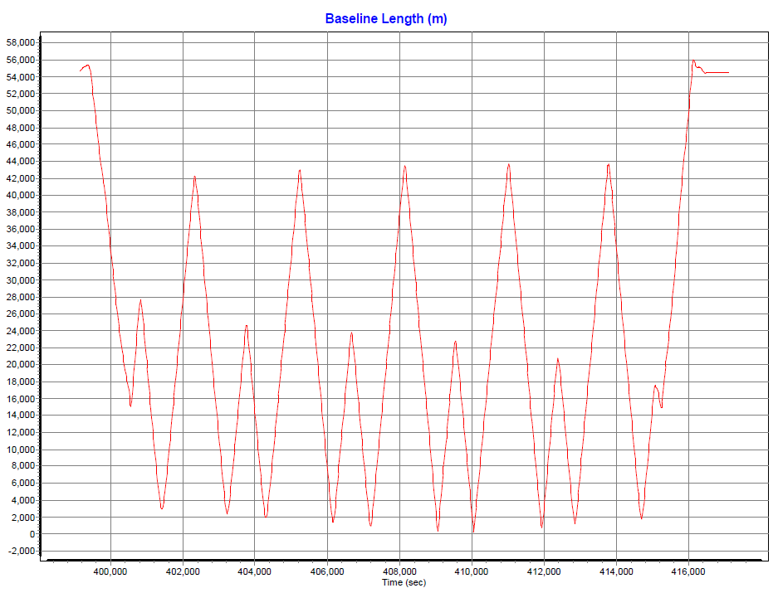

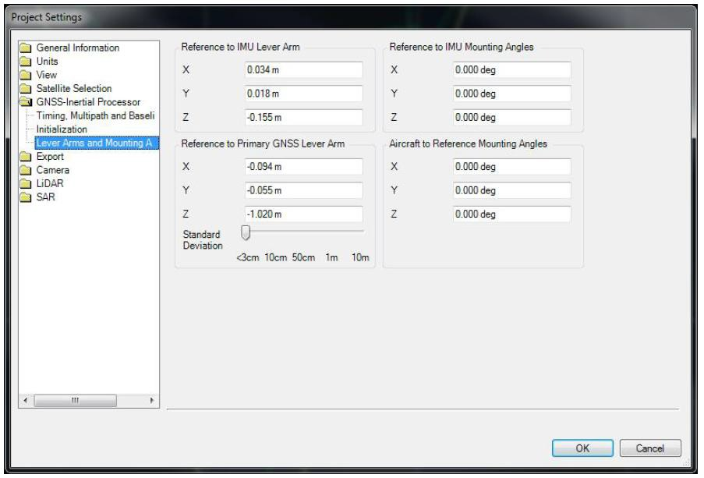

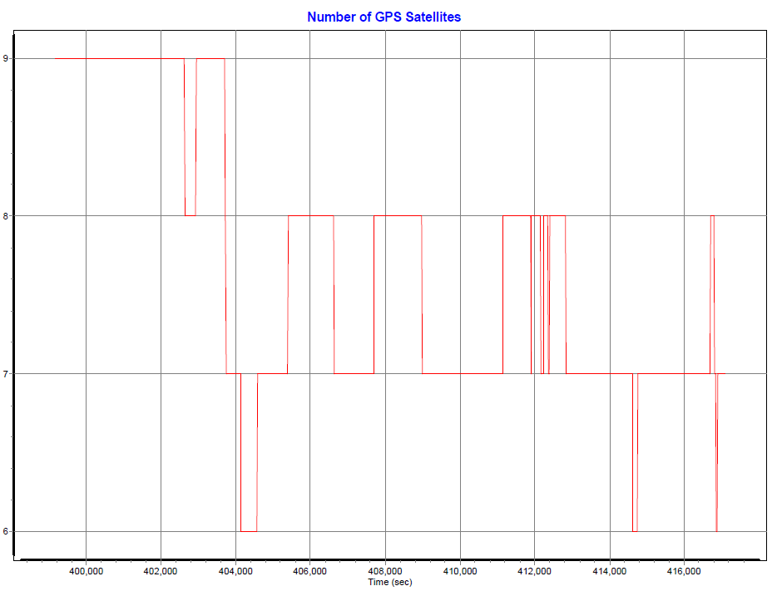

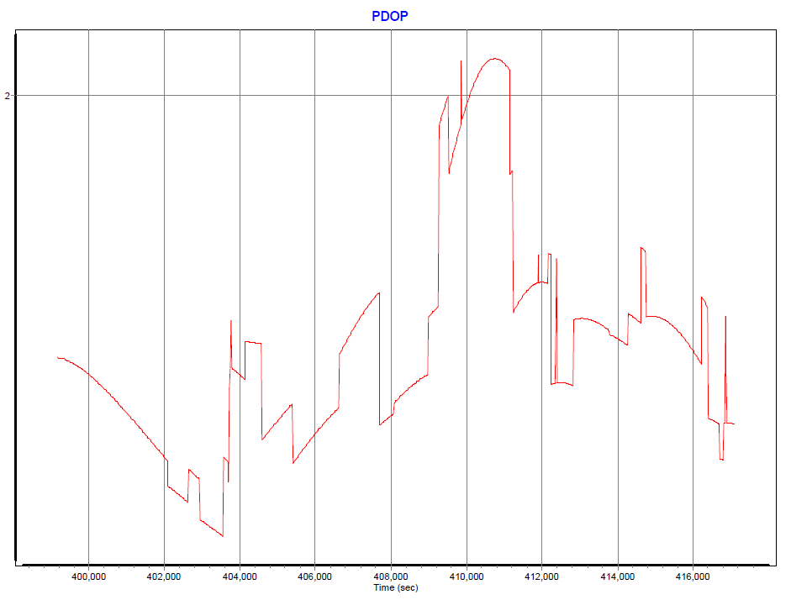

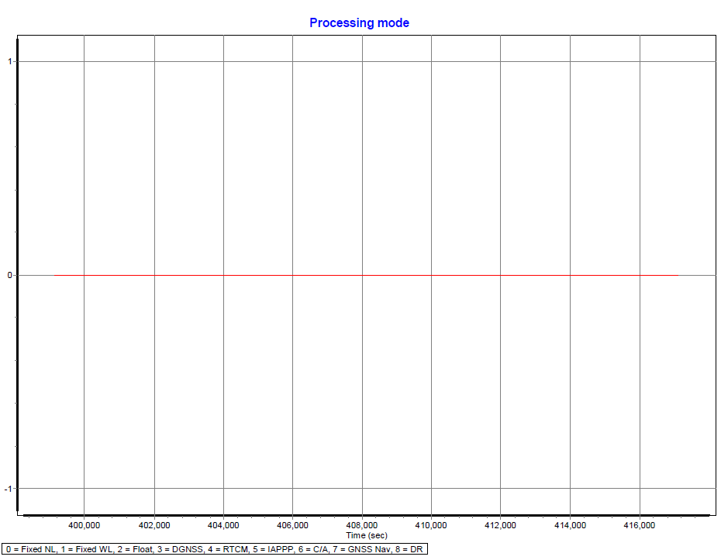

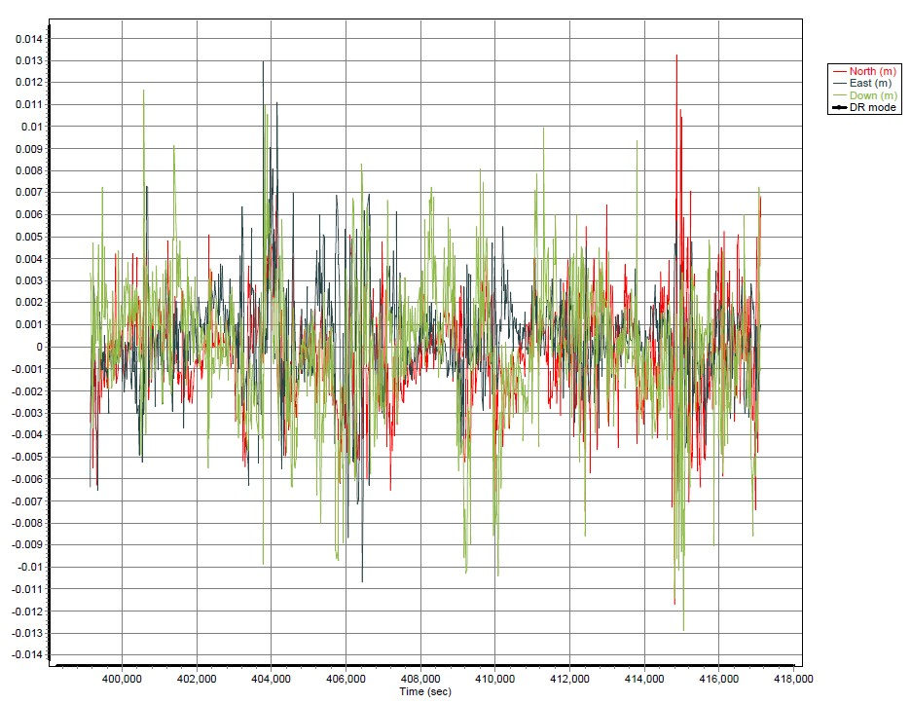

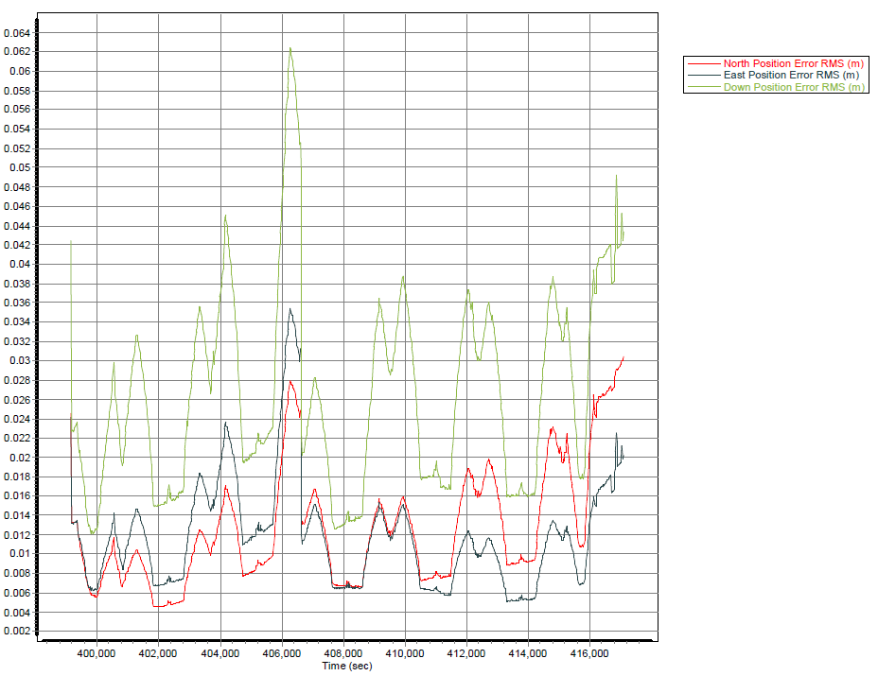

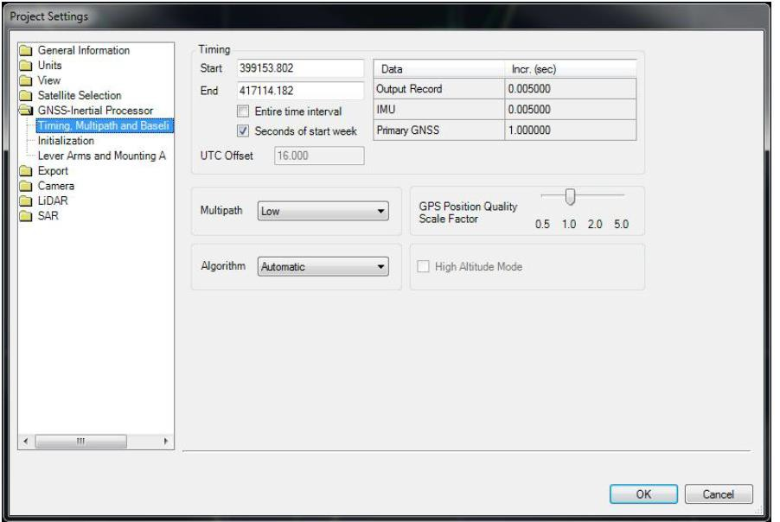

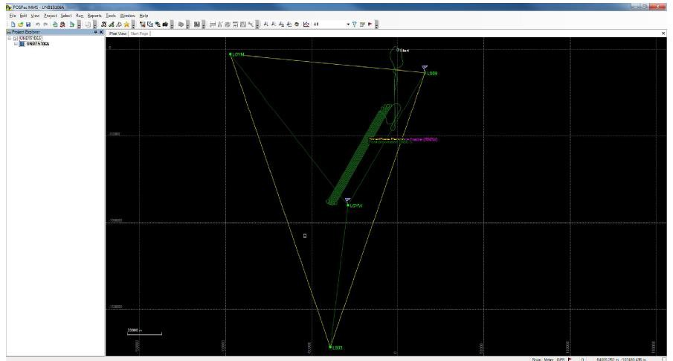

UNB15108A
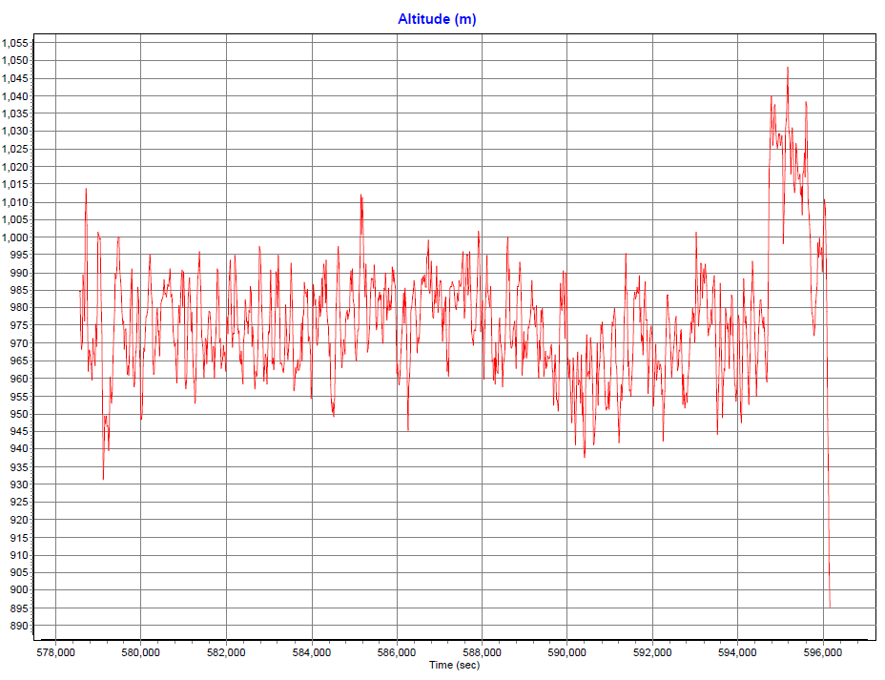

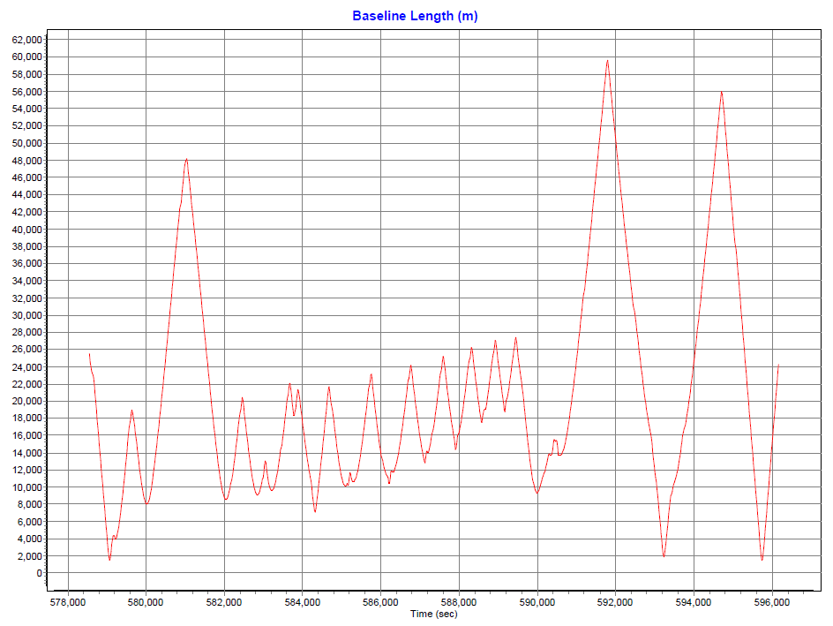

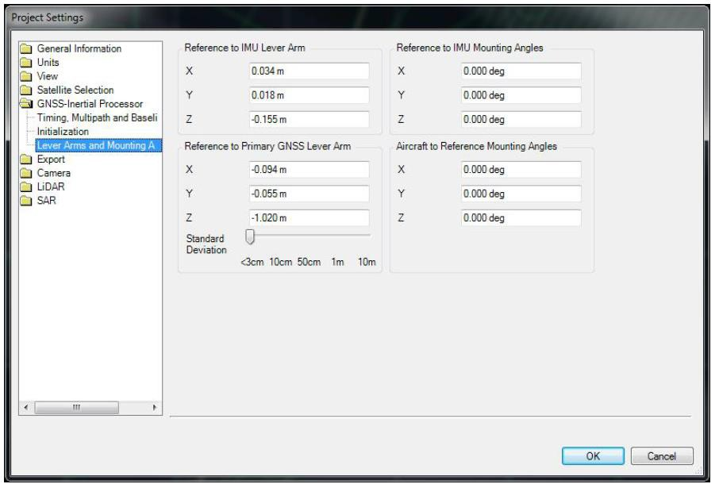

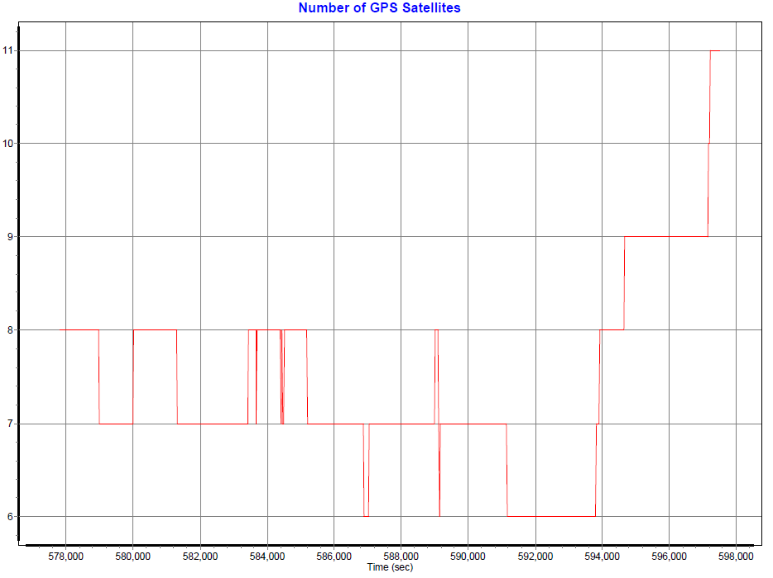

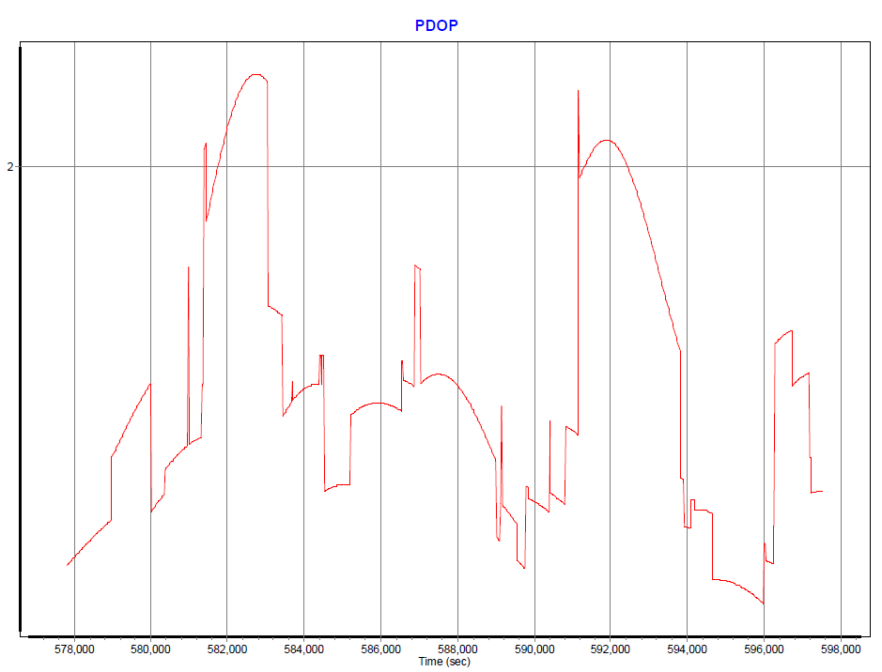

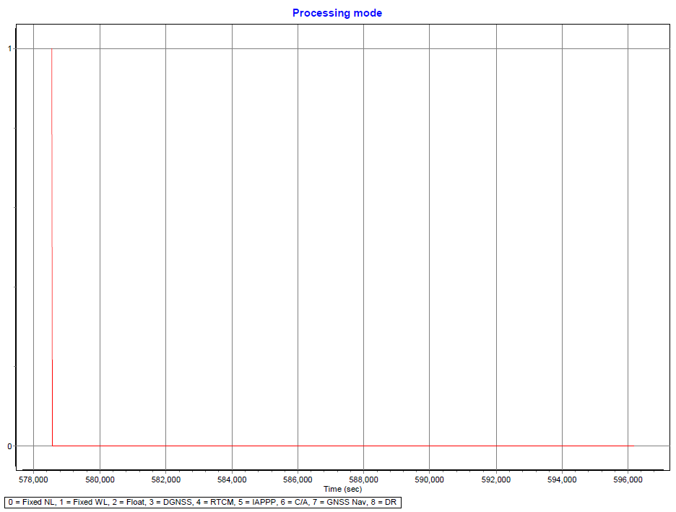

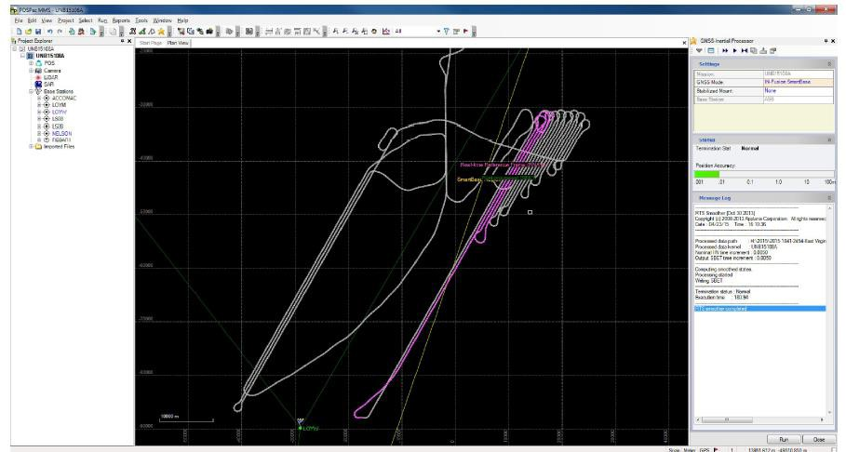

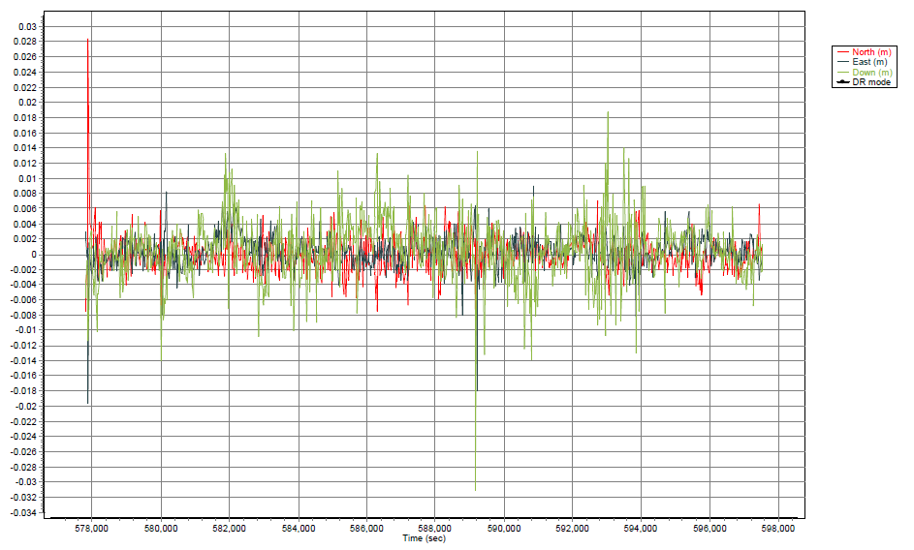

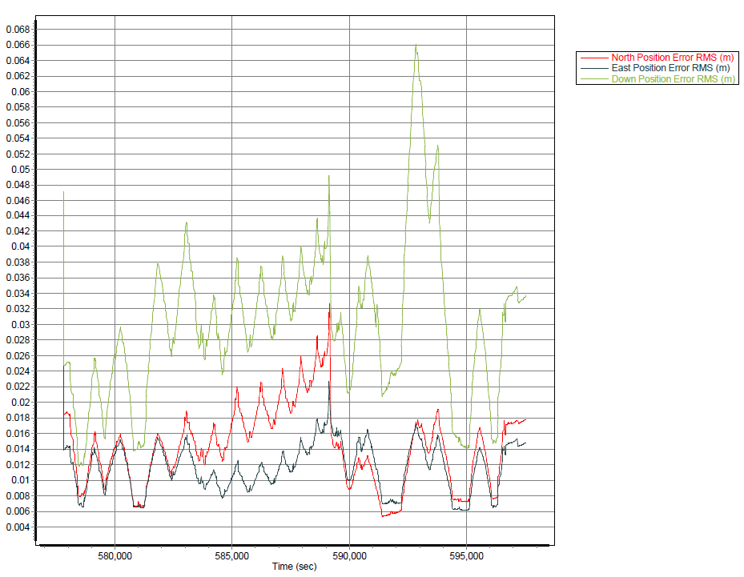

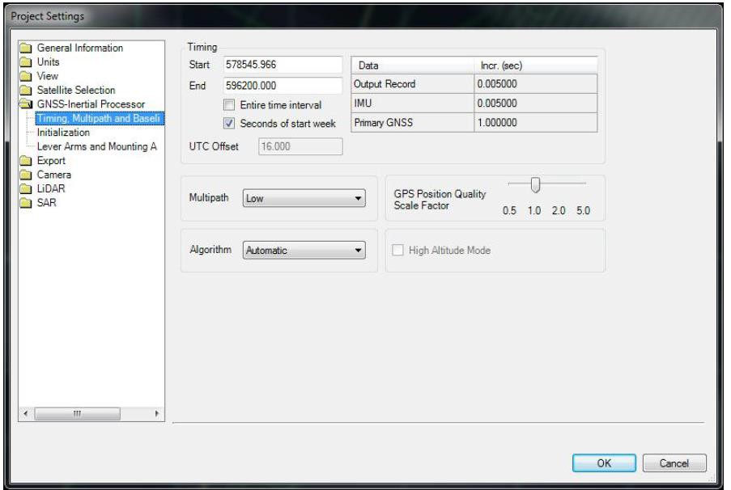

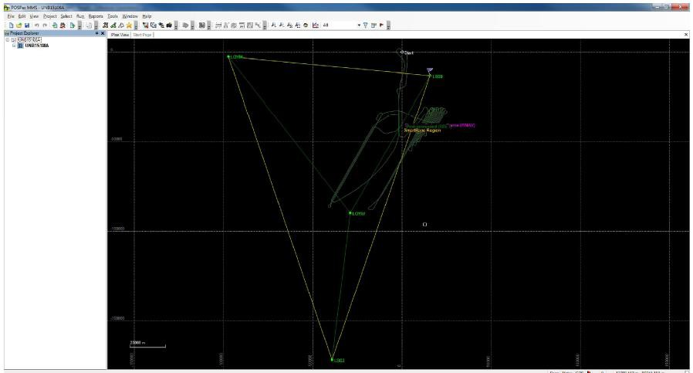

UNB15111A
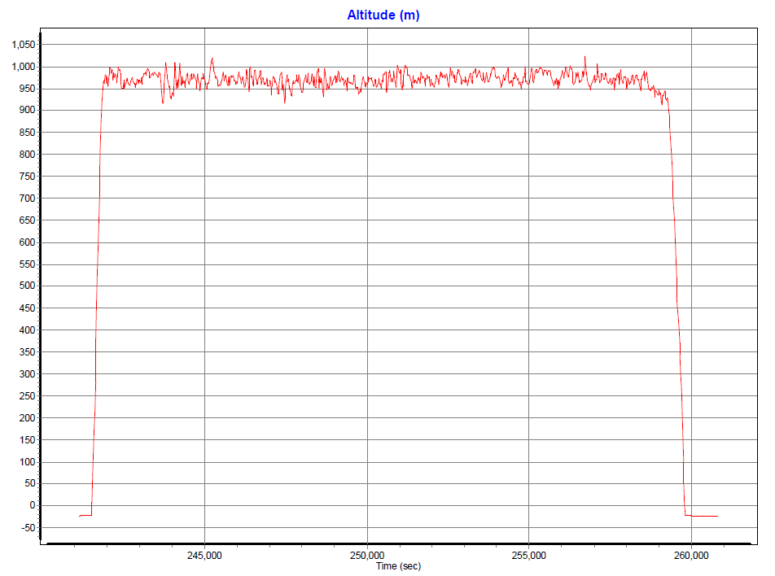

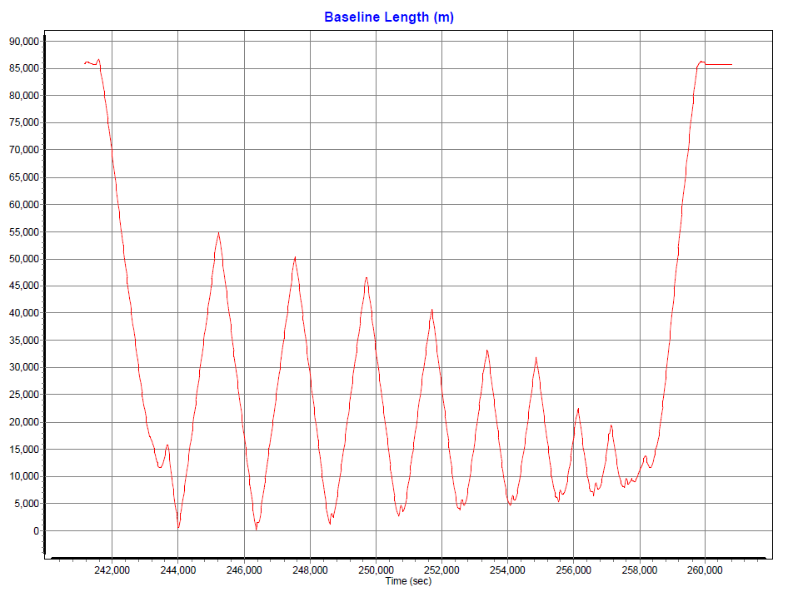

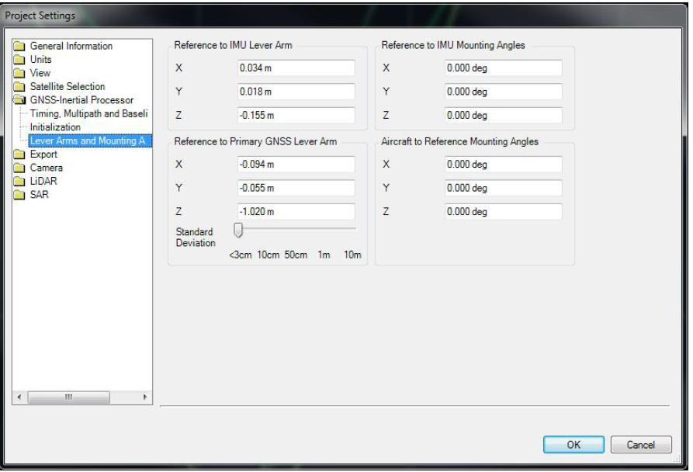

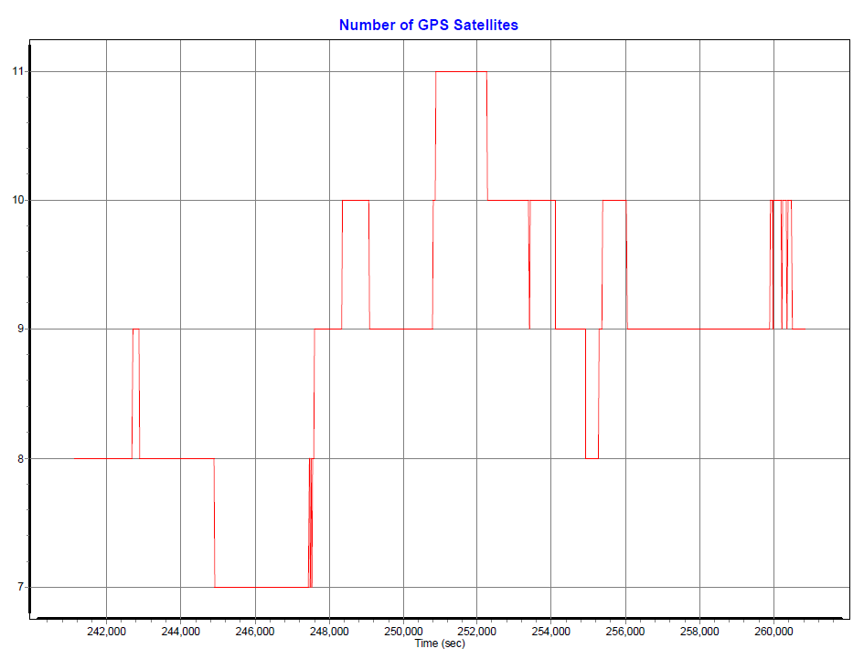

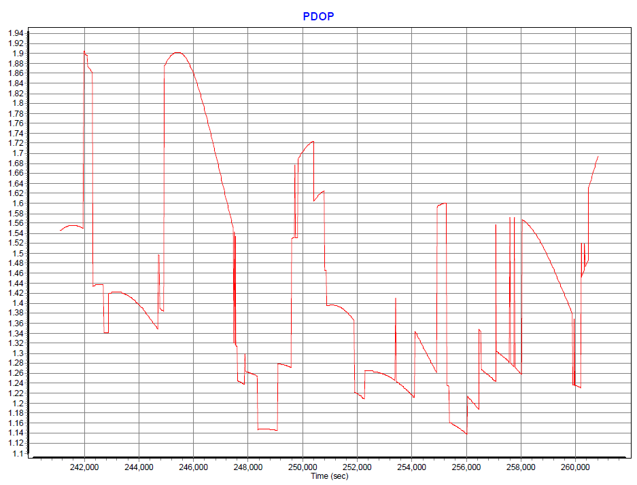

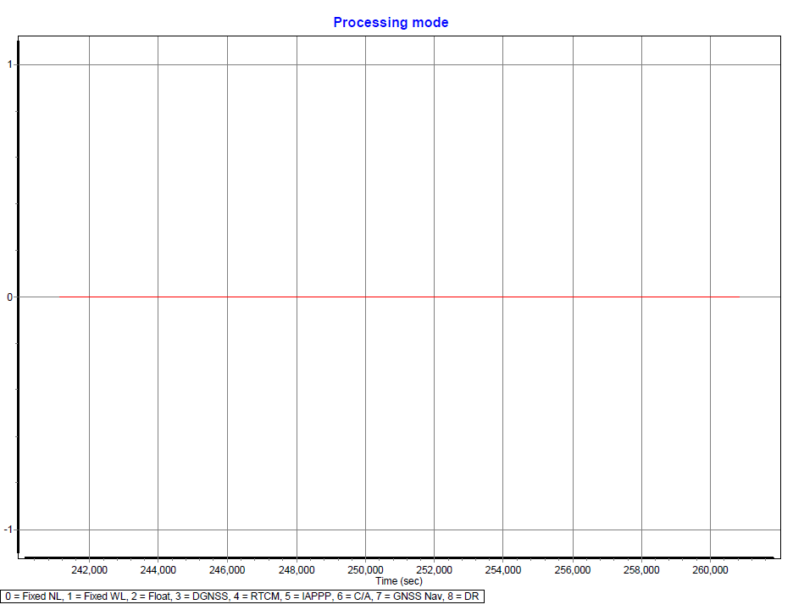

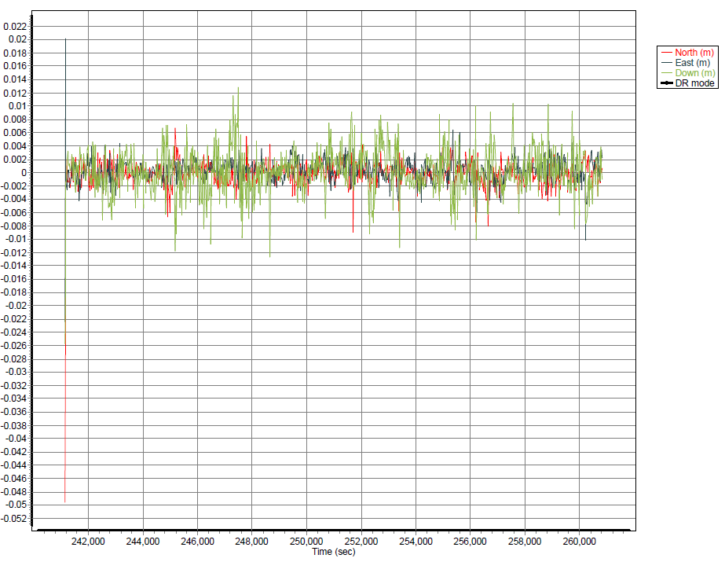

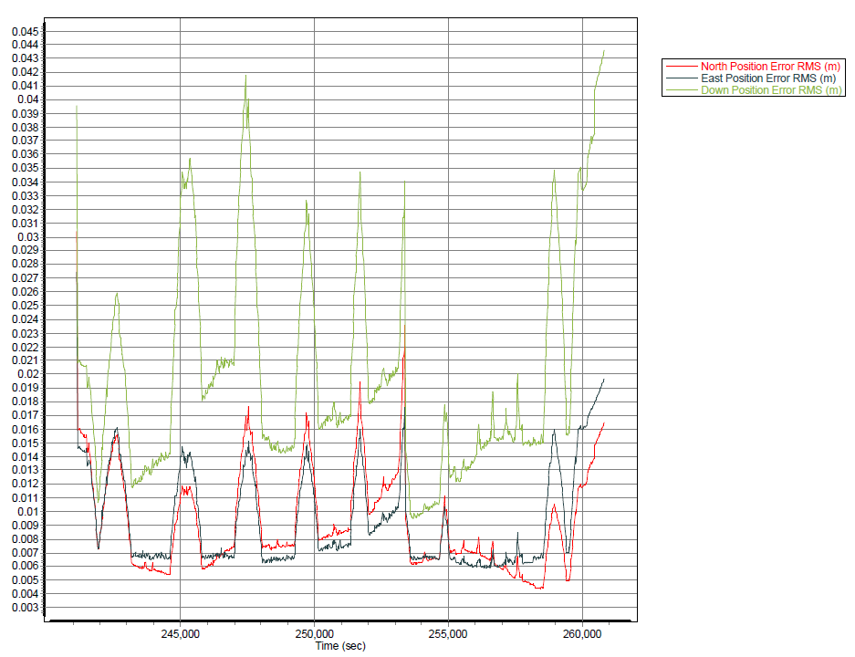

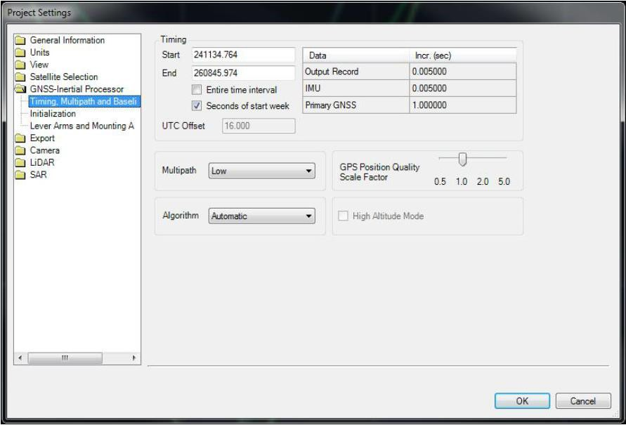

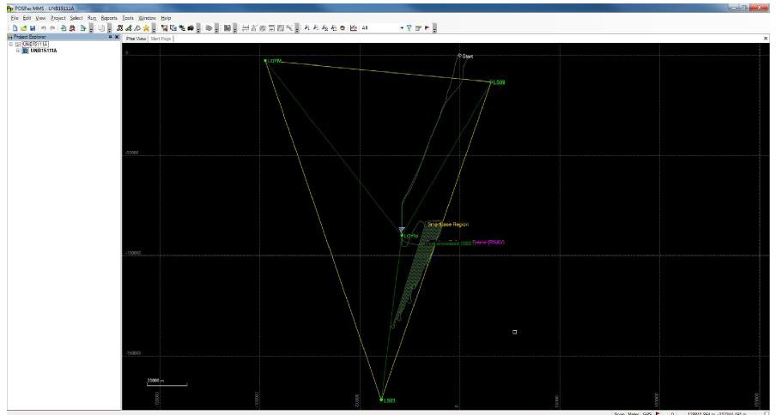

UNB15113A
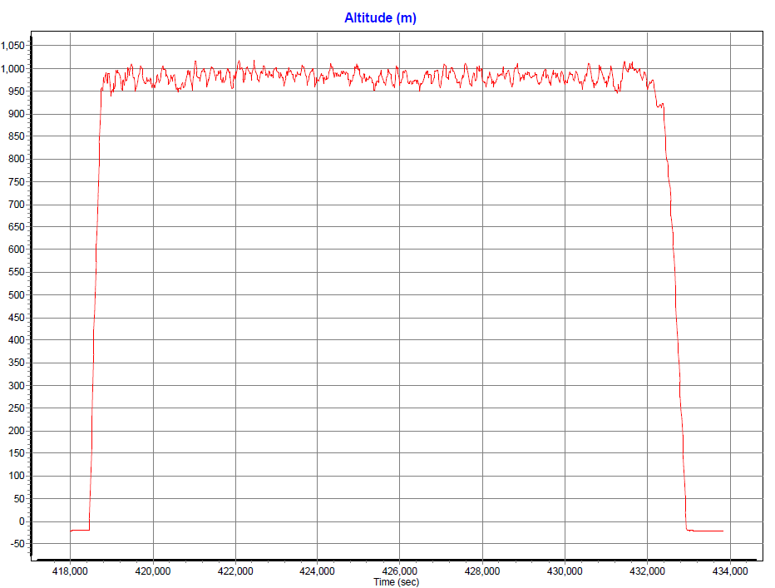

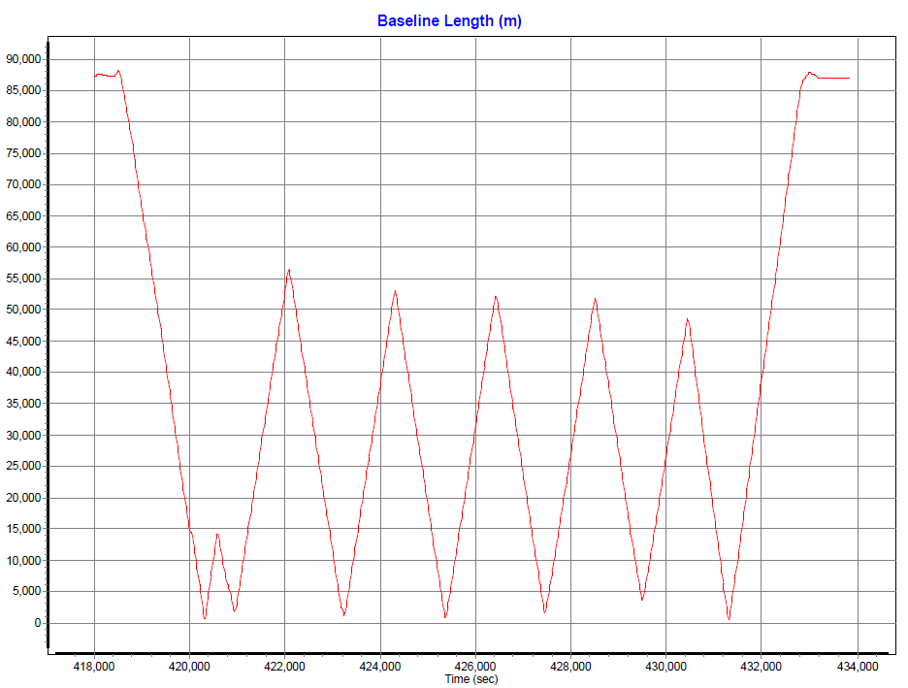

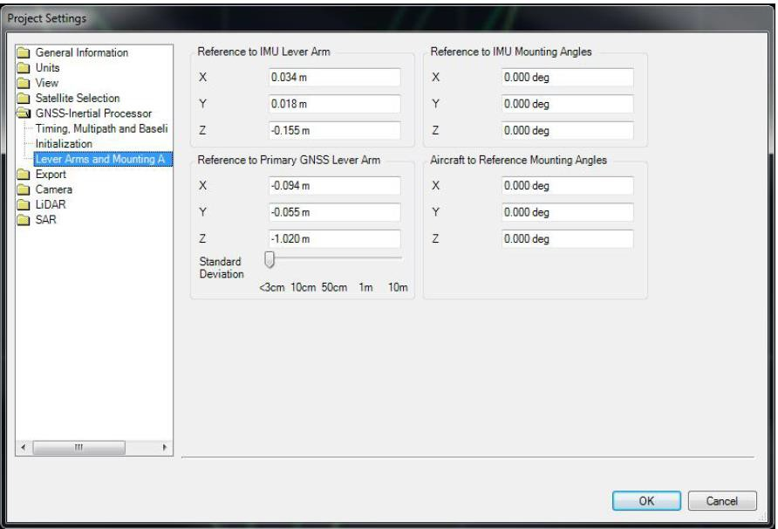

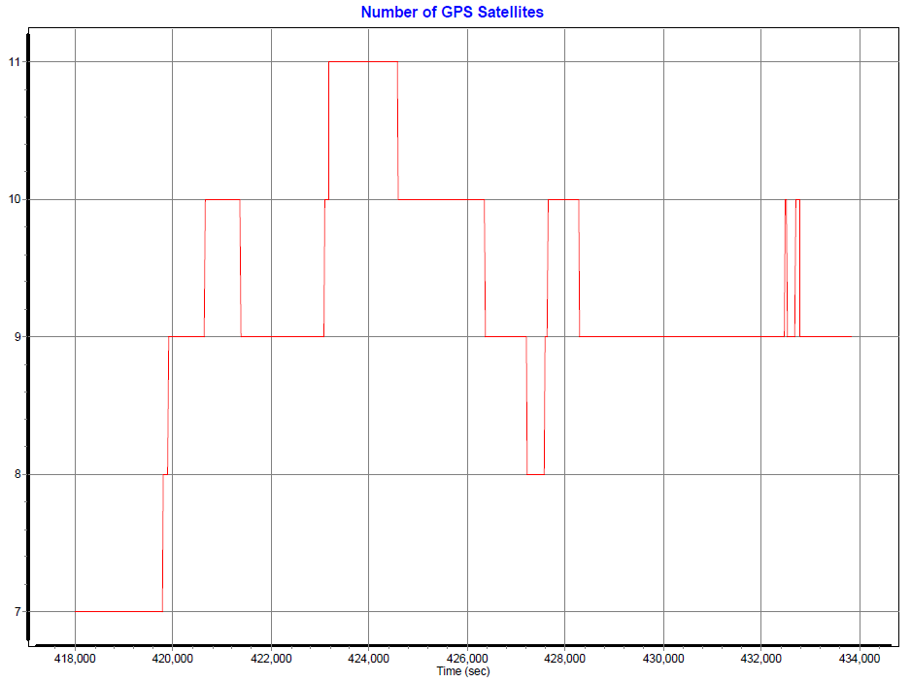

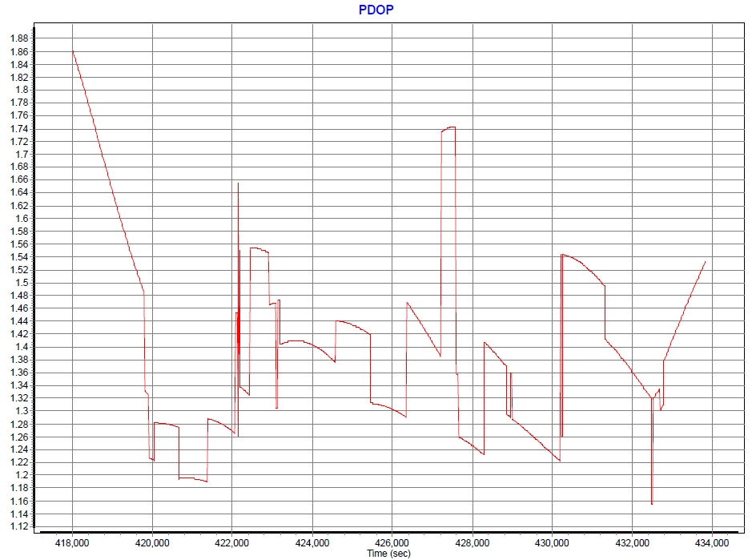

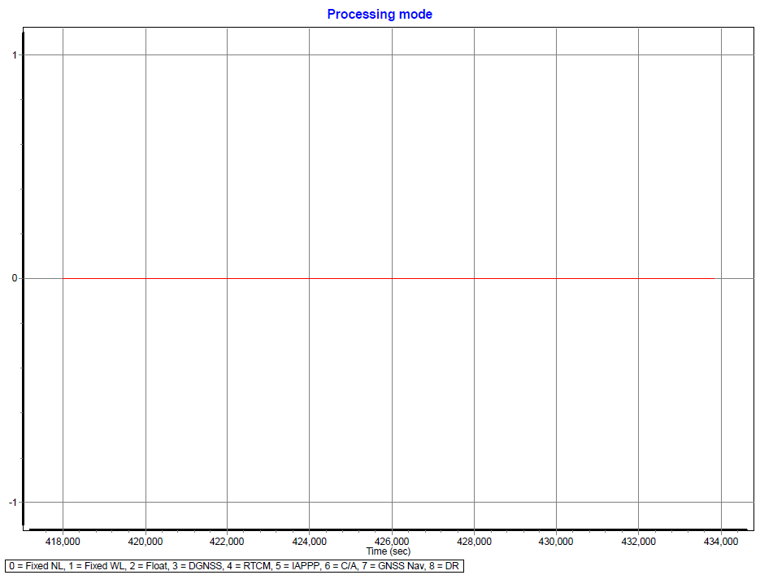

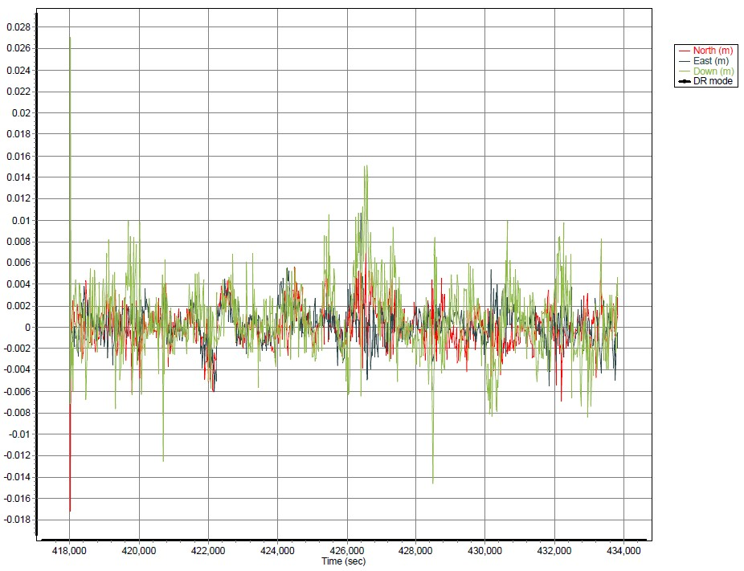

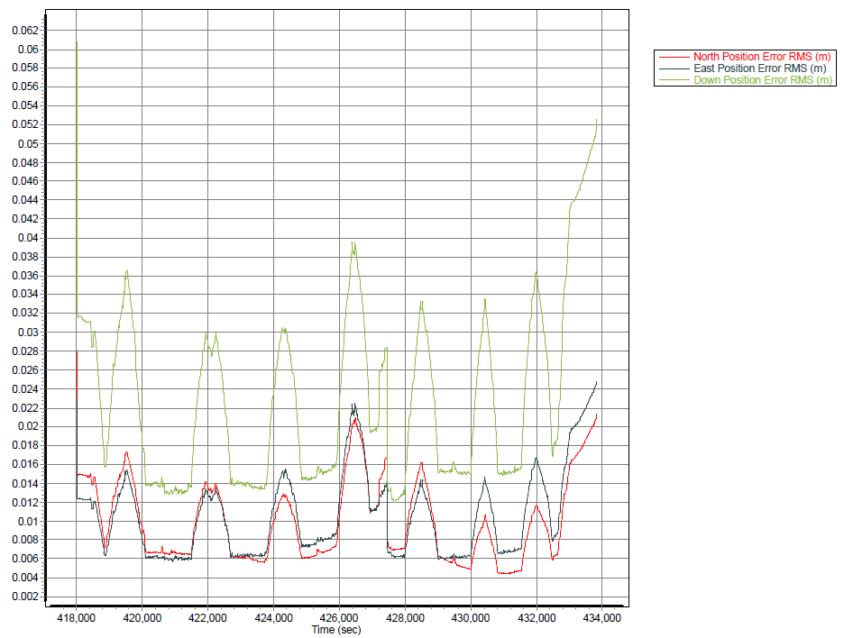

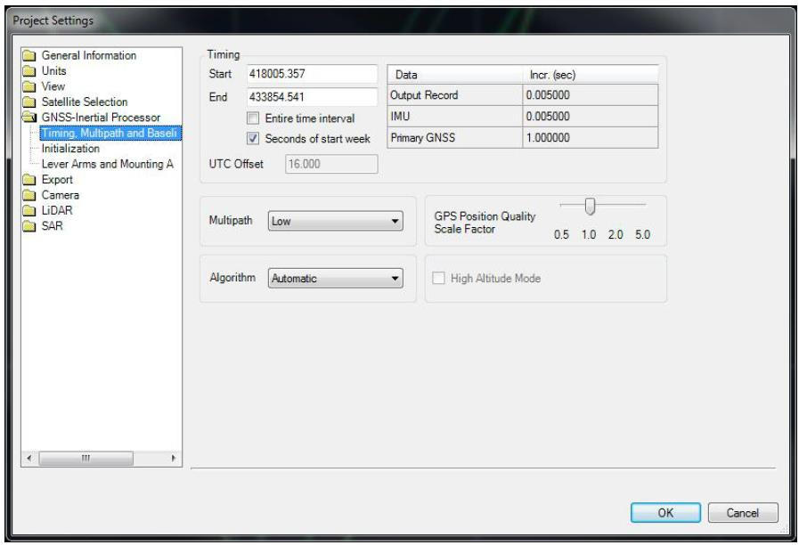

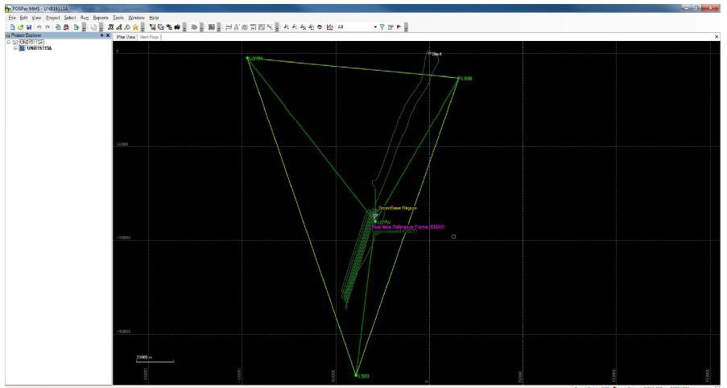

UNB15114A
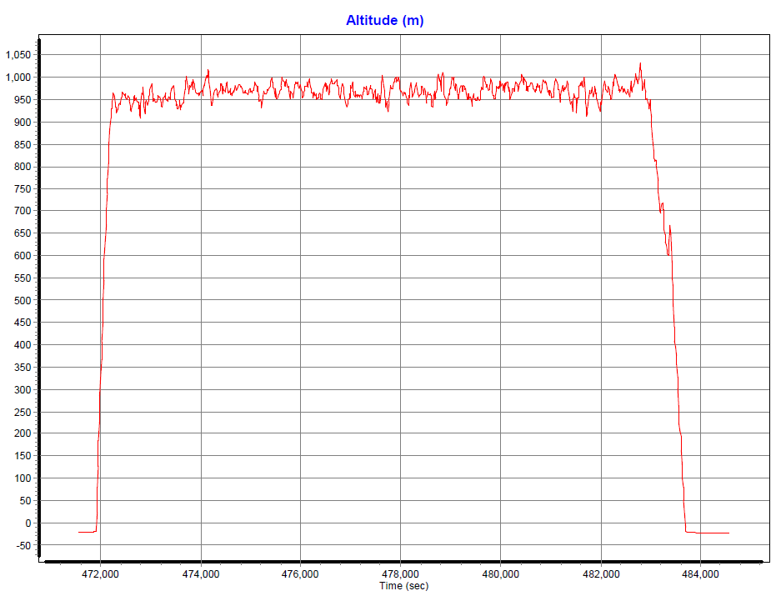

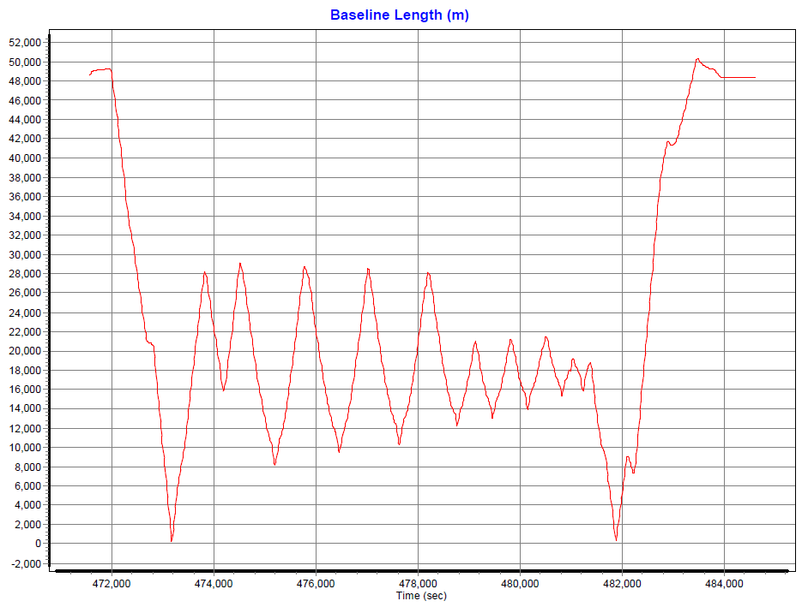

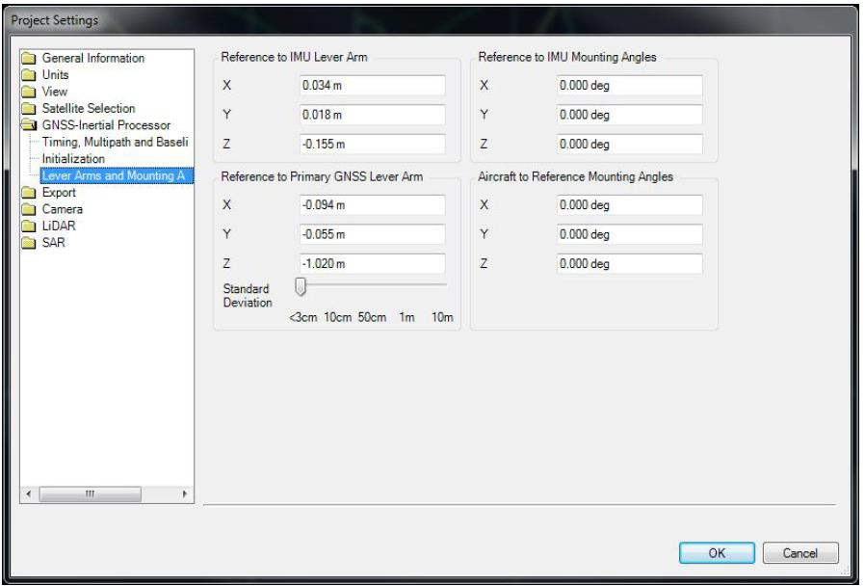

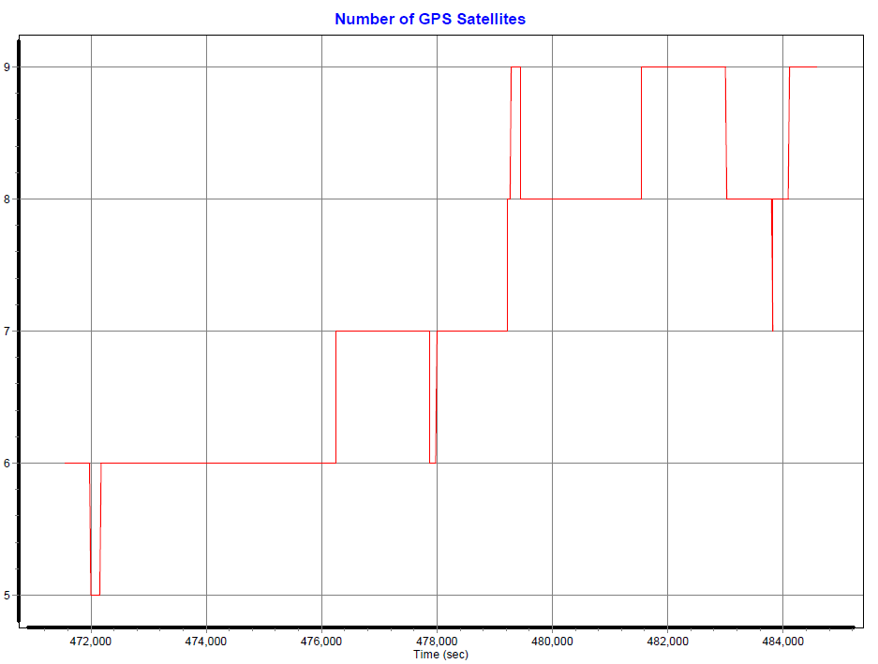

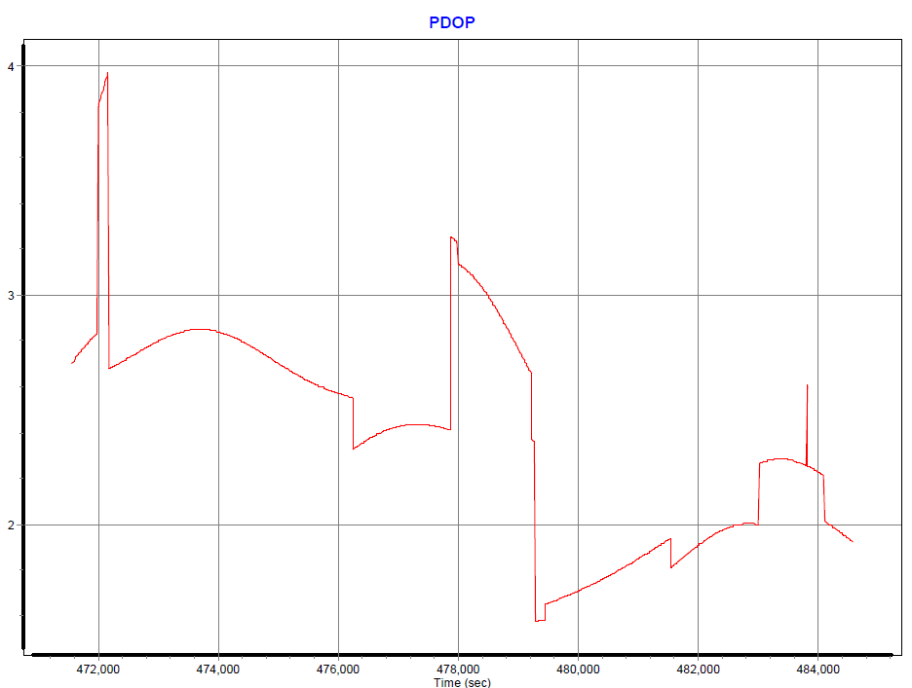

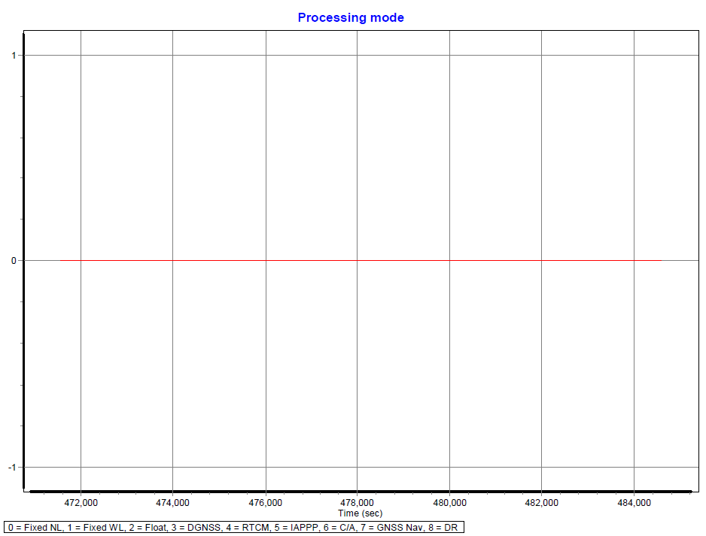

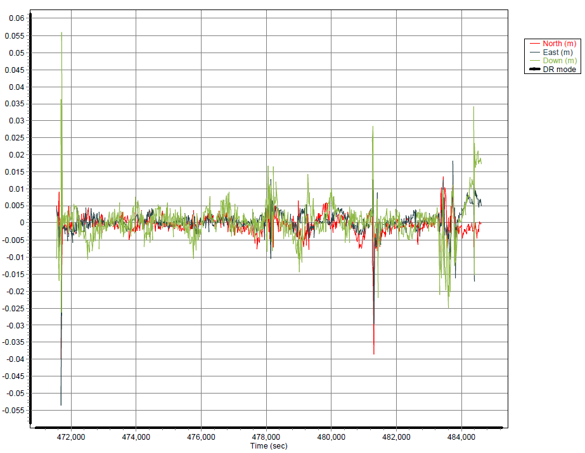

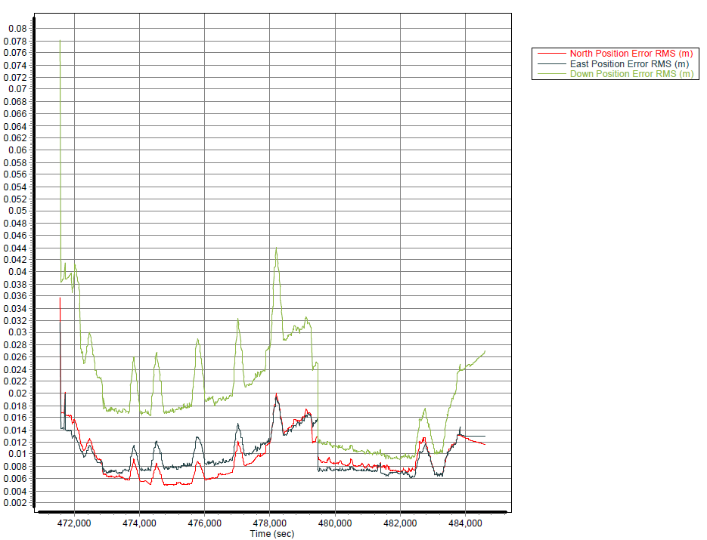

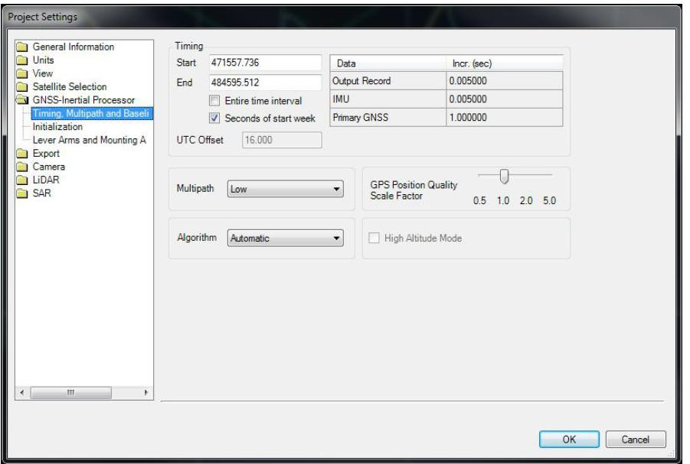

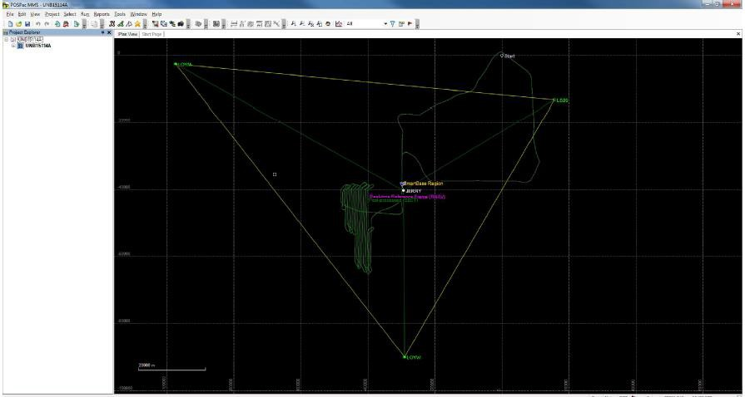

UNB15114B
