**Southwest Florida Water Management District**

**FY2014 Peace River Corridor LiDAR Hydrographic & Topographic Survey Lower Peace River MFL Establishment Project (B081), and Lake Hancock Water Level Modification project (H008)**

**Florida Standards of Practice for Mapping Projects**

**Survey and Map Report**

Submitted to:



**Mr. Alvan Karlin, Ph.D. GISP, District Senior GIS Scientist**

**Mr. Jim Owens PSM, District Land Survey Supervisor**

**Southwest Florida Water Management District**

**Mapping and GIS Section**

**2379 Broad Street**

**Brooksville, FL 34604**

**Office: 352-796-2711, x4204**

**Fax: 352-540-6018**

[Al.karlin@swfwmd.state.fl.us](mailto:Al.karlin@swfwmd.state.fl.us)

Prepared by:



Mr. Mitchell R. Jarrells, PSM

Project Manager

**Aerial Cartographics of America, Inc.**

423 South Keller Road, Suite 300

Orlando, Florida 32810

Office: 407-851-7880

Fax: 407-855-8250

Cell: 407-690-8344

[mjarrells@aca-net.com](mailto:mjarrells@aca-net.com)

Aerial Cartographics of America, Inc. Job Number: 2014124

***Florida Surveying and Mapping Report***

*FY2014 Peace River Corridor LiDAR Hydrographic & Topographic Survey Lower Peace River MFL Establishment Project (B081), and Lake Hancock Water Level Modification project (H008) Project performed for the Southwest Florida Water Management District.*

*Aerial Cartographics of America, Inc. Project Number 2014124*

*The Southwest Florida Water Management District (SWFWMD) contracted with Aerial Cartographics of America, Inc. (ACA) to acquire four laser ground points per one meter ground distance LiDAR over a project area of approximately 150 square miles. ACA utilized the Riegl Q680i Laser technology to collect LiDAR data. The LiDAR will be used to for developing topography (i.e. breaklines and one-foot contours, digital elevation model) for 167 standard 5000 feet x 5000 feet cells. See Figure 1 for illustration of the FY2013 LiDAR Acquisition for the Peace River project area.*

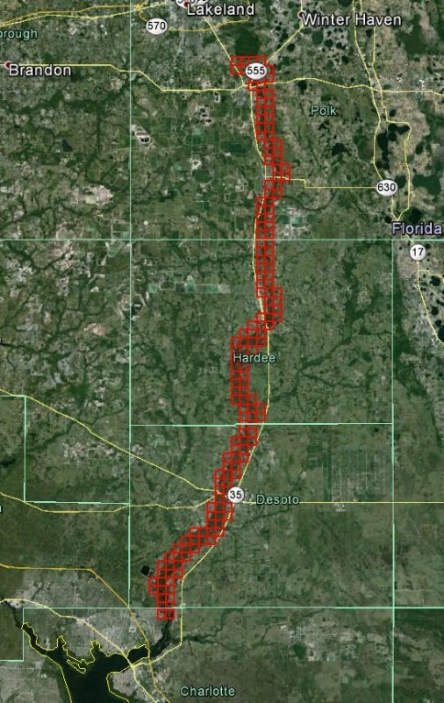

Figure

I, Mitchell R. Jarrells, a Professional Surveyor and Mapper (PSM) licensed in the State of Florida (LS0006438) do hereby state that this Survey and Map Report is correct and accurate, all to the best of my knowledge and belief for the mapping data, which was signed by me along with the signature date and job number listed below, and submitted to SWFWMD under Job Number 2014124:

Hard Drives Project Description* Date

Project deliverables PRELIMINARY**

Area A 6/19/2015

Area B 7/07/2015

Area C 8/14/2015

Area D 8/14/2015

Project Deliverables FINAL

Area A 8/19/2015

Area B 8/19/2015

Area C 8/19/2015

Area D 8/19/2015

* A full description of the deliverables is outlined below under ***Listing of final files and descriptions of media.***

** PRELIMINARY indicates that the deliverables were submitted to SWFWMD for review. These deliverables were not signed and sealed by a Florida PSM; therefore, said deliverables are not considered complete and final.

*** FINAL indicates the project-wide submittal of the reviewed and accepted deliverables signed and sealed by a Florida PSM, and accompanied by the Survey and Map Report.

**THIS PHOTOGRAMMETRIC MAPPING DATA AND REPORT IS CERTIFIED TO THE SOUTHWEST WATER MANAGEMENT DISTRICT AS MEETING THE STANDARDS OF PRACTICE OF THE FLORIDA BOARD OF PROFESSIONAL SURVEYORS AND MAPPERS, CHAPTER 5J-17.050 THROUGH 17.052, FLORIDA ADMINISTRATIVE CODE, PURSUANT TO SECTION 472.027, FLORIDA STATUTES.**

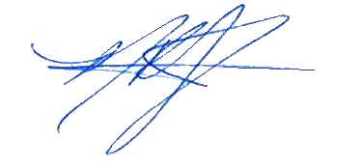

_______________________________ 8/24/2015

Mitchell R. Jarrells, PSM 6438 Date:

Aerial Cartographics of America, Inc. Project Number 2014124

This certification is not valid without the signature and raised seal of a Florida Professional Surveyor and Mapper.

***Table Contents***

Description Page

Glossary of terms ……………………………………………………..…………………………………. 4

Project title ……………………………………………………………………………………..………….. 5

Name of client ………………………………………………………………………………….……..….. 6

Client contract information ………………………………………………………………….……… 6

Intended use ……………………………………………………………………………………..………... 6

Responsible PSM name, number, address …………………………………………….…..… 6

Name of PSM company ………………………………………………………………………..……... 6

LB of PSM company ………………………………………………………………………….............. 6

Dates of survey …………………………………………………………………………………..………… 7

Dates of photography ………………………………………………………………………………..…. 7

Dates of LiDAR acquisition …………………………………………………………………............. 7

Horizontal and vertical datum ……………………………………………………………….......... 7

Horizontal and vertical control monuments used ………………………………………….. 7

Accuracy statement of survey ……………………………………………………………………….. 7

Supplemental monument type ………………………………………………………………………. 7

Accuracy statement of photography ………………………………………………………..………7

Accuracy statement of LiDAR ………………………………………………………………………….. 8

Accuracy statement of final deliverables ……………………………………………….………… 9

Intended display scale …………………………………………………………………………………….. 9

Metadata …………………………………………………………………………………………...………….. 9

Statement of any data limitations …………………………………………………………..……… 9

Listing of final files and description of media …………………………………………....……..9

Type of survey …………………………………………………………………………………..………..….. 9

LiDAR Mapping Report …………………………………………………………...................………10

Exhibit A – Cardno Survey Report………………………………………….…. 32

***Glossary of Terms***

Term Description

AGL Above Ground Level

ABGPS Airborne Global Positioning System

ASPRS American Society of Photogrammetry and Remote Sensing

AT Aerial Triangulation

CD Compact Disk

CMS Certified Mapping Scientist

CP Certified Photogrammetrist

CVA Consolidated Vertical Accuracy

DEM Digital Elevation Model

DFIRM Digital Flood Insurance Rate Maps

DTM Digital Terrain Model

DVD Digital Versatile Disk / Digital Video Disk

DXF Drawing Exchange Format

ECW Enhanced Compression Wavelet

FDEM Florida Department of Emergency Management

FDOT Florida Department of Transportation

FEMA Federal Emergency Management Agency

FGDC Federal Geographic Data Committee

FIRM Flood Insurance Rate Maps

FPRN Florida Permanent Reference Network

FVA Fundamental Vertical Accuracy

FY Fiscal Year

GIS Geographic Information system

GISP Geographic Information System Professional

GSD Ground Sample Distance

GPS Global Positioning System

HARN High Accuracy Reference Network

HDD Hard Drive Disk

HPGN High Precision Geodetic Network

IMU Inertial Measurement Unit

LB License Business

LS Licensed Surveyor

LiDAR Light Detection and Ranging

MSL Mean Sea Level

NDEP National Digital Elevation Program

NGS National Geodetic Survey

NMAS National Map Accuracy Standards

No. Number

NSRS National Spatial Reference system

NSSDA National Standard for Spatial Data Accuracy

OPUS Online Positioning User Service

PDOP Positional Dilution of Precision

PH.D. Doctor of Philosophy

PRR Pulse Rate Repetition

PSM Professional Surveyor and Mapper

RMSE Root Mean Square Error

RMSEz Vertical Root Mean Square Error

RMSEr Horizontal Root Mean Square Error

SHA Secured Hash Standard

SWFWMD Southwest Florida Water Management District

SPCS State Plane Coordinate System

SVA Supplemental Vertical Accuracy

UTC Coordinated Universal Time

XML eXtensible Markup Language

• ***Project Title***

FY2014 Peace River Corridor LiDAR Hydrographic & Topographic Survey Lower Peace River MFL Establishment Project (B081)

• ***Name of Client***

Southwest Florida Water Management District

• ***Client contact information***

Mr. Alvan Karlin, Ph.D. GISP, District Senior GIS Scientist

Mr. Jim Owens PSM, District Land Survey Supervisor

Southwest Florida Water Management District

Mapping and GIS Section

2379 Broad Street

Brooksville, FL 34604

Office: 352-796-7211, x-4204

Fax: 352-540-6018

[al.karlin@swfwmd.state.fl.us](mailto:al.karlin@swfwmd.state.fl.us)

• ***Intended use***

The primary use is for the creation of a ground surface DEM.

• ***Responsible PSM name, number and address***

Mr. Mitchell R. Jarrells

PSM 6438,

423 South Keller Rd. Suite 300

Orlando, FL 32810

407-851-7880

[mjarrells@aca-net.com](mailto:mjarrells@aca-net.com)

• ***Name of PSM Company***

Aerial Cartographics of America, Inc.

423 South Keller Rd. Suite 300

Orlando, FL 32810

407-851-7880

[www.aca-net.com](http://www.aca-net.com/)

• ***LB Number of PSM Company***

Aerial Cartographics of America, Inc. LB6748

• ***Dates of survey (Cardno)***

November 22, 2014

• ***Dates of photography***

December 15, 2014

• ***Dates of Lidar acquisition***

December 1 thru 3, 2014

• ***Horizontal and vertical datum***

Projection – Florida State Plane Coordinate System (SPCS), West Zone (0902)

Horizontal Datum – North American Datum 1983 HARN (NAD83), National Spatial Reference System adjustment of 2011 (NSRS 2011)

Vertical datum – North American Vertical Datum 1988 HARN (NAVD88) using the latest geoid (Geiod12A) for converting ellipsoidal heights to orthometric heights

Units – U.S. Survey Foot

• ***Horizontal and vertical control monuments used (descriptions, coordinates, elevations, to-reach, monument type, etc.)***

National Geodetic Survey (NGS) monuments and horizontal and vertical values were used as the basis to control the SWFWMD project. All GPS checkpoint control was tied to the above mentioned NGS control. NGS monuments descriptions, horizontal values, elevations and to-reach descriptions, as well as other control data sheets and references are all contained within the Cardno survey and map report attached in Exhibit A. The following are the NGS monuments used: A624, GPS 3194, W 2620, and X 65.

eGPS Real Time Network of static stations were used to supplemental NGS CORS stations to produce the Airborne Global Position System trajectory.

• ***Accuracy statement of ground control survey***

Cardno preformed the ground control checkpoints survey activities in support of the required accuracies for this project. See Exhibit A for the Cardno survey and map report.

• ***Accuracy statement of photography***

The accuracy of the project imagery was determined from check points provided by SWFWMD was tested to meet a Horizontal Accuracy (Accuracyr) of 3.8’ at the 95% confidence level using the formula RMSE(r) x 1.7308 as defined by the National Standard for Spatial Data Accuracy (NSSDA). The accuracy for LiDAR data over well defined surfaces will meet or exceed requirements as set forth in the Federal Geographic Data Committee’s (FGDC) Geospatial Positioning Accuracy Standards, Part 3: National Standard for Spatial Data Accuracy (NSSDA).

• ***Accuracy statement of LiDAR***

The bare earth LiDAR dataset was tested to meet a Fundamental Vertical Accuracy (FVA) of 0.60’ at the 95% confidence level using the formula RMSEz x 1.9600 as defined by the National Standard for Spatial Data Accuracy (NSSDA) in open, well defined terrain. The vertical accuracy for LiDAR data over well defined surfaces will meet or exceed requirements as set forth in the Federal Geographic Data Committee’s (FGDC) Geospatial Positioning Accuracy Standards, Part 3: National Standard for Spatial Data Accuracy (NSSDA).

The *LiDAR Mapping Report* section documents the procedures used in planning, acquisition, post-processing, boresighting, and classification. An accuracy assessment performed by ACA using SWFWMD check points for Fundamental Vertical Accuracy and Consolidated Vertical Accuracy are included in the LiDAR mapping report on page 10.

• ***Intended display scale***

The topographic data is intended to be displayed at a scale of 1”=100’ (1:1200) or smaller.

• ***Metadata***

Fully compliant metadata with the FGDC Content Standard for Spatial Metadata in ESRI ArcCatalog and XML format accompanies this report for each feature class to include LiDAR collection dates, sensor description, DEM source information, processing software, processing methodology, projection information and positional accuracy and procedures used to determine accuracy.

• ***Statement of any data limitations***

There is no limitation other than the previously defined map accuracy and display scale.

• ***Listing of final files and descriptions of media***

* Raw LiDAR instrument\ IMU\ GPS data.
* Classified NIR point cloud LAS 1.2 or newer.
* Unclassed Hydrographic LAS data with Full Wave Form Data.
* Tested for Fundamental Vertical Accuracy (FVA) of 0.6’ (0.3’ RMSez) at the 95% confidence interval and a Supplemental/Consolidated Vertical Accuracy (SVA/CVA) of 1.19’ (0.6’ RMSEz) at the 95% Confidence Level as determined by the National Standards for Spatial Data Accuracy (NSSDA)
* Ortho-Imagery RGBi format, with 0.5’ GSD, 5.2’ (3.0’ RMSe) horizontal accuracy.
* Compiled Breaklines to include:

1. HydroFeatures as needed for surface hydrology
2. Overpass (elevated roadway or bridge, if captured)
3. Waterbody (as necessary for DTM)

Deliverables are not complete without the signed and sealed Survey and Map Report.

• ***Type of survey***

Topographic Survey

**LiDAR Mapping Report**

Provided by:

**AERIAL CARTOGRAPHICS OF AMERICA, INC.**

**LB # 0006748**

U.S.MAIL DELIVERIES

P.O. Box 593846 423 South Keller Road, Suite 300

Orlando, FL 32809-3846 Orlando, FL 32810

Phone (407) 851-7880 Fax (407)855-8250

P.S.M. in responsible charge: Mitchell R. Jarrells, PSM #6438

Type of Survey: Topographic Survey

Date of Survey (LiDAR): December 1-3, 2014

Date of Photography: December 15, 2014

Project Name: FY2014 Peace River Corridor LiDAR Hydrographic & Topographic Survey Lower Peace River MFL Establishment Project (B081), and Lake Hancock Water Level Modification project (H008*)*

ACA Project No.: 2014124

File Names: 167 standard 5000’ x 5000’ tiles of classified LiDAR point cloud in LAS 1.2 format, breaklines in ArcGIS file geodatabase, digital color orthophotograph mosaic in ECW format.

Field Surveys for check points provided by: Southwest Florida Water Management District 2379 Broad Street Brooksville, FL 34604

**Purpose**

ACA was contracted by Southwest Florida Water Management District to perform a topographic survey using Light Detection and ranging (LiDAR) technology for the project area located on the Peace River. The purpose of the project was to produce accurate, high resolution ground LAS.

The contents of this report summarize the methods used to perform the LiDAR data collection and post-processing, as well as the results of the methods used.

**Acquisition**

The area was defined by a shape file in Polk, Hardee, Desoto and Charlotte Counties, Florida as represented by Figure 1. LiDAR was collected on December 1 thru 3, 2014 in a Cessna 206 utilizing a Riegl LMS-Q680i laser scanner at an approximate altitude of 1,800 feet above ground level (AGL), an approximate ground speed of 110 knots at a Pulse Rate Repetition (PRR) of 340kH, resulting in a minimum of 6.97 points per square meter. The sensor used a 60 degree field of view. The project was flown to have 50 percent overlap between swaths.

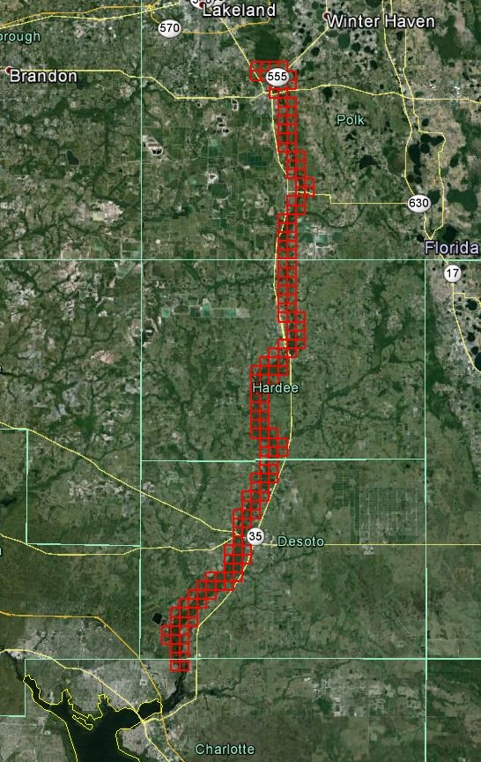

Figure 1

The flight mission used a Topcon base station set up by ACA’s base of aircraft operations, and Continuously Operating Reference Stations (CORS) as base station control. A stationary alignment procedure of 5 minutes was performed in addition to an in-air alignment over the Bartow (BRTW) CORS station. This standard procedure requires straight and level flight beginning three (3) minutes before the CORS station and continuing for three minutes past the station to establish alignment of the Inertial measuring Unit (IMU) and resolve GPS ambiguities. During collection the system operator monitored and recorded information on log sheets pertaining to weather, flight lines and operating conditions. Flight plans were made using Track’Air software to show the lines in correct geographic position to aid the pilot and system operator in acquiring complete, error free data. At the end of the flight another in-air alignment was performed over the BRTW CORS to aid in the processing of the trajectory. Following the flight operations the data was transported to our main office facility in Orlando where post processing took place to ensure data completeness and quality. Refer to Figure 4 for flight line trajectories.

A separate flight mission was accomplished on December 15, 2015 to acquire imagery of the project area using ACA’s Vexcel UltraCamX large format digital camera system at an altitude of 7,500’ above ground level. The purpose of the imagery flight was to support the classification and breakline collection process.

**Airborne GPS Processing**

The Global Positioning System (GPS) data were processed using Applanix POSPac Mobile Mapping Suite version 5.2 using Smart Base methods. A fixed bias carrier phase solution was computed in forward and reverse directions. The LiDAR collection took place when Positional Dilution of Precision (PDOP) was at or below 3. Occasionally, the PDOP rose slightly above 3. This had no affect on the data. The GPS trajectory was combined with the IMU data using the Applanix POSPac software. The resulting Smoothed Best Estimate of Trajectory (SBET) was exported and used in Riegl RiProcess software to compute the laser mass point positions in Northing, Easting, and Elevations coordinates. Refer to Figures below for Satellites, PDOP and Performance Metrics for the LiDAR and imagery flights by date. (Note: the figures are hard to read due to the size in the report. A copy of the images are supplied in a folder on the delivery drive called *Report Metrics.*)

December 1st flight, Lift 1

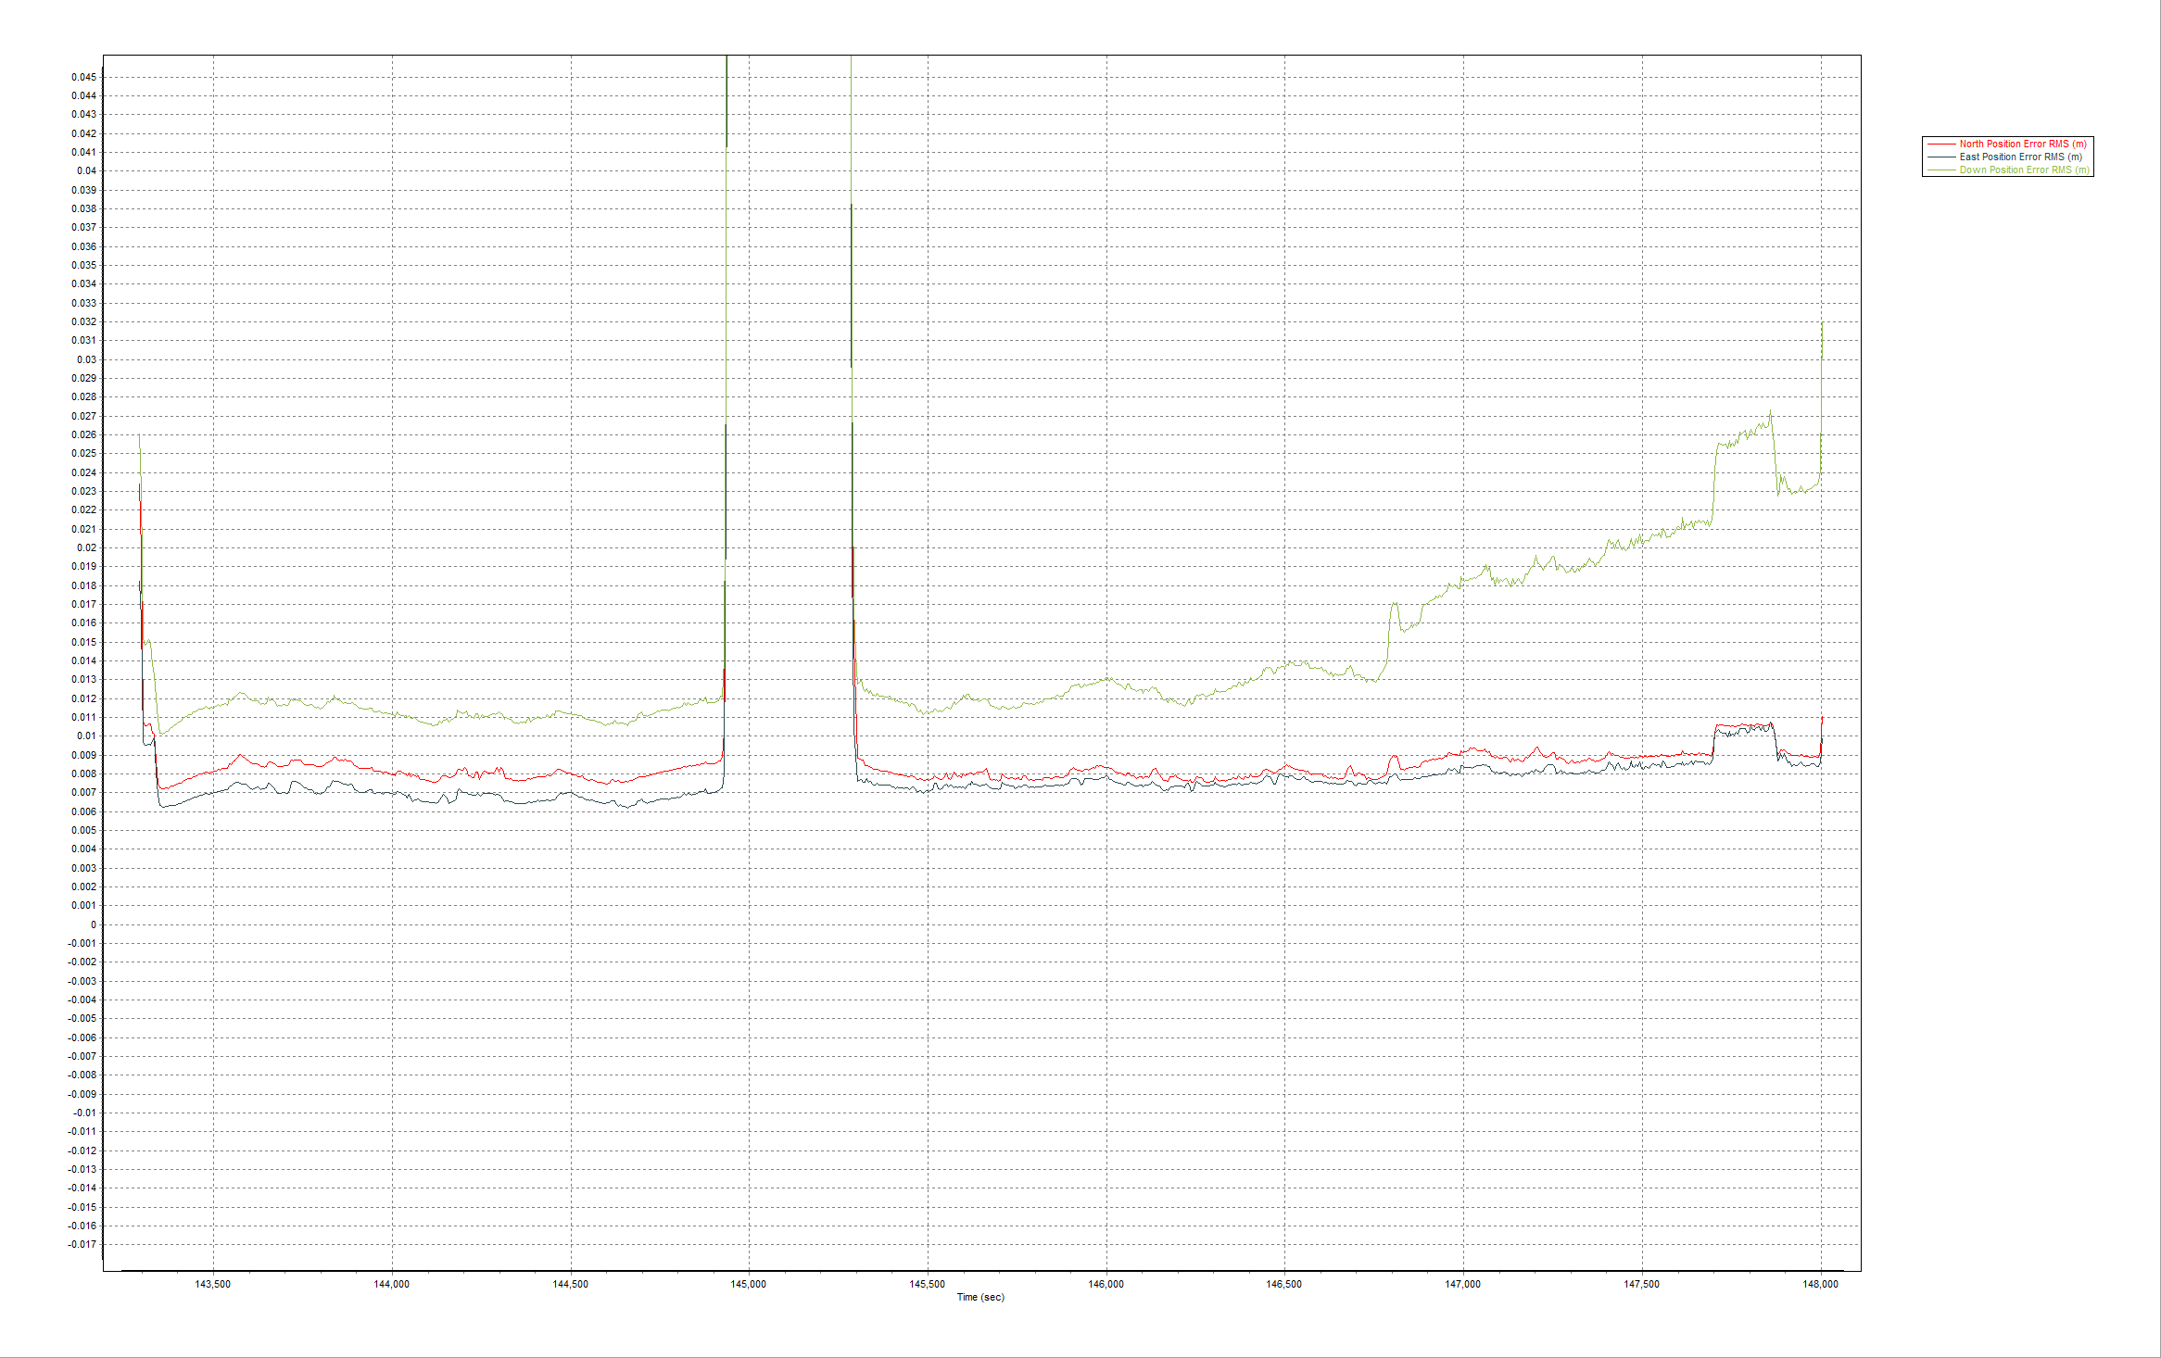

Smoothed Performance Metrics

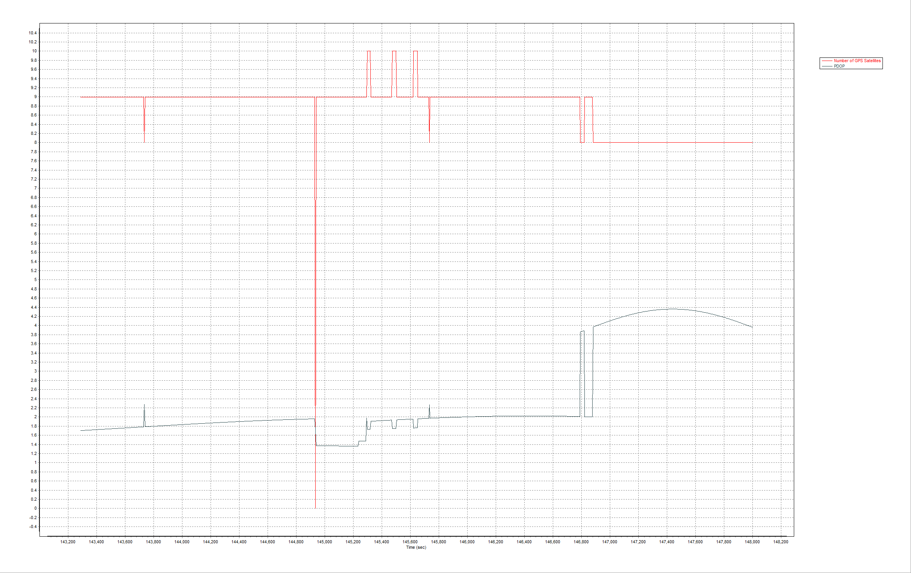

PDOP and Satellites

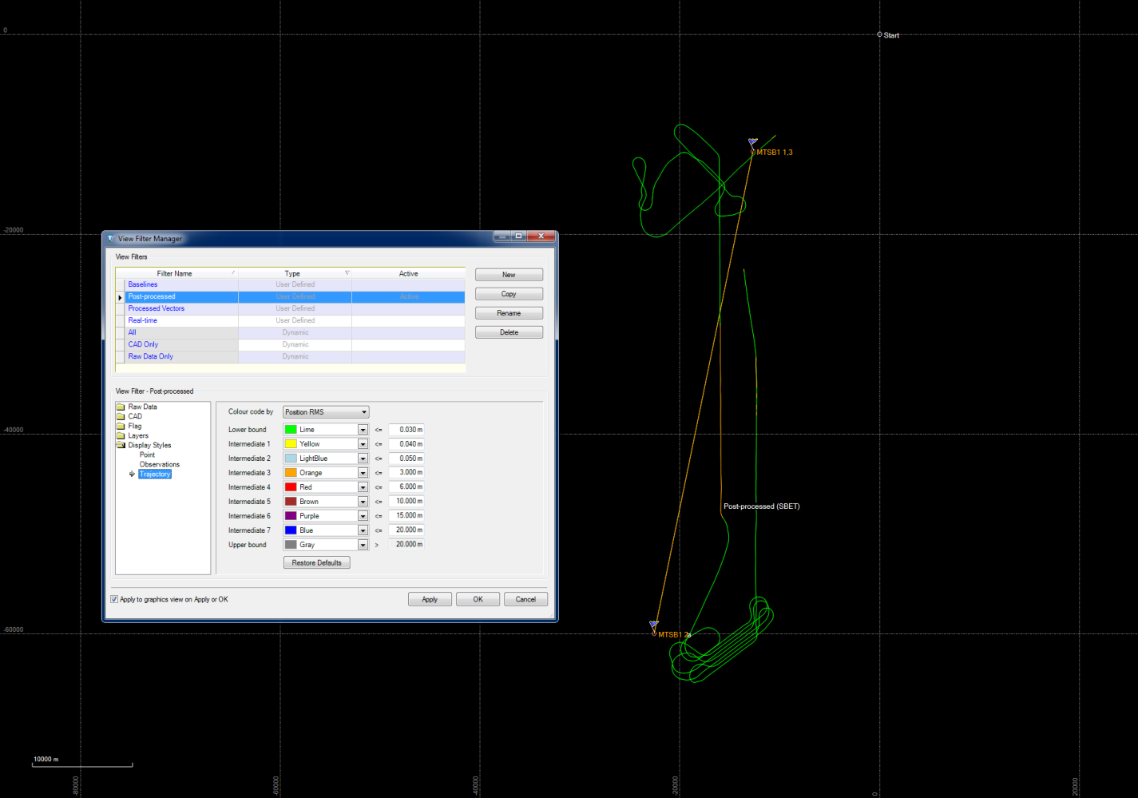

Trajectory

December 1stflight, Lift 2

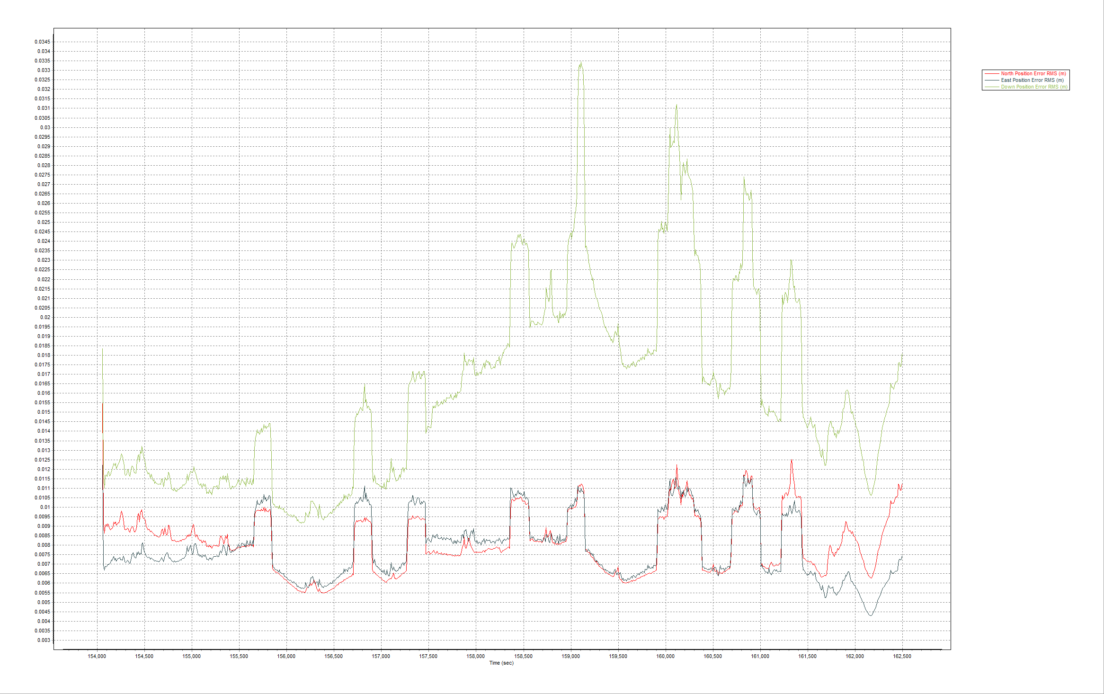

Smoothed Performance Metrics

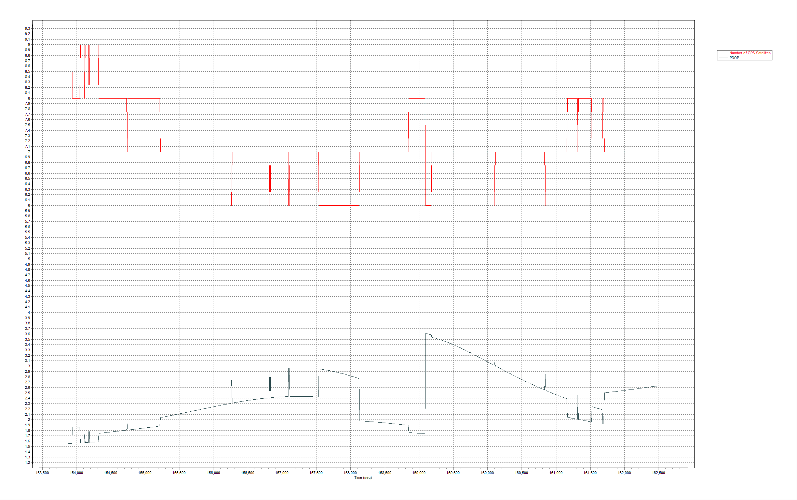

PDOP and Satellites

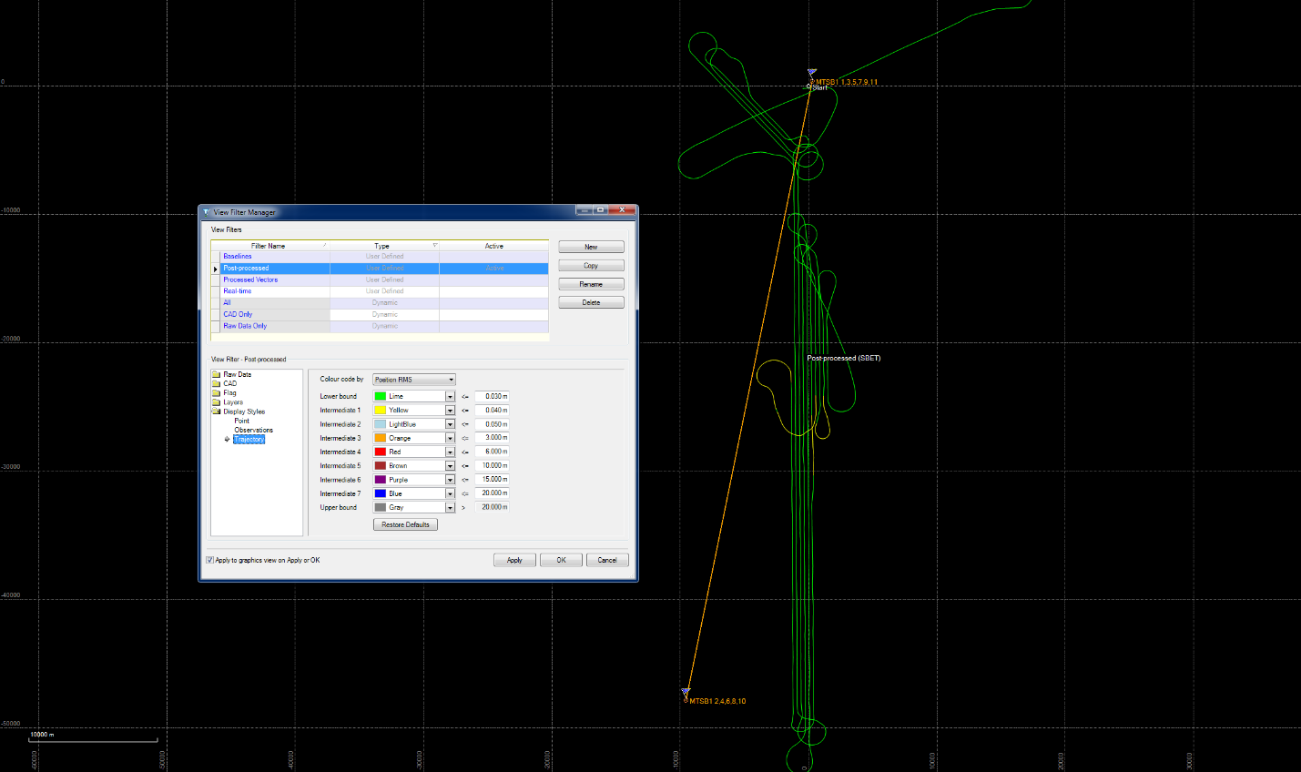

Trajectory

December 2nd flight

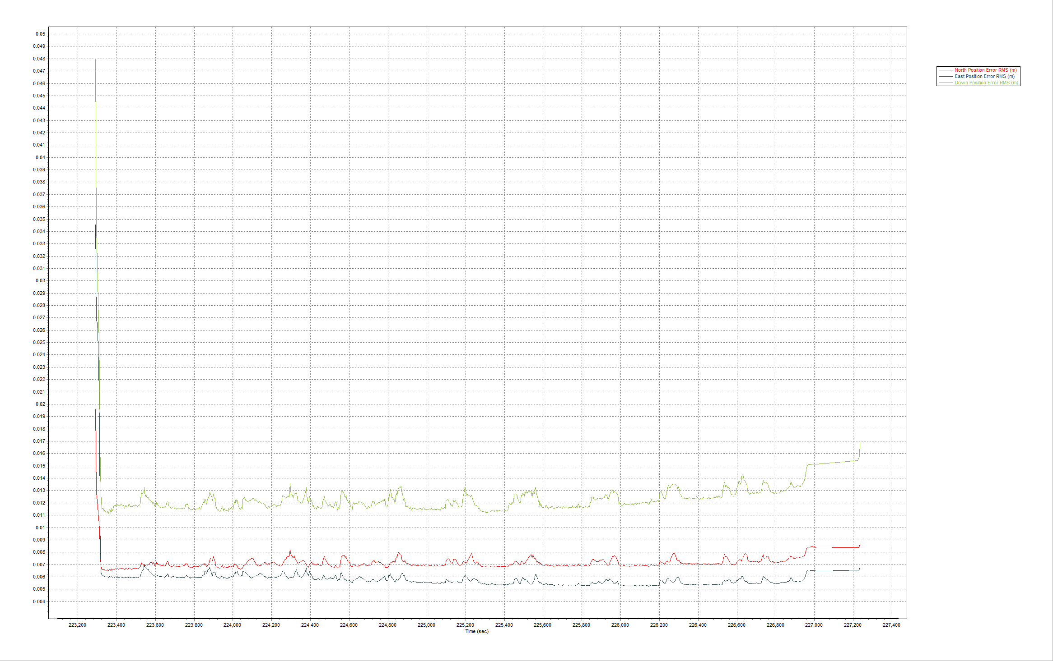

Smoothed Performance Metrics

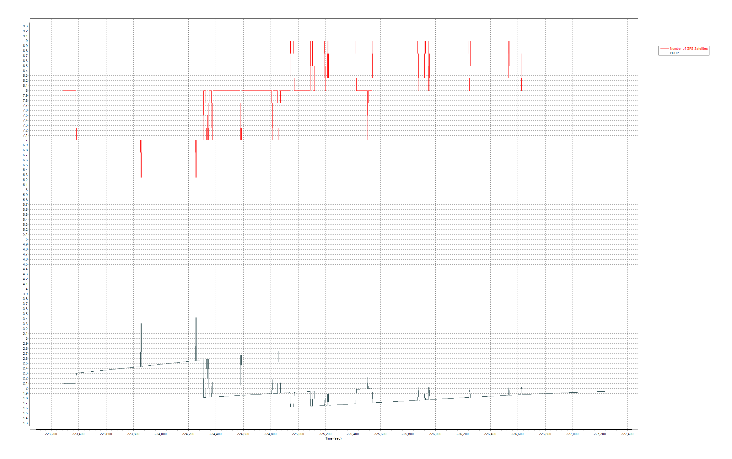

PDOP and Satellites

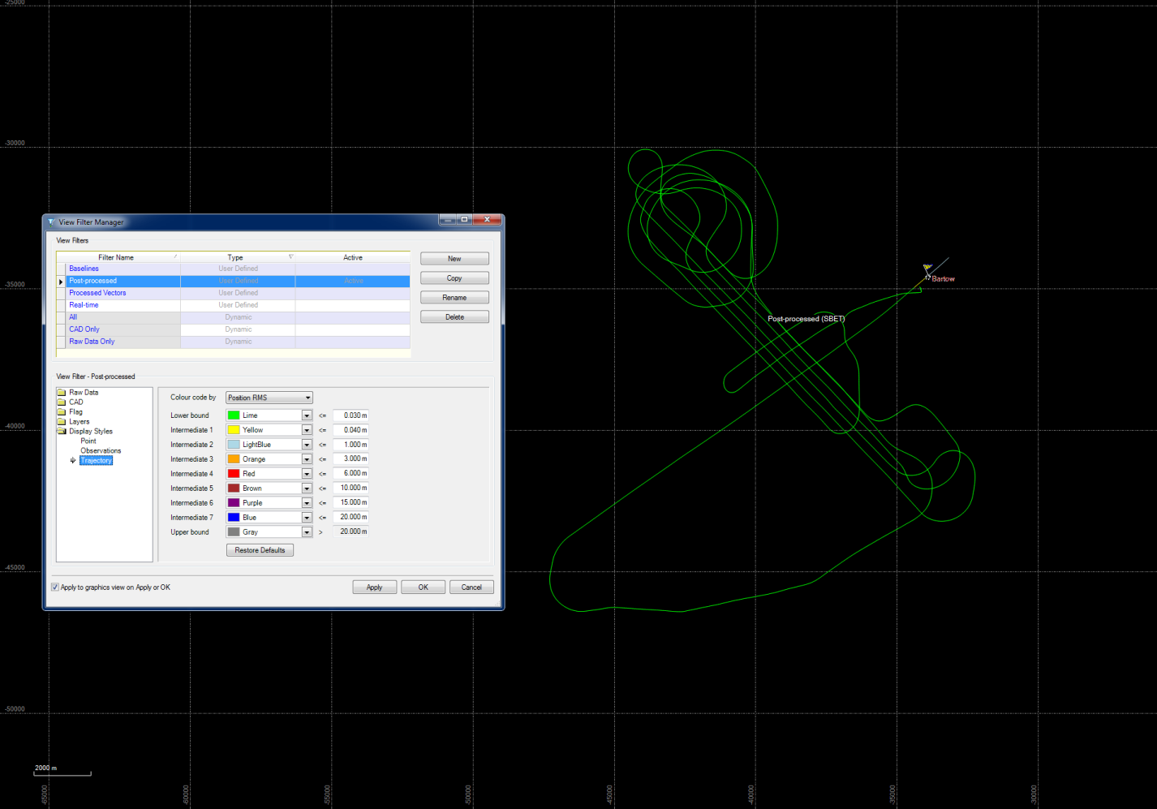

Trajectory

December 3rd flight

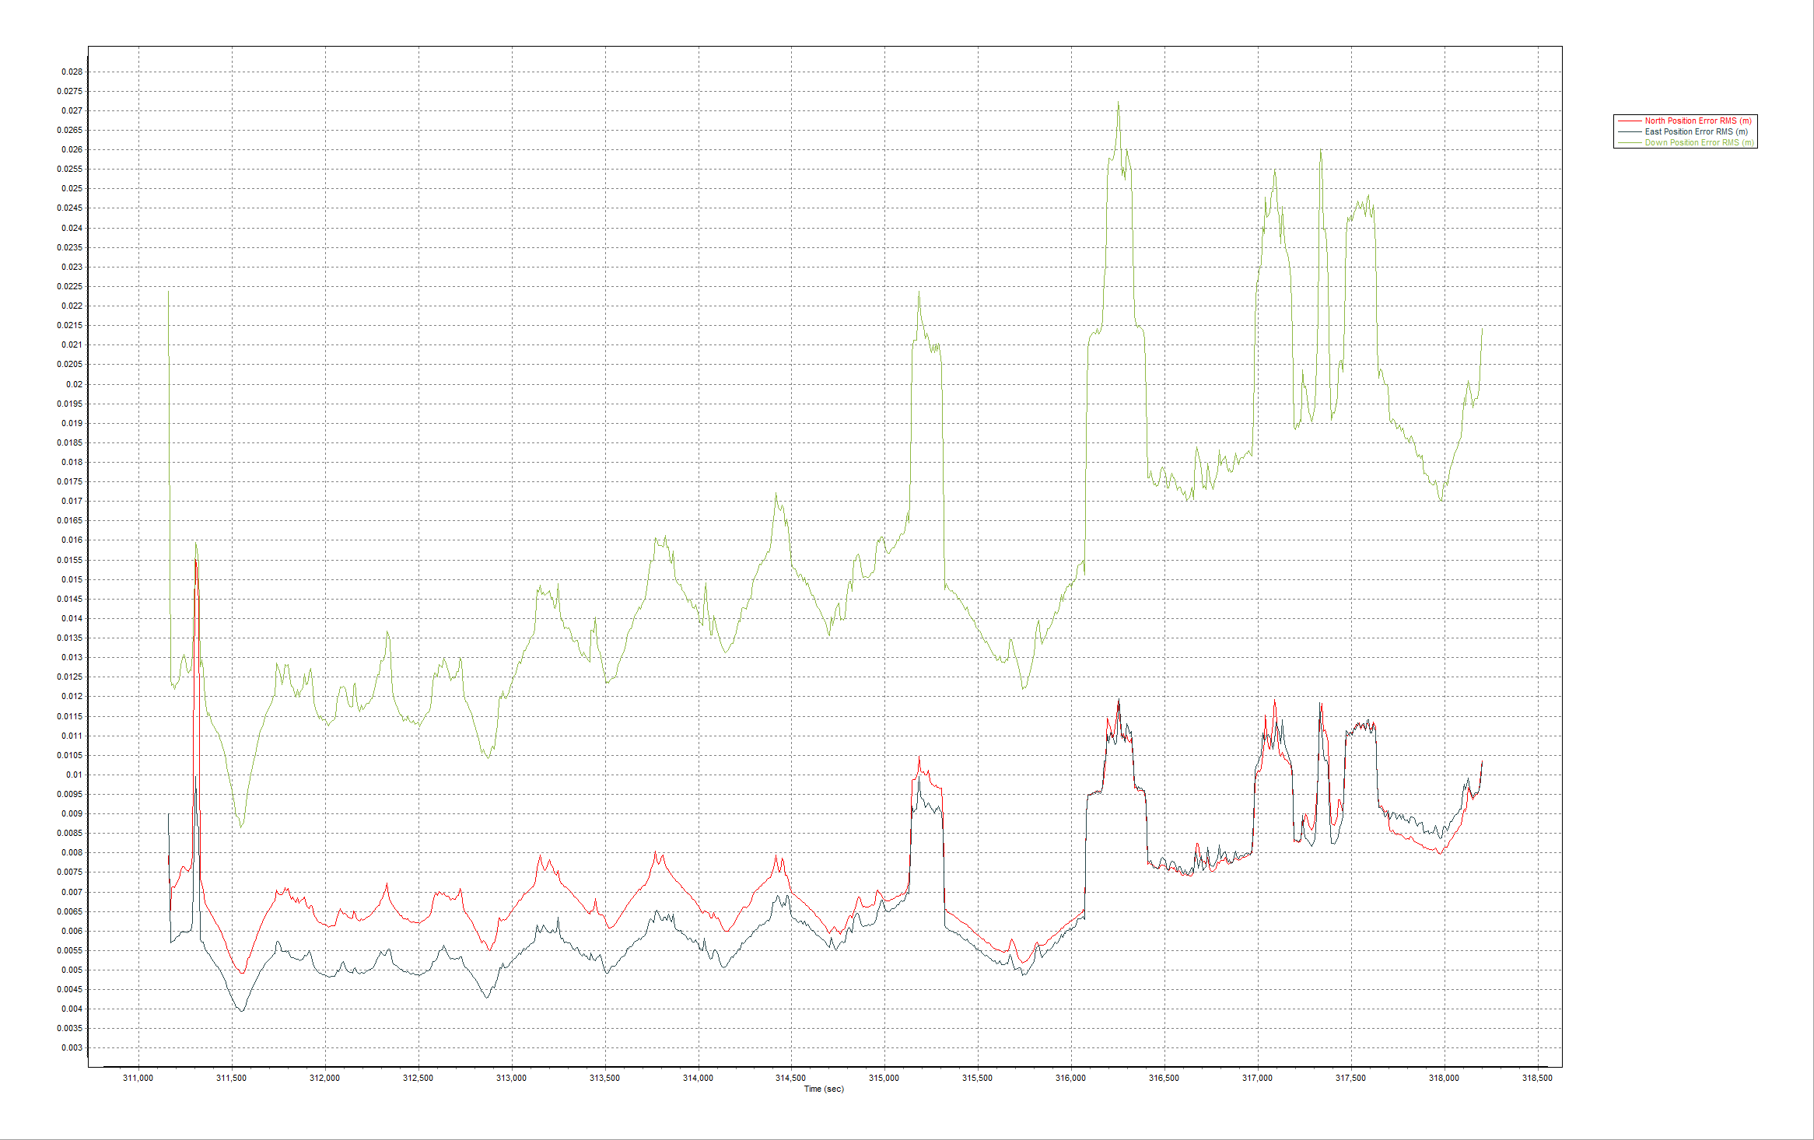

Smoothed Performance Metrics

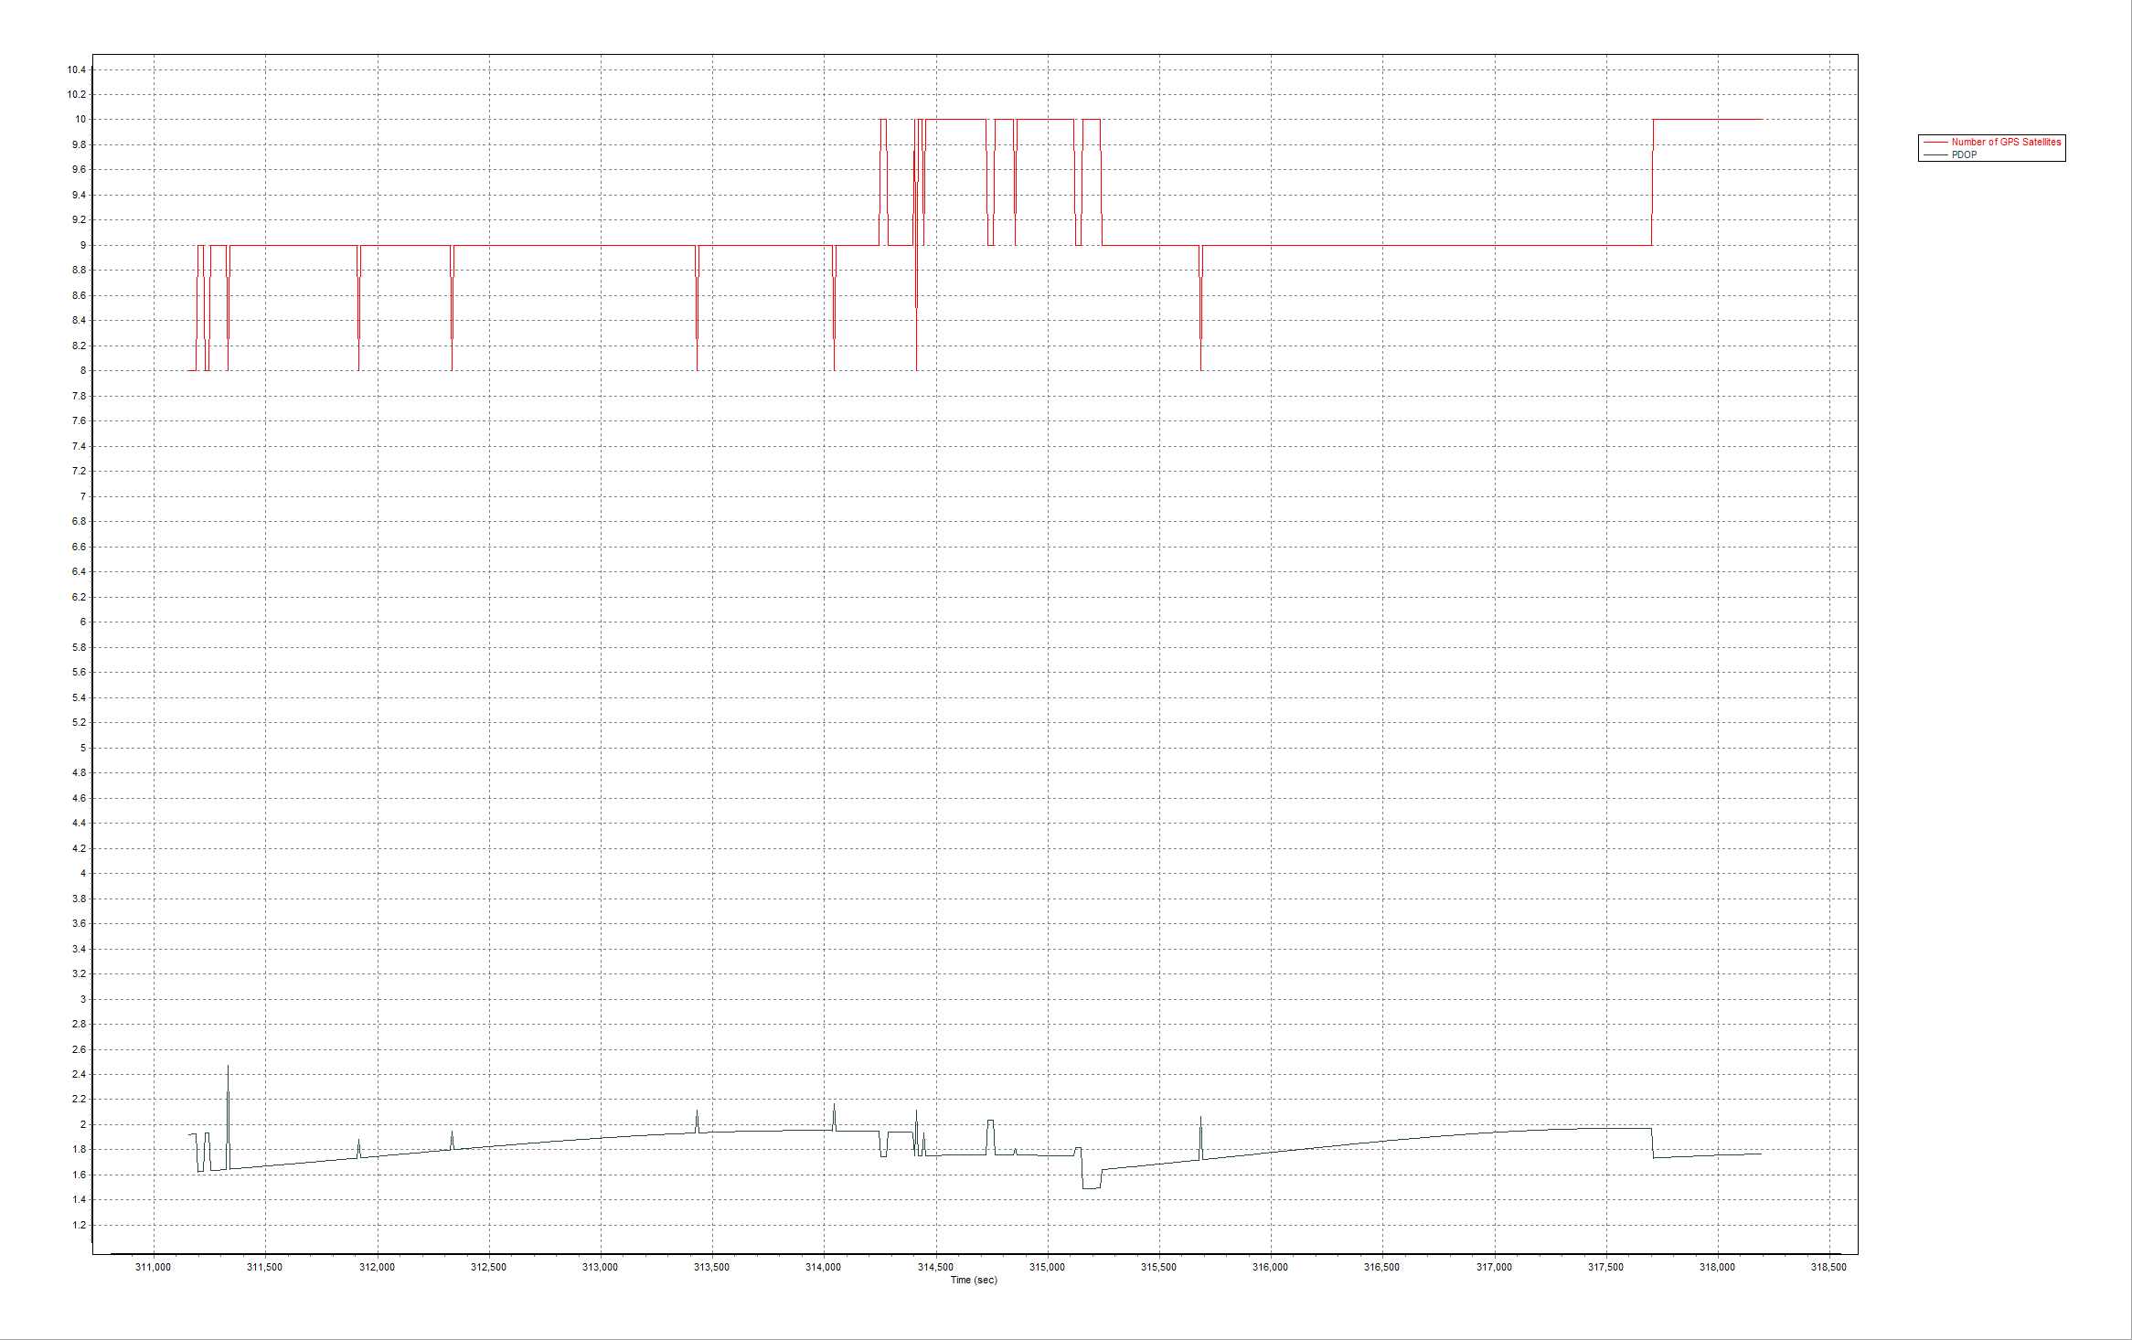

PDOP and Satellites

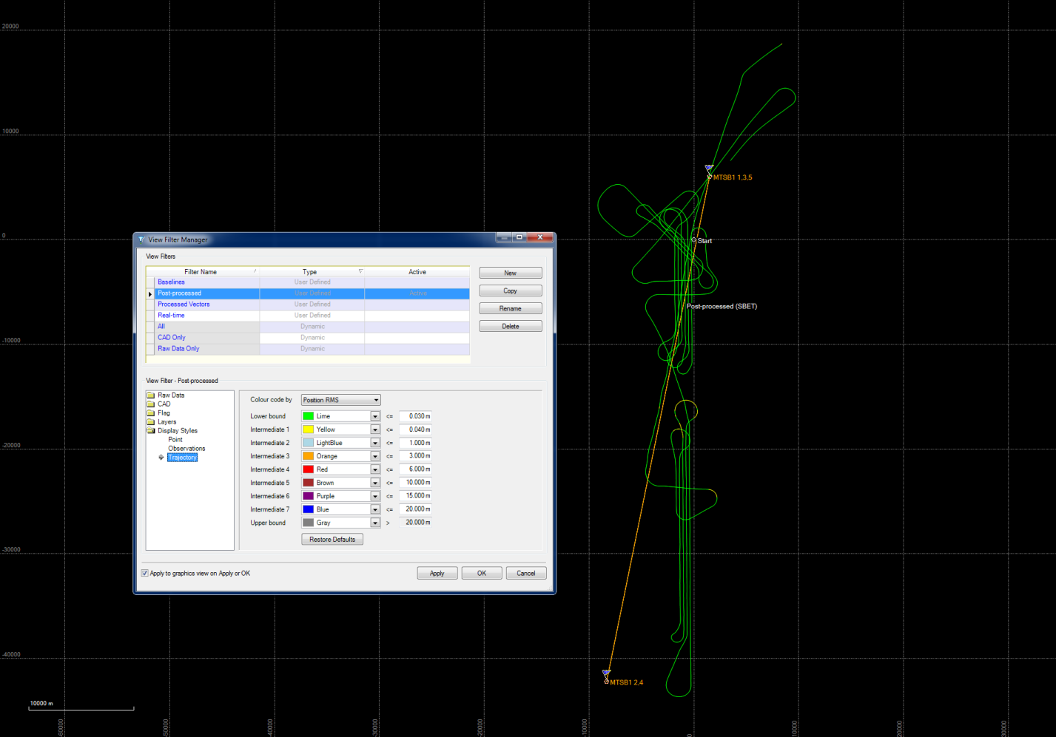

Trajectory

December 15th flight, imagery

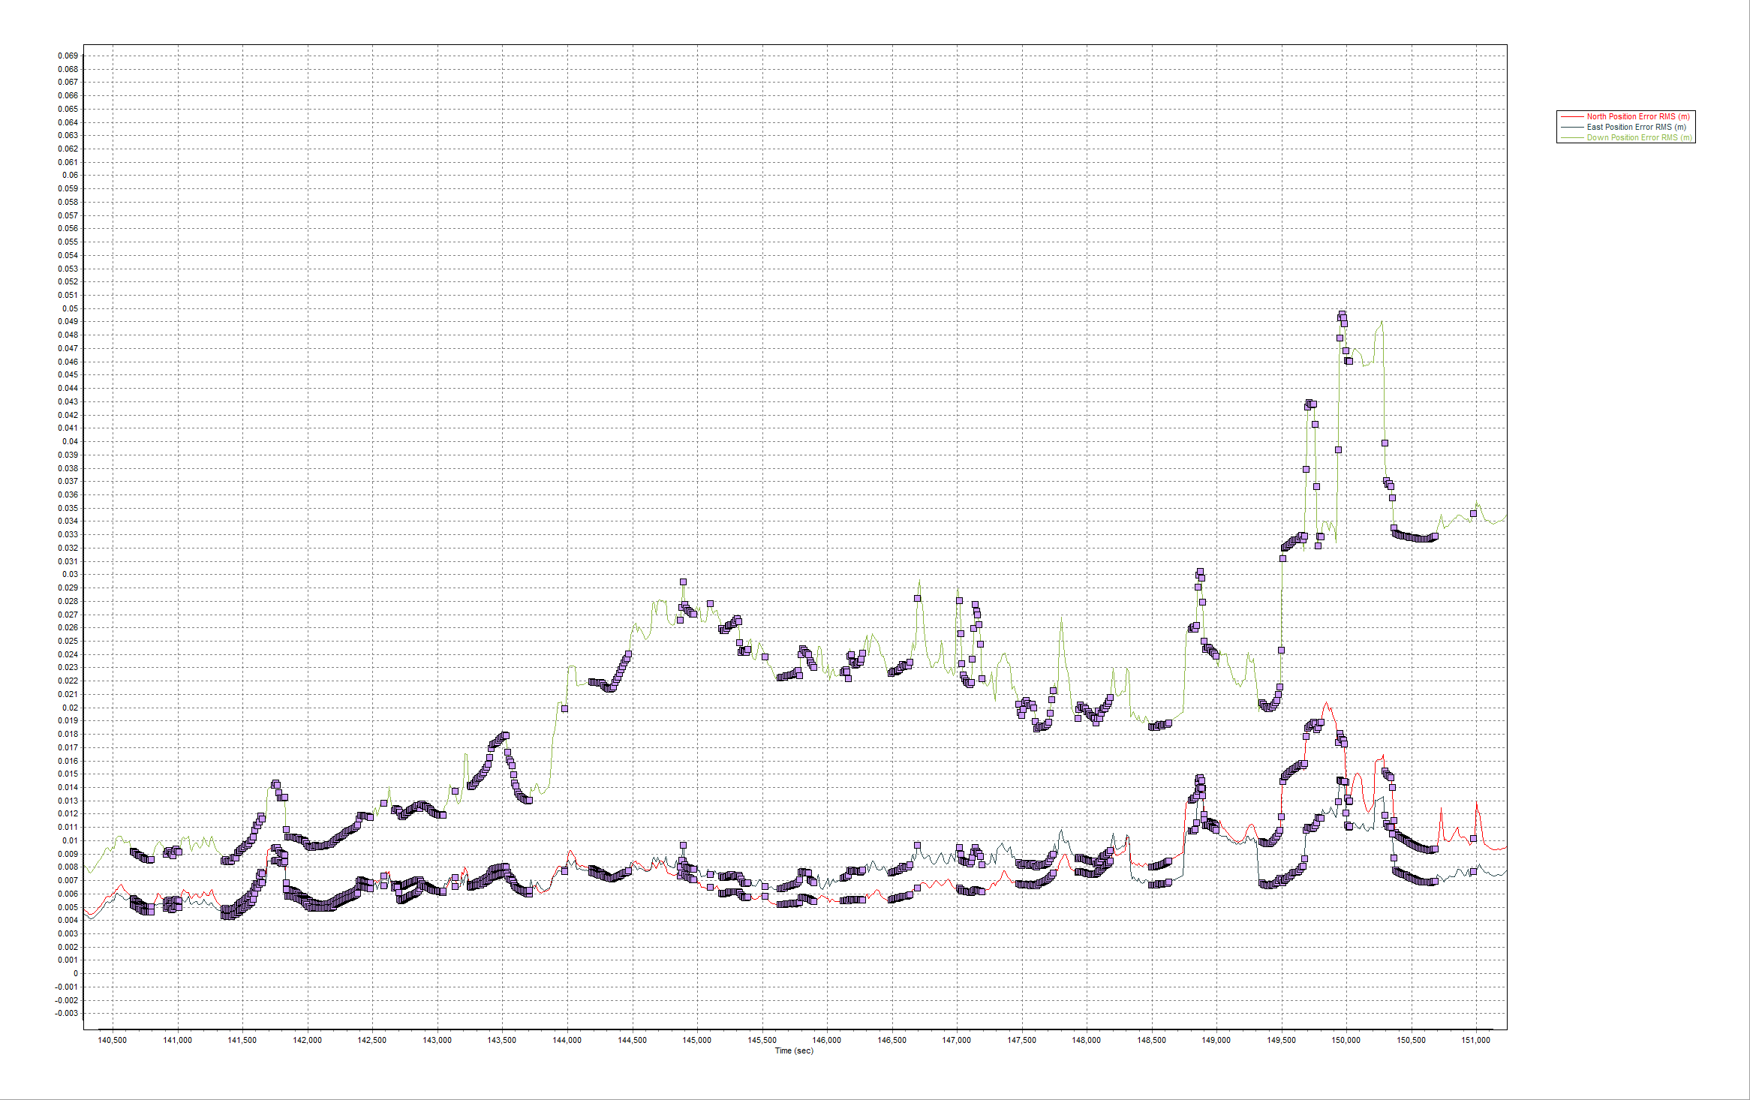

Smoothed Performance Metrics

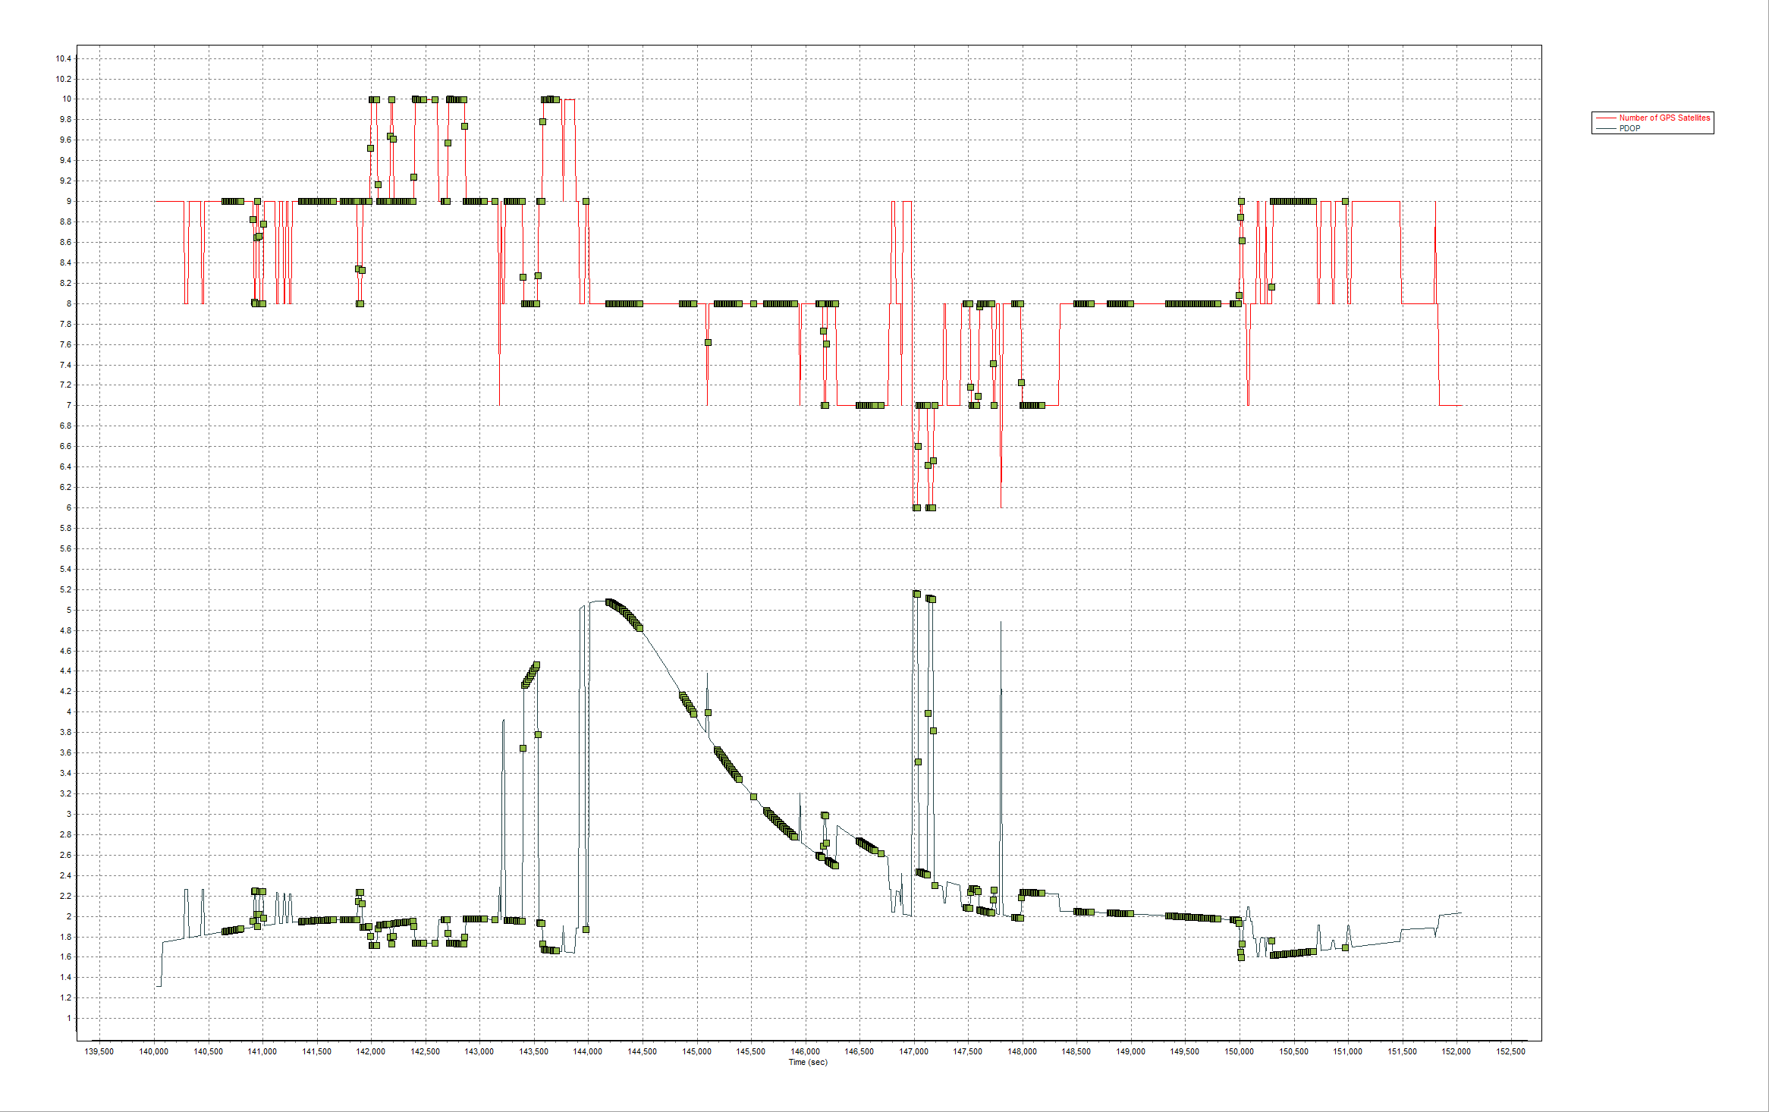

PDOP and Satellites

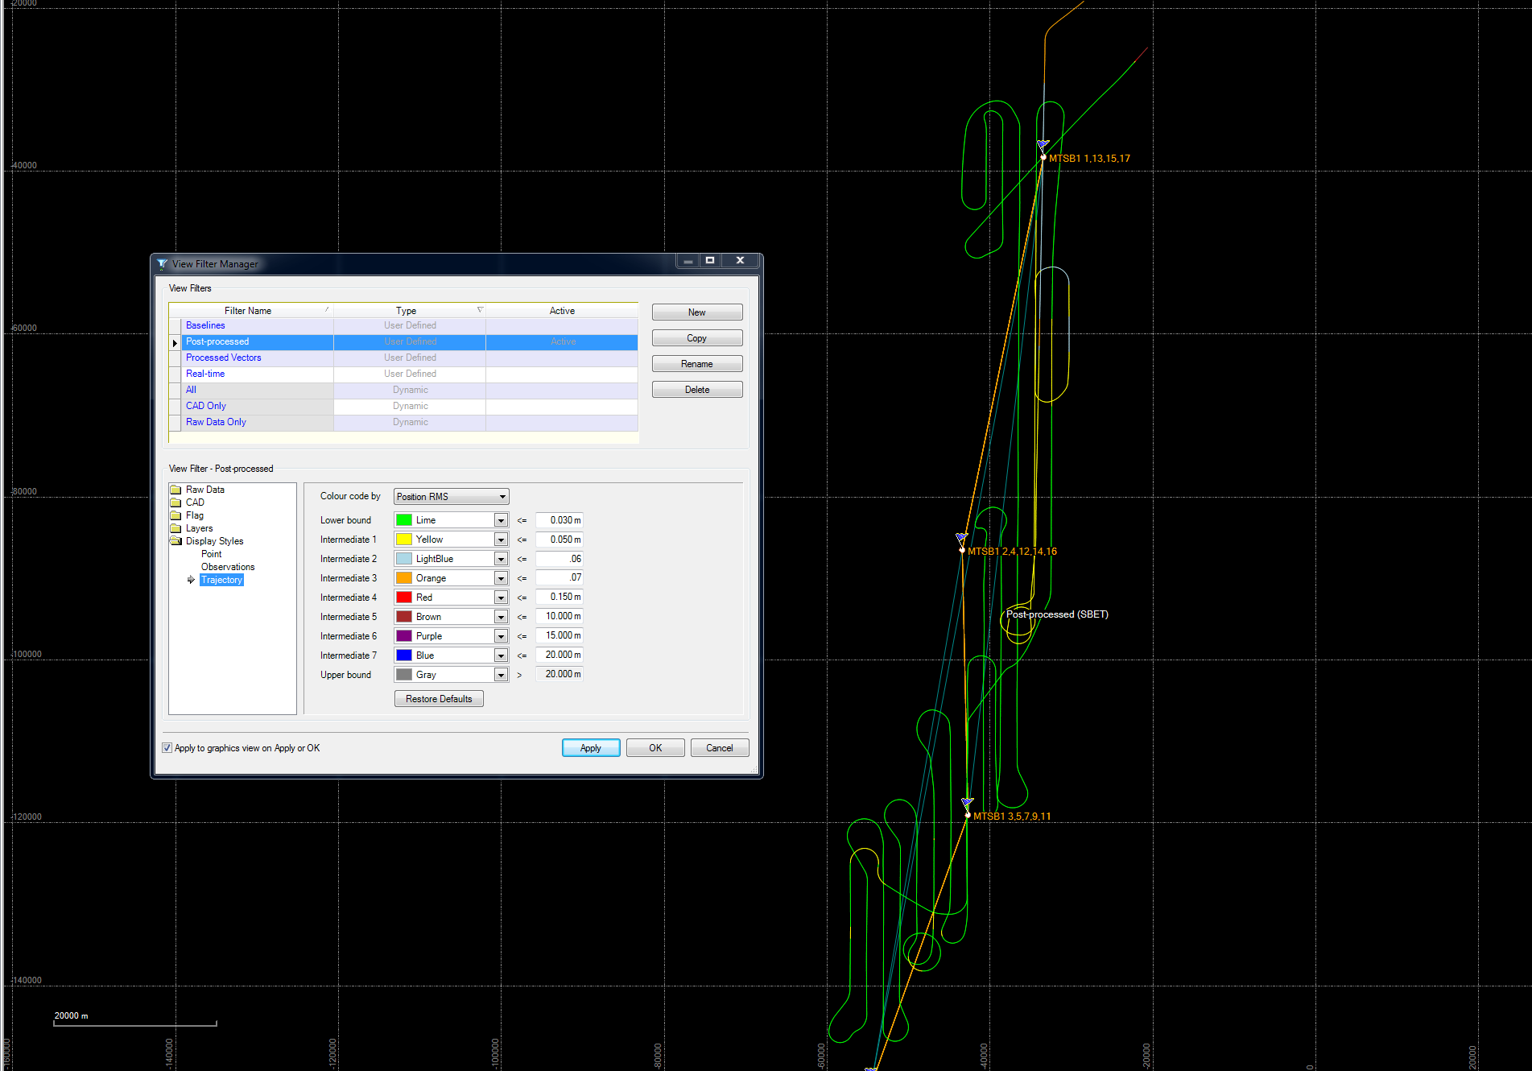

Trajectory

**Image Processing**

Raw images were processed using Microsoft Vexcel UltraMap software to produce 24 bit RGB Level 3 images without color modifications. The exterior Orientation values from Airborne GPS processing and ground survey check points were used in the aerial triangulation (AT) program to orient the images in the most precise positions with accurate rotation angles. A Digital Elevation Model (DEM) was developed for the orthographic rectifying of aerial imagery for the project area from the LiDAR point cloud. The LiDAR data was sampled to a 100-foot DEM to process the images generated for the project area. Raw images were processed using KLT Atlas Ortho software x64 to process the images into a seamless set of RGB orthographic images. Ortho images were created as 8 bits per channel and have an 18" pixel resolution. Ortho tiles were clipped to the Statewide Tiling Scheme in Tagged Image File format (TIFF) TFW format. The completed RGB digital orthophotos were checked for image quality. Minor artifacts were corrected using Adobe Photoshop in an interactive editing session.

**LiDAR Processing**

The raw laser data were merged with the SBET using Riegl RiProcess software. The data set was processed using RiProcess, RiAnalyze, and RiWorld software where each flight line was processed to a point cloud. The data were adjusted flight line to flight line using Riegl’s Scan Data Adjustment tool to ensure a proper relative calibration match between flight lines. Each flight was checked for project coverage, data gaps between overlapping flight lines, point density and then exported in LAS 1.2 format. The entire project was collected without gaps with a Nominal Point Spacing (NPS) of approximately 2 points per square meter. The files were projected to the North American Datum 1983 (2007) Florida State Plane Coordinate System, West Zone (902), and National American Vertical Datum of 1988 (NAVD88). Ellipsoidal heights were converted to orthometric heights using the current Geiod12A. All units are U.S. Survey Feet. The LAS files were imported to TerraSolid, LTD TerraScan software to be classified to bare earth ground and later feature coded to SWFWMD specifications.

The tiles dataset was imported to Digital Transfer Solutions EarthShaper® software to collect breaklines according to specifications directly from the LiDAR data. The single and double line linear hydrographic features were hydro-enforced with downhill constraints to model correct flow patterns. Water bodies were hydro-flattened to ensure uniform elevation across the feature. Point data were further classified with EarthShaper to project specifications and a Digital Elevation Model (DEM) of the bare earth surface was created as a hydro-enforced 32-bit floating point grid format and constructed with a 5’ cell size. ESRI ArcHydro was used to check the data met project specifications. EarthShaper was used to produce one-foot contours.

**LiDAR Fundamental Vertical Accuracy (FVA)**

The following listing shows the results of the LiDAR compared to the ground survey check point data provided by Cardno. The listing is sorted by elevation error column, in ascending order, the vertical difference between the LiDAR points and the ground control check points. The comparison is shown in State Plane Coordinates. Below is a FVA Data Comparison listing of the control points used for the Fundamental Vertical Accuracy (FVA) Report.

Name X Y Z (control) Z (TIN) Delta Z

712510.06 1149233.09 65.66 65.67 -0.01

10003 701761.49 1140516.07 59.53 59.49 0.04

10009 691333.41 1057704.24 41.33 41.18 0.15

10011 696183.76 1068727.97 51.82 51.71 0.12

10012 709264.10 1071177.91 65.57 65.55 0.02

10013 703818.41 1084756.48 67.55 67.34 0.21

10015 705344.24 1132860.71 33.25 33.38 -0.13

10016 705048.40 1125209.59 28.45 28.32 0.13

10017 705489.84 1115543.55 27.34 27.35 -0.01

10018 707589.14 1105915.48 30.81 30.76 0.05

10019 713729.84 1095113.71 29.80 29.77 0.03

10000 721133.87 1162942.91 72.90 72.99 -0.09

GPS2015 720107.30 1204086.15 57.50 57.59 -0.09

GPS2020 727871.32 1238221.50 90.23 90.37 -0.14

GPS2021 725448.25 1230111.39 85.47 85.65 -0.18

GPS2022 725415.45 1230315.82 76.23 76.52 -0.29

GPS2024 724354.87 1224733.15 119.86 120.00 -0.14

GPS2025 724384.40 1224655.23 119.53 119.34 0.19

GPS2026 724325.03 1218433.65 116.95 116.78 0.17

GPS2029 724375.61 1219169.86 119.17 118.86 0.31

GPS2030 724250.92 1210759.81 106.23 106.18 0.05

GPS2031 724288.70 1210733.16 106.64 106.29 0.35

GPS2032 724305.04 1210694.32 105.30 105.75 -0.45

GPS2033 719602.90 1229466.47 97.92 97.97 -0.05

GPS2034 719652.06 1229820.35 101.11 101.12 -0.01

GPS2035 718099.86 1224741.73 83.35 83.36 -0.01

GPS2036 718102.17 1224780.96 83.21 83.09 0.12

GPS2037 716748.90 1219202.33 74.71 74.92 -0.21

GPS2038 716822.26 1220353.47 75.80 75.82 -0.02

GPS2039 724416.00 1206374.86 108.32 108.19 0.13

GPS2040 724411.76 1206303.89 108.56 108.45 0.11

GPS2042 721932.21 1196120.81 77.04 77.35 -0.31

GPS2043 721936.97 1196104.12 77.72 77.87 -0.15

GPS2044 717947.96 1195852.12 76.62 76.58 0.04

GPS2045 717959.29 1195719.49 77.12 76.98 0.15

GPS2047 715136.58 1202200.01 100.11 100.14 -0.03

GPS2048 715267.68 1201526.37 98.67 98.61 0.06

GPS2100 720506.99 1238959.91 133.88 133.84 0.04

GPS2101 720485.10 1239018.73 134.71 134.66 0.05

GPS2102 720281.01 1235032.84 128.66 128.89 -0.23

GPS2105 715205.38 1226117.93 92.74 92.83 -0.09

GPS2106 715139.56 1226154.79 94.01 93.99 0.02

GPS2108 717751.14 1204164.01 77.56 77.52 0.04

GPS2109 715040.41 1211311.51 95.89 95.95 -0.06

W703 716819.31 1219194.10 73.81 73.94 -0.13

10001 718944.31 1156410.74 93.62 93.27 0.35

10014 728548.91 1156634.09 74.31 74.19 0.12

PR5001 715160.87 1189927.18 107.91 107.93 -0.02

PR5007 720243.19 1167646.40 72.62 72.67 -0.05

PR5008 720247.40 1167769.67 72.42 72.41 0.01

PR5009 721072.60 1166646.24 55.46 55.33 0.13

PR5012 723153.22 1165881.36 53.23 53.04 0.19

PR5014 724664.94 1165362.63 68.16 67.86 0.30

PR5016 724776.00 1165556.96 68.56 68.17 0.39

PR5017 727319.82 1167683.89 71.58 71.44 0.14

PR5021 722411.06 1169777.88 56.48 57.08 -0.60

PR5022 722367.63 1169756.69 58.88 59.01 -0.13

PR5027 726263.49 1169771.86 61.24 61.14 0.10

PR5028 726217.08 1169790.60 60.21 60.17 0.05

PR5031 726424.52 1171738.31 65.89 65.57 0.32

PR5034 729741.98 1169543.54 67.93 67.79 0.15

PR5038 727789.19 1166388.76 74.29 74.22 0.07

PR5039 729873.40 1172002.04 69.29 69.04 0.25

PR5045 727620.39 1174560.39 78.43 78.39 0.04

PR5050 722669.39 1172115.91 59.09 58.96 0.13

PR5053 722668.99 1171978.54 60.10 60.13 -0.03

PR5056 719894.62 1172837.97 87.69 87.80 -0.11

PR5057 719917.27 1173245.10 90.11 90.23 -0.12

PR5059 719158.11 1175565.45 91.49 91.50 -0.01

PR5062 719158.12 1175565.50 91.55 91.50 0.05

PR5063 719155.08 1175620.74 90.56 90.49 0.07

PR5064 719156.49 1175649.30 90.43 90.28 0.15

PR5067 724864.48 1189878.35 81.36 81.05 0.31

PR5076 724841.62 1182853.24 79.90 79.66 0.24

PR5078 724788.64 1182590.72 76.35 76.23 0.12

PR5080 722657.25 1182352.78 76.12 76.17 -0.05

PR5081 722707.23 1182305.63 75.31 75.37 -0.06

PR5085 715045.64 1182294.80 108.14 108.10 0.04

PR5086 715096.35 1175039.93 123.52 123.43 0.09

PR5087 715323.86 1175059.84 123.41 123.42 -0.01

PR5088 715324.20 1175131.23 123.21 123.22 -0.01

PR5093 715320.32 1187330.67 88.97 88.93 0.04

PR5094 715398.41 1187334.17 88.96 88.86 0.11

PR5097 717329.15 1189471.75 80.19 80.38 -0.19

PR5103 717757.61 1184229.30 86.16 86.41 -0.25

PR5109 717663.03 1179936.70 86.90 86.90 0.00

PR5122 716891.99 1176086.19 116.34 116.50 -0.16

PR5123 716853.31 1176086.01 116.41 116.54 -0.13

PR5124 716764.74 1176111.57 115.58 115.72 -0.14

PR5126 716977.53 1175912.58 111.06 111.37 -0.31

AB01 712254.83 1309764.02 122.34 122.88 -0.54

AB02 710136.26 1309897.75 121.84 122.36 -0.52

AB03 711607.87 1306417.27 111.14 111.48 -0.34

AB04 709294.23 1308241.76 124.14 123.98 0.16

AB05 712739.82 1313479.45 124.84 124.94 -0.10

AB06 714075.88 1311511.47 112.14 112.23 -0.09

AB07 714383.87 1313590.13 126.64 126.26 0.38

AB08 704585.02 1313924.51 121.54 121.56 -0.02

AB09 712686.78 1307493.91 118.94 119.25 -0.31

AB10 704704.93 1310161.58 121.14 120.98 0.16

AB11 706281.80 1314121.85 121.84 121.95 -0.11

AB12 715852.78 1309202.62 110.44 110.41 0.03

AB13 710136.26 1309897.75 121.84 122.36 -0.52

AB14 707311.23 1308525.18 124.14 124.41 -0.27

AB15 708437.84 1313321.48 122.74 122.75 -0.01

24802 725341.00 1247048.00 121.20 121.14 0.06

24834 720424.00 1267089.00 101.20 101.06 0.14

25163 716879.00 1293964.00 94.60 94.71 -0.11

670286 720740.00 1286440.00 95.80 95.87 -0.07

670299 717201.00 1275805.00 90.70 90.80 -0.10

670305 719074.00 1284085.00 94.90 94.91 -0.01

GPS0018 723316.73 1267762.69 97.41 97.60 -0.19

GPS0023 725308.05 1247102.90 121.87 121.97 -0.10

GPS0001 719589.19 1312067.87 108.82 108.59 0.23

GPS0002 719593.48 1312137.66 107.84 107.61 0.24

GPS0003 719605.18 1312159.38 107.23 106.98 0.25

GPS0004 722280.98 1308897.00 109.58 109.64 -0.06

GPS0005 722271.36 1308885.01 109.84 109.89 -0.05

GPS0007 722510.74 1300507.27 108.70 108.76 -0.06

GPS0008 722505.16 1300520.07 108.12 108.27 -0.15

GPS0009 722499.44 1300507.28 107.71 107.86 -0.15

GPS0010 715288.91 1267526.67 133.66 133.36 0.30

GPS0011 715320.45 1267628.81 131.81 131.62 0.19

GPS0012 715345.02 1267633.26 131.88 131.59 0.29

GPS0013 720841.44 1263974.67 101.71 101.62 0.09

GPS0014 720857.27 1263939.98 101.63 101.84 -0.21

GPS0015 723320.38 1267722.34 98.30 98.47 -0.17

GPS0016 723337.24 1267779.41 97.51 97.74 -0.23

GPS0017 723357.21 1267776.23 97.40 97.51 -0.11

GPS0019 720360.96 1251229.62 141.03 140.91 0.12

GPS0020 720362.97 1251199.33 141.36 141.21 0.16

GPS0021 722902.83 1251566.91 108.23 108.09 0.15

GPS0022 722927.01 1251655.07 109.83 109.72 0.11

GPS0024 725317.34 1247138.06 121.45 121.38 0.07

GPS0025 725389.49 1247125.25 120.78 120.85 -0.07

GPS0026 725311.44 1246450.51 120.42 120.50 -0.08

GPS0027 730920.48 1245186.52 98.36 98.20 0.16

GPS0028 730883.66 1245235.36 97.20 97.08 0.12

GPS0029 730967.16 1245241.81 96.70 96.55 0.15

GPS0030 733585.92 1240901.69 109.20 109.15 0.05

GPS0031 733575.90 1240863.36 108.64 108.66 -0.02

GPS0032 733568.37 1240888.53 108.32 108.41 -0.09

GPS2001 704199.63 1310056.15 106.23 106.08 0.15

GPS2006 704624.74 1310275.27 121.01 120.73 0.28

GPS2007 702153.57 1314697.81 106.31 106.11 0.20

GPS2008 702101.40 1314718.01 107.60 107.51 0.09

GPS2009 700867.87 1306229.23 115.51 115.04 0.47

GPS2010 712015.35 1295353.89 110.62 110.52 0.10

5001 658215.28 978044.62 9.11 8.91 0.20

5779 664940.57 976942.86 3.39 3.40 -0.01

5693 664219.84 987410.18 19.83 19.82 0.01

5689 655585.82 987324.34 3.44 3.37 0.07

5104 655178.89 992521.15 4.76 4.84 -0.08

5697 659965.20 996420.46 10.78 10.73 0.05

5111 653982.61 999490.12 16.25 16.26 -0.01

5703 656318.12 1003616.83 18.20 18.19 0.01

5710 662978.13 1001372.27 16.58 16.63 -0.05

5721 669809.64 1005931.73 39.23 38.76 0.48

5025 663885.81 1009664.07 16.78 16.83 -0.05

5714 667682.03 1017866.75 20.16 19.81 0.36

5725 674110.33 1011055.74 43.00 42.89 0.12

5764 671935.47 1017008.05 5.01 4.73 0.28

5768 675521.47 1018885.79 6.30 6.36 -0.06

5772 670151.03 1024077.94 22.94 22.57 0.37

5733 675947.66 1029985.79 47.43 47.30 0.13

5781 684020.84 1020214.29 37.33 37.16 0.17

5739 680726.88 1024569.91 7.07 6.91 0.16

5729 684355.99 1029191.11 19.08 19.07 0.02

10004 694624.55 1029003.95 23.79 24.81 -1.02

10006 699659.45 1041909.62 46.58 46.59 -0.01

10007 698319.31 1048179.10 37.18 37.23 -0.05

10008 688558.82 1043997.28 52.85 52.63 0.22

10010 687677.38 1028194.72 17.77 17.60 0.17

Error Mean: 0.02

Error Range: [-1.022 0.475]

Skew **: -1.07

RMSE: 0.20

NMAS/VMAS Accuracy (90% CI): ±0.333

ASPRS/NSSDA Accuracy (95% CI): ±0.396

Accuracy Class: 0.21

Min Contour Interval: 0.63

The RMSEz in this data set should be less than or equal to 0.30’ allowing for a computed Accuracyz of 0.60’. The bare earth ground LiDAR data meets or exceeds the absolute positional accuracy of 0.60’ feet at the 95% confidence interval as stated in the contract’s Statement of Work.

**LiDAR Consolidated Vertical Accuracy (CVA)**

SWFWMD provided ACA with horizontal and vertical control for a LiDAR for a Consolidated Vertical Accuracy report. The listing is sorted by elevation error column, in ascending order, the vertical difference between the LiDAR points and the ground control check points. Below is a CVA Data Comparison listing of the control points used for the Consolidated Vertical Accuracy (CVA) Report.

**Low/Medium Vegetation**

Name X Y Z (Control) Z (TIN) Delta Z

11002 712411.25 1149245.52 66.44 66.93 -0.49

11003 701953.68 1139767.43 56.72 56.86 -0.14

11009 691423.89 1057702.35 40.70 40.65 0.05

11011 696214.46 1068683.99 52.11 52.35 -0.24

11012 709234.19 1071161.17 65.45 65.53 -0.08

11013 703752.63 1084750.46 67.38 67.15 0.23

11015 705759.54 1132423.36 34.41 35.39 -0.98

11016 704455.96 1124736.21 33.18 33.29 -0.11

11017 706076.75 1115325.24 33.20 33.40 -0.20

11018 707423.64 1105930.07 31.28 31.62 -0.34

11019 713886.49 1094964.63 29.71 30.12 -0.41

11000 721084.09 1162886.27 73.41 73.66 -0.25

Y703 719700.38 1229638.91 96.79 97.29 -0.50

GPS2018 727664.02 1238242.35 87.42 87.92 -0.50

GPS2019 727626.10 1238198.95 86.96 89.50 -2.54

GPS2023 725449.83 1230295.14 76.48 77.18 -0.70

GPS2027 724291.79 1218398.11 116.61 116.83 -0.22

GPS2028 724269.70 1218354.86 116.71 117.31 -0.60

GPS2041 724439.94 1206346.46 108.76 109.28 -0.52

GPS2046 717797.03 1195618.27 81.17 81.11 0.06

GPS2107 715296.13 1226243.67 90.74 91.95 -1.21

11001 718942.30 1156430.02 97.23 97.05 0.18

11014 728589.15 1156642.09 73.93 74.13 -0.20

PR5002 717328.88 1189527.96 79.78 79.98 -0.20

PR5003 719878.81 1189889.22 68.48 68.61 -0.13

PR5011 722800.04 1165937.11 49.34 49.28 0.06

PR5015 724658.77 1165129.98 67.14 67.17 -0.03

PR5019 722454.63 1169698.95 55.09 55.90 -0.81

PR5024 722183.59 1169315.01 54.88 55.29 -0.41

PR5037 727795.82 1166354.93 72.51 72.64 -0.13

PR5043 727693.46 1174788.37 81.32 81.29 0.03

PR5047 724882.14 1177568.95 77.44 77.18 0.26

PR5048 724689.32 1177569.35 76.53 76.44 0.09

PR5049 724473.35 1177608.04 76.49 76.44 0.05

PR5055 722749.34 1171924.04 57.26 57.82 -0.56

PR5058 719951.42 1173264.33 90.68 90.90 -0.22

PR5060 719157.43 1175527.07 90.60 91.08 -0.48

PR5061 719156.52 1175476.76 90.55 90.87 -0.32

PR5068 724673.96 1189779.05 78.29 78.13 0.16

PR5069 724563.82 1189793.44 77.66 77.74 -0.08

PR5074 724825.82 1185622.76 85.08 85.13 -0.05

PR5075 724621.57 1185621.52 83.76 83.71 0.06

PR5091 715146.73 1187316.77 89.72 89.70 0.02

PR5096 717327.91 1189496.85 80.03 80.09 -0.06

PR5125 716978.58 1176105.38 109.39 109.72 -0.33

2109 717219.46 1294431.30 91.17 90.86 0.31

2110 717234.32 1294448.70 91.43 91.21 0.22

2136 718299.24 1293599.54 88.99 90.54 -1.55

2146 718201.44 1293465.11 89.35 90.24 -0.89

2147 718187.94 1293446.57 89.56 90.64 -1.08

2148 718177.47 1293432.20 90.51 90.30 0.21

2002 718137.05 1291392.41 98.49 98.60 -0.11

2003 718119.67 1291382.50 98.14 97.97 0.17

2004 718102.30 1291372.59 97.74 97.59 0.15

3194 718223.19 1274400.47 84.57 85.33 -0.76

3195 718243.88 1274397.30 84.53 85.37 -0.84

3205 718077.84 1274422.73 84.37 84.85 -0.48

3206 718052.68 1274426.58 84.50 85.32 -0.82

5437 723258.83 1262052.79 81.05 81.68 -0.63

5438 723248.61 1262081.80 81.34 81.54 -0.20

505 726659.90 1250006.71 75.70 76.64 -0.94

527 726518.59 1249922.45 77.33 77.23 0.10

831 726821.21 1242325.18 75.84 75.52 0.32

726813.03 1242325.15 76.28 75.84 0.44

833 726788.00 1242324.98 76.71 76.41 0.30

852 726639.22 1242323.61 75.99 75.62 0.37

853 726625.62 1242323.46 76.14 76.02 0.12

854 726594.79 1242323.26 76.94 76.73 0.22

GPS2004 704363.36 1309977.90 105.89 105.99 -0.10

GPS2005 704307.55 1309930.00 97.70 98.23 -0.53

5103 658764.33 978040.90 2.85 3.31 -0.46

5101 657730.79 978126.52 8.24 8.57 -0.33

5777 664709.60 976855.05 4.43 4.49 -0.06

5778 664957.85 976775.67 3.52 3.73 -0.21

5694 664395.42 987366.99 19.03 19.32 -0.29

5695 664383.75 987280.85 17.39 18.53 -1.14

5690 655478.17 987258.81 5.26 5.14 0.12

5691 655690.85 987288.20 1.67 2.11 -0.44

5112 655046.90 990902.52 4.99 5.40 -0.41

5113 655171.09 990780.68 5.07 5.58 -0.51

5698 660004.20 996356.24 12.54 12.73 -0.19

5699 660004.63 996330.03 12.84 12.88 -0.04

5110 654313.43 999488.44 8.16 8.50 -0.34

5108 654440.02 999609.67 8.39 8.65 -0.26

5701 656289.26 1004012.89 20.05 20.31 -0.26

5704 656371.14 1003173.68 16.26 16.54 -0.28

5711 662919.48 1001387.34 16.13 16.49 -0.36

5712 662930.33 1001373.75 15.72 16.64 -0.92

5722 669895.23 1005864.33 38.56 38.48 0.08

5723 669854.20 1005876.49 38.63 38.86 -0.23

5719 663964.97 1009206.57 15.15 15.01 0.14

5718 663293.76 1008965.02 9.38 9.98 -0.60

5715 667731.51 1017923.57 19.74 19.46 0.28

5716 667582.56 1017892.20 19.63 20.68 -1.05

5726 673747.65 1011056.17 39.06 39.41 -0.35

5727 673780.94 1011016.02 39.14 40.26 -1.12

5765 671943.02 1017107.92 5.27 5.12 0.15

5767 671948.06 1017337.78 4.75 5.12 -0.37

5036 675530.01 1018742.72 4.52 4.64 -0.12

5770 675416.58 1018646.71 5.48 5.91 -0.43

5773 670100.06 1024040.02 23.02 22.72 0.30

5774 670069.66 1024132.52 23.18 23.05 0.13

5734 675932.54 1029974.05 46.95 46.89 0.06

5735 675986.30 1029952.16 46.92 47.15 -0.23

5044 684030.47 1020627.93 32.82 32.95 -0.13

5783 683956.49 1020649.47 33.97 35.19 -1.22

5741 680500.72 1024656.20 9.89 9.82 0.07

5738 680075.08 1023929.96 8.91 9.73 -0.82

5730 684587.83 1029038.99 8.29 8.33 -0.04

5731 684634.55 1029042.37 7.93 9.10 -1.17

11004 694428.31 1028914.85 25.34 25.37 -0.03

11006 699674.46 1041957.87 46.00 46.09 -0.09

11007 698374.81 1048162.85 38.57 38.55 0.02

11008 688537.76 1044015.75 53.22 53.21 0.01

11010 687628.41 1027955.81 13.10 12.93 0.17

Error Mean *: -0.276

Error Range: "[-2.535,0.441]"

Skew**: -1.497

RMSE: 0.536

NMAS/VMAS Accuracy (90% CI): ±0.882

ASPRS/NSSDA Accuracy (95% CI): ±1.051

Accuracy Class: 0.54

Min Contour Interval: 1.62

**High Vegetation**

Name X Y Z (Control) Z (TIN) Delta Z

701824.42 1140427.21 58.27 58.08 0.20

12009 691420.20 1057775.38 41.40 41.39 0.01

12011 696201.10 1068592.26 51.48 51.54 -0.06

12012 708870.57 1071056.21 66.03 66.27 -0.24

12013 703844.55 1084836.37 67.88 67.29 0.59

12015 705588.66 1132951.90 33.96 34.04 -0.08

12016 704634.20 1125392.32 33.93 33.38 0.55

12017 705277.24 1115545.50 30.49 30.22 0.27

12018 707699.72 1105890.19 31.19 31.24 -0.05

12019 713679.05 1094930.69 30.16 29.95 0.21

12000 722045.04 1162877.96 59.54 59.92 -0.38

12001 718984.24 1156458.77 93.65 93.87 -0.22

12014 727951.37 1157043.37 69.85 70.01 -0.16

1822 723714.00 1165888.00 52.65 52.50 0.15

1834 723573.00 1165965.00 41.39 41.48 -0.09

1854 723633.00 1165596.00 53.45 53.40 0.05

1883 723430.00 1165664.00 41.25 41.54 -0.29

4309 719960.00 1196089.00 60.15 60.46 -0.31

4336 719865.00 1196209.00 56.18 56.71 -0.53

4383 720270.00 1196398.00 59.90 60.08 -0.18

4392 720136.00 1196477.00 58.26 58.80 -0.54

4399 720096.00 1196500.00 56.40 56.68 -0.28

1615 722860.00 1169674.00 48.46 48.98 -0.52

1637 722733.00 1169650.00 49.47 49.43 0.04

1009 724072.00 1231771.00 70.80 70.60 0.20

1033 723873.00 1231912.00 74.94 75.74 -0.80

1094 724246.00 1232097.00 72.38 72.77 -0.39

1116 724019.00 1232186.00 71.29 70.86 0.43

1370 720260.00 1208163.00 61.59 62.01 -0.42

1373 720209.00 1208180.00 61.57 61.74 -0.17

1398 720072.00 1208226.00 58.03 58.16 -0.13

1327 720221.00 1207810.00 61.68 63.76 -2.08

1335 720278.00 1207820.00 59.14 59.45 -0.31

1356 720494.00 1207862.00 60.03 60.64 -0.61

1361 720432.00 1207850.00 60.67 61.17 -0.50

5455 720463.00 1194417.00 57.48 57.41 0.07

5484 720255.00 1194403.00 56.58 56.71 -0.13

5488 720204.00 1194399.00 57.19 57.46 -0.27

25006 720792.00 1186284.00 54.15 53.90 0.25

25038 720934.00 1186509.00 52.09 51.98 0.11

25075 723594.00 1170387.00 55.73 55.58 0.15

PR5018 725914.67 1169776.12 56.28 56.23 0.05

PR5029 725724.62 1172142.96 54.74 54.86 -0.12

PR5032 726510.91 1171738.45 66.52 66.93 -0.41

PR5042 727692.70 1174882.41 81.94 81.99 -0.05

PR5044 727655.39 1174680.31 80.14 80.03 0.11

PR5046 727760.59 1174591.18 78.08 78.38 -0.30

PR5052 722720.66 1172169.14 57.36 58.49 -1.13

PR5054 722717.56 1171976.14 57.38 58.22 -0.84

PR5079 724795.18 1182458.62 71.98 71.84 0.14

PR5095 715032.02 1187218.91 87.86 87.71 0.15

PR5110 717707.28 1179991.31 78.50 79.26 -0.76

PR5115 718153.56 1180095.00 72.91 72.68 0.23

PR5116 718172.38 1180079.41 71.68 71.41 0.27

PR5119 717730.26 1178276.54 79.92 80.14 -0.22

2120 717152.21 1294352.57 92.03 91.64 0.39

2121 717137.35 1294335.18 92.18 91.62 0.56

2122 717123.68 1294319.16 92.56 92.61 -0.05

2123 717112.99 1294306.65 92.06 91.46 0.60

2166 718304.50 1291487.94 91.58 91.37 0.22

2167 718321.96 1291497.89 94.35 94.23 0.12

2168 718325.80 1291500.09 94.04 94.05 -0.01

3196 718268.08 1274393.13 84.61 85.39 -0.78

3197 718276.96 1274391.74 84.64 85.35 -0.71

3203 718127.48 1274415.13 84.77 85.80 -1.03

3204 718102.54 1274418.95 84.45 85.24 -0.79

5415 723343.93 1261810.69 81.76 81.81 -0.05

5416 723335.24 1261835.86 81.50 81.59 -0.09

5435 723276.62 1262001.17 81.14 81.90 -0.76

5436 723268.41 1262023.87 81.49 81.86 -0.37

506 726648.94 1250000.19 76.15 76.84 -0.69

507 726637.49 1249993.29 77.04 76.96 0.08

526 726542.58 1249936.75 77.70 77.45 0.25

528 726500.43 1249911.92 76.49 76.59 -0.10

709 726824.96 1242586.91 75.32 75.76 -0.44

710 726800.91 1242588.76 76.18 76.34 -0.16

711 726785.12 1242589.76 77.04 76.80 0.24

729 726630.07 1242599.93 74.21 74.07 0.14

730 726617.27 1242600.67 74.82 74.57 0.25

731 726606.72 1242601.23 75.54 75.42 0.12

732 726600.16 1242601.61 75.72 75.71 0.01

5102 658280.47 978093.30 8.20 8.21 -0.01

5776 664686.12 976888.45 4.52 4.45 0.07

5696 664752.35 987536.88 19.26 19.53 -0.27

5692 655737.97 987291.82 1.16 1.13 0.03

5105 655141.93 992545.95 4.50 4.56 -0.06

5700 659852.59 996196.03 8.00 8.37 -0.37

5109 654204.78 999356.90 7.49 7.71 -0.22

5702 656377.61 1003649.80 12.39 12.52 -0.13

5713 662958.81 1001406.44 15.94 16.24 -0.30

5724 669856.52 1005804.72 38.75 38.70 0.05

5720 663850.28 1009255.26 17.37 17.30 0.07

5717 667493.74 1017821.45 19.96 19.64 0.32

5728 673834.95 1010928.96 39.96 39.84 0.12

5766 671705.68 1017124.09 5.70 5.57 0.13

5769 675571.93 1018949.70 5.84 6.02 -0.18

5775 670141.66 1024111.69 23.22 23.06 0.17

5736 676023.90 1029907.95 47.25 47.06 0.19

5782 683715.08 1020614.86 35.43 35.57 -0.14

5740 680652.00 1024507.70 8.23 8.05 0.18

5732 684473.20 1029045.43 10.22 10.37 -0.15

12004 694688.20 1029116.24 21.15 20.87 0.28

12006 699777.83 1041955.26 45.28 45.22 0.06

12007 698295.74 1048132.57 37.32 37.10 0.22

12010 687681.57 1028100.98 14.16 14.01 0.15

Error Mean *: -0.116

Error Range: "[-2.083,0.596]"

Skew **: -1.457

RMSE: 0.414

NMAS/VMAS Accuracy (90% CI): ±0.681

ASPRS/NSSDA Accuracy (95% CI): ±0.811

Accuracy Class: 0.42

Min Contour Interval: 1.26

**LiDAR Horizontal Accuracy**

The RMSEr in this data set is less than or equal to 2.2’ allowing for a computed Accuracyr of 3.8’. The bare earth ground LiDAR data meets or exceeds the absolute positional accuracy of 3.8’ feet at the 95% confidence interval as stated in the contract’s Statement of Work.