### Agricultural Canals

#### Collect

##### Primary Conveyance

The primary conveyance, or source of water, in agricultural areas should be collected as dual line drain. These features are typically larger in width than the agricultural canals. The single line drain agricultural canals should burn through culverts and connect to intersecting single line drains and the primary conveyance.

Only in agricultural canals shall single line drains burn through culverts. In all non-agricultural areas, connectors should be placed across culverts snapping to the single line drain on each side.

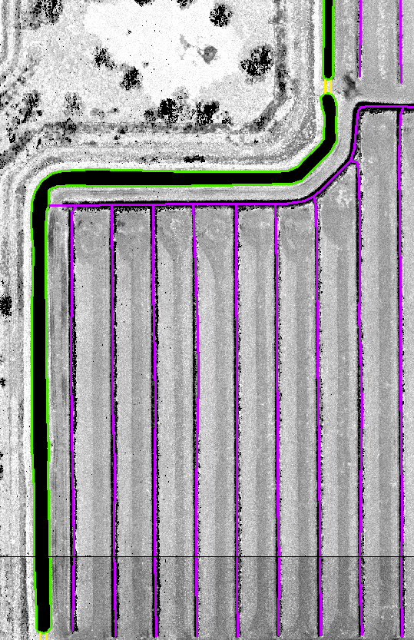

Figure 1- The image above shows the primary conveyance, or source of water for agricultural canals, collected as dual line drains (green). The dual line drains are broken at the culverts and connectors (yellow) are placed across the culvert. The single line drains (pink) in agricultural canals connect to intersecting single line drain agricultural canals, burning through any culvert features, and connecting to the primary conveyance.

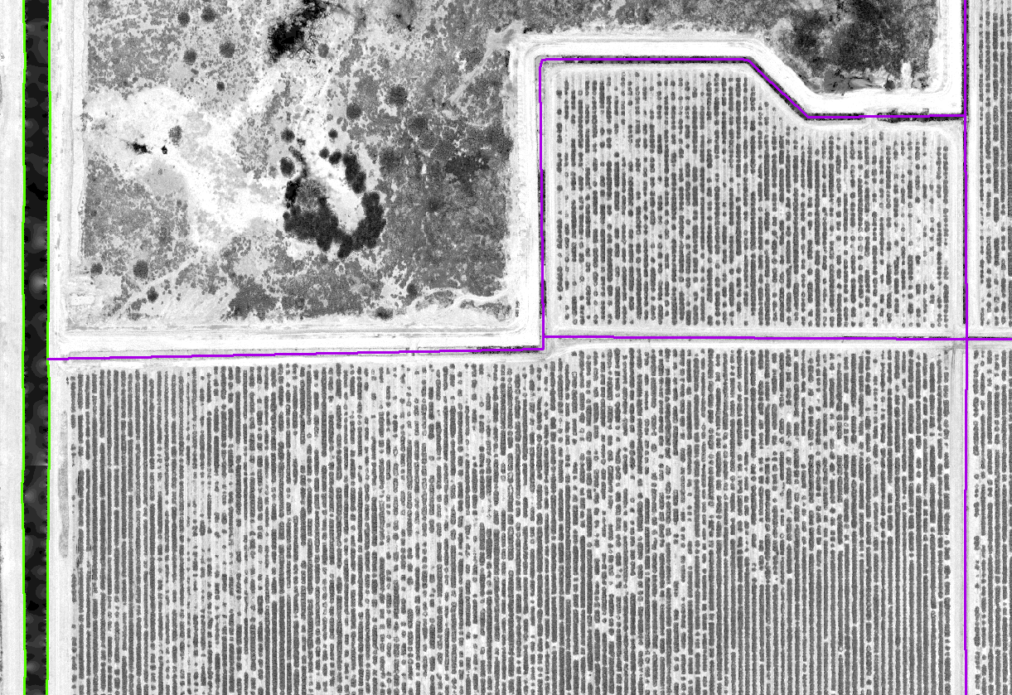

Figure 2- The image above shows the primary conveyance, or source of water for agricultural canals, collected as dual line drain (green). The single line drains (pink) in agricultural canals connect to intersecting single line drain agricultural canals, burning through any culvert features, and connecting to the primary conveyance.

#### Not Collect

##### Isolated Agricultural Canals

If agricultural canals are not connected to a primary conveyance and are truly isolated with a pump for recirculating water then the features will be treated as a closed system and should not be collected.

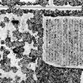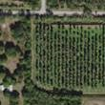

Figure 3- The image on the left shows isolated agricultural canals that are not connected to a primary conveyance in the intensity imagery. The right image shows the agricultural canals in the BaseMap.