LiDAR ACCURACY REPORT
Project: | 2017 ILHMP LiDAR Project
Report Area: | Hancock County, IL
Project No.: | U17075
Retainer Contract: | U14R19
Date: | 27-September-2017
Submitted by: | Jim Gottgetreu, C.P.  Project Manager

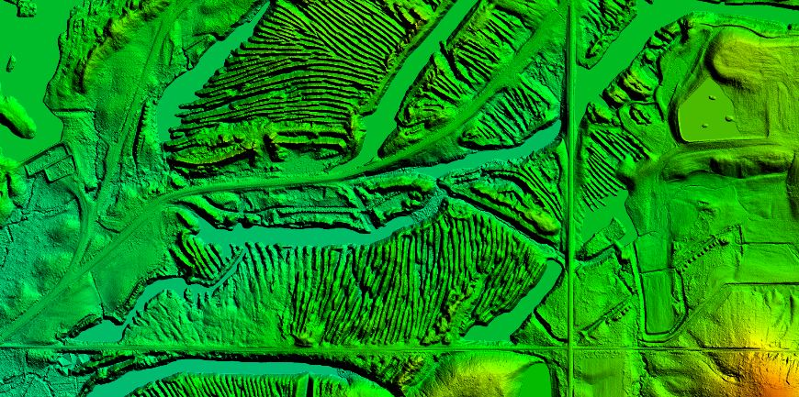

Project Overview
The University of Illinois contracted with Surdex Corporation in the Spring of 2017 to collect high resolution LiDAR elevation data as part of a dual county LiDAR Project. The purpose of the project was to acquire detailed surface elevation data for the Illinois Height Modernization Program (ILHMP) which is managed by the Illinois State Geological Survey (ISGS). The Hancock County project area totaled 863 square miles of coverage. Processing of the LiDAR data and bare-earth model followed USGS Base LiDAR Specifications V1.0 standards. Surdex tested that the deliverables meet or exceed Quality Level 2 (QL2) accuracy as stated in the USGS National Requirements for Enhanced Elevation Data. Non-Vegetated bare earth survey control points were collected by Surdex in order to calibrate the swath LAS data, the results are listed in the table on page 3. In addition, independent survey check points were collected on bare earth features as well as vegetated features. In order to meet the Non-Vegetated Vertical Accuracy (NVA) project specifications the overall vertical accuracy of these points should be 10.0cm (0.328 feet) RMSEz or less. The RMSEz was calculated as the square root of the average of the set of squared differences between the bare-earth and the survey points collected for the individual features (bare-earth, brush, short grass, tall grass & trees). The final results for this delivery area are listed on the last page of this report.

Delivery Area
This report covers the collection and processing of LiDAR elevation data over Hancock County IL. The project limits are presented in the graphics below. The project area consisted of 6,021 tiles sized 2,000’ square, covering approximately 863 square miles of elevation data (county plus buffer for full tiles).
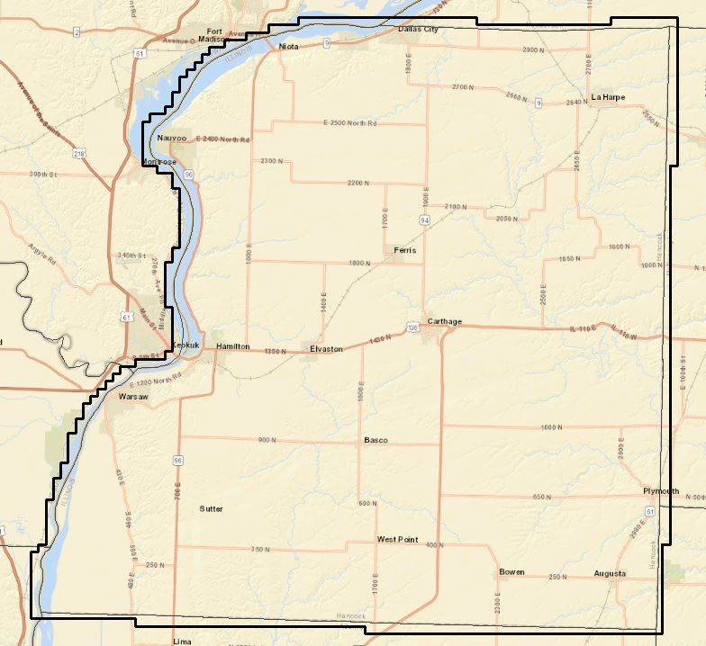

LiDAR Data Collection
The LiDAR elevation data for this project was collected March 15 to April 12 with re-flights occurring on June 7 and 8th, 2017 utilizing an Optech Galaxy Aerial LiDAR sensor system mounted in a single engine Cessna 206. The acquisition of LiDAR data lines was flown approximately 6,060’ above mean terrain in a North-South alignment, with a perpendicular cross flight used for calibration purposes. The collection scenario called for the acquisition of a minimum contract point spacing of 0.67 meters on the ground.

Hancock Co. Swath LiDAR
The field survey for this county consisted of 31 bare-earth control points used for calibrating the unclassified LiDAR swath data. The graphic below presents these control points over the county. A complete copy of the results has been provided in the Accuracy folder, this chart shows the results.
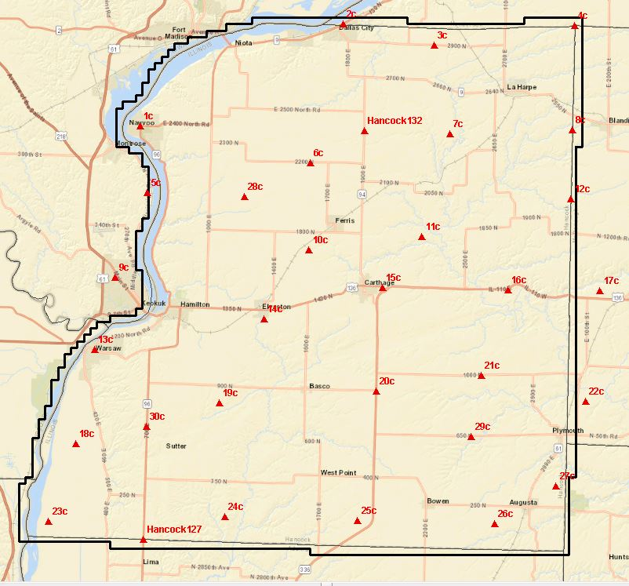

Stat | Bare-Earth (BE)
Count | 31
RMSEz (NVA) feet | 0.094
95% Confidence Level (NVA) feet | 0.185

Hancock Co. LiDAR QC Check
An additional set of survey check points were collected over the Hancock flight plan for an independent QC of the LiDAR as validated against the swath LAS & DEM deliverable tiles. The points were collected over the following feature types: Bare earth or Non-vegetated points and Vegetated points for a total of 59 QC check points in the county. The graphic below presents the distribution of QC check points over both counties.
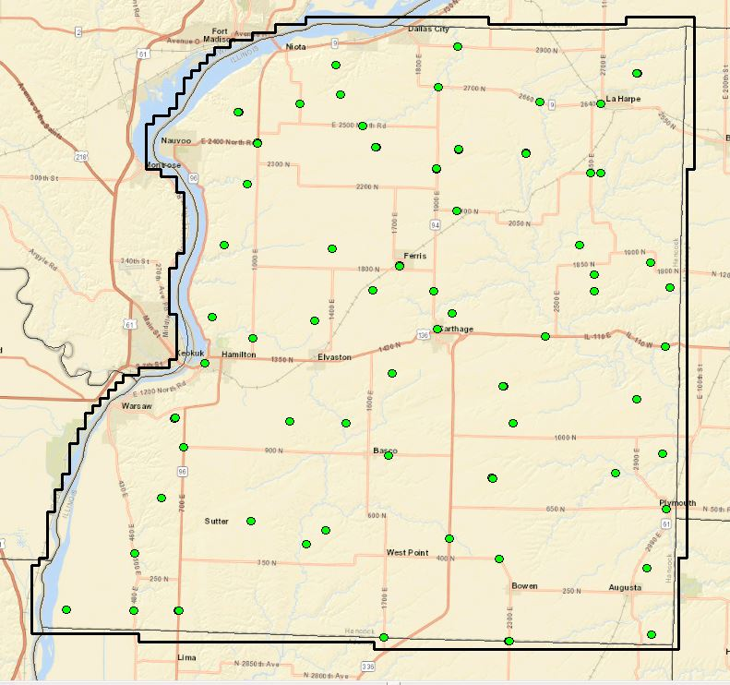

These points consisted of various types of ground cover including bare-earth, brush, short grass, tall grass and trees. Examples of actual points surveyed in Hancock County are included below.
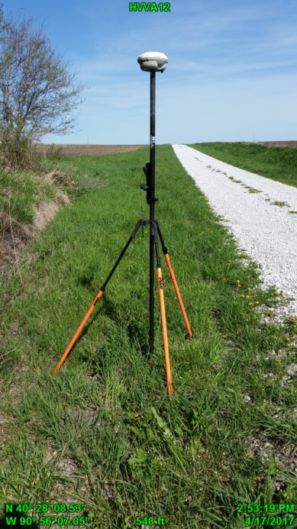
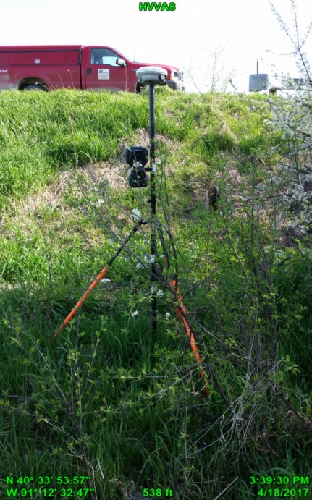

Vegetated Point #8 above Vegetated Point #12 above
Vegetated Point #17 below Non-Vegetated Point #3 below
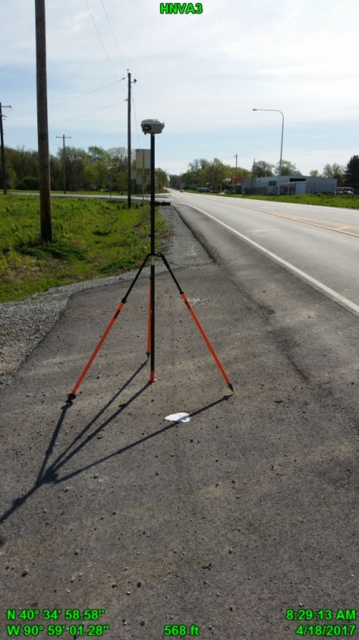
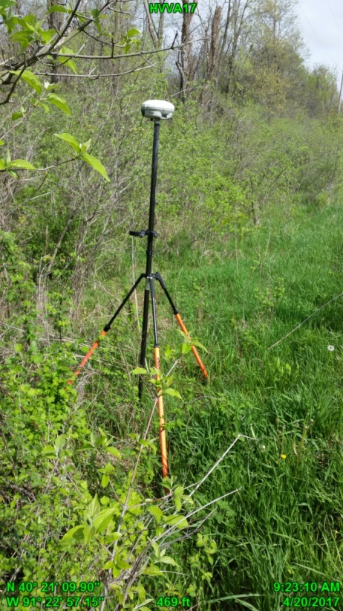
The required LiDAR elevation data values were derived within ArcGIS off the classified LAS and 4’ gsd raster grids. For each QC point location a LiDAR elevation value was derived and exported and the surface value subtracted from the survey elevation. These derived values were imported into Excel and comparisons were performed to generate statistics by ground cover type and for the overall dataset. Values reported are in US Feet due to the fact that all data was processed in IL Stateplane, NAD83-2011, West Zone however metric equivalents are stated in some cases.
As indicated above the Swath LiDAR LAS hard surface Non-Vegetated Vertical Accuracy (NVA) meets project specifications RMSEz less than or equal to 10.0 cm (0.328 feet) & 19.6cm (0.643 feet) at the 95-percent confidence level. The calculated bare-earth RMSEz equals 4.9 cm (0.104 feet) and 9.6 cm (0.204feet) at the ACCz 95-percent confidence level.
In addition, the DEM grids Vegetated Vertical Accuracy (VVA) meet project specifications less than or equal to 29.4cm (0.965 feet) at the 95th percentile.

Swath LAS QC Accuracy Results
Stat | NVA (Bare Earth, Short Grass)
Count | 36
RMSEz (NVA) feet | 0.104
95% Confidence Level (NVA) feet | 0.204

Classified LAS QC Accuracy Results
The table below presents the results of the QC accuracy analysis for the county. The data set was derived from the classified LAS tile data. All values are in US Feet.
Statistic | Overall | NVA (Bare Earth, Short Grass) | VVA (Tall Grass, Trees, Brush)
Count | 59 | 36 | 23
RMSEz | 0.147 | 0.098 | 0.200
ACCz 95% CI | 0.288 | 0.193 | 0.393
95th Percentile | 0.275 | 0.181 | 0.342

DEM QC Accuracy Results
The table below presents the results of the QC accuracy analysis for the county data set derived from the DEM grids. All values are in US Feet.

Statistic | Overall | NVA (Bare Earth, Short Grass) | VVA (Tall Grass, Trees, Brush)
Count | 59 | 36 | 23
RMSEz | 0.163 | 0.097 | 0.231
ACCz 95% CI | 0.320 | 0.191 | 0.453
95th Percentile | 0.376 | 0.173 | 0.427

