Project U17075

LiDAR Acquisition
IL County of Hancock
Surdex Corporation Project # 2700305
September 2017

LIDAR Acquisition:

The Illinois project area of Hancock County was fully covered by 2,000’ tiles in a State Plane IL West layout provided by the University of Illinois. Full tiles covering these counties areas were buffered for flight planning purposes. The following parameters were used in preparing the flight plan.

Flight altitude | Approximately 2000 meters AMT
Airspeed | 150 knots
Full swath width | 1,535 meters
Scan Rate | 49 Hz
Sidelap | 20.00%
Field of View | 45 degrees
Nominal Post Spacing | 0.67 meters
Max Pulse Repetition Rate | Up to 550 KHz
Returns per pulse | Up to 8 + intensity

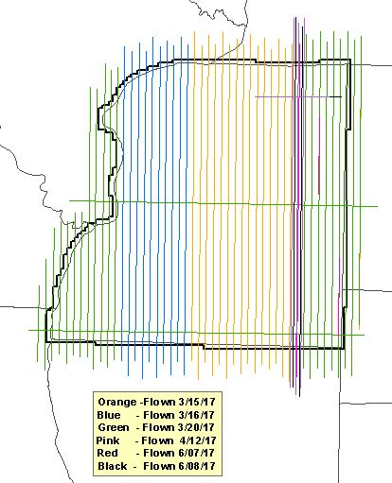
LiDAR data was flown by Surdex Corporation between March 15 and April 12 with two re-flights occurring on June 7 and June 8, 2017. Surdex utilized their single engine Cessna 206 with a Optech Galaxy multi-pulse instrument and based their operations from the Keokuk Municipal Airport, IA in order to keep the baseline distance to a minimum. The graphic below shows areas covered by each flight date. Perpendicular (North-South) main lines with East-West cross flights shown.

The flight crew was guided by a GPS controlled flight management system, which displayed the flight plan; including altitude, heading, cross track deviation and PDOP. During the flight mission, the system operator monitored flight management data and laser information, to ensure a successful mission.

Additional swaths, though not strictly necessary for meeting point density or project coverage requirements, are acquired for every project area. These additional swaths are often referred to as “cross strips”. A number of cross strips are included in critical locations and in sufficient number that the combination of the normal production swaths and the cross strips constitutes a geometrically stable “block” of LiDAR coverage. The additional swaths are used for instrument calibration and project block adjustment purposes. The LiDAR cross strips serve a purpose that is analogous to the use of cross strips in a photogrammetric bundle adjustment, providing additional redundant observations of the ranging data that can be used for QC and adjustment of the data from the LiDAR acquisition mission(s).

All data in the aircraft, including GPS, IMU (inertial measurement unit, i.e. rotational angles); laser ranges; are recorded onto removable hard drives and flash memory cards. Upon landing the system operator removes all storage devices from the LIDAR system and the GPS receivers. At the end of each flight day, all is transmitted (via FTP and/or FED-EX ) to the office for processing.

Data Processing

Post processing of LiDAR involves the following software packages and procedures:

- POSPac MMS (Applanix)
- GrafNet (Waypoint)
- LMS Manager (Optech)
- TerraScan, TerraModeller, TerraMatch (TerraSolid)
- GeoCue (NIIRS10)

Once the mission data arrives from the field, it is immediately archived and enters into a QC process. The real time airborne GPS/IMU data is combined with the LiDAR range data to produce preliminary LiDAR swaths. The preliminary swaths are used to generate interim raster products for review and QC operations. The data is compared with the project boundary, planned flight lines, and previously collected swaths. The swath data is checked for gaps to verify complete data coverage. Any areas of missed coverage, coverage of insufficient point density, or showing any collection anomalies are identified and queued for re-flight before the flight crew leaves the project area.

After initial QC has completed, the mission’s airborne GPS data is differentially processed using GPS base station data, blended with the IMU data, and the integrity of the blended solution is verified. The blended GPS/IMU data is combined with the laser range data and instrument calibration parameters to produce raw swath files in the target/project coordinate system. The use of current instrument calibration settings enables the process to account for and correct all systematic sensor errors from the raw swath files for each mission.

The calibrated swath files from one or more missions next undergo a block adjustment to produce final swath files. The block adjustment process accomplishes three distinct goals. 1) It uses the LiDAR cross strips to detect and correct any non-modeled (residual) sensor errors in the calibrated swath data. 2) It uses all overlapping swath data to detect and correct GPS/IMU position and orientation (relative) errors. 3) It uses adjacent adjusted swath data (if present) and ground control points (if present) to detect and correct (absolute) positioning errors in the LiDAR point data. The final block adjustment ensures that all inter-swath discrepancies within the block are minimized and that all discrepancies with adjacent blocks of coverage and with ground control are minimized.

Ground Surface filtering and classification:

After the LAS files have been processed through block adjustment, they were loaded into Geocue and tiled into manageable units or working tiles. A senior Lidar analyst reviews the project to determine the correct macros and algorithms to apply for each unique block. Several sources were used to determine the best algorithms to apply for each area. These include landcover classification polygons, slope rasters and available imagery. Once blocks are identified a senior LiDAR analyst chose several working tiles and applied the best classification macro for the identified area. The analyst runs several iterations of the macro to produce the best results within each category. Once the macros are refined and the results evaluated, the macro was assigned and ran on all working tiles within the block. This process is replicated for each unique processing block. Data integrity is assured by LiDAR technicians reviewing each working tile. Technicians built multiple shaded relief images for data review and profile any areas of suspect classification. Technicians can also make minor classification adjustments to the LAS files using specialized LiDAR tools developed internally for bare earth processing.

All of the laser points are stored in a database that retains information about flight day, time, return number, laser scan angle, and other information. The database is reviewed and areas of like characteristics are delineated and flagged. The LIDAR processing group determined which type of filtering techniques need to be applied to each type of area, to provide the best quality at ground elevation surface. Factors that affect this decision are slope, vegetation and cultural features. Each project has unique characteristics that can only be assessed after the data is collected. Data integrity is assured after visualizing results from the selected filtering techniques such as shaded relief models, 3-D viewers and elevation images.

All LiDAR data processing followed the USGS Version 1.2 Base LiDAR Specifications. Surdex used a combination of automated and manual filtering techniques for the creation of the bare-earth surface. A minimum 95% of the artifacts, outliers, voids, systematic and random errors, noise, anomalies, manmade features and vegetation were removed. The resulting digital terrain model will support production of 2’ contours for ASPRS Class I Standards. The final step involves output of data into LAS version 1.4 format.

Create Hydro-Flattening Breaklines

Surdex has a wide variety of tools available for the compilation of breaklines required for the hydro-flattening services. Surdex’s R&D staff has developed proprietary software to assist and improve efficiency in the hydro-flattening process. Several data sources are available to assist the technicians in developing the hydro-flattening breaklines. These sources include; color hill shade maps derived from the LiDAR data, NHD vectors, intensity images and current existing imagery are all useful in developing the hydrological breaklines. Surdex has proven that using custom color hill shade rasters in ArcMap is superior for both accuracy and efficiency in breakline compilation. The custom hill shades provide a much more intelligent representation of the bare earth surface allowing for precise determination of hydrological features.

Using the custom hill shades, GIS technicians digitized breaklines representing water features consisting of ponds/lakes greater than ~2 acres and streams/rivers wider than ~100 feet per the guidelines for hydro flattened derivative products. To improve efficiency, the various data sets described above may be used as a guide directing the technician to areas containing hydro features and providing confirmation of the features as determined in the hill shades. The hydro-flattening is applied to ponds, again using Surdex proprietary applications, by converting the 2-D breaklines to 3-D lines. This was accomplished by draping the digitized hydrological features to the bare earth surface and at the discretion of the technicians, based on terrain relief, to apply either a “lowest elevation” or “average elevation” to the 3-D breakline.

Hydro-flattening of streams and rivers is similar to impoundments in that the initial compilation is again derived from the hill shades as described above. Technicians compile 2-D breaklines at the edges of rivers and streams using techniques and resources as described above. For river/stream features, however, rather than applying an average or lowest point elevation to the breaklines, technicians compile a profile centerline to be used in determining elevation. The 3-D shapefile centerline is processed through the Surdex application applying elevations to the breaklines at vertices perpendicular to the centerline creating 3-D breaklines. By applying consistent elevations to both sides of the rivers/streams, hydro-flattening produces a level surface perpendicular to the stream in the correct direction of flow. All breaklines will be delivered as PolylineZ or PolygonZ features compatible with GIS and CAD software.

Create Digital Elevation Models

The final 4 foot resolution Digital Elevation Models (DEM) were created once the data had been calibrated, edited and filtered using our workflows described above. This DEM represents the ground surface, interpolated using the gridded network from the bare earth surface. Water Bodies (ponds and lakes), wide streams and rivers, and other non-tidal water bodies will be hydro-flattened within the DEM.
Hydro-flattening was applied to all water impoundments, natural or man-made, that are larger than ~2 acres in area (equivalent to a round pond ~350’ in diameter), to all streams wider than ~100’, and to all non-tidal boundary waters bordering the project area regardless of size. Areas outside survey boundary shall be coded as “No Data”. Internal voids (e.g., open water areas) will be coded as “No Data”.

All final Imagine DEM files and hydro data were generated into the following projection: IL Stateplane NAD83-2011, West Zone, NAVD88 US Survey feet. NAVD88 Geoid12B, US Survey feet using butt-matched 2,000 foot tiles.

Surdex performed quality checks against all missions to ensure sufficient point coverage of all collected flight lines, review of intensity data and verification that all collected GPS-IMU data was within expected data quality ranges. All other initial processing yielded no issues and allows Surdex to progress into full processing and delivery.

Ground Survey

Surdex collected 31 survey ground control points across the county. This data was used to vertically adjust the LiDAR data, if necessary, once all bare earth classification macros have been successfully run.

Surdex has found the most success with ground control adjustment when evaluated exclusively against bare earth data. Although all points would receive the adjustment, performing the assessment at this stage ensures that low lying vegetation is not used to assess the vertical accuracy of the LiDAR data when determining how much of a vertical adjustment should be applied.

Here is an overview of the survey control collected for the project.
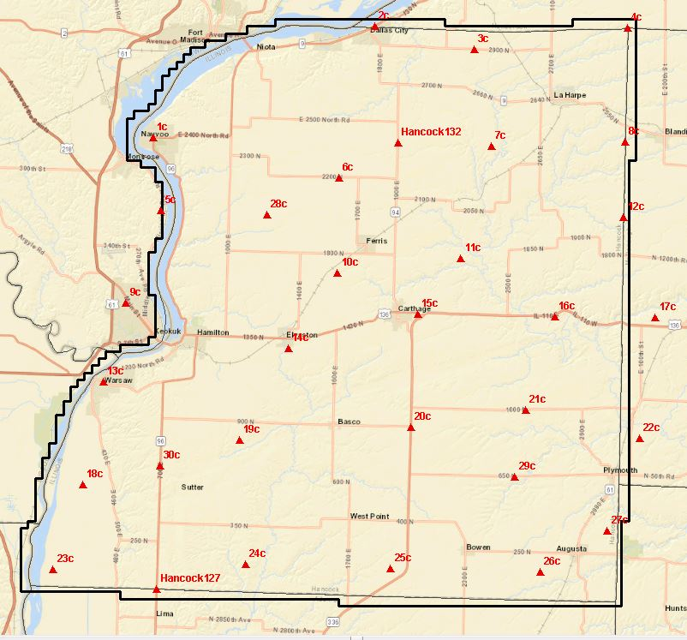

QC Check Points

Surdex has also completed field collection of 59 QC points in State Plane IL West zone. This data will provide an independent evaluation of the processed LiDAR against both the NVA and VVA check points. This data will be used for final completion of all project deliverables.

Overview of the point locations is shown below.

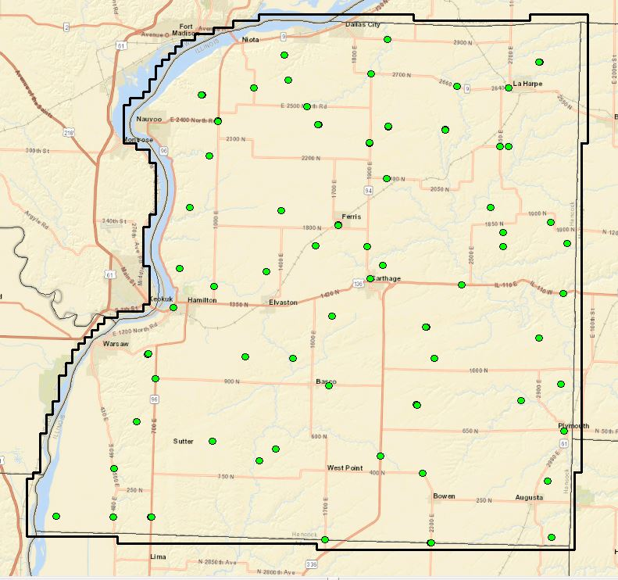

Sample ground photos of QC points by groundcover:

Vegetated Vertical Accuracy point - VVA

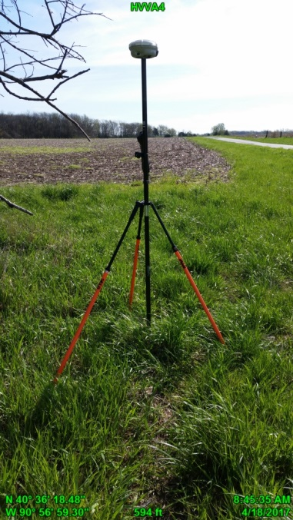

Non-Vegetated Accuracy QC point - NVA

