Illinois Height Modernization Program
Acquisition of Airborne LiDAR Data for
Hancock County in Illinois

The following initiates a request for retainer services for the Illinois Height Modernization Program, which is managed by the Illinois State Geological Survey (ISGS), to acquire Light Detection and Ranging (LiDAR) data for Hancock County in Illinois in Spring of 2017, depending on field conditions after contract execution. The response to this request should summarize activities for:

Data Acquisition: project data acquisition of Light Detection and Ranging (LiDAR) data, initial processing and data quality assurance (QA) and quality control (QC) to validate the quality of newly acquired data, and delivery of one pilot project areas containing a sample of classified las files and related data.

The proposal should include a detailed scope of work, timeline for project completion, proposed staff breakdown, and proposed service fee with detailed pricing. Upon completion of negotiations, ISGS will issue the necessary funding commitment forms to UIUC Facilities and Services in support of these efforts.

Full data processing would include: las classification, hydrological breaklines, generation of derivative products, creation of metadata and reports, and final delivery of all data.

Overview

Conduct all tasks related to the acquisition of LiDAR data for a project area encompassing the roughly 864 square mile area that comprises Hancock County in Illinois. The task list should include, but should not be limited to: travel to project area to determine suitable ground conditions for acquiring data, acquire airborne LiDAR data, conduct field surveys to collect ground control points, detail data collection parameters and flight plan specifications, conduct initial data validation QA/QC, complete LiDAR data point cloud classification for pilot project area, verify LiDAR mapping accuracy, and compile related metadata and GIS tile index data. The proposal should state that data products will ultimately be delivered as stand-alone county collections with a 1 tile buffer at the separation boundary between the counties.

Acquisition of LiDAR data deliverables should be designed so that data and derivative data deliverables will ultimately be compliant with U.S. Geological Survey National Geospatial Program Lidar Base Specification, Version 1.2, November 2014. Project data should be collected at a nominal point spacing of .7 meters, or two (2) points per square meter with a minimum side lap of 30 degrees, sufficient to meet the USGS 3DEP Quality Level 2 (QL2).

The intention is to complete data acquisition during the Spring of 2017 during leaf-off vegetative conditions after snowmelt and prior to Spring flooding or advanced foliage development, followed by preliminary data processing and data QA/QC sufficient to ensure high-quality data have been acquired. The ISGS requests a 15-day review of a pilot project area to be proposed by the vendor, for data quality assurance (QA) and quality control (QC).

The approximate project boundary is shown in the image below, and defined by the attached GIS data layer provided by Janet Camarca of ISGS. The intention is for this project to extend beyond each county boundary by a single, complete, index tile. Extension of the overall project area would be acceptable, if proposed and clearly justified; the ISGS would like an ample buffer around the perimeter of each county. These counties lie within the State Plane West coordinate system, specifically the North American Datum 1983 (NAD 83) High Accuracy Reference Network (HARN) State Plane West Federal Information Processing Standard (FIPS) 1202 (with the 2011 adjustment).

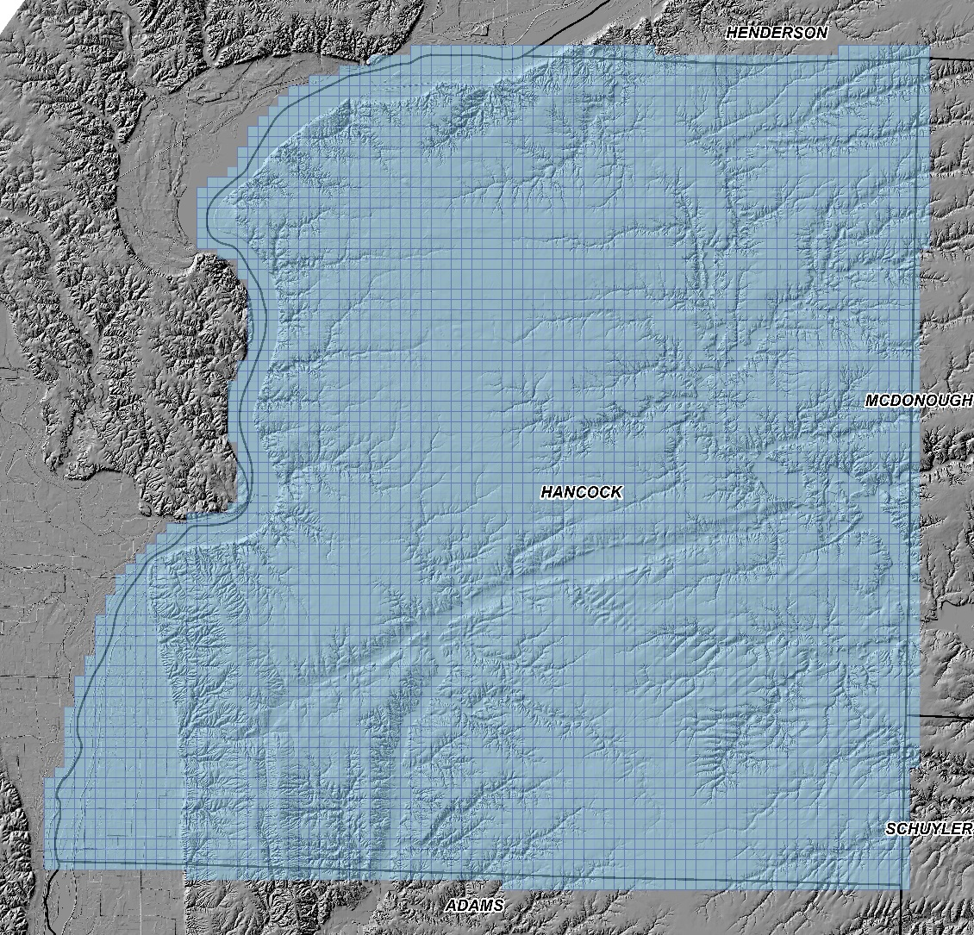

Note: If the county boundary line intersects more than half of the boundary tile then an additional tile is added to ensure full coverage.

ISGS would request delivery of Phase 1 products by July 31, 2017. Given these declarations, however, ISGS would like to clearly state that while the ultimate goal is to acquire data in the Spring of 2017 if at all feasible, if there is no clear window to acquire data in sufficient leaf-off and non-flooding conditions after contracts have been executed, ISGS would prefer that the vendor propose delayed project delivery dates.

In their document, the vendor should state their proposed project square mileage and include a proposed time schedule listing all milestones with associated target dates and fees. Given that the UIUC contract review and project structuring process will take a number of weeks, we estimate that the earliest date that a Notice to Proceed could be issued by March 31, 2017. The vendor should also list all deliverables described in the body of each proposal into summary lists of Delivery Items. Finally, it is requested that the vendor include a statement that they will report project progress as milestones and percentage of each milestone completed to every 2 weeks. ISGS will provide a 1-page form once milestones, dates, and related fees are agreed upon.

Questions clarifying any of the above are welcome, and should be transmitted to Kelly Jo Hoffmann at UIUC Facilities and Services.

APPENDIX A: PROJECT SCOPE OF WORK, AS DEFINED BY ISGS

- LiDAR data shall be compliant with U.S. Geological Survey National Geospatial Program Lidar Base Specification, Version 1.2, November 2014; as such, classified point cloud deliverables are required to be in fully compliant LAS file format, v1.4. This version must be used for all LAS deliverables in the project.

- Thoroughness of survey methods for collection of field vertical ground control checkpoints to support the airborne acquisition and subsequent LiDAR processing, including vertical accuracy assessment (i.e., Fundamental Vertical Accuracy and Consolidated Vertical Accuracy).

- Classified Point Cloud:
Code: Description:
0 Created, never classified
1 Unclassified1
2 Ground
3 Low Vegetation [numeric cutoff values to be provided by INHS]
4 Medium Vegetation [numeric cutoff values to be provided by INHS]
5 High Vegetation [numeric cutoff values to be provided by INHS]
6 Building
7 Low Point (noise)
8 Model Key-point (mass point)
9 Water
10 Ignored ground (near a breakline)
17 Bridge decks
18 High noise

- Breaklines: All breaklines developed for use in hydro-flattening shall be delivered as an ESRI feature class, PolylineZ or PolygonZ format, as appropriate to the type of feature represented. ESRI file geodatabase format is required. Breaklines should be as a continuous layer and must use the same horizontal and vertical coordinate reference system and units as the LiDAR point delivery.

- Field survey ground control point data with accompanying picture(s), and a report detailing the method used to collect each shot (total station, GPS RTK, level) should be provided as project deliverables. Plus, if RTK is used, a listing of the base stations used for each setup.

- Project-level metadata shall be delivered that fully comply with Federal Geographic Data Committee (FGDC) Content Standard for Digital Geospatial Metadata (CSDGM) format standard in XML format. Metadata shall describe the project, data acquisition methods, system calibration, processing methods, and statistical validation process and results. Project documentation will include control point and flight diagram information from the LiDAR acquisition flight.

- The project area is to be cloud free and fog free between the aircraft and the ground. The ground must be snow free. No unusual flooding or inundation is allowed on the floodplain and upland areas. The acquisition will occur during leaf-off ground conditions

- Data shall be accompanied by acquisition metadata, control, collection reports, survey reports, compliance with National Standard for Spatial Database Accuracy (NSSDA) accuracy standards, and data calibration reports.

- Applicants should specify LiDAR sensor system technologies employed for this project within the acquisition metadata. The LiDAR sensor system must be capable of deriving multiple discrete returns, and capable of at least three returns for each pulse.

