Illinois Height Modernization Program
Processing of Airborne LiDAR Data for
Hancock County in Illinois

The following initiates a request for retainer services for the Illinois Height Modernization Program, which is managed by the Illinois State Geological Survey (ISGS), to process Light Detection and Ranging (LiDAR) data for Hancock County in Illinois acquired in Spring of 2017. The response to this request should summarize activities for:

- Data Processing: data processing to create contract deliverables including las classification, , creation of hydrological breaklines, generation of derivative products (like .dat, .dgn, .tin), creation of metadata and reports, and final delivery of all data.

The proposal should include a detailed scope of work, timeline for project completion, proposed staff breakdown, and proposed service fee with detailed pricing. Upon completion of negotiations, ISGS will issue the necessary funding commitment forms to UIUC Facilities and Services in support of these efforts.

Overview

Conduct tasks related to the processing of LiDAR data for a project area encompassing the 864 square mile area that comprises Hancock County in Illinois. The task list should include, but should not be limited to: complete LiDAR data point cloud classification and data processing to generate hydro-flattened digital elevation models, perform data QA/QC, verify LiDAR mapping accuracy, and compile related metadata and GIS tile index data. The proposal should state that data products will be delivered as stand-alone county collections with a 1 tile buffer at the separation boundary between the counties.

Processing of LiDAR data deliverables should be designed so that data and derivative data deliverables will ultimately be compliant with U.S. Geological Survey National Geospatial Program Lidar Base Specification, Version 1.2, November 2014. Project data were contracted to be collected at a nominal point spacing of .7 meters, or two (2) points per square meter with a minimum side lap of 30 degrees, sufficient to meet the USGS 3DEP Quality Level 2 (QL2).

The project boundary is shown in the image below, defined by the GIS data layer provided by Janet Camarca of ISGS; the intention is for the project to extend beyond each county boundary by a single, complete, index tile. These counties lie within the State Plane West coordinate system, specifically the North American Datum 1983 (NAD 83) State Plane West Federal Information Processing Standard (FIPS) 1202 (with the 2011 adjustment).

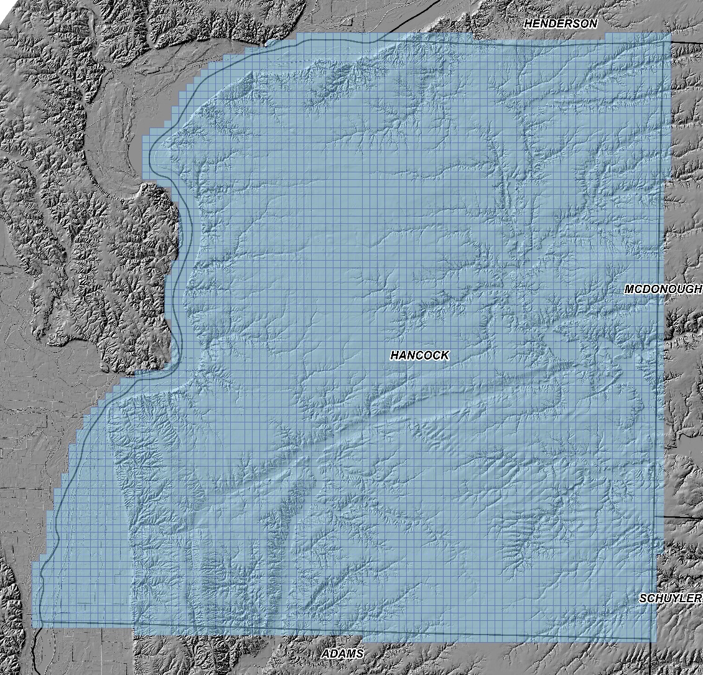

If the county boundary line intersects the boundary tile, an additional tile is added to ensure full coverage.
In the document, please state the proposed project square mileage and include a proposed time schedule listing all milestones with associated target dates and fees; given that the UIUC contract review and project structuring process will take a number of weeks, we estimate that the earliest date that a Notice to Proceed could be issued by April 28, 2017. ISGS would request final delivery of Phase 2 products by November 30, 2017. Also, list all deliverables described in the body of each proposal into summary lists of Delivery Items. Finally, it is requested that a statement mentioned that they would report project progress as milestones and percentage of each milestone completed to every 2 weeks. ISGS will provide a 1-page form once milestones, dates, and related fees are agreed upon.

Questions clarifying any of the above are welcome, and should be transmitted to Kelly Jo Hoffmann at UIUC Facilities and Services.

APPENDIX A: PROJECT SCOPE OF WORK, AS DEFINED BY ISGS

- LiDAR data shall be compliant with U.S. Geological Survey National Geospatial Program Lidar Base Specification, Version 1.2 November 2014 (see http://pubs.er.usgs.gov/publication/tm11B3); as such, classified point cloud deliverables are required to be in fully compliant LAS file format, v1.4. This version must be used for all LAS deliverables in the project.

- Thoroughness of survey methods for collection of field vertical ground control checkpoints to support the airborne acquisition and subsequent LiDAR processing, including vertical accuracy assessment (i.e., Fundamental Vertical Accuracy and Consolidated Vertical Accuracy).

- Classified Point Cloud:
Code: Description:
0 Created, never classified
1 Unclassified1
2 Ground
3 Low Vegetation [numeric cutoff values to be provided]
4 Medium Vegetation [numeric cutoff values to be provided]
5 High Vegetation [numeric cutoff values to be provided]
6 Building
7 Low Point (noise)
8 Model Key-point (mass point)
9 Water
10 Ignored ground (near a breakline)
17 Bridge Decks
18 High Noise

- Breaklines: All breaklines developed for use in hydro-flattening shall be delivered as an ESRI feature class, PolylineZ or PolygonZ format, as appropriate to the type of feature represented. ESRI file geodatabase format is required. Breaklines should be as a continuous layer and must use the same horizontal and vertical coordinate reference system and units as the LiDAR point delivery.

- Field survey ground control point data with accompanying picture(s), and a report detailing the method used to collect each shot (total station, GPS RTK, level) should be provided as project deliverables. Plus, if RTK is used, a listing of the base stations used for each setup.

- Project-level metadata shall be delivered that fully comply with Federal Geographic Data Committee (FGDC) Content Standard for Digital Geospatial Metadata (CSDGM) format standard in XML format. Metadata shall describe the project, data acquisition methods, system calibration, processing methods, and statistical validation process and results. Project documentation will include control point and flight diagram information from the LiDAR acquisition flight.

- Data shall be accompanied by acquisition metadata, control, collection reports, survey reports, compliance with National Standard for Spatial Database Accuracy (NSSDA) accuracy standards, and data calibration reports.

- Applicants should specify LiDAR sensor system technologies employed for this project within the acquisition metadata. The LiDAR sensor system must be capable of deriving multiple discrete returns, and capable of at least three returns for each pulse.

