LiDAR Accuracy Assessment

Wayne County, Indiana for
LiDAR Acquired Spring 2017

Prepared by

Jeff Padgett CP, PSM
August 31, 2017

Summary

GRW was contracted in the Spring of 2017 to develop elevation data to support 2’ contours for Wayne County, Indiana. The project included the acquisition of LiDAR data utilizing an Optech Gemini sensor. Data was acquired Spring 2017.

Control points were field surveyed to be used in the calibration and adjustment of the LiDAR dataset as part of the original project. Validation points to be used in the reporting of RMSE_{z}, Supplemental, NVA and VVA Accuracies were surveyed in March 2017. The validation points surveyed in March 2017 serve as the basis for the accuracy assessment contained in this report.

The charts and statistics on the following pages were derived by comparing the final project DEM (generated from bare earth LiDAR) to the surveyed XYZ position of each point. Comparisons were made using the TerraModel software, comparing the surveyed position to the TIN generated from the DEM.

The project was delivered to the client in NGVD88 vertical datum, US Survey Foot. All XYZ coordinates reported herein are based on NAD88 Indiana East horizontal and NGVD88 vertical datums.

Accuracy Statements

Tested 6.94944 cm RMSE_{z} open terrain using urban and ground control validation points.
Tested 13.80 cm Non-Vegetated Accuracy at 95th percentile in open terrain using urban and ground control points with RMSE_{z} * 1.9600.
Tested 0.65072 feet supplemental vertical accuracy at 95th percentile in Bare Earth category.
Tested 0.46844 feet supplemental vertical accuracy at 95th percentile in Urban category.
Tested 1.3426 feet supplemental vertical accuracy at 95th percentile in Brush category.
Tested 1.39552 feet supplemental vertical accuracy at 95th percentile in Forested Area category.

Tested 1.00156 feet supplemental vertical accuracy at 95th percentile in High Grass category.

Tested 38.23 cm vegetated vertical accuracy at 95th percentile in vegetated areas including Forested, High Grass, and Brush categories with RMSE_{z}* 1.9600.

Location of points used in calculation of NVA, SVA, and VVA. Project Boundary is shown as a red polygon.
At each location, a point was collected for each land cover type in 4 well distributed areas throughout the county. For example, Brush points 1 through 5 were surveyed near Fountain City and Brush points 6 through 10 south of Richmond. In all a total of 20 brush points were surveyed and the same was true for the four other vegetation categories such as: urban, open, tall grass and forested. A total of 100 validation points were surveyed to assess the LiDAR accuracy.

Density Calculation

Five (5) randomly chosen 5,000’ x 5,000’ .las tiles of classified LiDAR data were chosen for this calculation. The tiles were composed of complete calibrated flight lines having 50% overlap and in some cases including a cross-flight. The density was calculated in tiles formatted in meters as the unit of measure with LAS Info statistics queried from LAS Tools. The resulting chart indicated a density of 3.468 points using all points and a density of 2.62 points per square meter comparing only the last return.

TILE | ALL DENSITY | LAST DENSITY | ALL SPACING | LAST SPACING
15 | 2.36 | 2.25 | 0.65 | 0.67 | Meters
100 | 2.21 | 2.07 | 0.67 | 0.7 | Meters
150 | 4.75 | 3.2 | 0.46 | 0.56 | Meters
300 | 4.39 | 2.92 | 0.48 | 0.58 | Meters
500 | 3.63 | 2.66 | 0.52 | 0.61 | Meters
AVG | 3.468 | 2.62 | 0.556 | 0.624 | Meters
Measured by Las Info from Las Tools.
Ran on tiles that had been converted to meters.

* Calculated with Urban Area and Ground Control Validation Points

Number | Easting | Northing | Elevation | DTM Z | Errors (ft) | Errors (cm)
UR 13 | 466909.61 | 1662270.13 | 933.26 | removed | *
LID 7 | 562409.41 | 1716146.82 | 1139.34 | 1139.8 | 0.46 | 14.0208
UR 2 | 538017.79 | 1713458.73 | 1086.98 | 1087.43 | 0.45 | 13.716
ADD 108 | 494017.44 | 1663793.38 | 964.681 | 965.13 | 0.449 | 13.68552
UR 11 | 467149.79 | 1662277.41 | 932.15 | 932.49 | 0.34 | 10.3632
LID 12 | 557157.07 | 1638782.21 | 1126.98 | 1127.27 | 0.29 | 8.8392
UR 15 | 466957.36 | 1662604.06 | 933.84 | 934.08 | 0.24 | 7.3152
ADD 109 | 542905.45 | 1674260.73 | 979.023 | 979.26 | 0.237 | 7.22376
LID 10 | 547182.8 | 1661329.71 | 1023.05 | 1023.28 | 0.23 | 7.0104
OP 17 | 537037.25 | 1717588.82 | 1120.46 | 1120.65 | 0.19 | 5.7912
UR 5 | 537087.48 | 1714919.59 | 1105.36 | 1105.52 | 0.16 | 4.8768
UR 3 | 538440.33 | 1713779.63 | 1087.77 | 1087.92 | 0.15 | 4.572
UR 14 | 466741.33 | 1662262.55 | 935.05 | 935.19 | 0.14 | 4.2672
UR 1 | 537413.76 | 1717451.59 | 1117.97 | 1118.1 | 0.13 | 3.9624
ADD 106 | 525854.46 | 1688449.04 | 1028.215 | 1028.34 | 0.125 | 3.81
UR 4 | 538166.04 | 1715255.48 | 1103.36 | 1103.48 | 0.12 | 3.6576
UR 18 | 470025.51 | 1698452.08 | 1005.2 | 1005.31 | 0.11 | 3.3528
LID 5 | 474306 | 1729082.46 | 1083.64 | 1083.74 | 0.1 | 3.048
OP 11 | 559355.22 | 1670178.88 | 1096.77 | 1096.86 | 0.09 | 2.7432
LID 2 | 471807.44 | 1662734.36 | 968.75 | 968.83 | 0.08 | 2.4384
OP 10 | 472024.37 | 1661263.77 | 961.22 | 961.3 | 0.08 | 2.4384
LID 11 | 556989.29 | 1648652.48 | 1113.3 | 1113.37 | 0.07 | 2.1336
OP 13 | 558267.48 | 1669214.79 | 1081.36 | 1081.41 | 0.05 | 1.524
UR 12 | 467012.44 | 1662267.21 | 934.15 | 934.19 | 0.04 | 1.2192
F 277 | 557135.36 | 1642897.61 | 1121.91 | 1121.95 | 0.04 | 1.2192
ADD 101 | 499926.55 | 1727750.85 | 1182.266 | 1182.28 | 0.014 | 0.42672
ADD 102 | 533509.71 | 1728930.57 | 1209.991 | 1209.99 | -0.001 | -0.03048
UR 9 | 516130.35 | 1664988.84 | 1007.76 | 1007.71 | -0.05 | -1.524
ADD 105 | 503230.3 | 1679073.25 | 1093.713 | 1093.66 | -0.053 | -1.61544
ADD 110 | 517590.42 | 1635307.35 | 1055.304 | 1055.25 | -0.054 | -1.64592
UR 20 | 469992.95 | 1698572.2 | 1007.47 | 1007.41 | -0.06 | -1.8288
LID 9 | 563023.71 | 1677282.64 | 1004.87 | 1004.77 | -0.1 | -3.048
ADD 103 | 505405.55 | 1711135 | 1136.431 | 1136.32 | -0.111 | -3.38328
UR 16 | 470016.84 | 1698310.31 | 1002.89 | 1002.74 | -0.15 | -4.572
UR 17 | 470022.18 | 1698391.58 | 1004.32 | 1004.16 | -0.16 | -4.8768
LID 3 | 474840.87 | 1687314.98 | 1045.44 | 1045.2 | -0.24 | -7.3152
UR 8 | 516764.13 | 1665042.24 | 1009.51 | 1009.27 | -0.24 | -7.3152
UR 19 | 469981.71 | 1698515.03 | 1007.47 | 1007.22 | -0.25 | -7.62
UR 7 | 516386.79 | 1665093.32 | 1011.51 | 1011.25 | -0.26 | -7.9248
LID 6 | 562518.85 | 1730035.04 | 1204.77 | 1204.5 | -0.27 | -8.2296
LID 4 | 474700.4 | 1709121.86 | 1040.49 | 1040.2 | -0.29 | -8.8392
LID 1 | 476875.09 | 1633880.32 | 882.84 | 882.49 | -0.35 | -10.668
UR 6 | 516433.46 | 1665339.79 | 1007.39 | 1007.02 | -0.37 | -11.2776
ADD 104 | 458559.62 | 1676088.22 | 1008.764 | 1008.39 | -0.374 | -11.39952
UR 10 | 515937.95 | 1665281.22 | 996.62 | 996.15 | -0.47 | -14.3256
LID 8 | 562278.65 | 1701490.1 | 1096.01 | removed | *
*Blunder, not included in accuracy calculations |  |  |  | Average | 0.012 | 0.36576
 |  |  |  | Minimum | -0.47 | -14.3256
 |  |  |  | Maximum | 0.46 | 14.0208
 |  |  |  | Std Dev | 0.231 | 7.04088
 |  |  |  | RMSE | 0.228 | 6.94944
 |  |  |  | 95th | 0.45276 | 13.8001248

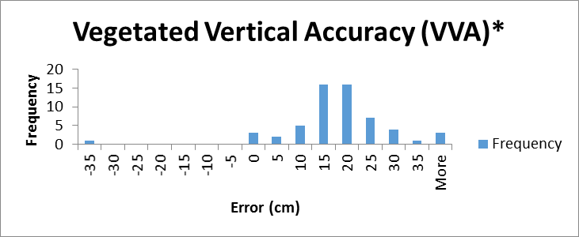

* Calculated with all vegetation validation points

Class | Num | Easting | Northing | Elevation | DTM Z | Error (ft) | Error (cm)
FA | 11 | 562181.13 | 1675185.89 | 1004.24 | removed | *
FA | 20 | 537164.93 | 1714933.99 | 1104.93 | 1106.2 | 1.27 | 38.7096
BR | 6 | 546157.33 | 1659536.62 | 974.91 | 976.06 | 1.15 | 35.052
BR | 13 | 472087.82 | 1663421.78 | 968.84 | 969.99 | 1.15 | 35.052
FA | 18 | 538011.23 | 1713304.98 | 1084.45 | 1085.52 | 1.07 | 32.6136
BR | 11 | 471836.42 | 1663983.2 | 965.36 | 966.34 | 0.98 | 29.8704
BR | 3 | 537082.37 | 1717329.96 | 1114.64 | 1115.62 | 0.98 | 29.8704
FA | 4 | 475569.43 | 1695857.54 | 1068.2 | 1069.07 | 0.87 | 26.5176
TG | 11 | 563878.91 | 1671742.24 | 1054.86 | 1055.7 | 0.84 | 25.6032
TG | 8 | 471904.99 | 1661331.73 | 960.27 | 961.07 | 0.8 | 24.384
BR | 19 | 475463.7 | 1695195.17 | 1051.68 | 1052.43 | 0.75 | 22.86
BR | 2 | 537148.17 | 1717278.91 | 1114.57 | 1115.32 | 0.75 | 22.86
BR | 14 | 472339.95 | 1663085.91 | 965.3 | 966.02 | 0.72 | 21.9456
BR | 4 | 537019.63 | 1717427.05 | 1116.32 | 1117.01 | 0.69 | 21.0312
TG | 12 | 565682.6 | 1671099.66 | 1068.83 | 1069.52 | 0.69 | 21.0312
TG | 6 | 471778.54 | 1663944.28 | 967.21 | 967.9 | 0.69 | 21.0312
BR | 7 | 546214.01 | 1658921.31 | 970.36 | 971.01 | 0.65 | 19.812
FA | 14 | 562231.69 | 1675734.2 | 978.79 | 979.43 | 0.64 | 19.5072
FA | 19 | 538537.65 | 1713827.83 | 1086.94 | 1087.58 | 0.64 | 19.5072
BR | 5 | 537218.03 | 1717826.79 | 1121.25 | 1121.88 | 0.63 | 19.2024
FA | 6 | 471714.88 | 1663823.04 | 962.21 | 962.84 | 0.63 | 19.2024
BR | 1 | 537460.9 | 1717539.04 | 1116.16 | 1116.79 | 0.63 | 19.2024
TG | 16 | 537394.52 | 1717391.98 | 1116.38 | 1117 | 0.62 | 18.8976
TG | 4 | 475306.32 | 1695010.02 | 1046.67 | 1047.29 | 0.62 | 18.8976
FA | 17 | 537035.51 | 1717415.17 | 1116.13 | 1116.71 | 0.58 | 17.6784
FA | 15 | 562067.64 | 1675487.5 | 985.54 | 986.11 | 0.57 | 17.3736
FA | 13 | 562379.07 | 1675390.29 | 991.73 | 992.29 | 0.56 | 17.0688
TG | 2 | 475998.26 | 1695825.99 | 1069.61 | 1070.16 | 0.55 | 16.764
FA | 12 | 562318.17 | 1675146.24 | 1010.82 | 1011.36 | 0.54 | 16.4592
TG | 5 | 475441.6 | 1695161.75 | 1050.14 | 1050.67 | 0.53 | 16.1544
BR | 20 | 475609.74 | 1695269.03 | 1056.2 | 1056.7 | 0.5 | 15.24
TG | 20 | 538013.2 | 1713409.96 | 1085.28 | 1085.78 | 0.5 | 15.24
BR | 15 | 472108.5 | 1661418.85 | 960.48 | 960.97 | 0.49 | 14.9352
TG | 3 | 476195.33 | 1695837.65 | 1078.38 | 1078.85 | 0.47 | 14.3256
BR | 18 | 475332.9 | 1695032.83 | 1047.18 | 1047.64 | 0.46 | 14.0208
FA | 7 | 471969.22 | 1663099.04 | 971.09 | 971.55 | 0.46 | 14.0208
FA | 10 | 467743.99 | 1663587.09 | 924.79 | 925.23 | 0.44 | 13.4112
TG | 10 | 466437.99 | 1661953.99 | 938.04 | 938.47 | 0.43 | 13.1064
FA | 9 | 467541.76 | 1663663.39 | 925.02 | 925.43 | 0.41 | 12.4968
BR | 8 | 546172.16 | 1658717.76 | 969.13 | 969.53 | 0.4 | 12.192
BR | 9 | 546170.84 | 1658675.29 | 968.95 | 969.35 | 0.4 | 12.192
TG | 13 | 559888.06 | 1671343.9 | 1063.13 | 1063.53 | 0.4 | 12.192
TG | 1 | 475617.25 | 1695703.04 | 1061.59 | 1061.98 | 0.39 | 11.8872
TG | 7 | 470353.5 | 1662375.28 | 939.03 | 939.42 | 0.39 | 11.8872
BR | 16 | 476094.99 | 1695895.45 | 1072.09 | 1072.46 | 0.37 | 11.2776
TG | 17 | 537265.83 | 1717370.94 | 1115.59 | 1115.96 | 0.37 | 11.2776
BR | 17 | 475307.18 | 1695830.78 | 1078.18 | 1078.55 | 0.37 | 11.2776
TG | 18 | 537031.23 | 1717492.5 | 1117.68 | 1118.03 | 0.35 | 10.668
BR | 12 | 471960.65 | 1663903.11 | 972.46 | 972.78 | 0.32 | 9.7536
BR | 10 | 546270.58 | 1658668 | 967.63 | 967.93 | 0.3 | 9.144
TG | 9 | 471926.5 | 1661979.75 | 973.74 | 974.04 | 0.3 | 9.144
TG | 14 | 561578.88 | 1671440.69 | 1048.44 | 1048.73 | 0.29 | 8.8392
FA | 16 | 537484.88 | 1717601.46 | 1115.41 | 1115.58 | 0.17 | 5.1816
TG | 15 | 563390.85 | 1669843.5 | 1036.69 | 1036.82 | 0.13 | 3.9624
TG | 19 | 537268.57 | 1717701.23 | 1121.72 | 1121.8 | 0.08 | 2.4384
FA | 2 | 475663.07 | 1695603.58 | 1059.84 | 1059.83 | -0.01 | -0.3048
FA | 1 | 475612.13 | 1695761.14 | 1063.99 | 1063.91 | -0.08 | -2.4384
FA | 3 | 475804.33 | 1695839.26 | 1068.21 | 1068.1 | -0.11 | -3.3528
FA | 8 | 466539.73 | 1661941.02 | 941.12 | 939.54 | -1.58 | -48.1584
FA | 5 | 475391.98 | 1695929.08 | 1079.2 | outside | *
Blunder, point excluded from accuracy calculations
 |  |  |  |  | Average | 0.503 | 15.33144
 |  |  |  |  | Minimum | -1.58 | -48.1584
 |  |  |  |  | Maximum | 1.27 | 38.7096
 |  |  |  |  | Std Dev | 0.398 | 12.13104
 |  |  |  |  | RMSE | 0.64 | 19.5072
 |  |  |  |  | 95th | 1.2544 | 38.23

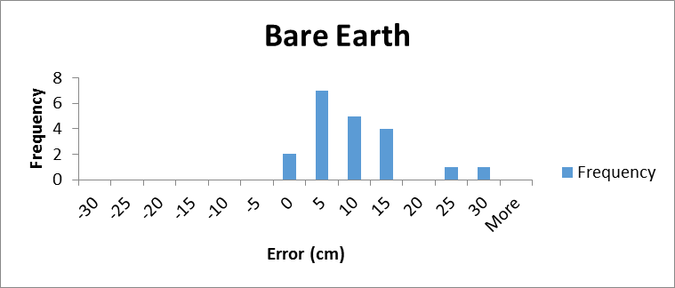

Number | Easting | Northing | Elevation | DTM Z | Error (ft) | Error (cm)
OP 8 | 472128.3 | 1663785 | 974.11 | 974.95 | 0.84 | 25.6032
OP 9 | 472009.2 | 1663285 | 957.12 | 957.85 | 0.73 | 22.2504
OP 6 | 471611.9 | 1663810 | 957.1 | 957.53 | 0.43 | 13.1064
OP 2 | 472008 | 1699930 | 979.06 | 979.44 | 0.38 | 11.5824
OP 7 | 472028.8 | 1663987 | 969.31 | 969.68 | 0.37 | 11.2776
OP 16 | 537433.8 | 1717573 | 1117.44 | 1117.79 | 0.35 | 10.668
OP 12 | 559205.1 | 1669911 | 1092.22 | 1092.5 | 0.28 | 8.5344
OP 20 | 537239.7 | 1714909 | 1103.58 | 1103.85 | 0.27 | 8.2296
OP 19 | 538481.3 | 1713819 | 1087.44 | 1087.71 | 0.27 | 8.2296
OP 18 | 538024.6 | 1713550 | 1085.55 | 1085.8 | 0.25 | 7.62
OP 17 | 537037.3 | 1717589 | 1120.46 | 1120.65 | 0.19 | 5.7912
OP 1 | 472201.3 | 1700411 | 982.75 | 982.89 | 0.14 | 4.2672
OP 11 | 559355.2 | 1670179 | 1096.77 | 1096.86 | 0.09 | 2.7432
OP 10 | 472024.4 | 1661264 | 961.22 | 961.3 | 0.08 | 2.4384
OP 5 | 471784.6 | 1698773 | 978.63 | 978.71 | 0.08 | 2.4384
OP 13 | 558267.5 | 1669215 | 1081.36 | 1081.41 | 0.05 | 1.524
OP 3 | 471694.3 | 1699721 | 980.93 | 980.96 | 0.03 | 0.9144
OP 4 | 471605.4 | 1699075 | 980.16 | 980.18 | 0.02 | 0.6096
OP 15 | 559834.2 | 1669413 | 1124.32 | 1124.25 | -0.07 | -2.1336
OP 14 | 558911.5 | 1669120 | 1089.92 | 1089.85 | -0.07 | -2.1336
 |  |  |  | Average | 0.236 | 7.19328
 |  |  |  | Minimum | -0.07 | -2.1336
 |  |  |  | Maximum | 0.84 | 25.6032
 |  |  |  | Std dev | 0.25 | 7.62
 |  |  |  | RMSE | 0.332 | 10.11936
 |  |  |  | 95th | 0.65072 | 19.83395

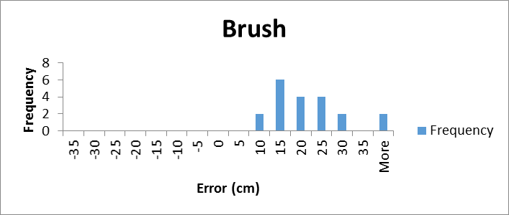

Number | Easting | Northing | Elevation | DTM Z | Error (ft) | Error (cm)
BR 6 | 546157.33 | 1659536.6 | 974.91 | 976.06 | 1.15 | 35.052
BR 13 | 472087.82 | 1663421.8 | 968.84 | 969.99 | 1.15 | 35.052
BR 11 | 471836.42 | 1663983.2 | 965.36 | 966.34 | 0.98 | 29.8704
BR 3 | 537082.37 | 1717330 | 1114.64 | 1115.62 | 0.98 | 29.8704
BR 19 | 475463.7 | 1695195.2 | 1051.68 | 1052.43 | 0.75 | 22.86
BR 2 | 537148.17 | 1717278.9 | 1114.57 | 1115.32 | 0.75 | 22.86
BR 14 | 472339.95 | 1663085.9 | 965.3 | 966.02 | 0.72 | 21.9456
BR 4 | 537019.63 | 1717427.1 | 1116.32 | 1117.01 | 0.69 | 21.0312
BR 7 | 546214.01 | 1658921.3 | 970.36 | 971.01 | 0.65 | 19.812
BR 5 | 537218.03 | 1717826.8 | 1121.25 | 1121.88 | 0.63 | 19.2024
BR 1 | 537460.9 | 1717539 | 1116.16 | 1116.79 | 0.63 | 19.2024
BR 20 | 475609.74 | 1695269 | 1056.2 | 1056.7 | 0.5 | 15.24
BR 15 | 472108.5 | 1661418.9 | 960.48 | 960.97 | 0.49 | 14.9352
BR 18 | 475332.9 | 1695032.8 | 1047.18 | 1047.64 | 0.46 | 14.0208
BR 8 | 546172.16 | 1658717.8 | 969.13 | 969.53 | 0.4 | 12.192
BR 9 | 546170.84 | 1658675.3 | 968.95 | 969.35 | 0.4 | 12.192
BR 16 | 476094.99 | 1695895.5 | 1072.09 | 1072.46 | 0.37 | 11.2776
BR 17 | 475307.18 | 1695830.8 | 1078.18 | 1078.55 | 0.37 | 11.2776
BR 12 | 471960.65 | 1663903.1 | 972.46 | 972.78 | 0.32 | 9.7536
BR 10 | 546270.58 | 1658668 | 967.63 | 967.93 | 0.3 | 9.144
 |  |  |  | Average | 0.635 | 19.3548
 |  |  |  | Minimum | 0.3 | 9.144
 |  |  |  | Maximum | 1.15 | 35.052
 |  |  |  | Std dev | 0.265 | 8.0772
 |  |  |  | RMSE | 0.685 | 20.8788
 |  |  |  | 95th | 1.3426 | 40.92245

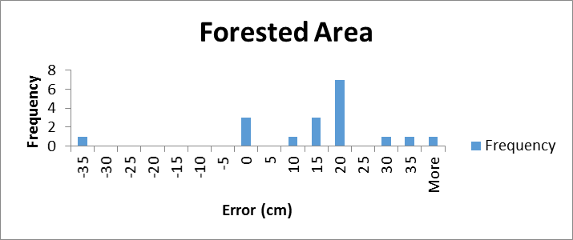

Number | Easting | Northing | Known Z | Laser Z | Error (ft) | Error (cm)
FA 11 | 562181.13 | 1675185.9 | 1004.24 | removed | *
FA 20 | 537164.93 | 1714934 | 1104.93 | 1106.2 | 1.27 | 38.7096
FA 18 | 538011.23 | 1713305 | 1084.45 | 1085.52 | 1.07 | 32.6136
FA 4 | 475569.43 | 1695857.5 | 1068.2 | 1069.07 | 0.87 | 26.5176
FA 14 | 562231.69 | 1675734.2 | 978.79 | 979.43 | 0.64 | 19.5072
FA 19 | 538537.65 | 1713827.8 | 1086.94 | 1087.58 | 0.64 | 19.5072
FA 6 | 471714.88 | 1663823 | 962.21 | 962.84 | 0.63 | 19.2024
FA 17 | 537035.51 | 1717415.2 | 1116.13 | 1116.71 | 0.58 | 17.6784
FA 15 | 562067.64 | 1675487.5 | 985.54 | 986.11 | 0.57 | 17.3736
FA 13 | 562379.07 | 1675390.3 | 991.73 | 992.29 | 0.56 | 17.0688
FA 12 | 562318.17 | 1675146.2 | 1010.82 | 1011.36 | 0.54 | 16.4592
FA 7 | 471969.22 | 1663099 | 971.09 | 971.55 | 0.46 | 14.0208
FA 10 | 467743.99 | 1663587.1 | 924.79 | 925.23 | 0.44 | 13.4112
FA 9 | 467541.76 | 1663663.4 | 925.02 | 925.43 | 0.41 | 12.4968
FA 16 | 537484.88 | 1717601.5 | 1115.41 | 1115.58 | 0.17 | 5.1816
FA 2 | 475663.07 | 1695603.6 | 1059.84 | 1059.83 | -0.01 | -0.3048
FA 1 | 475612.13 | 1695761.1 | 1063.99 | 1063.91 | -0.08 | -2.4384
FA 3 | 475804.33 | 1695839.3 | 1068.21 | 1068.1 | -0.11 | -3.3528
FA 8 | 466539.73 | 1661941 | 941.12 | 939.54 | -1.58 | -48.1584
FA 5 | 475391.98 | 1695929.1 | 1079.2 | outside | *
Blunder, not included in accuracy calculations
 |  |  |  | Average | 0.393 | 11.97864
 |  |  |  | Minimum | -1.58 | -48.1584
 |  |  |  | Maximum | 1.27 | 38.7096
 |  |  |  | Std dev | 0.611 | 18.62328
 |  |  |  | RMSE | 0.712 | 21.70176
 |  |  |  | 95th | 1.39552 | 42.5354496

Number | Easting | Northing | Elevation | DTM Z | Error (ft) | Error (cm)
TG 11 | 563878.91 | 1671742.2 | 1054.86 | 1055.7 | 0.84 | 25.6032
TG 8 | 471904.99 | 1661331.7 | 960.27 | 961.07 | 0.8 | 24.384
TG 12 | 565682.6 | 1671099.7 | 1068.83 | 1069.52 | 0.69 | 21.0312
TG 6 | 471778.54 | 1663944.3 | 967.21 | 967.9 | 0.69 | 21.0312
TG 16 | 537394.52 | 1717392 | 1116.38 | 1117 | 0.62 | 18.8976
TG 4 | 475306.32 | 1695010 | 1046.67 | 1047.29 | 0.62 | 18.8976
TG 2 | 475998.26 | 1695826 | 1069.61 | 1070.16 | 0.55 | 16.764
TG 5 | 475441.6 | 1695161.8 | 1050.14 | 1050.67 | 0.53 | 16.1544
TG 20 | 538013.2 | 1713410 | 1085.28 | 1085.78 | 0.5 | 15.24
TG 3 | 476195.33 | 1695837.7 | 1078.38 | 1078.85 | 0.47 | 14.3256
TG 10 | 466437.99 | 1661954 | 938.04 | 938.47 | 0.43 | 13.1064
TG 13 | 559888.06 | 1671343.9 | 1063.13 | 1063.53 | 0.4 | 12.192
TG 1 | 475617.25 | 1695703 | 1061.59 | 1061.98 | 0.39 | 11.8872
TG 7 | 470353.5 | 1662375.3 | 939.03 | 939.42 | 0.39 | 11.8872
TG 17 | 537265.83 | 1717370.9 | 1115.59 | 1115.96 | 0.37 | 11.2776
TG 18 | 537031.23 | 1717492.5 | 1117.68 | 1118.03 | 0.35 | 10.668
TG 9 | 471926.5 | 1661979.8 | 973.74 | 974.04 | 0.3 | 9.144
TG 14 | 561578.88 | 1671440.7 | 1048.44 | 1048.73 | 0.29 | 8.8392
TG 15 | 563390.85 | 1669843.5 | 1036.69 | 1036.82 | 0.13 | 3.9624
TG 19 | 537268.57 | 1717701.2 | 1121.72 | 1121.8 | 0.08 | 2.4384
 |  |  |  | Average | 0.472 | 14.38656
 |  |  |  | Minimum | 0.08 | 2.4384
 |  |  |  | Maximum | 0.84 | 25.6032
 |  |  |  | Std dev | 0.201 | 6.12648
 |  |  |  | RMSE | 0.511 | 15.57528
 |  |  |  | 95th | 1.00156 | 30.527549

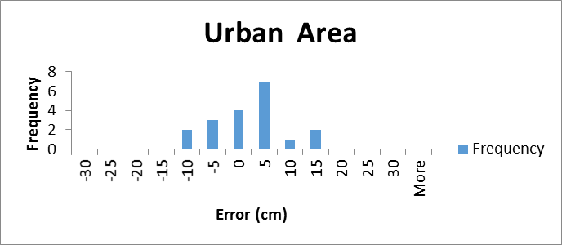

Number | Easting | Northing | Known Z | DTM Z | Error (ft) | Error (cm)
UR 13 | 466909.61 | 1662270.13 | 933.26 | removed | *
UR 2 | 538017.79 | 1713458.73 | 1086.98 | 1087.43 | 0.45 | 13.716
UR 11 | 467149.79 | 1662277.41 | 932.15 | 932.49 | 0.34 | 10.3632
UR 15 | 466957.36 | 1662604.06 | 933.84 | 934.08 | 0.24 | 7.3152
UR 5 | 537087.48 | 1714919.59 | 1105.36 | 1105.52 | 0.16 | 4.8768
UR 3 | 538440.33 | 1713779.63 | 1087.77 | 1087.92 | 0.15 | 4.572
UR 14 | 466741.33 | 1662262.55 | 935.05 | 935.19 | 0.14 | 4.2672
UR 1 | 537413.76 | 1717451.59 | 1117.97 | 1118.1 | 0.13 | 3.9624
UR 4 | 538166.04 | 1715255.48 | 1103.36 | 1103.48 | 0.12 | 3.6576
UR 18 | 470025.51 | 1698452.08 | 1005.2 | 1005.31 | 0.11 | 3.3528
UR 12 | 467012.44 | 1662267.21 | 934.15 | 934.19 | 0.04 | 1.2192
UR 9 | 516130.35 | 1664988.84 | 1007.76 | 1007.71 | -0.05 | -1.524
UR 20 | 469992.95 | 1698572.2 | 1007.47 | 1007.41 | -0.06 | -1.8288
UR 16 | 470016.84 | 1698310.31 | 1002.89 | 1002.74 | -0.15 | -4.572
UR 17 | 470022.18 | 1698391.58 | 1004.32 | 1004.16 | -0.16 | -4.8768
UR 8 | 516764.13 | 1665042.24 | 1009.51 | 1009.27 | -0.24 | -7.3152
UR 19 | 469981.71 | 1698515.03 | 1007.47 | 1007.22 | -0.25 | -7.62
UR 7 | 516386.79 | 1665093.32 | 1011.51 | 1011.25 | -0.26 | -7.9248
UR 6 | 516433.46 | 1665339.79 | 1007.39 | 1007.02 | -0.37 | -11.2776
UR 10 | 515937.95 | 1665281.22 | 996.62 | 996.15 | -0.47 | -14.3256
Blunder, point not included in accuracy calculations
 |  |  |  | Average | -0.007 | -0.21336
 |  |  |  | Minimum | -0.47 | -14.3256
 |  |  |  | Maximum | 0.45 | 13.716
 |  |  |  | Std dev | 0.246 | 7.49808
 |  |  |  | RMSE | 0.239 | 7.28472
 |  |  |  | 95th | 0.46844 | 14.278051

LiDAR Flight Mission – Summary
LiDAR data was acquired during the late winter and early spring during the period when vegetation was primarily dormant. Using a Cessna 206 single engine aircraft, LiDAR was acquired with an Optech ALTM Gemini LiDAR sensor on board. The objective was USGS QL2 Lidar data suitable for a 2-foot contour at an altitude of 1400 meters above average ground level. Overlap between adjacent flight lines was 50% with line spacing designed to be 1315 feet per swath. The speed of the aircraft was at 120 knots and the resultant density was designed for 2 points per square meter including the overlapping data from adjacent flight lines.
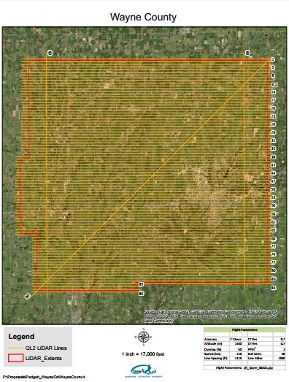
LiDAR Flight Map

