Indiana Central Wayne County Vertical Accuracy Re-assessment for Vegetated Vertical Accuracy
NGTOC – U.S. Geological Survey – 6/5/2019

- USGS specifications require that the VVA be 29.4 cm or better at 95% confidence level.
-Reported
-VVA at the 95% confidence level is 38.23 cm.
-NVA at the 95% confidence level is 13.9 cm.
-USGS tested
-VVA at the 95% confidence level is 35.4 cm.
-NVA at the 95% confidence level is 18.2 cm.

- USGS specifications require 20 VVA checkpoints for this area of 446 square miles. 60 VVA checkpoints were delivered and processed. 58 VVA checkpoints were reported to have been checked from the vendor’s end (via xml metadata). 60 VVA checkpoints were checked in USGS original vertical accuracy check. After points were removed due to high delta z values, 51 VVA checkpoints were checked.

Results from running VA after removing the above points:
-VVA at the 95% confidence level is 22.7076 cm with 51 VVA points checked.
-NVA at the 95% confidence level is 16.3629 cm with 39 NVA points checked.

The following check points were evaluated in the point cloud because of high z difference values (ft):
Checkpoint ID | Landcover Type | Z difference (US Feet)
FA11 | VVA | 1.77001
FA20 | VVA | 1.179985
FA18 | VVA | 1.159985
BR06 | VVA | 1.14998
BR13 | VVA | 1.14999
BR11 | VVA | .989976
BR03 | VVA | .939956
FA04 | VVA | .860059
OP08 | NVA | .840012
FA08 | VVA | -1.659978

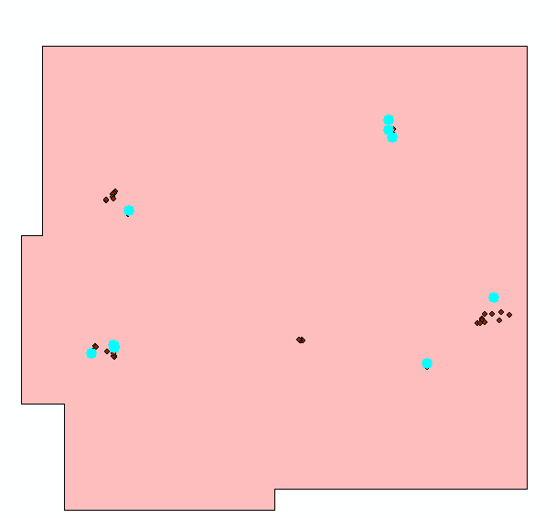
FA11: ʥ = 1.77001 feet
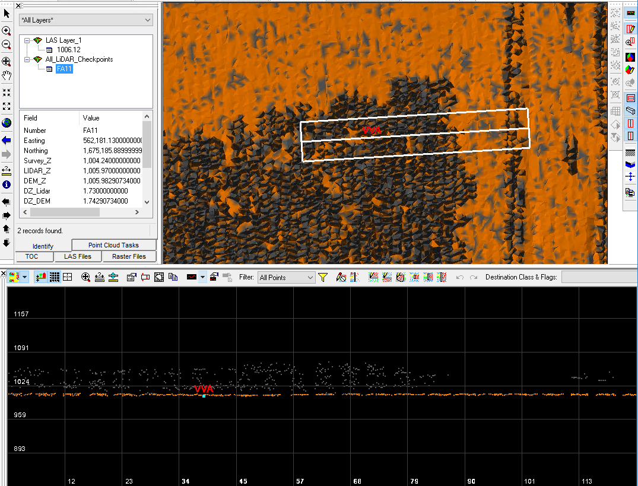
FA20: ʥ = 1.179985 feet
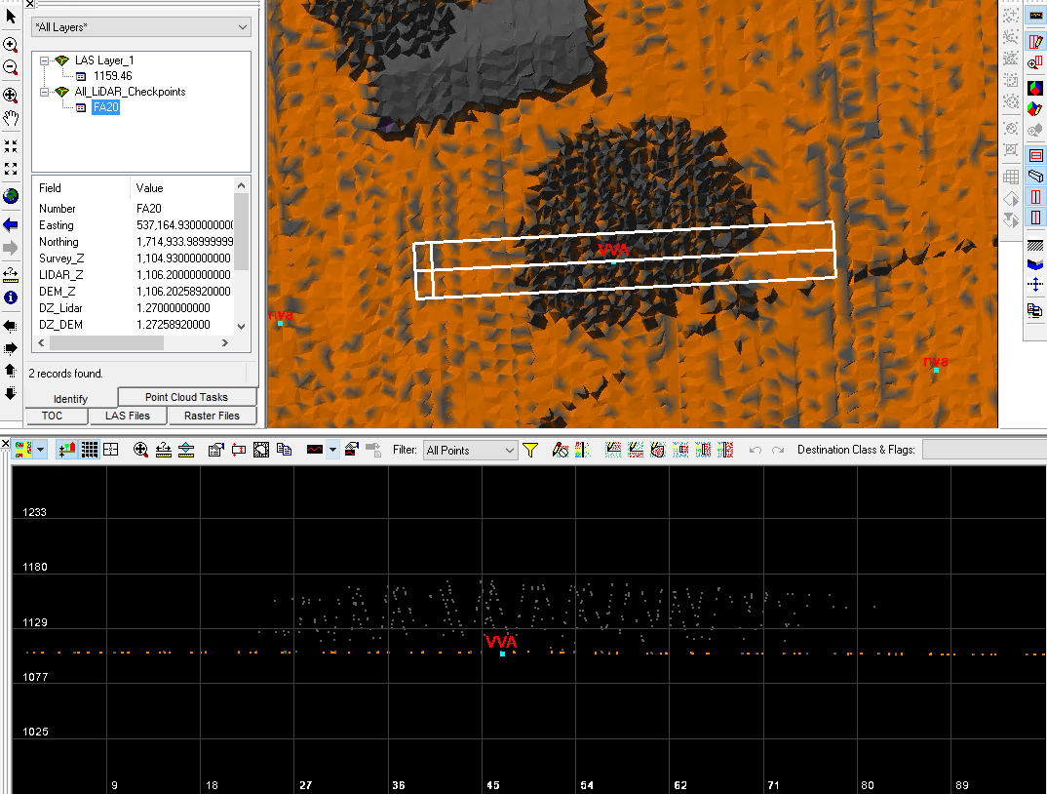
FA18: ʥ = 1.159985 feet
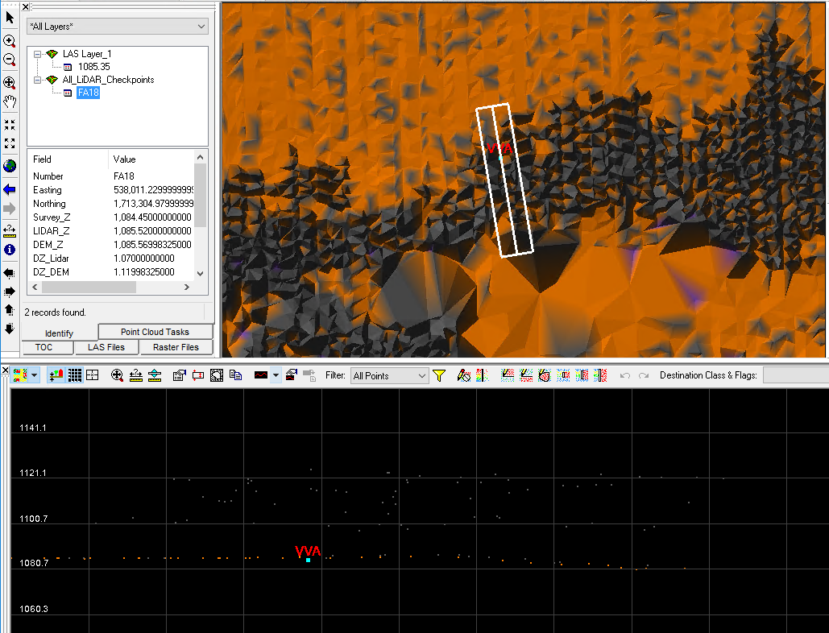
BR06: ʥ = 1.14998 feet
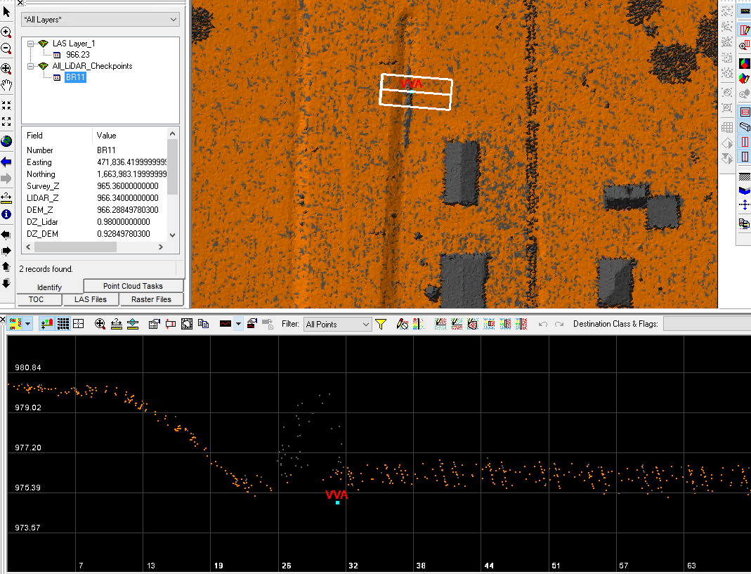
BR13: ʥ = 1.14999 feet
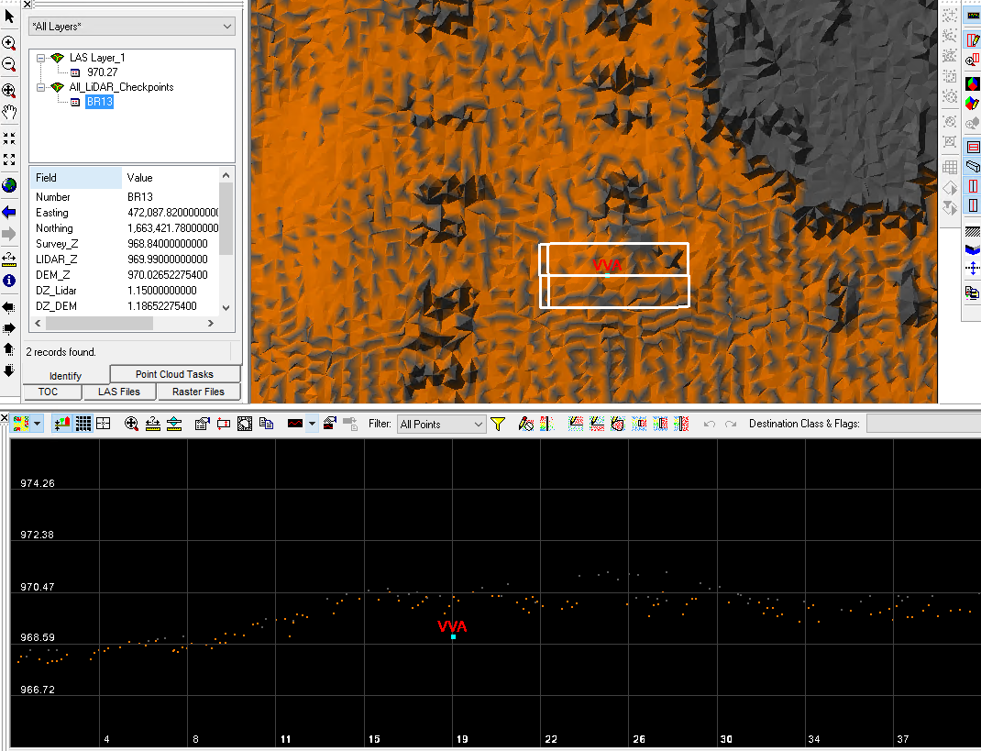
BR11: ʥ = .989976 feet
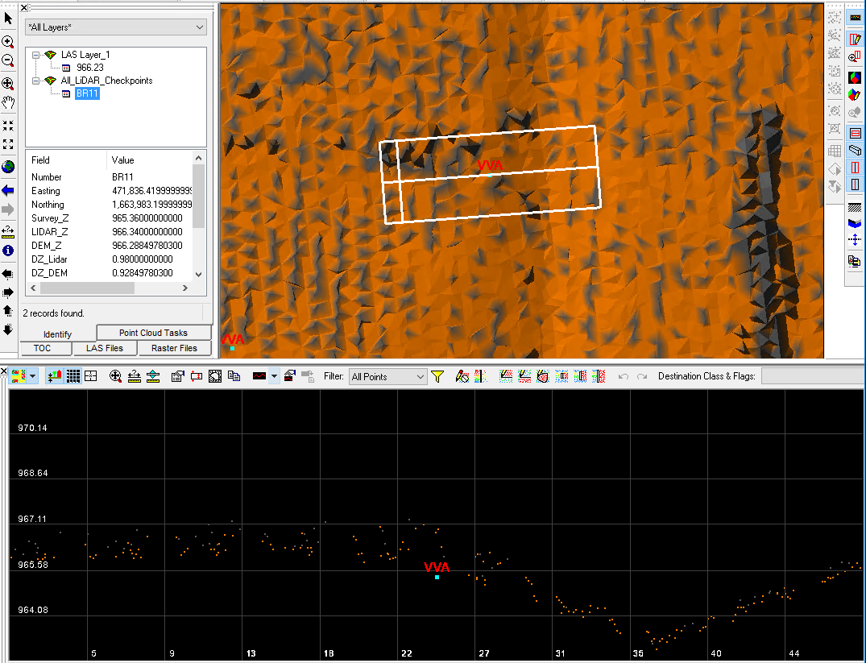

BR03: ʥ = .939956 feet
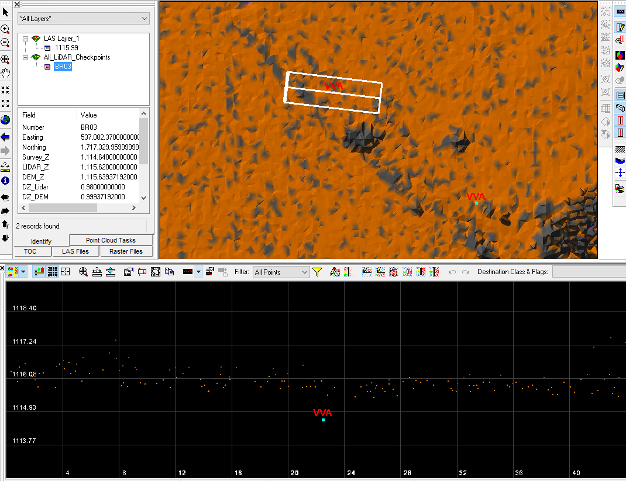
FA04: ʥ = .860059 feet
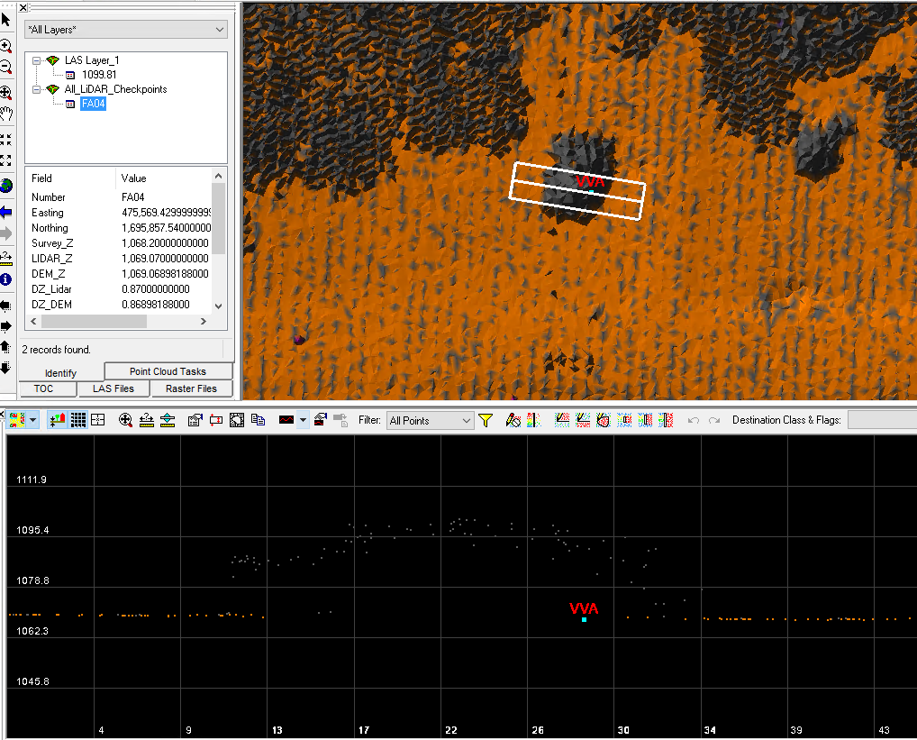
OP08: ʥ = .840012 feet
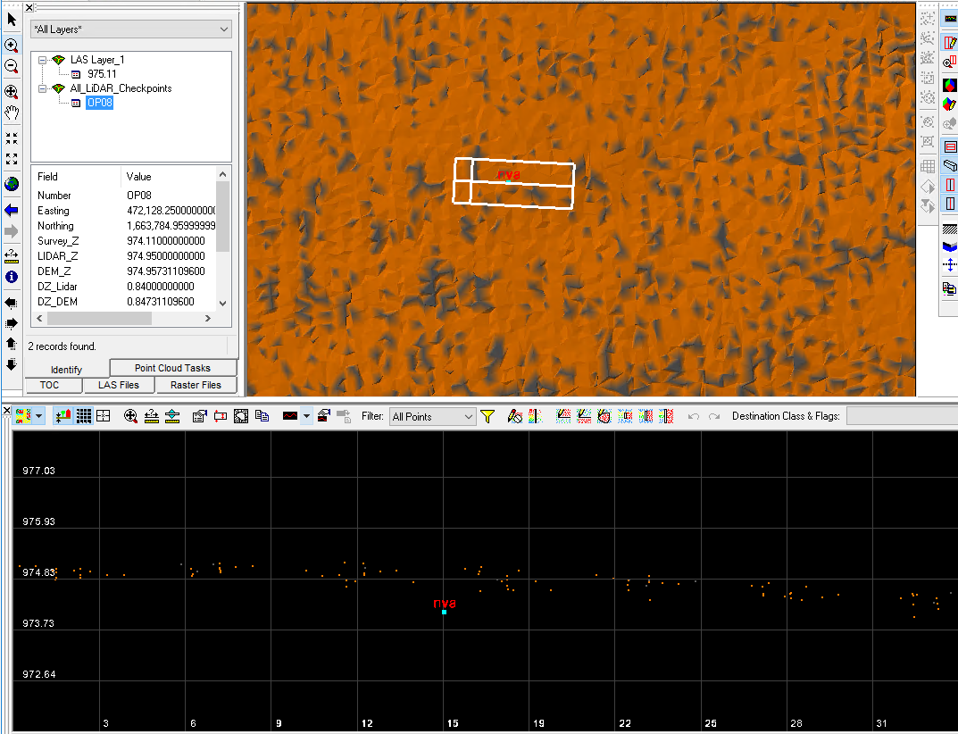
FA08: ʥ = -1.659978 feet
