Kansas LiDAR
Mapping Program
Ground Control Survey Report
2012

Prepared By:

Sanborn
1935 Jamboree Drive, Suite 100
Colorado Springs, CO 80920
(719) 593-0093



EXECUTIVE SUMMARY

Sanborn Map Company was contracted by Kansas Geological Survey Department at University of Kansas to perform LiDAR aerial surveys of 8,792 square miles, which covers following counties: Hamilton, Kearny, Grant, Scott, Lane, Finney, Gray, Haskell, Seward and Meade.
LiDAR was flown to produce a 0.6 points per meter square return density or 1.4 meters Nominal Point Spacing (NPS). Break lines will be produced to supplement the bare-earth classified LiDAR with the objective of producing a high-accuracy topographic map. A DTM meeting a 12.5 cm RMSE in open areas is required.
A network of ground control points has been design and implemented into the project process to establish common basis for geo-referencing of the LiDAR data products. These control points are used in conjunction with airborne GPS data collected during acquisition of LiDAR data. Additionally, 200 Quality Control checkpoints were collected based on the same ground control network.
The local network was designed, processed and adjusted using Trimble Business Center (TBC) version 2.60. Final horizontal coordinates are projected on UTM Zone14 meters, on the North American Datum of 1983/HARN. Furthermore, orthometric elevations were estimated for all points in the network using sophisticated geoidal modeling techniques (GEOID 09) and are provided on the North American Vertical Datum of 1988 (NAVD88).
A set consisting of fourteen (14) AGPS control monuments and two hundred (200) LiDAR check points was established within project area by Sanborn. The network set, consisting of NGS monuments and semi-permanent monuments, is to be used to establish common datum for AGPS base stations and check point surveys. The check points set is to be implemented as LiDAR data Quality Control and adjustments.

TABLE OF CONTENTS
TABLE OF CONTENTS 3
1. INTRODUCTION 4
1.1 Purpose of the Survey 5
1.2 Duration/Time Period 6
1.3 Field Procedures 6
1.4 Contact 7
1.5 Accuracy requirements 7
1.6 GPS Network and Check Points Diagrams 7
2. project area sCOPE and details 8
2.1 Monuments and Station Naming 9
3. CONDITIONS AFFECTING PROGRESS 9
4. POST PROCESSING 10
4.1 Baseline Processing 10
4.2 Minimally Constrained Network Adjustment 10
4.3 Constrained Network Adjustment 11
5. Final Coordinates and Elevations 12
APPENDIX A1
Network Adjusted Coordinates
APPENDIX A2
Check Points Adjusted Coordinates
APPENDIX b1
Network Adjustment Reports
APPENDIX b2
LiDAR Check Points Adjustment Reports
APPENDIX C
Check Points Recovery Sheets
APPENDIX D
NGS Sheets
APPENDIX E
Field Logs

1. INTRODUCTION

This report contains the technical write-up of the differential GPS surveys performed for the ground control LiDAR check points in support of high-resolution digital elevation model developed from LiDAR data for Kansas 10 counties project.
Sanborn was responsible for the preparation of this report, all fieldwork including reconnaissance of existing control points, establishment of additional control points, LiDAR check points, GPS surveys, all GPS data processing and reductions.

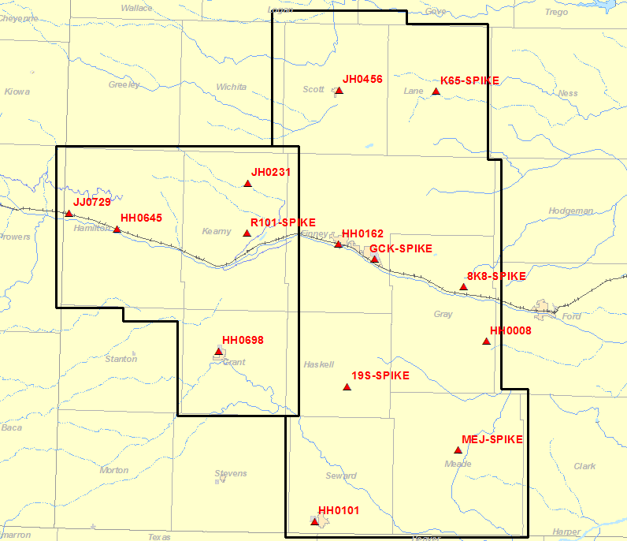
Figure 1: LiDAR Project Layout with GCP.

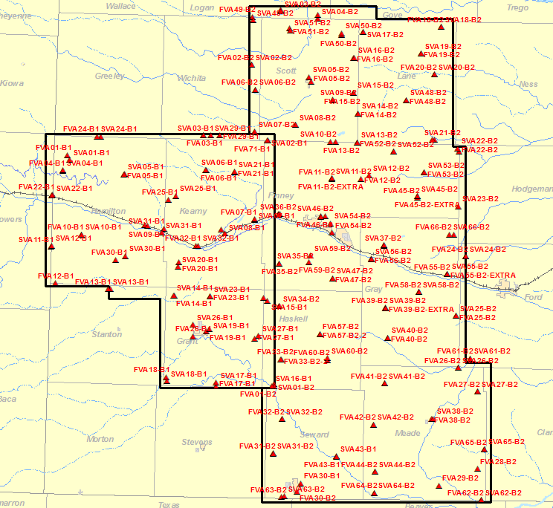
Figure 2: Project Layout with LiDAR Check Points.

Purpose of the Survey

The GPS Network surveys were designed to provide ground control for high-accuracy LiDAR data collection of the Kansas mapping project. AGPS stations were strategically placed so the LiDAR collection occurs 40km or closer from any base station. Multiple receivers would be used to achieve this requirement. The GPS control network consists of nine (14) control stations. The network includes eight (8) NGS monuments: JJ0729, HH0645, JH0231, HH0698, JH0456, HH0162, HH0008 and HH0101. There are six (6) newly established, semi-permanent control points: R101-SPIKE, K65_SPIKE, GCK-SPIKE, 8K8-SPIKE, 19S-SIKE and MEJ-SPIKE, see APPENDIX A for adjusted coordinates and APPENDIX D for NGS recovery sheets. The horizontal and vertical datum of the local GPS network is based on these control monuments.
Two hundred (200) LiDAR Check Points control points were established throughout project area to serve as LiDAR data Quality Control and adjustments. There are 2 classes of check points surveyed throughout the project area: FVA (main bare earth or low vegetation class) and SVA (supplemental or higher vegetation class). Every possible effort was taken to find suitable vegetation class for each QC point. Check points were positioned with the intent of accomplishing even and random point distribution over the area of interest. See APPENDIX C for point recovery sheets.

Duration/Time Period
The acquisition of ground control and Check Points control was completed between January 20, 2012 (Julian day 020) and March 11, 2012 (Julian day 071).

1.3 Field Procedures
A careful reconnaissance was undertaken prior to the monumentation and subsequent GPS survey. Most of the points in the network have good satellite visibility. The satellite window provided 24–hour coverage, and GPS observation sessions were scheduled between 7:00 am and 7:00 PM, local time, each day. Some difficulties were experienced with solar storm activity, but these days were avoided and no surveys were done with high solar activity. All baseline processing, analysis, and preliminary reductions were performed on a daily basis, thus allowing for continuous quality control.
The GPS control survey was set up as a fast static at 0.5s logging rate. Field crew members followed a session schedule established by office personnel to facilitate observation location and duration, which were at least 20 minutes per mission for LiDAR check point surveys. Network surveys were scheduled to last at least 1 hour per observation, with no trivial baselines. Personnel navigated to points using hand-held GPS receivers, USGS Quadrangle maps and state road maps. The hand-held GPS receivers had approximate geodetic coordinates loaded for the required observation points. Upon arriving at the desired location, the field personnel initiated a search for an adequate check point location that was in a GPS “friendly” spot. The receiver was set on the tripod and leveled over the point. The following information was recorded: control point name and code, stamping if available, date, Julian date, observer name, receiver model & serial number, antenna type, where the antenna height was measured to, antenna height, start time, end time, site sketch with ties. The data file name is also included on this sheet. The file name convention is SSSSJJJf.dat, where “SSSS” is the last four digits of the receiver serial number, “JJJ” is the Julian date, and “f” is the data file number for that day’s work. “f” = 0 for the first file, 1 for the second and so on. See APPENDIX E with field logs for details.
Digital photographs or sketches were taken at each point showing the targeted point and its relationship to its surroundings.

1.4 Contact
Questions regarding the technical aspects of this report should be addressed to:
Sanborn
1935 Jamboree Drive, Suite 100
Colorado Springs, Colorado, 80920
Attention: Krysia Sapeta Project Manager
Karol Szczubelek Geodetic Engineer
Telephone: (719) 593-0093
FAX: (719) 528-5093

1.5 Accuracy requirements

The Kansas GPS network meets the current Federal Geodetic Control Subcommittee (FGCS) accuracy standard for horizontal First order GPS surveys. All baselines meet the required relative horizontal positional accuracy of 10 mm + 100 ppm, at the 95% level of confidence.

1.6 GPS Network and Check Points Diagrams

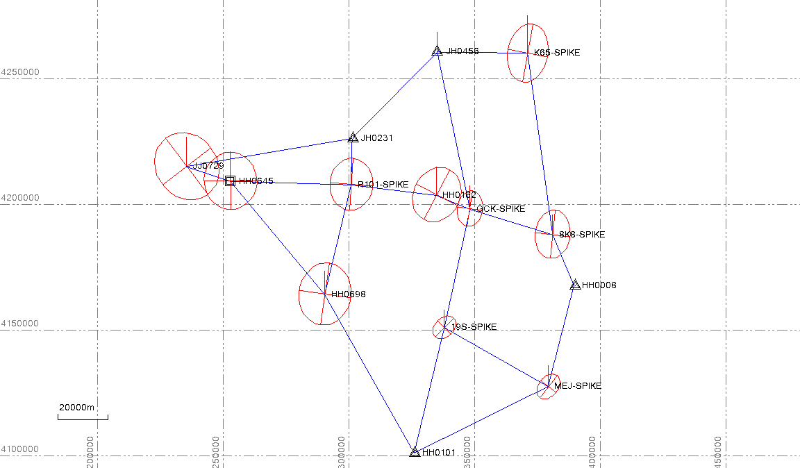
Figure 3: Network Diagram

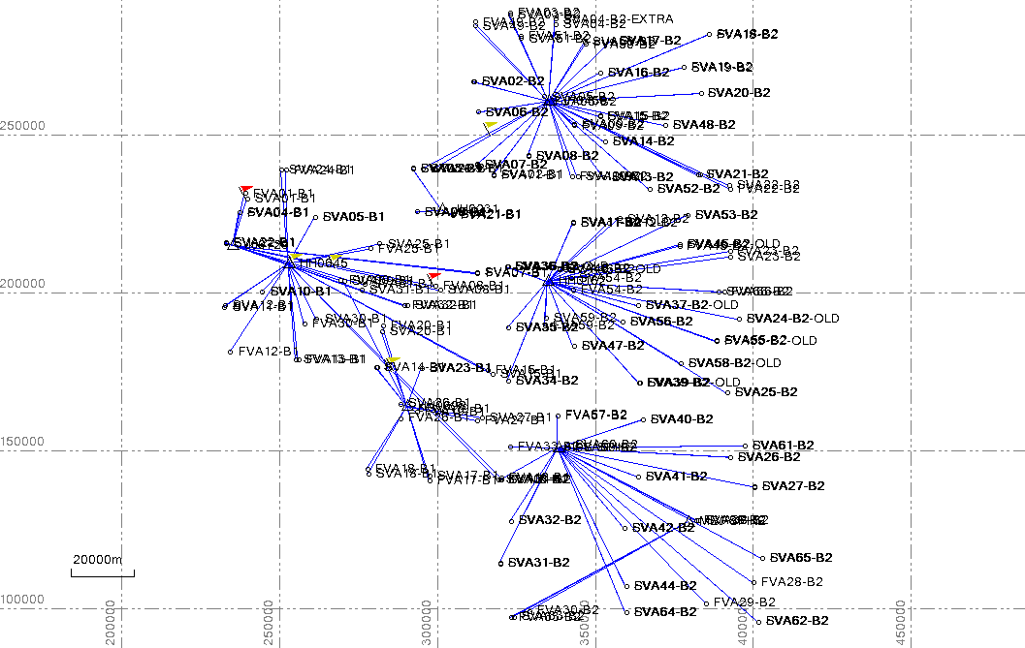
Figure 4: Check Points Diagram

2. project area sCOPE and details

Sanborn Map Company was contracted by Kansas Geological Survey Department at University of Kansas to perform LiDAR aerial surveys of 8,792 square miles, which covers following counties: Hamilton, Kearny, Grant, Scott, Lane, Finney, Gray, Haskell, Seward and Meade.
LiDAR was flown to produce a 0.6 points per meter square return density or 1.4 meters Nominal Point Spacing (NPS). Break lines will be produced to supplement the bare-earth classified LiDAR with the objective of producing a high-accuracy topographic map. A DTM meeting a 12.5 cm RMSE in open areas is required.

Monuments and Station Naming

The GPS Network surveys were designed to provide ground control for high-accuracy LiDAR data collection of the Kansas mapping project. AGPS stations were strategically placed so the LiDAR collection occurs 40km or closer from any base station. Multiple receivers would be used to achieve this requirement. The GPS control network consists of nine (14) control stations. The network includes eight (8) NGS monuments: JJ0729, HH0645, JH0231, HH0698, JH0456, HH0162, HH0008 and HH0101. There are six (6) newly established, semi-permanent control points: R101-SPIKE, K65_SPIKE, GCK-SPIKE, 8K8-SPIKE, 19S-SIKE and MEJ-SPIKE. Semi-permanent monuments were established using 12” spike driven into dirt. The horizontal and vertical datum of the local GPS network is based on these control monuments.
Two hundred (200) LiDAR Check Points control points were established throughout project area to serve as LiDAR data Quality Control and adjustments. There are 2 classes of check points surveyed throughout the project area: FVA (main bare earth or low vegetation class) and SVA (supplemental or higher vegetation class). Every possible effort was taken to find suitable vegetation class for each QC point. Check points were positioned with the intent of accomplishing even and random point distribution over the area of interest. See APPENDIX C for point recovery sheets.

3. CONDITIONS AFFECTING PROGRESS

A careful reconnaissance was undertaken prior to target control selection and subsequent GPS surveys. All check points are boldly visible and un-obscured. Most of the points in the network have good satellite visibility. The satellite window provided 24–hour coverage, and GPS observation sessions were scheduled between 7:00 am and 7:00 PM, local time, each day. . Some difficulties were experienced with solar storm activity, but these days were avoided and no surveys were done with high solar activity.

4. POST PROCESSING

4.1 Baseline Processing

All static baseline vectors for Kansas project were processed using Trimble Business Center (Ver. 2.60) software. Fixed solutions were adopted for all baselines. The broadcast ephemeris was used, since the accuracy and extent of the network does not warrant the use of the precise ephemeris. GEOID09 was incorporated into the reductions, thereby allowing rigorous interpolation of the geoidal undulation values (N) at each point in the network. This provides a useful method of estimating the elevations at all points in the network. Project network was surveyed using closed loop GPS survey method, while Check Points were collected using rapid static, radial survey method. For baseline processing reports, loop closures and constrained adjustments see APPENDIX B.

Minimally Constrained Network Adjustment
A minimally constrained least squares adjustment for Kansas project was performed using Trimble Business Center (Ver. 2.60) 3-dimensional adjustment software. The published latitude and longitude of the NGS point HH0008, and the orthometric elevation of the NGS point HH0008 were held fixed in the minimally constrained adjustment. The adjustment comprised nine (14) stations and thirty three (60) baseline vector components. A priori weights for the observations were based on the (scaled 5.78) variance-covariance sub-matrices to obtain realistic solution.
None of the standardized residual was flagged for possible rejection under the Taumax–test (τ_{MAX}–test), at the 0.05 level of significance. The histogram of standardized residuals indicates that the observations are well distributed. The a posteriori variance factor (σ_{o}²= 1.00) indicates that the scaled a priori standard deviations of the vector components are realistic. The absolute and relative confidence regions were not scaled by the a posteriori variance factor.
The relative confidence regions and the associated relative horizontal and vertical precision were computed for all pairs of points that were directly connected by vectors. All station pairings meet the horizontal positioning standard for First order class one surveys, i.e., the relative horizontal precision between each pair of points does not exceed 10 mm + 100 ppm of their horizontal separation, at the 95 percent level of confidence. The network is therefore classified as Second order class one in terms of its internal accuracy.

Constrained Network Adjustment

A subset of well distributed throughout the network existing NGS control points provide a basis for the constrained network adjustment. Since network has a high internal accuracy, and since the fit of the network to the existing control is good, a strategy was devised in which the networks would be constrained tightly to the existing control stations. This would further ensure a smooth integration between the newly established control and the existing framework.
The constraints assigned for the final network adjustment are shown in table 1. Five (5) NGS control points were used to constrain the network horizontally. The network was further constrained to the orthometric height of three vertical control point, which were occupied during the GPS survey, see table 1 for details. GEOID09 was incorporated into the adjustment, thereby allowing rigorous interpolation of the geoidal undulation values (N) at each point in the network. This provides a useful method of estimating the elevations at all points in the network.
The adjustment was constrained to the NAD83/HARN NGS control values to ensure the mapping datum for the Kansas project agrees with the previous control framework established within the area on previous projects.
A full listing of the constrained adjustment is contained in APPENDIX B1 and APPENDIX B2. The residuals and the standardized residuals are also listed in the adjustment results section. The absolute and relative confidence regions were not scaled by the a posteriori variance factor.

Table 1. Adjustment Constraints

Horizontal

Station Name PID Order
Z 191 HH0008 0
AP STA B HH0101 0
Q 99 JH0231 0
AERO JH0456 0

Vertical
Station Name PID Order
Z 191 HH0008 2
AP STA B HH0101 2
K 556 HH0645 I
Q 99 JH0231 2

5. Final Coordinates and Elevations

The final NAD83/HARN UTM Zone 14, are presented in meters in APPENDIX A1 and APPENDIX A2. Final orthometric elevations, referenced to the North American Vertical Datum of 1988 (NAVD88) in meters, are also presented in the above given APPENDICES. All final coordinates are derived from the constrained adjustments shown in APPENDIX B1 and APPENDIX B2.

APPENDIX A1

Network Adjusted Coordinates

Sanborn Map Company
Network Control for Kansas Project
Final Coordinate List
Horizontal Datum: NAD83/HARN
Vertical Datum: NAVD88
Projection: UTM Zone 14
 | Geographic Coordinates |  |  | UTM Zone 14
Name | Latitude (Deg) | Longitude (Deg) | Ellipsoidal Ht m | NORTH (Y) m | EAST (X) m | NAVD88 ELEV (Z) m
8K8-SPIKE | N37°49'49.38293" | W100°20'57.36079" | 811.583 | 4187853.628 | 381262.901 | 837.383
19S-SPIKE | N37°29'23.71988" | W100°49'53.27643" | 860.575 | 4150798.565 | 338087.644 | 886.743
GCK-SPIKE | N37°55'00.65128" | W100°43'33.15705" | 849.478 | 4197993.460 | 348296.007 | 875.112
HH0008 | N37°38'56.42110" | W100°14'59.63153" | 806.760 | 4167607.334 | 389739.120 | 832.881
HH0101 | N37°02'15.22496" | W100°57'21.50117" | 848.803 | 4100828.241 | 326041.543 | 875.570
HH0162 | N37°57'51.86317" | W100°52'46.77326" | 840.338 | 4203532.333 | 334883.935 | 865.833
HH0645 | N37°59'48.17255" | W101°48'57.76498" | 970.864 | 4209193.137 | 252723.345 | 995.279
HH0698 | N37°35'56.43782" | W101°22'28.48617" | 906.758 | 4163977.147 | 290372.713 | 932.276
JH0231 | N38°09'44.34695" | W101°16'03.52127" | 941.664 | 4226254.740 | 301334.093 | 966.321
JH0456 | N38°28'46.35964" | W100°53'18.99726" | 876.864 | 4260713.386 | 335263.827 | 901.792
JJ0729 | N38°02'39.95640" | W102°01'05.45454" | 1004.260 | 4215046.256 | 235141.937 | 1028.329
K65-SPIKE | N38°28'53.45980" | W100°28'33.17786" | 819.778 | 4260274.310 | 371270.037 | 845.165
MEJ-SPIKE | N37°17'05.04545" | W100°21'35.81852" | 742.832 | 4127326.472 | 379446.686 | 769.512
R101-SPIKE | N37°59'42.84466" | W101°16'02.72116" | 944.843 | 4207712.194 | 300900.772 | 969.960

APPENDIX A2

Check Points Adjusted Coordinates

Sanborn Map Company
Check Point Control for Kansas Project
Final Coordinate List
Horizontal Datum: NAD83/HARN
Vertical Datum: NAVD88
Projection: UTM Zone 14
POINT NO. | NORTH (Y) m | EAST (X) m | NAVD88 ELEV (Z) m
FVA01-B1 | 4231390.306 | 238871.361 | 1153.404
FVA01-B2 | 4140637.141 | 319892.078 | 863.946
FVA02-B2 | 4266891.874 | 311323.097 | 972.194
FVA03-B1 | 4239386.200 | 292162.940 | 1010.326
FVA03-B2 | 4288675.859 | 322710.505 | 898.451
FVA04-B1 | 4225278.244 | 237132.240 | 1103.282
FVA05-B1 | 4224006.287 | 261183.071 | 1081.770
FVA05-B2 | 4260347.823 | 334534.102 | 903.106
FVA06-B1 | 4225553.434 | 293341.386 | 987.533
FVA06-B2 | 4257213.426 | 312687.760 | 967.224
FVA07-B1 | 4205994.417 | 312530.008 | 902.839
FVA07-B2 | 4240532.201 | 312478.573 | 959.101
FVA08-B1 | 4202043.811 | 299275.641 | 940.556
FVA08-B2 | 4243366.018 | 328615.276 | 902.104
FVA09-B1 | 4203893.697 | 269187.411 | 968.058
FVA09-B2 | 4252918.854 | 343238.935 | 907.868
FVA10-B1 | 4200207.232 | 244359.722 | 1061.684
FVA10-B2 | 4236686.399 | 342358.760 | 893.165
FVA11-B2 | 4221909.835 | 342904.685 | 895.643
FVA11-B2-EXTRA | 4222252.136 | 342930.247 | 897.190
FVA12-B1 | 4181110.750 | 234187.256 | 1089.241
FVA12-B2 | 4222058.988 | 354133.128 | 881.185
FVA13-B1 | 4178680.361 | 255817.126 | 1002.101
FVA13-B2 | 4236485.157 | 352650.614 | 880.964
FVA14-B1 | 4176270.648 | 280728.097 | 965.761
FVA14-B2 | 4247777.374 | 352924.972 | 894.541
FVA15-B1 | 4175384.853 | 315789.770 | 911.312
FVA15-B2 | 4255900.104 | 351234.284 | 890.110
FVA16-B1 | 4141343.322 | 320095.389 | 879.628
FVA16-B2 | 4269701.254 | 351412.116 | 886.693
FVA17-B1 | 4140406.332 | 297318.051 | 930.590
FVA17-B2 | 4279769.195 | 354944.769 | 876.507
FVA18-B1 | 4144141.249 | 277614.197 | 961.213
FVA18-B2 | 4281803.129 | 385838.581 | 813.579
FVA19-B1 | 4162231.602 | 293409.313 | 925.694
FVA19-B2 | 4271438.547 | 377756.534 | 839.250
FVA20-B1 | 4189397.487 | 282631.837 | 984.178
FVA20-B2 | 4263191.787 | 383190.546 | 824.489
FVA21-B1 | 4224566.499 | 304560.895 | 961.048
FVA21-B2 | 4237452.283 | 382984.798 | 802.793
FVA22-B1 | 4216010.852 | 232837.080 | 1031.084
FVA22-B2 | 4232908.394 | 392662.910 | 794.398
FVA23-B1 | 4175888.993 | 294856.687 | 936.107
FVA23-B2 | 4213084.705 | 4213084.705 | 799.011
FVA24-B1 | 4238771.682 | 251862.629 | 1112.314
FVA24-B2 | 4191552.124 | 395276.000 | 809.035
FVA24-B2-EXTRA | 4191555.435 | 395242.581 | 809.654
FVA25-B1 | 4213883.949 | 278543.737 | 1028.590
FVA25-B2 | 4168196.567 | 391547.914 | 828.859
FVA26-B1 | 4160133.201 | 288047.652 | 918.835
FVA26-B2 | 4147836.302 | 392448.860 | 773.516
FVA27-B1 | 4159355.470 | 312487.225 | 923.708
FVA27-B2 | 4138422.113 | 400151.055 | 788.463
FVA28-B2 | 4108076.494 | 399922.228 | 698.621
FVA29-B1 | 4239264.132 | 298786.872 | 993.965
FVA29-B2 | 4101535.959 | 384973.896 | 714.346
FVA30-B1 | 4190208.408 | 257736.133 | 1063.978
FVA30-B1 | 4102332.004 | 330631.072 | 861.432
FVA30-B2 | 4099101.453 | 328949.268 | 867.315
FVA31-B2 | 4114160.504 | 319626.438 | 892.744
FVA32-B1 | 4195819.075 | 289440.619 | 940.130
FVA32-B2 | 4127612.965 | 323123.048 | 889.841
FVA33-B2 | 4151079.150 | 322833.764 | 906.998
FVA33-B2-2 | 4151072.355 | 322774.131 | 906.485
FVA34-B2 | 4172059.643 | 322137.592 | 925.351
FVA35-B2 | 4188824.387 | 322138.997 | 903.022
FVA36-B2 | 4208167.275 | 321765.069 | 898.584
FVA37-B2 | 4195892.193 | 363294.878 | 862.339
FVA37-B2-EXTRA | 4195901.452 | 363343.949 | 862.353
FVA38-B2 | 4127714.965 | 381846.395 | 752.687
FVA39-B2 | 4171360.111 | 363753.891 | 844.150
FVA39-B2-EXTRA | 4171306.251 | 363917.959 | 844.828
FVA40-B2 | 4159613.005 | 364827.536 | 840.506
FVA41-B2 | 4141670.749 | 363428.313 | 845.912
FVA42-B2 | 4125349.074 | 359049.568 | 841.070
FVA43-B1 | 4112974.854 | 344518.281 | 779.191
FVA44-B2 | 4106938.340 | 359617.699 | 821.923
FVA45-B2 | 4214725.518 | 376433.718 | 834.949
FVA45-B2-EXTRA | 4215198.445 | 376465.262 | 834.913
FVA46-B2 | 4207291.743 | 340219.600 | 867.425
FVA47-B2 | 4182948.314 | 342961.670 | 879.815
FVA48-B2 | 4253028.915 | 372012.887 | 853.000
FVA49-B2 | 4285732.542 | 311677.271 | 938.130
FVA50-B2 | 4278647.582 | 346731.207 | 893.716
FVA51-B2 | 4281397.603 | 326066.394 | 939.811
FVA52-B2 | 4232877.368 | 367080.530 | 854.192
FVA53-B2 | 4224533.243 | 378998.158 | 779.262
FVA54-B2 | 4200955.559 | 342871.224 | 857.952
FVA55-B2 | 4184521.657 | 388223.974 | 809.516
FVA55-B2-EXTRA | 4184662.458 | 388222.582 | 811.141
FVA56-B2 | 4190672.464 | 358341.255 | 827.845
FVA57-B2 | 4161054.786 | 337997.229 | 893.191
FVA57-B2-2 | 4161006.457 | 338002.003 | 892.849
FVA58-B2 | 4177610.220 | 376920.416 | 825.860
FVA58-B2-EXTRA | 4177634.282 | 376908.221 | 825.824
FVA59-B2 | 4189453.379 | 333854.779 | 883.923
FVA60-B2 | 4150868.038 | 341015.225 | 882.670
FVA61-B2 | 4151428.537 | 397187.160 | 769.618
FVA62-B2 | 4095722.952 | 401432.343 | 688.002
FVA63-B2 | 4096963.681 | 323035.587 | 880.394
FVA64-B2 | 4098571.317 | 359574.211 | 740.827
FVA65-B2 | 4115695.187 | 402710.499 | 658.660
FVA66-B2 | 4200226.700 | 390575.345 | 809.342
FVA71-B1 | 4237188.619 | 317577.164 | 933.086
SVA01-B1 | 4229610.493 | 239574.081 | 1151.394
SVA01-B2 | 4140643.220 | 319917.456 | 864.923
SVA02-B1 | 4237284.025 | 317495.465 | 933.907
SVA02-B2 | 4266969.883 | 311287.575 | 972.240
SVA03-B1 | 4239271.368 | 292130.944 | 1010.279
SVA03-B2 | 4288033.307 | 322700.435 | 900.864
SVA04-B1 | 4225427.921 | 237045.102 | 1098.781
SVA04-B2 | 4285077.883 | 337276.839 | 916.716
SVA04-B2-EXTRA | 4286666.496 | 337253.791 | 915.216
SVA05-B1 | 4223934.183 | 261076.862 | 1083.032
SVA05-B2 | 4262128.920 | 333668.488 | 906.065
SVA06-B1 | 4225586.421 | 293234.253 | 988.369
SVA06-B2 | 4257171.141 | 312661.968 | 967.112
SVA07-B1 | 4206330.089 | 312469.995 | 910.442
SVA07-B2 | 4240613.977 | 312474.001 | 958.086
SVA08-B1 | 4200720.167 | 300750.192 | 919.638
SVA08-B2 | 4243318.705 | 328563.518 | 902.396
SVA09-B1 | 4203558.628 | 270269.686 | 967.718
SVA09-B2 | 4253291.605 | 343205.655 | 907.776
SVA10-B1 | 4200154.340 | 244300.367 | 1063.176
SVA10-B2 | 4236698.769 | 344297.894 | 875.664
SVA11-B1 | 4195424.571 | 232319.475 | 1072.002
SVA11-B2 | 4222191.163 | 342906.776 | 897.535
SVA12-B1 | 4195826.761 | 232554.857 | 1071.320
SVA12-B2 | 4223434.423 | 357399.652 | 856.362
SVA13-B1 | 4178690.888 | 255013.355 | 1005.760
SVA13-B2 | 4236459.668 | 352652.980 | 881.679
SVA14-B1 | 4176272.982 | 280437.455 | 962.943
SVA14-B2 | 4247830.257 | 352909.282 | 894.465
SVA15-B1 | 4174127.335 | 317364.147 | 918.007
SVA15-B2 | 4255933.855 | 351270.693 | 889.726
SVA16-B1 | 4140678.949 | 319071.678 | 858.048
SVA16-B2 | 4269710.051 | 351443.621 | 886.713
SVA17-B1 | 4141985.949 | 297360.456 | 933.187
SVA17-B2 | 4279796.741 | 355005.133 | 876.175
SVA18-B1 | 4142516.077 | 278045.801 | 960.109
SVA18-B2 | 4281874.357 | 385815.542 | 813.463
SVA19-B1 | 4162976.617 | 294541.699 | 911.434
SVA19-B2 | 4271386.037 | 377754.086 | 839.227
SVA20-B1 | 4187498.585 | 282313.420 | 977.987
SVA20-B2 | 4263218.884 | 383200.665 | 824.493
SVA21-B1 | 4224904.494 | 304555.978 | 964.475
SVA21-B2 | 4237410.203 | 382291.996 | 807.342
SVA22-B1 | 4215549.865 | 232808.333 | 1028.537
SVA22-B2 | 4234047.916 | 392285.377 | 818.058
SVA23-B1 | 4175881.147 | 294838.538 | 936.355
SVA23-B2 | 4211345.642 | 392431.567 | 791.977
SVA24-B1 | 4238824.880 | 250415.182 | 1116.229
SVA24-B2 | 4191570.118 | 395274.295 | 808.993
SVA25-B1 | 4215439.965 | 281500.859 | 1025.182
SVA25-B2 | 4168174.674 | 391590.650 | 828.891
SVA26-B1 | 4164764.141 | 288128.895 | 937.804
SVA26-B2 | 4147770.056 | 392458.186 | 772.774
SVA27-B1 | 4160365.640 | 313786.797 | 924.993
SVA27-B2 | 4138372.127 | 400142.142 | 787.716
SVA29-B1 | 4239262.010 | 295164.635 | 1002.663
SVA30-B1 | 4191683.170 | 261506.377 | 1058.591
SVA31-B1 | 4202555.936 | 276638.491 | 988.359
SVA31-B1 | 4200896.789 | 275845.385 | 955.102
SVA31-B2 | 4114059.422 | 319642.163 | 891.669
SVA32-B1 | 4195799.602 | 290343.188 | 940.917
SVA32-B2 | 4127642.152 | 323169.339 | 888.497
SVA34-B2 | 4172080.124 | 322094.918 | 925.290
SVA35-B2 | 4188784.576 | 322144.602 | 905.105
SVA36-B2 | 4208179.216 | 322283.458 | 897.486
SVA36-B2-EXTRA | 4208134.831 | 321776.997 | 898.296
SVA37-B2 | 4195918.172 | 363377.687 | 861.861
SVA38-B2 | 4127685.030 | 382448.462 | 740.594
SVA39-B2 | 4171338.344 | 363917.640 | 843.703
SVA40-B2 | 4159657.402 | 364800.688 | 840.321
SVA41-B2 | 4141641.042 | 363407.071 | 845.427
SVA42-B2 | 4125380.192 | 359089.151 | 840.842
SVA43-B1 | 4112908.171 | 344520.584 | 778.209
SVA44-B2 | 4106863.730 | 359620.768 | 820.916
SVA45-B2 | 4215208.922 | 376444.686 | 834.502
SVA46-B2 | 4207505.695 | 338514.364 | 863.397
SVA46-B2-EXTRA | 4207256.926 | 338557.221 | 862.674
SVA47-B2 | 4182905.544 | 343000.172 | 878.510
SVA48-B2 | 4253050.287 | 372075.052 | 853.190
SVA49-B2 | 4284483.994 | 311698.734 | 969.909
SVA50-B2 | 4279387.985 | 346583.100 | 892.702
SVA51-B2 | 4280553.943 | 326354.352 | 938.320
SVA52-B2 | 4232841.959 | 367023.018 | 854.326
SVA53-B2 | 4224536.209 | 379058.542 | 778.074
SVA54-B2 | 4204537.953 | 342276.432 | 882.202
SVA55-B2 | 4184742.701 | 388228.850 | 811.084
SVA56-B2 | 4190608.787 | 358348.548 | 828.196
SVA58-B2 | 4177556.784 | 376882.786 | 824.814
SVA59-B2 | 4191833.096 | 334284.302 | 886.975
SVA60-B2 | 4151632.817 | 341022.281 | 882.694
SVA61-B2 | 4151436.205 | 397253.012 | 769.400
SVA62-B2 | 4095715.098 | 401400.039 | 688.337
SVA63-B2 | 4097246.830 | 324163.761 | 881.101
SVA64-B2 | 4098557.357 | 359548.144 | 740.675
SVA65-B2 | 4115711.166 | 402730.787 | 660.277
SVA66-B2 | 4200265.927 | 388919.519 | 807.416

APPENDIX b1

Network Adjustment Reports
(Electronically Attached)

APPENDIX b2

LiDAR Check Points Adjustment Reports
(Electronically Attached)

APPENDIX C

Check Points Recovery Sheets
(Electronically Attached)

APPENDIX D

NGS Sheets
(Electronically Attached)

APPENDIX E

Field Logs

(Electronically Attached)

