2019 CPRA Lidar Block Dates and Gage Trends
Summary provided by: Yvonne Allen (USFWS Southeast Science Applications and Migratory Birds Program; yvonne_allen@fws.gov)

This document summarizes the available data regarding hydrologic conditions that occurred during lidar acquisition for each of the 6 CPRA blocks. This analysis closely mirrors the methods outlined in Allen (2016).
The information presented in this document should be used with this AGOL map of Southeast-wide inundation extent and frequency with gages and lidar blocks: https://fws.maps.arcgis.com/apps/mapviewer/index.html?webmap=971855403c384fd0b47922400e92d9fc
The Southeast Inundation Frequency (IF) map was built using multiple observations of inundation extent using Landsat imagery. Any extent that is shaded blue on the AGOL map is subject to typical seasonal inundation. This composite map should be used to identify any areas that are potential low confidence areas due to inundation. Lidar acquired over these areas should be carefully inspected to ensure that the returns are bare earth and not flooded land. Examination of the lidar data over these areas is the most robust method for determining data confidence since comprehensive gaging data are not available for each stream in the Southeast.
Where gage data are available, figures below plot the long-term hydrographs (line) for NWIS gages intersecting each lidar acquisition block. Note that several gaging stations are on reservoirs and are not necessarily useful. For each figure:
- Dates of lidar acquisition are shown with green dots.
- Red dots are observations of inundation extent based on Landsat.
- Long term annual mean gage height is horizontal line.
Tables show gage heights on all the lidar acquisition dates for each lidar acquisition block. The date that lidar was flown directly over a gaging station is shown in bold - but note that a single lidar swath (acquired at a single point in time) may cross multiple watershed boundaries and hydrologic conditions at that point in time may vary dramatically between watersheds. For this reason, it is best to err on the side of caution and always examine the lidar return data over all areas that are subject to inundation.
Example application of gaging information:
Block 1 - The Lower Atchafalaya River at Morgan City is the key gaging station for this block. During lidar acquisition in April 2019 (10-26 April 2019), gage heights at Morgan City were 7.2-7.5 feet.
This gage height is:
- higher than the annual average (horizontal line on the gage plot) and
- higher than any observations of inundation extent using Landsat
Therefore: the lidar for this area was acquired when the extent of inundation equaled to or exceeded any areas shaded in blue on the AGOL map for Block 1.

Block 1
Atchafalaya River at Morgan City https://waterdata.usgs.gov/nwis/uv?site_no=07381600
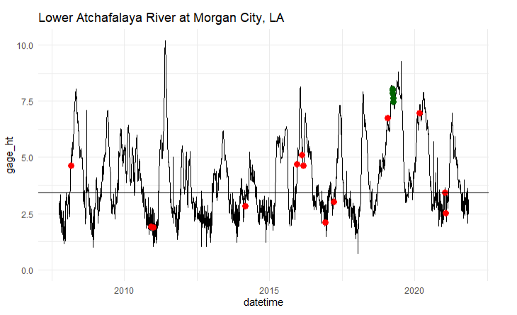
StartDate source gage_ht site_no
2019-04-10 Lidar 7.5 07381600
2019-04-15 Lidar 7.3 07381600
2019-04-16 Lidar 7.3 07381600
2019-04-20 Lidar 7.3 07381600
2019-04-21 Lidar 7.2 07381600
2019-04-22 Lidar 7.2 07381600
2019-04-23 Lidar 7.2 07381600
2019-04-26 Lidar 7.4 07381600

Blocks 2 & 5 (PR 2437)
16 May 2019 Little Corney Bayou near Lillie, LA https://waterdata.usgs.gov/nwis/uv?site_no=07366200
Above annual average – some areas may have been inundated depending on location and time of acquisition. Lidar returns should be inspected over potentially inundated areas.
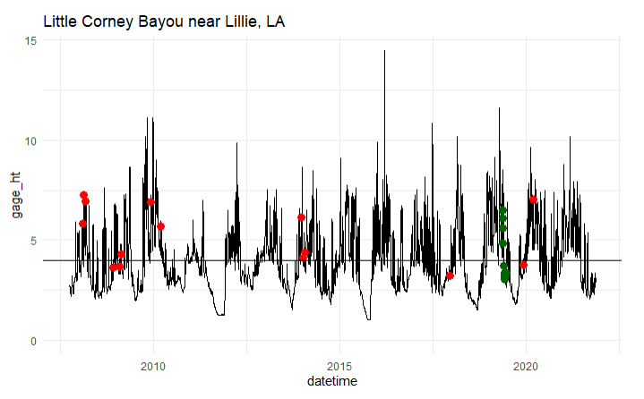
StartDate source gage_ht site_no
2019-05-14 Lidar 6.515625 07366200
2019-05-15 Lidar 6.080208 07366200
2019-05-16 Lidar 5.618750 07366200
2019-05-17 Lidar 4.852083 07366200
2019-05-27 Lidar 3.695208 07366200
2019-05-29 Lidar 3.372708 07366200
2019-06-01 Lidar 3.232292 07366200
2019-06-02 Lidar 3.168958 07366200
2019-06-03 Lidar 3.039583 07366200
2019-06-11 Lidar 3.176458 07366200
2019-06-19 Lidar 3.364375 07366200
15 May 2019
Saline Bayou near Lucky, LA https://waterdata.usgs.gov/nwis/uv?site_no=07352000
Above annual average – some areas may have been inundated depending on location and time of acquisition. Lidar returns should be inspected over potentially inundated areas.
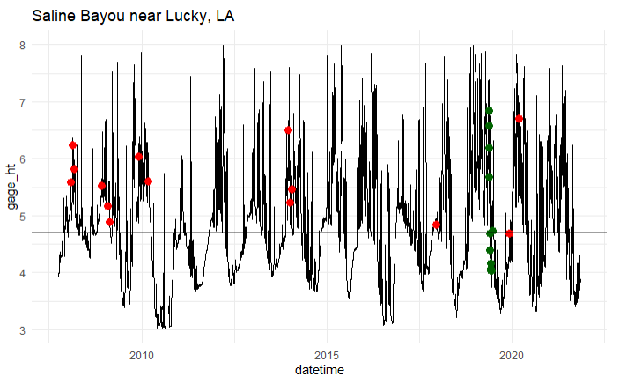
StartDate source gage_ht site_no
2019-05-14 Lidar 6.848750 07352000
2019-05-15 Lidar 6.583750 07352000
2019-05-16 Lidar 6.187292 07352000
2019-05-17 Lidar 5.680208 07352000
2019-05-27 Lidar 4.684583 07352000
2019-05-29 Lidar 4.390625 07352000
2019-06-01 Lidar 4.155625 07352000
2019-06-02 Lidar 4.073125 07352000
2019-06-03 Lidar 4.039792 07352000
2019-06-11 Lidar 4.030625 07352000
2019-06-19 Lidar 4.728958 07352000
June 2019
Lake Claiborne near Aycock, LA https://waterdata.usgs.gov/nwis/uv?site_no=07364840
Reservoir gage - so this data is of limited use
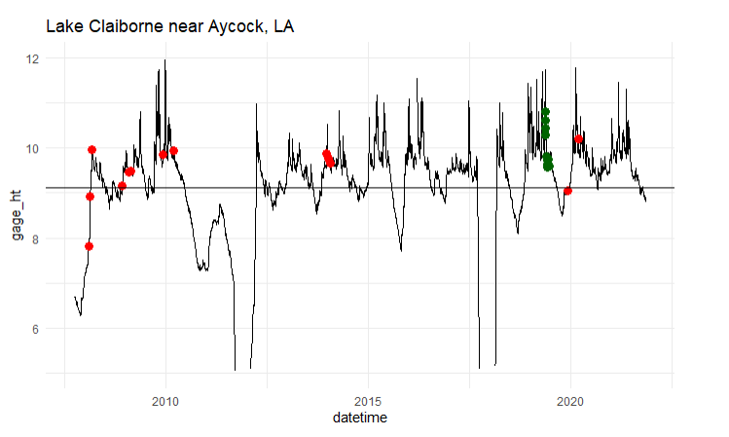
StartDate source gage_ht site_no
2019-05-14 Lidar 10.820000 07364840
2019-05-15 Lidar 10.611458 07364840
2019-05-16 Lidar 10.442083 07364840
2019-05-17 Lidar 10.296875 07364840
2019-05-27 Lidar 9.812083 07364840
2019-05-29 Lidar 9.723750 07364840
2019-06-01 Lidar 9.633958 07364840
2019-06-02 Lidar 9.601458 07364840
2019-06-03 Lidar 9.573542 07364840
2019-06-11 Lidar 9.753333 07364840
2019-06-19 Lidar 9.591458 07364840

Block 3
October 2019
3.1: Bayou Dorcheat near Minden, LA https://waterdata.usgs.gov/monitoring-location/07349000
Data were collected over the gaging station in October which is typically low water. Lidar is likely to be fine, but returns should be inspected over potentially inundated areas to be certain.
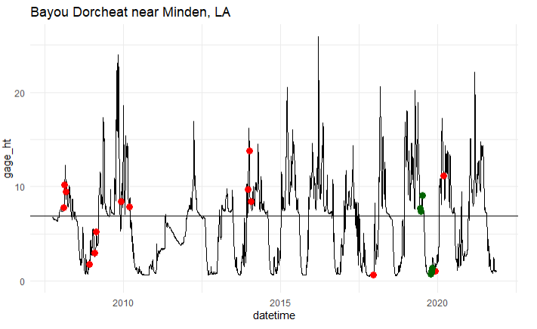
StartDate source gage_ht site_no
2019-06-11 Lidar 7.6987500 07349000
2019-06-12 Lidar 7.6800000 07349000
2019-06-19 Lidar 7.3852083 07349000
2019-07-03 Lidar 9.0312500 07349000
2019-10-12 Lidar 0.7222917 07349000
2019-10-16 Lidar 0.8891667 07349000
2019-10-17 Lidar 0.9993750 07349000
2019-10-18 Lidar 0.9004167 07349000
2019-10-19 Lidar 0.9162500 07349000
2019-10-23 Lidar 1.0187500 07349000
2019-10-24 Lidar 1.3833333 07349000
October 2019
3.2: Bayou Dorcheat near Springhill, LA https://waterdata.usgs.gov/nwis/uv?site_no=07348700
Lidar is likely to be fine, but returns should be inspected over potentially inundated areas to be certain.
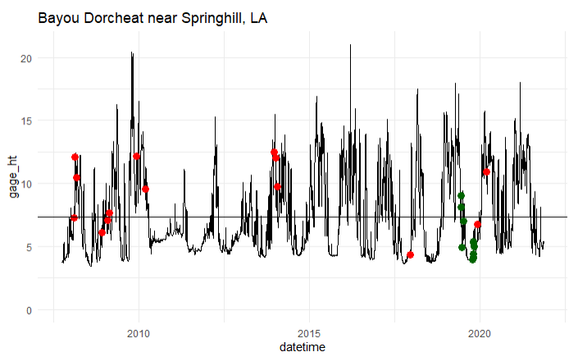
StartDate source gage_ht site_no
2019-06-11 Lidar 9.020333 07348700
2019-06-12 Lidar 8.107188 07348700
2019-06-19 Lidar 4.969583 07348700
2019-07-03 Lidar 7.029271 07348700
2019-10-12 Lidar 3.988958 07348700
2019-10-16 Lidar 4.386042 07348700
2019-10-17 Lidar 4.143021 07348700
2019-10-18 Lidar 4.082396 07348700
2019-10-19 Lidar 5.317604 07348700
2019-10-23 Lidar 5.389896 07348700
2019-10-24 Lidar 4.984167 07348700
11 June 2019
3.3: Bodcau Bayou near Sarepta, LA https://waterdata.usgs.gov/nwis/uv?site_no=07349500
Higher than annual average - Lidar returns should be inspected over potentially inundated areas.
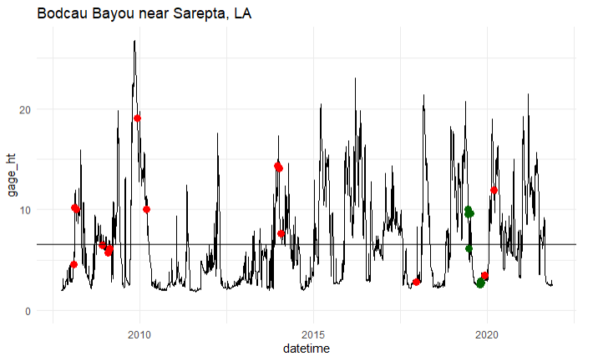
StartDate source gage_ht site_no
2019-06-11 Lidar 10.005625 07349500
2019-06-12 Lidar 9.493542 07349500
2019-06-19 Lidar 6.130625 07349500
2019-07-03 Lidar 9.634375 07349500
2019-10-12 Lidar 2.540000 07349500
2019-10-16 Lidar 2.903542 07349500
2019-10-17 Lidar 2.778333 07349500
2019-10-18 Lidar 2.673958 07349500
2019-10-19 Lidar 2.590625 07349500
2019-10-23 Lidar 2.786667 07349500
2019-10-24 Lidar 2.691042 07349500
3.4: Bodcau Bayou near Springhill, LA https://waterdata.usgs.gov/nwis/uv?site_no=07349450
At annual average - Lidar is likely to be fine, but returns should be inspected over potentially inundated areas to be certain.
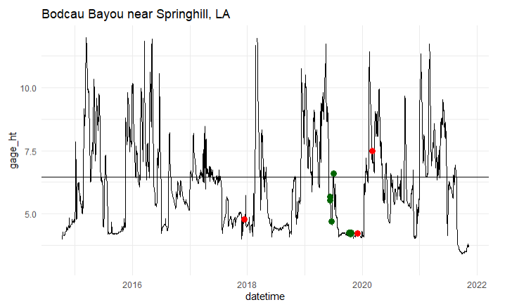
StartDate source gage_ht site_no
2019-06-11 Lidar 5.686667 07349450
2019-06-12 Lidar 5.525208 07349450
2019-06-19 Lidar 4.708125 07349450
2019-07-03 Lidar 6.599687 07349450
2019-10-12 Lidar 4.243333 07349450
2019-10-16 Lidar 4.247708 07349450
2019-10-17 Lidar 4.208229 07349450
2019-10-18 Lidar 4.207604 07349450
2019-10-19 Lidar 4.203021 07349450
2019-10-23 Lidar 4.240208 07349450
2019-10-24 Lidar 4.225521 07349450

Block 4
2019-05-16
Little Corney Bayou near Lillie, LA - No better stations for this Block – need to look at the lidar data to determine potential inundation at TOA - https://waterdata.usgs.gov/nwis/uv?site_no=07366200
Higher than average for that date and coming down off a large peak - Lidar returns should be inspected over potentially inundated areas.
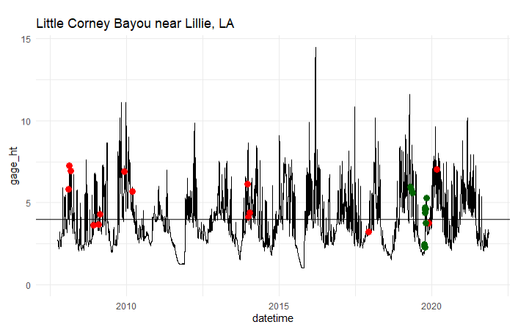
StartDate source gage_ht site_no
2019-04-26 Lidar 5.974167 07366200
2019-04-27 Lidar 5.843333 07366200
2019-05-16 Lidar 5.618750 07366200
2019-10-05 Lidar 2.473750 07366200
2019-10-08 Lidar 2.312917 07366200
2019-10-12 Lidar 2.273125 07366200
2019-10-16 Lidar 4.365208 07366200
2019-10-17 Lidar 4.698750 07366200
2019-10-18 Lidar 4.579583 07366200
2019-10-19 Lidar 4.611875 07366200
2019-10-22 Lidar 3.778750 07366200
2019-11-01 Lidar 5.276667 07366200

Block 6
Way too high. Atchafalaya River and Mississippi Rivers
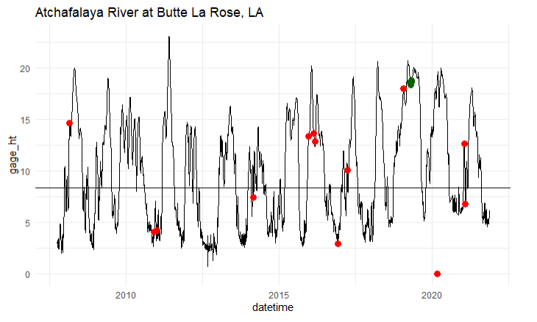
StartDate source gage_ht site_no
2019-04-10 Lidar 18.57740 07381515
2019-04-15 Lidar 18.39500 07381515
2019-04-16 Lidar 18.35385 07381515
2019-04-20 Lidar 18.60125 07381515
2019-04-21 Lidar 18.59448 07381515
2019-04-22 Lidar 18.59677 07381515
2019-04-23 Lidar 18.62344 07381515
2019-04-26 Lidar 18.79437 07381515

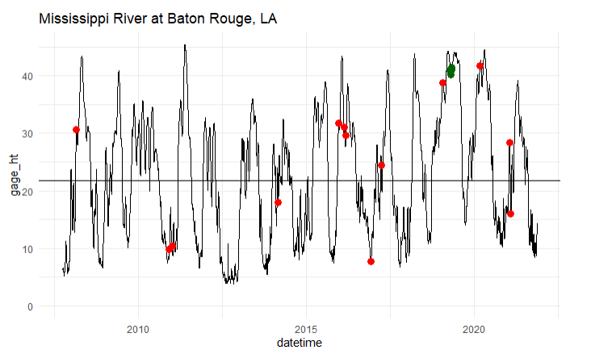
StartDate | source | gage_ht | site_no
2019-04-10 | Lidar | 40.82844 | 07374000
2019-04-15 | Lidar | 40.22333 | 07374000
2019-04-16 | Lidar | 40.15990 | 07374000
2019-04-20 | Lidar | 40.79000 | 07374000
2019-04-21 | Lidar | 40.88792 | 07374000
2019-04-22 | Lidar | 40.92437 | 07374000
2019-04-23 | Lidar | 41.03598 | 07374000
2019-04-26 | Lidar | 41.48271 | 07374000

Allen, Y. (2016) Landscape Scale Assessment of Floodplain Inundation Frequency Using Landsat Imagery. River Res. Applic., 32: 1609– 1620. doi: 10.1002/rra.2987.

