Michigan LiDAR 2015
LiDAR Campaign Report
February 21, 2016

EXECUTIVE SUMMARY
The State of Michigan (DTMB) contracted with Sanborn to provide LiDAR mapping services for 13 counties in the State of Michigan. These counties include Alger, Allegan, Baraga, Benzie, Berrien, Delta, Emmet, Grand Traverse, Leelanau, Mackinac, Manistee, Marquette, and Van Buren. Utilizing multi-return systems, Light Detection and Ranging (LiDAR) data in the form of 3-dimensional positions of a dense set of mass points was collected for the 13 counties beginning in December 2014 through Fall 2015. All systems consist of geodetic GPS positioning, orientation derived from high-end inertial sensors and highly-accurate lasers. The sensor is mounted inside an aircraft and emits rapid pulses of light, through an opening in the fuselage, that are used to determine distances between the plane and terrain below.
The Leica ALS70-HP (Sanborn) and ALS80-HP (subcontractor) were used to collect data for the survey campaign. The LiDAR systems are calibrated by conducting flight passes over a known ground surface before and after each LiDAR mission. During final data processing, the calibration parameters are inserted into post-processing software.
Multiple airborne GPS (Global Positioning System) base stations were used in the Michigan LiDAR 2015 Project. These base stations were provided by Sanborn and subcontractors.
The acquired LiDAR data was processed to all return point data. The last return data was further filtered to yield a LiDAR surface representing the bare earth.
The contents of this report summarize the methods used to establish the base station coordinate check, perform the LiDAR data collection and post-processing as well as the results of these methods.
Contents
1.0 INTRODUCTION 3
1.1 Contact Information 3
1.2 Purpose of the LiDAR Acquisition 3
1.3 Project Location 3
1.4 Standard Specifications for LiDAR 4
2.0 LiDAR CALIBRATION 4
2.1 Introduction 4
2.2 Calibration Procedures 4
2.3 Building Calibration 5
2.4 Runway Calibration, System Performance Validation 5
3.0 RUNWAY CALIBRATION and SYSTEM PERFORMANCE VALIDATION 6
3.1 Calibration Results 6
4.0 LiDAR FLIGHT AND SYSTEM REPORT 7
4.1 Introduction 7
4.2 Field Work Procedures 7
4.3 Final LiDAR Processing 8
4.4 Product Generation For QL2 LiDAR 9
5.0 Accuracy Assessment 10
5.1 Final LiDAR Verification 10
6.0 Coordinates and Datum 11
6.1 Introduction 11
6.2 Horizontal Datum 11
6.3 Vertical Datum 11

List of Tables

Table 1: LiDAR Leica Acquisition Parameters 7
Table 2: Collection Date, Time, Average Flight Collection Parameters and PDOP (Sanborn 2014 Collection Only) 8
Table 3: Processing Accuracies and Requirements 10

List of Figures
Figure 1: Area of Collection 3
Figure 2: Calibration Pass 1 5
Figure 3: Calibration Pass 2 5
Figure 4: Runway Calibration 5
Figure 5: Runway Calibration Results 6

1.0 INTRODUCTION

This document contains the technical write-up of the LiDAR campaign, including system calibration techniques, the establishment and processing of base stations, and the collection and post-processing of the LiDAR data.

1.1 Contact Information
Questions regarding the technical aspects of this report should be addressed to:

Shawn Benham
Project Manager
Sanborn Map Co., Inc.
1935 Jamboree Drive, Suite 100
Colorado Springs, CO
719.502.1296
sbenham@sanborn.com

1.2 Purpose of the LiDAR Acquisition
As stated in the Statement of Work for Acquisition and Production of High Resolution Elevation data for the State of Michigan, this LiDAR operation was designed to create high resolution data sets that will establish an authoritative source for elevation information for the State of Michigan.

1.3 Project Location
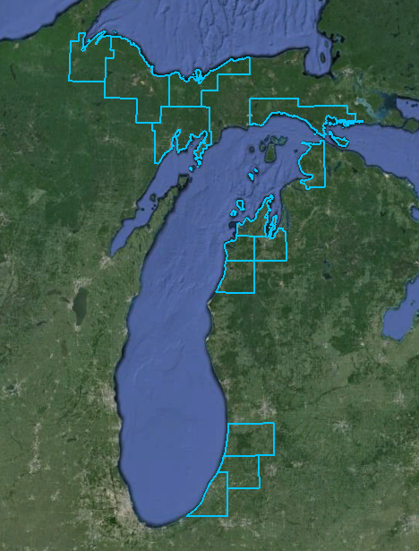

Figure 1: Area of Collection

1.4 Standard Specifications for LiDAR
Acquisition
Requirement | Description
Returns per pulse | LiDAR sensor shall be capable of recording up to 4 (or more) returns per pulse, including 1st and last returns
Scan angle | ≤ ±20 degrees
Swath overlap | 30%
Design pulse density | 2 points per meter
GPS procedures | At least 2 GPS reference stations in operation during all missions, sampling positions at 1 Hz or higher frequently. Differential GPS baseline lengths shall not exceed 30 km. Differential GPS unit in aircraft shall sample position at 2 Hz or higher. LiDAR data shall only be acquired when GPS PDOP is ≤ 3.5 and at least 6 satellites are in view.
Coverage | No voids between Swaths or due to cloud cover or instrument failure

2.0 LiDAR CALIBRATION

2.1 Introduction
LiDAR calibrations are performed to determine and therefore eliminate systematic biases that occur within the hardware of the Leica ALS70 system. Once the biases are determined they can be modeled out. The systematic biases are corrected for include scale, roll, heading, and pitch.
The following procedures are intended to prevent operational errors in the field and office work, and are designed to detect inconsistencies. The emphasis is not only on the quality control (QC) aspects, but also on the documentation, i.e., on the quality assurance (QA).

2.2 Calibration Procedures
Sanborn performs two types of calibrations on its LiDAR system. The first is a building calibration, and it is done any time the LiDAR system has been moved from one plane to another. New calibration parameters are computed and compared with previous calibration runs. If there is any change, the new values are updated internally or during the LiDAR post-processing. These values are applied to all data collected with the plane and the ALS70 system configurations.
Once final processing calibration parameters are established from the building data, a precisely-surveyed surface is observed with the LiDAR system to check for stability in the system. This is done several times during each mission. An average of the systematic biases are applied on a per mission basis.

2.3 Building Calibration
Whenever the ALS70 system is moved to a new aircraft, a building calibration is performed. The rooftop of a large, flat, rectangular building is surveyed on the ground using conventional survey methods, and used as the LiDAR calibration target. The aircraft flies several specified passes over the building with the ALS70 system set first in scan mode, then in profile mode, and finally in both scan and profile modes with the scan angle set to zero degrees.
Figure 2 shows a pass over the center of the building. The purpose of this pass is to identify a systematic bias in the scale of the system.
Figure 3 demonstrates a pass along a distinct edge of the building to verify the roll compensation performed by the Inertial Navigation System, INS.
Additionally, a pass is made in profile mode across the middle of the building to compensate for any bias in pitch.
Figure 2: Calibration Pass 1 | 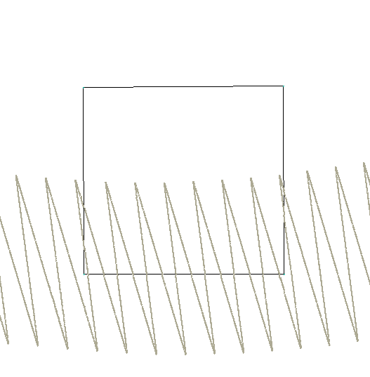  Figure 3: Calibration Pass 2

2.4 Runway Calibration, System Performance Validation
Active runways were precisely surveyed throughout the collection areas using kinematic GPS survey techniques (accuracy: ±3cm at 1σ, along each coordinate axis) to establish an accurate digital terrain model of the runway surface. The LiDAR system is flown at right angles over the runway several times and residuals are generated from the processed data. Figure 4 shows a typical pass over the runway surface.
Approximately two million LiDAR points are observed with each pass. A Triangulated Irregular Network (TIN) surface is created from these passes. After careful analysis of noise associated with non-runway returns, any system bias is documented and removed from the process.
Figure 4: Runway Calibration

3.0 RUNWAY CALIBRATION and SYSTEM PERFORMANCE VALIDATION

3.1 Calibration Results
The LiDAR data captured over the building is used to determine whether there have been any changes to the alignment of the Inertial Measurement Unit, IMU, with respect to the laser system. The parameters are designed to eliminate systematic biases within certain system parameters.
The runway over-flights are intended to be a quality check on the calibration and to identify any system irregularities and the overall noise. IMU misalignments and internal system calibration parameters are verified by comparing the collected LiDAR points with the runway surface.
Figure 5 shows the typical results of a runway over-flight analysis. The X-axis represents the position along the runway. The overall statistics from this analysis provides evidence of the overall random noise in the data (typically, 7 cm standard deviation – an unbiased estimator, and 4 cm RMS which includes any biases) and indicates that the system is performing within specifications. As described in later sections of this report, this analysis will identify any peculiarities within the data along with mirror-angle scale errors (identified as a “smile” or “frown” in the data band) or roll biases.
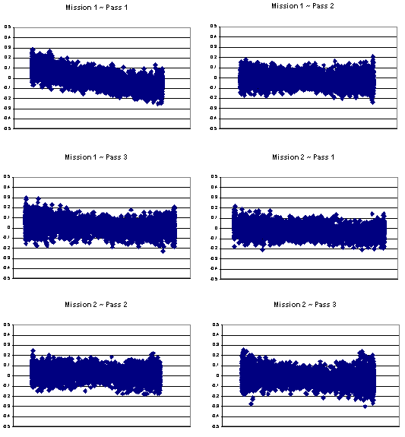
A z bump adjustment was made to the entire data set based on the survey points in the project area and the relative accuracy of the data to itself and in all areas.

Figure 5: Runway Calibration Results

4.0 LiDAR FLIGHT AND SYSTEM REPORT

4.1 Introduction
This section addresses LiDAR system, flight reporting and data acquisition methodology used during the collection of the Michigan LiDAR 2015 campaign. Although Sanborn conducts all LiDAR with the same rigorous and strict procedures and processes, all LiDAR collections are unique.

4.2 Field Work Procedures
Pre-flight checks such as cleaning the sensor head glass are performed. A four minute INS initialization is conducted on the ground, with the engines running, prior to flight, to establish fine-alignment of the INS. GPS ambiguities are resolved by flying within ten kilometers of the base stations.

The flight missions were about 2-5 hours in duration including runway calibration flights flown at the beginning and the end of each mission. During the data collection, the operator recorded information on log sheets which includes weather conditions, LiDAR operation parameters, and flight line statistics. Near the end of the mission GPS ambiguities are again resolved by flying within ten kilometers of the base stations, to aid in post-processing.

Table 1 shows an example of planned LiDAR acquisition parameters with a flying height of 2400 meters above ground level (AGL) for the Leica ALS70 on a mission to mission basis.

Table 1: LiDAR Leica Acquisition Parameters

Average Altitude | 2400 Meters AGL
Airspeed | ~130 Knots
Scan Frequency | 33.0 Hertz
Scan Width Half Angle | 20 Degrees
Pulse Rate | 244000 Hertz

Preliminary data processing was performed in the field immediately following the missions for quality control of GPS data and to ensure sufficient overlap between flight lines. Any problematic data could then be re-flown immediately as required. Final data processing was completed in the Colorado Springs office.

Table 2: Collection Date, Time, Average Flight Collection Parameters and PDOP (Sanborn 2014 Collection Only)

Mission | Date | Sensor  SN (1 or 2) | Start Time | End Time | Altitude (m) | Airspeed (Knots) | Scan Angle | Scan Rate | Pulse  Rate | PDOP
1 | Dec 6b | ALS70-HP | 8:14 | 12:25 | 2400 | 130 | 20˚ | 33.0 | 244000 | 1.1
2 | Dec 7a | ALS70-HP | 3:01 | 6:51 | 2400 | 130 | 20˚ | 33.0 | 240000 | 1.2
3 | Dec 7b | ALS70-HP | 1:28 | 5:33 | 2400 | 130 | 20˚ | 33.0 | 240000 | 1.3
4 | Dec 7c | ALS70-HP | 8:06 | 12:55 | 2400 | 130 | 20˚ | 33.0 | 240000 | 1.2
5 | Dec 8 | ALS70-HP | 7:20 | 10:08 | 2400 | 130 | 20˚ | 33.0 | 244000 | 1.2
6 | Dec 10 | ALS70-HP | 10:26 | 2:34 | 2400 | 130 | 20˚ | 33.0 | 244000 | 1.1
7 | Dec 11 | ALS70-HP | 4:30 | 5:32 | 2400 | 130 | 20˚ | 33.0 | 244000 | 1.1
8 | Dec 23 | ALS70-HP | 4:09 | 5:55 | 2400 | 130 | 20˚ | 33.0 | 244000 | 1.2

4.3 Final LiDAR Processing
Final post-processing of LiDAR data involves several steps. The airborne GPS/IMU data was post-processed using Leica’s Inertial Explorer software to create an *.sol file.
The solution file (*.sol) and refined attitude data are then re-introduced into the Leica CloudPro post processor for the Leica system to compute the laser point-positions. The trajectory is then combined with the attitude data and laser range measurements to produce the 3-dimensional coordinates of the mass points.

All return values are produced within Leica CloudPro processing software for the Leica system. The multi-return information is processed to obtain the “Bare Earth Dataset” as a deliverable. All LiDAR data is processed using the binary LAS format 1.2 file format.

LiDAR filtering was accomplished using GeoCue, TerraSolid, TerraScan LiDAR processing and modeling software. The filtering process reclassifies all the data into classes with in the LAS formatted file based scheme set using the LAS format 1.2 specifications or by the client. Once the data is classified, the entire data set is reviewed and manually edited for anomalies that are outside the required guidelines of the product specification.

The coordinate and datum transformations are then applied to the data set to reflect the required deliverable projection, coordinate and datum systems as provided in the contract. Then the counties were adjusted to the control points collected by Sanborn and a subcontractor.

The client required deliverables are then generated. At this time, a final QC process is undertaken to validate all deliverables for the project. Prior to release of data for delivery, Sanborn’s Quality control/quality assurance department reviews the data and then releases it for delivery.

4.4 Product Generation For QL2 LiDAR
The following products, along with the All Returns LiDAR, were generated using the final coordinate system as defined in the contract, and provided in section 5.0 of this report.

Raw Point Cloud
After the FVA checkpoint report is generated, the swaths are solely filtered to Unprocessed and delivered in LAS format V1.2.

Bare Earth DEM
Digital Elevation Models (or DEMs) were created on a tile-by-tile bases conforming to the clients specifications. The DEMs consist of using interpolated ground points in floating point 32 Bit IMAGINE Image format with a cell size of 2 feet and hydro-flattened using the collected breaklines. Pyramids were then created using the resampling of Nearest Neighbor.

Breaklines
The breaklines were digitized using LP360- an advanced LiDAR processing and modeling software extension of ArcGIS. 3D polygons were digitized for all standing water bodies as to hydro-flattening contract specifications. Each water body and river was collected based upon surface conditions at the time of acquisition. Delivery format consisted of shape file format (.shp).

Intensity Images
Intensity Images were created from the reflected intensity values in the LAS processed LiDAR dataset in GeoTIFF (.tif) format. Each pixel contains an intensity value interpolated from the LiDAR. Interpolation method was used during the rasterization process for determining the intensity values and to create an unsigned integer 8 Bit TIFF format with a pixel size of 2 feet.

Metadata
The project, Area, and tile-level metadata files were created using XML format and follows FGDC requirements. All metadata must passes the USGS metadata parser without errors.

Other Deliverables
- Control/Checkpoint points (.shp)
- Project tiling geometry/Boundary
- Accuracy assessment of each County (.xlsx)

A final QC process was undertaken to validate all deliverables for the project. Prior to release of data for delivery, Sanborn’s Quality control/quality assurance department reviews the data and then releases it for delivery.

5.0 Accuracy Assessment

5.1 Final LiDAR Verification
The LiDAR data was evaluated using a collection of GPS surveyed checkpoints which were provided by Sanborn and a subcontractor. These checkpoints were evaluated against the LiDAR for each county resulting in a lower RMSE and standard deviation than the project required.

The control layout for the Michigan LiDAR 2015 project was designed in areas consisting of 2 to 4 counties each. Area 1 includes the counties of Baraga and Marquette. Area 2 includes Alger and Delta counties. Area 3 includes Mackinac and Emmet counties. Area 4 consists of Manistee, Benzie, Grand Traverse, and Leelanau counties. Area 5 includes Allegan, Van Buren, and Berrien counties.

Each county was evaluated using 3 different accuracy reports. The FVA (Fundamental Vertical Accuracy) report shows accuracy of the data when compared to Bare Earth points. The SVA (Supplemental Vertical Accuracy) report shows the accuracy of the data when compared to the checkpoint classes of Urban, Low Vegetation, Medium Vegetation, and High Vegetation. The CVA (Consolidated Vertical Accuracy) report shows the accuracy of the data when compared to all checkpoints. For more detailed information per county refer to the accuracy reports delivered with the LiDAR and other deliverables.

Table 3: Processing Accuracies and Requirements

FVA for Swath and DEM (95th percentile) | 24.5 cm
SVA for DEM (95th percentile) | 36.3 cm
CVA for DEM (95th percentile) | 36.3 cm

6.0 Coordinates and Datum

6.1 Introduction
The final adjustment was constrained to the published NAD83 (2011) coordinates (φ, λ) and North American Vertical Datum (NAVD88) elevations.

6.2 Horizontal Datum
The final horizontal coordinates are provided in State Plane Michigan (appropriate zone) on the North American Datum of 1983 (2011) with units of international feet.

6.3 Vertical Datum
The final orthometric elevations were determined for all points in the network using North American Vertical Datum (NAVD88) in units of international feet.

