New Topographic Data TSDN Project Narrative

Branch County, MI
March 2018

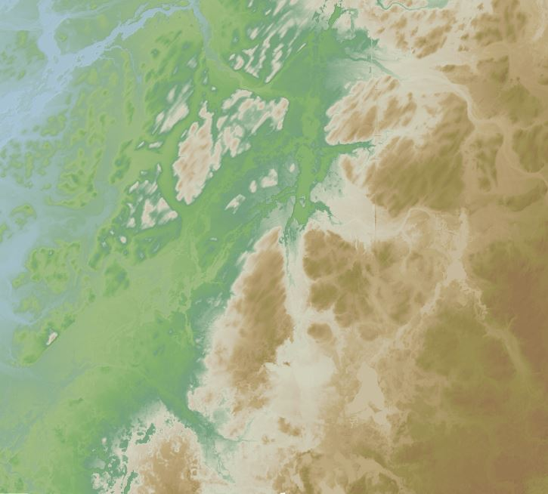

Federal Emergency Management Agency, Region V
Department of Homeland Security
536 South Clark Street
Chicago, IL 60605

Table of Contents

1.0 Introduction 1
2.0 Scope of Work 3
3.0 Issues 4
4.0 Information for the Next Mapping Partner 4
4.1 Vertical Accuracy 4
4.2 LiDAR Acquisition and Post Processing 5
4.3 Quality Assurance 5

1.0 Introduction
To support the Risk Mapping, Assessment, and Planning (Risk MAP) program FEMA has made a commitment to acquire high-resolution LiDAR elevation data. The incorporation of more accurate topography improves the precision and reliability of flood hazard data. This, in turn, improves the quality of Flood Insurance Rate Maps and Flood Risk Assessments so communities are able to make informed decisions to protect their citizens and become more resilient to flood related hazards.

The purpose of this elevation dataset is to provide the basis for riverine hydrologic and hydraulic modeling and flood risk product development in Branch County, Michigan.

LiDAR acquisition and post processing objectives for the Branch County, MI project are as follows:

- Satisfy USGS 3DEP requirements for Quality Level 2 elevation data
- ASPRS LAS 1.4 format with point data record 6
- Collect raw point cloud swaths that cover the entire project area
- Obtain an Aggregate Pulse Density (ANPD) of greater than 2 pulses per square meter
- Achieve an Aggregate Point Spacing (ANPS) of less than 0.71 meters or 2.32 feet
- Provide LAS files in tiled format with the following classifications
  - Class 1 = Processed but Unclassified
  - Class 2 = Bare Earth
  - Class 7 = Low Noise
  - Class 9 = Water
  - Class 10 = Ignored Ground (Near a Breakline)
  - Class 17 = Bridge Decks
  - Class 18 = High Noise
- Meet or exceed the Non-Vegetated Vertical Accuracy Requirements for Quality Level 2
  - Less than 10 centimeters RMSE_{Z}
  - Less than 19.6 centimeters at the 95% confidence level (Accuracy_{Z})
- Meet or exceed the Vegetated Vertical Accuracy Requirements for Quality Level 2
  - Less than 29.4 centimeters at the 95th percentile
- Create hydro-flattened Digital Elevation Models with Breaklines

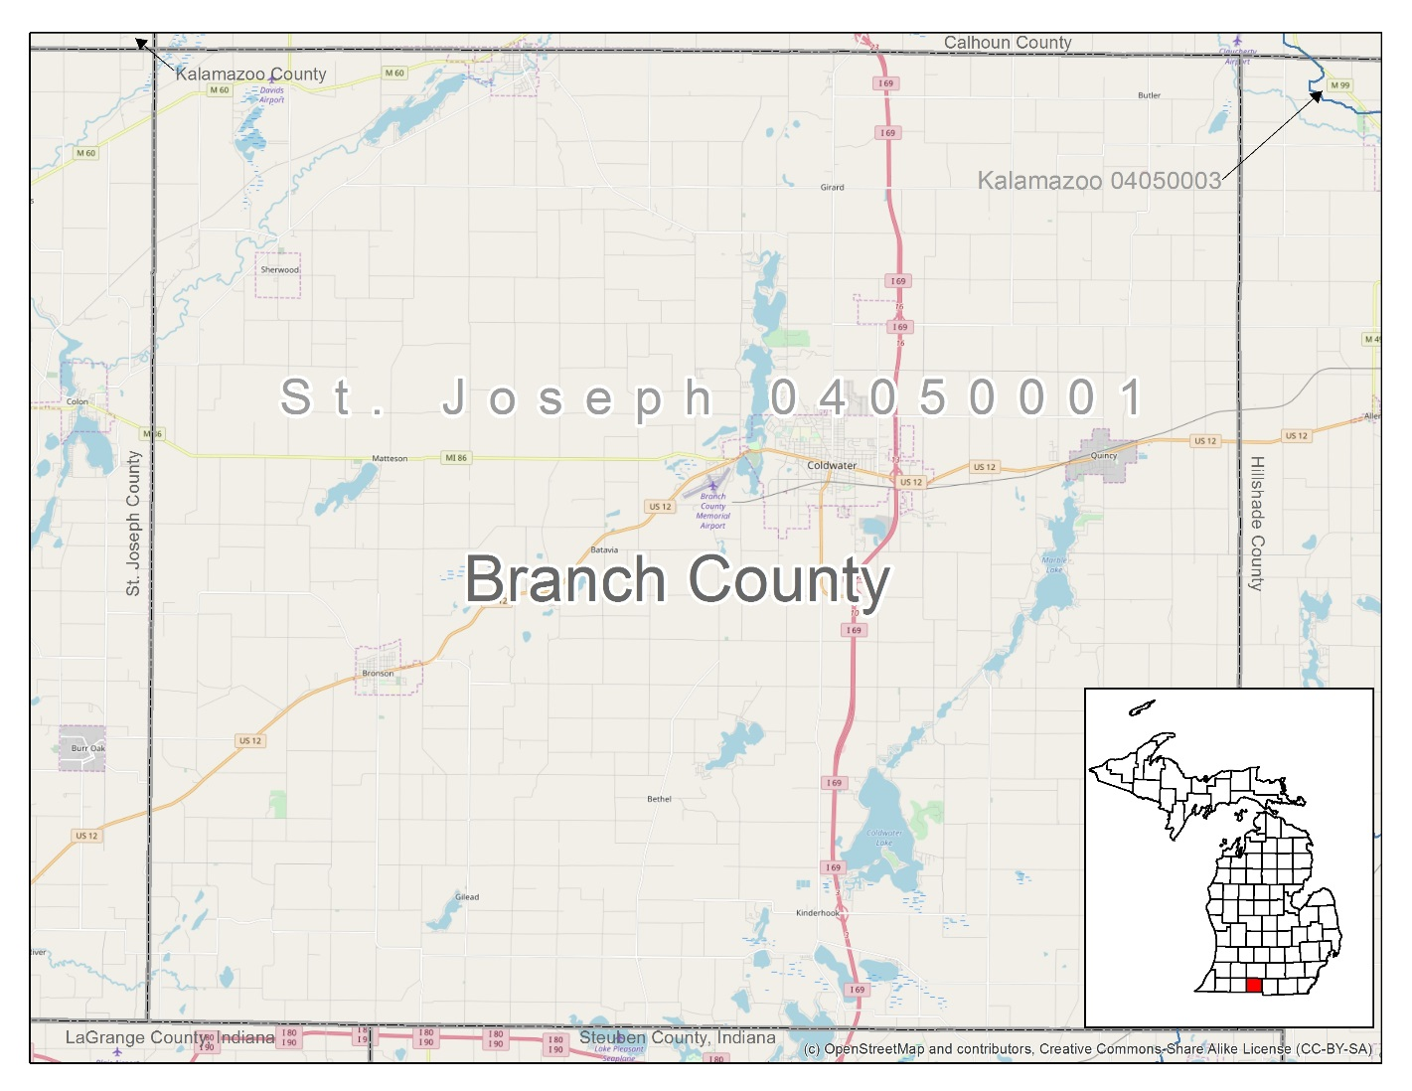
Figure 1. Branch County, Michigan Project Area

2.0 Scope of Work
Task order HSFE05-16-J-0207 requires STARR II to collect and process LiDAR data for the Branch County, MI area of interest, the scope of work is as follows:
Acquire and process 535 square miles of USGS defined Quality Level 2 LiDAR, collection of hydro-breaklines, and creation of Hydro-Flattened Digital Elevation Models.
Tasks include:
- Field Survey collection of 21 ground control points
- Field Survey collection of 37 NVA and 28 VVA vertical accuracy check points
- Aerial Acquisition of LiDAR data
- Calibration and processing LiDAR data to point cloud
- Post-processing point cloud to fully classified LAS data (including bare earth)
- Collection of breaklines for hydrographic features
- Creation of hydro-flattened DEMs
- Independent QA/QC including vertical accuracy testing and verification
  - Visual examination of 5% for unclassified raw point cloud tiles
  - Visual examination of 20% for classified point cloud tiles and Bare Earth DEMs

Activities completed under this task order will comply with the USGS LiDAR Base Specifications version 1.2 for quality level 2 data, ASPRS LAS version 1.4 requirements, and current FEMA Technical References and Guidance documents for elevation data.
Deliverables for this task are:
- Collection Report Including Mission Planning
- Survey Report Including Ground Control Precision and Absolute Vertical Accuracy Test Results
- Ground Control and Check Points Shapefiles
- Processing and QA/QC Reports
- Indices and Project Extent Shapefiles
- Metadata Files in XML Format
- Raw Point Cloud Swaths
- Tiled Classified Point Cloud
- 3D Breaklines
- Hydro-flattened DEMs
- FEMA Certificate of Completion, Terrain Metadata XML, and Project Narrative
- Project Independent QA/QC Report

Issues
None.

Information for the Next Mapping Partner
The Branch County, MI project covers the entire county. This project included LiDAR Acquisition, Post Processing, and LiDAR derived product development. Point cloud data is composed of LAS version 1.4 unclassified swaths and classified tiles. All data collected has the following spatial reference information:

Coordinate System: Michigan State Plane South, FIPS 2113
Linear units: International Feet
Horizontal Datum: North American Datum 1983 (2011)
Vertical Datum: North American Vertical Datum of 1988 (Geoid 12B)
Vertical units: International Feet

4.1 Vertical Accuracy
USGS Quality Level 2 Absolute Vertical Accuracy Requirements as published in the LiDAR Base Specifications version 1.2:

LiDAR Swath NVA Summary Statistics | Test Results (International Feet /Meter)
Number of Check Points | 37
Points with Swath Coverage and required accuracy | 37
Average Z Error | 0.04/0.01
Maximum Z Error | 0.27/0.08
Minimum Z Error | -0.22/-0.07
NVA RMSEz <= 10 cm | 0.108/0.033 PASS
NVA AccuracyZ <= 19.6 cm at 95% Confidence | 0.212/0.064 PASS

Bare Earth NVA Summary Statistics | Test Results (International Feet /Meter)
Number of Check Points | 37
Points with Swath Coverage and required accuracy | 37
Average Z Error | -0.04/-0.01
Maximum Z Error | 0.17/0.05
Minimum Z Error | -0.20/-0.06
NVA RMSEz <= 10 cm | 0.092/0.028 PASS
NVA AccuracyZ <= 19.6 cm at 95% Confidence | 0.180/0.055 PASS

Bare Earth VVA Summary Statistics | Test Results (International Feet /Meter)
Number of Check Points | 28
Points with Bare Earth Coverage | 28
Average Z Error | -0.01/0.00
Maximum Z Error | 0.38/0.12
Minimum Z Error | -0.98/-0.29
VVA at 95th Percentile <=29.4 cm | 0.251/0.077 PASS

4.2 LiDAR Acquisition and Post Processing
LiDAR was acquired between March 22, 2017 and April 24, 2017 and covers the total task order area of 535 square miles. This collection has a point density of approximately 2.5 points per square meter and point spacing of 0.64 meters. The classified LiDAR tiles are 5,000 x 5,000-foot and classified in accordance with the scope of work.

Code | Description
1 | Processed but not classified
2 | Bare Earth
7 | Low Noise
9 | Water
10 | Ignored Ground (near a breakline)
17 | Bridge Decks
18 | High Noise

Breaklines are created using the class 2 LiDAR. The bare earth surface model was then used to heads-up digitize 2D breaklines of inland streams and rivers with a 100-foot nominal width and Inland Ponds and Lakes of 2 acres or greater surface area. Elevation values were assigned to all Inland Ponds and Lakes, and Islands to create final 3D breaklines. Class 2 LiDAR in conjunction with the hydro breaklines were used to create the 2-foot Hydro-Flattened Raster DEMs.

4.3 Quality Assurance
Quality assurance for all elevation data delivered for this project has been completed based on the following specifications:
- USGS Lidar Base Specification Version 1.2, November 2014
- ASPRS LAS Specification Version 1.4 – R13 July 15, 2013
- ASPRS Positional Accuracy Standards for Digital Geospatial Data (Edition 1, Version 1.0. – November 2014)
- FEMA Data Capture Standards format for terrain deliverables May 2017

LiDAR elevation data created during this project are checked for compliance to the guidance and specifications before submittal to FEMA. Quality assurance results are incorporated into the New Topographic Data, Independent QAQC Report – Branch County MI included with this submission.
STARR II will provide deliverables to the FEMA Engineering Library via external hard drive. All supporting documentation (i.e., the content of the Task Documentation, Correspondence, and Spatial Files folders) has been uploaded to the MIP at this location:

J:/FY2017/17-05-1292S/Topographic - Branch County, MI - 1/New Topographic Data Capture - New Topographic Data Capture 26023C - 1

