FEMA Region V– Branch, MI

Ground Control Project Report for STARR II

Flyer: Continental Mapping

October 2017

Project Information

CDI Project Number: FSG5017

FEMA Task Order Number: HSFE05-16-J-0207

STARR II Project Number: 400000347

STARR II Partner Tracking No: CD S2 R05 16 T0207

WO Period of Performance: 9/30/16 – 3/31/2018

Task Code: R0501.12.G

Geographic Location: Branch, MI

Number of GCPs Requested: 80

Number of GCPs Collected: 86

Project Specifications

Precision (Horizontal/Vertical): CDI Quality 1 ≤ 6.5 cm H/V
Coordinate System: Michigan South
Datum: NAD83 (2011)
Altitude Reference: NAVD88 (Geoid12B)
Units: International Feet

Summary

The purpose of this project was to locate and survey ground control points (GCPs) in multiple areas of interest as defined by FEMA-supplied shape and kml files. The GCP coordinates are to be used to control the vertical aspect of all newly-flown LiDAR data during post-processing and subsequent deliverables creation. CompassData visited the project area, found suitable GCPs, and determined accurate coordinates for each GCP according to the customer’s specifications.

Area Specification and Request

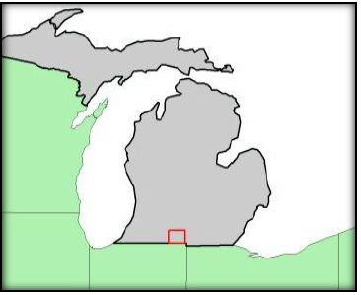
The Branch County AOI encompasses ~535 square miles (1384 square kilometers). The flyer has requested 21 ground control points for their processing. In adherence to the USGS v.1.2 quality level 2 requirements, an additional 65 checkpoints will be collected. These numbers are derived from the ASPRS recommended number of check points based on area for project areas between 1251-1500 sq.km. The division of these points will be 35 NVA points and 25 VVA points. Distribution will be determined through discussions with the flier and based on locations of different land classifications.

Equipment

CompassData used a Trimble R10 to perform the control survey. This device is accurate to within 1 cm on a position-by-position basis per Trimble specifications. Operating within the VRS network provided accurate coordinate values at or around 6.5 cm H/V. CompassData has consistently demonstrated this level of accuracy on many GCP collection jobs across North and South America, Europe, Asia and Africa. Specifications for the Trimble R10 are available upon request.

Survey Methodology

CompassData has met the required precision for this project by using a high-quality GPS receiver with differential corrections provided by a RTK and RTN network setup in the area. The GPS antenna used to survey the control and test points sat atop a bubble-leveled, fixed-height range pole that was placed over the center of the desired GCP. At least 180 positions (captured at a rate of one per second) were geometrically averaged to calculate a single coordinate for each GCP. All required field documentation was filled out and the points were identified on web-based imagery. Digital pictures of each GCP location were collected in the field.

Quality Control Procedures

CompassData collects GCPs with an unobstructed view of the sky to ensure proper GPS-operation. CompassData works to avoid potential sources of multipath error such as trees, buildings, and fences that may adversely affect the GPS accuracy. Additional quality control comes from the fact that at least 180 GPS positions are collected for each GCP. While operating within a RTN network, valid solutions are reached within seconds; however, we continue to collect additional data to ensure meeting collection specifications. To ensure project integrity, a GCP will be observed again or moved to a more suitable location if it does not meet project specifications.

In addition to the afore mentioned procedures, CompassData “surveys” existing geodetic control monuments to see if our coordinates match the published coordinates to the required accuracy. These monuments are usually established by the National Geodetic Survey (NGS) in the United States. If it is found that our coordinates are outside the acceptable accuracy, the reason for the difference will be found or the GCPs will be observed again under different GPS constellation constraints. There are certain geodetic considerations that must be taken in account that affect whether a GPS-derived coordinate will line up with a survey monument, especially when these monuments reference local coordinate systems or the systems of another country. Sometimes the published coordinates for a monument are not accurate, although this is very infrequent.

Deliverables

Deliverables for this project include:

- Coordinates (in spreadsheet format)
- Digital Pictures
- QA/QC Data

Project Notes

All collected points were retrieved from the Trimble Survey Controller and processed with the Trimble Business Center software. The GPS survey is producing in this step heights above ellipsoid (HAEs).

Geoid12B was then used to generate the geoid separation at every Lat/Long location. NAVD88 orthometric heights were then generated in spreadsheet form using the formula HAE - Geoid = Orthometric Height. Those values were then included into the final delivery coordinate CSV files and have been tested against NGS monuments collected during this survey and are showing millimeter-level agreement.

The Horizontal and Vertical accuracies reported in the Final Coordinates file were obtained from field measurements and post-processing. The report contains all points collected during each daily survey deployment, including NVA, VVA and Ground Control.
Area with Ground Control Points

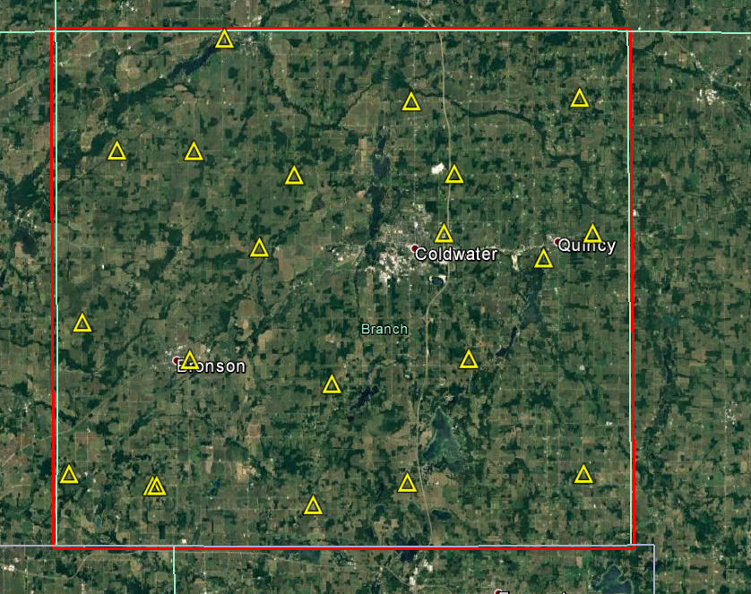

Area with NVA and VVA Test Points
Blue Squares – NVA Test Points
Yellow Circles – VVA Brush
Red Circles – VVA Crop
Green Trees – VVA Forest

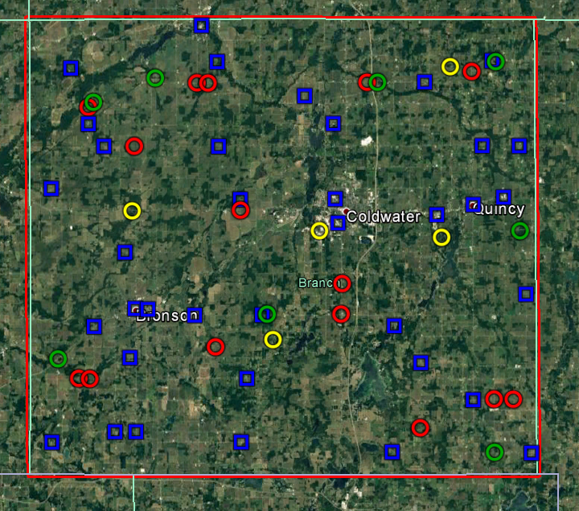

Results of NVA

Point ID | Easting  Int. Survey Feet | Northing  Int. Survey Feet | NAVD88 MSL Int. Survey Feet | LiDAR Elevation  Int. Survey Feet |  | Δ Z  Int. Survey Feet | Δ Z²
NVA200 | 12876383.286 | 103986.712 | 916.657 | 916.660 |  | -0.003 | 0.000
NVA201 | 12923972.658 | 103650.275 | 961.027 | 961.080 |  | -0.053 | 0.003
NVA202 | 12961896.662 | 100875.637 | 1030.269 | 1030.180 |  | 0.089 | 0.008
NVA203 | 12996916.495 | 100332.600 | 1090.066 | 1089.990 |  | 0.076 | 0.006
NVA204 | 12887240.214 | 132880.567 | 908.667 | 908.640 |  | 0.027 | 0.001
NVA205 | 12912562.023 | 135510.135 | 931.662 | 931.390 |  | 0.272 | 0.074
NVA206 | 12929532.543 | 135449.555 | 1006.519 | 1006.470 |  | 0.049 | 0.002
NVA207 | 12962709.099 | 132430.175 | 991.210 | 991.220 |  | -0.010 | 0.000
NVA208 | 12995878.939 | 140105.916 | 1066.659 | 1066.470 |  | 0.189 | 0.036
NVA209 | 12924246.685 | 164372.487 | 939.450 | 939.350 |  | 0.100 | 0.010
NVA210 | 12973618.156 | 160161.765 | 1016.469 | 1016.400 |  | 0.069 | 0.005
NVA211 | 12990419.761 | 164393.248 | 1012.444 | 1012.440 |  | 0.004 | 0.000
NVA212 | 12994461.658 | 177213.195 | 1060.511 | 1060.450 |  | 0.061 | 0.004
NVA213 | 12985162.981 | 177330.241 | 1005.871 | 1005.880 |  | -0.009 | 0.000
NVA214A | 12970821.879 | 193363.426 | 974.758 | 974.640 |  | 0.118 | 0.014
NVA215 | 12925559.243 | 119562.805 | 981.755 | 981.810 |  | -0.055 | 0.003
NVA216 | 12890096.088 | 177989.001 | 913.111 | 912.970 |  | 0.141 | 0.020
NVA217A | 12897551.408 | 106465.844 | 946.868 | 946.850 |  | 0.018 | 0.000
NVA218 | 12896186.470 | 125018.011 | 913.210 | 913.200 |  | 0.010 | 0.000
NVA219 | 12969292.875 | 123159.906 | 1011.283 | 1011.500 |  | -0.217 | 0.047
NVA220A | 12982380.062 | 113765.874 | 1051.466 | 1051.390 |  | 0.076 | 0.006
NVA221 | 12987811.035 | 198587.862 | 995.702 | 995.450 |  | 0.252 | 0.064
NVA222 | 12947760.994 | 183177.095 | 967.918 | 967.800 |  | 0.118 | 0.014
NVA223 | 12940646.477 | 190153.669 | 935.470 | 935.370 |  | 0.100 | 0.010
NVA224 | 12918729.805 | 198876.052 | 932.171 | 932.090 |  | 0.081 | 0.007
NVA225 | 12918907.401 | 177691.470 | 984.847 | 984.780 |  | 0.067 | 0.004
NVA226 | 12881902.491 | 197577.014 | 853.680 | 853.620 |  | 0.060 | 0.004
NVA227 | 12895178.882 | 151386.266 | 932.042 | 932.020 |  | 0.022 | 0.000
NVA228 | 12876752.612 | 167496.031 | 907.728 | 907.570 |  | 0.158 | 0.025
NVA250 | 12892302.647 | 106491.522 | 931.455 | 931.490 |  | -0.035 | 0.001
NVA400 | 12897591.004 | 137292.868 | 913.271 | 913.460 |  | -0.189 | 0.036
NVA401A | 12900823.349 | 137093.445 | 914.931 | 915.010 |  | -0.079 | 0.006
NVA402 | 12886256.992 | 183605.454 | 879.850 | 879.900 |  | -0.050 | 0.002
NVA403 | 12948088.555 | 164307.270 | 957.830 | 957.880 |  | -0.050 | 0.002
NVA404 | 12948765.993 | 158278.767 | 965.361 | 965.280 |  | 0.081 | 0.007
NVA405 | 12982788.052 | 162625.670 | 1018.670 | 1018.620 |  | 0.050 | 0.002
NVA406 | 12914856.349 | 208018.849 | 908.844 | 908.800 |  | 0.044 | 0.002
Datum: NAD83(2011) |  | Summary is in International Feet |  |  | International Feet |  | Meters
Epoch: 2010 |  | Z Mean | 0.04 | RMSE: | 0.109 |  | 0.033
Geoid: 12B |  | Z Min: | -0.22 | * 1.9600 | 0.213 |  | 0.065
State Plane: Michigan South |  | Z Max: | 0.27
Units: International Feet

Results of VVA

Point ID | Easting  Int. Survey Feet | Northing  Int. Survey Feet | NAVD88 MSL Int. Survey Feet | LiDAR Elevation  Int. Survey Feet | Δ Z  Int. Survey Feet |  | ΔZ²
VVA501 | 12932220.094 | 129176.605 | 1003.646 | 1003.450 | 0.196 |  | 0.038
VVA502 | 12897085.975 | 161681.897 | 888.236 | 888.470 | -0.234 |  | 0.055
VVA503 | 12944128.309 | 156315.350 | 967.094 | 967.000 | 0.094 |  | 0.009
VVA504 | 12969067.210 | 106791.275 | 1050.690 | 1050.720 | -0.030 |  | 0.001
VVA505A | 12886087.185 | 119730.726 | 894.099 | 894.330 | -0.231 |  | 0.053
VVA506 | 12977325.516 | 197113.089 | 993.666 | 993.720 | -0.054 |  | 0.003
VVA507 | 12974805.301 | 154440.210 | 982.845 | 983.820 | -0.975 |  | 0.951
VVA800 | 12992502.505 | 113750.136 | 1046.190 | 1045.950 | 0.240 |  | 0.058
VVA801A | 12917774.409 | 127485.390 | 944.911 | 944.940 | -0.029 |  | 0.001
VVA802A | 12883330.302 | 119876.022 | 896.284 | 896.290 | -0.006 |  | 0.000
VVA803 | 12886274.235 | 187696.376 | 870.406 | 870.330 | 0.076 |  | 0.006
VVA804 | 12924320.988 | 161637.503 | 944.045 | 943.920 | 0.125 |  | 0.016
VVA805 | 12897759.428 | 177852.649 | 901.586 | 901.710 | -0.124 |  | 0.015
VVA806 | 12956390.460 | 193383.616 | 957.188 | 957.090 | 0.098 |  | 0.010
VVA807A | 12982711.265 | 195877.006 | 987.570 | 987.560 | 0.010 |  | 0.000
VVA808 | 12916399.203 | 193500.875 | 950.849 | 950.850 | -0.001 |  | 0.000
VVA809 | 12949709.803 | 143047.871 | 1003.547 | 1003.290 | 0.257 |  | 0.066
VVA810 | 12949372.411 | 135422.044 | 999.283 | 999.300 | -0.017 |  | 0.000
VVA850 | 12987671.020 | 113841.724 | 1061.865 | 1061.810 | 0.055 |  | 0.003
VVA851 | 12913633.739 | 193574.565 | 934.344 | 934.110 | 0.234 |  | 0.055
VVA900A | 12988784.119 | 198274.937 | 994.920 | 994.950 | -0.030 |  | 0.001
VVA901AA | 12878156.927 | 124806.228 | 904.705 | 904.780 | -0.075 |  | 0.006
VVA902A | 12930806.696 | 135562.022 | 1021.813 | 1021.890 | -0.077 |  | 0.006
VVA903A | 12994553.341 | 155906.177 | 1026.289 | 1025.910 | 0.379 |  | 0.144
VVA904A | 12887574.957 | 188933.515 | 879.108 | 879.530 | -0.422 |  | 0.178
VVA905A | 12903178.665 | 194866.840 | 896.441 | 896.250 | 0.191 |  | 0.036
VVA906B | 12959004.005 | 193341.857 | 952.185 | 951.980 | 0.205 |  | 0.042
VVA907A | 12987706.739 | 100527.532 | 1088.413 | 1088.600 | -0.187 |  | 0.035
 |  | Summary is in International Feet |  |  | International Feet |  | Meters
Datum: NAD83(2011) |  | Z Average | 0.01 | RMSE: | 0.257 |  | 0.078
Epoch: 2010 |  | Z Min: | -0.98 | * 1.9600 | 0.504 |  | 0.154
Geoid: 12B |  | Z Max: | 0.38 | 95th Percentile |  | 0.251 | 0.077
State Plane: Michigan South
Units: International Feet

Contact Information

Philipp Hummel, PLS, CFedS, CP
Phone: (303) 627-4058
E-mail: phummel@compassdatainc.com

