New Topographic Data,
Independent QA/QC Report
Calhoun County, MI
March 2018

Federal Emergency Management Agency, Region V
Department of Homeland Security
536 South Clark Street
Chicago, IL 60605

INTRODUCTION
The purpose of this project is to provide FEMA accurate high-quality elevation datasets derived from Light Detection and Ranging (LiDAR) point clouds. STARR II is responsible for the collection, post processing, and independent quality control of all datasets and derived products. The goal of these tasks is to assure all LiDAR related data are of sufficient quality to meet the USGS 3DEP Quality Level 2 (QL2) requirements and be used for future FEMA Risk MAP projects.
This report summarizes all quality assurance testing completed on the LiDAR datasets based on the following specifications:

- USGS Lidar Base Specification Version 1.2, November 2014.
- ASPRS LAS Specification Version 1.4 – R13 July 15, 2013.
- ASPRS Positional Accuracy Standards for Digital Geospatial Data (Edition 1, Version 1.0. – November 2014).
- FEMA Data Capture Technical Reference May 2017

PROJECT SUMMARY
The Calhoun County, Michigan project is a countywide LiDAR acquisition encompassing an area of approximately 745 square miles. LiDAR was collected in three lifts from April 18, 2017 through April 23, 2017 and processed in compliance with USGS Quality Level 2 data specifications. LAS 1.4 swath files, Classified LAS 1.4 5,000 X 5,000-foot tiles, breaklines, and hydro-flattened bare earth DEMs have been produced for the project area. For additional information regarding the scope of work, please refer to the project narrative included with this submission.

Data for this project were created using the following Coordinate Reference System:

Coordinate System: Michigan State Plane South, FIPS 2113
Horizontal Datum: NAD83 (2011), Epoch 2010.00
X, Y Linear Units: International Feet
Vertical Datum: NAVD88, Geoid 12B
Z Linear Units: International Feet

The Deliverables for this project are listed below:
- Collection Report Including Mission Planning
- Survey Report Including Ground Control Precision and Absolute Vertical Accuracy Test Results
- Ground Control and Check Points Shapefiles
- Processing and QA/QC Reports
- Indices and Project Extent Shapefiles
- Metadata Files in XML Format
- Raw Point Cloud Swaths
- Tiled Classified Point Cloud
- 3D Breaklines
- Hydro-flattened DEMs
- FEMA Certificate of Completion, Terrain Metadata XML, and Project Narrative
- Project Independent QA/QC Report
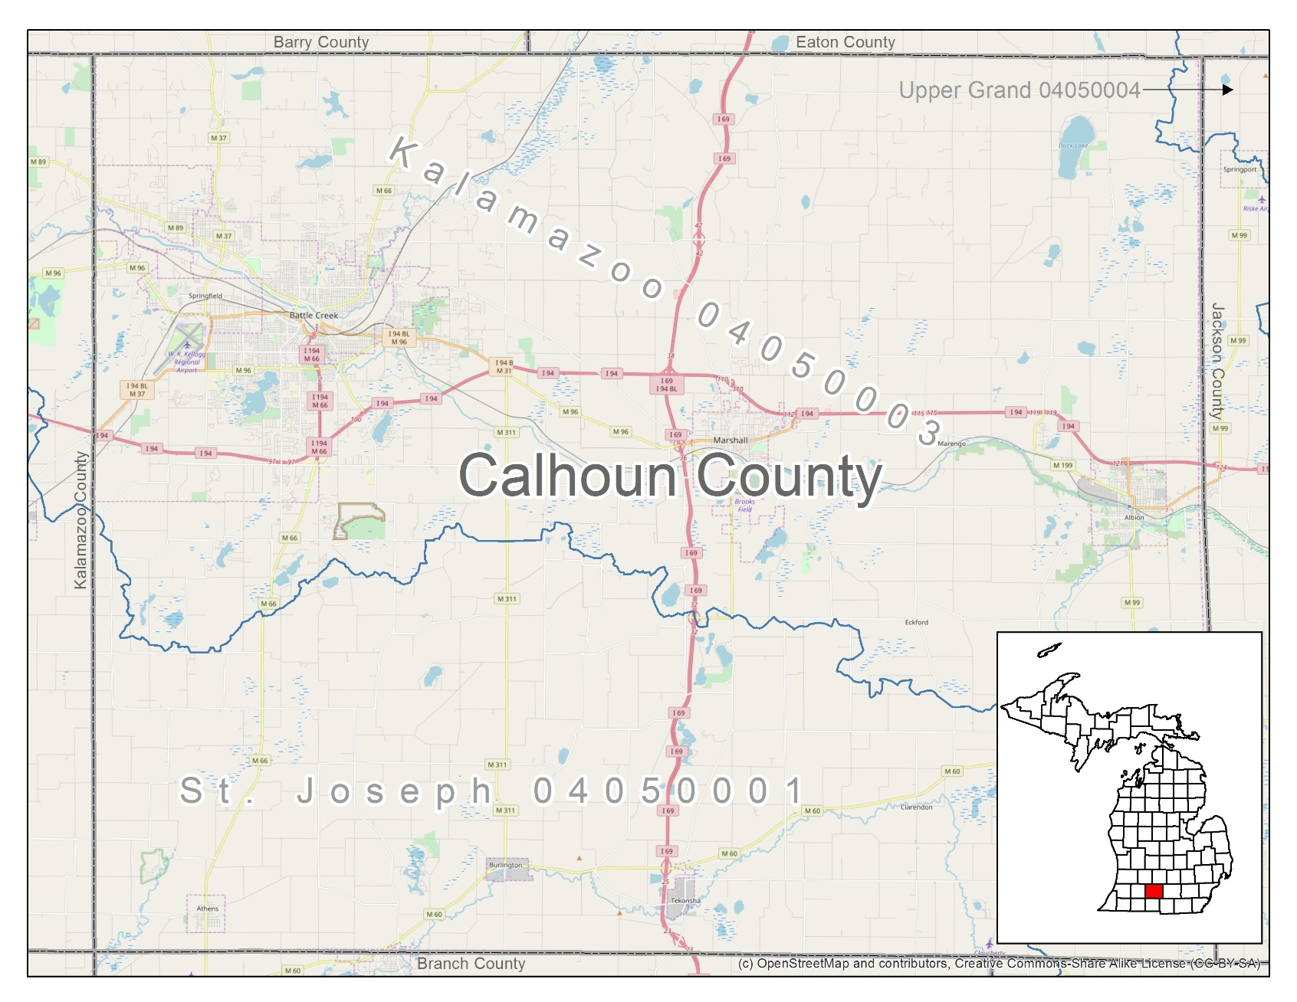
Figure 1. Project Location

PROJECT DATA INVENTORY
Project deliverables are submitted per FEMA project requirements and USGS specifications. To initiate the independent quality assurance and control task, all required datasets and documentation deliverables are inventoried and confirmed.

Table 1. Project Data Inventory
Deliverable | Included | Format | # | Notes
Documentation and Metadata
FEMA Compliance Form |  | PDF | 1 | Signed and Sealed
Mission Planning Report |  | PDF | 1
Flight Report and Logs |  | PDF | 2 | Flight Logs Included with Report
Survey Report(s) |  | PDF | 2 | Ground Control and Vertical Accuracy
Processing QA/QC Report(s) |  | PDF | 4 | Calibration/Accuracy, Classification, Breakline, and DEM
Project Level Metadata |  | XML | 1
Lift(s) Metadata |  | XML | 3
Classified Metadata |  | XML | 1
Breakline Metadata |  | XML | 1
DEM Metadata |  | XML | 1
Survey Data
Monument Datasheets |  | PDF | 3 | Also Includes Shapefile and Photos
Control Calibration Points |  | SHP | 1 | 25 Ground Control Points and Photos
Validation Check Points |  | SHP | 2 | 45 NVA and 35 VVA points and Photos
Validation Results |  | XLSX | 2 | Vertical Accuracy Calculation Spreadsheets
Geospatial Vector Data
Buffered Project Area |  | SHP | 1 | 100-meter buffer
Base Station(s) |  | SHP | 1
Flight Lines |  | SHP | 1
As Flown Trajectories (SBET) |  | SOL | 3
Indices |  | SHP | 3 | Swath, Classified, and DEM
Low Confidence |  | SHP | 1 | Polygon Shapefile
LiDAR Data
Swath Point Cloud Files |  | LAS | 38 | Includes Cross Flights
Tiled Classified Point Cloud |  | LAS | 891 | 5000’x5000’ tiles
LiDAR Derived Data
Breaklines |  | SHP, GDB | 1 | Polygon Z shapefile and ESRI Feature Class
Hydro-flattened DEMs |  | IMG | 891 | Has pyramids and statistics

PROJECT DOCUMENTATION
To confirm the project documentation meets the specification standards, reports and metadata undergo an editorial review. Reports are reviewed to ensure they are complete and comprehendible. Metadata are reviewed to ensure correct FGDC formatted xml, provide the necessary project details, include LiDAR tags, and pass the USGS metadata parser.

Table 2. Metadata QC Checklist
Metadata File | QC | MP | Pass/Fail
Project Level |  |  | Pass
Lifts |  |  | Pass
Classified LiDAR |  |  | Pass
Breaklines |  |  | Pass
Hydro-flattened DEM |  |  | Pass

Table 3. Report QC Checklist
Report | QC | Pass/Fail
Preflight collection report detailing mission planning |  | Pass
Post flight collection report |  | Pass
Flight logs |  | Pass
Ground Control Survey Report |  | Pass
Check Point Survey Report |  | Pass
Calibration Processing and QA Report |  | Pass
Classification Processing and QA Report |  | Pass
Breakline Processing and QA Report |  | Pass
Hydro-flattened DEM Processing and QA Report |  | Pass
Absolute NVA Vertical Accuracy Test Results |  | Pass
Relative Vertical Accuracy |  | Pass
Bare-earth surface absolute accuracy NVA and VVA Test Results |  | Pass
FEMA Certificate of Completion |  | Pass

RAW POINT CLOUD SWATH DATA
Quality control procedures for swath data evaluate the LiDAR system performance. This provides vital information in determining if the proper quality assurance and calibration procedures were used during the acquisition. Several checks are performed on the raw point cloud to confirm the data meet planned LiDAR collection expectations.
Table 4. Swath Raw Point Cloud Checklist
Swath Raw Point Cloud | QC | Pass/Fail
Complete Coverage of Buffered Project Area |  | Pass
Absolute NVA Absolute Vertical Accuracy |  | Pass
Relative Accuracy |  | Pass
Point Density |  | Pass
Point Spacing |  | Pass
Spatial Distribution |  | Pass
Visual Review and Data Voids |  | Pass
LAS file formatting |  | Pass
Coordinate Reference System WKT |  | Pass

PROJECT AREA COVERAGE
The USGS LiDAR Base Specification Version 1.2 requires that data collection for the defined project area be buffered by a minimum of 100 meters. The purpose of this section is to show LiDAR coverage to the extent of a 100-meter buffer of the project boundary.
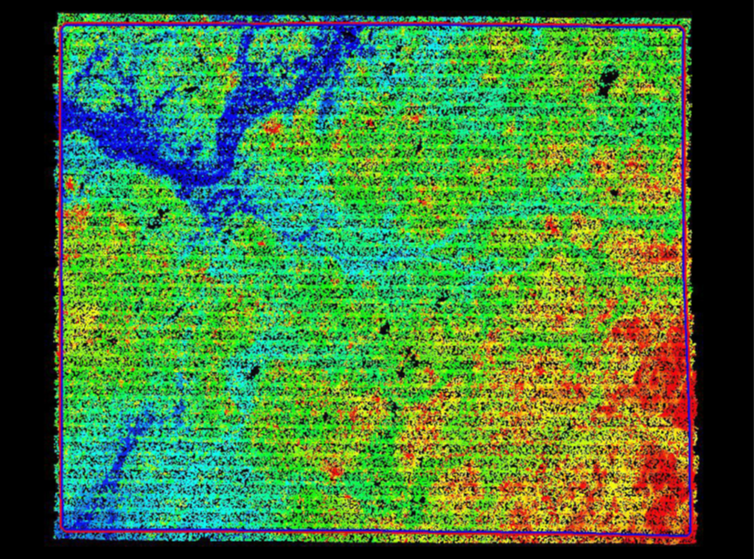
Figure 2. Project Area LiDAR Coverage

ABSOLUTE VERTICAL ACCURACY NVA
To assess the absolute vertical accuracy of the raw point cloud, a collection of discreet checkpoints was surveyed dispersed throughout the project area in non-vegetated, clear open spaces. A TIN created from the irregularly spaced LiDAR points was utilized to determine the interpolated elevation at the checkpoint location, and the interpolated elevation was compared to the surveyed elevation. The differences between the interpolated surface and checkpoint elevations are used to statistically determine the vertical error compared with ASPRS Positional Accuracy Standards for Digital Geospatial Data and USGS Base Specification v1.2, QL2 requirements (RMSEZ <= 10 cm, 95% confidence level <= 19.6 cm). The results of this test for raw point cloud data must meet the specified requirements for absolute vertical accuracy before any LiDAR post processing can begin.
STARR II tested the raw point cloud data using forty-five non-vegetated surveyed check points dispersed across the project area in clear and open spaces. Independent test results verify the raw point cloud absolute vertical accuracy is within the specified requirements. Survey data included with this deliverable provide detailed documentation and photos of each location surveyed.
Table 5. Absolute Vertical Accuracy for NVA Swath
LiDAR Swath NVA Summary Statistics | Test Results (International Feet /Meter)
Number of Check Points | 45
Points with Swath Coverage and required accuracy | 45
Average Z Error | 0.03/0.01
Maximum Z Error | 0.37/0.11
Minimum Z Error | -0.37/-0.11
NVA RMSEz <= 10 cm | 0.168/0.051 PASS
NVA AccuracyZ <= 19.6 cm at 95% Confidence | 0.330/0.1 PASS

Figure 3. Histogram of NVA Test Results

Figure 4. Scatter Plot of NVA Test Results

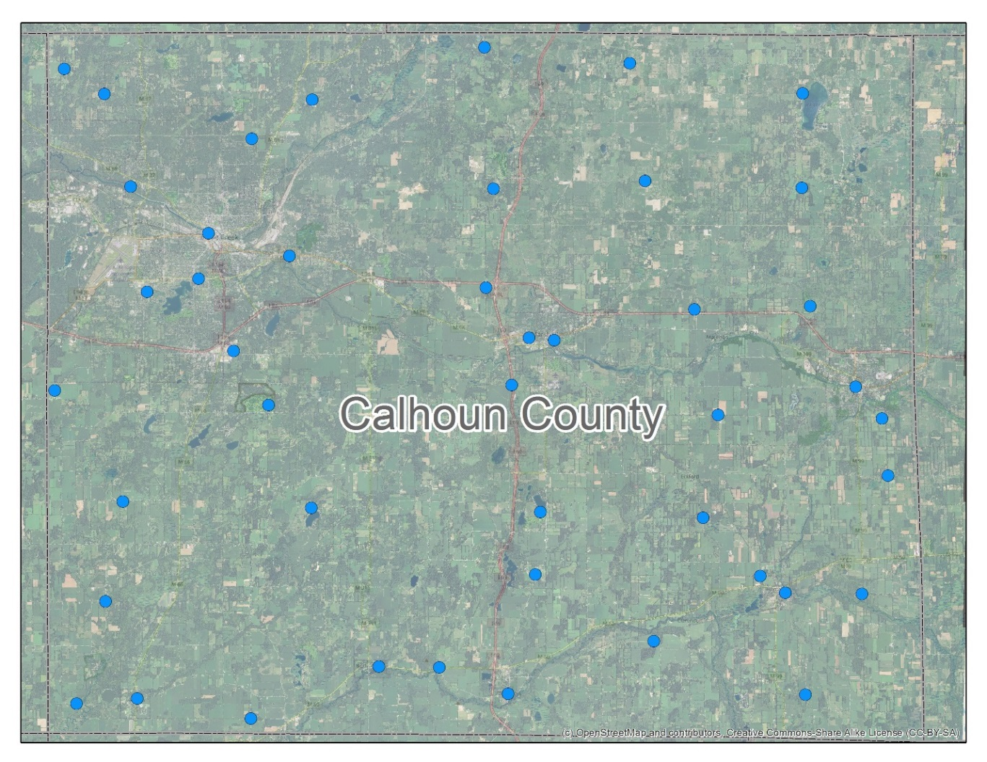
Figure 5. NVA Survey Check Point Distribution

RELATIVE ACCURACY
The USGS LiDAR Base Specifications v1.2 for quality level 2 data requires an inter-swath relative accuracy of 8 cm RMSDz with maximum differences less than 16 cm. STARR II tested the inter-swath relative accuracy by analyzing the flight line separation within swath overlaps in non-vegetated open terrain.
DeltaZ images were created to examine swath alignment and quantify elevation differences between overlapping swaths. Elevation differences are summarized and the RMSDz is calculated to verify that the swath data meet the quality level 2 relative accuracy requirements. Test results confirm this project meets the criteria for relative accuracy.
Horizontal alignment between adjacent overlapping swaths was tested by drawing cross-sections across locations such as rooftops and embankments. Profiles derived from the cross sections were analyzed and confirm proper alignment.
Smooth surface repeatability (intraswath) testing was performed throughout the project using a minimum of 50 square meter areas. Samples were taken from developed areas and included rooftops, airport tarmac, baseball infield, and cul-de-sacs located within swaths. The single return LiDAR points are extracted using LAS tools las2las for each area. The extracted LAS files are loaded into an ArcGIS LAS dataset. Minimum and maximum elevation rasters are created and subtracted to create a difference raster. USGS quality level 2 data must meet an intra-swath relative accuracy of less than or equal to 6 centimeters. This project meets these criteria for flat open areas with moderate slope.
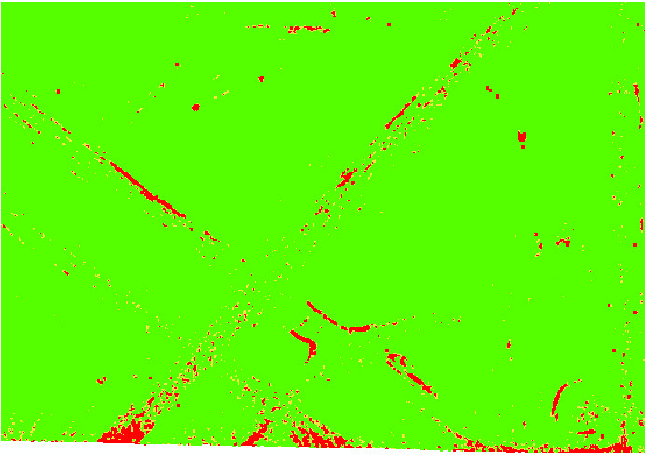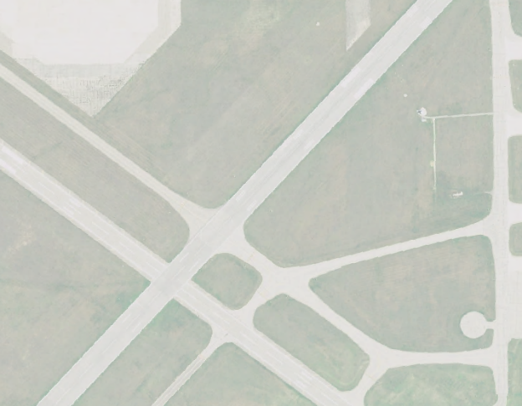
Figure 6. Intra-swath testing at airport green areas are within specifications and red areas are sloped terrain

POINT DENSITY, SPACING, AND SPATIAL DISTRIBUTION
The USGS LiDAR Base Specifications v1.2 for quality level 2 data requires a minimum Aggregated Nominal Point Density of 2 points per square meter with a maximum Aggregated Nominal Point Spacing of 0.71 meters. Testing was completed using single swath, single instrument, first return only data, including only the geometrically usable part of the swath (typically the center 95 percent) and excluding acceptable data voids. Test results are presented in the table below.
Table 6. Aggregate Nominal Point Density and Spacing
Requirements | Test Results
>= 2 points per m² | 2.9 points per square meter
<= 0.71-meter point spacing | 0.58-meter point spacing

The spatial distribution of geometrically usable points is expected to be uniform. To test the project area a density grid from the data with cell sizes equal to the design ANPS times 2, using a radius equal to the design ANPS. A minimum of 90% of the cells must contain 1 LiDAR point to meet specifications. This project meets the requirements for spatial distribution.
Table. 7 Spatial Distribution
Requirement | Cells with No Data | Cells with Point | Percentage
90% Density Grid Cells with 1 first return LiDAR Point | 15,295,086 | 816,015,703 | 98.16

No data grid cells from the spatial distribution testing are considered data voids. These cells were converted into a polygon shapefile and visually reviewed. It was determined that no unacceptable voids are present in the project. The voids were determined to be caused by bodies of water and areas of low near infrared reflectivity.

LAS FILES
All submitted LAS files meet USGS and ASPRS specification requirements. File headers are consistent and the OGC WKT georeferencing information is correct.
Table 8. Swath LAS Checklist
Swath Raw Point Cloud LAS | QC | Pass/Fail | Notes
LAS Format 1.4 |  | Pass
Point Record Format 6-10 |  | Pass | Format 6
Adjusted GPS Time |  | Pass | Global Encoding 17
File Creation Date |  | Pass
Multiple returns (Minimum of 3) |  | Pass
Point Families Present |  | Pass
Waveform Data Present |  | N/A
WKT georeferencing |  | Pass
Coordinate Reference System |  | Pass | Michigan State Plane South
Horizontal Datum |  | Pass | NAD83(2011)
Horizontal Units |  | Pass | International Foot
Vertical Datum |  | Pass | NAVD88 – Geoid 12b
Vertical Units |  | Pass | International Foot
Intensity Normalized 16 bit |  | Pass
Swath ID matches Point ID |  | Pass
No points classified as class 0 |  | Pass
Withheld and Overlap Flags Set |  | Pass

CLASSIFIED POINT CLOUD DATA
Quality control for tiled classified data evaluate LiDAR post processing procedures. ASPRS and USGS specification details provide a framework for the confirmation of data reliability. Classification of all LiDAR swath points not identified as withheld must meet the ASPRS LAS 1.4 standards. Several data checks are performed on the classified point cloud data to confirm the data meet applicable standards. Outputs from testing results, geospatial files, and comment responses are included with quality assurance supporting documentation.

GENERAL DATA REVIEW
All data received is functional and adheres to the ASPRS LAS 1.4 specifications for point record format 6 with multiple discreet returns, point families, adjusted GPS time, and intensity values present. The data have the correct tile extents and are properly clipped at the buffered project boundary. Classifications are correct and correspond with the minimum classification scheme and include withheld and overage flags. The coordinate system is correct and in OGC WKT format.

Table 9 ASPRS 1.4 Classifications
Tiled LAS Classification Test Results
Classes Expected: 1,2,7,9,10,17,18 | Classes Present: 1,2,7,9,10,17,18
Use of LAS Withheld Flag | TRUE
Use of LAS Overlap Flag | TRUE
Use of LAS Class 0 | FALSE
Total Class Numbers
Class 1- Processed but not classified | 2,745,637,765
Class 2 - Ground | 3,846,714,346
Class 7 – Low Noise | 4,150,021
Class 9 - Water | 10,708,353
Class 10 – Ignored Ground | 656,107
Class 17 – Bridge Decks | 447,954
Class 18 – High Noise | 1,473

The LAS files are statistically evaluated by reading each tile and checking the point density and spacing, total number of points and returns, X Y Z values, GPS timestamps, intensity ranges, and flight lines present in each tile. All points are accounted for and no issues or anomalies were identified. A single non-overlapping tile scheme polygon shapefile was evaluated and found to meet USGS LiDAR Base Specification v1.2.

VISUAL REVIEW
The scope of work required a visual review for 20% of submitted tiles. A detailed examination of 180 tiles out of 891 were completed for the project area. Tiles selected for review were chosen focusing on combined urban development and hydrographic significance, diverse land cover types, and areas of stream confluence.
The Calhoun County project area contains Palustrine wetlands and poorly drained hydric soils that retain water after snow melt and/or spring rains. Most soil types, according to the Soil Survey Geographic Database (SSURGO) for Calhoun County, have available water storage between 15-37 cm. Low confidence areas have been designated where it was apparent that the ground conditions were saturated and produced minimal returns.
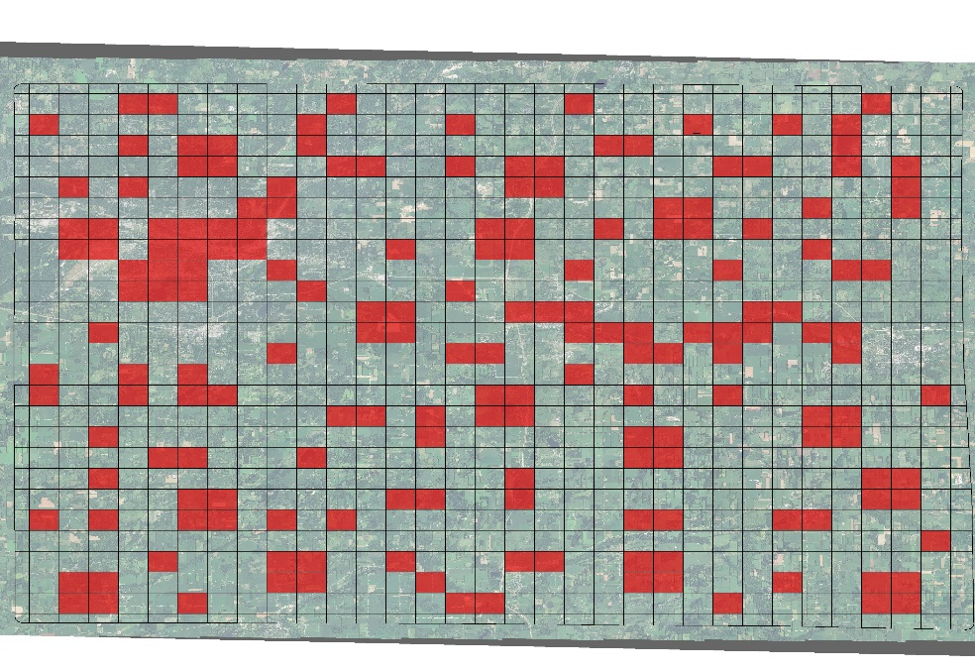
Figure 7. Classified LiDAR Tiles Reviewed
Point classifications must be accurate and consistent across the entire project. Within a 1-square kilometer area, no more than 1% of non-withheld will have classification errors. There cannot be any noticeable variations in the character, texture or quality between swaths or tiles.
Using a LiDAR viewer, to turn on and off classifications, analysts can evaluate point classification assignment consistency. For example, making class 17 (bridges) the only class visible, all points should be located over roads that span over water or other roads. Class 9 (water) points should only be located within water bodies and so on. Profiling bare earth (Class 2) allows verification of error free surfaces. Edge matching adjacent LAS tiles ensure that classifications are consistent from tile to tile.
All data reviewed for classification accuracy and consistency are compliant with specification requirements. The visual review documentation is included with this submittal.

BREAKLINES AND HYDRO-FLATTENED DEMS
The creation of LiDAR derived bare earth DEMs requires hydro flattening. Waterbodies such as ponds, lakes, inland streams, and tidal areas existing within stated USGS thresholds are expected to have uniform elevations and appear flat on the final DEM. The goal is to create topographic DEMs that contain water surfaces free of unnatural triangulation effects and other elevation inconsistencies. DEMs produced in this manner allow for greater accuracy in hydrologic and hydraulic modeling, resulting in high quality floodplain and floodway delineations.
USGS requirements for hydro flattening provide detailed guidance for the creation of DEMs and breaklines. USGS organizes requirements into five distinct water body categories: inland ponds and lakes, inland streams and rivers, non-tidal boundary waters, tidal waters, and islands. For Calhoun County, MI, inland ponds, lakes, streams, rivers, and islands are applicable.
A combination of visual inspection and automated data testing are performed to confirm products comply with specifications. Breakline checks for elevation monotonicity and connectivity include topology, visual inspection, and vertex testing. A visual inspection of breaklines confirms proper placement based upon hydro flattening requirements using either intensity or ortho imagery. Finally, breakline vertices compared against adjacent elevations provide confirmation of static water surface for ponds and lakes and stream or river bank-to-bank elevation gradients.
Bare earth surface evaluation in combination with the breakline placement visual inspection provides a comprehensive evaluation of hydro flattened surface. The DEM surface is hillshaded and visually compared with a hillshade derived from a first return Digital Surface Model (DSM). This comparison confirms the proper removal of artifacts such as vegetation, buildings, and bridges. Each breakline reviewed using the bare earth hillshade reveals any triangulation or unusual elevation changes. Cross section and centerline profiles created in hydro flattened areas within the DEM confirm proper elevation values and they are at or below the surrounding terrain.
Table 10. Breakline Quality Control Checklist
Breaklines | Pass/Fail
Functional Polygon/Polyline Z aware shapefile or ESRI Feature Class | Pass
Correct Georeferencing | Pass
Topologically Correct | Pass
Complete coverage with no missing hydrographic features | Pass
Elevations are consistent, flattened, and are at or below surrounding terrain | Pass

Table 11. Hydro-Flattened DEM Quality Control Checklist
Bare Earth Surface | Pass/Fail
All rasters delivered, tiled, complete coverage and functional | Pass
No overlaps or quilted appearance and generated to the limits of the BPA | Pass
DEM as 32-bit floating point erdas imagine format with 2-foot resolution | Pass
Correct georeferencing | Pass
Artifacts have been properly removed from the bare earth surface and edge match correctly | Pass
Bridges removed from bare earth surface with continuous flattened streams and rivers | Pass
Culverts intact in the bare earth surface with breaks in flattened streams and rivers | Pass
Ponds and lakes have a minimum surface area of 2 acres | Pass
Inland streams and rivers have a nominal width of 100 feet | Pass
Long impoundments treated as inland streams and rivers | Pass
Streams, rivers, lakes, and ponds are flattened and at or below surrounding terrain | Pass
Flattened streams and rivers has a gradient downhill water surface following surrounding terrain | Pass
Permanent islands greater than or equal to 1 acre are delineated within waterbodies | Pass

ABSOLUTE VERTICAL ACCURACY NVA AND VVA
To finalize the LiDAR data submission, an absolute vertical accuracy test for both non-vegetated and vegetated areas over the DEM is required. NVA checkpoints tested against the DEM use the same QL2 requirements as for validating the unclassified LiDAR vertical accuracy. This confirms no significant changes to surface elevations occurred during post processing.
The vegetated checkpoints for the VVA (vegetated vertical accuracy) assessment are collected in tall grass, brush, and forested land cover. Testing vegetated locations against the bare earth surface also validate the post processing and must meet USGS QL2 requirements for VVA at the 95th percentile (<= 29.4 cm). Meeting the QL2 requirements for both assessments validate the surface consistency and reliability of elevation values.
Table 12. NVA Absolute Vertical Accuracy for DEMs
Bare Earth NVA Summary Statistics | Test Results (International Feet /Meter)
Number of Check Points | 45
Points with Swath Coverage and required accuracy | 45
Average Z Error | 0.07/0.02
Maximum Z Error | 0.44/0.13
Minimum Z Error | -0.26/-0.08
NVA RMSEz <= 10 cm | 0.160/0.049 PASS
NVA AccuracyZ <= 19.6 cm at 95% Confidence | 0.313/0.096 PASS

Table 13. VVA Absolute Vertical Accuracy for DEMs
Bare Earth VVA Summary Statistics | Test Results (International Feet /Meter)
Number of Check Points | 35
Points with Bare Earth Coverage | 35
Average Z Error | 0.06/0.02
Maximum Z Error | 0.64/0.20
Minimum Z Error | -0.79/-0.24
VVA at 95th Percentile <=29.4 cm | 0.300/0.112 PASS
Figure 8. Vegetated Vertical Accuracy Checkpoint Distribution

CONCLUSION
Under task order HSFE05-16-J-0207, STARR II completed an independent quality assurance and quality control review for Calhoun County, MI. Based upon the vertical accuracy test results, project documentation, unclassified swaths, classified tiles, breaklines, and hydro-flattened DEMs reviews all data meets the requirements for use in flood risk analysis. In addition, this data conforms to the USGS QL2 specifications for integration with the National Map for public use.
LiDAR product deliverables follow the FEMA Data Capture Standards for New Topographic Data Capture format and includes all relevant ancillary information.

Approvals

QA Team Lead: James L. Huffines Date: 3/27/2018

