FEMA Region V– Calhoun, MI

Ground Control Project Report for STARR II

Flyer: Continental Mapping

July 2017

Project Information

CDI Project Number: FSG5017

FEMA Task Order Number: HSFE05-16-J-0207

STARR II Project Number: 400000347

STARR II Partner Tracking No: CD S2 R05 16 T0207

WO Period of Performance: 9/30/16 – 3/31/2018

Task Code: R0501.13.G

Geographic Location: Calhoun, MI

Number of GCPs Requested: 105

Number of GCPs Collected: 105

Project Specifications

Precision (Horizontal/Vertical): CDI Quality 1 ≤ 6.5 cm H/V
Coordinate System: Michigan South
Datum: NAD83 (2011)
Altitude Reference: NAVD88 (Geoid12B)
Units: International Feet

Summary

The purpose of this project was to locate and survey ground control points (GCPs) in multiple areas of interest as defined by FEMA-supplied shape and kml files. The GCP coordinates are to be used to control the vertical aspect of all newly-flown LiDAR data during post-processing and subsequent deliverables creation. CompassData visited the project area, found suitable GCPs, and determined accurate coordinates for each GCP according to the customer’s specifications.

Area Specification and Request
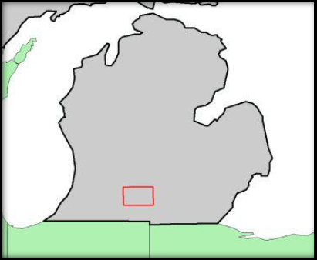
The Calhoun County AOI encompasses ~1863 sq.km. The flyer has requested 25 ground control points for their processing. In adherence to the USGS v.1.2 quality level 2 requirements, an addition 141 checkpoints will be collected. These numbers are derived from a requirement for under 2500 sq.km. The division of these points will be 45 NVA points and 35 VVA points. Distribution will be determined through discussions with the flier and based on locations of different land classifications.

Equipment

CompassData used a Trimble R10 to perform the control survey. This device is accurate to within 1 cm on a position-by-position basis per Trimble specifications. Operating within the VRS network provided accurate coordinate values at or around 6.5 cm H/V. CompassData has consistently demonstrated this level of accuracy on many GCP collection jobs across North and South America, Europe, Asia and Africa. Specifications for the Trimble R10 are available upon request.

Survey Methodology

CompassData has met the required precision for this project by using a high-quality GPS receiver with differential corrections provided by a RTK and RTN network setup in the area. The GPS antenna used to survey the control and test points sat atop a bubble-leveled, fixed-height range pole that was placed over the center of the desired GCP. At least 180 positions (captured at a rate of one per second) were geometrically averaged to calculate a single coordinate for each GCP. All required field documentation was filled out and the points were identified on web-based imagery. Digital pictures of each GCP location were collected in the field.

Quality Control Procedures

CompassData collects GCPs with an unobstructed view of the sky to ensure proper GPS-operation. CompassData works to avoid potential sources of multipath error such as trees, buildings, and fences that may adversely affect the GPS accuracy. Additional quality control comes from the fact that at least 180 GPS positions are collected for each GCP. While operating within a RTN network, valid solutions are reached within seconds; however, we continue to collect additional data to ensure meeting collection specifications. To ensure project integrity, a GCP will be reobserved or moved to a more suitable location if it does not meet project specifications.

In addition to the afore mentioned procedures, CompassData “surveys” existing geodetic control monuments to see if our coordinates match the published coordinates to the required accuracy. These monuments are usually established by the National Geodetic Survey (NGS) in the United States. If it is found that our coordinates are outside the acceptable accuracy, the reason for the difference will be found or the GCPs will be reobserved under different GPS constellation constraints. There are certain geodetic considerations that must be taken in account that affect whether a GPS-derived coordinate will line up with a survey monument, especially when these monuments reference local coordinate systems or the systems of another country. Sometimes the published coordinates for a monument are not accurate, although this is very infrequent.

Deliverables

Deliverables for this project include:

- Coordinates (in spreadsheet format)
- Digital Pictures
- QA/QC Data

Project Notes

All collected points were retrieved from the Trimble Survey Controller and processed with the Trimble Business Center software. The GPS survey is producing in this step heights above ellipsoid (HAEs).

Geoid12B was then used to generate the geoid separation at every Lat/Long location. NAVD88 orthometric heights were then generated in spreadsheet form using the formula HAE - Geoid = Orthometric Height. Those values were then included into the final delivery coordinate CSV files and have been tested against NGS monuments collected during the course of this survey and are showing millimeter-level agreement.

The Horizontal and Vertical accuracies reported in the Final Coordinates file were obtained from field measurements and post-processing. The report contains all points collected during each daily survey deployment, including NVA, VVA and Ground Control.
Area with Ground Control Points

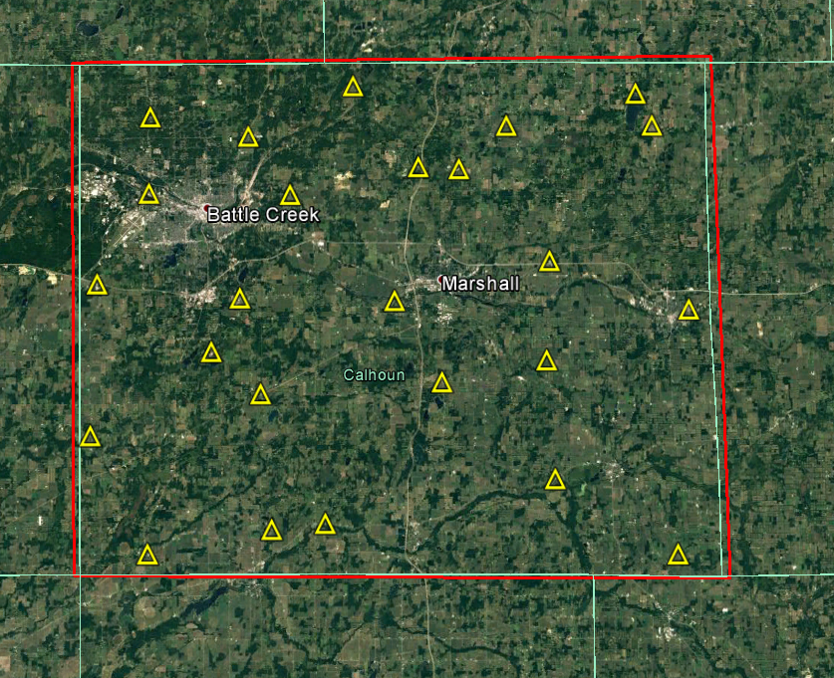

Area with NVA and VVA Test Points
Blue Squares – NVA Test Points
Yellow Circles – VVA Grass
Red Circles – VVA Crop and Brush
Green Trees – VVA Forest

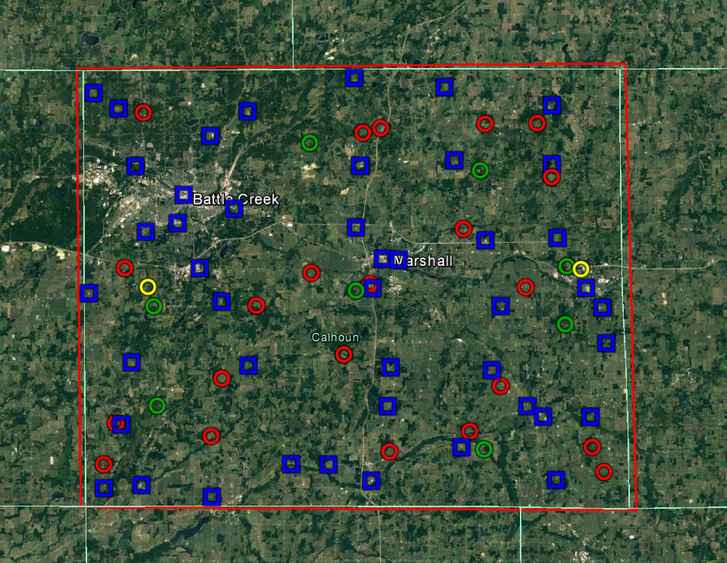

Results of NVA

Point ID | Easting  Int. Survey Feet | Northing  Int. Survey Feet | NAVD88 MSL Int. Survey Feet | LiDAR Elevation  Int. Survey Feet |  | Δ Z  Int. Survey Feet | Δ Z²
NVA301 | 12876885.278 | 214987.285 | 881.136 | 880.901 |  | 0.235 | 0.055
NVA302 | 12908445.594 | 212303.117 | 905.554 | 905.251 |  | 0.303 | 0.092
NVA303 | 12942591.502 | 221547.753 | 932.285 | 932.354 |  | -0.069 | 0.005
NVA304 | 12981409.506 | 226333.732 | 964.984 | 964.732 |  | 0.252 | 0.064
NVA305 | 13008888.053 | 216630.473 | 991.459 | 991.561 |  | -0.102 | 0.010
NVA306 | 12882140.862 | 233526.497 | 916.564 | 916.361 |  | 0.203 | 0.041
NVA307 | 12931650.754 | 221725.971 | 920.013 | 920.036 |  | -0.023 | 0.001
NVA308 | 12959956.895 | 238381.608 | 976.153 | 976.251 |  | -0.098 | 0.010
NVA309 | 13000707.422 | 238145.352 | 985.057 | 985.281 |  | -0.224 | 0.050
NVA310 | 13019105.758 | 234908.431 | 983.040 | 983.106 |  | -0.066 | 0.004
NVA311 | 12885257.585 | 251619.916 | 961.937 | 961.723 |  | 0.214 | 0.046
NVA312 | 12919407.409 | 250473.468 | 912.632 | 912.321 |  | 0.311 | 0.097
NVA313 | 12960891.244 | 249737.445 | 948.847 | 948.681 |  | 0.166 | 0.028
NVA314 | 12990372.440 | 248673.450 | 986.198 | 986.136 |  | 0.062 | 0.004
NVA315 | 13023860.251 | 256346.027 | 986.392 | 986.281 |  | 0.111 | 0.012
NVA316 | 12872937.901 | 271783.820 | 972.808 | 972.723 |  | 0.085 | 0.007
NVA317 | 12911675.176 | 269141.710 | 948.442 | 948.261 |  | 0.181 | 0.033
NVA318 | 12955706.826 | 272749.098 | 928.736 | 928.616 |  | 0.120 | 0.014
NVA319 | 12993084.291 | 267331.530 | 981.831 | 981.881 |  | -0.050 | 0.002
NVA320 | 13022732.045 | 266676.830 | 974.055 | 974.201 |  | -0.146 | 0.021
NVA321 | 12889656.117 | 289622.495 | 920.279 | 920.236 |  | 0.043 | 0.002
NVA322 | 12915463.170 | 296145.152 | 886.299 | 886.279 |  | 0.020 | 0.000
NVA323 | 12951028.186 | 290407.185 | 938.073 | 938.184 |  | -0.111 | 0.012
NVA324 | 12988769.388 | 286472.181 | 968.122 | 968.014 |  | 0.108 | 0.012
NVA325 | 13009769.584 | 287068.531 | 947.148 | 947.021 |  | 0.127 | 0.016
NVA326 | 12881904.124 | 325500.051 | 889.265 | 889.178 |  | 0.087 | 0.008
NVA327 | 12908648.885 | 317366.033 | 937.893 | 937.720 |  | 0.173 | 0.030
NVA328 | 12952366.197 | 308354.208 | 944.596 | 944.714 |  | -0.118 | 0.014
NVA329 | 12979849.521 | 309757.543 | 924.679 | 924.891 |  | -0.212 | 0.045
NVA330 | 13008259.405 | 308478.801 | 920.034 | 920.158 |  | -0.124 | 0.015
NVA331 | 12874648.210 | 330058.218 | 952.470 | 952.356 |  | 0.114 | 0.013
NVA332 | 12919569.639 | 324452.459 | 844.771 | 844.621 |  | 0.150 | 0.022
NVA333 | 12950780.964 | 333948.700 | 894.428 | 894.301 |  | 0.127 | 0.016
NVA334 | 12977091.632 | 331082.165 | 958.232 | 958.294 |  | -0.062 | 0.004
NVA335 | 13008376.276 | 325611.168 | 946.570 | 946.701 |  | -0.131 | 0.017
NVA701 | 12958818.277 | 281295.859 | 917.627 | 917.744 |  | -0.117 | 0.014
NVA702 | 13017971.518 | 272424.421 | 939.929 | 939.906 |  | 0.023 | 0.001
NVA703 | 12955018.004 | 216777.893 | 940.493 | 940.316 |  | 0.177 | 0.031
NVA704 | 12887871.683 | 215908.210 | 889.698 | 889.326 |  | 0.372 | 0.139
NVA705 | 12905344.535 | 278903.881 | 935.063 | 935.068 |  | -0.005 | 0.000
NVA706 | 12898973.824 | 292017.618 | 931.594 | 931.644 |  | -0.050 | 0.003
NVA707 | 13005242.166 | 235103.020 | 991.026 | 991.171 |  | -0.145 | 0.021
NVA708 | 12963392.686 | 280894.553 | 902.273 | 902.347 |  | -0.074 | 0.006
NVA709 | 12886700.722 | 308689.932 | 807.079 | 807.451 |  | -0.372 | 0.138
NVA710 | 12900747.367 | 300256.627 | 818.509 | 818.774 |  | -0.265 | 0.070
Datum: NAD83(2011) |  | Summary is in International Feet |  |  | International Feet |  | Meters
Epoch: 2010 |  | Z Mean | 0.03 | RMSE: | 0.168 |  | 0.051
Geoid: 12B |  | Z Min: | -0.37 | * 1.9600 | 0.330 |  | 0.100
State Plane: Michigan South |  | Z Max: | 0.37
Units: International Feet

Results of VVA

Point ID | Easting  Int. Survey Feet | Northing  Int. Survey Feet | NAVD88 MSL Int. Survey Feet | LiDAR Elevation  Int. Survey Feet | Δ Z  Int. Survey Feet |  | ΔZ²
VVA401 | 12889172.749 | 324200.552 | 898.961 | 898.950 | 0.011 |  | 0.000
VVA402 | 12953231.955 | 317876.812 | 945.485 | 945.320 | 0.165 |  | 0.027
VVA403 | 12958480.477 | 319206.289 | 934.726 | 934.690 | 0.036 |  | 0.001
VVA404 | 12988927.922 | 320237.319 | 933.686 | 933.590 | 0.096 |  | 0.009
VVA405 | 13004123.524 | 320369.261 | 976.835 | 976.870 | -0.035 |  | 0.001
VVA406 | 12883478.309 | 278973.033 | 978.562 | 978.340 | 0.222 |  | 0.049
VVA407 | 12937953.061 | 277227.119 | 947.598 | 947.470 | 0.128 |  | 0.016
VVA408 | 12982412.770 | 289750.457 | 913.341 | 913.090 | 0.251 |  | 0.063
VVA409 | 13008197.661 | 304664.753 | 975.628 | 975.310 | 0.318 |  | 0.101
VVA410 | 12880535.608 | 233860.914 | 912.102 | 911.850 | 0.252 |  | 0.064
VVA411 | 12921904.184 | 267788.984 | 919.699 | 919.710 | -0.011 |  | 0.000
VVA412 | 12955000.287 | 273916.859 | 917.509 | 917.420 | 0.089 |  | 0.008
VVA413 | 13000437.079 | 272656.031 | 964.724 | 964.830 | -0.106 |  | 0.011
VVA414 | 13012707.275 | 278730.797 | 985.526 | 985.620 | -0.094 |  | 0.009
VVA415 | 12947281.122 | 253449.524 | 925.446 | 925.090 | 0.356 |  | 0.127
VVA416 | 12911635.066 | 246708.526 | 935.441 | 935.100 | 0.341 |  | 0.116
VVA417 | 12992980.003 | 244034.056 | 1015.658 | 1016.080 | -0.422 |  | 0.178
VVA418 | 12983887.501 | 230868.075 | 967.050 | 967.320 | -0.270 |  | 0.073
VVA419 | 12876939.299 | 221894.113 | 904.273 | 904.120 | 0.153 |  | 0.023
VVA420 | 12908407.463 | 229918.388 | 919.721 | 919.330 | 0.391 |  | 0.153
VVA421 | 12960468.679 | 225120.057 | 997.975 | 997.860 | 0.115 |  | 0.013
VVA422 | 13019556.356 | 226091.186 | 1011.540 | 1011.680 | -0.140 |  | 0.020
VVA423 | 13022968.618 | 218809.179 | 1052.956 | 1052.680 | 0.276 |  | 0.076
VVA501 | 12890249.583 | 273456.647 | 945.107 | 944.850 | 0.257 |  | 0.066
VVA502 | 13016611.250 | 277841.752 | 990.952 | 990.770 | 0.182 |  | 0.033
VVA601A | 12886882.621 | 308876.125 | 805.989 | 806.780 | -0.791 |  | 0.626
VVA602A | 12937744.293 | 315065.055 | 878.070 | 877.940 | 0.130 |  | 0.017
VVA603A | 12987412.943 | 306730.221 | 962.853 | 962.210 | 0.643 |  | 0.413
VVA604A | 12891890.356 | 267811.895 | 926.362 | 926.410 | -0.048 |  | 0.002
VVA605A | 12950985.371 | 272014.376 | 927.168 | 926.820 | 0.348 |  | 0.121
VVA606A | 13012477.195 | 278691.869 | 978.472 | 978.640 | -0.168 |  | 0.028
VVA607A | 12892703.707 | 238861.931 | 876.811 | 876.760 | 0.051 |  | 0.003
VVA708A | 12947370.627 | 253514.659 | 921.684 | 921.430 | 0.254 |  | 0.065
VVA709A | 13011912.767 | 261822.177 | 957.074 | 957.770 | -0.696 |  | 0.484
VVA710A | 12988019.460 | 225593.928 | 967.769 | 968.000 | -0.231 |  | 0.053
 |  | Summary is in International Feet |  |  | International Feet |  | Meters
Datum: NAD83(2011) |  | Z Average | 0.06 | RMSE: | 0.300 |  | 0.091
Epoch: 2010 |  | Z Min: | -0.79 | * 1.9600 | 0.587 |  | 0.179
Geoid: 12B |  | Z Max: | 0.64 | 95th Percentile |  | 0.366 | 0.112
State Plane: Michigan South
Units: International Feet

Contact Information

Philipp Hummel, PLS, CFedS, CP
Phone: (303) 627-4058
E-mail: phummel@compassdatainc.com

