Stoddard Mississippi USGS Corrections

UTM 15
-In the original delivery 18 .las files were delivered for the 16 delivery tiles.
We are redelivering the 16 .las files intended for the Stoddard Mississippi UTM 15 delivery.

UTM 16
-Several Linear anomalies were measured less than 10 cm and in some cases less than 5 cm. These anomalies are considered to be within flightline to flighline tolerance.

-There is an edit call for a median to be removed from the ground class.
This median is low to the ground, almost like a curb, and has remained in the ground class.
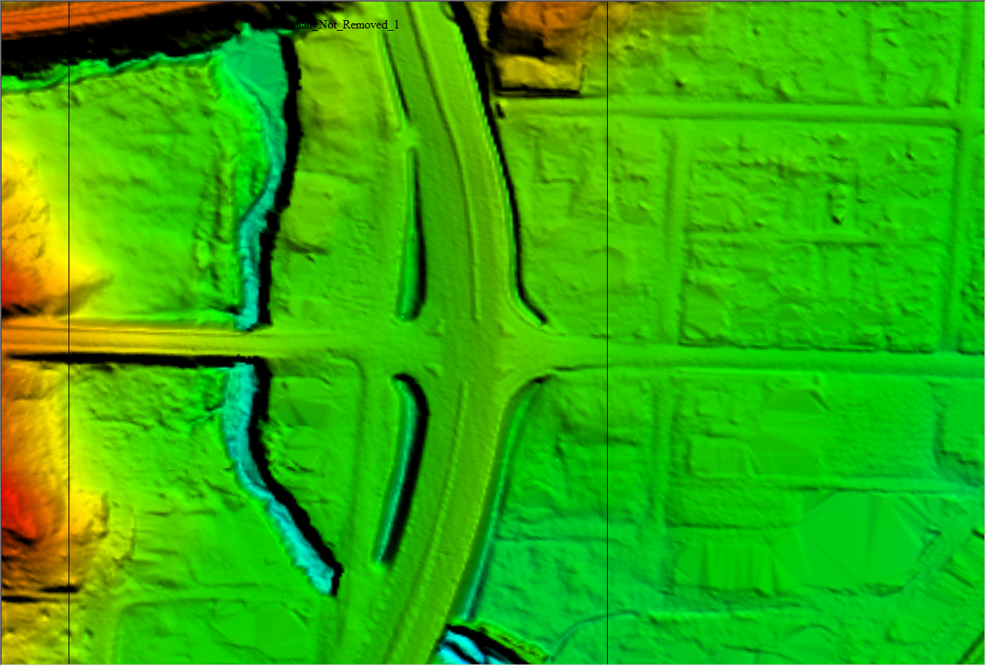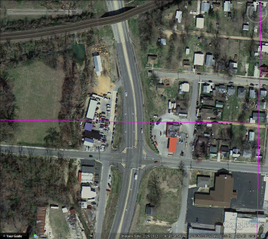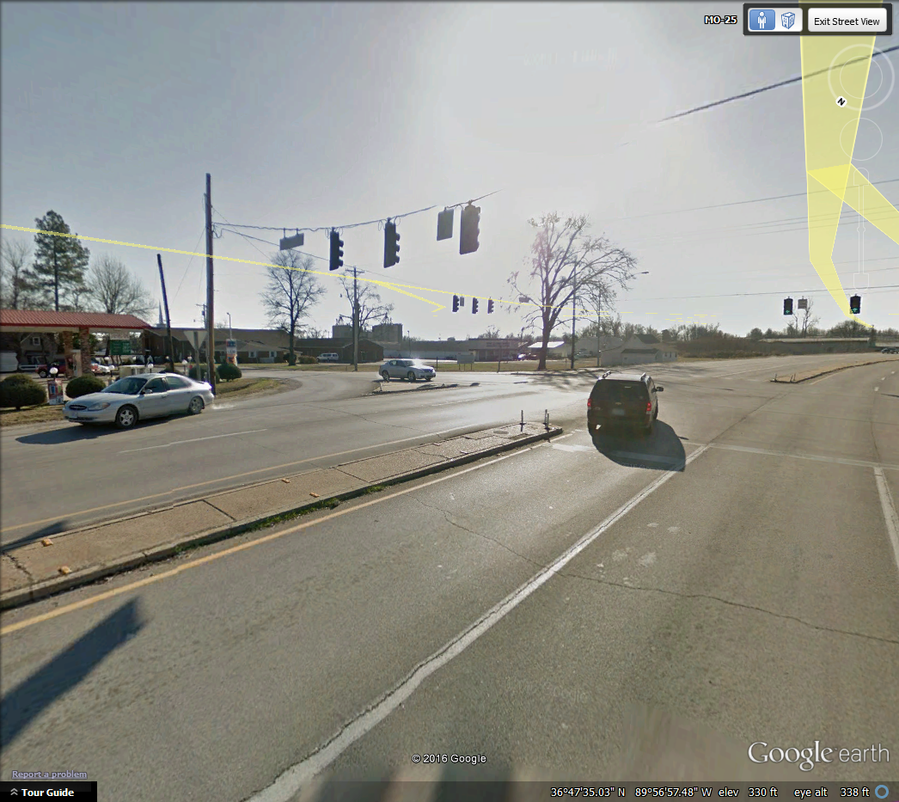

-Edit call Hydorflattening_2
The hydro was processed separately because the LiDAR was acquired on different dates where the water level was different.

-There is an edit call referring to steep banks on a pond.
The banks for the pond actually steep.
Hydro flattened DEM:
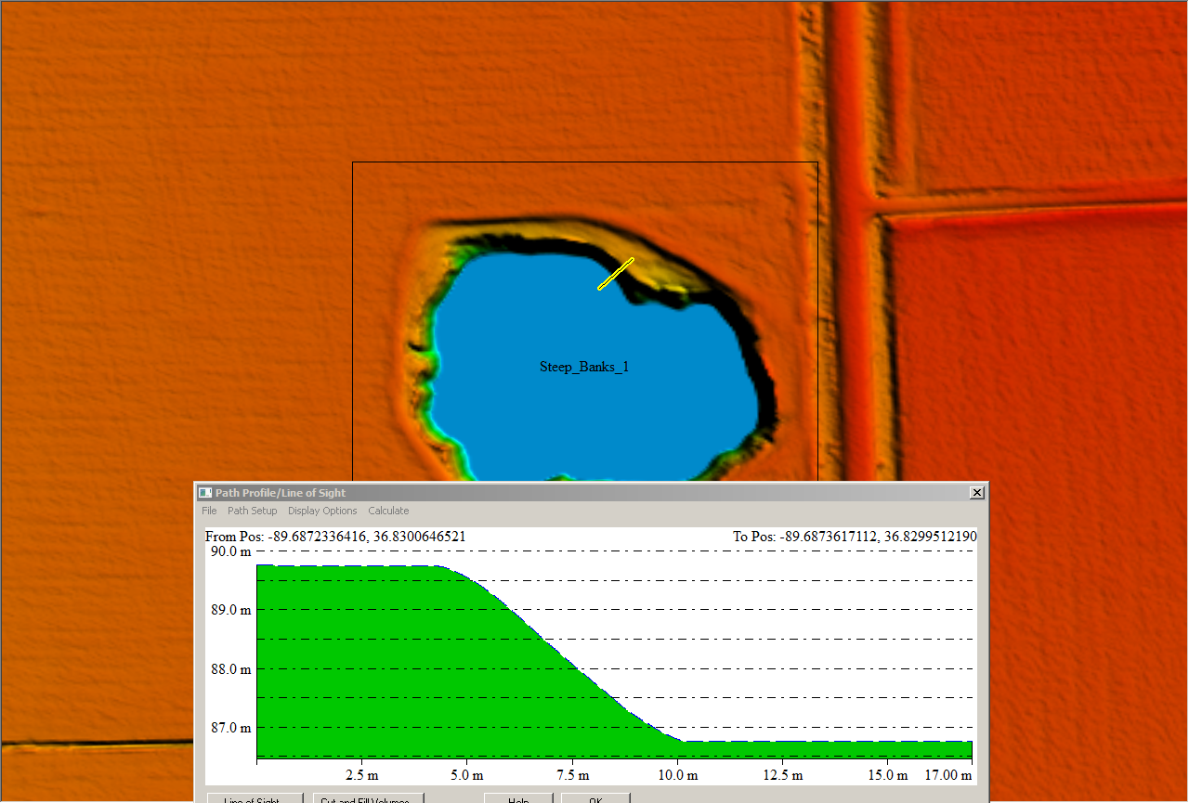

Unprocessed Bare Earth DEM:
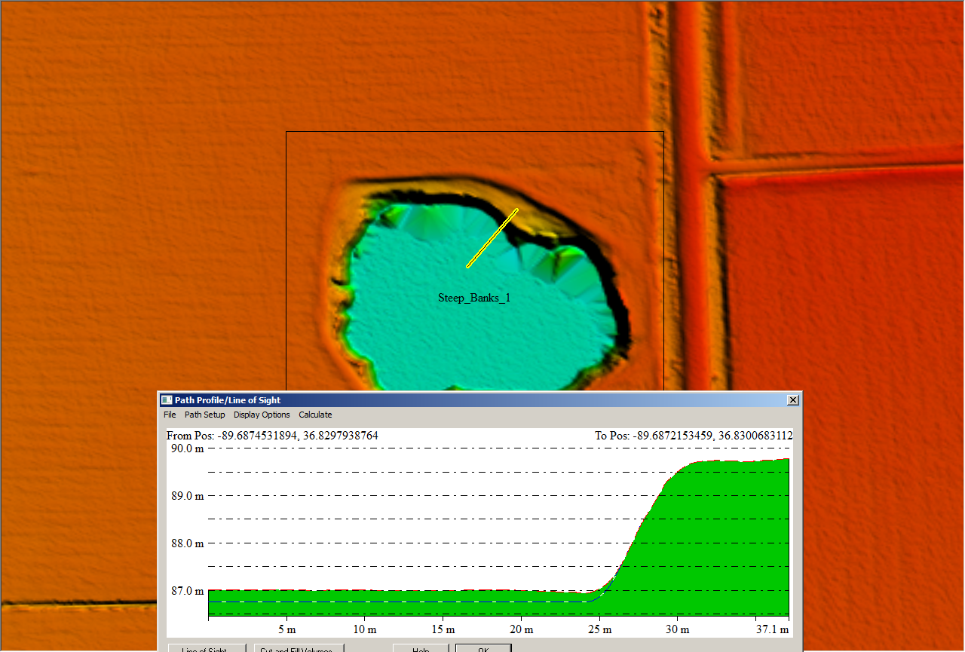

-Classified .las files for tiles 299_4089 and 299_4093 have been recreated.

