Pike County Responses to USGS Editcalls

Metadata- Project level metadata required.
Surdex response: The project level metadata is now included.
Vertical Accuracy- check shapefile coverage and descriptions.
Surdex response: The check SHP file with descriptions is now included.
Swath/Raw LAS- Does not meet vertical accuracy.
Surdex response: The corrected swath LAS data has been included.
Tiled/Classified LAS- Does not meet the USGS 1.0 Spec, specifically the greatly decreased number of points in both classified LAS deliveries is unacceptable.
Surdex response: Point density will be different between swath and classified LAS deliverables because each of the classified deliverables is a subset of the swath dataset. A tiled TPC file was not a deliverable.
Hydro Breaklines-
Surdex response: The flow on the Mississippi in the profile view shows a 1cm variance in elevation. The islands and edges of the river form triangles that can be profiled in such a way to show small variances in elevation, within specifications.
Locks were left in to show the change in elevation for the river on each side of the locks. Without the locks the river ramps in an unnatural way that would be visible within the DEM.
Misplaced breakline does not match stream flattening-
Surdex response: Corrected hydro breaklines.
Dem(s)- Multiple callouts for vegetation.
Surdex response: These are actually ground features, vegetation has been removed from the bare earth. See screengrabs below.

Veg3
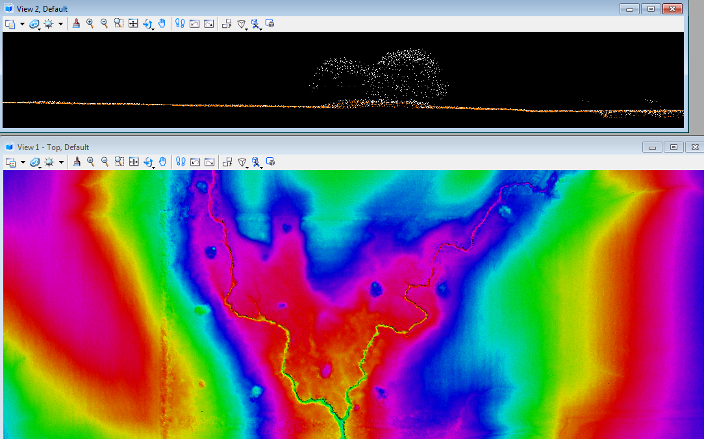

Veg1
