NGMC LiDAR Quality Assessment Report

State: KY Project Name: KY_Lower_and_Middle_Green_Pond_Rough_2012 Project Type: LiDAR QAQC
Year Funded: Materials Received Date: September, 2012 Project ID:

Project Description: LIDAR and Derivative Products for the Lower Green, Pond, Rough and Middle Green Watersheds for USDA Natural Resources Conservation Service (NRCS).

LiDAR was collected at a 0.5 meter nominal post spacing for approximately 2289 square miles of an area generally encompassing portions of the Lower Green, Pond, Rough and Middle Green Watersheds in parts of Breckinridge, Hancock, Daviess, Henderson, Webster, McLean, Ohio, Grayson, Butler, Muhlenberg, Hopkins, Christian, Todd and Logan Counties in Kentucky. Data was acquired during leaf-off conditions while no snow was on the ground and rivers were at or below normal levels. The project area required a 0.5 meter nominal post spacing and a required 9.25cm Vertical Accuracy. Lifts are planned to meet project specifications and are flown under cloud-free conditions in order to collect LIDAR points at an average of 0.5 meter point spacing.

Project Alias(es): KY_2012
Years of Collection: 2011-2012
AR_LakeConway_PointRemove_2012 Project Extent: West Bounding Coordinates: -87.695256 North Bounding Coordinates: 37.938427 East Bounding Coordinates: -86.478331 South Bounding Coordinates: 36.863537
Project Extent Image: 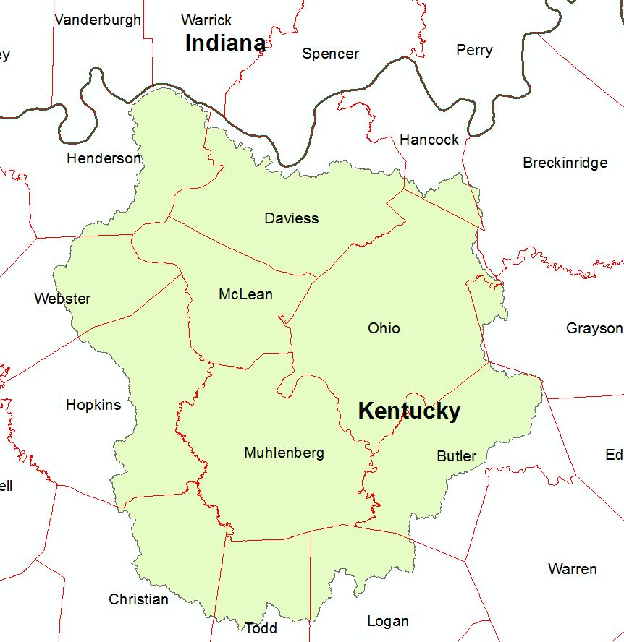

The following is a painted relief depiction of Lower Green, Pond, Rough and Middle Green Watersheds, Kentucky created in ERDAS2011 from the 1st Return DEMs.
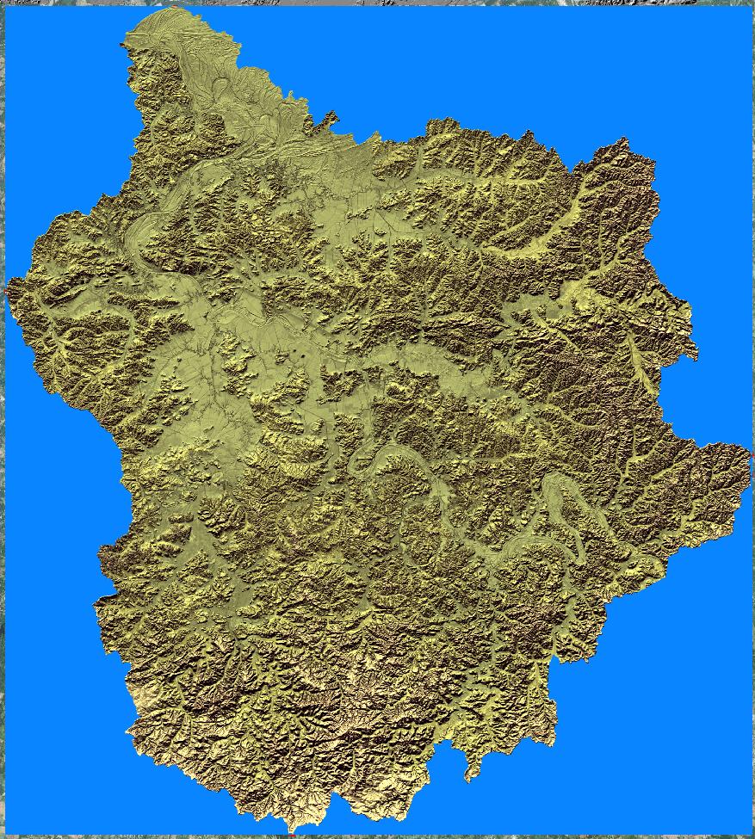

Project Extent ‘Overview’ showing Lower Green, Pond, Rough and Middle Green Watersheds over 2010 NAIP Imagery and seamless ERDAS Imagine mosaics of the 1st Return DEM and the Hydro Flattened DEM (HF DEM) in order to display project wide elevation ranges.
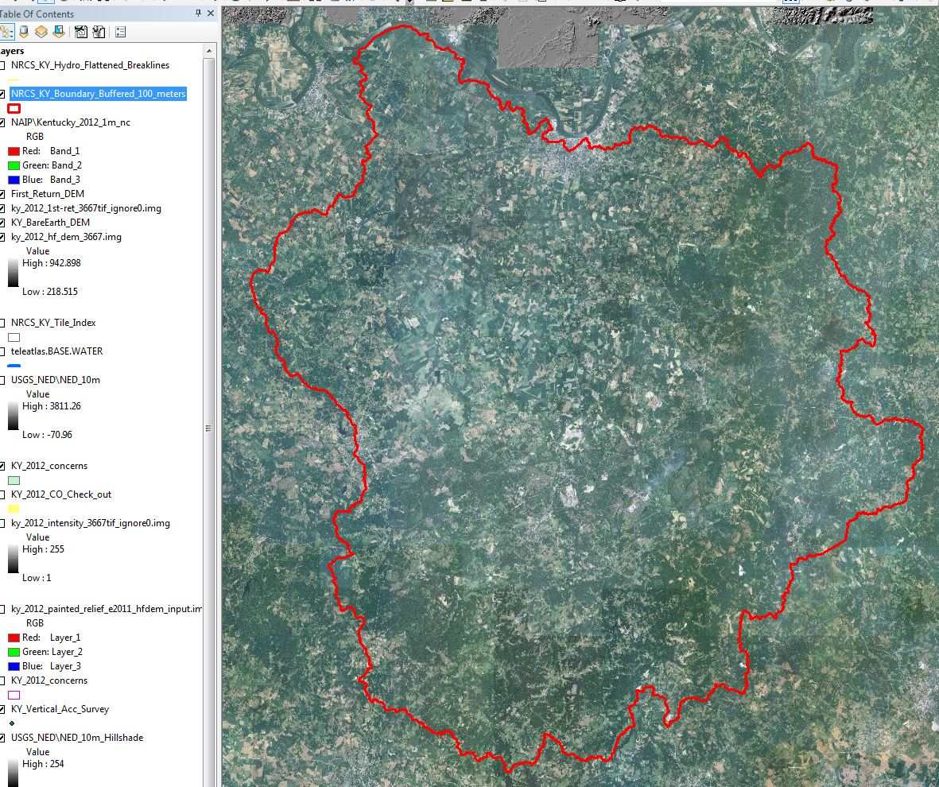

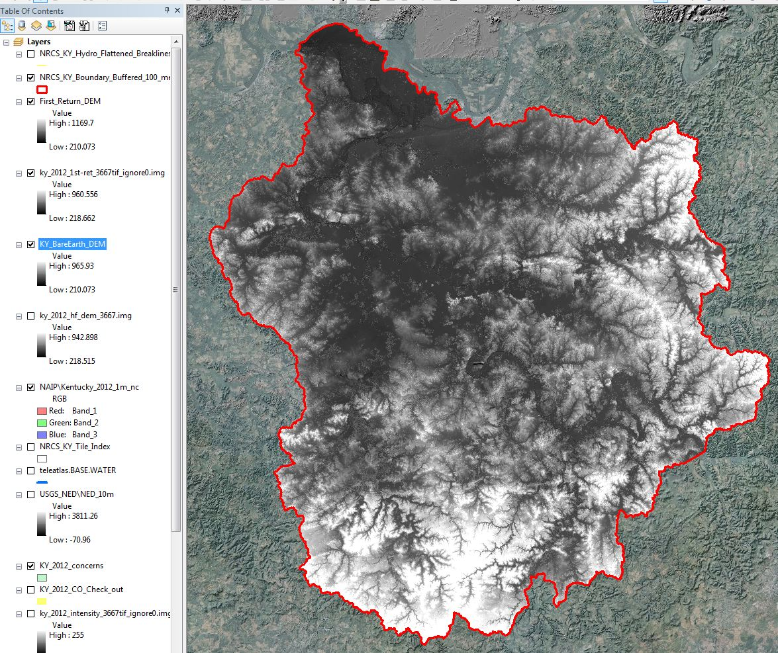

Project Tiling Scheme:
The index for this project , ‘NRCS_KY_Tile_Index, ’ is dated 7/30/2012 and consists of 3667 tiles as shown in the graphic below.

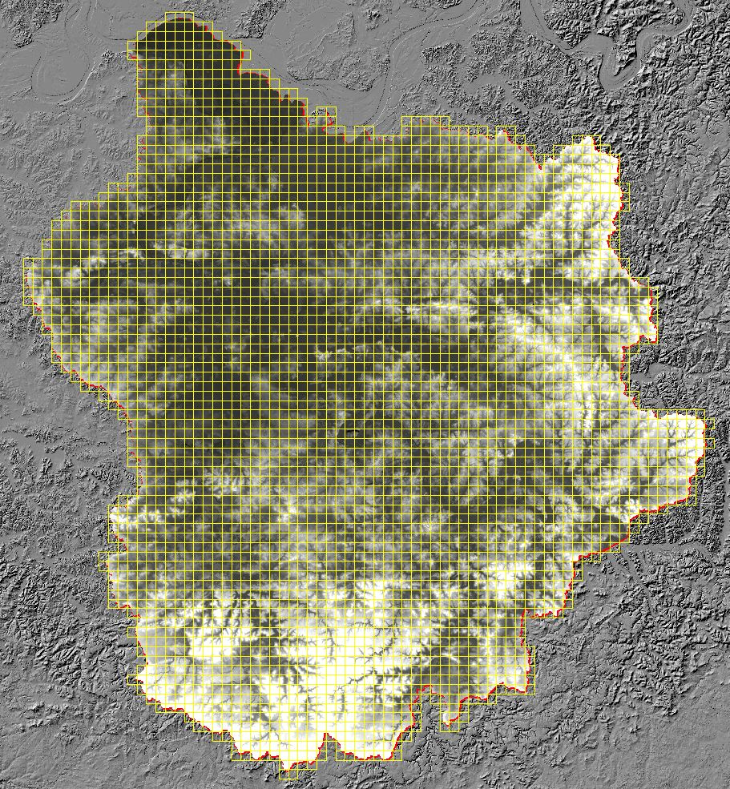

Contractor: Photo Science, Inc. products.

Applicable Specification: LAS 1.2 files

Licensing Restrictions: N/A

Third Party Performed QA? No. All previous QA was performed by vendor Photo Science, Inc.

Project Points of Contact:

POC Name | Primary Phone: | E-Mail:
Mark Meade | 859-277-8700 | mmeade@photoscience.com

Project Deliverables Received:
N - Collection Report – N/A Not Requested, Not Received
Y Project Tiling Scheme Shapefile – 1 shapefile NRCS_KY_Tile_Index
Y - Survey Report (.xls) – ‘KY_LiDAR_ Vertical_Accuracy’
Y - Hydro Flattened Breakline (HFB) Shapefile (1) ‘NRCS_KY_ Hydro_Flattened_Breaklines’
N - Processing Report – N/A Not Requested, Not Received
N - QA/QC Report – N/A Not Requested, Not Received
Y - Project Shapefiles – ‘NRCS_KY_Boundary_Buffered_100_meters’
Y - Control and Calibration Points Shapefile - ‘KY Vertical Acc Survey’ (Survey Report .shp)
Y - Classified LAS Metadata - NRCS_ Kentucky _Classified_LAS_Metadata’
Y – Hydro Breakline XML Metadata – NRCS_ Kentucky _Hydro_Breakline_Metadata’
Y – Project Metadata – NRCS_ Kentucky _Project_Metadata’
Y - Bare-Earth DEM XML Metadata ‘NRCS_ Kentucky _RasterDEM_Metadata’
N - Swath LAS Metadata – N/A Not Requested, Not Received

Multi-File Deliverables:

File Type Quantity
N - Swath LAS Files 0
Y - Intensity Image Files 3667
Y- CLASSIFIED LAS Files 3667
Y – Hydro Flattened Breakline Files 1 Shapefile – NRCS_KY_Hydro_Flattened_Breaklines.shp
Y Bare Earth DEM Files 3667 .img files
Y – First Return DEM 3667 .img files

Additional Deliverables - Geodatabases:
BareEarth_Terrain_final_delivery.gdb – “KY_BareEarth_LiDAR.gdb’
Additional Deliverables – Shapefiles
Flightline_SHP

Errors, Anomalies, Other Issues to documents:

Project Geographic Information:
Areal Extent: 2,289 mi²
DEM Grid Size: 1 Meter (metadata says 2m but measured at 1 M per requirement)
Tile Size: 1500 m X 1500 m
NPS required: 0.5 meters
Vertical Datum: NAVD88 U.S. Feet
Horizontal Datum: NAD 1983 U.S. Feet
Requested Project Projection/Coordinate Reference System: NAD 1983 UTM Zone 15N Meters
The Projection Coordinate Ref. System Delivered: UTM Zone 15N

File Type | Datum | Coordinate System | Units-XY | Units-Z
Classified LAS (.las) | NAD 1983 | UTM Zone 15N | m
Deliverable_Boundary (.shp) | NAD 1983 | UTM Zone 15N | m | N/A
Bare Earth Terrain (KY_BareEarth_Lidar.gdb) | NAD 1983 | UTM Zone 15N | m
First Return Terrain (KY_First_Return_Lidar.gdb) | NAD 1983 | UTM Zone 15N | m
LiDAR Bare Earth DEM (.img) | NAD 1983 | UTM Zone 15N | m
LiDAR First Return (.img) | NAD 1983 | UTM Zone 15N | m
Hydro-Flattened Breaklines (.shp) | NAD 1983 | UTM Zone 15N | m
Hydro Flattened DEM (.img) | NAD 1983 | UTM Zone 15N | m
Intensity Images (.tif) | NAD 1983 | UTM Zone 15N | m | N/A
Control Survey (F _V_A.shp) | NAD 1983 | UTM Zone 15N | m | U.S. Survey Ft
Tile Index | NAD 1983 | UTM Zone 15N | m | N/A

Review Cycle
Reviewer: | Review Start Date:
Charlotte Odom, Brent Duncan, LiDAR team | 09/17

Metadata Review
Provided 4 metadata files provided consist of:
NRCS_Kentucky_Classified_LAS_Metadata.xml
NRCS_Kentucky_Hydro_Breakline_Metadata.xml
NRCS_Kentucky_Project_Metadata.xml
NRCS_Kentucky_RasterDEM_Metadata.xml

NRCS_Kentucky_Classified_LAS_Metadata.xml file parsed without errors.
NRCS_Kentucky_Hydro_Breakline_Metadata.xml file parsed without errors.
NRCS_Kentucky_Project_Metadata file parsed without errors.
NRCS_Kentucky_RasterDEM_Metadata file parsed without errors.

Errors, Anomalies, Other Issues to document? YES
- The Abscissa and Ordinate Resolution shown in the Spatial Reference section of all four metadata files is give as 2 meters. The data delivered is 1-m data.

Project QA/QC Report Review
Checkpoint Shapefile: Y - Checkpoint/Distribution Image (Shown below displayed on NED10_relief)
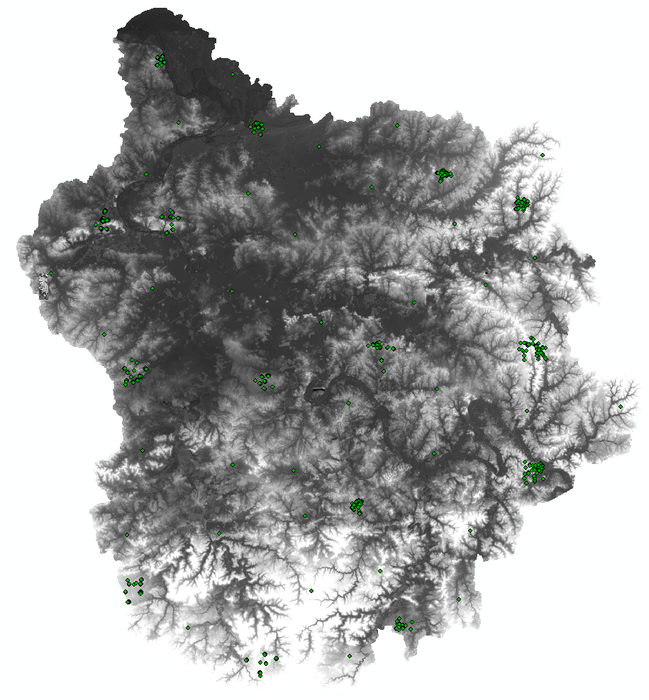

No independent checkpoints were located for this analysis.

Errors, Anomalies, Other Issues to document? Reports generated using USGS Vertical Accuracy Tools and LP360 QAQC tools in ArcGIS need further evaluation and documentation.
NOTE: Checkpoint collection has at least 60 test points -- 20 each in a minimum of three land cover categories representative of the floodplain.

Accuracy values are reported in terms of Fundamental Vertical Accuracy (FVA),
Supplemental Vertical Accuracy(s) (SVA), and Consolidated Vertical Accuracy (CVA).

Accuracy values are reported in: (example: U.S. feet): cm
Required FVA Value is 0.595’ ft or less.
Target SVA Value is 0.595’ ft or less.
Required CVA Value is or less. 0.595’ ft or less.

Results from the Control Point Report using the vendor supplied 263 Check Points generated by using LP360 to compare Control Points to the LiDAR data are shown below:
Note: See Brent’s report for Vertical Accuracy tests for the LAS files.

The reported FVA of the LAS data is ft .
The reported FVA of the LAS Swath data is .
The reported FVA of the Bare-Earth DEM data is .

USGS SVA tool results

SVA are required for each land cover type present in the data set with the exception of bare-earth. SVA is calculated and reported as a 95th Percentile Error.

Land Cover Type | Number of Checkpoints | Skew Value | SVA Value | Units
Bare Earth (CP)
Brush
Short Grass
Tall Grass
Urban Asphalt
Urban Concrete
Urban Gravel
Woods
* The skew exceeds ±0.5. Further investigation of the error values are recommended to determine if vertical errors follow a normal error distribution.

The reported CVA of this data set is: .

LAS Swath File Review:
The following was determined for LAS swath data for this project: not requested/not delivered

LAS Swath Version: N/A
Swath File Characteristics: Received ONLY classified LAS, No Swath files
N -Separate folder for LAS swath files (No Swath files delivered)
N - Each swath files <= 2GB
N/A *If specified, *.wdp files for full waveform have been provided

The reported FVA of the LAS swath data is N/A.

LAS Tile File Review
The following Classified LAS Tile File Characteristics were determined for this project:

Y - Separate folder for Classified LAS tile
Y - Classified LAS tile files conform to Project Tiling Scheme
Y - Quantity of Classified LAS tile files conforms to Project Tiling Scheme
Y- Classified LAS tile files do not overlap
?- Classified LAS tile files have no points classified as '12' < confirm>

Classifications present in the LAS files:

Code | Description
1 | “All Other Values” (processed but not classified)
2 | Ground
3 | Low Vegetation
4 | Medium Vegetation
5 | High Vegetation
6 | Building
7 | Low Point (Noise)
8 | Model Keypoint (mass point)
9 | Water
<confirm classifications, add 10 & 11>
Errors, Anomalies, Other Issues to document?

None or Describe: A ‘Data Void’ covering portions of 4 tiles (16_05314114, 05314116, 05324116, 05324117 as shown in the following 2 graphics.

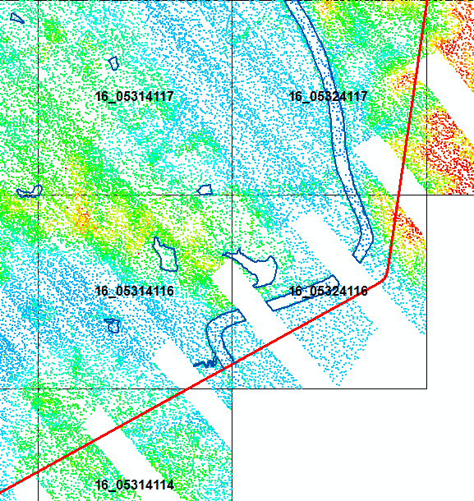

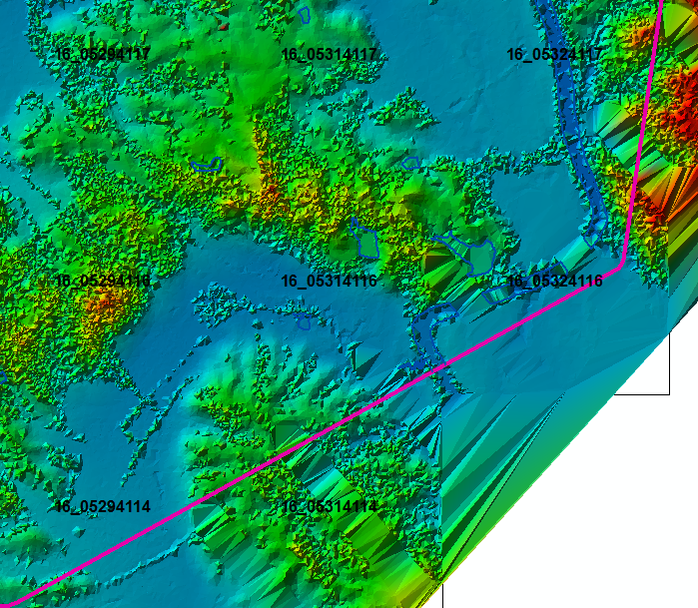
LP360 software was used to generate a QA/QC Feature Class Shapefile “KY_2012_QAQC.shp” which geolocates this void as well as other review concerns.

‘Spikes‘ and ‘Dips’ which were located in the KY_Lower_and_Middle_Green_Pond_Rough_2012 dataset (example shown below) NEED FURTHER EVALUATION
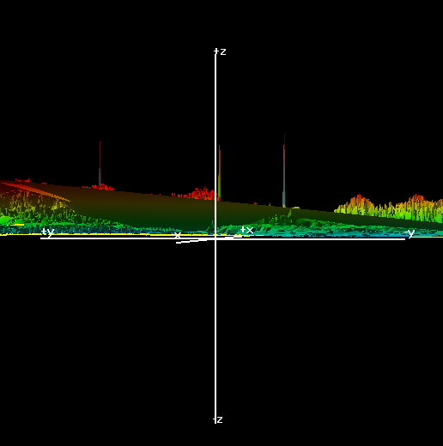
<add spike/dip/noiseto report >

Breakline File Review
Characteristics of Breakline Files provided :
Separate folder for breakline files? Yes
All breaklines captured as PolylineZ? Yes (Polyline ZM)

Review of the Lower_and_Middle_Green_Pond_Rough Watersheds, KY 2012 project data raised numerous Hydro Flattened Breakline (HFB) placement concerns. Please see the following graphics and the review concerns shapefile for more detail.

Overview of KY_2012 Hydro Flattened Breaklines (HFB) displayed over an ERDAS Imagine 2011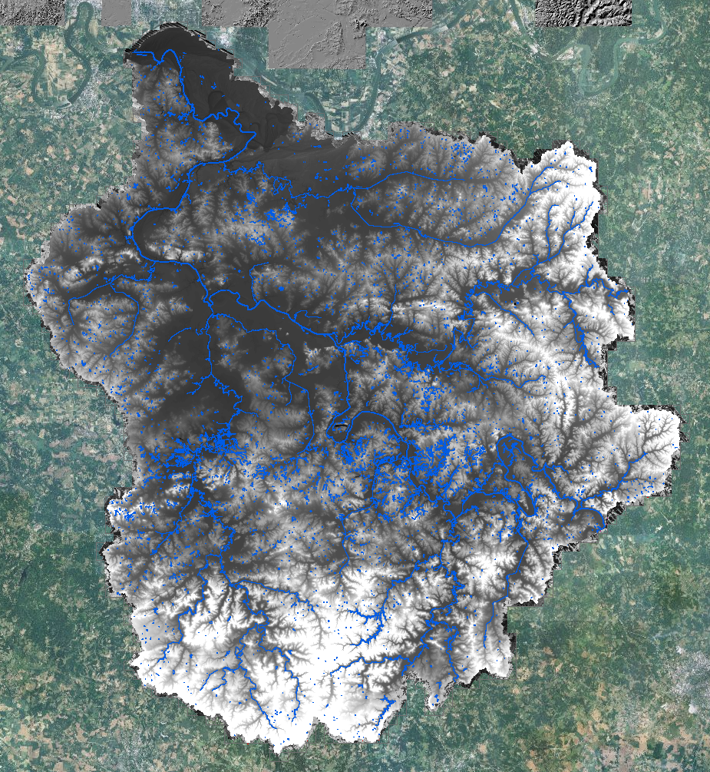 seamless mosaic of the Hydro Flattened DEMs provided by vendor are shown in the graphic below.

No HFB have been created to connect ‘hanging’ stream portions in some major stream segments as shown in the graphic below which shows the HFB delivered over a mosaic of the HF DEM.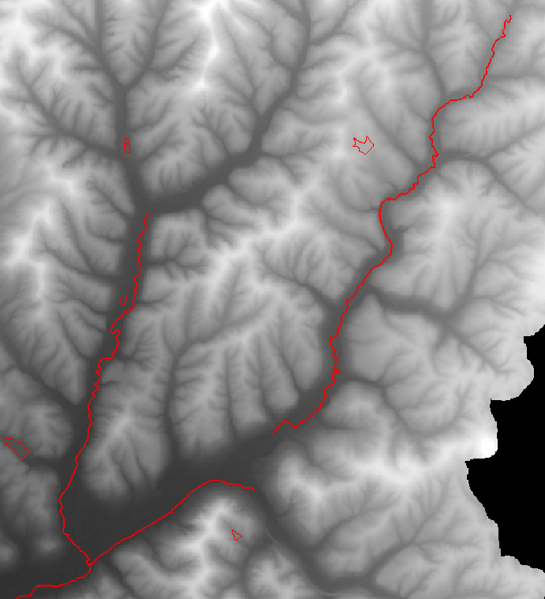

HFBs WERE generated in some areas which would appear not to need HFB such as in saturated fields. (one example from 16_05144120-22 is shown below and georeferenced in the QAQC review concerns document.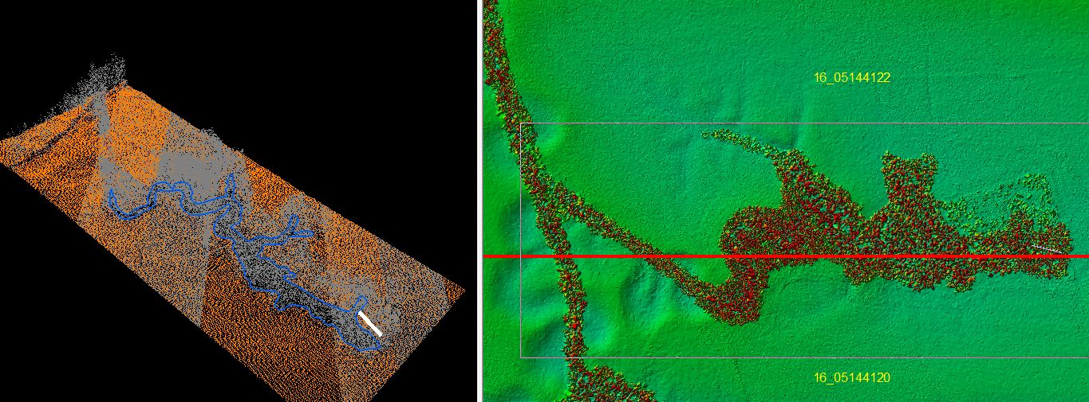

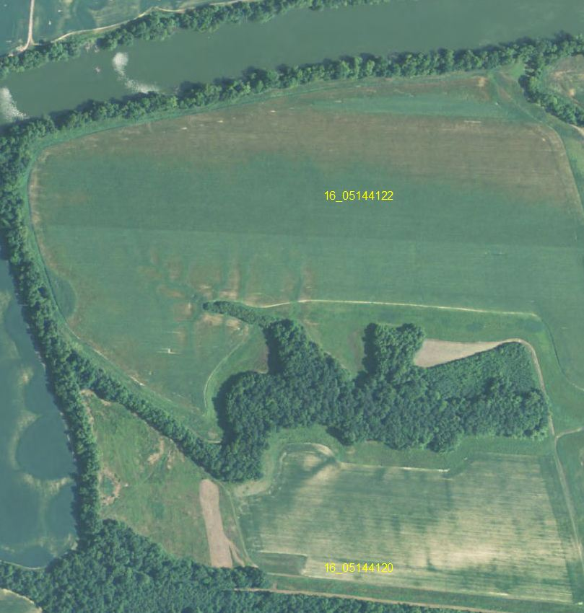

In attempt to understand why HFB were added on the area of concern above, several classes were displayed individually. The first slide has the display set to class 2 and class 8.
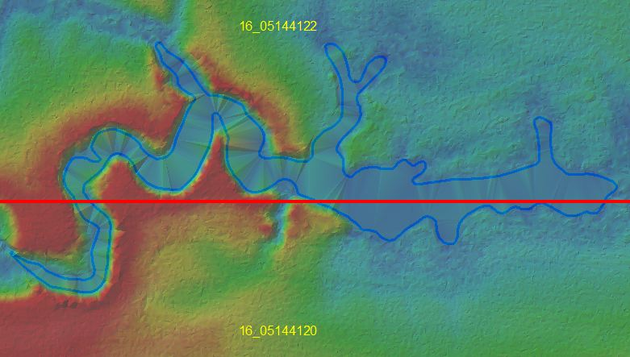

The next slide shows only Class 7 displayed. Further evaluation is suggested.
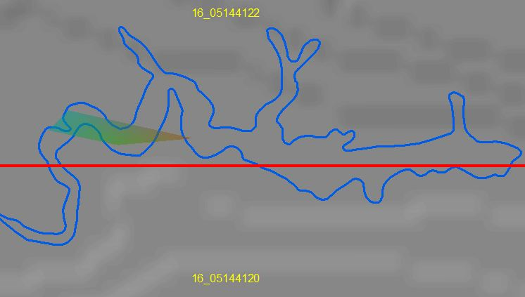

Class 11 Reserved shown below:
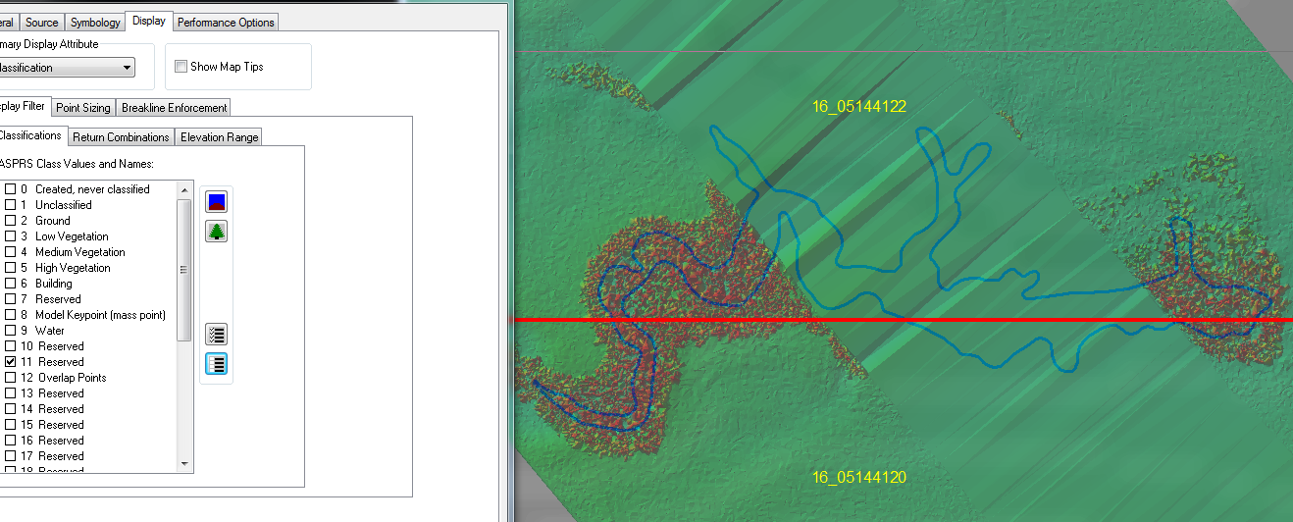
Class 9 shown below

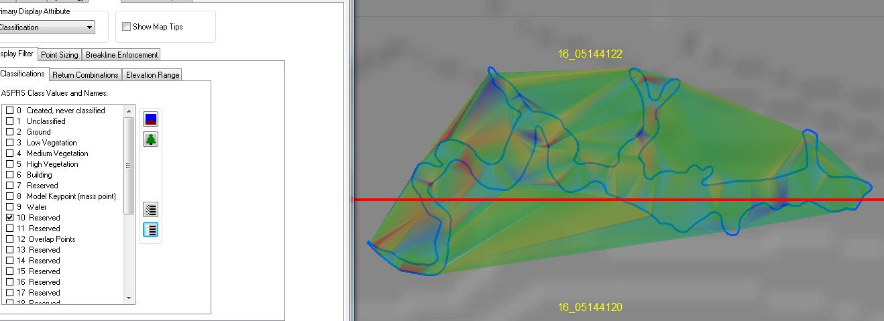

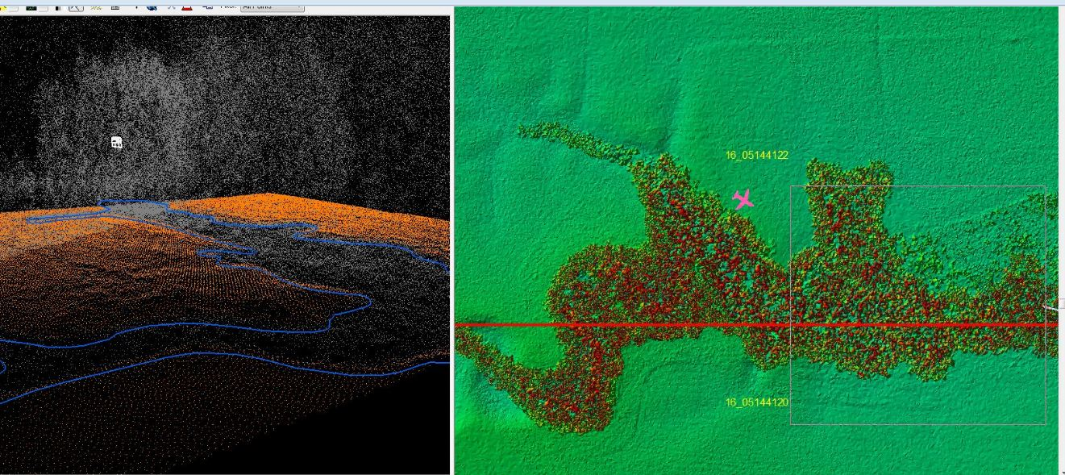

HFB have been used inconsistantly. Instances of ponds smaller than 1 acre with HFB have been noted (shown beolw), but ponds which are larger than one acre do not have HFB.
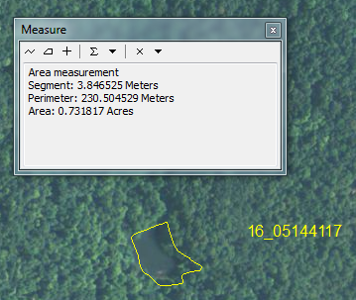

Bare-Earth DEM Tile File Review
The derived bare-earth DEM file receives a review of the vertical accuracies provided by the data supplier, vertical accuracies calculated by NRCS using supplied and independent checkpoints, and a manual check of the appearance of the DEM layer.

Bare-Earth DEM files provided in the following format: *.img.

ERDAS Imagine 2011 seamless mosaic of Bare Earth (Hydro Flattened) DEMS shown below:
The elevation range of the 1st Return DEM geodatabase (210-1169) is a bit different from the elevation range found by mosaicing the 3667 individual 1st Return DEM tiles (218-961). The vaiue of the BareEarth Dem (210-966) delivered by Photo Science is also different from that found by mosaicing the 3667 individual HydroFalttened DEM tiles (218-942) . Please note values shown in graphic and evaluate evaluate.

Bare-Earth DEM Tile File Characteristics:
Y- Separate folder for bare-earth DEM files
Y - DEM files conform to Project Tiling Scheme
Y - Quantity of DEM files conforms to Project Tiling Scheme
Y - DEM files do not overlap
N - DEM files are uniform in size
check - DEM files properly edge match
N/A - Independent check points are well distributed

All accuracy values reported in decimal feet with 2-decimal point precision.

Reported Accuracies

Land Cover Category | # of Points | Fundamental  Vertical Accuracy  @95% Confidence  Interval (Accuracyz)  Required FVA = 0.595'  or less. | Supplemental Vertical Accuracy  @95th Percentile  Error  Target SVA =  0.595' or less. | Consolidated  Vertical  Accuracy @95th  Percentile Error  Required CVA =  0.595' or less.
Open Terrain
Low Vegetation
High Vegetation
Trees
All Points

