P:\Survey\MCSD Projects\PR_USVI_Lidar 2018\Wes St. Croix\GCP Data Sheets\DOC009.tif

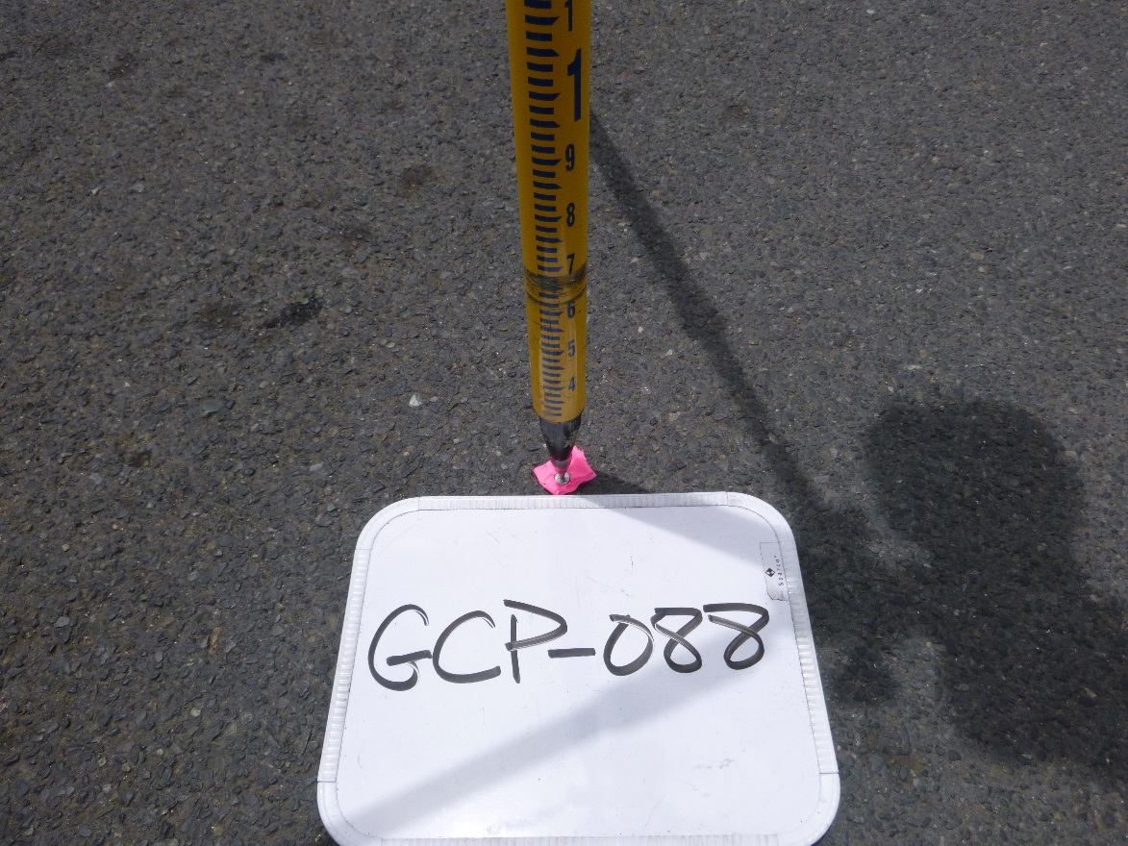

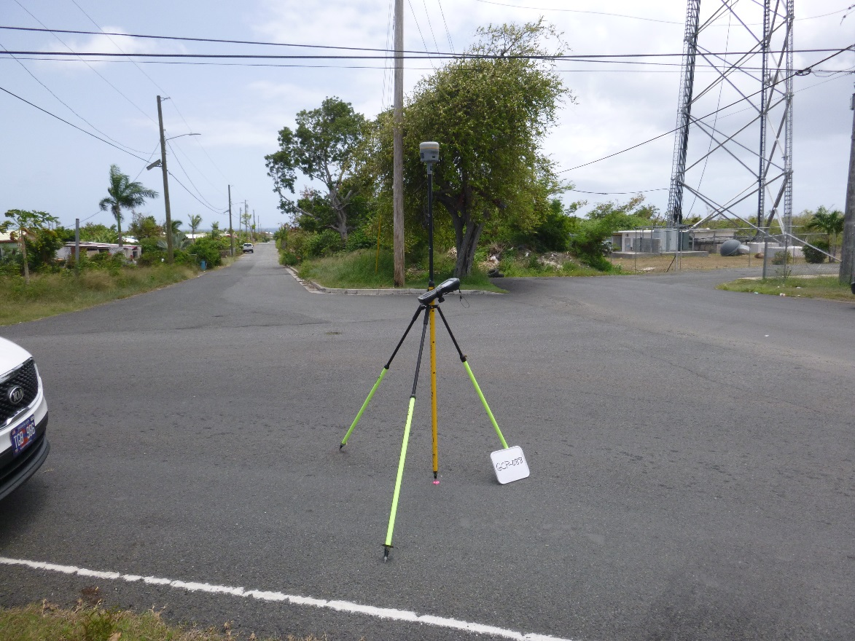

P:\Survey\MCSD Projects\PR_USVI_Lidar 2018\Wes St. Croix\GCP Data Sheets\DOC010.tif

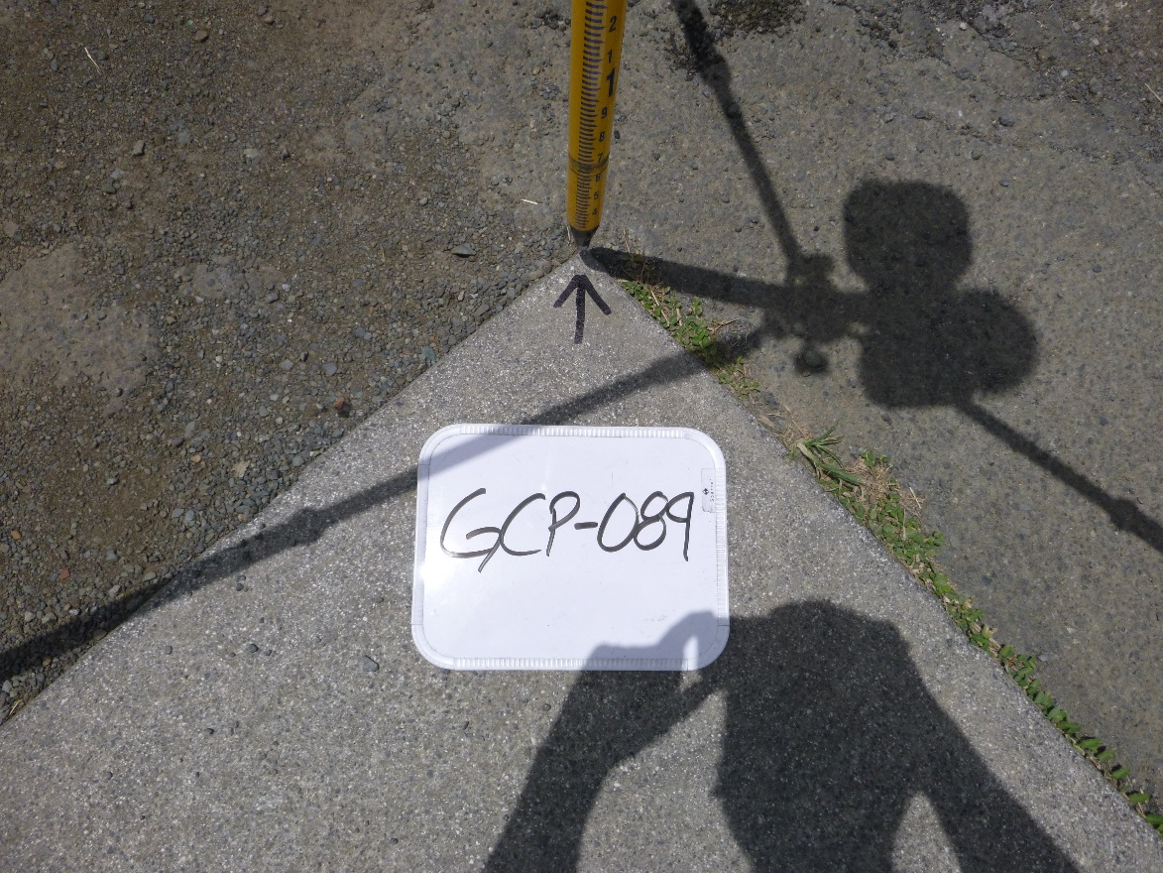

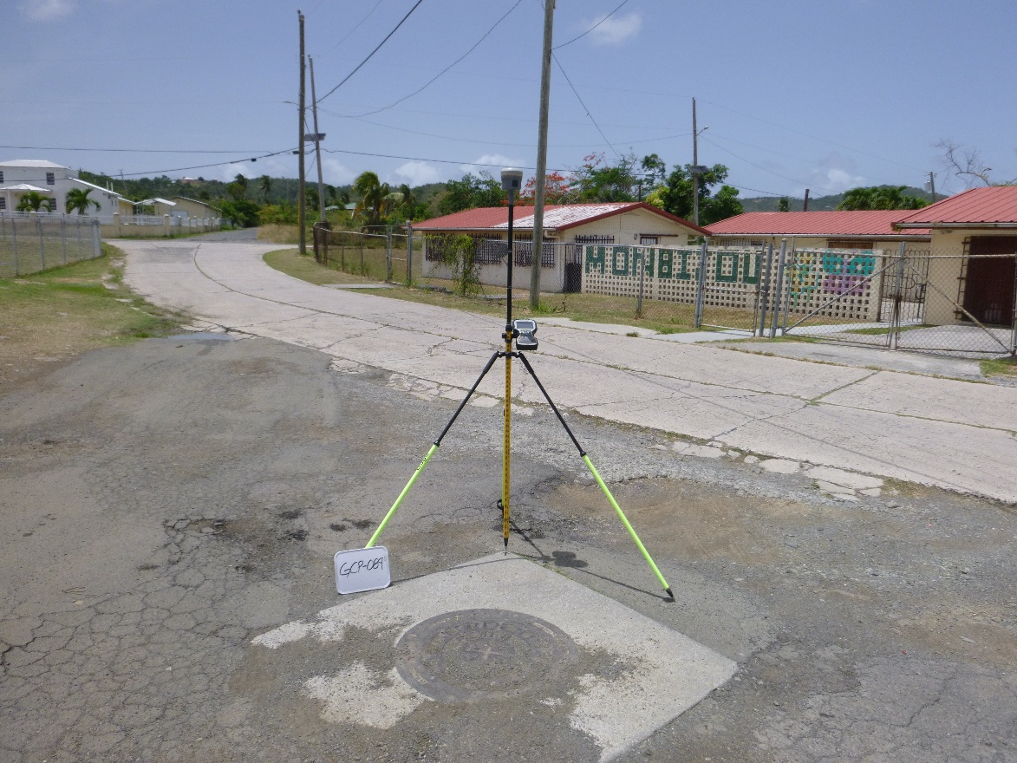

P:\Survey\MCSD Projects\PR_USVI_Lidar 2018\Wes St. Croix\GCP Data Sheets\DOC011.tif

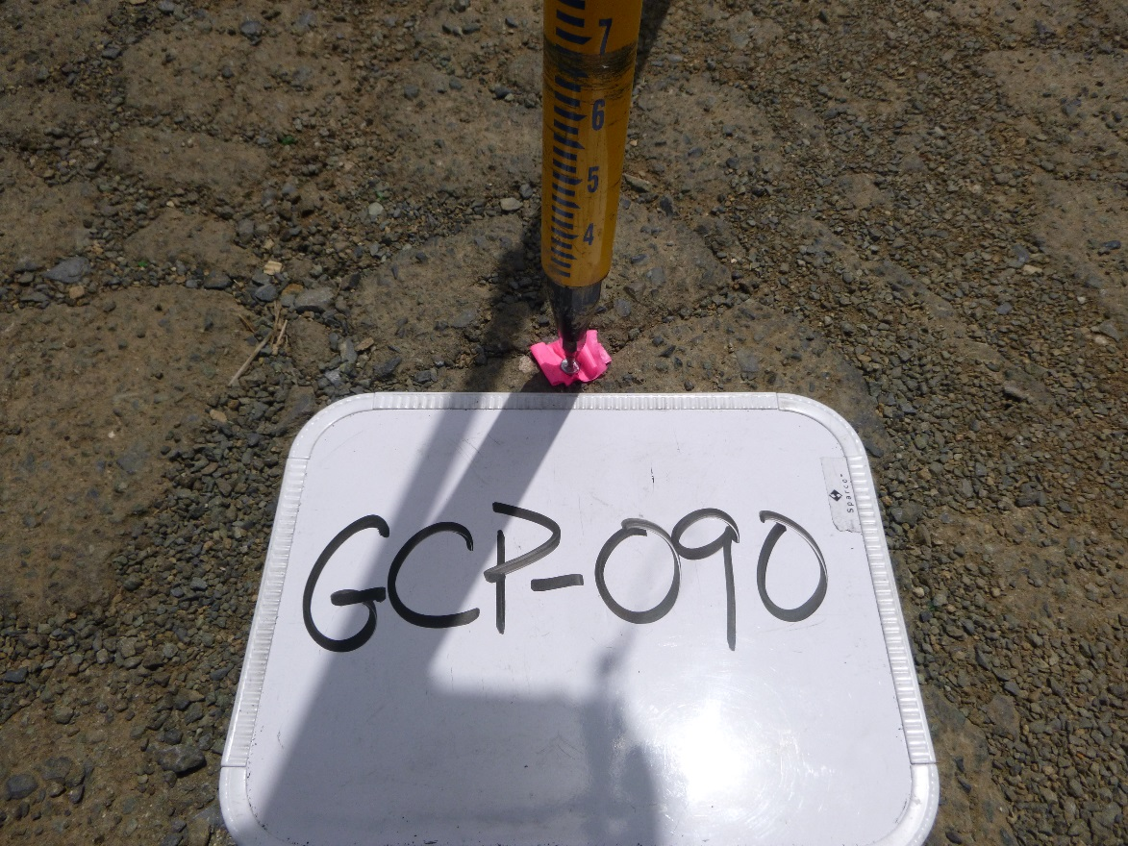

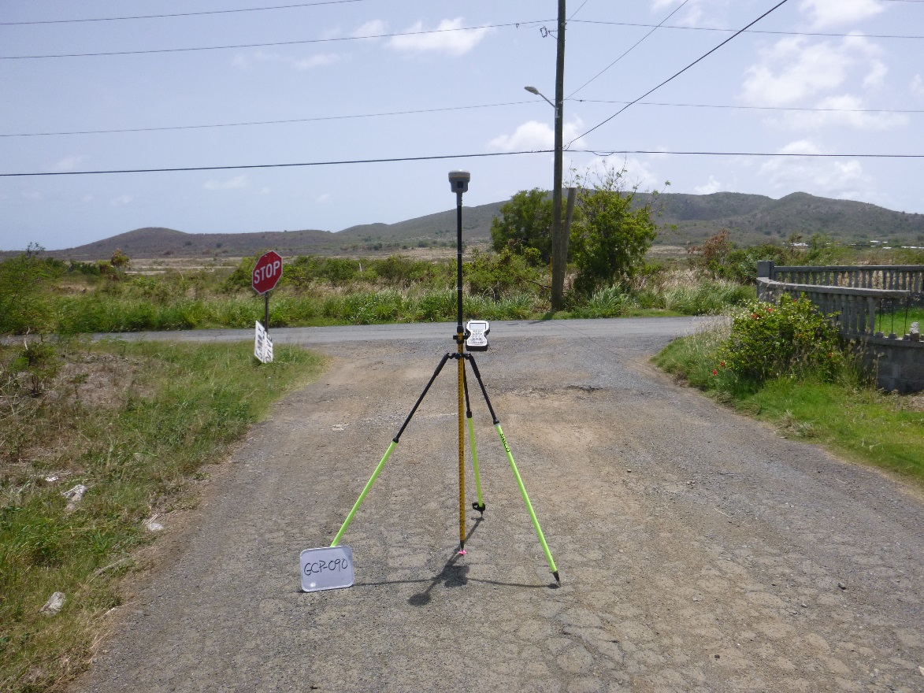

P:\Survey\MCSD Projects\PR_USVI_Lidar 2018\Wes St. Croix\GCP Data Sheets\DOC012.tif

