P:\Survey\MCSD Projects\PR_USVI_Lidar 2018\Wes Culebra\NVA Doc Sheets\DOC003.tif

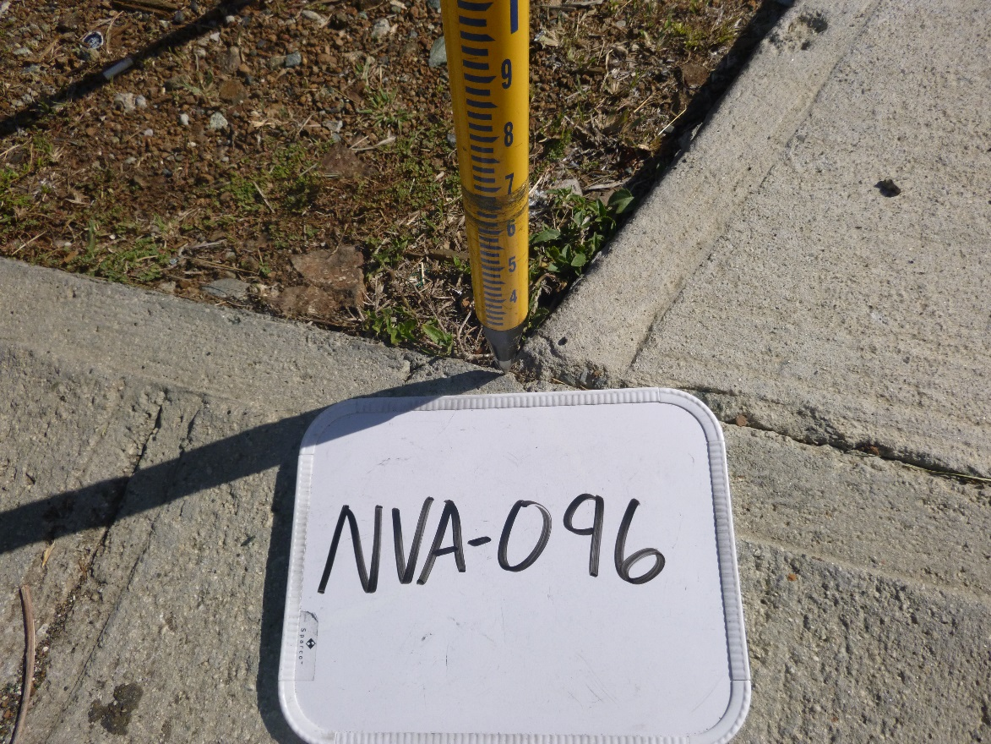

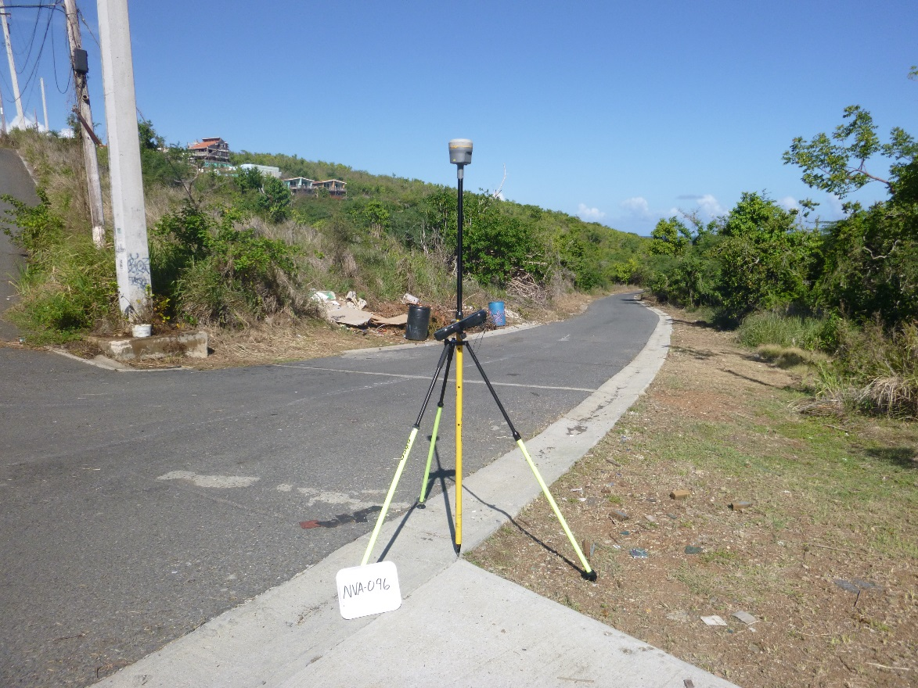

P:\Survey\MCSD Projects\PR_USVI_Lidar 2018\Wes Culebra\NVA Doc Sheets\DOC004.tif

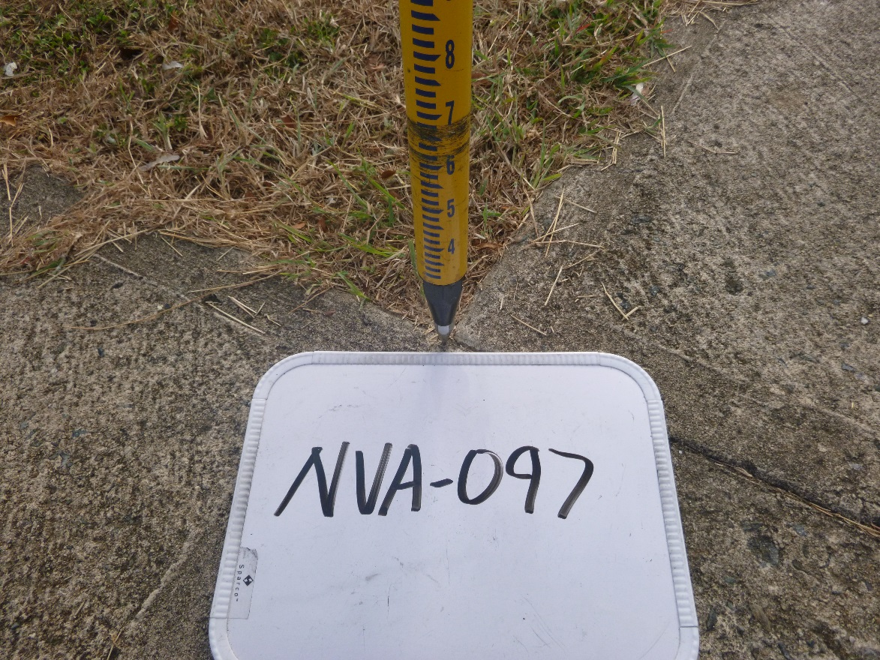

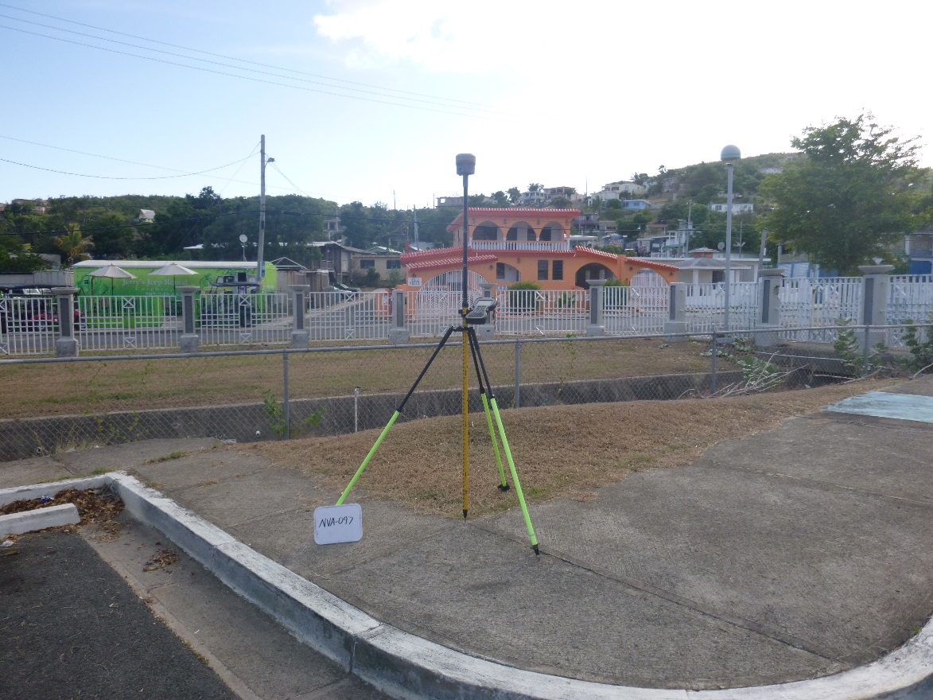

P:\Survey\MCSD Projects\PR_USVI_Lidar 2018\Wes Culebra\NVA Doc Sheets\DOC005.tif

