P:\Survey\MCSD Projects\PR_USVI_Lidar 2018\Wes St. Thomas\VVA Doc Sheets\DOC052.tif

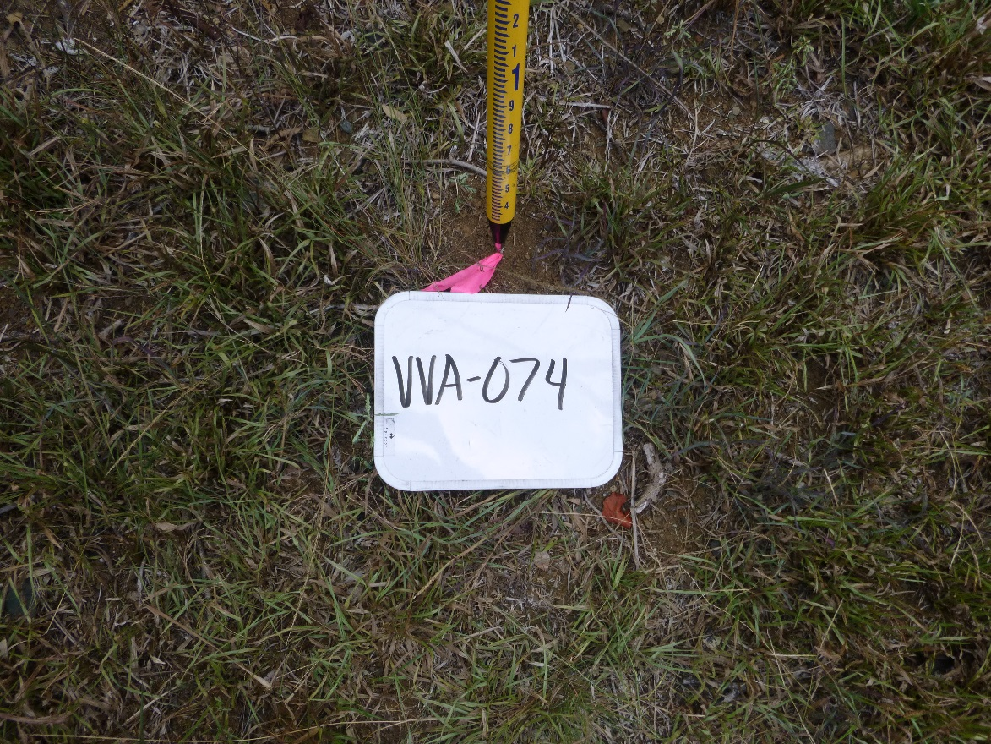

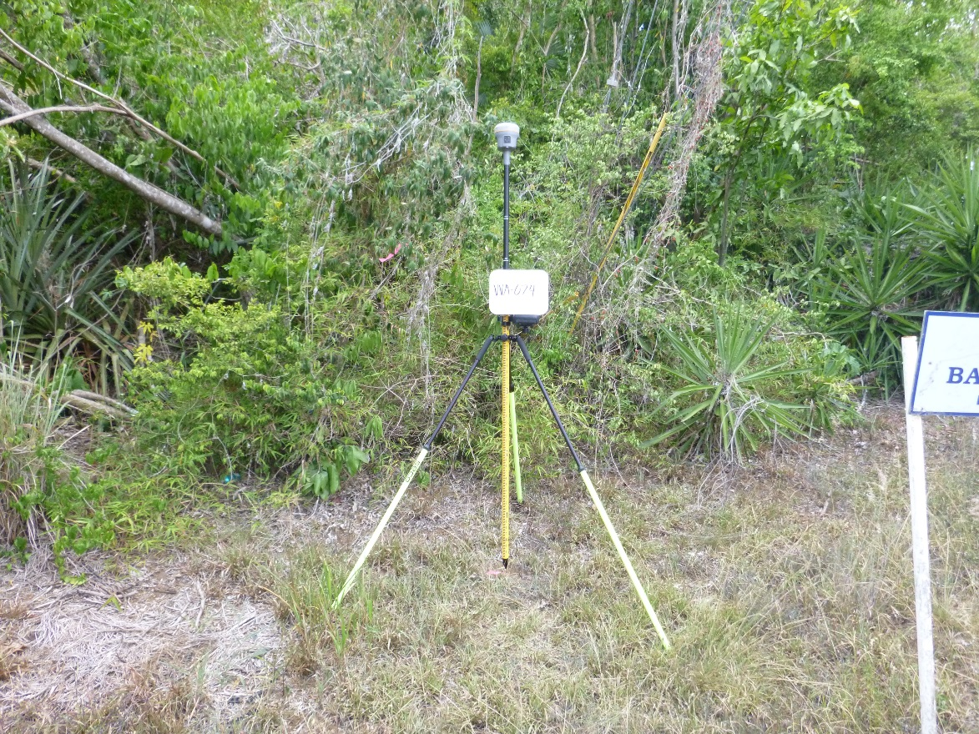

P:\Survey\MCSD Projects\PR_USVI_Lidar 2018\Wes St. Thomas\VVA Doc Sheets\DOC053.tif

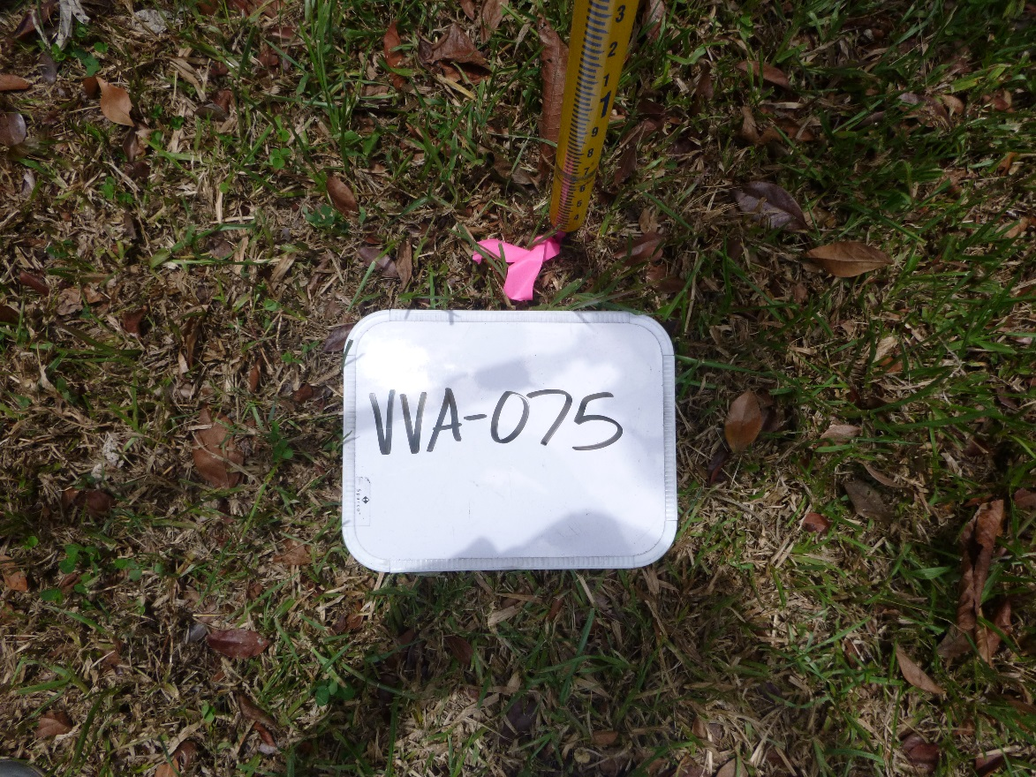

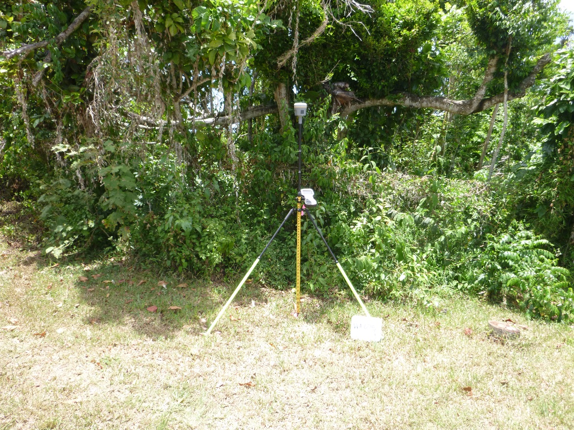

P:\Survey\MCSD Projects\PR_USVI_Lidar 2018\Wes St. Thomas\VVA Doc Sheets\DOC054.tif

