**Sensor Utilization Consistency**

One of TNRIS’ concerns utilizing two different LiDAR sensors was alternating systems on adjacent lines

repeatedly. The expectation assumed sensors would capture “groups of lines” to the limits of practicality. To

demonstrate that differing sensors were not used repeatedly on adjacent flightlines TNRIS requests Fugro

supply a SHP or GDB of the flightlines based on the Collection List table from Section 2.2 in 580-18-

SOW0050_Coastal_Texas_Lidar_Flight_Report.pdf appended as the attributes that also identifies the

sensor used in the acquisition.

Our acquisition crews segregated blocks by sensor type to the best of their abilities.  See below for the overall map.  The standalone eastern AOI was divided using the 2 sensor types, however the collected lines are contiguous.

Green                  (163) 680

Yellow                  (165) 680

Light Blue            (421) 780

Dark Blue             (961) 780

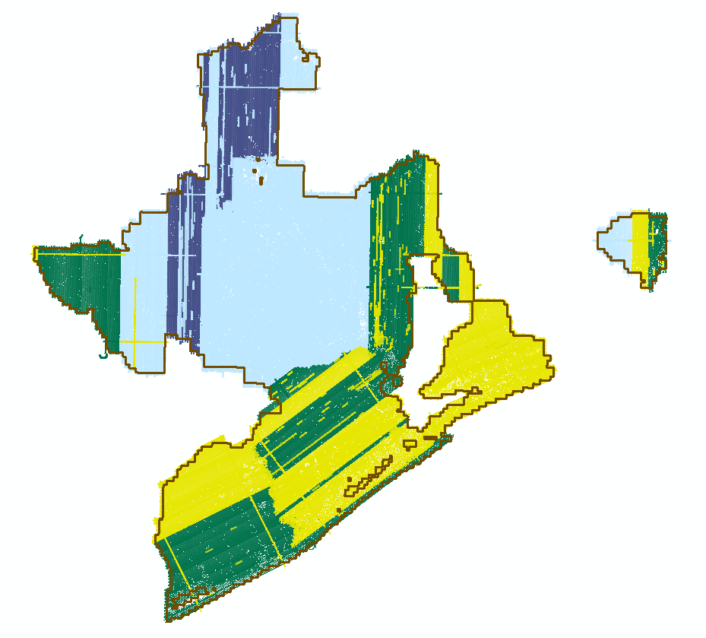

On occasion we collected cross-ties using one sensor type to cover an entire block.  These cross-ties however were only used in the block adjustment process.

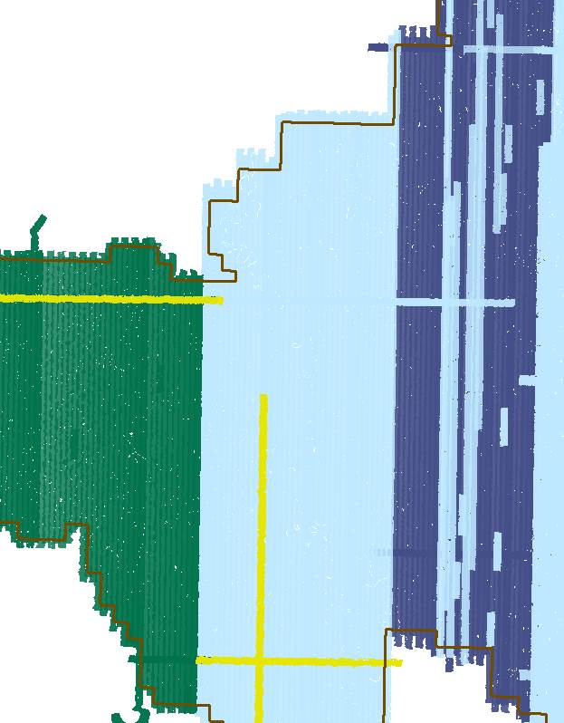

The north/south line shown in the screenshot was rejected and finalized using a 780 sensor.

|  |  |  |
| --- | --- | --- |
| 180129_165_17004800_16 | 180129_194052 | Rejected |