MEMORANDUM

TO: United States Geological Survey

FROM: Robert W. Merry
Chief Surveyor

DATE: March 27, 2018

SUBJECT: SOUTHEAST WISCONSIN 2015 LIDAR (SEWI_5)

The memorandum is intended to provide the United State Geological Survey (USGS) a report on the work effort pertaining to the delivery of the 2015 QL2 Light Detection and Ranging (LiDAR) data for the counties of Milwaukee, Ozaukee, Walworth, Washington, and Waukesha. A Cooperative Agreement between the Southeastern Wisconsin Regional Planning Commission and USGS governing work to be done by the Commission on behalf of the counties mentioned above for the reprocessing of the 2015 LiDAR data as part of the USGS 3D Elevation Model (3DEP) Broad Agency Announcement (BAA) – SEWI 5.

In 2015, Milwaukee, Ozaukee, Walworth, Washington, and Waukesha Counties within the Southeastern Wisconsin Region, obtained LiDAR elevation data. This LiDAR data for this project area was collected by Quantum Spatial, Inc. under contract to the Southeastern Wisconsin Regional Planning Commission, the Commission being, in turn, under a contract to the counties. This project was acquired in multiple missions that ranged from March 24 to April 3, 2015 at a point density of greater than two points per meter square area or a USGS Quality Level of 2 (QL2) over an area covering approximately 2,084 square miles (see Figure 1). With respect to horizontal position, the data for this project was referred to the North American Datum of 1927 (NAD27) and, with respect to vertical, the data were referred to the National Geodetic Vertical Datum of 1929 (NGVD29). This acquired data was also processed by Quantum Spatial, Inc. to edit the LiDAR ground surface, compile hydro flattened breaklines, generate contour lines having a contour interval of one foot, the contour lines being suitable for display on orthophotography having a scale of one inch equals 100 feet.

The first delivery the Commission received was Washington County in September of 2015. After Commission staff inspected this final data set as provided, the Commission rejected it and supplied a report on our review, requiring Qauntum Spatial, Inc. to make significant corrections to the delivered data. The second delivery in November of 2015 was for the entire project area, but this delivery review also found issues with regards to quality and the Commission again rejected the data as delivered. Appended to this report are the quality reviews that the Commission provided Quantum Spatial, Inc. If necessary, the Commission could also provide shapefiles of the edit calls found with each County too. After numerous submissions and resubmissions due to repeated quality issues, the final data set delivered in July of 2016 was approved.

In October of 2016, the Commission was awarded a contract with USGS to reformat, reproject and transform the data delivered by Quantum Spatial, Inc. to follow the delivery formats and guidelines as outlined in the USGS LiDAR Base Specification, version 1.2. The Commisssion’s geodetic expertise with regards to transformations and datum conversions was able to succcessfully migrate the LiDAR data to latest federal datums, North American Datum of 1983 with the National Readjustment of 2011 and the North American Vertical Datum of 1988, (NAD83/2011 and NAVD88, respectively) using the Wisconsin State Plane Coordinate System, South Zone and horizontal and vertical units using US Survey Feet for the inclussion of this high accuracy mapping data. The softwares used to support these processes were a combination of the following softwares: National Oceanic and Atmospheric Adminstration (NOAA) Vertical Datum Transformation (VDATUM), version 3.7 – used to support the vertical conversion of the LAS files from NGVD29 to NAVD88; GeoCue Group Inc., LP360, version 2017.1.54.7 – used to reclassify the LAS files, output the vertical control reports for the LAS files, reestablish the breakline elevations for lakes and ponds to be flat, and generate the hydro-flattened digital elevation models; Microstation V8i, version 08.11.09.459 – used to support the breakline horizontal and vertical conversion; and Global Mapper, version 17.2.5 – used to support the horizontal datum conversion for the LAS files, quality check the digital elevation models, and report the vegetated control points for the DEM tiles.

The final data deliverables are in conformance with the USGS Base LiDAR Specfications with the following delivery formats:

Classified LAS Tiles – The Commission prepared final LAS tiles using LAS 1.4 format on a 10,000 feet by 10,000 feet tiling scheme. The final Classified LAS data has been verified to meet an accuracy of RMSEz ≤ 0.33 feet, NVA ≤ 0.643 feet at 95% confidence level according to NSSDA standards. The calibrated lidar point cloud has been reclassified to the following base classification scheme:
- Class 1 = Processed, but unclassified. This also includes overlap unclassified points that have the overlap bit flag used to identify these points.
- Class 2 = Bare-earth ground. This also includes overlap ground points that have the overlap bit flag used to identify these overlap ground points. In addition Model Key Points (Originally Class 8) are also in the ground class but with the Model Key Points bit flag used.
- Class 7 = Low Noise
- Class 9 = Water
- Class 10 = Ignored ground (breakline proximity)
- Class 17 = Bridge Decks

Breaklines –Inland ponds and lakes that are 2 acres or greater have been collected. The entire water surface has been collected using a single elevation for all vertices defining the water perimeter and compiled as a polygon. Whereas, streams and rivers that are wider than 100-feet in width and also bridge breaklines to asist in the DEM enforcement have elevations that change in elevation but are monotonic in flow and perpendicular to the apparent stream flow centerline.
Hydro-flattened bare-earth digital elevation models (DEMs) – The Commission prepared hydro-flattened bare-earth (ground classified points along with model keypoints but excluded overlap ground points) DEMs. The prepared files are a 32-bit raster binary IMG format based on the same 10,000 feet by 10,000 feet Clasified LAS tiling. These 32-bit binary DEM tiles utilize a 2-feet pixel resolution and were tested and exceeded the accuracy supporting a QL2 deliverable. The accuracy being less than a RMSEz of 0.33 feet and 0.643 feet at 95% confidence level for all nonvegetated vertical accuracy (NVA) control points and further tested its accuracy for vegetated vertical accuracy (VVA) control points being less than 0.965 feet at a 95th percentile.

Raw Point Cloud – The Commission prepared final raw swath files. These raw data files are output by individual flightlines and have been calibrated but not classified (Class 0). The files have been properly formated and georeferenced as well know text (WKT) in the header using LAS 1.4, Point Data Record Format 6.

5) Breaklines: One geodatabase containing all breaklines supporting USGS LiDAR Base Specifications (100ft or wider for river/streams and 2acres or greater for lakes and ponds)
6) 2ft hydro-flattened DEM as tiled above

The multiple county lidar data was previously acquired and processed in 2015 at a nominal point spacing of 0.7 meters, including overlap. Lidar acquisition was conducted when the ground was free of snow, and when the atmospheric conditions between the aircraft and the ground were free of clouds and fog. Lidar acquisition was flown with an average of 30% overlap between swaths. Ground control was established for calibration and for quality control. Ground Control index points were established to supplement the airborne GPS positional accuracy. Ground Control Quality Check Points were established for validation of positional accuracy. Appropriate non-vegetated vertical accuracy check points were collected in clear open terrain and uban land cover and vegetated vertical accuracy check points were collected in tall weeds and crops, brush land and low trees, and forested land covers to validate the vertical accuracy of the final data sets.

The Commission is prepared to provide a complete data set that has been acquired and processed by Quantum Spatial. The final data has been verified to meet an accuracy of RMSEz ≤ 10 cm, NVA ≤ 19.6 cm at 95% confidence level according to NSSDA standards (Point Cloud and DEM), and VVA ≤ 29.4 cm at 95th percentile level according to ASPRS guidelines (DEM only). Hydro-flattened breaklines have been compiled for ponded water that is 2 acres or greater and double lined streams with a minimum width of 100 feet. The calibrated lidar point cloud has been classified to the following base classification scheme: Class 1 = Processed, but unclassified; Class 2= Bare-earth ground; Class 7 = Low Noise; Class 8 = Model Key Point; Class 9 = Water; Class 10 = Ignored ground (breakline proximity); Class 14 = Bridge Decks; Class 17=Overlap, Unclassified; Class 18 = Overalp, Ground.

Lidar deliverables will be tiled in 10,000 foot by 10,000 foot tiles across the project area and will extend 100 meters beyond the project areas. Reports will be prepared for the assessed vertical accuracy of the bare earth surface (NVA and VVA); data collection report with flight logs; survey report detailing the collection of supplemental control for calibration and QA/QC, the control and calibration points; processing report for calibration, classification, and production of deliverables.

The lidar data and derivative products produced will be based on the USGS National Geospatial Program Lidar Base Specification Version 1.2. Lidar data will meet the USGS definition of Quality Level 2 (QL2).

Commission's Chief Surveyor has significant experience in physical geodesy, LiDAR, and digital imagery. He has been actively working with LiDAR data since 2001. He has been instrumental in providing innovative techniques supporting the perpetuation of USPLSS monuments along w/ supplemental uses of LiDAR data. Currently, he is managing the conversion of over 12,000 USPLSS monuments from NAD27 to NAD83 & LiDAR suppporting change detection for bluff erosion.
Figure 1

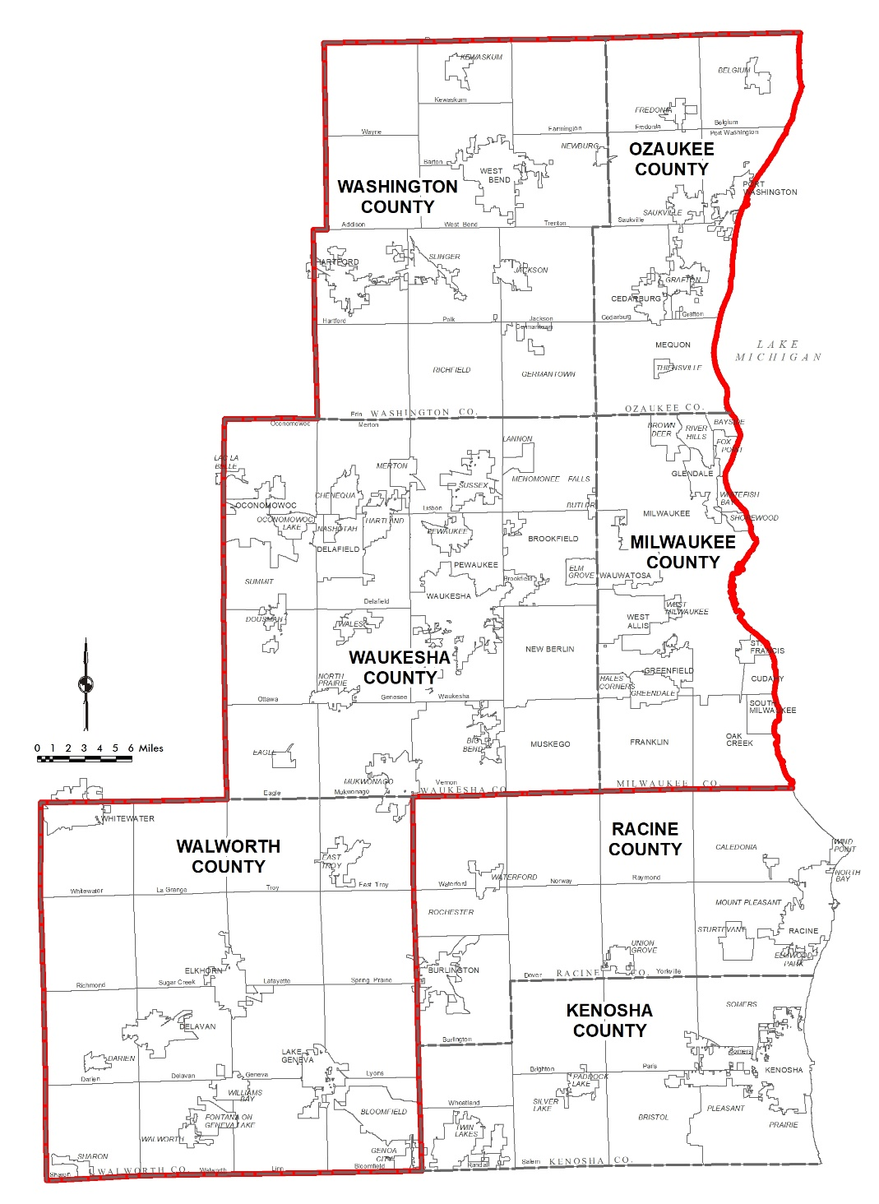
2015 – SEWI 5 - LiDAR Project Area
Review Comments on September 23, 2015
Washington County LiDAR Review
- FEMA Vertical Accuracy Report – Missing. Need report
- FOCUS Report
  - Project Summary
    - FOCUS Report prepared using incorrect datum (NAD 83 (2011) / NAVD 88 (2012))
    - Project – SP Wisconsin South FIPS 4803 Feet (should indicate US Survey Feet…not feet)
    - Class 17 – labeled Bridge – assume Overlap non-ground
    - Did not sign or no area to sign. Has this changed since Appendix A demonstrates that both the LiDAR Manager and Project Lead signing the FOCUS document.
  - Relationship between Non-Ground points (Class 1) compared to Ground points (Class 2) is 30% whereas the Overlap Non-Ground points (Class 17) compared to Overlap Ground points (Class 18) is 25% – Possible Flightline mismatch concerns. See below regarding Calibration.
    - Note: This is only an initial review of only the FOCUS Report. Review of actual LAS data will be performed after redelivery given the edit calls documented below.
  - Intensity Map – Poor intensity normalization. Evident that 2 sensors were assigned to the collection. Appears majority was collected using a Leica sensor with the southern 1/3 using an Optech sensor. This is based on intensity values customary to both sensor. Viewing intensity for the LAS tiles where both sensors are operated is very cumbersome.
    - Should fix using an intensity normalization routine.
    - Normalization is essential to permit viewing of an area collected using two different LiDAR sensors.
    - Suggest correcting the LiDAR data collected with the low intensity values (Optech) and shift to the higher values for a more balanced range.
  - Appendix A – Explanation of Report – The FOCUS Report has an explanation about Calibration that would follow after the “Breakline Map” but the actual report does not have this included. Why would calibration be omitted?
- Classified LAS Files Review
  - Missing Tile “Id15_BE_2485_505.las”
  - Included an extra tile “Id15_BE_2414_435.las” – not required for Washington County
Missing Tile

Extra Tile

- Classified LAS Editing Review and Comments
  - Numerous bridges were improperly classified (still consider ground) which also affects DTM and Contours – Samples documenting the misclassification are evident throughout the County – reedit of Classified LAS files, contour regeneration, and new DTM files would be necessary to correct this issue.
  - Numerous bridges were improperly classified (Class 1) instead of contracted Class 14 – reedit of Classified LAS files would be necessary, however, contour regeneration, and new DTM files are not necessary in correcting this issue.
  - Below are samples of ground points on top of bridge sites and misclassified bridges. Each sample has an XY location and comments to understand the edit call.

XY Location:
Northing: 488900
Easting: 2422800
Comment: Bridge classified using Classes 1 and 17 (Non-Ground and Overlap Non-Ground)…should be Class 14 (Bridge)
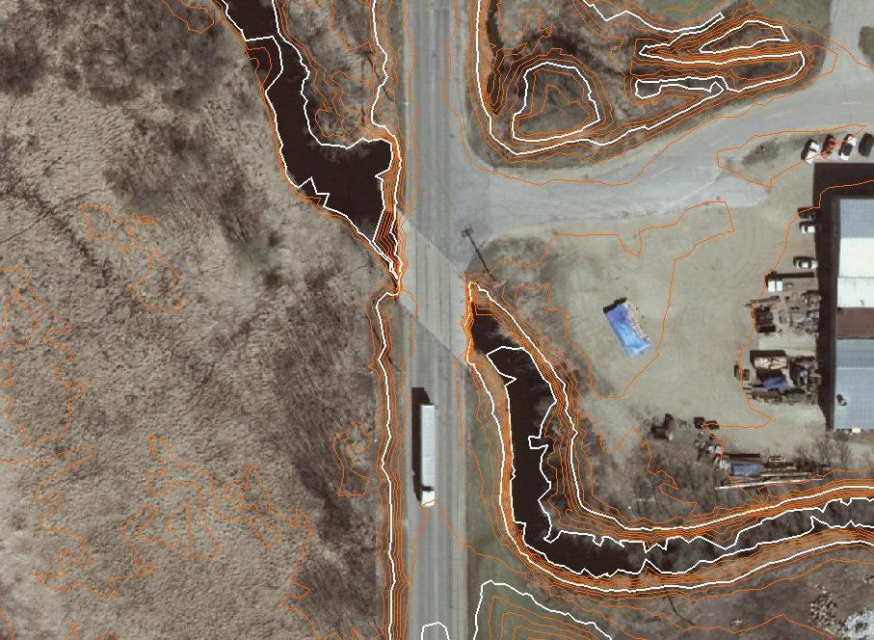
XY Location:
Northing: 485500
Easting: 2428440
Comment: Ground points left in surface causing improper contouring around structure.

XY Location:
Northing: 502300
Easting: 2513200
Comment: Ground points left in surface causing improper contouring around structure.

XY Location: Northing: 450600; Easting: 2497600
Comment: Ground points left in surface causing improper contouring around structure.
XY Location:
Northing: 495900
Easting: 2511300
Comment: Bridge classified using Class 1 (Non-Ground)…should be Class 14 (Bridge)
XY Location:
Northing: 477200
Easting: 2476400
Comment: Bridge classified using Class 1 (Non-Ground)…should be Class 14 (Bridge)

  - Minor edits are also evident throughout the project area with low points (point in storm sewers) that affect the surface accuracy of roads. In addition found a lone Model Keypoint in a water surface. Editing team should correct these errors and make a review of the ground surface for other minor imperfections when fixing the bridges. Sample of these minor issues is below along with the XY location
XY Location:
Northing: 516154
Easting: 2482167
Comment: Ground points in storm sewer affecting the road elevation. Also model keypoint has a point in the storm sewer that would also affect the surface elevation
XY Location:
Northing: 511425
Easting: 2470591
Comment: Single Model keypoint in water body.

- Review of Metadata
  - All Metadata files indicate units are meters – should be US Survey Feet
  - Datums for Classifed LAS should reflect NAD83 (2011) / NAVD88 (2012) and also a secondary delivery reflecting NAD 27 / NGVD 29
  - Contours and DTM should only reflect NAD 83 (2011) / NAVD 88 datums
  - DTM procedure indicated Class 8 being used. I believe the DTM uses Class 2 and/or both Class 2 and Class 8
  - Contours indicate the resolution of the vertical is 0.01 – should be 1 to indicate contour interval.
  - Contours indicated Class 8 was used to generate the contours – I believe based on the contour noise level that only Class 2 was used to generate the contours.
  - Metadata for DTM and Contours indicate that the format is ESRI Geodatabase but data delivered in DGN format.
- Review of Contours
  - Data delivered in wrong format
  - Data provided on wrong datum
  - Bridge Contouring issues – need breakline along each side to enforce the triangulation down to the road and/or water surface. See samples below on erratic contouring along removed bridge points.
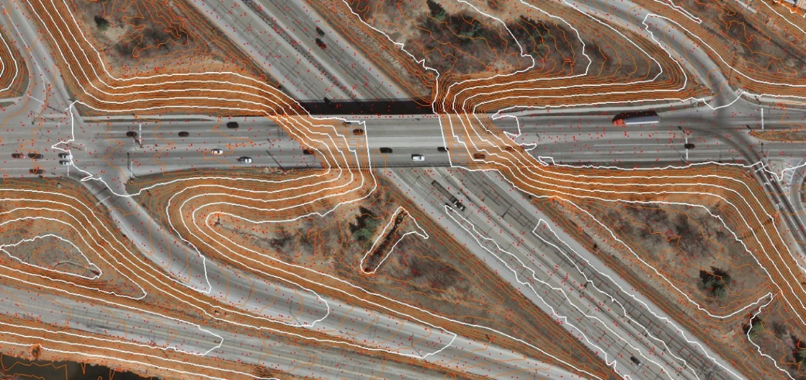
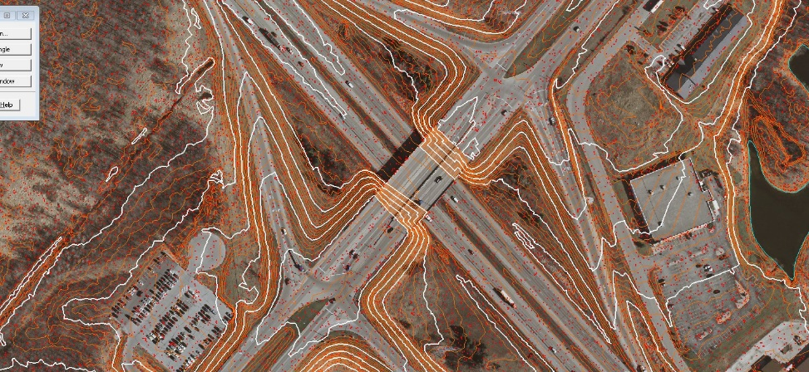
XY Location:
Northing: 487400
Easting: 2426200
2 Issues: Hydro breakline encroaches into the water body significantly. Also, the elevation of the breakline is approximately 1.5 feet lower than the classified water points.
Breakline: 956.000 feet
Water Elev. approximately 957.5 feet
  - Additional comments that require no action at this time:
    - Appears that Line Strings were used to generate the contours. Suggest using soft line strings in the contouring option to make easier transitions and less hard turns in the contouring process. Understand that the file sizes would slightly increase.
    - Model Keypoints – Points were generated but concerned that the points were generated based on a 2ft contour option instead of a 1ft. It appears that the Contour Keypoint algorithm was utilized with the settings of 2ft and 20ft which might be too general based on the screen capture below. Might look to reset contours keypoints to a 1ft option and possible 10ft to better characterize the topography with a greater accuracy.

- DTM Review
  - Data provided in wrong format
  - Data also provided on wrong datum
  - Quick review comment – Design file had wrong working units assigned. See screen capture below for future reference but is no factor since the data format will change:

December 9, 2015 – Review of Delivered LiDAR Data
In general the LiDAR classification, breakline compilation, contouring, and DTM development is acceptable at this time. There are still outstanding issues that will need to be addressed prior to full acceptance. The Commission has addressed them individually and are also providing shapefiles with descriptions addressing classification concerns.
Below itemizes the issues with the provided services:
Contour Review – The overall appearance is very good demonstrating accuracy and aesthetic smoothness. Overall the process used to generate the contours is acceptable and characterization of the topology is sufficient.
A few minor issues will need to be corrected prior to acceptance:
- A zero elevation breakline has been included affecting the contour generation which needs to be removed and new contours generated.

NAD83 Position:
X = 2394009ft; Y=556345ft

- Contouring filtering with removal of small contours are still evident throughout. Sample below show small contours of 27 ft² are evident. Agreed parameters of tops being 40ft² and depression that are 400ft² were to be filtered out. Regeneration of contours using provided parameters is necessary to remove analogous contours.

Breakline Review – It is acknowledged and appreciated regarding the collection of additional breaklines supporting the derivative services for this program. The additional breaklines are especially acknowledged supporting the contouring around water and bridge surface enforcement to ensure the contours are meeting accuracy standards. However, the breaklines have the greatest issues associated with the overall collection.
A few issues regarding breaklines:
- Overall all hydro breaklines appear to be 0.5 – 1.5 feet lower than expect terrain. See below for screen capture examples demonstrating the inconsistencies. It should be noted that the bridge breaklines are consistent with topology. The hydro breaklines might be a possible indexing related to finalization of the classified LAS files due to Geoid procedures.

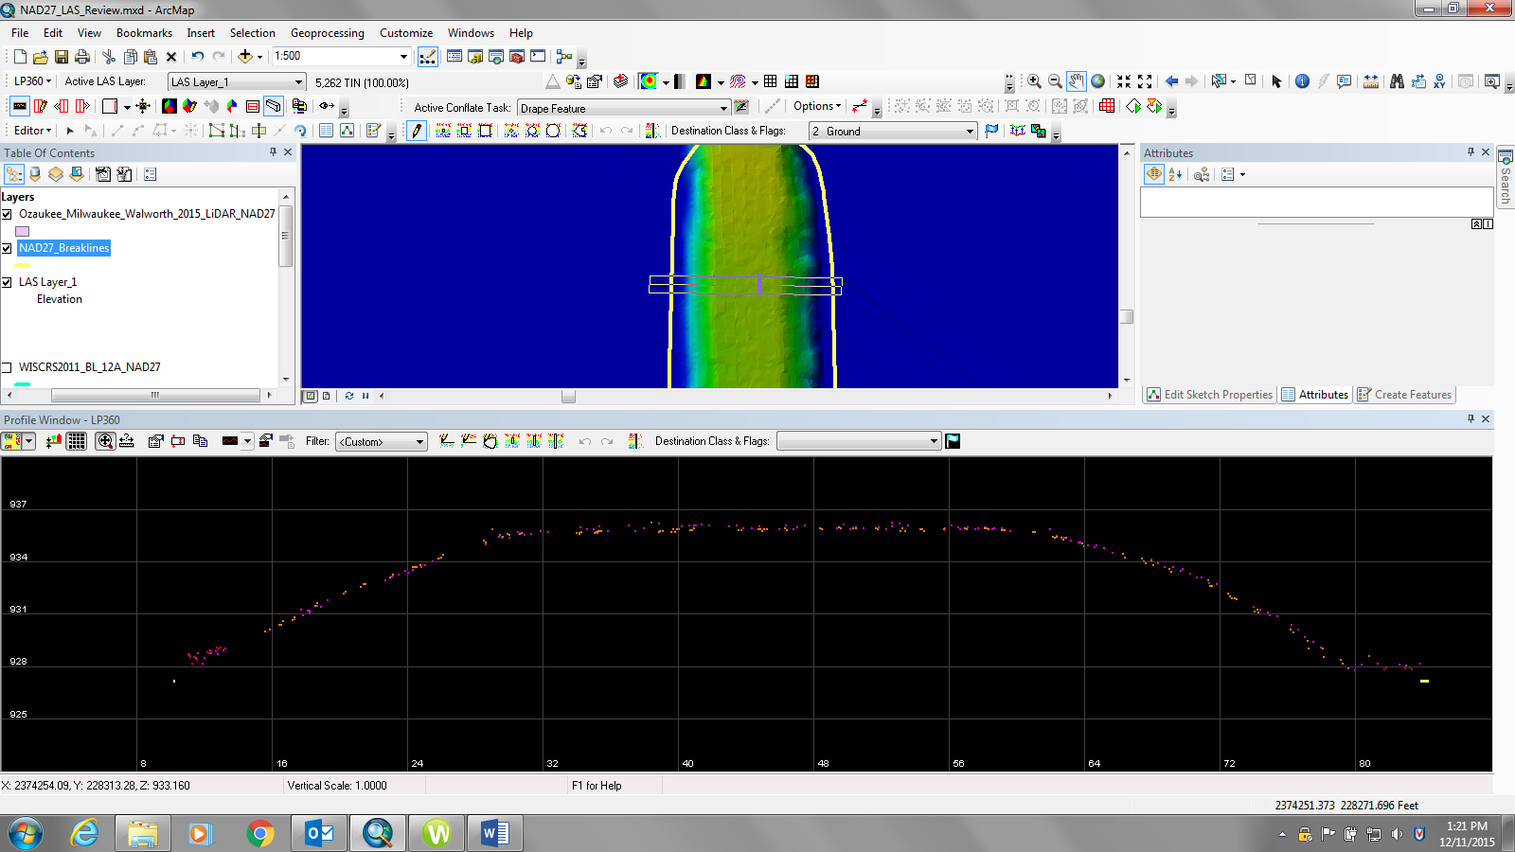
Breakline Elev: 926.831
Water Elev: 927.6

- A few bridge breakline were missed. Below is a screen capture demonstrating the isse when no breakline are used on shorter spans

- Breaklines in the city of Port Washington have been terminated leaving the breakwater wall classified as water and/or non-ground. Continue breaklines along these features and re-class to ground. Below is area of concern with 2015 Ortho with breaklines in red and also LiDAR point data by elevation with breaklines in red of the same area.

- Breaklines along dams need a line across the top and bottom and/or have closed polygons beginning and ending at the dam to properly enforce triangulation and minimize poor contouring around this hydro feature. See below demonstrating the issue.

- Single breakline has a 0 elevation and appears to be analogous. A simple removal of this breakline is required. See contour issue above for location.

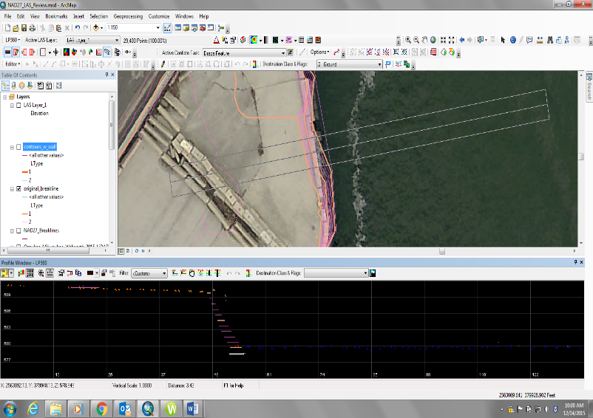
- Breaklines especially near walls have significant issues. The first issue is horizontal alignment accuracy. Most wall breaklines were collected well inside of the wall surface itself (i.e. breakline is placed in the water). The horizontal placement ranges anywhere from 3 – 10 feet off of apparent location which is cause numerous issues on the contour generation. Shown below is a location with both horizontal error and how the contouring looks when the breakline is enforced. The measured horizontal error on this sample below is 4.6 feet. The second major issue is the need to create a second breakline due to the significant vertical change and assurance of proper contouring around these features in meeting National Map Accuracy Standards. This second breakline allows proper enforcement and characterization of the topology around these specific wall features. The screen capture below shows what the contours look around this area. The Commisssion edited the existing line to locate it at the base of the wall iteself and placing the breakline at the water surface of 580.0. The second breakline was created using LP360-retaining wall conflation tool.

- Below demonstrates how the wall contours would look with use of the second breakline and proper enforcement..
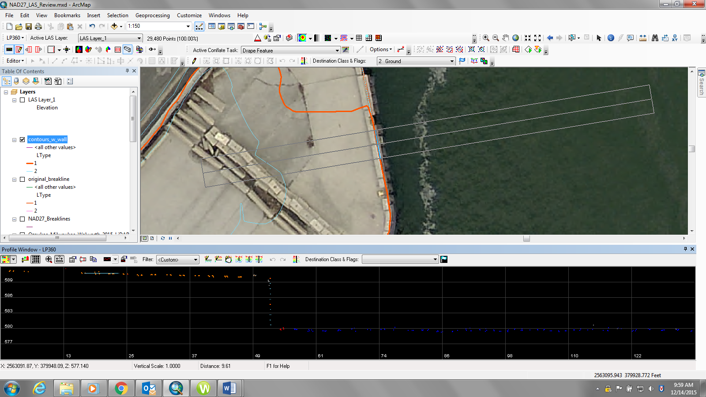

Additional Breakline Request:
- Could the Lake Michigan breakline be set to one elevation? Elevation range was 0.229 feet (578.689 to 578.918). Set elevation consistent for majority of shoreline based on LiDAR terrain to 580.0 feet profiling the existing LiDAR points. If one can set a consistent elevation then create a polygon that closes off any the lake beyond any subsequent tile so the lake can be properly enforced if future surface modeling is required?

Classification – A 10% review of all tiles were made in various geographical areas (urban vs suburban vs rural) and environmental (forested vs open lands) categories to understand the classification completeness. Overall, the classification was acceptable. Shapefiles are provided denoting the edit calls to be corrected prior to finalization of contour and DTM development. Below demonstrates the type of edit calls that were made in our review.
- Missing ground points and model keypoints. Need to put ground points back in surface supporting walls around collected breakline below.

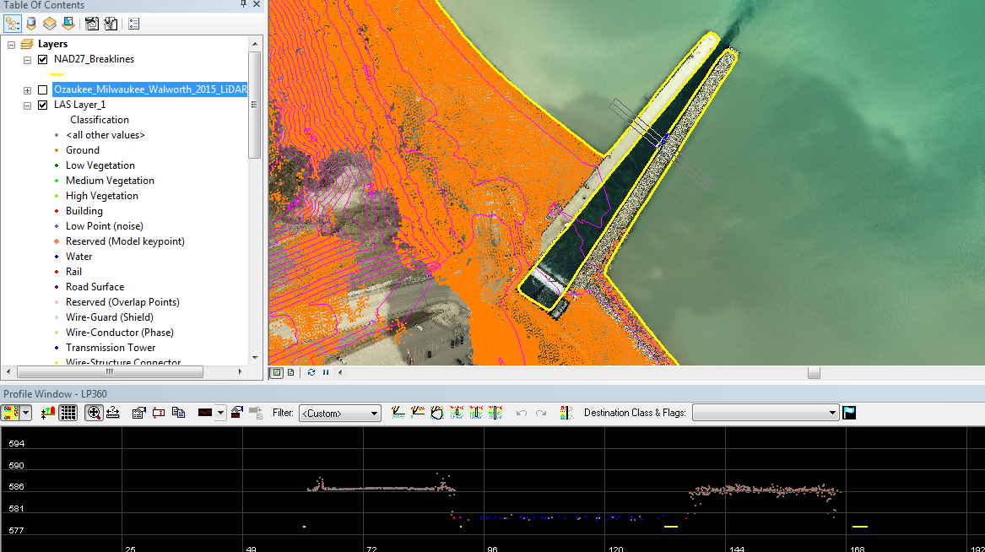

- Missing ground points around power plant. Smoke was causing a major ground obstruction on the primary flight line but the neighboring flight line(s) covered the ground well. Need to re-run ground around plant area to properly classify terrain. This mis-classification edit call was not in the shapefile but location was near the edit call location for ground points along the shoreline wall discussed above.

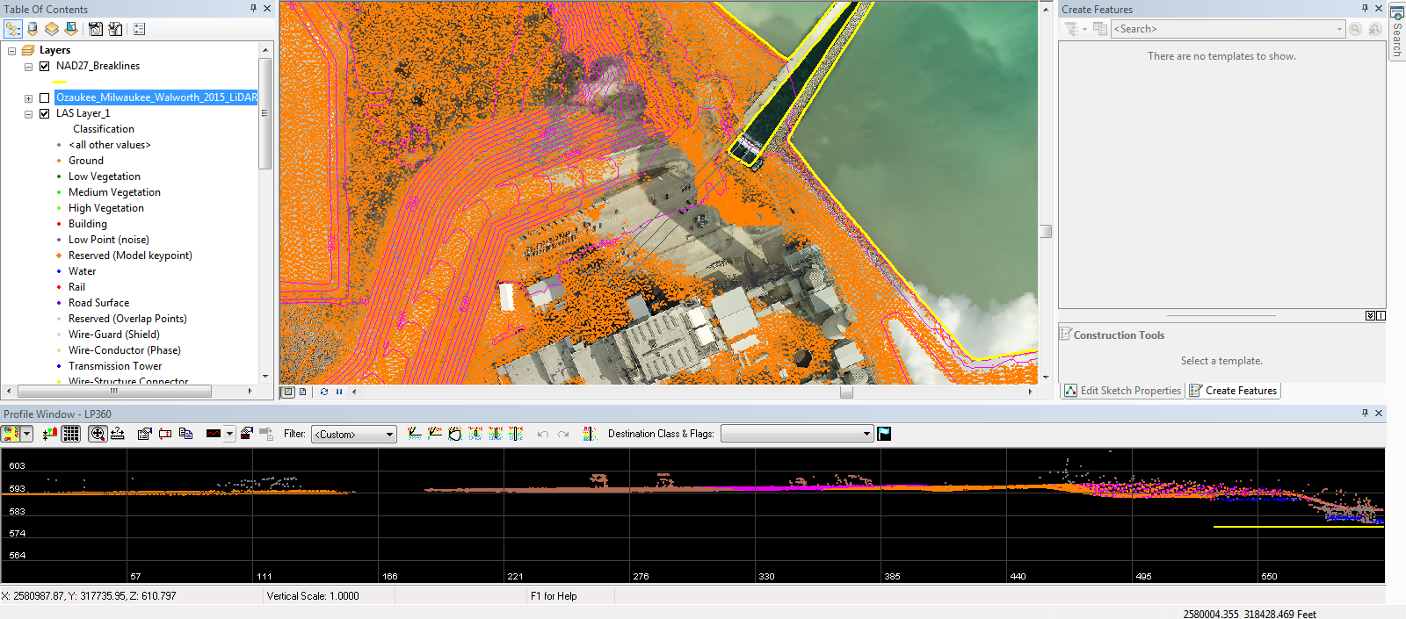

- Water points that were classed as ground. Need to re-classed points to water. These points are the tiles along Lake Michigan shoreline and are well out in the lake

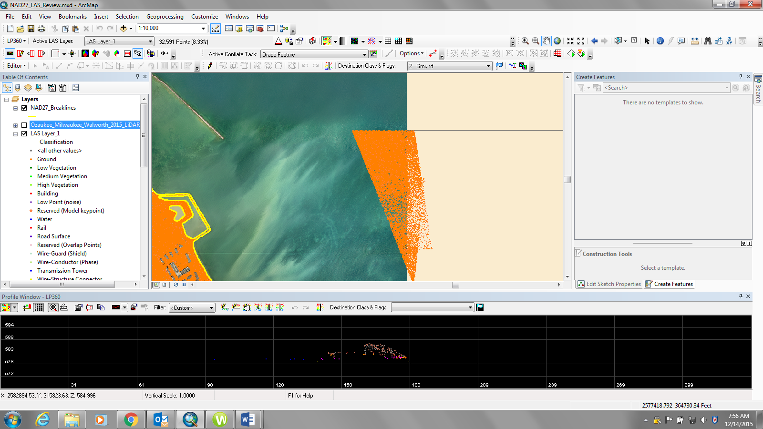

- All break water walls located along the near shoreline of Lake Michigan have been omitted. These wall need to be collected and a breakline captured around it consistent with the elevation of the shoreline for proper triangulation and contour generation for these missed features.

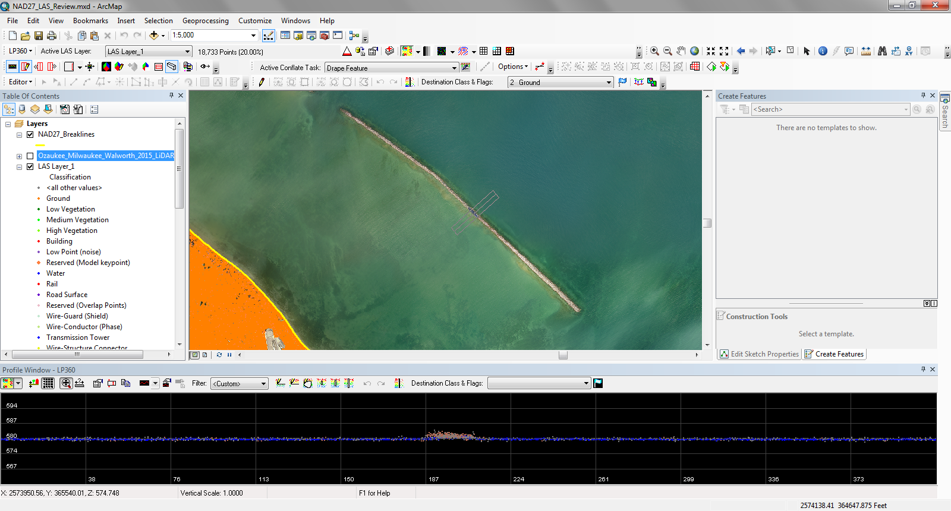

- Ground points missing causing the contouring to be affected.

Edit Call
FID - 10

- Missing ground points along a transportation wall that affects contouring and DTM surface modeling. See below regarding a sample effect of the ground macro peeling back the ground points along a vertical feature.

Edit Call
FID - 13

- Runway stripes seem to float above the average ground terrain based on the super reflective surfaces. See below of an example of the runway bias.

- Missing ground points in island breakline. Breakline capturing an island has been compiled but the ground points are missing. See below for an example.

- Some minor deck points in the QC review were found but overall the deck points were eliminated. Please look to clean up the QC deck call made on both files.

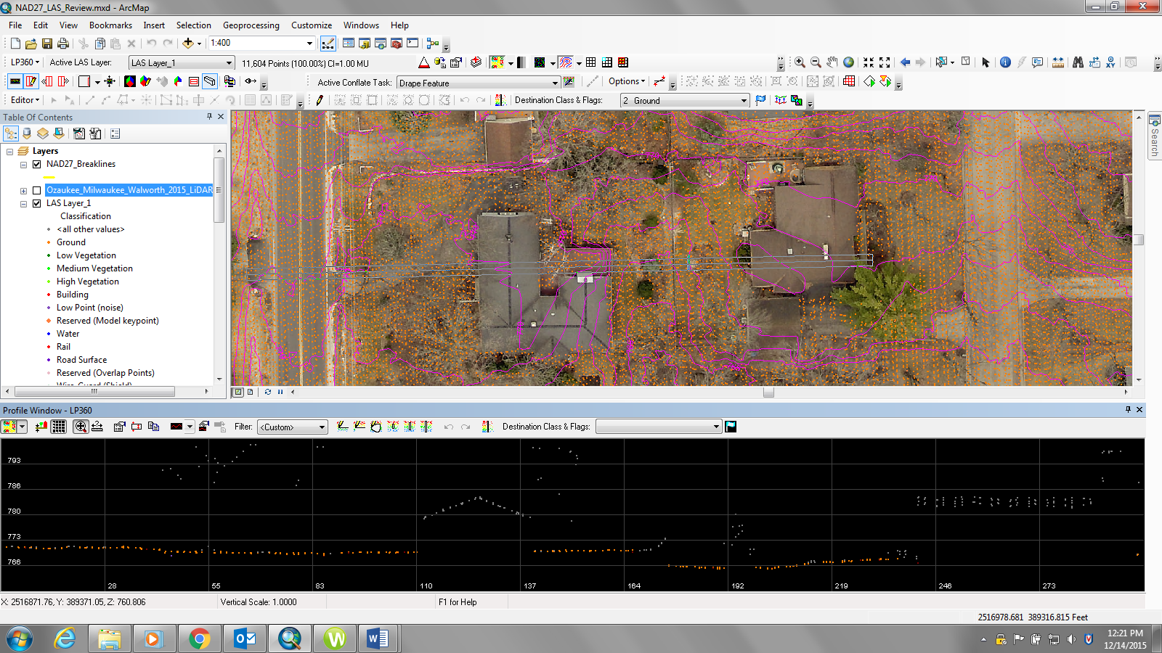

- Ground points in pools. In our 10% review we found a few pools that affected the contouring around a specific pool which the ground points should be removed. Below is a screen capture of the contouring affect with the pool. Edit calls were only made where ground points in pools affected the contours.

Review Comments on Survey Report December 18, 2015

The review of the “Field Survey Report of LiDAR and Imagery Ground Control & QC Points” dated August 27, 2015 documents discrepancies with respect to the coordinate listings, control validation/accuracy, and the LiDAR land cover categories as detailed by the FEMA guidelines.

- The first issue relates to the survey control. The provided control only references the North American Datum of 1983/2011 (NAD83/2011) horizontal and North American Vertical Datum of 1988 (NAVD88) vertical. The Ortho imagery and 3 of the 5 counties for LiDAR are contractually referenced to the North American Datum of 1927 (NAD27) horizontal and National Geodetic Vertical Datum of 1929 (NGVD29) vertical.

Please furnish final coordinate listings on both datums so the spatial data sets can be validated.

- The second discrepancy is in regards to understanding the overall accuracy achieved with the final coordinate listings. There is no mention of geodetic control whatsoever but it states the horizontal RMSE at 95% is within 0.017 feet and the elevation (Orthometric height) at 95% is within 0.011 feet. I believe this speaks more about the precision of the measurement/observation than its relationship to physical datums.

Note: One might be cautious about overstating the RMSE to hundredths of a foot at 95% confidence. If you are truly looking at this statistically, all outliers could consider measurements exceeding 3 sigma. If so, then you would have vertical measurements rejected with errors over 0.014 feet (stated 95% confidence of 0.011 feet for vertical) which would still be an excellent measurement precision.

Please provide the control closure differences between what was observed versus the published value on the individual control stations to demonstrate the accuracy as it relates to the specific datums. Please also provide the legacy control closure differences to validate the accuracy of the transformation that takes the NAD83/2011 and NAVD88 surveyed positions to the legacy datums.

- Each point location and quality data sheet had associated images of the type of land cover feature it supported. Based on the images, it was found that several images were inconsistent with the type of feature they were supporting. The first example found on the second page of this report documents that the land cover category specified was “Tall Weeds”, and Examples 2 and 3 were considered “Forest” points.

Example 1
Example 2

Example 3

Please review associated images to ensure proper labeling of land cover types prior to completing the Vertical Accuracy Report according to FEMA guidelines.

Quick Review Comments on Delivered Data - April 18, 2016

Milwaukee County – NAD27 / NGVD29

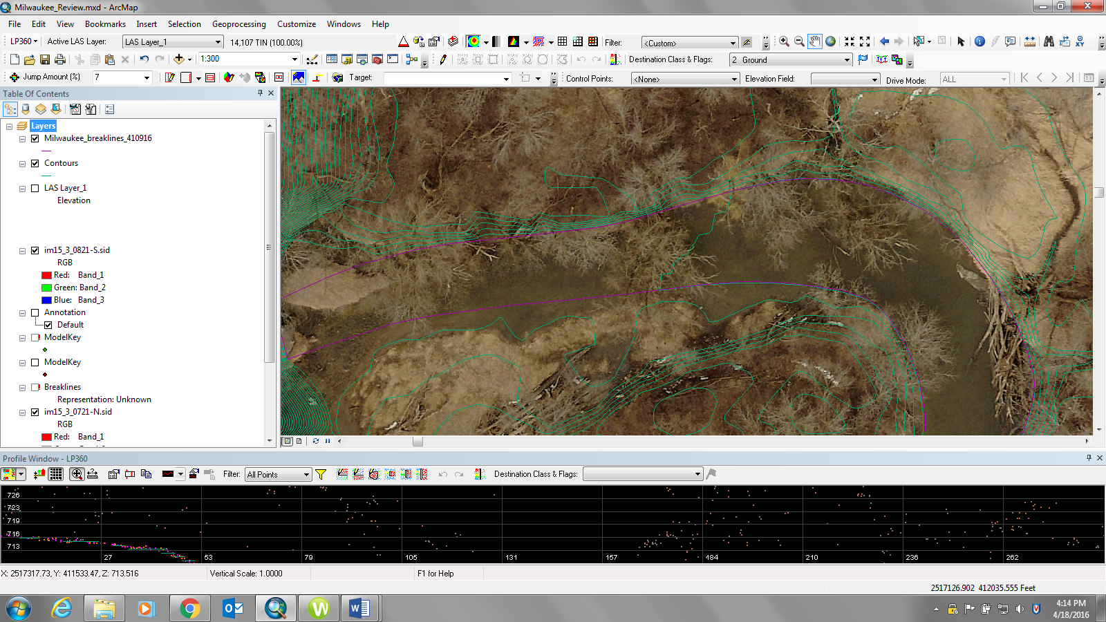
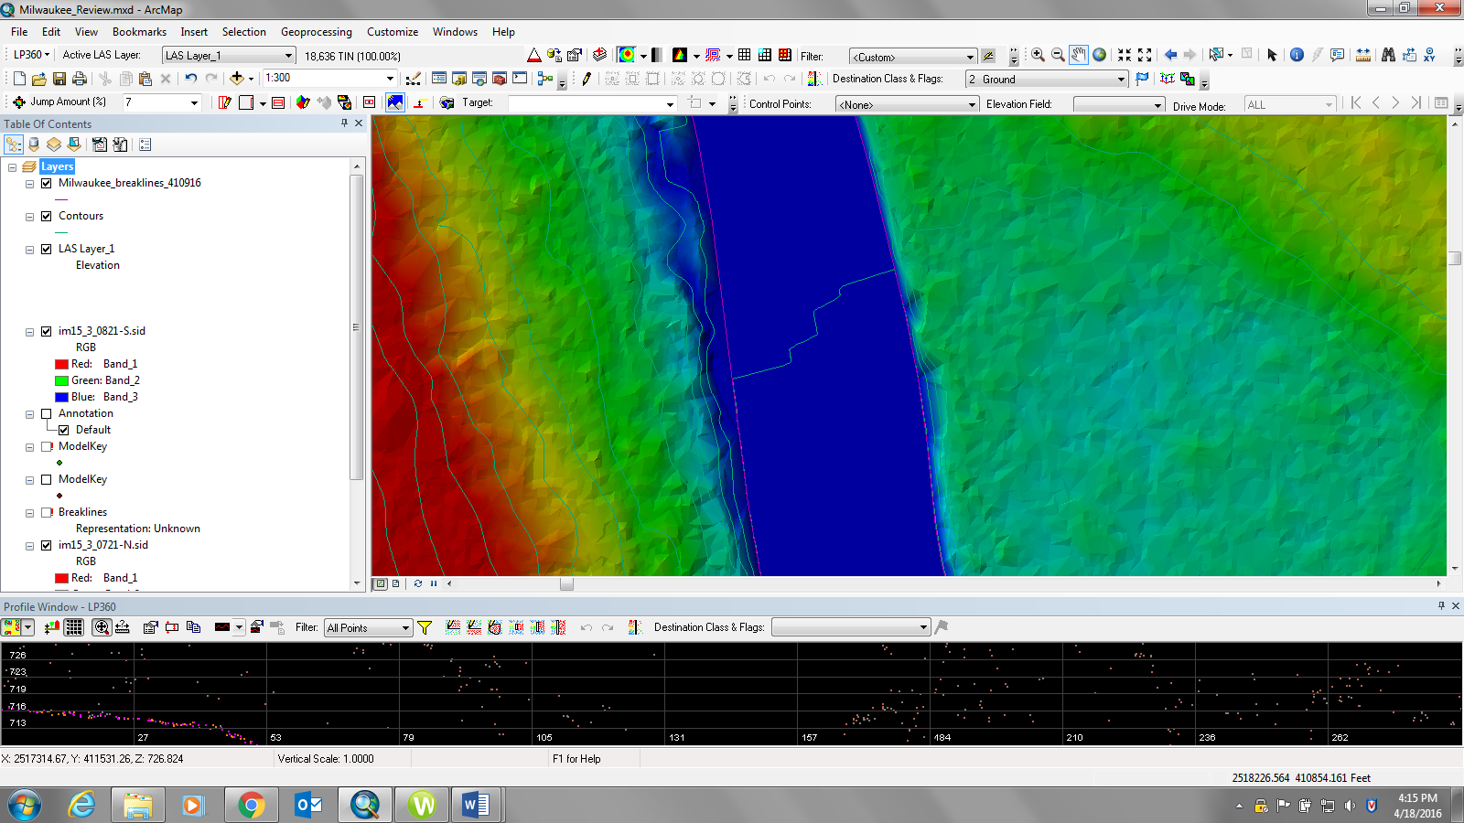
Points outside of breakline. Shoreline has points cleared but the breakwater wall did not have any points cleared away from breakline.

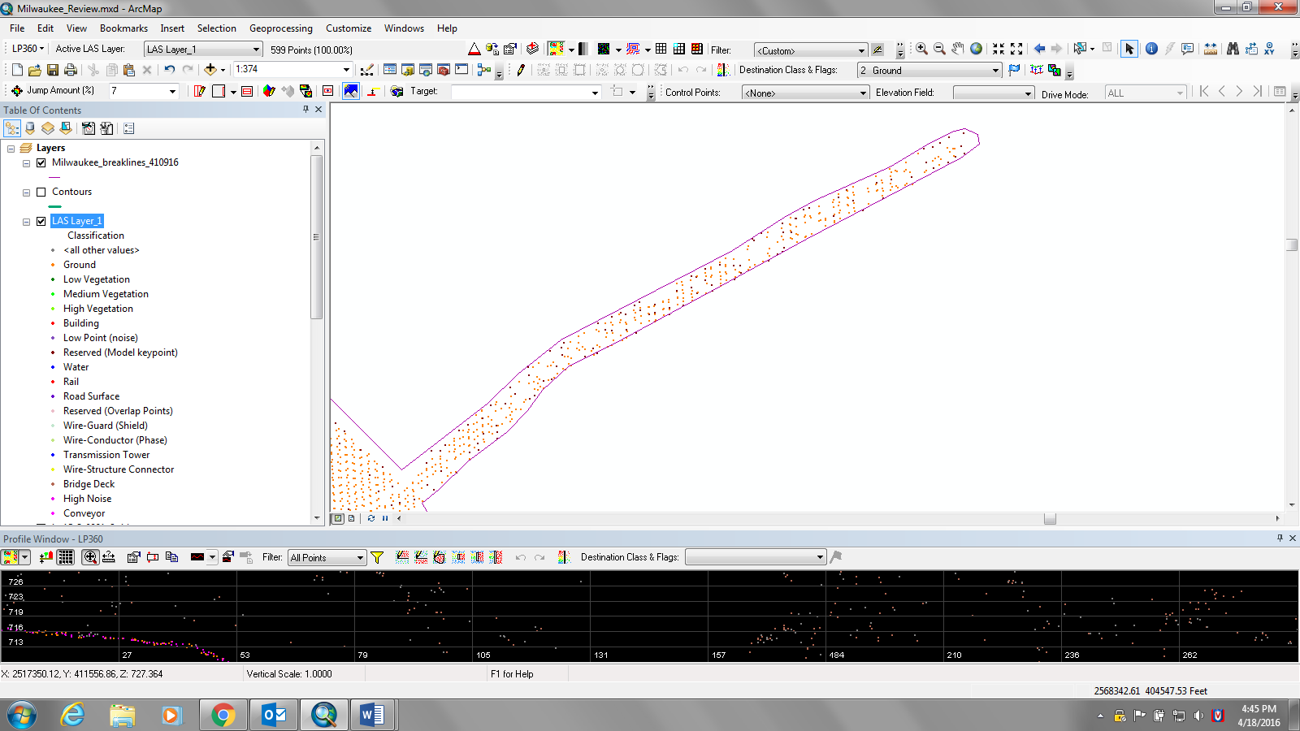

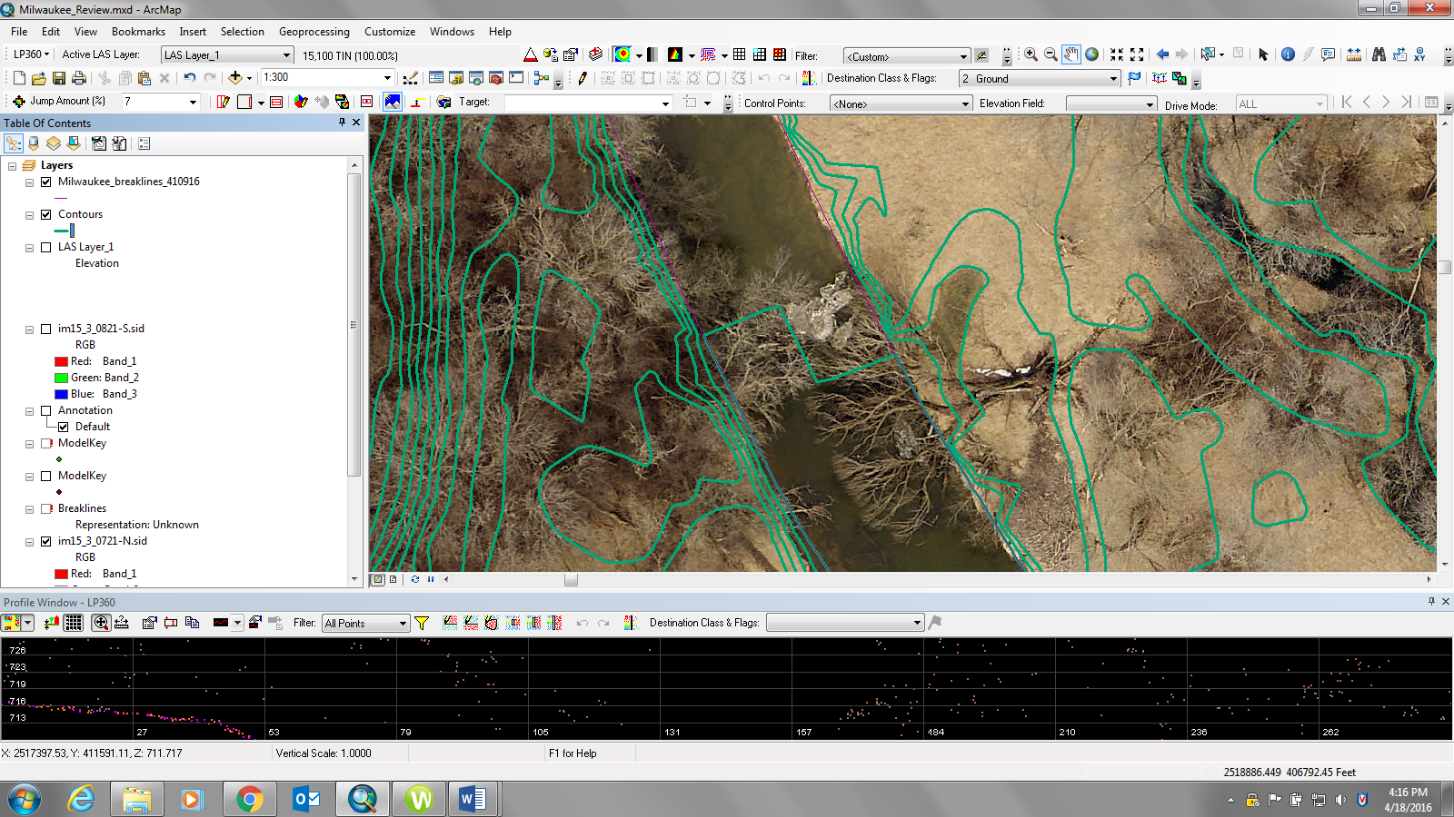

Washington County – NAD83 /NAVD88
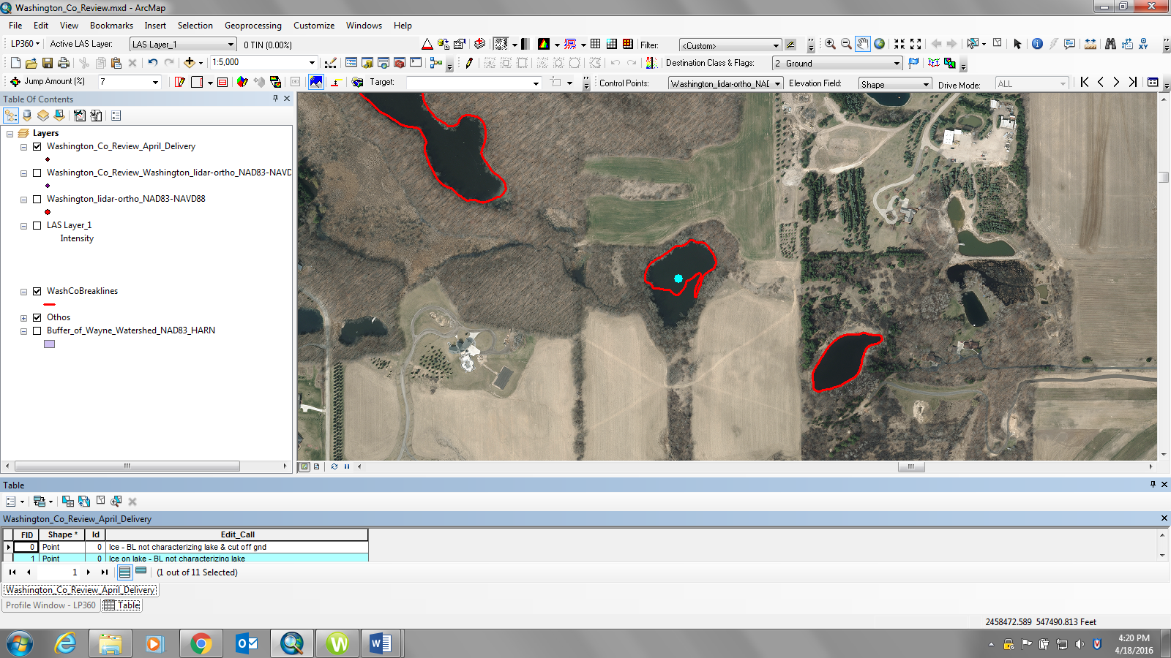
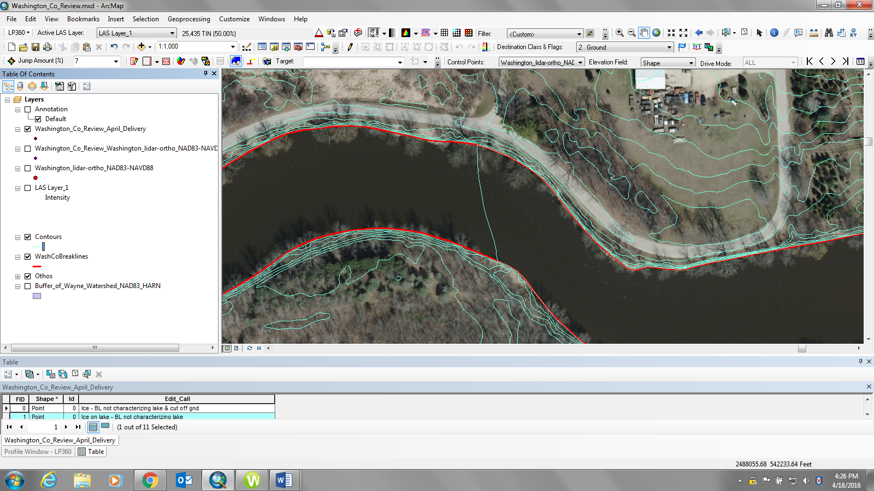

Single Tile delivery Review that Resulted in a Complete Redelivery – June 16, 2016

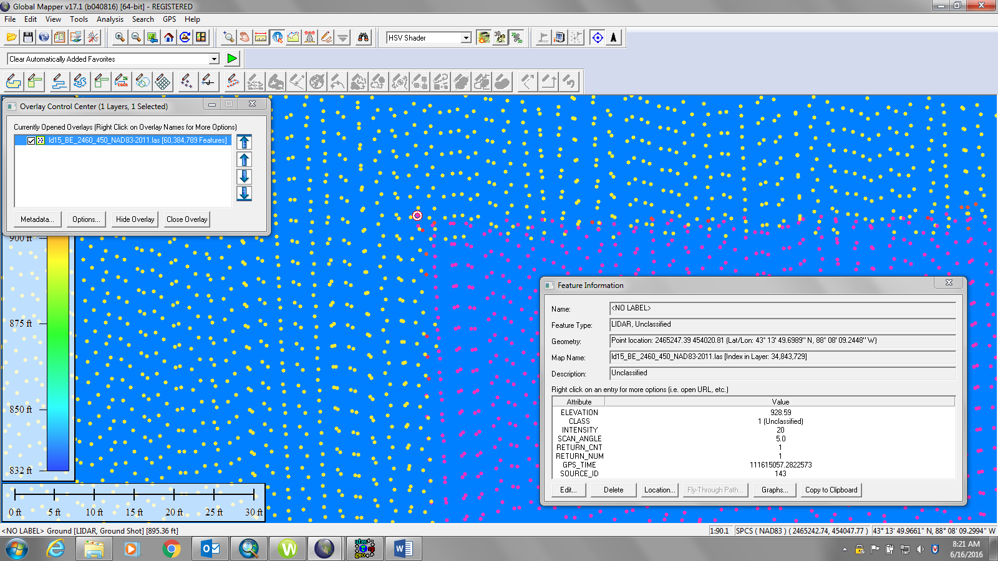
ND83/2011 TILE (ld15_BE_2460_450_NAD83-2011.las)

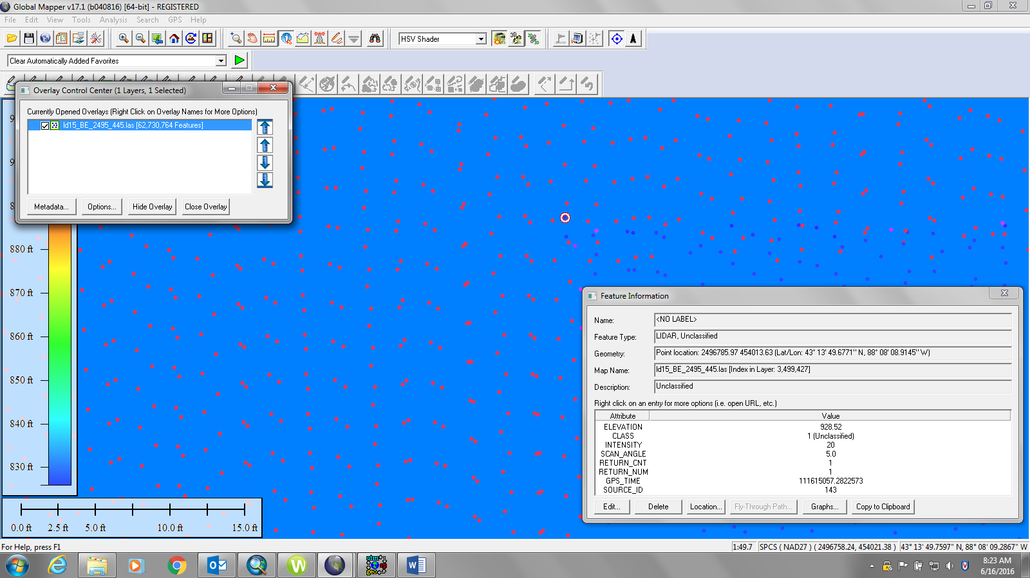
NAD27 Tile (ld15_BE_2495_445.las)

Converting from NAD83/2011 to NAD27, the sample point computed found is inconsistent between datums:

NAD83/2011 NAVD88 | NAD27 NGVD29 | Corpscon (83HARN to 27; 88 to 29) | Corpscon (83 to 27; 88 to 29) | Delta-Corpscon HARN to Pub. 27/29 | Delta-Corpscon to Pub. 27/29
454,020.81 | 454,013.63 | 454,012.638 | 454,013.608 | -0.992 | -0.022
2,465,247.39 | 2,496,785.97 | 2,496,785.322 | 2,496,785.977 | -0.648 | +0.007
928.59 | 928.52 | 928.82 | 928.820 | +0.300 | +0.300

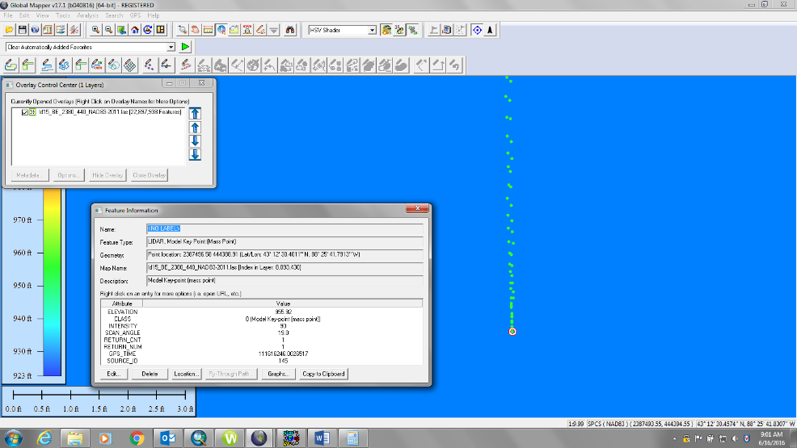
NAD83/2011 Tile (ld15_BE_2380_440_NAD83-2011.las)

NAD27 Tile (ld15_BE_2415_435.las)
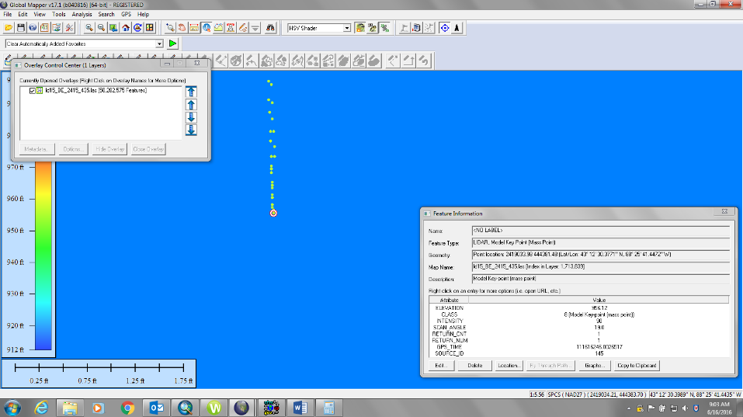

Converting from NAD83/2011 to NAD27, the sample point computed found is inconsistent between datums:

NAD83/2011 NAVD88 | NAD27 NGVD29 | Corpscon (83HARN to 27; 88 to 29) | Corpscon (83 to 27; 88 to 29) | Delta-Corpscon HARN to Pub. 27/29 | Delta-Corpscon to Pub. 27/29
444,388.91 | 444381.48 | 444,381.466 | 444382.296 | -0.014 | +0.830
2,387,496.58 | 2,419,033.98 | 2419033.985 | 2419034.551 | +0.005 | +0.566
955.92 | 956.12 | 956.117 | 956.117 | -0.003 | -0.003

* * *

RWM
[Worldox # – File Name]

Enclosure (#xxxxxx)

cc:

