

CASPER WY
2015 ORTHOIMAGERY PROGRAM
GROUND CONTROL SURVEY PROCEDURES

December 22, 2015

PROJECT LOCATION MAP

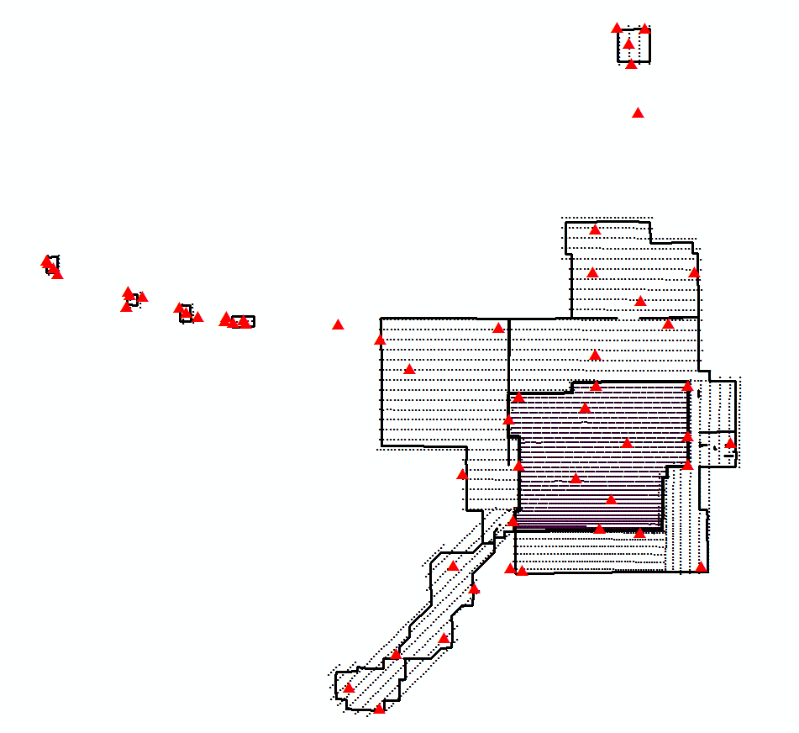

SURVEY METHODS, MEASUREMENTS AND EQUIPMENT

58 photo identifiable points were established within project area to be used in Aerial Triangulation process. Points were divided into 2 groups: existing photo identifiable points and targeted points. Vinyl targeting material was used to establish chevron shaped targets with the semi-permanent control point at the outside tip of the target. GPS base station was set up for all surveys at the NGS monument NR0224. Rover receiver was used to establish 58 photo identifiable points within project area. Surveys were tied to 2 other NGS monuments: NR0223 and AA2138 and CORS station: WYRF (DO2064). See attached NGS sheets, pictures and sketches for point detail. It was found that NR0223 NGS monument’s observation was shifted northerly wrt published value; therefore, this monument was used as check only.

The equipment configuration for this project consists of industry standard GPS surveying equipment. The GPS equipment used was Trimble 5700 dual frequency(L1/L2) receivers with Zephyr Geodetic antennas. Regular tripod was set at the base station. Variety of methods were used to observe rover data due to complexity of photo identifiable features. Each GPS observation was logged for site id, receiver id, height of antenna, start and end time and date.

Trimble Business Center v3.10, 3 dimensional adjustment software was used for processing collected observations. Three NGS monuments: NR0224, NR0223 and AA2138 and one CORS station: WYRF (DO2064) were implemented into adjustments performed. An independent quality control check on selected surveys were performed with an OPUS solution, to verify acceptable results, see attachment for details. The CORS station network is poor in Wyoming; therefore, OPUS solutions are of lesser reliability, but serve a good purpose as a sanity check. First surveys were processed with NGS published NAD83-2011, NAVD88 coordinates. OPUS checks were made and coordinates were verified. Second, NGS published NAD83-HARN(1993) coordinates were used to shift network from NAD83-2011 to NAD83-HARN. Third, we have used 9 local NGS monuments and NADCON official NGS utility to compute offsets between NAD83-HARN and NAD83-1986 horizontal datum. The values were averaged and applied to the GPS base station NR0224 and all surveys. See attached NADCON conversion screen captures for details and spreadsheet with averaged shift values. NAD83-1986 coordinates were outputted out of TBC adjustment software.

