**January 15, 2016**

**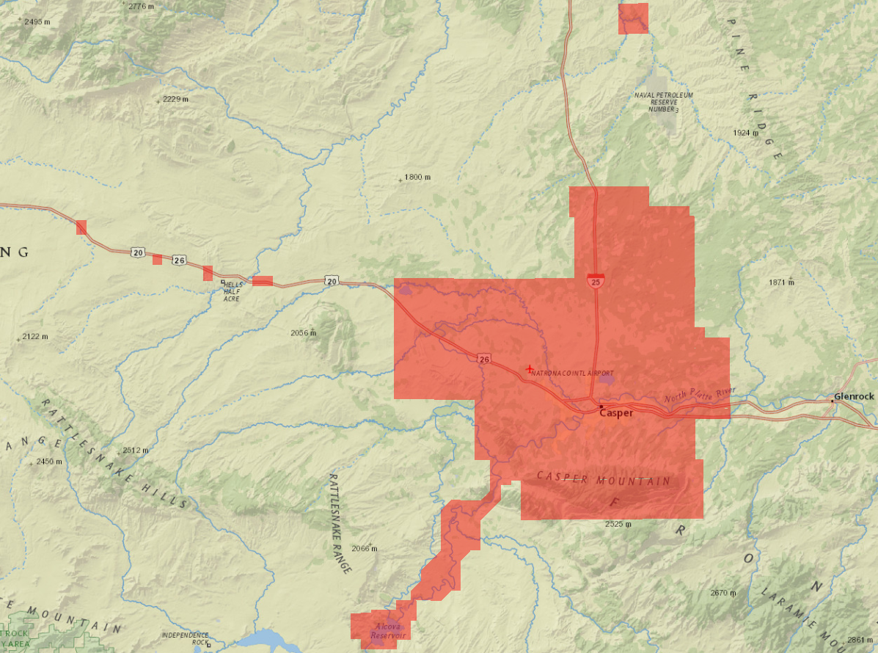**

Contents

[EXECUTIVE SUMMARY 3](#_Toc441223577)

[1 INTRODUCTION 4](#_Toc441223578)

[1.1 Purpose of the Survey 7](#_Toc441223579)

[1.2 Duration/Time Period 7](#_Toc441223580)

[1.3 Personnel 7](#_Toc441223581)

[1.4 Equipment 8](#_Toc441223582)

[1.5 Field Procedures 8](#_Toc441223583)

[1.6 Contact 8](#_Toc441223584)

[1.7 Accuracy requirements 9](#_Toc441223585)

[1.8 GPS Network 9](#_Toc441223586)

[2 PROJECT AREA SCOPE AND DETAILS 10](#_Toc441223587)

[2.1 Monuments and Station Naming 11](#_Toc441223588)

[3 CONDITIONS AFFECTING PROGRESS 11](#_Toc441223589)

[4 POST PROCESSING 12](#_Toc441223590)

[4.1 Baseline Processing 12](#_Toc441223591)

[4.2 NGS points evaluation 13](#_Toc441223592)

[4.3 OPUS solution test 13](#_Toc441223593)

[4.4 NAD83-2011 to NAD83-1986 adjustments 17](#_Toc441223594)

[4.5 NAD83-1986 investigations 22](#_Toc441223595)

[5 Final Coordinates and Elevations 24](#_Toc441223596)

[APPENDIX A 25](#_Toc441223597)

[APPENDIX B 26](#_Toc441223600)

[APPENDIX C 27](#_Toc441223602)

[APPENDIX D 28](#_Toc441223604)

[APPENDIX E 29](#_Toc441223606)

[APPENDIX F 30](#_Toc441223608)

**EXECUTIVE SUMMARY**

Sanborn Map Company is contracted with the City of Caper WY to acquire new color digital Orthophotography and LiDAR data of the project area totaling 812 square miles of City of Casper, WY and neighboring areas. The area has been divided into following subsets: three inch orthoimagery covering 208 square miles, six inch orthoimagery covering 604 square miles and USGS QL2 LiDAR covering 354 square miles.

The purpose of this survey was to establish the locations of ground control points (GCP) for the 2015 Casper WY Orthophotography and LiDAR calibration processes. Fifty six (56) control points were identified throughout project area. All points were surveyed by “Fast Static” GPS methods.

The local network was designed, processed and adjusted using Trimble Business center (TBC) version 3.10. Final horizontal coordinates are provided in State Plane Wyoming East Central coordinates based on the North American Datum of 1983, 1986 adjustment. Orthometric elevations were based on the GEOID 12A and are provided on the North American Vertical Datum of 1988 (NAVD88). All units are provided in US survey feet.

The survey’s field observations began on April 12 2015 and end on November 03 2015. GPS baselines were measured with a minimum of 30 minutes for shorter lines and were extended accordingly for longer baselines. The final adjustments were constrained to HARN network of NGS monuments and CORS station found in the project area, with quality control checks made by submitting the GPS data to the NGS “Online Positioning User Service” (OPUS).

## PROPINSET_31 INTRODUCTION

This report contains the technical write-up of the differential GPS surveys performed for the ground control photo control and LiDAR calibration points in support of orthophotography collection and high-resolution digital elevation model developed from LiDAR data for the 2015 Casper project.

Sanborn was responsible for the preparation of this report, all fieldwork including reconnaissance of existing control points, establishment of additional control points, LiDAR calibration points, GPS surveys, all GPS data processing and reductions.

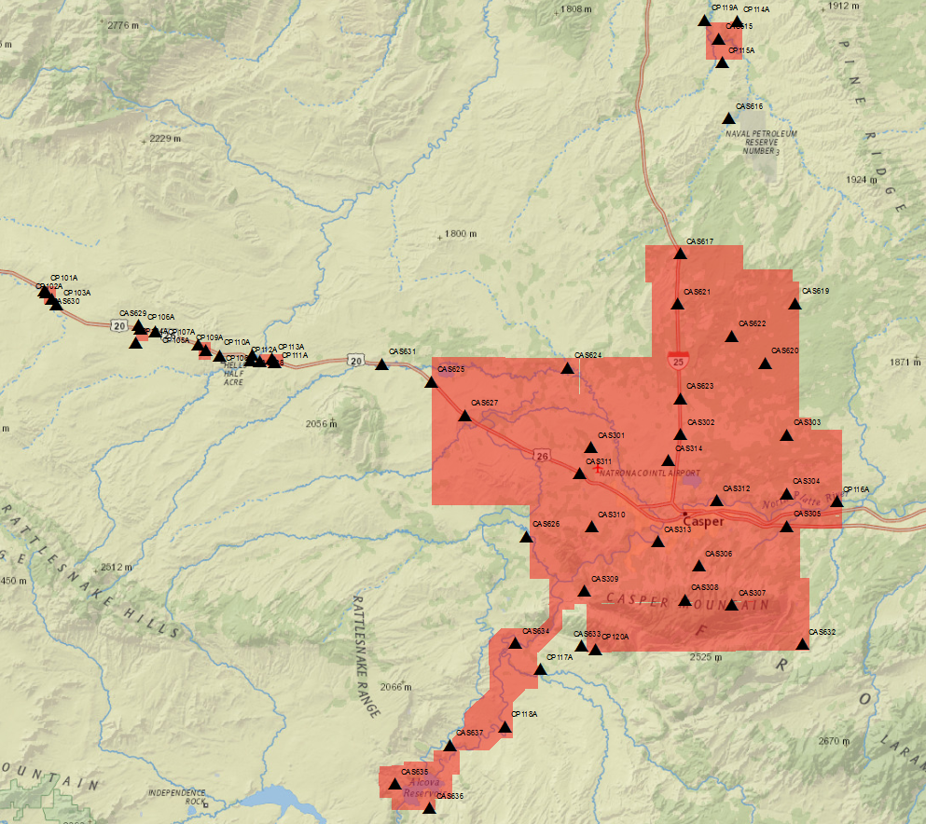

Figure 1: Project Layout with Control Points.

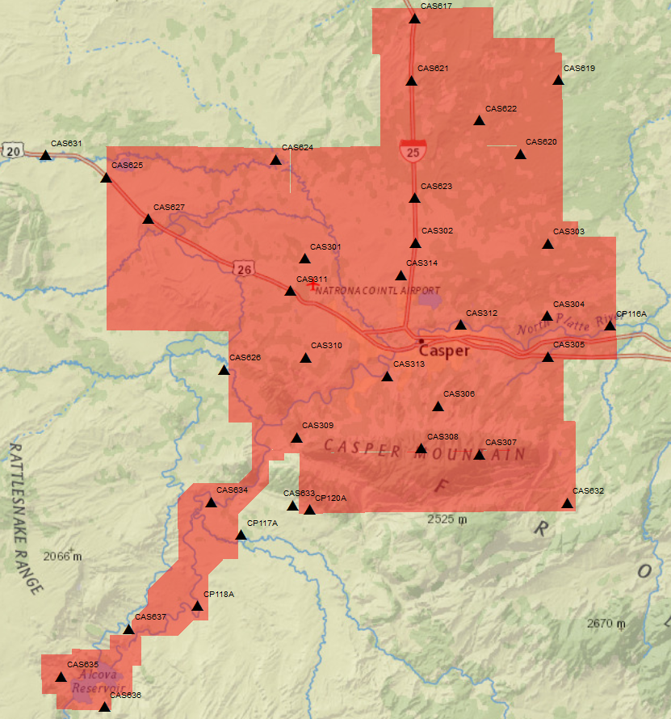

Figure 2: Main body (zoomed in) project Layout with Control Points.

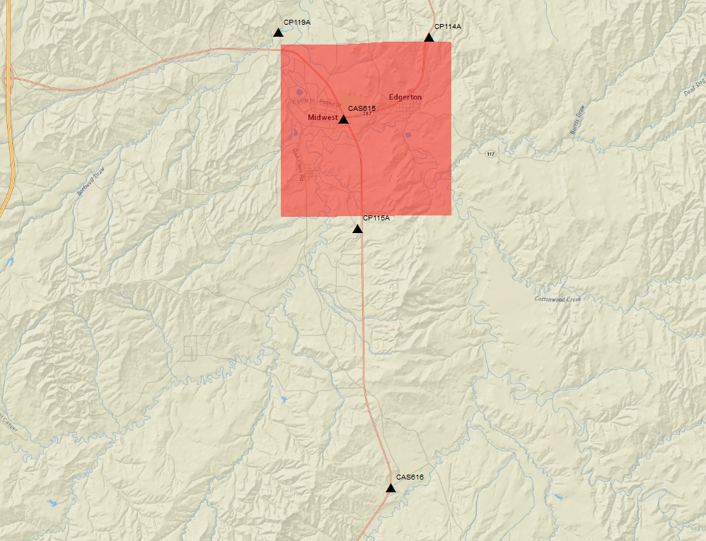

Figure 3: Northern portion (zoomed in) project Layout with Control Points.

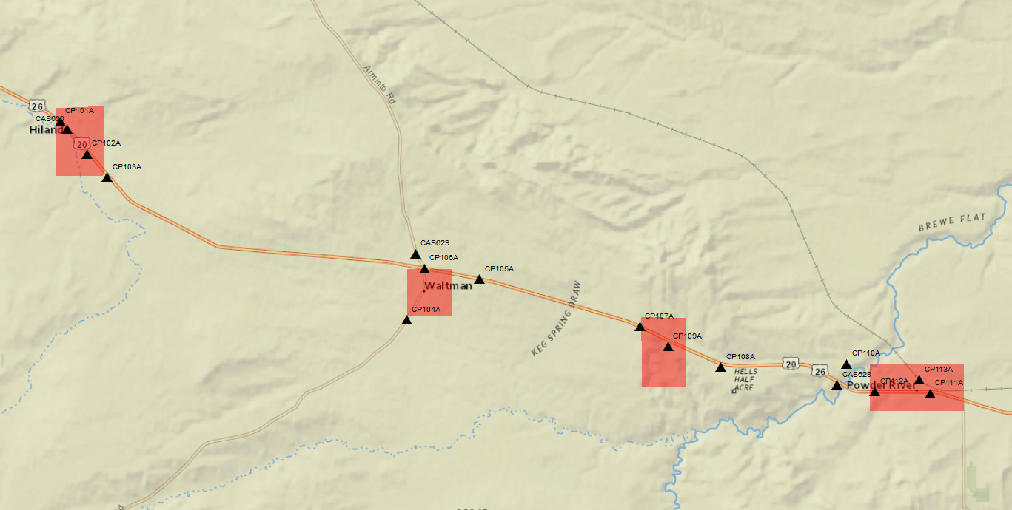

Figure 4: Western portion (zoomed in) project Layout with Control Points.

## Purpose of the Survey

The GPS Network surveys were designed to provide ground control for photo aerial collection and high-accuracy LiDAR data collection of the Casper mapping project. The 2015 Casper network consists of sixty one (61) control stations. The network includes two (3) NGS monuments: AA2138, NR0223 and NR0224, one (1) ABGPS base station point: CASPER\_APT, used for aerial collections, fifty six (56) control points, and one (1) CORS station WYRF, see APPENDIX A for adjusted coordinates and APPENDIX C for point recovery sheets. The horizontal and vertical datum of the local GPS network is based on HARN network and published values of the above listed NGS monuments. Final adjusted coordinates were shifted horizontally to achieve project required NAD83-1986 horizontal datum.

Casper control was designed to serve as both photo ID and LiDAR calibration control where both sensors are used. In these areas both below mentioned approaches were used in control design process.

Photo identifiable control points were strategically placed throughout the project area to serve in aerial triangulation (AT) process to build final orthophotography product. See APPENDIX C for point pictures and sketches.

The LiDAR calibration points were established throughout project area to serve in LiDAR data processing and adjustments. One (1) class of calibration points was surveyed throughout the project area: Bare Earth class. Calibration points were positioned with the intent of accomplishing even and random point distribution over the area of interest. See APPENDIX C for point pictures and sketches.

## Duration/Time Period

The acquisition of ground control and calibration points control was completed between April 12 2015 (Julian day 102) and November 03 2015 (Julian day 307).

## Personnel

Sanborn field data acquisition technicians are cross-trained as Survey Technicians as well as Airborne Sensor Operators to maximize their utility.

Table 1. Survey personel

|  |  |
| --- | --- |
| Field Survey Personnel | |
| Name Function | |
| Randy Jakus | Sensor Operator/ Survey Technician |
| Chris Larson | Sensor Operator/ Survey Technician |

## Equipment

The ground control survey was performed using survey grade L1/L2 GPS antennaes attached to adjustable height tripods with tribrach. The antennas include:

Trimble 5700 receivers with Zephyr/Zephyr Geodetic Antenna

## 1.5 Field Procedures

A careful reconnaissance was undertaken prior to the monumentation and subsequent GPS survey. Most of the points in the network have good satellite visibility. The satellite window provided 24–hour coverage, and GPS observation sessions were scheduled between 7:00 am and 7:00 PM, local time, each day. No difficulties were experienced with solar storm activity. All baseline processing, analysis, and preliminary reductions were performed on a daily basis, thus allowing for continuous quality control.

The GPS control survey was set up as a fast static at 1.0s logging rate. Field crew members followed a session schedule established by office personnel to facilitate observation location and duration, which were at least 30 minutes per session for surveys. Personnel navigated to points using hand-held GPS receivers, USGS Quadrangle maps and state road maps. The hand-held GPS receivers had approximate geodetic coordinates loaded for the required observation points. Upon arriving at the desired location, the field personnel initiated a search for an adequate calibration point location that was in a GPS “friendly” spot. The receiver was set on the tripod and leveled over the point. The following information was recorded: control point name and code, stamping if available, date, Julian date, observer name, receiver model & serial number, antenna type, where the antenna height was measured to, antenna height, start time, end time, site sketch with ties. The data file name is also included on this sheet. The file name convention is SSSSJJJf.dat, where “SSSS” is the last four digits of the receiver serial number, “JJJ” is the Julian date, and “f” is the data file number for that day’s work. “f” = 0 for the first file, 1 for the second and so on. See APPENDIX F with field logs for details.

Digital photographs or sketches were taken at each point showing the calibration point surveyed and its relationship to its surroundings.

## 1.6 Contact

Questions regarding the technical aspects of this report should be addressed to:

**Sanborn**

1935 Jamboree Drive, Suite 100

Colorado Springs, Colorado, 80920

Attention: Shawn Benham Project Manager

Karol Szczubelek Geodetic Engineer

Telephone: (719) 593-0093

FAX: (719) 528-5093

## 1.7 Accuracy requirements

The final horizontal datum NAD 83 yielded 2 sigma (95%) station confidence levels of less than 0.10 US ft horizontally (X, Y) and vertical datum NAVD88 of less than 0.20 US ft vertically (Z).

## 1.8 GPS Network

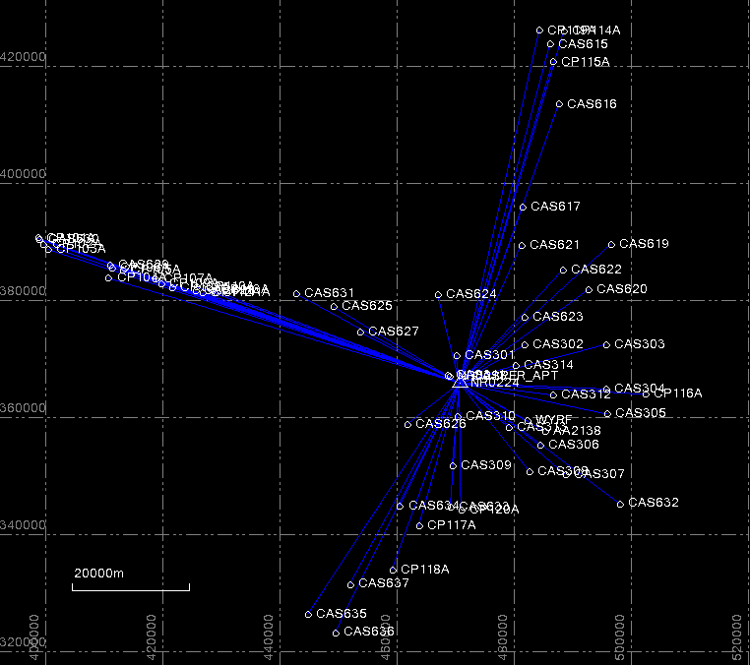

Figure 3: GCP Network Diagram.

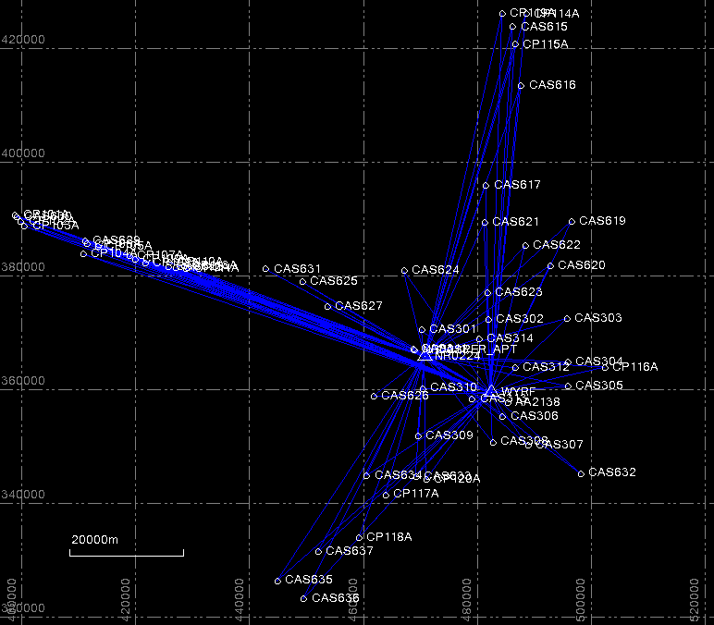

Figure 4: GCP Network Diagram with WYRF CORS.

## PROPINSET_32 PROPINSET_3PROJECT AREA SCOPE AND DETAILS

Sanborn Map Company is contracted with the City of Caper WY to acquire new color digital Orthophotography and LiDAR data of the project area totaling 812 square miles of City of Casper, WY and neighboring areas. The area has been divided into following subsets: three inch orthoimagery covering 208 square miles, six inch orthoimagery covering 604 square miles and USGS QL2 LiDAR covering 354 square miles.

The purpose of this survey was to establish the locations of ground control points (GCP) for the 2015 Casper WY Orthophotography and LiDAR calibration processes. Fifty six (56) control points were identified throughout project area. All points were surveyed by “Fast Static” GPS methods.

## Monuments and Station Naming

The GPS Network surveys were designed to provide ground control for photo aerial collection and high-accuracy LiDAR data collection of the Casper mapping program. The 2015 Casper network consists of sixty one (61) control stations total. Three NGS monuments were used in the Casper local network: AA2138, NR0223 and NR0224. PID identifiers of the NGS published monuments were used for naming purposes. CORS ID designation was used for CORS station used in Casper network: WYRF (PID: DO2064). New control was designated by following codes: CAS301 thru CAS637 and CP101A thru CP120A. See APPENDIX A for adjusted coordinates and APPENDIX C for points pictures and sketches. The horizontal and vertical datum of the local GPS network is based on High Accuracy Reference Network (HARN) and published values of the below listed NGS monuments. See APPENDIX C for pictures and sketches.

## CONDITIONS AFFECTING PROGRESS

A careful reconnaissance was undertaken prior to control selection and subsequent GPS surveys. Most of the points in the network have good satellite visibility. The satellite window provided 24–hour coverage, and GPS observation sessions were scheduled between 7:00 am and 7:00 PM, local time, each day. No difficulties were experienced with solar storm activity, KP index was under 4. NR0223 NGS point observation has not checked good with published values of the NGS monument. Both components of horizontal coordinates were off, but the OPUS solution returned good, conforming solution. Possible tripod cave in or arborous tripod set up could be the cause. This observation has not been used in adjustments.

## 4 POST PROCESSING

## 4.1 Baseline Processing

All static baselines and vectors for Casper project were processed using Trimble Business Center (Ver. 3.10) (TBC) software. Fixed solutions were adopted for all baselines using the precise ephemeris. GEOID12A was incorporated into the reductions, thereby allowing rigorous interpolation of the geoidal undulation values (N) at each point in the network. This provides a useful method of estimating the elevations at all points in the network. For baseline processing reports and adjustments, see APPENDIX B.

Table 1. HARN CONTROL USED

**Horizontal**

**Station Name PID Order**

R 334 NR0223 0

A 334 NR0224 0

WYRF DO0264 0

CITY POINT 91 3 AA2138 0

**Vertical**

**Station Name PID Order**

R 334 NR0223 1

A 334 NR0224 1

WYRF CZ0209 N/A

CITY POINT 91 3 AA2138 ELL

### **4.2 NGS points evaluation**

NGS points used in Casper network surveys were evaluated using NGS published values. It was discovered that NR0223 NGS monument observation did not check good with published coordinates. Point was not removed, but was not used in production. See below table for coordinate comparisons.

|  |  |  |  |  |  |  |  |  |  |
| --- | --- | --- | --- | --- | --- | --- | --- | --- | --- |
| PID | NGS published coordinates | | | Computed coordinates | | | Difference | | |
|  | Easting(ft) | Northing(ft) | Ortho H(ft) | Easting(ft) | Northing(ft) | OrthoH(ft) | Easting(ft) | Northing(ft) | OrthoH(ft) |
| AA2138 | 1591861.71 | 1173142.13 | 5614.49 | 1591861.63 | 1173142.17 | 5614.49 | -0.08 | 0.04 | 0.00 |
| NR0223 | 1538308.15 | 1203784.87 | 5305.53 | 1538308.13 | 1203784.49 | 5305.62 | -0.02 | -0.38 | 0.09 |
| NR0224 | 1544096.86 | 1200113.62 | 5311.08 | 1544096.86 | 1200113.62 | 5311.09 | 0.00 | 0.00 | 0.01 |
| WYRF(CORS) | 1582175.63 | 1178912.75 | N/A | 1582175.61 | 1178912.80 | N/A | -0.02 | 0.05 | N/A |

### **4.3 OPUS solution test**

GPS data collected in the field has been submitted to NGS OPUS solution. This process has been implemented as a QC check for collected GPS data. Six OPUS sheets have returned poor solutions, due to most likely either not enough CORS stations or poor or noisy CORS GPS data. Multiple points, which have been submitted to OPUS, did not return solution at all, due to not enough CORS stations. Base line processing for these points has been double checked to ensure good quality data.

|  |  |  |  |  |  |  |
| --- | --- | --- | --- | --- | --- | --- |
|  | | | | Adjusted VS OPUS differences. | | |
| **ID** | **Easting (Meter)** | **Northing (Meter)** | **Elevation (Meter)** | DE(Meter) | DN(Meter) | DH(Meter) |
| AA2138 | 485200.397 | 357574.447 | 1711.298 |  |  |  |
| AA2138-OPUS | 485200.392 | 357574.440 | 1711.299 | -0.005 | -0.007 | 0.001 |
| CAS301 | 470083.809 | 370492.575 | 1637.227 |  |  |  |
| CAS302 | 481758.301 | 372291.035 | 1617.227 |  |  |  |
| CAS303 | 495660.691 | 372386.483 | 1672.669 |  |  |  |
| CAS304 | 495739.390 | 364781.961 | 1608.452 |  |  |  |
| CAS304-OPUS | 495739.389 | 364781.947 | 1608.435 | -0.001 | -0.014 | -0.017 |
| CAS305 | 495847.876 | 360497.764 | 1573.505 |  |  |  |
| CAS305-OPUS | 495847.878 | 360497.774 | 1573.524 | 0.002 | 0.010 | 0.019 |
| CAS306 | 484339.966 | 355169.663 | 1759.059 |  |  |  |
| CAS306-OPUS | 484339.969 | 355169.646 | 1759.027 | 0.003 | -0.017 | -0.032 |
| CAS307 | 488771.261 | 350143.908 | 2373.445 |  |  |  |
| CAS308 | 482608.179 | 350694.540 | 2294.646 |  |  |  |
| CAS309 | 469415.934 | 351706.388 | 1638.003 |  |  |  |
| CAS309-OPUS | 469415.915 | 351706.380 | 1637.975 | -0.019 | -0.008 | -0.028 |
| CAS310 | 470256.320 | 360117.629 | 1636.614 |  |  |  |
| CAS310-OPUS | 470256.307 | 360117.624 | 1636.596 | -0.013 | -0.005 | -0.018 |
| CAS311 | 468646.701 | 367078.378 | 1619.629 |  |  |  |
| CAS312 | 486593.360 | 363732.638 | 1556.165 |  |  |  |
| CAS312-OPUS | 486593.356 | 363732.629 | 1556.155 | -0.004 | -0.009 | -0.010 |
| CAS313 | 478961.436 | 358266.465 | 1581.998 |  |  |  |
| CAS313-OPUS | 478961.433 | 358266.455 | 1581.988 | -0.003 | -0.010 | -0.010 |
| CAS314 | 480226.608 | 368868.717 | 1617.175 |  |  |  |
| CAS314-OPUS | 480226.606 | 368868.715 | 1617.167 | -0.002 | -0.002 | -0.008 |
| CAS615 | 486122.295 | 423690.971 | 1484.749 |  |  |  |
| CAS615-OPUS | 486122.290 | 423690.955 | 1484.727 | -0.005 | -0.016 | -0.022 |
| CAS616 | 487596.347 | 413422.076 | 1543.908 |  |  |  |
| CAS616-OPUS | 487596.336 | 413422.058 | 1543.905 | -0.011 | -0.018 | -0.003 |
| CAS617 | 481408.874 | 395809.707 | 1651.178 |  |  |  |
| CAS617-OPUS | 481408.869 | 395809.697 | 1651.183 | -0.005 | -0.010 | 0.005 |
| CAS619 | 496517.835 | 389537.288 | 1774.290 |  |  |  |
| CAS619-OPUS | 496517.832 | 389537.277 | 1774.247 | -0.003 | -0.011 | -0.043 |
| CAS620 | 492663.608 | 381728.984 | 1665.754 |  |  |  |
| CAS620-OPUS | 492663.602 | 381728.972 | 1665.743 | -0.006 | -0.012 | -0.011 |
| CAS621 | 481132.163 | 389286.486 | 1709.893 |  |  |  |
| CAS622 | 488331.825 | 385179.367 | 1692.302 |  |  |  |
| CAS622-OPUS | 488331.825 | 385179.358 | 1692.280 | 0.000 | -0.009 | -0.022 |
| CAS623 | 481636.963 | 376970.257 | 1626.065 |  |  |  |
| CAS623-OPUS | 481636.958 | 376970.250 | 1626.025 | -0.005 | -0.007 | -0.040 |
| CAS624 | 466956.471 | 380838.582 | 1625.092 |  |  |  |
| CAS625 | 449118.058 | 378843.722 | 1691.891 |  |  |  |
| CAS625-OPUS | 449118.048 | 378843.715 | 1691.909 | -0.010 | -0.007 | 0.018 |
| CAS626 | 461695.105 | 358745.395 | 1633.774 |  |  |  |
| CAS627 | 453557.050 | 374510.269 | 1693.758 |  |  |  |
| CAS628 | 425477.373 | 381519.714 | 1727.715 |  |  |  |
| CAS628-OPUS | 425477.366 | 381519.709 | 1727.711 | -0.007 | -0.005 | -0.004 |
| CAS629 | 410899.532 | 386005.231 | 1845.579 |  |  |  |
| CAS630 | 398852.785 | 390297.616 | 1828.475 |  |  |  |
| CAS631 | 442703.144 | 381099.148 | 1709.255 |  |  |  |
| CAS632 | 498095.619 | 345155.906 | 1740.286 |  |  |  |
| CAS632-OPUS | 498095.626 | 345155.908 | 1740.341 | 0.007 | 0.002 | 0.055 |
| CAS633 | 469062.310 | 344544.112 | 1701.004 |  |  |  |
| CAS633-OPUS | 469062.295 | 344544.109 | 1700.965 | -0.015 | -0.003 | -0.039 |
| CAS634 | 460439.191 | 344792.197 | 1600.211 |  |  |  |
| CAS634-OPUS | 460439.153 | 344792.196 | 1600.153 | -0.038 | -0.001 | -0.058 |
| CAS635 | 444738.828 | 326281.601 | 1716.025 |  |  |  |
| CAS636 | 449357.832 | 323121.948 | 1728.083 |  |  |  |
| CAS637 | 451888.913 | 331389.571 | 1661.693 |  |  |  |
| CASPER\_APT | 471435.244 | 366918.826 | 1622.224 |  |  |  |
| CP101A | 398621.571 | 390562.436 | 1830.857 |  |  |  |
| CP101-OPUS | 398621.568 | 390562.434 | 1830.891 | -0.003 | -0.002 | 0.034 |
| CP102A | 399550.714 | 389437.661 | 1832.194 |  |  |  |
| CP102-OPUS | 399550.709 | 389437.660 | 1832.197 | -0.005 | -0.001 | 0.003 |
| CP103A | 400251.202 | 388639.770 | 1857.384 |  |  |  |
| CP103-OPUS | 400251.197 | 388639.763 | 1857.427 | -0.005 | -0.007 | 0.043 |
| CP104A | 410597.379 | 383722.157 | 1815.625 |  |  |  |
| CP104-OPUS | 410597.369 | 383722.155 | 1815.626 | -0.010 | -0.002 | 0.001 |
| CP105A | 413115.716 | 385136.826 | 1853.410 |  |  |  |
| CP105-OPUS | 413115.713 | 385136.819 | 1853.394 | -0.003 | -0.007 | -0.016 |
| CP106A | 411206.345 | 385502.973 | 1842.442 |  |  |  |
| CP106-OPUS | 411206.341 | 385502.966 | 1842.452 | -0.004 | -0.007 | 0.010 |
| CP107A | 418660.189 | 383519.752 | 1852.154 |  |  |  |
| CP107-OPUS | 418660.184 | 383519.748 | 1852.127 | -0.005 | -0.004 | -0.027 |
| CP108A | 421460.734 | 382120.301 | 1816.679 |  |  |  |
| CP108-OPUS | 421460.730 | 382120.298 | 1816.694 | -0.004 | -0.003 | 0.015 |
| CP109A | 419624.078 | 382828.416 | 1839.630 |  |  |  |
| CP109-OPUS | 419624.072 | 382828.417 | 1839.590 | -0.006 | 0.001 | -0.040 |
| CP110A | 425795.747 | 382249.490 | 1746.700 |  |  |  |
| CP110-OPUS | 425795.753 | 382249.490 | 1746.690 | 0.006 | 0.000 | -0.010 |
| CP111A | 428689.183 | 381243.129 | 1738.798 |  |  |  |
| CP111-OPUS | 428689.189 | 381243.129 | 1738.768 | 0.006 | 0.000 | -0.030 |
| CP112A | 426773.913 | 381296.151 | 1745.367 |  |  |  |
| CP112-OPUS | 426773.919 | 381296.162 | 1745.363 | 0.006 | 0.011 | -0.004 |
| CP113A | 428310.613 | 381717.906 | 1743.520 |  |  |  |
| CP113-OPUS | 428310.621 | 381717.907 | 1743.486 | 0.008 | 0.001 | -0.034 |
| CP114A | 488483.884 | 426002.801 | 1545.439 |  |  |  |
| CP114-OPUS | 488483.901 | 426002.805 | 1545.406 | 0.017 | 0.004 | -0.033 |
| CP115A | 486574.244 | 420640.834 | 1509.677 |  |  |  |
| CP115-OPUS | 486574.256 | 420640.835 | 1509.627 | 0.012 | 0.001 | -0.050 |
| CP116A | 502357.226 | 363848.586 | 1539.437 |  |  |  |
| CP116-OPUS | 502357.238 | 363848.584 | 1539.426 | 0.012 | -0.002 | -0.011 |
| CP117A | 463694.742 | 341406.573 | 1651.829 |  |  |  |
| CP117-OPUS | 463694.731 | 341406.563 | 1651.828 | -0.011 | -0.010 | -0.001 |
| CP118A | 459098.186 | 333865.792 | 1610.753 |  |  |  |
| CP118-OPUS | 459098.178 | 333865.784 | 1610.735 | -0.008 | -0.008 | -0.018 |
| CP119A | 484291.019 | 426074.185 | 1461.571 |  |  |  |
| CP119-OPUS | 484291.031 | 426074.191 | 1461.531 | 0.012 | 0.006 | -0.040 |
| CP120A | 470893.683 | 344111.367 | 1764.316 |  |  |  |
| CP120-OPUS | 470893.678 | 344111.359 | 1764.270 | -0.005 | -0.008 | -0.046 |
| NR0223 | 468877.255 | 366914.247 | 1617.157 |  |  |  |
| NR0223-OPUS | 468877.241 | 366914.247 | 1617.140 | -0.014 | 0.000 | -0.017 |
| NR0224 | 470641.664 | 365795.363 | 1618.823 |  |  |  |
| NR0224-OPUS | 470641.667 | 365795.348 | 1618.794 | 0.003 | -0.015 | -0.029 |
| NR0224-OPUS1 | 470641.652 | 365795.358 | 1618.791 | -0.012 | -0.005 | -0.032 |
| NR0224-OPUS2 | 470641.665 | 365795.359 | 1618.793 | 0.001 | -0.004 | -0.030 |
| NR0224-OPUS3 | 470641.665 | 365795.350 | 1618.801 | 0.001 | -0.013 | -0.022 |
| NR0224-OPUS4 | 470641.660 | 365795.355 | 1618.792 | -0.004 | -0.008 | -0.031 |
| NR0224-OPUS1101 | 470641.658 | 365795.356 | 1618.820 | -0.006 | -0.007 | -0.003 |
| NR0224-OPUS1102 | 470641.663 | 365795.354 | 1618.806 | -0.001 | -0.009 | -0.017 |
| NR0224-OPUS1103 | 470641.675 | 365795.359 | 1618.799 | 0.011 | -0.004 | -0.024 |
| WYRF | 482248.090 | 359333.341 | 1647.403 |  |  |  |

### **4.4 NAD83-2011 to NAD83-1986 adjustments**

Initially, Casper network was processed in NAD83-2011 adjustments using published values of the NGS monuments and CORS network. Once satisfactory results were achieved, the Casper network was shifted by constant horizontal value to achieve NAD83-1986 datum. The shift was computed using mean value of the 9 local NGS monuments, see below table 2 for details. NADCON horizontal conversion utility was used to perform computations for each NGS location, see screen captures below. NADCON utility uses HARN to 86 adjustment conversion, therefore NAD83-1993 (HARN) adjustment coordinates were used for calculation shifts. The network was adjusted horizontally by vector sum of NAD83-2011 to NAD83-1993 (HARN) shift and NAD83-1993 (HARN) to NAD83-1986 shift.

Table 4. NAD83-1993 vs nad83-1986 differences

|  |  |  |  |  |
| --- | --- | --- | --- | --- |
| **NGS** | **DN(m)** | **DE(m)** | **DN(USft)** | **DE(Usft)** |
| AA2138 | -0.480 | -0.460 | -1.57480 | -1.50918 |
| AC9898 | -0.503 | -0.507 | -1.65026 | -1.66338 |
| AC9901 | -0.503 | -0.504 | -1.65026 | -1.65354 |
| AC9902 | -0.497 | -0.504 | -1.63057 | -1.65354 |
| DO2064 | -0.482 | -0.467 | -1.58136 | -1.53215 |
| NR0035 | -0.507 | -0.488 | -1.66338 | -1.60105 |
| NR0223 | -0.500 | -0.508 | -1.64042 | -1.66666 |
| NR0224 | -0.496 | -0.502 | -1.62729 | -1.64698 |
| NR0242 | -0.458 | -0.469 | -1.50262 | -1.53871 |
| **MEAN** | **-0.485** | **-0.493** | **-1.59011** | **-1.61745** |

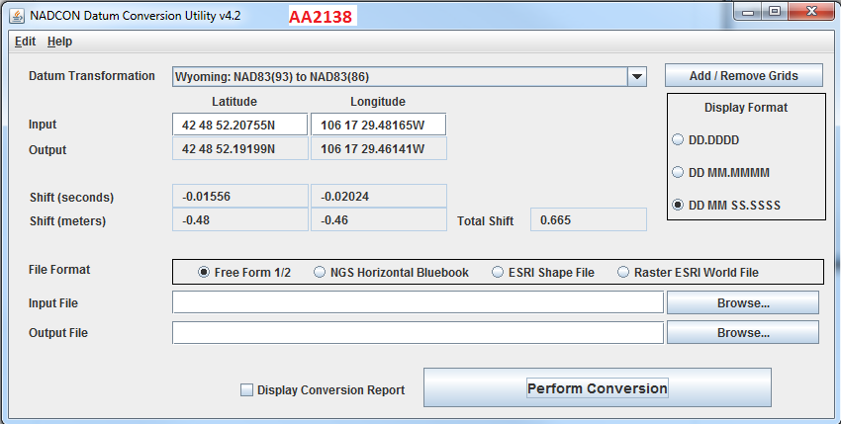

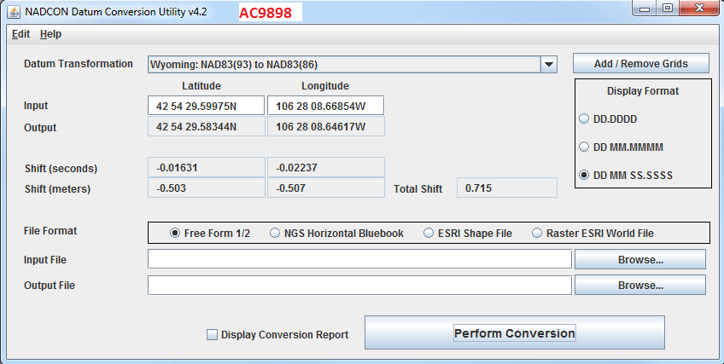

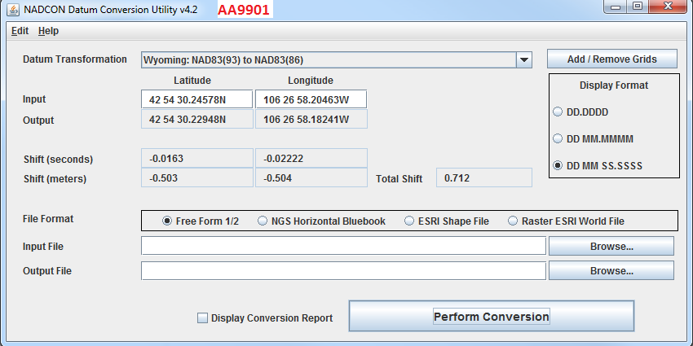

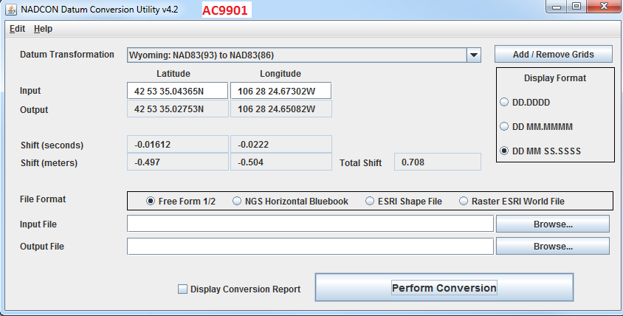

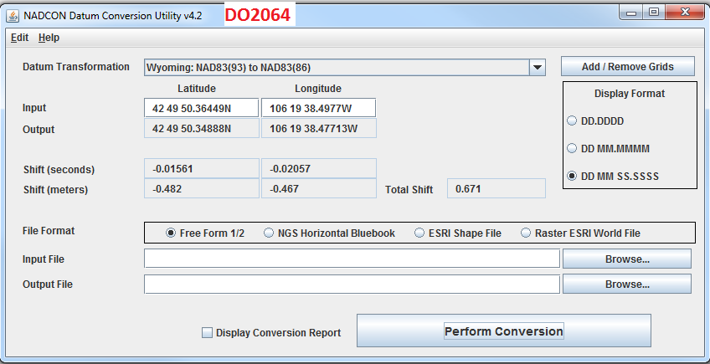

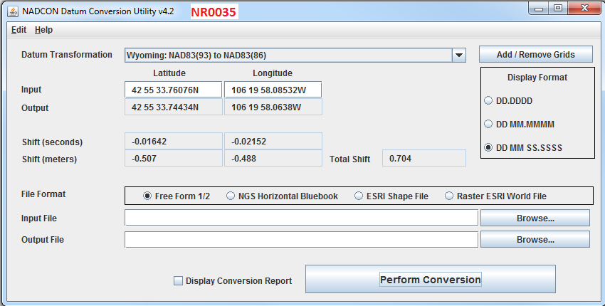

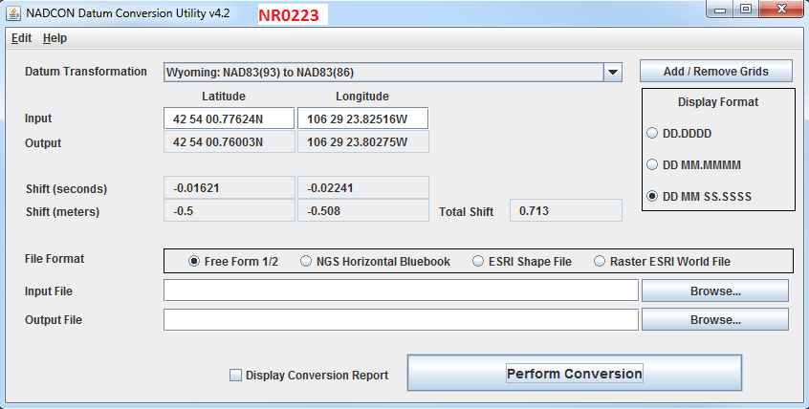

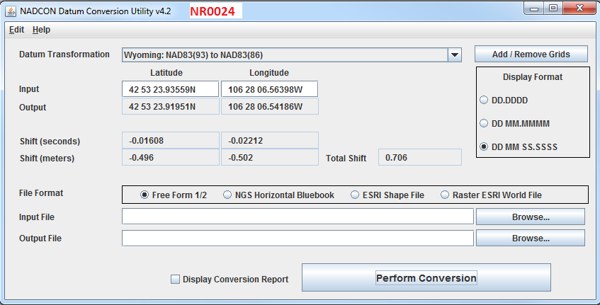

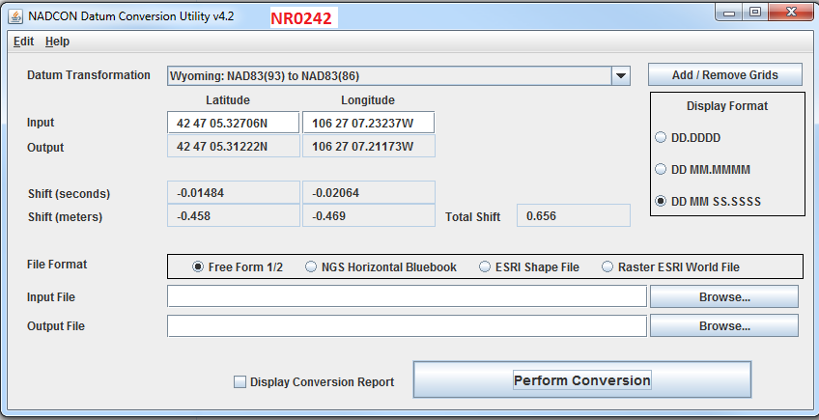

### **4.5 NAD83-1986 investigations**

1986 adjustment of NAD83 North American Horizontal datum is found to be very unstable in area of Casper WY. In general NAD83-1986 adjustment is known to include large inconsistencies in the adjustments NGS agency performed on the NGS control monuments in 1986. The adjustment, NGS agency performed in 1993 for Wyoming has solved many of the known problems with NGS monuments accuracy; therefore, the adjustment has been called High Accuracy Network (HARN). Sanborn has attempted to achieve best fit to NAD83-1986 adjustment. Local NGS monuments around Casper WY have found to be most consistent characteristics with respect to each other. Shift samples taken using NADCON utility, in the rural areas have showed large differences from the City of Casper samples. The rural areas have not been used in computations of the average horizontal adjustment, since they were determined to cause large bias to the computed horizontal shift. The single value adjustment have been applied to the complete project area, in order to avoid imagery stretching and pulling. See below examples of the large shift values of the rural areas of the project.

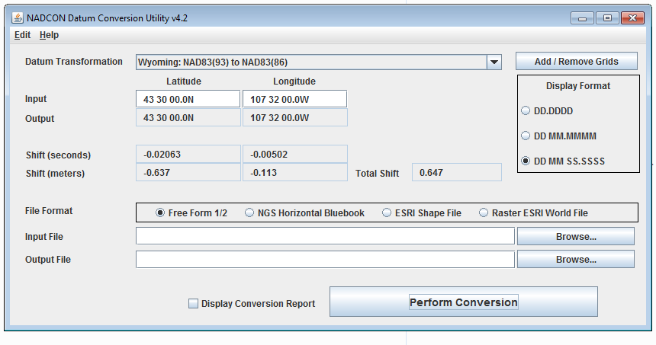

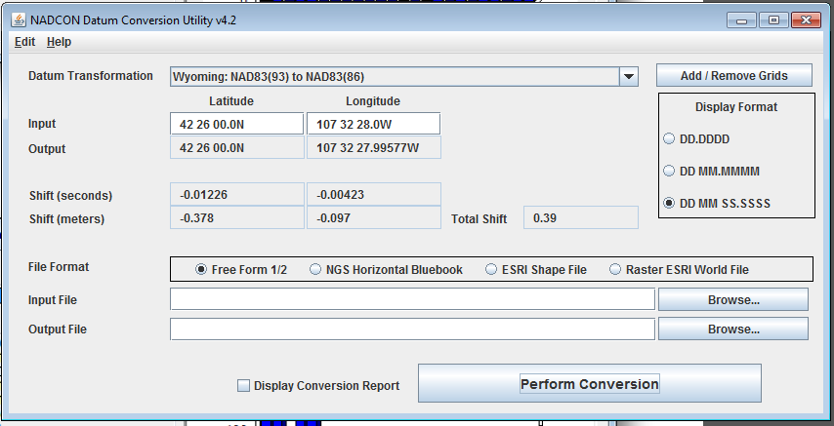

## Final Coordinates and Elevations

Final horizontal coordinates are provided in State Plane Wyoming East Central coordinates based on the North American Datum of 1983, 1986 adjustment. Orthometric elevations were based on the GEOID 12A and are provided on the North American Vertical Datum of 1988 (NAVD88). All units are provided in US survey feet. All final coordinates are derived from the constrained adjustments shown in APPENDIX B and adjusted horizontally by the values given in table 2.

## APPENDIX A

Adjusted Coordinates

(Electronically Attached)

## APPENDIX B

Adjustments Reports

(Electronically Attached)

## APPENDIX C

GCP Recovery Sheets

(Electronically Attached)

## APPENDIX D

NGS Sheets

(Electronically Attached)

## APPENDIX E

OPUS SOLUTIONS

(Electronically Attached)

## APPENDIX F

LOGS

(Electronically Attached)