Elevation QA Review Report

Project: Contract ID:

Liaison: Partner(s): Contractor:

Data Delivery Date: Date Data Reviewed:

Reviewer: Total Square Miles Reviewed:

Elevation Type: Format: Grid Spacing: Tile size:

Projection: Zone: Datum: Units:

Licensing: Metadata:

Materials Received:

Vertical Accuracy Test Performed: Test Point Source: RMSE:

Vertical Accuracy Test Notes:

QA Review Summary:

Alaska Nome Creek GPSC Lidar

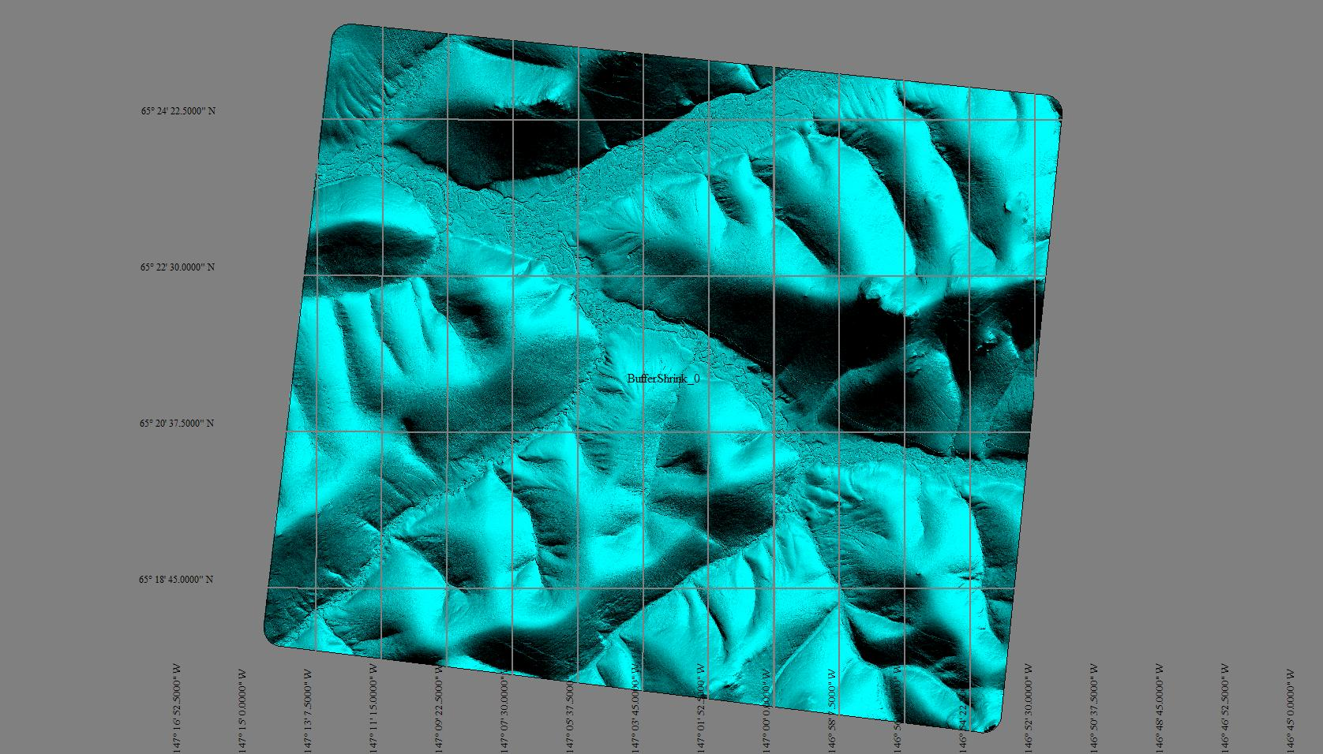

Alaska Nome Creek ADF Example of Seams
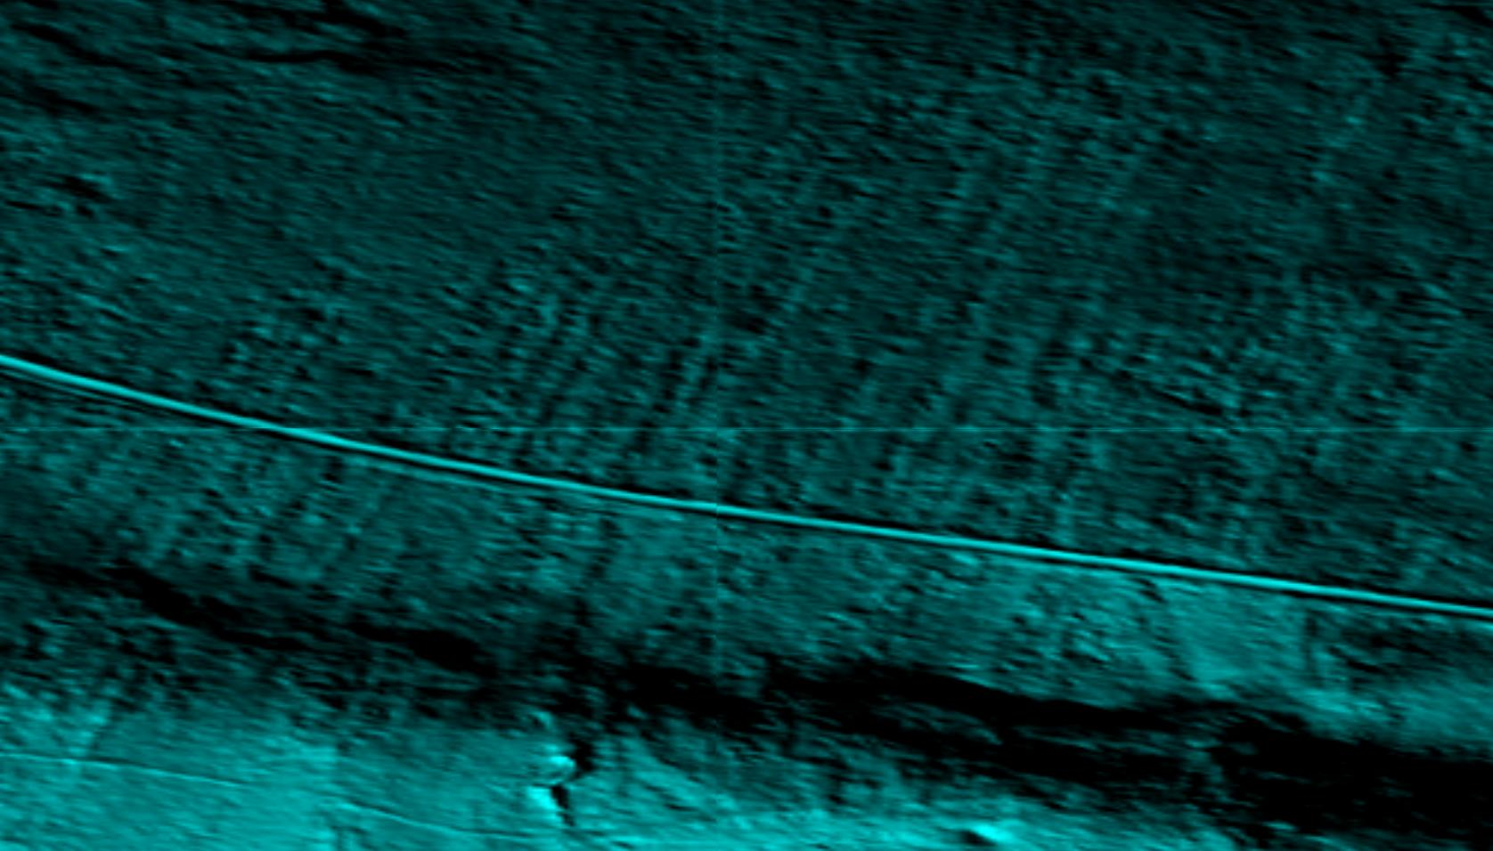

Alaska Nome Creek 1/9 arc image example of seams
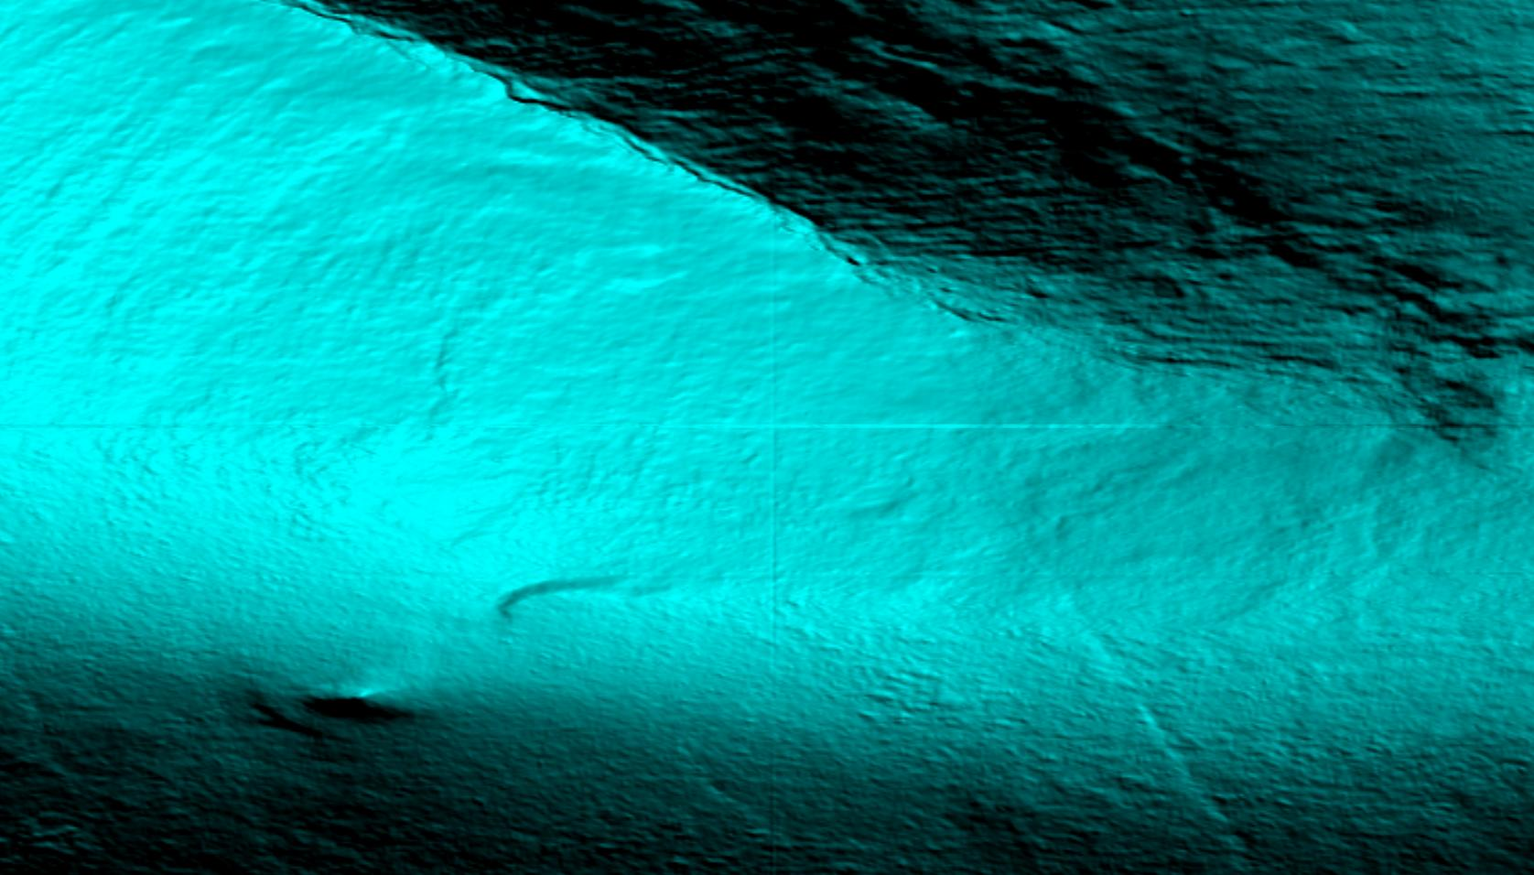

Alaska Nome Creek Vertical Accuracy
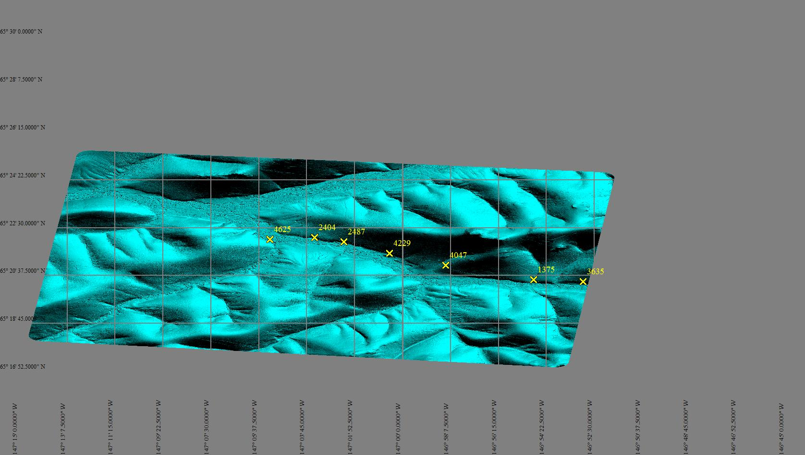

Alaska Nome Creek Vertical Accuracy Checklist


