Final Report: Golden Gate LiDAR project
San Francisco State University
Award #G10AC00122

PI: Ellen Hines, PhD
Associate Professor
Marine & Coastal Conservation and Spatial Planning Center
Department of Geography and Human Environmental Studies
San Francisco State University
1600 Holloway Ave
San Francisco, CA 94132 USA
1 415 338 1482
Fax: 1 415 338 6243
ehines@sfsu.edu
http://gis.sfsu.edu/coastal/default.htm

Award Term: January 31, 2010 through August 20, 2011
Submittal Date of final Report: October 3rd , 2011

Collection Report
Sensor data collected for this project include simultaneous capture of LiDAR, multi-spectral (color), and hyperspectral imagery for the San Francisco State University LiDAR project. The project area includes 835 sq miles in Marin and San Francisco counties, Point Reyes National Seashore, the Golden Gate National Recreation Area as well as portions of San Mateo and Sonoma Counties (Figure 1). The data were delivered in the UTM coordinate system, meters, zone 10 north, horizontal datum NAD83, vertical datum NGVD88, via 1500 x 1500 meter tiles.

An area of Muir Woods National Monument (see Figure 2 below) was flown with double point density (~4pts/sq meter) as a basis for future research.

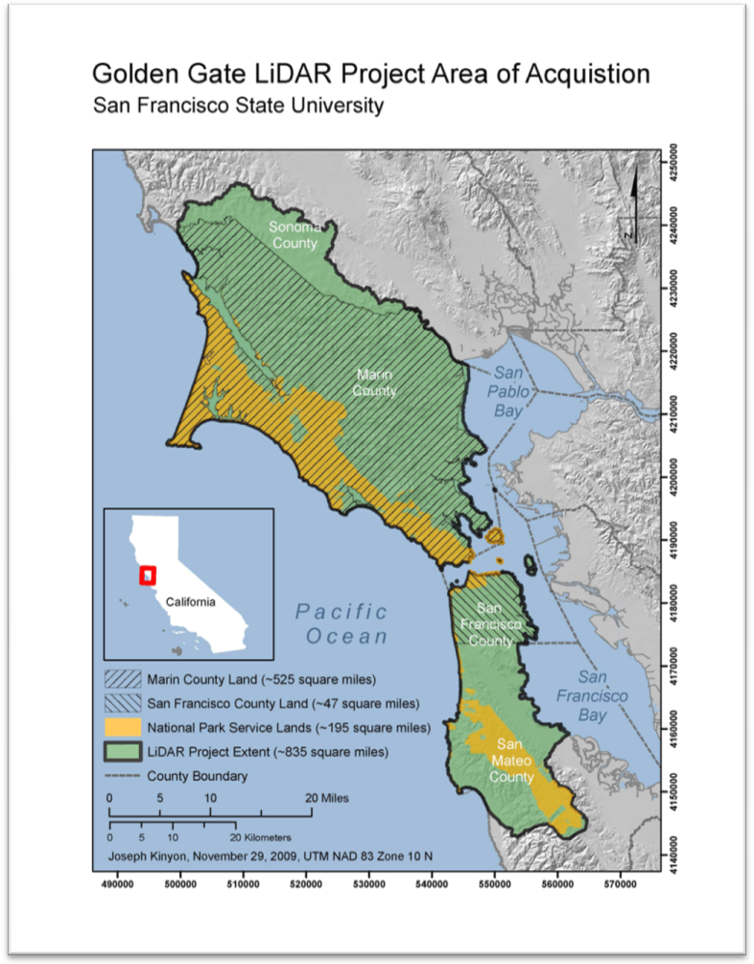
Figure 1. Golden Gate LiDAR project area.

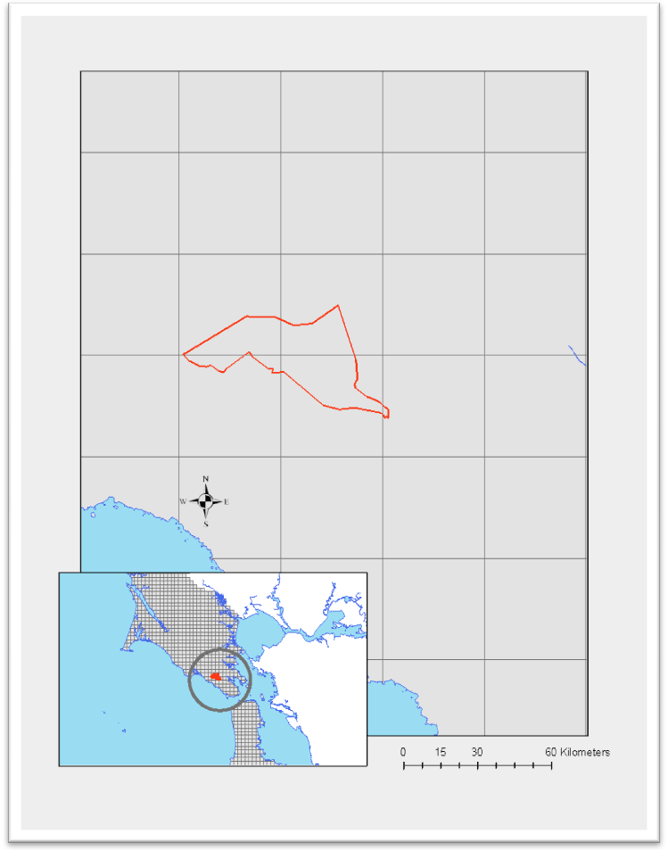
Figure 2. Muir Woods area of double point density

Equipment
All sensors were installed together in a Cessna 207 aircraft. The LiDAR sensor used was a Leica ALS60 MPiA(multi-pulse in air) sensor collecting multiple return x, y, and z data, full wave form data as well as intensity data. The digital camera used was a Leica RCD 105 with a 7,216 x 5412 CCD and a 60mm lens. The hyper-spectral camera used was an AISA Eagle equipped with a 23mm lens.

Mission Planning
- LiDAR Leica ALS60 - LiDAR data acquisition plan was developed to support a nominal post spacing of 2pts/sq meter @ 15% side-lap with 28 degree FOV to support a 1 foot contour accuracy with waveform data included.

- Multi-Spectral Leica RCD 105 - Color digital imagery was planned to support the delivery of 0.3m resolution imagery.

- VNIR Hyperspectral – Hyperspectral data were planned @ 256 bands to support a 2m GSD.

Mission/Flightlogs – range from April 23 to July 14, 2010. Specifically, acquisitions occurred on April 23rd, 24th, 25, 29th, 30th, May 5th, 6th, 7th, 8th, 11th, 12th, 23rd, 29th, 30th, 31st, June 5th, 6th, 7th, 9th, 10th, and July 14th.

Processing
LiDAR Calibration - The calibration process considered all errors inherent with the equipment including errors in GPS, IMU, and sensor specific parameters. Adjustments were made to achieve a flight line to flight line data match (relative calibration) and subsequently adjusted to control for absolute accuracy.

LiDAR Auto Classification - The auto-classification or ‘filtering’ step was performed with TerraScan to create a bare earth ground model and building classification by comparing each point’s relationship with its neighbors. Algorithms consider slope, angular relationships and distance in its computations which were successful in accurately defining the ground in at least 95% of the project area. LiDAR Classifications include:
- 1 (processed, but unclassified)
- 2 (bare-earth ground)
- 4 (vegetation)*
- 7 (noise)
- 9 (water)…included in the classified tiles with buffered breaklines embedded

*in addition to vegetation, this category includes all above-ground objects such as buildings, bridges, piers.

Multi-Spectral Orthomosaic – A rough orthomosaic was rectified to the auto-filtered ground surface for use as an intelligent backdrop in ECW format. Raw .tiffs will be orthorectified by SFSU researchers in Fall of 2011.

Hyperspectral – Data was processed to its native format and has been submitted to the Hyperspectral – LiDAR Research Group at the University of Victoria for future processing.

Please note, both Orthophotos and Hyperspectral images will be made available to USGS once processed.

Survey point collection
Compliance with the accuracy standard was ensured through the collection of GPS ground control during the acquisition of aerial LiDAR and the establishment of a GPS base station operating at the airport (Figure 2). In addition to the base station, CORS bases may have been used to supplement the solutions. The following criteria were adhered to during control point collection.
1. Each point was collected during periods of very low (<2) PDOP.
2. No point was collected with a base line greater than 25 miles.
3. Each point was collected at a place of constant slope so as to minimize any errors introduced through LiDAR triangulation.
4. Each point was collected at moderate intensity surfaces so any intensity based anomalies could be avoided.

Please note that all flights were arranged for the lowest tides possible.

The base station equipment used was a Trimble R7 with a Zephyr geodetic model 2 antenna. The control points were collected with a Trimble R8 integrated receiver and antenna unit.

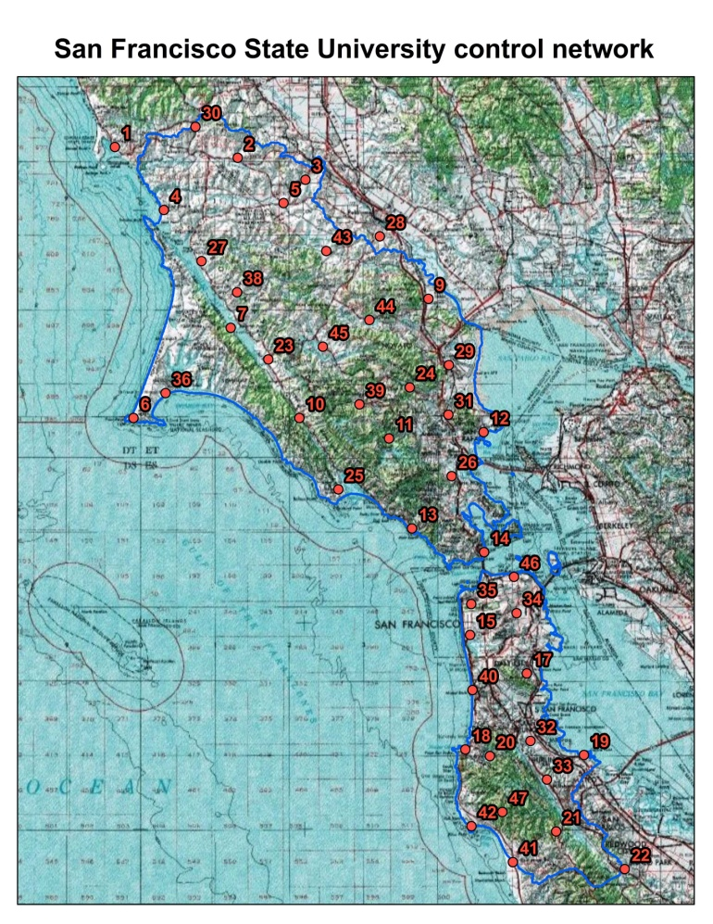
Figure 2. San Francisco State University ground control network.

Completeness Report:
The bare earth surface will contain voids where insufficient energy was reflected from the surface to generate a valid return from the terrain. Voids in the bare earth surface tend to occur in heavily vegetated areas, water bodies, and beneath buildings, motor vehicles, bridges etc. Fresh or wet asphalt, wet sand and certain types of vegetation can also cause voids or anomalous elevations.

Accuracy Report:
The following methods were used to ensure LiDAR accuracy.

1. Rigorous LiDAR calibration: all sources of error such as the sensor’s ranging and torsion parameters, atmospheric variables, GPS conditions, and IMU offsets were analyzed and removed to the highest level possible. This method addresses all errors, both vertical and horizontal in nature. Ranging, atmospheric variables, and GPS conditions affect the vertical position of the surface, whereas IMU offsets and torsion parameters affect the data horizontally. The horizontal accuracy is proven through repeatability: when the position of features remains constant no matter what direction the plane was flying and no matter where the feature is positioned within the swath, relative horizontal accuracy is achieved.

2. Absolute horizontal accuracy is achieved through the use of differential GPS with base lines shorter than 25 miles. The base station is set at a temporary monument that is ‘tied-in’ to the CORS network. The same position is used for every lift, ensuring that any errors in its position will affect all data equally and can therefore be removed equally.

3. Vertical accuracy is achieved through the adjustment to ground control survey points within the finished product. Although the base station has absolute vertical accuracy, adjustments to sensor parameters introduces vertical error.

The minimum expected horizontal accuracy was tested during the boresight process to meet or exceed the National Standard for Spatial Data Accuracy (NSSDA). Horizontal accuracy is 1 meter RMSE or better.

Vertical Accuracy
Accuracy Report:
Vertical Accuracy RMSE(z) ≤ 9.25 cm

Explanation:
Once all lifts were horizontally and vertically calibrated, the vertical misalignment between each lift was checked so that all lifts are aligned and the entire data set matched the ground control points within the project specified accuracy range. A final vertical accuracy check was run against the control after the z correction. The result was analyzed against the project specified accuracy to make sure it meet the requirement.

Process Step
Process Description (Step 1):
Earth Eye established ground control for the entire AOI. A total of 47 ground control points were acquired. GPS was used to establish the control network (Figure 2). The horizontal datum was the North American Datum of 1983, 2007 adjustment (NAD83/2007). The vertical datum was the North American Vertical Datum of 1988 (NAVD88).

Process Description (Step 2):
The Earth Eye and Galileo acquisition team collected ALS60 derived LiDAR, true color imagery and hyper-spectral imagery over the AOI with 2pts/sq m, nominal post spacing. The collection for the entire project area was accomplished from April 23rd through July 14th, 2010. The collection was performed using a Leica ALS60 MPiA LiDAR system, Leica RCD 105 camera, and AISA eagle HSI camera.

Process Description (Step 3):
1. LiDAR, GPS, and IMU data were processed together using LiDAR processing software.
2. The LiDAR data set for each flight line was checked for project area coverage and LiDAR post spacing was checked to ensure it meets project specifications.
3. The LiDAR collected at the calibration area and project areas were used to correct the rotational, atmospheric, and vertical elevation differences that are inherent to LiDAR data.
4. Intensity raster’s were generated to verify that intensity was recorded for each LiDAR point.
5. LiDAR data were transformed to the specified project coordinate system.
6. By utilizing the ground survey data collected at the calibration site and project area, the LiDAR data were vertically biased to the ground.
7. Comparisons between the biased LiDAR data and ground survey data within the project area were evaluated and a final RMSE value was generated to ensure the data meets project specifications.
8. LiDAR data in overlap areas of project flight lines were trimmed and data from all swaths were merged into a single data set.
9. The data set were trimmed to the digital project boundary including an additional buffer zone of 50 meters for internal tiles and 300m on edge tiles. The 50 meter buffer for each internal tiles ensures there are no gaps between tiles.
10. The resulting data set is referred to as the raw LiDAR data.

Process Description (Step 4):
1. The raw LiDAR data were processed through a minimum block mean algorithm, and points were classified as either bare earth or non-bare earth.
2. User developed "macros" that factor mean terrain angle and heights from ground were used to determine bare earth point classification.
3. The next phase of the surfacing process was a 3D edit procedure that ensures the accuracy of the automated feature classification.
4. Editors used a combination of imagery, intensity of the LiDAR reflection, profiles and tin-editing software to assess points.
5. The LiDAR data were filtered, as necessary, using a quadric error metric to remove redundant points.
6. The algorithms for filtering data were utilized within Earth Eye LLC and commercial software written by TerraSolid.
7. The flight line overlap points were merged back into the filtered data set for delivery to SFSU.

Data Set Credit:
Earth Eye LLC
3680 Avalon Park Blvd East
Suite 200
Orlando, FL 32828
407.382.6760

GGLP/SFSU processing:
All manual editing, breakline creation and DEM generation was conducted using Earth Eye Viewer (most recent version: EarthShaper 1.181.0). Additional software products including ArcGIS, Lastools, GDAL, Fusion and mcc-LiDAR were utilized for QA, visualization, format conversion, additional ground classification, LiDAR class management and intensity image creation.

1. Editing

An additional automated ground classification pass was made on the original TerraScan generated ground class (2) points to improve the quality of the points representing the ground. This was done since a significant amount of vegetation and building footprints existed in the original ground class. More than 10% of the original ground classified points were reclassified. However, this did soften the edges in terrain with very rapidly changing slope and reduced the ground point density in areas with above ground vegetation.

Manual editing of the ground class (2) was done after filtering to reclassify the remaining below ground noise blunders, the remaining buildings and the most obvious remaining near ground vegetation. Ground points were manually added back in for selected coastal cliffs, large offshore rocks and large land rock outcrops in Marin County. While this manual editing was systematic and purposeful, it may have inadvertently missed some details.

Manual editing to classify noise (7) in the point cloud was done to minimize the significant amount of noise points that remained in the other classes after the original vendor provided TerraScan classification. The noise points were often mostly associated with reflective surfaces in city, urban and around water. A tile by tile effort eliminated essentially all significant high and below ground noise points. Another pass eliminated the majority of the close-in noise near structures, vegetation, roads and water.

2. QA/QC
A comprehensive review of the whole LiDAR LAS data set was made upon receipt of the data and after editing to insure that the specifications were met. While the focus was on the quality of the ground classified points and aggressively classifying noise, a variety of issues were identified and corrected by the data vendor and the SFSU team. A non-trivial effort was made to produce and validate the LAS 1.3 with wdp waveform files. This was made more challenging by an ambiguous LAS 1.3 specification and the need to create new software to support the relatively new data format.

After the editing process was complete for each tile the following steps were taken:

- More than 2/3 of the tiles were individually reviewed in detail for ground and noise edit quality. Additional manual editing was performed where necessary. The focus was on city, urban and coastal areas where the need for editing had been the most intense. The remaining tiles, mostly in rural areas, were spot checked for editing quality.
- Hillshades were made of each area for a quick-look overview of any missed ground edits.
- All tiles were assembled and batch processed to insert descriptive header information, finalized classes, finalized tilenames and correct minor fileset discrepancies.
All tiles were returned to the data vendor to batch correct previously identified point data record problems in the LAS 1.2 versions and create the LAS 1.3 with associated wdp waveform files to accompany the delivery.

3. Breakline
Heads-up digitizing of and hydro-flattening of all single-line, double-line, polygonal water features and the coastline was completed using utilities in the Earth-Eye Viewer. Breaklines were then converted feature classes and imported into a file geodatabase as a single feature dataset.
- All breaklines were non-destructively buffered by 1 meter in the LAS tile by converting the points to withheld.
- Lakes - Using a cross sectional profile of the shore of a lake, the elevation of where water met land is locked into the 'Lake' tool. Any vertices and segments created while this elevation is locked in will be created at that elevation. The ground class representing the lake surface returns was reclassified to water. The TIN DEM elevation for each lake water body is set to the lake breakline elevation.
- Coast - The coast was created by using the 'Lake' tool with the elevation locked to a 0.0 meter elevation. After creating a line that followed the length of the coast, another connected line was created around the outer edges of the data, allowing the ocean to be classified into water as if it were a lake.
- Streams - The streams are processed by creating a vertex at the head waters of the stream, and then creating segments and vertices in the center line of the stream for the entire length (using a cross sectional profile). Each vertex takes the elevation of the data selected and the segments appear to be interpolated between the two vertices.
- Rivers - The River Bank tool is used to create a single segmented line down either side of the river (along the banks). The river segments must then be processed to enforce the data by selecting the first and last vertex point on each line, which creates a segment of equal elevation between the vertices. Multiple segments can be created connecting the two banks along the length of the stream if there are specific features that need to be identified. The ground class between the river banks were converted to water.
- Islands - The island tool creates a closed polygon locked at the surrounding water elevation. The ground and vegetation classes for the island are maintained.
- Connecters - Whenever a water feature passes underneath an above ground feature, these segments can be reclassified into a "connector segment", which causes all data that would be moved to the "Withheld" class to be returned to its original class.

4. DEM creation
Floating point (32-bit) bare earth surface digital elevation model tiles were created at a grid resolution of 1.0 meter using utilities in the Earth-Eye Viewer incorporating all breaklines. Tile edge buffering was used to eliminate tile boundary discontinuities. DEM tiles in the ocean were trimmed using GDAL (http://www.gdal.org) utilities to the support the >100m offshore buffer with 0.0 meter water elevation. Projection information was added during the format conversion to Erdas .img format.

5. Intensity Image creation
Intensity images tiles were created for each LAS tile at 1m resolution using a custom batch process running command line tools. Tile edge buffering was used to eliminate tile boundary discontinuities .The process was designed to provide improved higher quality intensity images with pixel resolutions approaching the LiDAR point density. This is accomplished by minimizing the number of no-data pixels using an anti-aliasing algorithm. The algorithm is implemented in the IntensityImage command line utility (http://forsys.cfr.washington.edu/fusion/FUSION_manual.pdf - page 82) in the USDA Forest Service Fusion LiDAR processing software (http://forsys.cfr.washington.edu/fusion/fusion290.html). File format conversions to 8-bit single band gray scale ERDAS .img was done using GDAL (http://www.gdal.org) command line utilities.
The intensity data provided in the LiDAR LAS tiles had already been effectively matched and scaled across the flightlines and the entire acquisition's land area by the data vendor, EarthEye. The intensity data represents the relative Near IR LiDAR pulse reflected intensity at each detected point is not calibrated. Water areas are not corrected and exhibit cross swath and specular artifacts.
The important processing steps are:
1) Create a 1m resolution raster intensity image derived from the LAS tile. The output format is .bmp with a world file.
Command line reference: IntensityImage /void:0,0,0 /allreturns /minint:0 /maxint:100 1 intensity_output_raster.bmp LiDAR_input_tile.las
2) The .bmp files are reformatted to an RGB Geotiff and a projection code added using the command line utility gdalwarp.
3) The RGB Geotiff is converted to a single band gray scale .img file using the command line utility gdal_translate.
6. Projection Information
GGLP/SFSU submission:

Final deliverables to USGS include:
- Project Information
  - Metadata for unclassified flightlines (Raw point cloud)
  - Metadata for classified tiles
  - Metadata for bare earth surface DEMS
  - Final report (including collection, survey, processing and accuracy reports)
  - Ground control points (San_Fran_Final_Control_Report.csv)
- Lidar Files
  - LAS_classified tiles
    - LAS v1.2 tiles
    - LAS v1.2 tiles with breaklines
    - LAS v1.3 waveform tiles
  - LAS unclassified flightlines
    - North flightlines LAS v1.2
    - North flightlines < 2 gb
    - South flightlines LAS v1.2
    - South flightlines < 2 gb
- Raster Files
  - Bare Earth Surface (Raster DEM based on .Las v.1.2) (1m resolution)(.img)
  - Intensity Images (1m resolution)(.img)
  - Air photo mosaic_RGB (please note, this is NOT a finalized deliverable, or orthorectified, only for your convenience)(.ecw)
- Vector Geodatabase
  - Breaklines Feature Dataset
    - Lake feature class
    - Island feature class
    - Streams feature class
    - Rivers feature class
  - GGLP Boundary feature class
  - GGLP Tile Scheme feature class

