Lidar Report

for

Stone County, MO

Contract Number: G10PC00026
Task Order: G10PD00579



July 29, 2010
Table of Contents

Project Description 1

Aerial Platform / Lidar Sensor 2

Flight Parameters 2

Dates Flown 3

Flight Line Layout 3

File Information 3

Projection / Datum 4

GPS Collection Parameters 4

Data Processing 4

QA/QC Analysis 5

Problems Encountered 7

List of Appendices (Reference Included Files)

Appendix A: Survey Report 8

Appendix B: Logs 8

Appendix C: System Calibration Reports 8

Appendix D: Aeroplan Sensor Report 8

Appendix E: Trajectory Report (by flight date) 8

Project Description
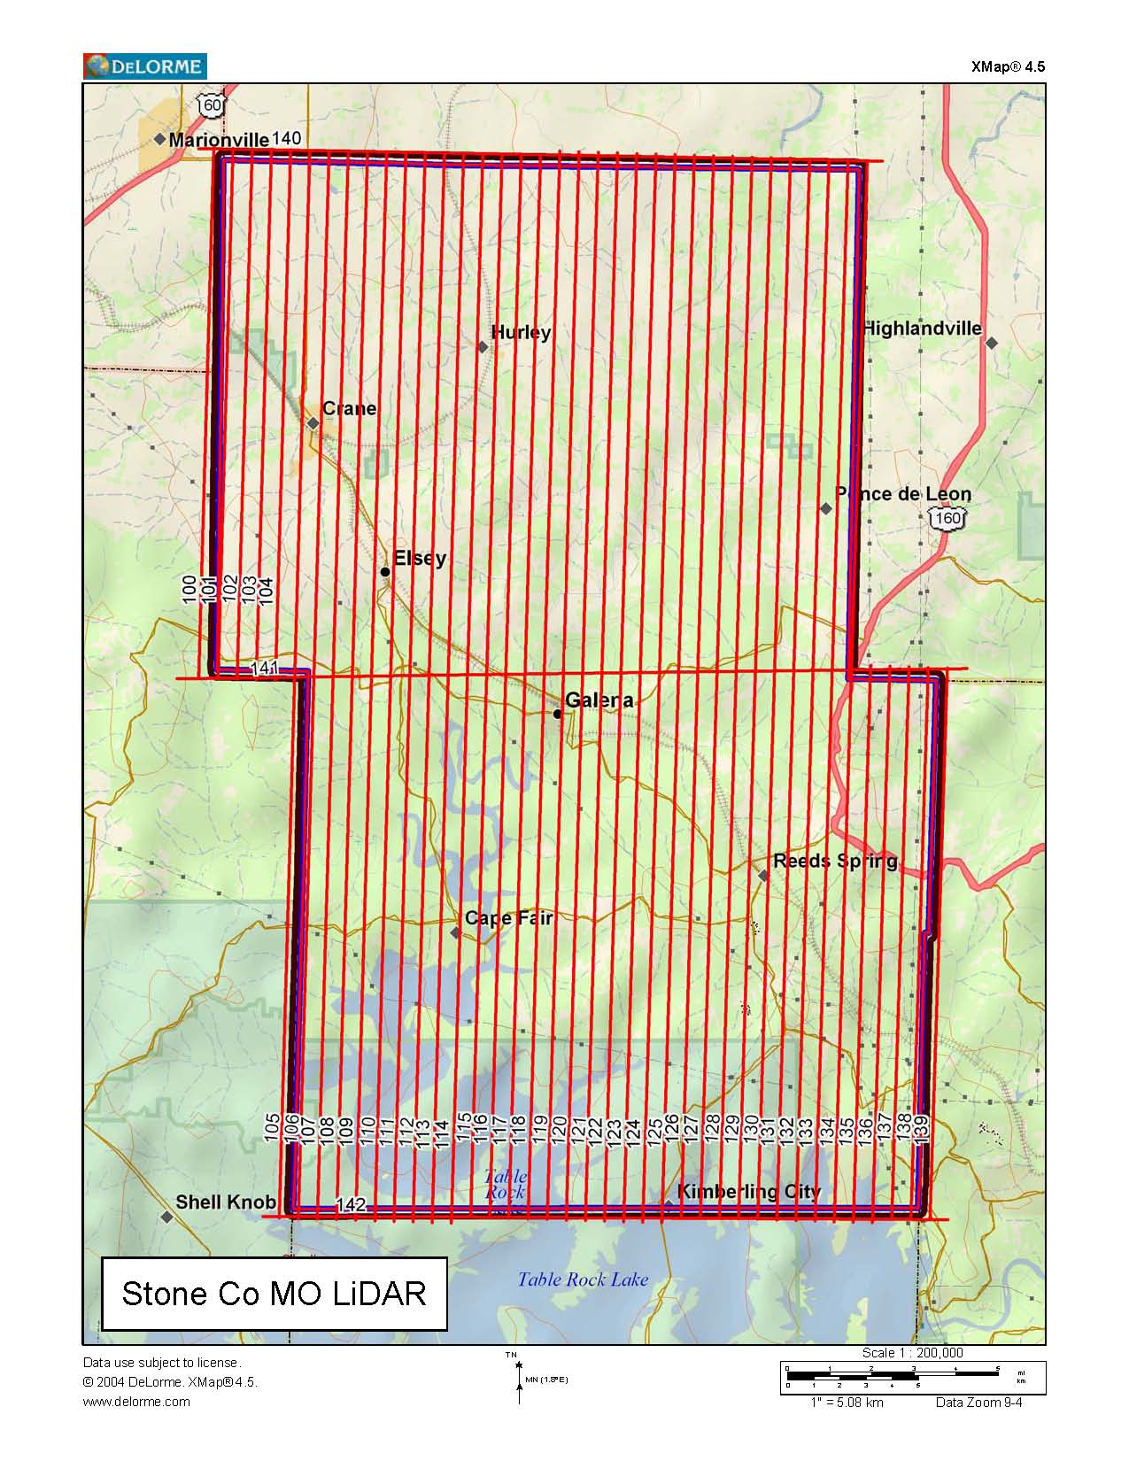
The purpose of this project is to provide professional surveying and mapping services for the creation of a high-resolution digital elevation model developed from LIDAR data for Stone County, MO. The project area is shown in the graphic below.

Aerial Platform / Lidar Sensor

All flights for the project were accomplished with customized single-engine Cessna 206s which provide an ideal, stable aerial base for Lidar acquisition. This platform has relatively fast cruise speeds that are beneficial for project mobilization / demobilization while maintaining relatively slow stall speeds which can prove ideal for collection of a high-density, consistent data posting.

Photo Science utilized both of our Optec Gemini LiDAR scanners on this project to date. Both systems are capable of collecting data at a maximum frequency of 167 kHz, which affords elevation data collection of up to 167,000 points per second. The system utilizes a Multi-pulse in the Air option (MPIA). This sensor is also equipped with the ability to measure up to 4 returns per outgoing pulse from the laser and these come in the form of 1st, 2nd, 3rd, and last returns. The intensity of the first three returns is also captured during the aerial acquisition.

See appendix C for system calibration information

Flight Parameters

Detailed project planning was performed for this project. This planning was based on project specific requirements and the characteristics of the project site. The basis of this planning included the required accuracies, type of development, amount and type of vegetation within the project area, the required data posting, and potential altitude restrictions for flights in the general area. A brief summary of the aerial acquisition parameters for this project are shown in the table below:

Area Flight Profile
-----------------------------
Total Length : 1303.46 km
Flight Time : 09:43:11
Laser Time : 05:51:54
Swath Area : 710.608 km^2
AOI Area : 1305.653 km^2
Altitude : 1828.8 m AGL
Speed : 61.7 m/s
Flight Lines : 36
Pass Heading : 1.61
Pass Spacing : 545.17 m
Overlap : 40% = 932.6 m
Turn Time : 5 min

Area LIDAR Settings
-----------------------------
Desired Res : 1.13 m
Density : 0.78 ppm^2
Cross Track Res : 1.13 m
Down Track Res : 1.131 m
Scan Frequency : 27.3 Hz
Scan Angle : +/- 22 deg
Scan Cutoff : +/- 0 deg
Scan Offset : 0 deg
System PRF : 71.429 kHz
Swath Width : 1477.77 m

Reference the Aeroplan sensor summary information included in Appendix D.

Dates Flown

Collection occurred as weather permitted between the period of March 30th, 2010 through April 9th, 2010. Four lifts were flown (March 30th, April 1st, 8th, 9th). Reference the flight logs and trajectory files included in Appendix B & E for graphical depictions and reports for each mission.

Flight Line Layout

As depicted above, a total of 43 Lines totaling 1509 Kilometers (937 Flight Line miles) were required to cover the project area.

File Information

1500x1500 meter tiles are delivered as LAS, DEM, and Intensity Images. The file naming schema is based on the lower left hand corner of each tile, with a “SC” added to the front of the tile name. The deliverable formats for the files are in the table below:

- LAS (506 – LAS Version 1.2 files)
- Hydro Enforced Raster DEM (506 – 1.5 Meter DEM files in ERDAS IMG format)
- Hydro Flattened Raster DEM (506 – 1.5 Meter DEM files in ERDAS IMG format)
- Intensity Images (506 – GeoTIFF Images in TIF/TFW Format)
- Hydro Breaklines (1 – Arc Shapfile format)
- Raw Flight Line Source (52 – LAS Files in 4 folders)

Projection / Datum

All data for this project were reduced to NAD83 - UTM Zone 15N, Meters. All elevations were presented as orthometric heights using NAVD88 - Geoid09, Meters.

There are several limiting factors to LiDAR data collection which include:

Weather: there can be no clouds, excess moisture (rain, fog or excessive humidity) between the sensor and the ground we are profiling. Additionally, high winds which if blowing perpendicular to the line of flight could provide for excessive crab resulting in “slivers” or “holidays” between flight lines as well as unsafe flight conditions such as wind shear or clear air turbulence.

Ground Conditions: Such as standing water from recent heavy rains, excessive “ponding” or “pooling” of water which will affect the accuracy of the LiDAR returns as will snow and Ice. This is especially apparent in ditches with high water and along roadways and fence lines with drifting snow.

Satellite Configuration: Typically one does not want to collect LiDAR during time of high PDOP, this is due to the GPS configuration providing accuracy less than desired. For this project there is to be no data collection during periods of PDOP above 3.5 or periods with less than 6 visible satellites. To these ends, PDOP was checked each morning with a fresh almanac and newly updated satellite health status from the US Coast Guard Navigation Center website.

GPS Collection Parameters

Collection parameters for this project included the following:

Parameter | Value
Maximum PDOP | 3.5
Minimum number of SVs | 6
Ground collection epoch | 2 Hz (0.5 sec)

Data Processing

Optech software was used in the post-processing of the airborne GPS and inertial data that is critical to the positioning of the sensor during all flights. This software suite includes Applanix’s PosPac and Waypoint’s GrafNav solutions. PosPac provides the smoothed best estimate of trajectory (SBET) that is necessary for Optech’s post processor to develop the point cloud from the Lidar missions. The point cloud is the mathematical three dimensional collection of all returns from all laser pulses as determined from the aerial mission. At this point this data is ready for analysis, classification, and filtering to generate a bare earth surface model in which the above ground features are removed from the data set.

The point cloud was created using Optech’s Post Processor software. GeoCue was used in the creation of some of the files needed in downstream processing, as well as in the tiling of the dataset into more manageable file sizes. The TerraScan and TerraModeler software packages are then used for the automated data classification, manual cleanup, and bare earth generation from this data. Project specific macros were used to classify the ground and to remove the side overlap between parallel flight lines. All data was manually reviewed and any remaining artifacts removed using functionality provided by TerraScan and TerraModeler. QT Modeler was used as a final check of the bare earth dataset. GeoCue was then used to create the deliverable LAS 1.2 files for both the All Point Cloud Data and the Bare Earth. In-house software was then used to perform final statistical analysis of the classes in the LAS files.

QA/QC Analysis

A total of 20 points in three different land cover types (bare earth, tall grass, and urban) were established in the field for check points assessing the accuracy of the Lidar surface. Two points in open areas over existing NGS benchmarks were established. The table below lists the statistics of this analysis of the QC (blind points):

Statistical Analysis |  |  | Coordinate System
Average Dz | - |  | Horizontal Projection
Minimum Dz | 0 |  | NAD83 - UTM Zone 15N, Meters
Maximum Dz | 0
RMSE | - |  | Vertical Datum
Standard Deviation | - |  | NAVD88 - Geoid09, Meters
Point | Easting | Northing | Known Z | LIDAR Z | Dz
B01 | 448512.75 | 4092861.80 | 428.71
B02 | 455334.43 | 4092635.20 | 387.53
B03 | 446709.14 | 4087327.95 | 352.74
B04 | 454236.21 | 4079625.80 | 379.62
B05 | 458246.22 | 4075577.49 | 375.10
B06 | 463444.90 | 4071106.12 | 371.75
B07 | 466484.43 | 4066959.28 | 366.35
B08 | 470049.82 | 4061278.50 | 283.33
B09 | 470619.64 | 4057517.64 | 389.57
B10 | 462569.62 | 4056894.55 | 418.67
B11 | 453291.47 | 4058829.69 | 390.92
B12 | 449970.09 | 4065121.72 | 379.12
B13 | 450988.84 | 4073112.36 | 311.81
B13A | 452386.23 | 4073633.17 | 391.14
B14 | 466667.10 | 4079004.95 | 332.79
B15 | 467894.40 | 4085792.09 | 344.90
B16 | 464749.00 | 4092551.75 | 390.14
B17 | 459465.17 | 4085024.32 | 325.40
B18 | 446968.34 | 4078959.13 | 408.85
B19 | 460249.08 | 4065728.83 | 408.12
B20 | 460476.12 | 4081205.01 | 380.21

In addition to the quality control points collected, the following production field control was utilized for this project:

Statistical Analysis |  |  | Coordinate System
Average Dz | 0.009 |  | Horizontal Projection
Minimum Dz | -0.093 |  | NAD83 - UTM Zone 15N, Meters
Maximum Dz | 0.141
RMSE | 0.064 |  | Vertical Datum
Standard Deviation | 0.065 |  | NAVD88 - Geoid09, Meters
Point | Easting | Northing | Known Z | LIDAR Z | Dz
Base95 | 458093.74 | 4076072.27 | 381.20 | 381.29 | 0.09
Base96=C05 | 458625.92 | 4087828.63 | 394.96 | 394.97 | 0.01
Base99 | 469510.03 | 4059091.88 | 399.11 | 399.05 | -0.06
C01 | 447284.10 | 4092895.39 | 429.19 | 429.23 | 0.04
C02 | 455208.00 | 4092309.45 | 380.85 | 380.88 | 0.03
C03 | 464601.78 | 4092539.08 | 380.12 | 380.07 | -0.05
C04 | 468160.74 | 4087205.07 | 377.32 | 377.34 | 0.02
C06 | 446707.07 | 4087107.91 | 365.14 | 365.18 | 0.04
C07 | 446167.06 | 4078679.59 | 417.81 | 417.83 | 0.02
C08 | 454227.38 | 4079347.37 | 357.97 | 358.07 | 0.10
C09 | 456709.38 | 4076500.97 | 390.69 | 390.63 | -0.06
C10 | 460384.46 | 4080935.43 | 384.94 | 384.99 | 0.05
C11 | 467323.47 | 4077440.85 | 349.58 | 349.56 | -0.02
C12 | 450979.85 | 4073088.92 | 309.21 | 309.22 | 0.01
C13 | 463528.03 | 4070762.10 | 390.06 | 390.03 | -0.03
C14 | 450995.78 | 4065176.37 | 410.62 | 410.76 | 0.14
C15 | 462193.74 | 4065621.10 | 419.39 | 419.32 | -0.07
C16 | 470932.34 | 4060854.33 | 289.69 | 289.61 | -0.08
C17 | 469935.08 | 4057094.57 | 390.59 | 390.55 | -0.04
C18 | 462163.49 | 4057144.56 | 413.67 | 413.58 | -0.09
C19 | 453998.63 | 4056475.99 | 300.53 | 300.67 | 0.14
C20 | 449586.47 | 4056760.80 | 397.90 | 397.91 | 0.01
C20E | 449585.07 | 4056768.31 | 397.41 | 397.42 | 0.01
C21 | 468954.94 | 4068921.05 | 434.58 | 434.56 | -0.02
GF0586 | 443938.63 | 4095047.13 | 412.54 | outside | *

Problems Encountered

Problems encountered during this project were minimal. There were a few times with winds outside what we consider an acceptable range. High cross winds result in crab and can minimize the overlap between adjacent flight strips. There were also some times with less than acceptable GPS configuration in terms of high PDOP or less than 6 satellites available for tracking. The crew checked the expected GPS configuration daily along with the weather and did not fly during less than ideal times. No issues were documented in the LAS tile development phase of production.

Appendix

Appendix A: Survey Report (Ref: Stone_County_MO_Survey Report_G10PD00579 directory)

Appendix B: Logs (Ref: Stone_County_MO_Flight Logs_G10PD00579 Directory)

Appendix C: System Calibration Reports (Ref: Stone_County_MO_System_Calibration_Report_G10PD00579 directory)

Appendix D: Aeroplan Sensor Report (Ref: Stone_County_MO_Aeroplan_G10PD00579 directory)

Appendix E: Trajectory Report by flight date (Ref: Stone_County_MO_Trajectory Report_G10PD00579 directory)

