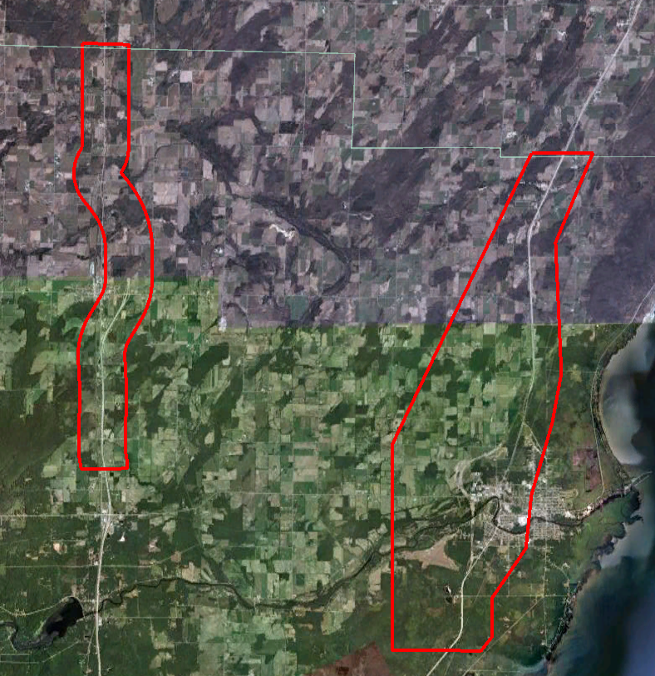

Oconto County

LiDAR Processing Report

Prepared by:

Aerometric, Inc.
4020 Technology Parkway
Sheboygan, WI 53083-6049
Phone: (920) 457-3631
FAX: (920) 457-0410

EXECUTIVE SUMMARY

Aerometric, Inc. in conjunction with Ayres Associates acquired accurate Light Detection and Ranging (LiDAR) data for two areas within Oconto County, Wisconsin. Using Aerometric’s ALTM Gemini LiDAR system, data was collected at 1700 meters above ground level along 17 pre-planned flight lines at a pulse rate of 70,000 points per second. Airborne GPS and IMU trajectories for the LiDAR sensor were also acquired during the time of flight.

The information maintains all standards and specifications as published by the United States Geological Survey – Base LiDAR Specifications.

1 INTRODUCTION

This report contains a summary of the LiDAR data acquisition and processing for Oconto County.

1.1 Contact Info

Questions regarding the technical aspects of this report should be addressed to:

Aerometric, Inc.
4020 Technology Parkway
Sheboygan, WI 53083

Attention: Robert Merry (Geomatics Manager)
Telephone: 920-457-3631
FAX: 920-457-0410
Email: rmerry@aerometric.com

Ayres Associates
1802 Pankratz Street
Madison, WI 53704-4069
Attention: Todd Thies (Project Manager)
Telephone: 608-443-1200
Email: ThiesT@AyresAssociates.com

1.2 Purpose

The LiDAR acquisition, bare-earth data set, breaklines, DEMS, 2ft contours, and a Geodatabase were performed to develop a highly detailed ground surface dataset for use by Oconto County.

1.3 Project Location

The project consisted of two areas within the County of Oconto in Wisconsin. The area was defined and supplied by Ayres Associates.

1.4 Time Period

The LiDAR acquisition was completed on April17th, 2010. One (1) flight mission was required to cover the project area. See Section 3 for a sketch of the acquisition mission and Section 7 of the report for the flight log.

1.5 Project Scope

Aerometric, Inc. along with Ayres Associates acquired accurate Light Detection and Ranging (LiDAR) data for two areas within Oconto County, Wisconsin. Using Aerometric’s ALTM Gemini LiDAR systems, data was collected at 1700 meters above ground level along 17 pre-planned flight lines at a pulse rate of 70,000 points per second. Airborne GPS and IMU trajectories for the LiDAR sensor were also acquired during the time of flight.

The information maintains all standards and specifications as published by the United States Geological Survey – Base LiDAR Specifications.

Aerometric, Inc utilized 12 existing ground check points spread throughout the project area to support mapping efforts completed in 2000. The checkpoints utilized RTK methods. These check points were used to verify the processed LiDAR data.

The accuracy as tested and published in this report in Section 9 has easily met the vertical accuracy requirements.

1.6 Conditions Affecting Progress

- None.

2 GEODETIC CONTROL

2.1 Network Scope

Base horizontal and vertical control for the Airborne GPS surveys consisted of the following NGS CORS or Wisconsin CORS stations: ABMS, DERE, and SHAN.

No additional stations were required due to the dense CORS network.

Horizontal control is referenced to the Wisconsin County Coordinates, Oconto County, based on the North American Datum of 1983/2007 (NAD83/07). Final coordinates are published in US Survey Feet.

Vertical control is based on the North American Vertical Datum of 1988 (NAVD88). Final elevation values for the LiDAR data sets are in US Survey Feet.

The NGS Geoid Model GEOID09 was applied to the derived ellipsoid heights.

2.2 Base Station Use

A minimum of two base stations were used to compute the Airborne GPS and IMU defined LiDAR trajectory per mission.

Figure 1: Base Station Location Diagram

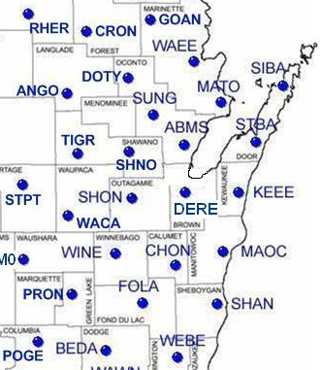
3 LiDAR ACQUISITION & PROCEDURES

3.1 Acquisition Time Period

LiDAR data acquisition and Airborne GPS control surveys were completed on April 17th, 2010. One (1) flight mission was required to cover the project areas.

3.2 LiDAR Planning

The LiDAR data for this project was collected with Aerometric’s Optech Gemini Airborne LiDAR system (Serial Number 07SEN201). All flight planning and acquisition was completed using Optech’s ALTM-Nav, version 2.1.25b (flight planning and LiDAR control software).
The following are the acquisition settings
- Flying Height (Above Ground): 1700 meters
- Laser Pulse Rate: 70 kHz
- Mirror Scan Frequency: 32 Hz
- Scan Angle (+/-): 20°
- Side Lap: 50 %
- Ground Speed: 160 kts
- Nominal Point Spacing: 1.2 meters

3.3 LiDAR Acquisition

One (1) flight mission was required to cover the project areas. The mission was flown using the above planned values. See next page for a sketch of the acquisition mission and Section 7 of the report for the flight log.

Airborne GPS and IMU trajectories for the LiDAR sensor were also acquired during the time of flight.

The mission was about four hours long. Before take-off, the LiDAR system and the Airborne GPS and IMU systems were initiated for a period of five minutes and then again after landing for another five minutes. The mission acquired data according to the planned flight lines.

3.4 LiDAR Trajectory Processing

The airborne positioning was based on the following control stations: ABMS, DERE, and SHAN.

L041710A
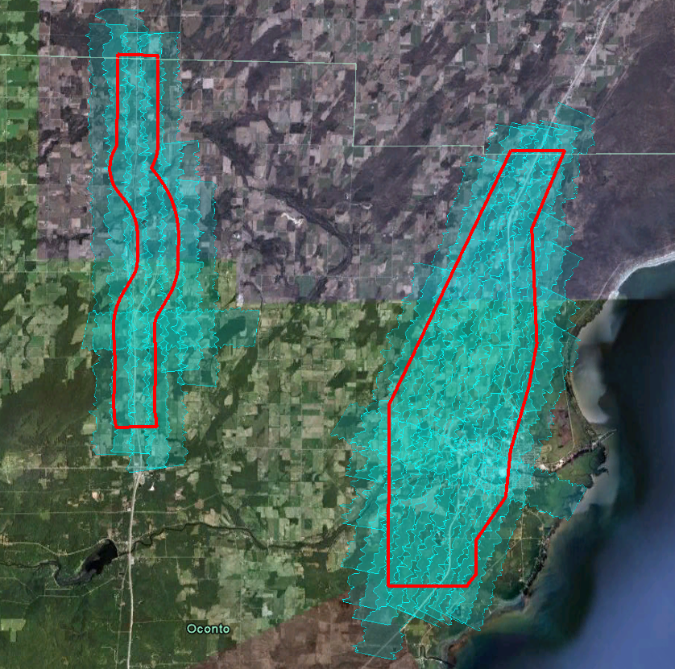

4 QC SURVEYS

The check point surveys were performed in 2000 using RTK GPS techniques. A total of 12 check points were surveyed across the project area. These points were collected in open terrain to assess the vertical accuracy.

See Section 9 of the control report for a complete listing.

5 FINAL LiDAR PROCESSING

5.1 ABGPS and IMU Processing

Airborne GPS

Applanix - POSGPS
Utilizing carrier phase ambiguity resolution on the fly (i.e., without initialization). The solution to sub-decimeter kinematic positioning without the operational constraint of static initialization as used in semi-kinematic or stop-and-go positioning was utilized for the airborne GPS post-processing.

The processing technique used by Applanix, Inc. for achieving the desired accuracy is Kinematic Ambiguity Resolution (KAR). KAR searches for ambiguities and uses a special method to evaluate the relative quality of each intersection (RMS). The quality indicator is used to evaluate the accuracy of the solution for each processing computation. In addition to the quality indicator, the software will compute separation plots between any two solutions, which will ultimately determine the acceptance of the airborne GPS post processing.

Inertial Data
The post-processing of inertial and aiding sensor data (i.e. airborne GPS post processed data) is to compute an optimally blended navigation solution. The Kalman filter-based aided inertial navigation algorithm generates an accurate (in the sense of least-square error) navigation solution that will retain the best characteristics of the processed input data. An example of inertial/GPS sensor blending is the following: inertial data is smooth in the short term. However, a free-inertial navigation solution has errors that grow without bound with time. A GPS navigation solution exhibits short-term noise but has errors that are bounded. This optimally blended navigation solution will retain the best features of both, i.e. the blended navigation solution has errors that are smooth and bounded.
The resultant processing generates the following data:
- Position: Latitude, Longitude, Altitude
- Velocity: North, East, and Down components
- 3-axis attitude: roll, pitch, true heading
- Acceleration: x, y, z components
- Angular rates: x, y, z components

The Applanix software, version 4.4, was used to determine both the ABGPS trajectory and the blending of inertial data.

The airborne GPS and blending of inertial and GPS post-processing were completed in multiple steps.

- The collected data was transferred from the field data collectors to the main computer. Data was saved under the project number and separated between LiDAR mission dates. Inside each mission date, a sub-directory was created with the aircraft’s tail number and an A or B suffix was attached for the time of when the data was collected. Inside the tail number sub-directory, five sub-directories were also created EO, GPS, IMU, PROC, and RAW.

- The aircraft raw data (IMU and GPS data combined) was run through a data extractor program. This separated the IMU and GPS data. In addition to the extracting of data, it provided the analyst the first statistics on the overall flight. The program was POSPac (POS post-processing PACkage).

- Executing POSGPS program to derive accurate GPS positions for all flights:
Applanix POSGPS
The software utilized for the data collected was PosGPS, a kinematic on-the-fly (OTF) processing software package. Post processing of the data is computed from each base station (Note: only base stations within the flying area were used) in both a forward and backward direction. This provides the analyst the ability to Quality Check (QC) the post processing, since different ambiguities are determined from different base stations and also with the same data from different directions.

The trajectory separation program is designed to display the time of week that the airborne or roving antenna traveled, and compute the differences found between processing runs. Processed data can be compared between a forward/reverse solution from one base station, a reverse solution from one base station and a forward solution from the second base station, etc. For the Applanix POSGPS processing, this is considered the final QC check for the given mission. If wrong ambiguities were found with one or both runs, the analyst would see disagreements from the trajectory plot, and re-processing would continue until an agreement was determined.

Once the analyst accepts a forward and reverse processing solution, the trajectory plot is analyzed and the combined solution is stored in a file format acceptable for the IMU post processor.

Please see Section 8 of the control report for the final accepted trajectory plot.

- When the processed trajectory data was accepted after quality control analysis, the combined solution is stored in a file format acceptable for the IMU post processor (i.e. POSProc).

- Execute POSProc.
POSProc comprises a set of individual processing interface tools that execute and provide the following functions:

The following diagram shows the organization of these tools, and is a function of the POSProc processing components.

Diagram 3
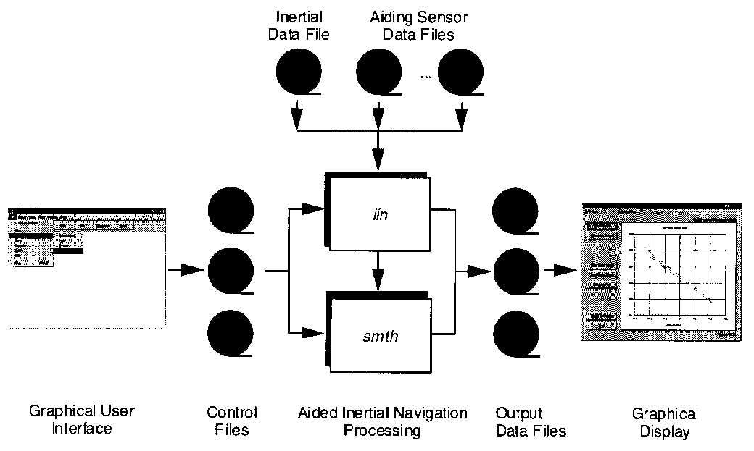

- Integrated Inertial Navigation (iin) Module.
The name iin is a contraction of Integrated Inertial Navigation. iin reads inertial data and aiding data from data files specified in a processing environment file and computes the aided inertial navigation solution. The inertial data comes from a strapdown IMU. iin outputs the navigation data between start and end times at a data rate as specified in the environment file. iin also outputs Kalman filter data for analysis of estimation error statistics and smoother data that the smoothing program smth uses to improve the navigation solution accuracy.
iin implements a full strapdown inertial navigator that solves Newton’s equation of motion on the earth using inertial data from a strapdown IMU. The inertial navigator implements coning and sculling compensation to handle potential problems caused by vibration of the IMU.

- Smoother Module (smth).
smth is a companion processing module to iin. smth is comprised of two individual functions that run in sequence. smth first runs the smoother function and then runs the navigation correction function.

The smth smoother function performs backwards-in-time processing of the forwards-in-time blended navigation solution and Kalman filter data generated by iin to compute smoothed error estimates. smth implements a modified Bryson-Frazier smoothing algorithm specifically designed for use with the iin Kalman filter. The resulting smoothed strapdown navigator error estimates at a given time point are the optimal estimates based on all input data before and after the given time point. In this sense, smth makes use of all available information in the input data. smth writes the smoothed error estimates and their RMS estimation errors to output data files.

The smth navigation correction function implements a feedforward error correction mechanism similar to that in the iin strapdown navigation solution using the smoothed strapdown navigation errors. smth reads in the smoothed error estimates and with these, corrects the strapdown navigation data. The resulting navigation solution is called a Best Estimate of Trajectory (BET), and is the best obtainable estimate of vehicle trajectory with the available inertial and aiding sensor data.

The above mentioned modules provide the analyst the following statistics to ensure that the most optimal solution was achieved: a log of the iin processing, the Kalman filter Measurement Residuals, Smoothed RMS Estimation Errors, and Smoothed Sensor Errors and RMS.

5.2 LiDAR “Point Cloud” Processing

The ABGPS/IMU post processed data along with the LiDAR raw measurements were processed using Optech Incorporated’s ASDA software. This software was used to match the raw LiDAR measurements with the computed ABGPS/IMU positions and attitudes of the LiDAR sensor. The result was a “point cloud” of LiDAR measured points referenced to the ground control system.

5.3 LiDAR CALIBRATION

Introduction
The purpose of the LiDAR system calibration is to refine the system parameters in order for the post-processing software to produce a “point cloud” that best fits the actual ground.

The following report outlines the calibration techniques employed for this project.

Calibration Procedures
Aerometric routinely performs two types of calibrations on its Optech Gemini LiDAR system. The first calibration, system calibration, is performed whenever the LiDAR system is installed in the aircraft. This calibration is performed to define the system parameters affected by the physical misalignment of the system versus aircraft. The second calibration, in-situ calibration, is performed for each mission using that mission’s data. This calibration is performed to refine the system parameters that are affected by the on site conditions as needed.

System Calibration and Correction Software
Optech has developed a proprietary calibration software in December of 2009 that performs system calibration. The results from this new software achieved excellent results and an accuracy that meets the project requirements.

This new calibration tool incorporates Optech’s proprietary optical sensor models to compute laser point positions and provide laser point calibration improvements on a per flightline basis for the entire project area. It furthermore calculates planar surfaces at different angles from each flight line and then uses a robust least squares solution to compute the orientation parameters at the optical level instead of the traditional methods relating to the ground points. Determining and correcting at the optical level is critical when correcting the data especially when working in terrain and aggressive design parameters as found in this project. Each flight line was computed individually and output in LAS 1.2 format.

In-situ Calibration
The in-situ calibration is performed as needed using the mission’s data. This calibration is performed to refine the system parameters that are affected by the on site conditions.

For each mission, LiDAR data for at least one cross flight is acquired over the mission’s acquisition site. The processed data of the cross flight is compared to the perpendicular flight lines using either the Optech proprietary software or TerraSolid's TerraMatch software to determine if any systematic errors are present. In this calibration, the data of individual flight lines are compared against each other and their systematic errors are corrected in the final processed data.

5.4 LiDAR Processing

The LAS files were then imported, verified, and parsed into manageable, tiled grids using GeoCue version 6.1.21.0. GeoCue allows for ease of data management and process tracking.

The first step after the data has been processed and calibrated is to perform a relative accuracy assessment on the flightline to flightline comparisons.

Once the accuracy between swaths is accepted an automated classification algorithm is performed using TerraScan. This will produce the majority of the bare-earth datasets.

The remainder of the data was classified using manual classification techniques. The majority of the manual edit removed points misclassified as ground (class 2) to unclassified (class 1). Erroneous low points, high points, including clouds are classified to class 7.

5.5 Check Point Validation

The data was then verified using the ground control data collected by Aerometric. TerraScan then computes the vertical differences between the surveyed elevation and the LiDAR derived elevation for each control point.

A report listing the differences and common statistics was created and can be found in Section 9 of this report.

5.6 LiDAR Data Delivery

Raw point cloud data supplied is in the following format:
- LAS, version 1.2
- GPS seconds of week
- Full swaths and delivered as 1 swath per file not to exceed 2gb.

Classified point cloud data is also being supplied using the following criteria.
- LAS, version 1.2
- GPS seconds of week
- Classification scheme:
    - Code 1 – Processed, but unclassified
    - Code 2 – Ground
    - Code 7 – Noise
    - Code 8 – Model Keypoints
    - Code 9 – Water
    - Code 10 – Ignored Ground (Breakline proximity)

The 5ft bare-earth DEMs were created in the following manner. First, ArcGrids in ASCII format were created using TerraModeler version 10.004 (TerraSolid Ltd.). The ASCII grids were then imported into ARC and translated to raster format and placed in an Arc raster format. For the areas of this project, there were no culverts contained within the limits and the delivered DEMs are to be considered as being hydro enforced.

Collected breaklines are first collected in a Microstation environment using the base specifications. Upon acceptance the breaklines, either polygons or lines, are translated into ARC and imported to shapefile format as separate features and also translated to an AutoCAD (DWG) format.

The 2-foot contours are created using the hyrdro enforced breaklines and also the contour keypoints that are critical in defining the surface. The contours are provided in ESRI Shapefile and AutoCAD DWG formats. The elevation values are embedded in the attribute table of each feature and are part of the 3D feature geometry.

6 CONCLUSION

Because of the rigorous procedures and use of new technology, this project will serve the client of Oconto County and all users requiring the provided LiDAR derivative products well into the future. Although this project tested the limits of both the equipment and personnel, the results are extremely accurate and reliable.

7 FLIGHT LOG
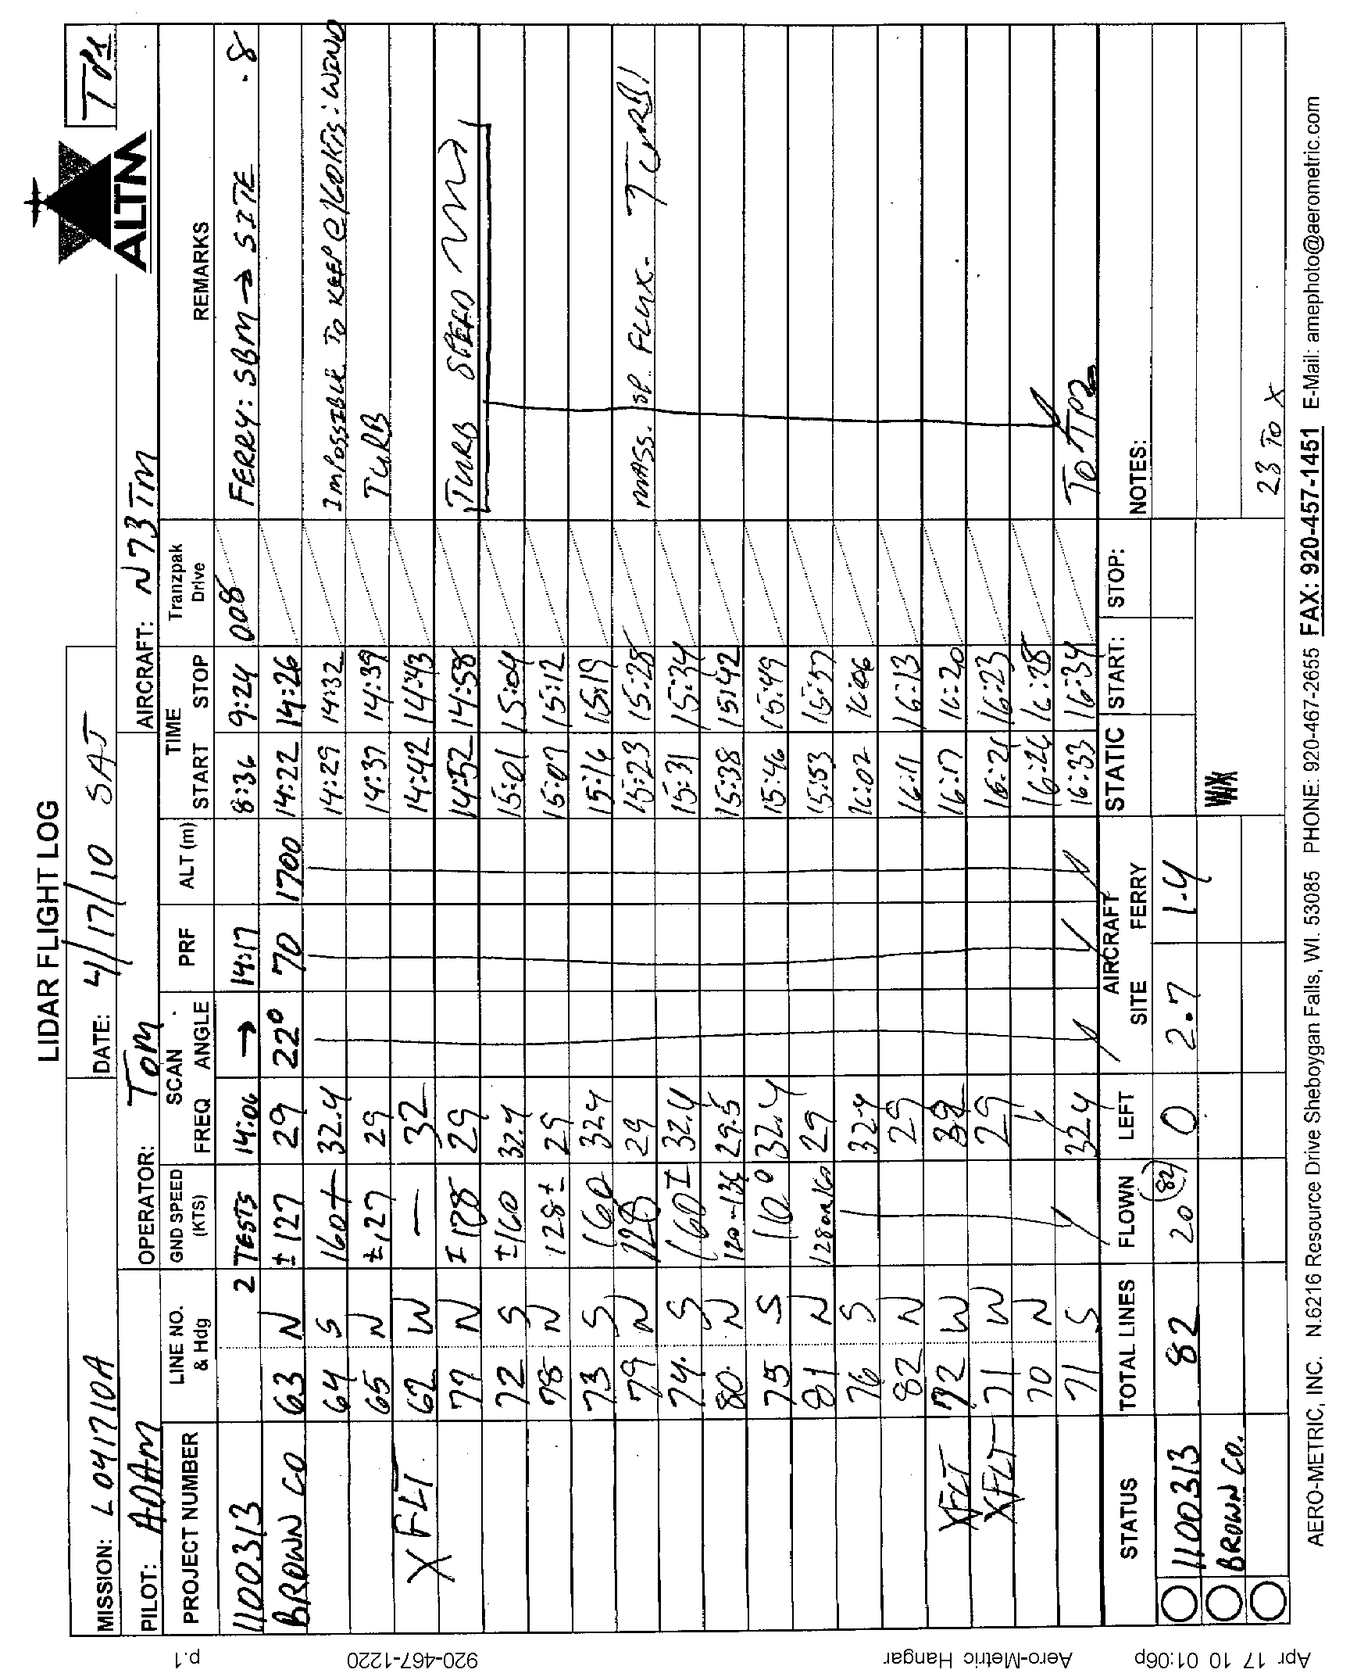

8 SEPARATION PLOTS
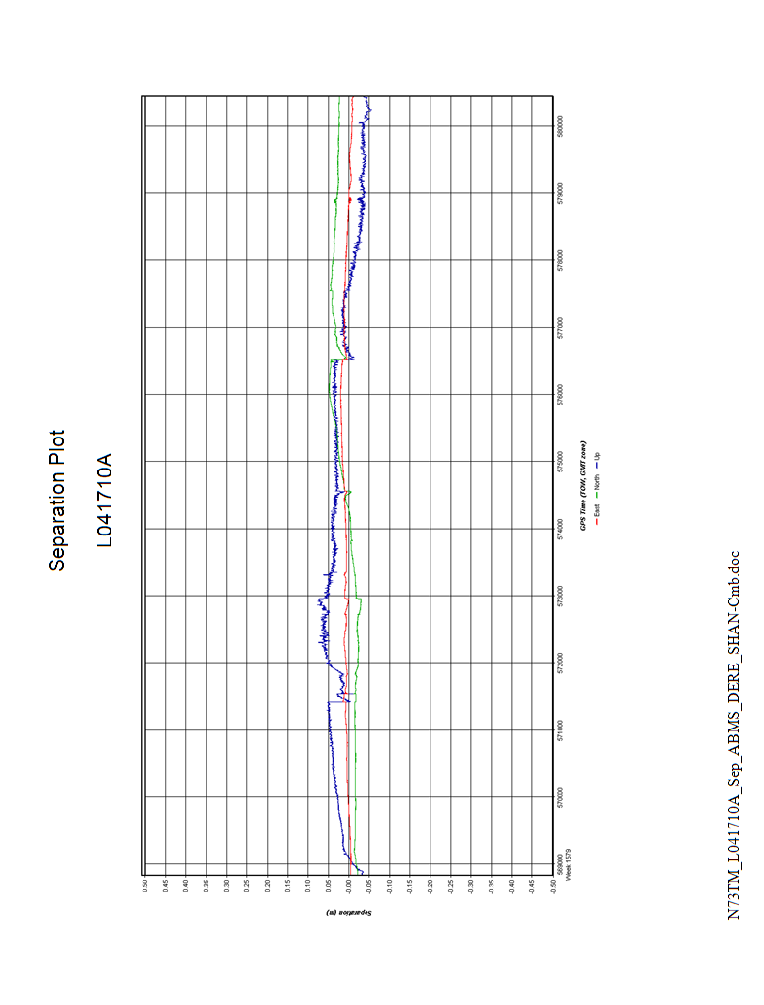

9 QC REPORT

Number Easting Northing Known Z Laser Z Dz
1000 602417.860 169966.050 599.570 599.570 +0.000
1001 602418.160 169846.450 599.560 599.540 -0.020
1002 602370.880 169830.640 599.570 599.610 +0.040
1003 609558.970 200858.120 619.840 619.830 -0.010
1004 609652.540 200858.770 621.070 620.990 -0.080
1005 609646.950 200907.220 621.350 621.220 -0.130
2000 564295.100 186535.650 706.420 706.520 +0.100
2001 564254.220 186448.560 706.900 706.870 -0.030
2002 564205.590 186445.820 706.800 706.690 -0.110
2003 564753.360 222937.500 700.770 700.860 +0.090
2004 564693.870 222877.610 702.630 702.550 -0.080
2005 564646.080 222873.340 702.700 702.910 +0.210
S6GPS 606538.890 176177.580 591.450 removed *
E129GPS 604049.300 170008.580 595.270 removed *
V6GPS 612681.520 200456.620 596.260 removed *
W18GPS 564107.590 177249.940 655.930 outside *
660GPS 563562.520 202003.730 714.400 removed *
Average dz -0.002
Minimum dz -0.130
Maximum dz +0.210
Average magnitude 0.075
Root mean square 0.094
Std deviation 0.099

