Elevation QA Review Report

Project: Contract ID:

Liaison: Partner(s): Contractor:

Data Delivery Date: Date Data Reviewed:

Reviewer: Total Square Miles Reviewed:

Elevation Type: Format: Grid Spacing: Tile size:

Projection: Zone: Datum: Unit

Licensing: Metadata:

Materials Received:

Vertical Accuracy Test Performed: Test Point Source: RMSE:

Vertical Accuracy Test Notes:

QA Review Summary:

Vertical Accuracy Statistic Worksheet
elevations units in meters
A | B |  | C | D | E | F | G | H
Point | Easting |  | Northing | Point | z | z
number |  |  |  | description | (independent) | (test) | diff in z |  | (diff in z)²
1 | 118 46 31.71663(W) |  | 34 40 20.21683(N) | BLACK MTN M 10 | 941.3 | 941.465 | -0.165 |  | 0.027
2 | 118 45 07.61067(W) |  | 34 39 11.21080(N) | BLACK MTN O 12 | 926.8 | 926.649 | 0.151 |  | 0.023
3 | 118 52 04.27087(W) |  | 34 36 32.33668(N) | COBBLESTONE | 2053.8 | 2053.156 | 0.644 |  | 0.415
4 | 118 46 31.48637(W) |  | 34 40 19.94531(N) | JERRY CDWR 1973 | 940.7 | 941.094 | -0.394 |  | 0.155
5 | 118 44 10.63840(W) |  | 34 38 57.79459(N) | LIEBRE MTN B 13 | 1163.1 | 1163.266 | -0.166 |  | 0.028
6 | 118 43 18.92974(W) |  | 34 37 45.53711(N) | LIEBRE MTN D 15 | 973.4 | 973.179 | 0.221 |  | 0.049
7 | 118 44 33.95563(W) |  | 34 34 02.75240(N) | WHITAKER AUX 1 | 1255.3 | 1254.589 | 0.711 |  | 0.506
8 | 118 41 28.28920(W) |  | 34 33 34.53257(N) | WHITAKER PK H 8 | 970.2 | 969.959 | 0.241 |  | 0.058
9 | 118 40 08.40182(W) |  | 34 33 21.93821(N) | WHITAKER PK J 9 | 773.8 | 773.795 | 0.005 |  | 0.000
10 | 118 44 34.19350(W) |  | 34 34 03.14932(N) | WHITAKER RESET | 1256.1 | 1256.004 | 0.096 |  | 0.009
 |  |  |  |  |  |  | sum |  | 1.269
OutLier: a control point located in an area that does not reflect |  |  |  |  |  |  | average |  | 0.127
the true ground elevation, i.e. bridges, etc. |  |  |  |  |  |  | RMSE |  | 0.356
 |  |  |  |  |  |  | NSSDA |  | 0.698

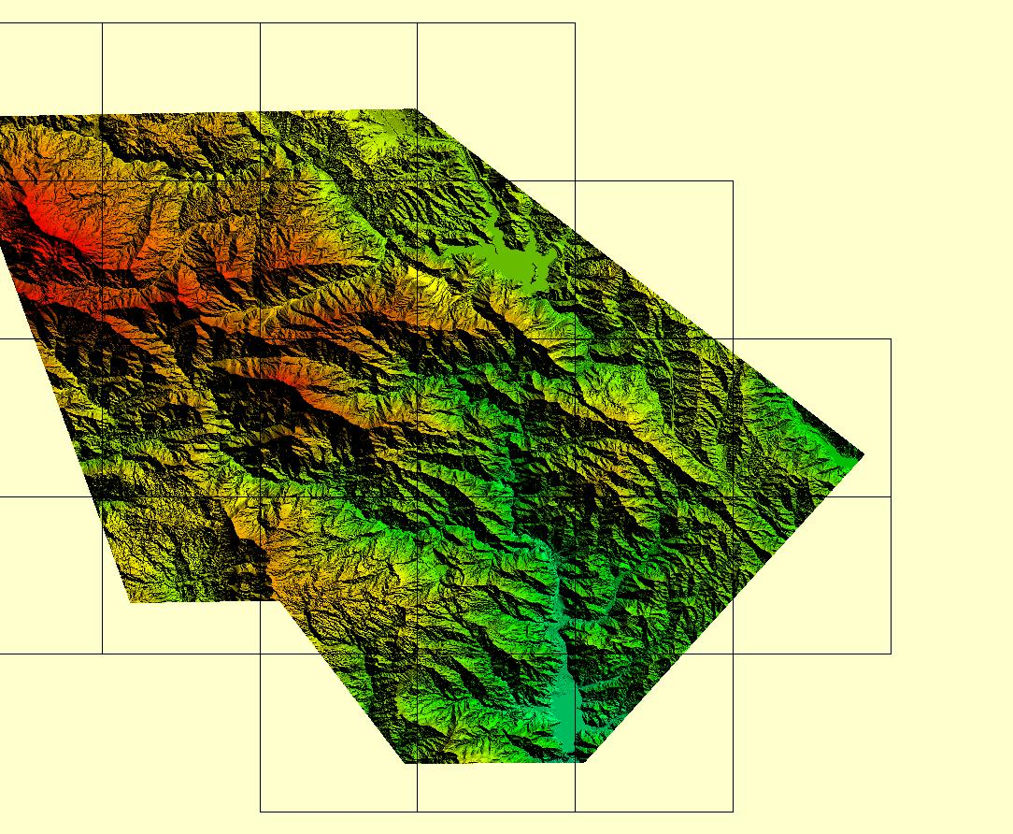

Day Fire, CA Footprint

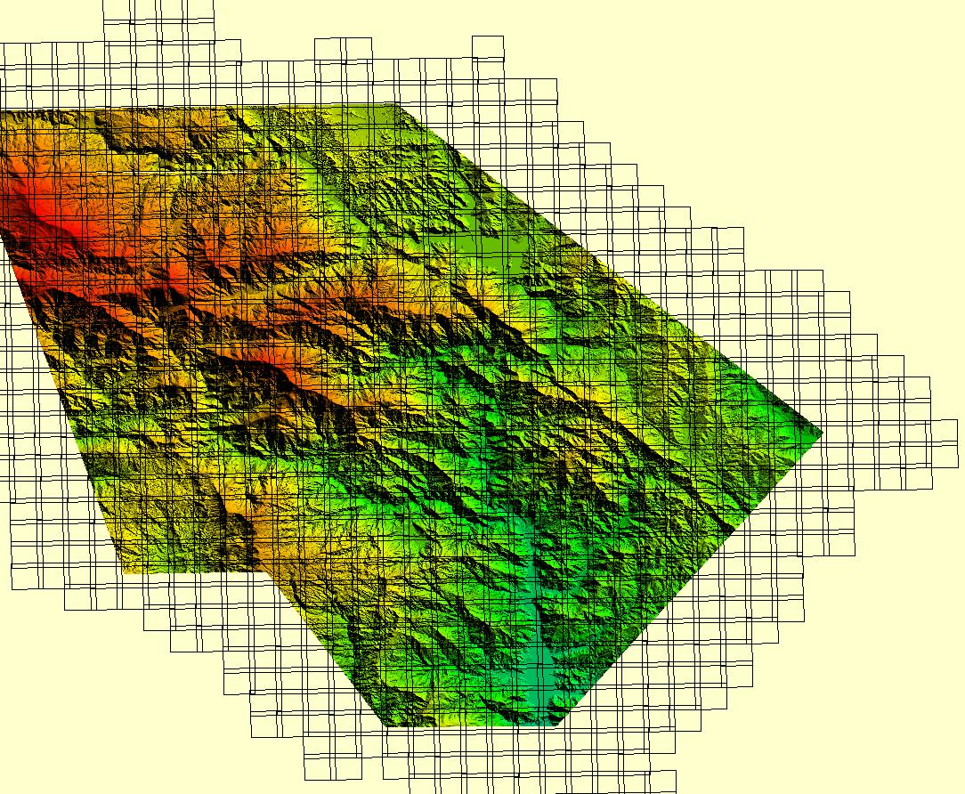

Tile Index showing location of 100 m overlap

Distribution of NGS test points

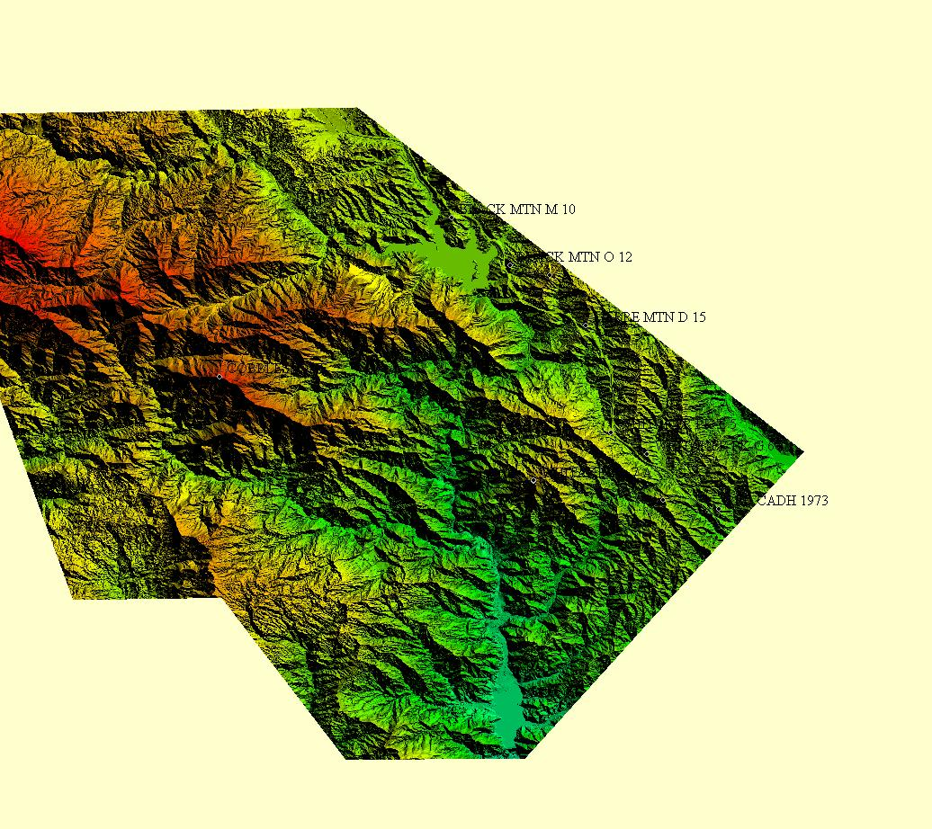
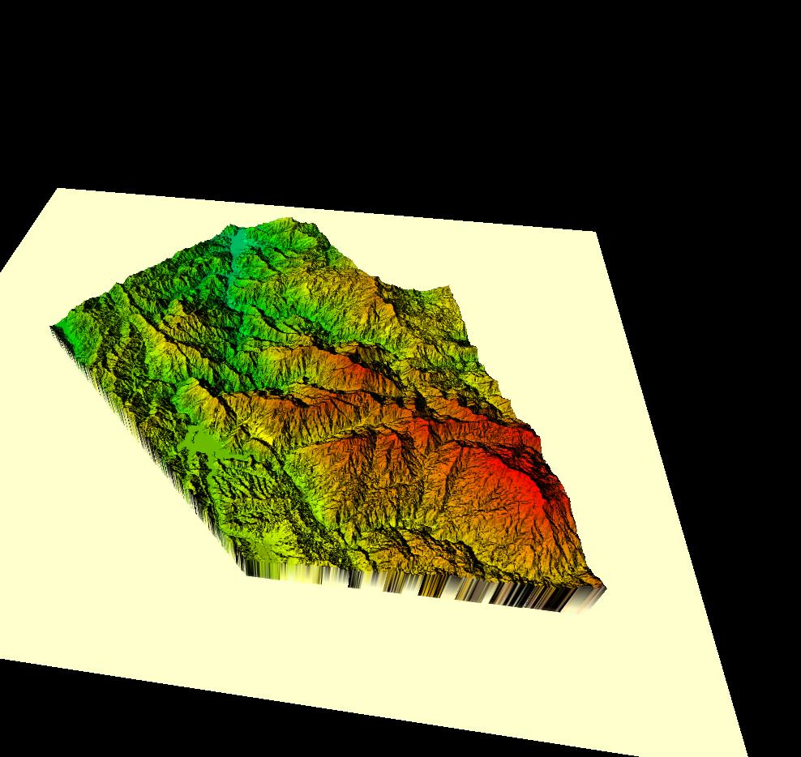

Day Fire, CA Lidar – Vegetation removed

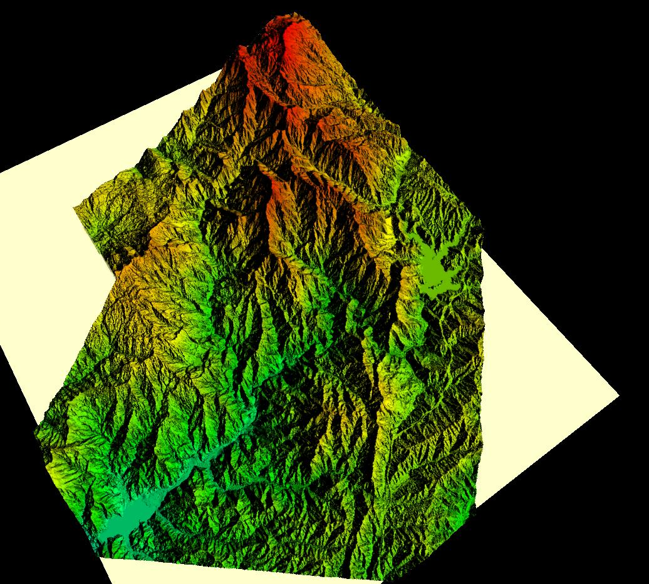

Day Fire, CA Lidar – Large buildings and overpasses removed

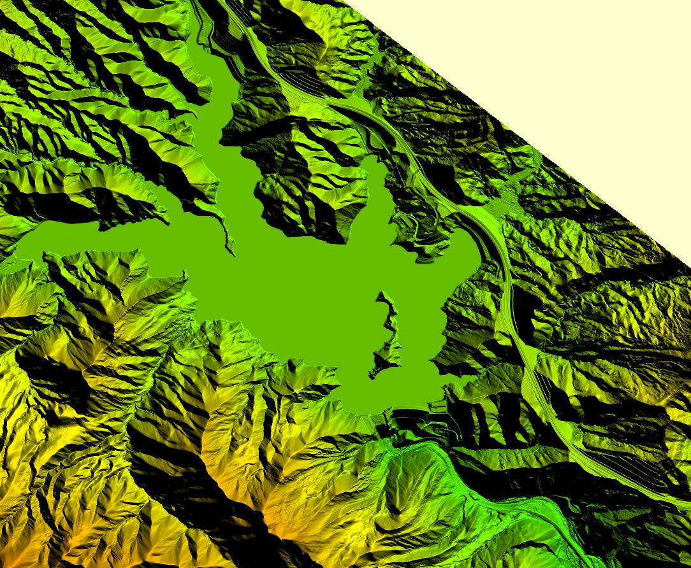

Day Fire, CA Lidar water leveled

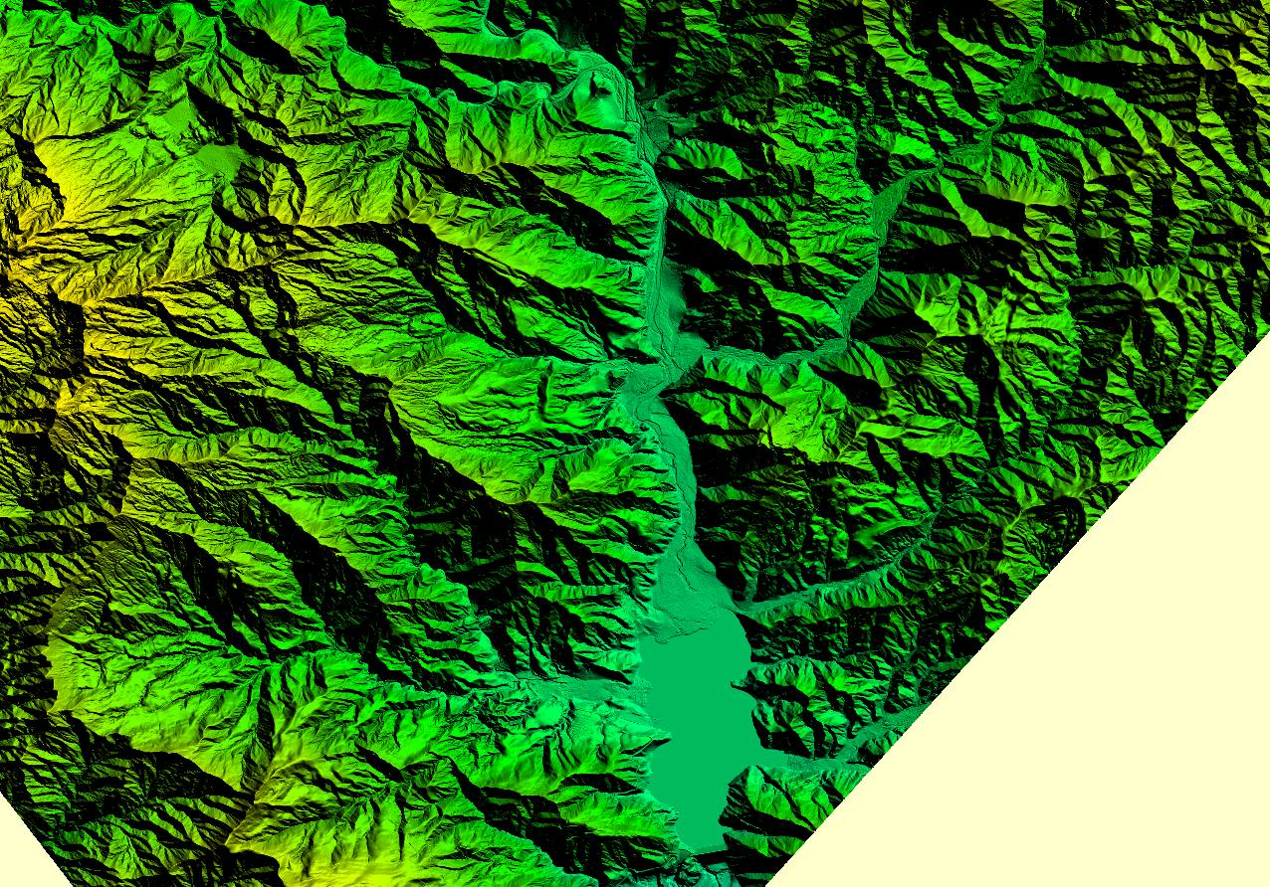
Day Fire, CA Lidar Vegetation removed, water leveled

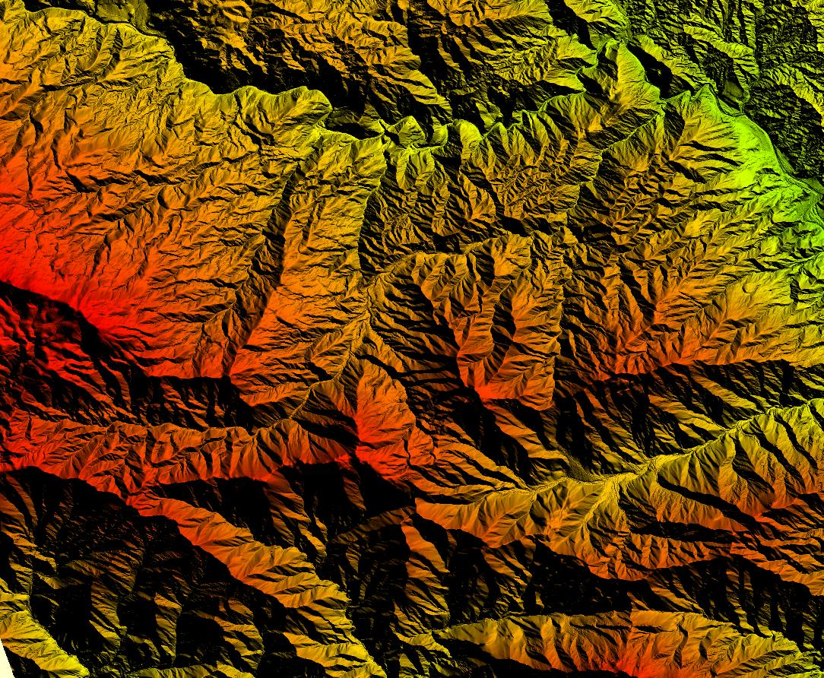
Day Fire Lidar
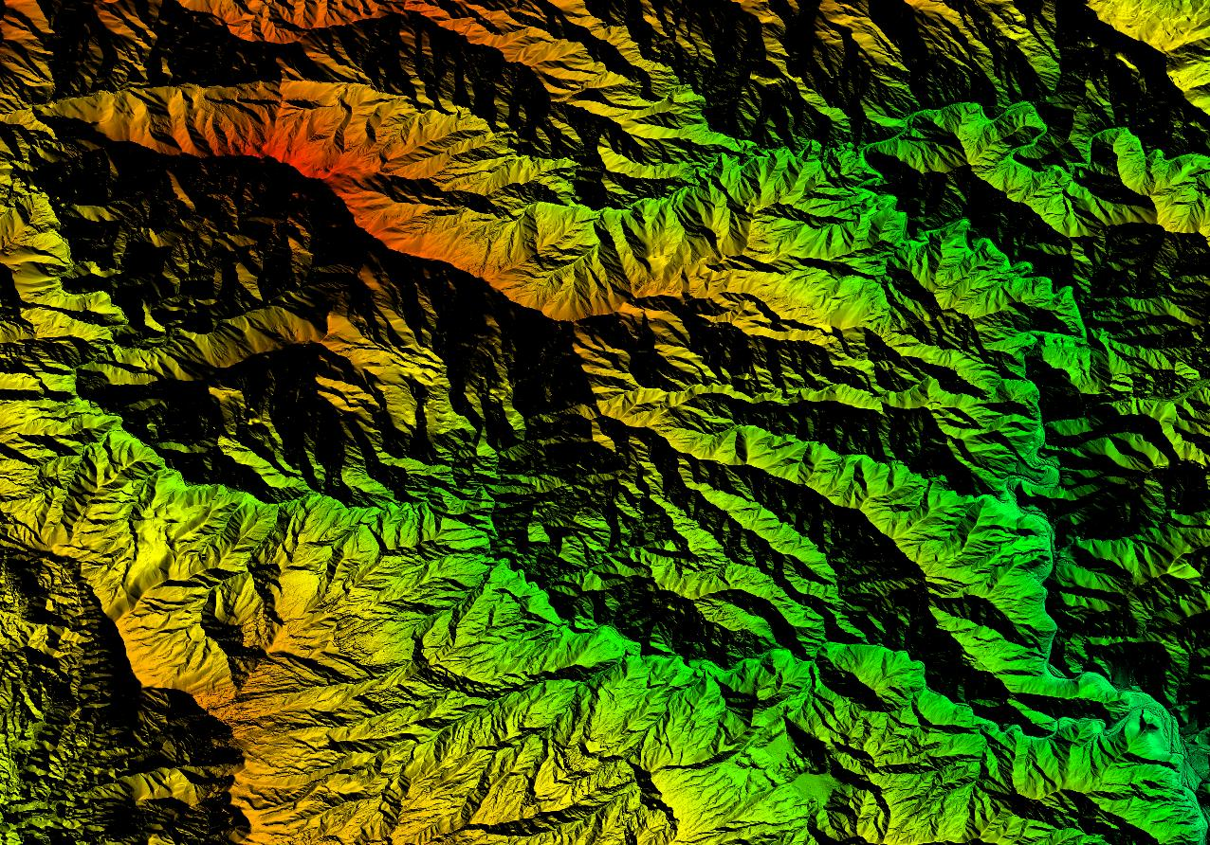

Day Fire, CA Lidar overhead view

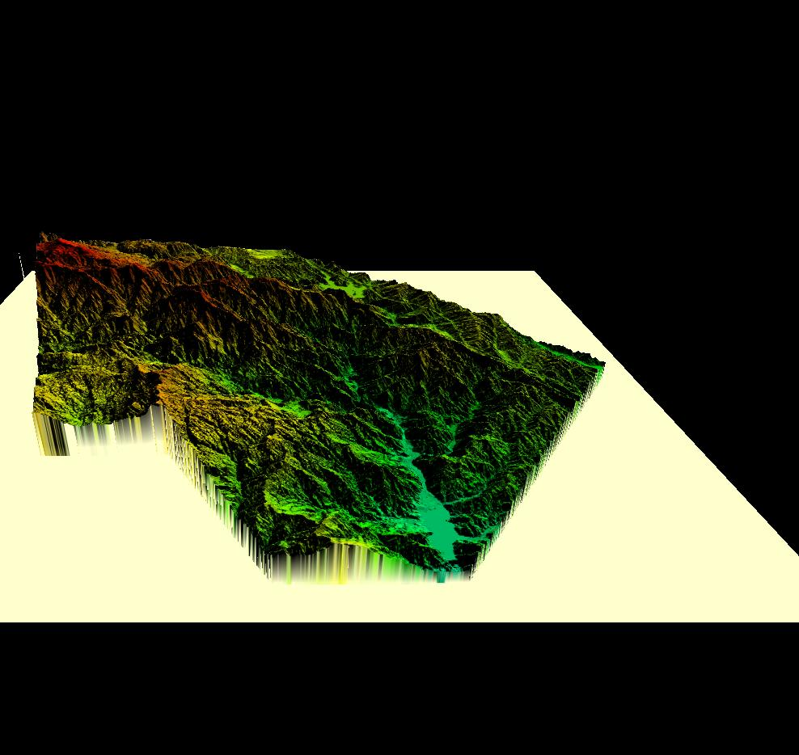
Day Fire, CA Lidar

