Elevation QA Review Report

Project: Contractor:

Data Delivery Date: Date Data Reviewed:

Reviewer: Total Square Miles Reviewed:

Elevation Type: Format: Grid Spacing: Tile size:
Projection: Zone: Datum: Units:

Licensing: Metadata:

Materials Received:

Vertical Accuracy Test Performed: Test Point Source: RMSE:
Vertical Accuracy Test Notes:

QA Review Summary:

Seam Line Attachments: 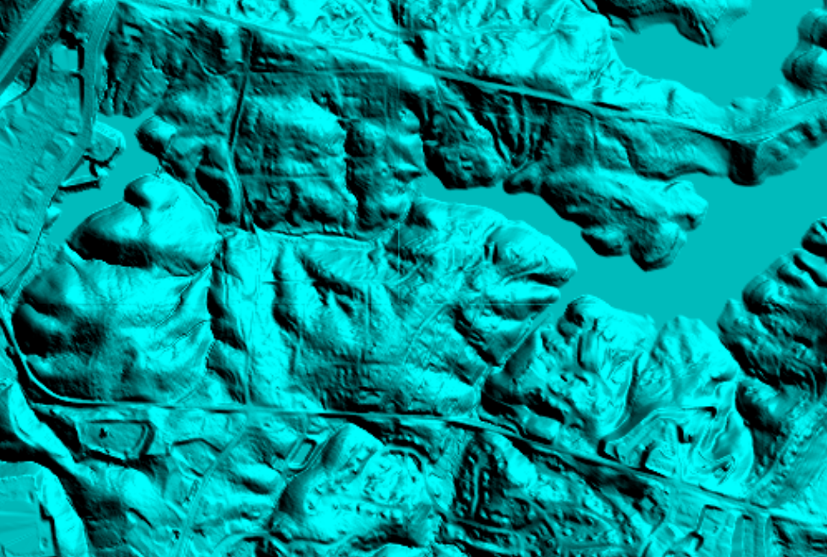

Obtrusive Feature:


