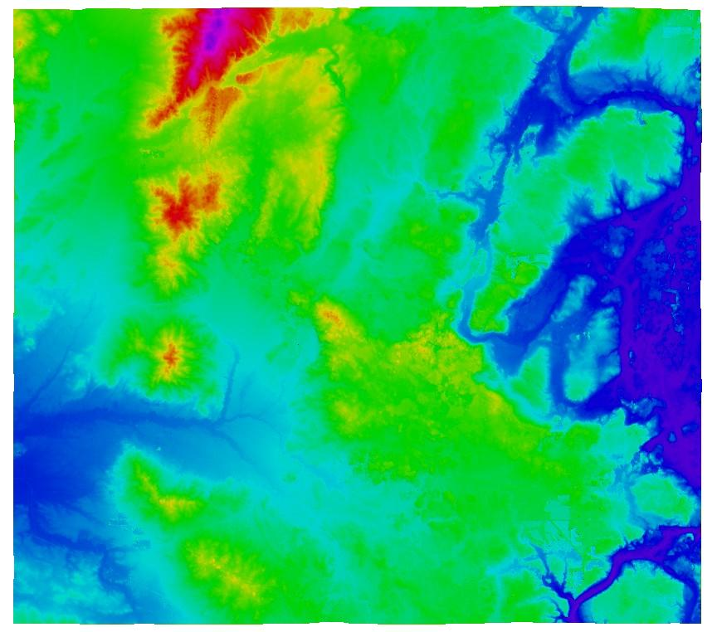

VERTICAL ACCURACY ASSESSMENT

REPORT

FOR

U.S. ARMY CORPS OF ENGINEERS
ST. LOUIS DISTRICT

McHENRY COUNTY, IL

December 12, 2008

AERO-METRIC PROJECT NO. 1-080208

U.S. Army Corps of Engineers
St Louis District

McHenry County, Illinois

Vertical Accuracy Assessment Report

AERO-METRIC, INC.
4020 Technology Parkway
Sheboygan, WI 53083

AERO-METRIC Project No. 1-080208

Background

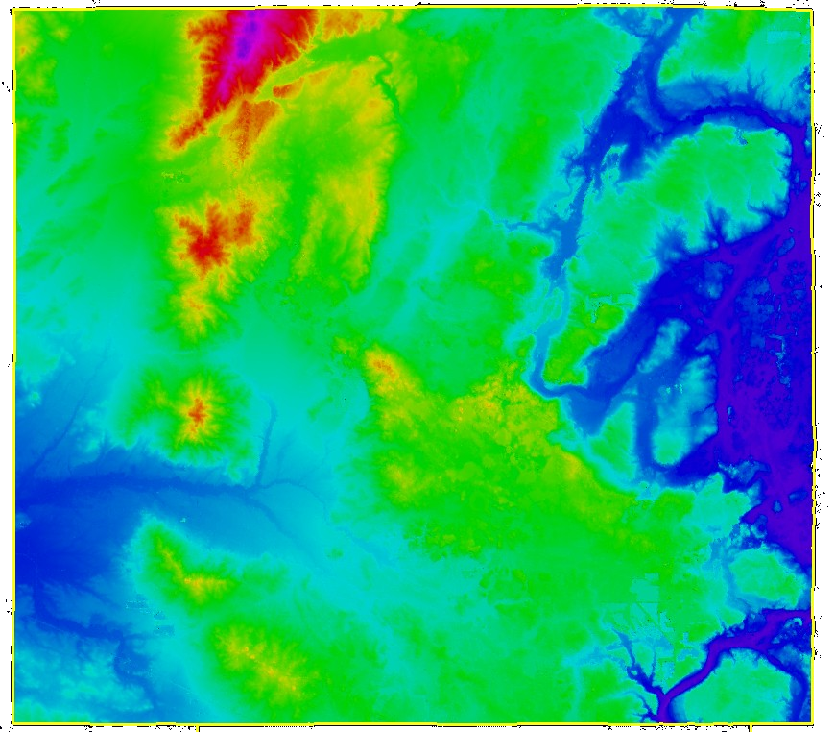
The National Standard for Spatial Data Accuracy (NSSDA) defines guidelines for testing and reporting the accuracy of digital geospatial data. The NSSDA makes the assumption that all errors follow a normal error distribution where Root-Mean-Square-Error (RMSE) procedures apply. The Federal Emergency Management Agency (FEMA) guidelines implement the NSSDA standards and recommend the survey of a minimum of 20 checkpoints per ground cover category representative of the area being tested. A minimum of three categories (60 checkpoints) is required. The National Digital Elevation Program (NDEP) and the American Society for Photogrammetry and Remote Sensing (ASPRS) provide an alternative method for reporting the vertical accuracy whereby errors in vegetation categories are not assumed to follow a normal error distribution. Even though the ASPRS guidelines are directly referenced to the assessment of LiDAR digital data, the same ideals can be applied to the digital elevation data collected for this project. A minimum of 60 checkpoints is again recommended, with up to 100 points preferred. For the McHenry County project, five major ground cover categories were defined by AERO-METRIC (AME) as representative of the project area. Each county met the checkpoint requirements of five separate major ground cover categories containing at least 20 points per category. For one of the categories (short grass), only 16 checkpoints were surveyed due to limited accessibility. For the remaining four categories (hard surface, tall grass, brush, and woods), 20 or more checkpoints were surveyed in each of these areas. An additional 19 cross section points were included making a total of 126 checkpoints over the entire project area.

AME’s vertical accuracy assessment for the McHenry County project was carried out in accordance with the two methods mentioned above. The first method (defined by NSSDA and FEMA) assumes all errors follow a normal error distribution and the newer second method (defined by NDEP and ASPRS) assumes that errors in some land cover categories may not follow a normal error distribution. Comparing the two methods helps determine the amount of systematic errors that may exist in the five ground cover categories: hard surface, short grass, tall grass, brush, and woods. The following table summarizes the criteria used to evaluate the vertical data. Criteria highlighted in yellow refer to the NSSDA and FEMA guidelines and those highlighted in orange refer to the NDEP and ASPRS guidelines.

Table 1 -- DTM Acceptance Criteria

Criteria | Acceptable Value
RMSE_{z}= NSSDA vertical accuracy statistic at 68% confidence level (1.0 x RMSE_{z}) | 0.60 ft for all ground cover categories combined
Accuracy_{z}= NSSDA vertical accuracy statistic at the 95% confidence level (1.96 x RMSE_{z}) | 1.19 ft (RMSE_{z} x 1.9600) for all ground cover categories combined
Fundamental Vertical Accuracy (FVA) in open terrain only = 95% confidence level | 1.19 ft (RMSE_{z} x 1.9600) for open terrain only
Supplemental Vertical Accuracy (SVA) in individual ground cover categories = 95% confidence level | 1.19 ft (based on 95th percentile per category; this is a target value only, not mandatory)
Consolidated Vertical Accuracy (CVA) in all ground cover categories combined = 95% confidence level | 1.19 ft (based on combined 95th percentile)

AME tested the digital vertical data using the following steps:

- AME ground survey personnel collected and processed GPS data for each of the ground cover checkpoints. These points were distributed throughout ground cover category areas within the McHenry County project limits.
- The checkpoints were compared to the digital vertical data using the TerraSolid, LTD program TerraScan. The program creates a TIN surface from the digital vertical data and computes vertical differences between the surface and the surveyed checkpoints. An output file records the vertical differences and associated statistics. Files were created for each of the ground cover categories separately and one file for all categories combined.
- The results were analyzed by AME to assess the quality of the data. Various accuracy parameters as defined by the NDEP and ASPRS guidelines were used in the review process. Also, the overall descriptive statistics of each dataset were computed to assess any tendencies or inconsistencies. The following tables, graphs, and figures illustrate the data quality.

Using the NDEP and ASPRS Guidelines for Vertical Accuracy Testing

The required Fundamental Vertical Accuracy (FVA) and the optional Supplemental Vertical Accuracy (SVA) and Consolidated Vertical Accuracy (CVA) are specified by the NDEP and ASPRS guidelines. FVA determines how well the digital data was collected in open terrain type ground cover where all errors are presumed to be random. The SVA determines how well the digital data represents the actual ground in each of the ground cover categories, tested separately. The CVA determines the overall accuracy of all the ground categories combined as one test.

FVA for this project is calculated using only the checkpoints in the Hard Surface ground cover category. The digital data in this category is most likely to represent the actual ground surface and the random errors will follow a normal error distribution. The FVA shows how well the Photogrammetric process used to produce the digital vertical data represents the actual ground. With a normal error distribution, the vertical accuracy at the 95% confidence level is computed as the vertical root mean square error (RMSE_{z}) of the checkpoints x 1.9600, as specified in Appendix 3-A of the NSSDA guidelines. As shown in Table 1, the maximum allowable FVA for this project (2 ft contours) is 1.19 ft.
CVA is calculated with all the checkpoints in all the ground cover categories combined plus the 19 cross section points. There is a possibility that the digital vertical data may yield errors that do not follow a normal distribution. CVA at the 95% confidence level equals the 95th percentile error for all checkpoints in all ground cover categories combined. The CVA produces a listing of the 5% outliers that are larger than the 95th percentile and that may not follow the normal error distribution.

SVA is computed for each ground cover category separately. There again is a possibility that the digital vertical data may yield errors that do not follow a normal error distribution. Systematic errors per ground cover category are identified. For each category, the SVA at the 95% confidence level equals the 95th percentile error for all checkpoints in each individual ground cover category. The individual SVA statistics are used to analyze the data based on each of the ground cover categories.

Table 2 summarizes the vertical accuracy by Fundament, Consolidated, and Supplemental methods:

Table 2 – FVA, CVA, and SVA Vertical Accuracy at 95% Confidence Level

Ground Cover  Category | # of  Points | FVA  Fundamental Vertical Accuracy  Spec = 1.19 ft | CVA  Consolidated Vertical Accuracy  Spec = 1.19 ft | SVA  Supplemental Vertical Accuracy  Target = 1.19 ft
Total Combined | 126 |  | 0.45 ft
Hard Surface | 26 | 0.27 ft |  | 0.24 ft
Short Grass | 16 |  |  | 0.33 ft
Tall Grass | 22 |  |  | 0.28 ft
Brush | 23 |  |  | 0.62 ft
Woods | 20 |  |  | 0.45 ft

The digital vertical data for the McHenry County project meets all mandatory and target specifications as per the following vertical accuracy tests:

Compared with the 1.19 ft FVA specification, FVA tested 0.27 ft at the 95% confidence level on the hard surfaces ground cover category, based on RMSE_{z} x 1.9600. The NSSDA specifies that vertical accuracy at the 95% confidence level equals RMSE_{z} x 1.9600; the NDEP and ASPRS state that this method is valid only when random errors follow a normal error distribution, as in the hard surface category.

Compared with the 1.19 ft CVA specification, CVA tested 0.45 ft at the 95% confidence level on the hard surfaces, short grass, tall grass, brush, and woods ground cover categories combined, based on the 95th Percentile. NDEP and ASPRS guidelines specify that vertical accuracy at the 95% confidence level equals the 95th percentile when random errors may not follow a normal error distribution, as in vegetated or obstructed areas. Table 3 lists the 5% outliers larger than the 95th percentile (0.45ft).

Table 3 – 5% Outliers Larger than 95th Percentile

Ground Cover Category | Elev. Diff (ft) | None of the errors were larger than the CVA standard (1.19ft) which permits up to 5% of the checkpoints, 6 out of 126, to be larger than 1.19 ft.
Tall Grass | 0.55
Brush | 0.52
Brush | 0.56
Brush | 0.62
Brush | 1.07
Woods | 0.46

Compared with the 1.19 ft SVA target values, SVA tested 0.24 ft at the 95% confidence level on hard surfaces; 0.33 ft in short grass; 0.28 ft in tall grass; 0.62 ft in brush; and 0.45 ft in woods ground cover categories, based on the 95th Percentile. These values exceed all of their target values (1.19 ft).

Figure 1 illustrates the SVA by specific ground cover category. Figure 2 illustrates the magnitude of the differences between the checkpoints and the digital vertical data by specific ground cover category and sorted from lowest to highest. All of the checkpoints are within the 1.19 ft criteria shown in figure 2. This exceeds the 95% requirement, where up to five checkpoints could be outside the 1.19 ft criteria.

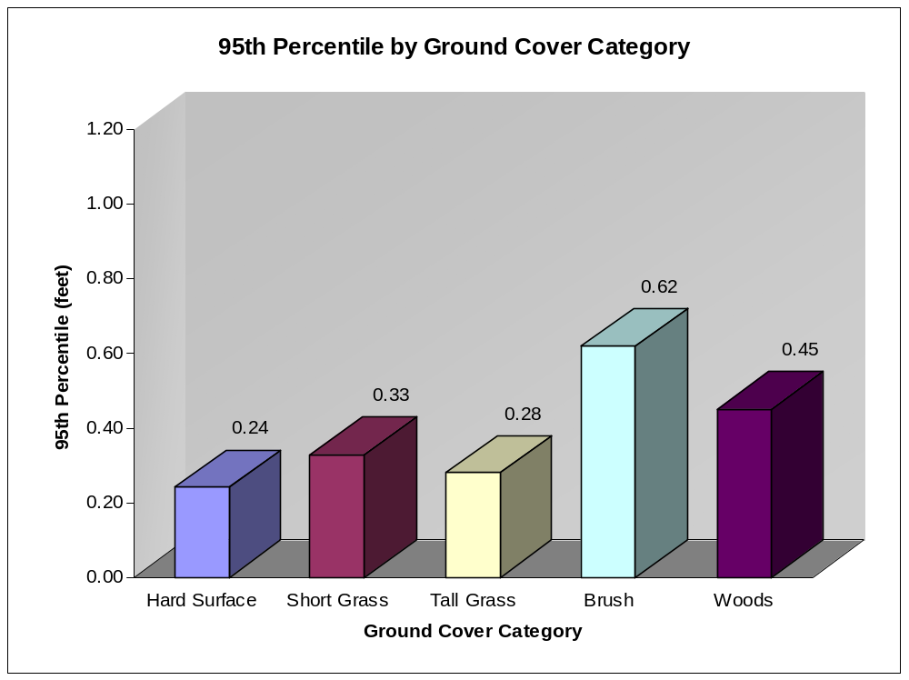

Figure 1 -- Graph of SVA Values by Ground Cover Category

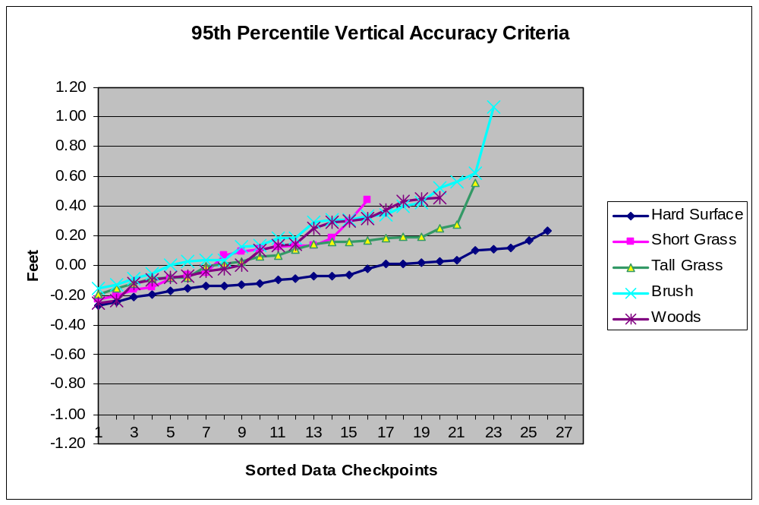

Figure 2 – Magnitude of Elevation Discrepancies, Sorted from Largest Negative to Largest Positive

Vertical Accuracy Testing in Accordance with NSSDA and FEMA Procedures

The NSSDA and FEMA guidelines were both published before it was recognized that digital data errors do not always follow a normal error distribution. Future changes to these guidelines are expected to follow those of the NDEP and ASPRS. In order to comply with FEMA’s current requirements, RMSE_{z} and other statistics were computed in all five ground cover categories, individually and combined. These statistics are shown in Figures 3 and 4 and Table 4 below.

Figure 3 shows the RMSEz values as calculated for each ground cover category separately.

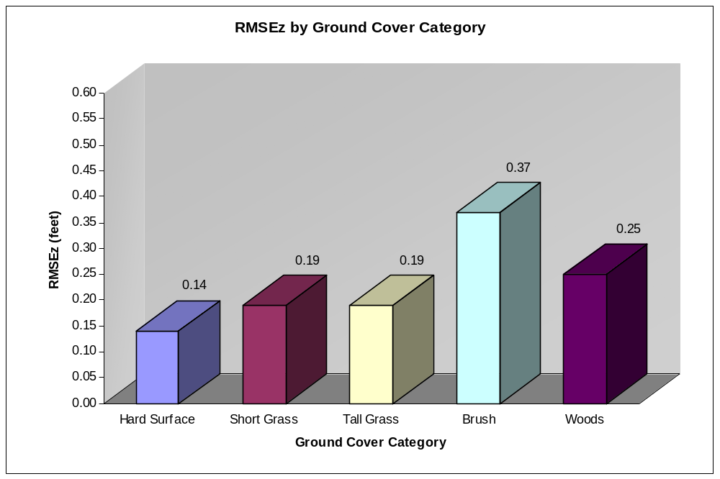

Figure 3 – RMSE_{z} statistics by Ground Cover Category

Table 4 – Overall Descriptive Statistics by Ground Cover Category

Land Cover Category | RMSEz  (ft) | Mean  (ft) | Median  (ft) | Skew | Std Dev  (ft) | # of Points | Min  (ft) | Max  (ft)
Consolidated | 0.25 | 0.06 | 0.02 | 0.97 | 0.25 | 126 | -0.43 | 1.07
Hard Surface | 0.14 | -0.05 | -0.07 | 0.38 | 0.13 | 26 | -0.27 | 0.23
Short Grass | 0.19 | 0.04 | 0.08 | 0.38 | 0.19 | 16 | -0.23 | 0.44
Tall Grass | 0.19 | 0.08 | 0.09 | 0.63 | 0.17 | 22 | -0.20 | 0.55
Brush | 0.37 | 0.24 | 0.18 | 1.02 | 0.29 | 23 | -0.15 | 1.07
Woods | 0.25 | 0.12 | 0.12 | 0.01 | 0.23 | 20 | -0.25 | 0.46

Figure 4 shows a histogram of the elevation differences between the field surveyed checkpoints and the TIN surface computed from the digital vertical data. The histogram shows the number of occurrences (frequency) along the vertical axis that fell within the 0.20 ft ranges shown along the horizontal axis.

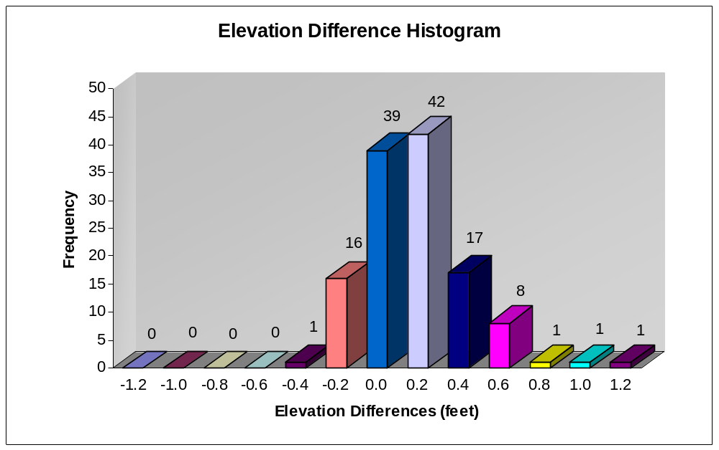

Figure 4 – Histogram of Elevation Discrepancies within 0.2 ft bands

Summary and Conclusions

The vertical accuracy testing methods derived from the NSSDA/FEMA and NDEP/ASPRS guidelines, when applied to the McHenry County project, verify that the digital vertical data provided by AME is well suited for the production of 2 ft contours.

Per NSSDA/FEMA guidelines: RMSE_{z} x 1.9600 = 95% confidence level
0.25 x 1.9600 = 0.49 ft

Per NDEP/ASPRS guidelines: 95th percentile (CVA) = 95% confidence level
= 0.45 ft

Both of the 95% confidence level test results exceed the required 1.19 ft accuracy level to support the generation of 2 ft contours.

Part 3: National Standards for Spatial Data Accuracy (NSSDA), “Geospatial Positioning Accuracy Standards,” published by the Federal Geographic Data Committee (FGDC), 1998
Appendix A, Guidance for Aerial Mapping and Surveying, “Guidelines and Specifications for Flood Hazard Mapping Partners,” published by the Federal Emergency Management Agency (FEMA), April 2003
Guidelines for Digital Elevation Data, Version 1.0, published by the National Digital Elevation Program (NDEP), May 2004
ASPRS Guidelines, Vertical Accuracy Reporting for Lidar Data, published by the American Society for Photogrammetry and Remote Sensing (ASPRS), May 2004 APPENDIX Quality Control Report (All Check Points) O:\1080208\Lidar\QC\McHenry\McHenry_all.txt Number Easting Northing Known Z Laser Z Dz ----------------------------------------------------------------------- 100 896601.274 2026374.271 790.461 790.580 +0.119 101 896617.544 2019690.521 809.405 809.510 +0.105 102 896595.523 2019785.514 807.853 808.000 +0.147 103 896640.986 2019790.291 808.086 808.210 +0.124 104 896649.946 2019638.746 807.741 808.020 +0.279 105 898090.454 2029241.174 796.747 796.660 -0.087 106 898114.063 2029179.035 797.344 797.790 +0.446 107 898136.530 2029238.996 797.325 797.450 +0.125 108 898035.704 2029252.933 796.258 796.430 +0.172 109 963921.734 2032991.246 931.081 931.020 -0.061 110 963981.104 2032886.794 928.413 928.870 +0.457 111 964137.576 2032885.350 930.274 931.340 +1.066 112 964196.592 2033019.303 932.518 932.590 +0.072 113 964133.420 2033010.911 931.957 932.070 +0.113 114 960287.866 2032175.381 920.644 920.810 +0.166 115 960405.297 2032196.382 918.751 919.180 +0.429 116 960472.669 2032225.502 914.929 915.450 +0.521 117 960628.305 2032245.374 917.285 917.350 +0.065 118 960642.383 2032266.844 917.964 918.000 +0.036 119 960062.237 2032213.718 919.004 919.140 +0.136 120 964478.668 2028990.683 894.516 894.750 +0.234 121 964845.866 2028968.951 893.351 893.730 +0.379 122 964477.021 2029015.118 893.929 894.370 +0.441 123 964511.657 2028963.823 892.357 892.700 +0.343 124 964467.251 2028956.424 892.406 892.960 +0.554 125 965233.713 2035878.008 905.884 905.830 -0.054 126 965190.009 2035907.460 911.156 911.000 -0.156 127 965163.309 2036053.369 911.396 911.310 -0.086 128 965225.829 2036140.901 913.696 913.610 -0.086 129 965229.694 2036210.954 914.207 914.130 -0.077 130 982499.623 2021747.482 886.317 886.150 -0.167 131 982555.676 2021689.087 884.500 884.370 -0.130 132 982440.525 2021547.492 891.412 891.160 -0.252 133 982417.917 2021516.879 892.479 892.250 -0.229 134 982512.254 2021594.536 889.788 889.800 +0.012 135 982904.045 2016492.368 902.462 902.190 -0.272 136 982954.051 2016649.238 907.019 906.900 -0.119 137 982857.988 2016728.270 906.475 906.500 +0.025 138 982881.125 2016311.742 899.309 899.070 -0.239 139 983003.234 2016037.658 893.217 893.170 -0.047 140 986644.388 2019569.734 889.477 889.510 +0.033 141 986716.045 2019419.436 866.845 867.140 +0.295 142 986647.968 2019414.514 866.475 866.730 +0.255 143 986589.985 2019449.170 866.202 866.540 +0.338 144 988833.619 2017446.857 885.156 885.270 +0.114 145 988771.595 2017524.856 885.152 885.450 +0.298 146 903356.481 2105031.607 908.158 908.020 -0.138 147 903572.566 2105137.112 906.432 906.440 +0.008 148 903557.724 2105203.591 906.166 906.460 +0.294 149 903648.134 2105189.182 905.973 906.160 +0.187 150 903471.208 2105148.198 906.209 906.300 +0.091 151 912433.936 2113249.707 955.959 956.520 +0.561 152 912347.844 2113128.024 955.930 955.860 -0.070 153 916329.086 2110069.274 1023.748 1023.650 -0.098 154 916361.478 2110038.129 1021.461 1021.500 +0.039 155 916538.324 2110130.488 1028.380 1028.570 +0.190 156 911971.188 2109780.203 946.786 946.640 -0.146 157 912055.440 2109793.996 948.351 948.160 -0.191 158 912244.593 2109712.090 948.177 948.110 -0.067 159 912361.354 2109707.014 947.200 947.510 +0.310 160 912470.554 2109703.648 948.062 948.210 +0.148 161 911897.595 2104328.288 975.802 975.820 +0.018 162 911753.518 2104344.800 969.145 969.460 +0.315 163 911938.780 2104352.573 975.074 975.080 +0.006 164 912005.712 2104367.589 976.409 976.330 -0.079 165 912172.057 2104368.295 977.252 977.090 -0.162 166 911475.713 2108407.322 945.405 945.710 +0.305 167 911605.342 2108303.798 948.328 948.950 +0.622 168 911568.662 2108074.035 949.795 949.820 +0.025 169 911506.878 2108069.360 950.917 950.930 +0.013 170 938815.485 2075087.822 923.249 923.280 +0.031 171 938819.796 2075036.985 923.919 924.020 +0.101 172 938784.143 2075159.842 921.576 921.760 +0.184 173 938852.368 2075142.280 918.587 918.780 +0.193 174 938726.472 2075044.741 925.694 925.880 +0.186 175 936164.765 2072989.643 908.220 908.100 -0.120 176 936128.938 2072926.628 905.799 905.960 +0.161 177 936192.544 2072944.634 906.993 906.960 -0.033 178 936126.185 2073061.707 908.633 908.480 -0.153 179 936129.798 2073033.400 907.921 908.060 +0.139 180 930601.462 2074387.377 922.810 922.820 +0.010 181 930654.418 2074415.559 919.158 919.290 +0.132 182 930600.084 2074313.046 918.036 918.460 +0.424 183 930479.783 2074067.916 916.409 916.480 +0.071 184 930410.239 2074085.245 915.700 915.860 +0.160 185 932222.378 2075927.833 948.787 948.650 -0.137 186 932185.901 2076015.956 947.967 947.890 -0.077 187 933672.467 2075276.525 911.527 911.400 -0.127 188 933649.288 2075323.189 911.012 910.890 -0.122 189 933571.758 2075214.380 905.320 905.720 +0.400 190 933725.964 2075220.918 905.845 905.840 -0.005 191 934774.981 2075091.782 913.922 913.860 -0.062 192 993678.344 2096367.428 834.027 834.010 -0.017 193 993676.031 2096312.195 835.156 835.410 +0.254 194 993833.629 2096395.640 826.225 826.140 -0.085 195 993816.487 2096332.520 829.729 829.840 +0.111 196 992979.694 2093780.150 834.523 834.450 -0.073 197 992918.634 2093794.165 830.185 830.320 +0.135 198 992556.827 2099632.126 778.411 778.170 -0.241 199 992637.185 2099623.484 777.147 776.950 -0.197 200 992622.503 2099574.938 776.101 776.410 +0.309 201 992739.212 2099569.685 776.367 776.350 -0.017 202 987338.928 2095240.823 813.630 813.420 -0.210 203 987110.191 2095187.755 812.974 812.880 -0.094 204 987168.984 2095122.371 800.645 800.440 -0.205 205 987365.309 2095344.382 808.496 808.680 +0.184 206 987412.579 2095423.513 803.653 803.500 -0.153 300 965222.262 2036125.357 913.728 913.480 -0.248 301 965210.025 2036124.294 912.656 912.530 -0.126 302 965205.970 2036124.409 912.567 912.690 +0.123 303 965200.937 2036124.209 913.302 913.210 -0.092 304 965190.586 2036123.333 913.683 913.370 -0.313 305 965179.553 2036122.840 913.433 913.150 -0.283 306 965174.087 2036122.614 912.623 913.490 +0.867 307 965168.972 2036122.598 915.372 915.070 -0.302 400 934758.829 2075180.958 913.092 912.900 -0.192 401 934759.456 2075174.642 913.476 913.680 +0.204 402 934760.411 2075165.358 917.006 916.710 -0.296 403 934761.077 2075159.528 917.872 917.640 -0.232 404 934761.858 2075148.468 918.328 918.060 -0.268 405 934762.501 2075137.267 918.194 917.850 -0.344 406 934762.740 2075132.313 917.531 917.100 -0.431 407 934763.905 2075117.995 912.003 912.270 +0.267 408 934763.764 2075116.355 912.147 912.090 -0.057 409 934764.305 2075114.180 912.757 912.500 -0.257 410 934764.938 2075100.906 913.450 913.470 +0.020 Average dz +0.056 Minimum dz -0.431 Maximum dz +1.066 Average magnitude 0.193 Root mean square 0.253 Std deviation 0.248 Quality Control Report (Hard-Surface Check Points) O:\1080208\Lidar\QC\McHenry\McHenry_hard-surface.txt Number Easting Northing Known Z Laser Z Dz ----------------------------------------------------------------------- 100 896601.274 2026374.271 790.461 790.580 +0.119 101 896617.544 2019690.521 809.405 809.510 +0.105 105 898090.454 2029241.174 796.747 796.660 -0.087 109 963921.734 2032991.246 931.081 931.020 -0.061 114 960287.866 2032175.381 920.644 920.810 +0.166 120 964478.668 2028990.683 894.516 894.750 +0.234 126 965190.009 2035907.460 911.156 911.000 -0.156 130 982499.623 2021747.482 886.317 886.150 -0.167 135 982904.045 2016492.368 902.462 902.190 -0.272 140 986644.388 2019569.734 889.477 889.510 +0.033 144 988833.619 2017446.857 885.156 885.270 +0.114 146 903356.481 2105031.607 908.158 908.020 -0.138 152 912347.844 2113128.024 955.930 955.860 -0.070 153 916329.086 2110069.274 1023.748 1023.650 -0.098 157 912055.440 2109793.996 948.351 948.160 -0.191 161 911897.595 2104328.288 975.802 975.820 +0.018 169 911506.878 2108069.360 950.917 950.930 +0.013 170 938815.485 2075087.822 923.249 923.280 +0.031 175 936164.765 2072989.643 908.220 908.100 -0.120 180 930601.462 2074387.377 922.810 922.820 +0.010 185 932222.378 2075927.833 948.787 948.650 -0.137 187 933672.467 2075276.525 911.527 911.400 -0.127 192 993678.344 2096367.428 834.027 834.010 -0.017 196 992979.694 2093780.150 834.523 834.450 -0.073 198 992556.827 2099632.126 778.411 778.170 -0.241 202 987338.928 2095240.823 813.630 813.420 -0.210 Average dz -0.051 Minimum dz -0.272 Maximum dz +0.234 Average magnitude 0.116 Root mean square 0.137 Std deviation 0.130 Quality Control Report (Short Grass Check Points) O:\1080208\Lidar\QC\McHenry\McHenry_short-grass.txt Number Easting Northing Known Z Laser Z Dz ----------------------------------------------------------------------- 103 896640.986 2019790.291 808.086 808.210 +0.124 113 964133.420 2033010.911 931.957 932.070 +0.113 119 960062.237 2032213.718 919.004 919.140 +0.136 122 964477.021 2029015.118 893.929 894.370 +0.441 128 965225.829 2036140.901 913.696 913.610 -0.086 133 982417.917 2021516.879 892.479 892.250 -0.229 139 983003.234 2016037.658 893.217 893.170 -0.047 145 988771.595 2017524.856 885.152 885.450 +0.298 150 903471.208 2105148.198 906.209 906.300 +0.091 156 911971.188 2109780.203 946.786 946.640 -0.146 165 912172.057 2104368.295 977.252 977.090 -0.162 174 938726.472 2075044.741 925.694 925.880 +0.186 179 936129.798 2073033.400 907.921 908.060 +0.139 183 930479.783 2074067.916 916.409 916.480 +0.071 191 934774.981 2075091.782 913.922 913.860 -0.062 204 987168.984 2095122.371 800.645 800.440 -0.205 Average dz +0.041 Minimum dz -0.229 Maximum dz +0.441 Average magnitude 0.159 Root mean square 0.186 Std deviation 0.187 Quality Control Report (Tall Grass Check Points) O:\1080208\Lidar\QC\McHenry\McHenry_tall-grass.txt Number Easting Northing Known Z Laser Z Dz ----------------------------------------------------------------------- 104 896649.946 2019638.746 807.741 808.020 +0.279 108 898035.704 2029252.933 796.258 796.430 +0.172 112 964196.592 2033019.303 932.518 932.590 +0.072 117 960628.305 2032245.374 917.285 917.350 +0.065 124 964467.251 2028956.424 892.406 892.960 +0.554 127 965163.309 2036053.369 911.396 911.310 -0.086 134 982512.254 2021594.536 889.788 889.800 +0.012 136 982954.051 2016649.238 907.019 906.900 -0.119 142 986647.968 2019414.514 866.475 866.730 +0.255 149 903648.134 2105189.182 905.973 906.160 +0.187 155 916538.324 2110130.488 1028.380 1028.570 +0.190 160 912470.554 2109703.648 948.062 948.210 +0.148 164 912005.712 2104367.589 976.409 976.330 -0.079 168 911568.662 2108074.035 949.795 949.820 +0.025 173 938852.368 2075142.280 918.587 918.780 +0.193 176 936128.938 2072926.628 905.799 905.960 +0.161 184 930410.239 2074085.245 915.700 915.860 +0.160 186 932185.901 2076015.956 947.967 947.890 -0.077 190 933725.964 2075220.918 905.845 905.840 -0.005 195 993816.487 2096332.520 829.729 829.840 +0.111 199 992637.185 2099623.484 777.147 776.950 -0.197 206 987412.579 2095423.513 803.653 803.500 -0.153 Average dz +0.085 Minimum dz -0.197 Maximum dz +0.554 Average magnitude 0.150 Root mean square 0.188 Std deviation 0.172 Quality Control Report (Brush Check Points) O:\1080208\Lidar\QC\McHenry\McHenry_brush.txt Number Easting Northing Known Z Laser Z Dz ----------------------------------------------------------------------- 107 898136.530 2029238.996 797.325 797.450 +0.125 111 964137.576 2032885.350 930.274 931.340 +1.066 116 960472.669 2032225.502 914.929 915.450 +0.521 118 960642.383 2032266.844 917.964 918.000 +0.036 123 964511.657 2028963.823 892.357 892.700 +0.343 125 965233.713 2035878.008 905.884 905.830 -0.054 131 982555.676 2021689.087 884.500 884.370 -0.130 137 982857.988 2016728.270 906.475 906.500 +0.025 143 986589.985 2019449.170 866.202 866.540 +0.338 148 903557.724 2105203.591 906.166 906.460 +0.294 151 912433.936 2113249.707 955.959 956.520 +0.561 154 916361.478 2110038.129 1021.461 1021.500 +0.039 159 912361.354 2109707.014 947.200 947.510 +0.310 163 911938.780 2104352.573 975.074 975.080 +0.006 167 911605.342 2108303.798 948.328 948.950 +0.622 172 938784.143 2075159.842 921.576 921.760 +0.184 178 936126.185 2073061.707 908.633 908.480 -0.153 182 930600.084 2074313.046 918.036 918.460 +0.424 189 933571.758 2075214.380 905.320 905.720 +0.400 194 993833.629 2096395.640 826.225 826.140 -0.085 197 992918.634 2093794.165 830.185 830.320 +0.135 200 992622.503 2099574.938 776.101 776.410 +0.309 205 987365.309 2095344.382 808.496 808.680 +0.184 Average dz +0.239 Minimum dz -0.153 Maximum dz +1.066 Average magnitude 0.276 Root mean square 0.368 Std deviation 0.286 Quality Control Report (Trees Check Points) O:\1080208\Lidar\QC\McHenry\McHenry_trees.txt Number Easting Northing Known Z Laser Z Dz ----------------------------------------------------------------------- 102 896595.523 2019785.514 807.853 808.000 +0.147 106 898114.063 2029179.035 797.344 797.790 +0.446 110 963981.104 2032886.794 928.413 928.870 +0.457 115 960405.297 2032196.382 918.751 919.180 +0.429 121 964845.866 2028968.951 893.351 893.730 +0.379 129 965229.694 2036210.954 914.207 914.130 -0.077 132 982440.525 2021547.492 891.412 891.160 -0.252 138 982881.125 2016311.742 899.309 899.070 -0.239 141 986716.045 2019419.436 866.845 867.140 +0.295 147 903572.566 2105137.112 906.432 906.440 +0.008 158 912244.593 2109712.090 948.177 948.110 -0.067 162 911753.518 2104344.800 969.145 969.460 +0.315 166 911475.713 2108407.322 945.405 945.710 +0.305 171 938819.796 2075036.985 923.919 924.020 +0.101 177 936192.544 2072944.634 906.993 906.960 -0.033 181 930654.418 2074415.559 919.158 919.290 +0.132 188 933649.288 2075323.189 911.012 910.890 -0.122 193 993676.031 2096312.195 835.156 835.410 +0.254 201 992739.212 2099569.685 776.367 776.350 -0.017 203 987110.191 2095187.755 812.974 812.880 -0.094 Average dz +0.118 Minimum dz -0.252 Maximum dz +0.457 Average magnitude 0.208 Root mean square 0.253 Std deviation 0.230

