1. Overview
To support FEMAs Risk MAP program, STARR has processed Point Cloud elevation data collected for Saline, IL under the HQFY10 Task Order into Fully Classified LAS files.

Figure 1 Saline Illinois LiDAR Post Processing Area
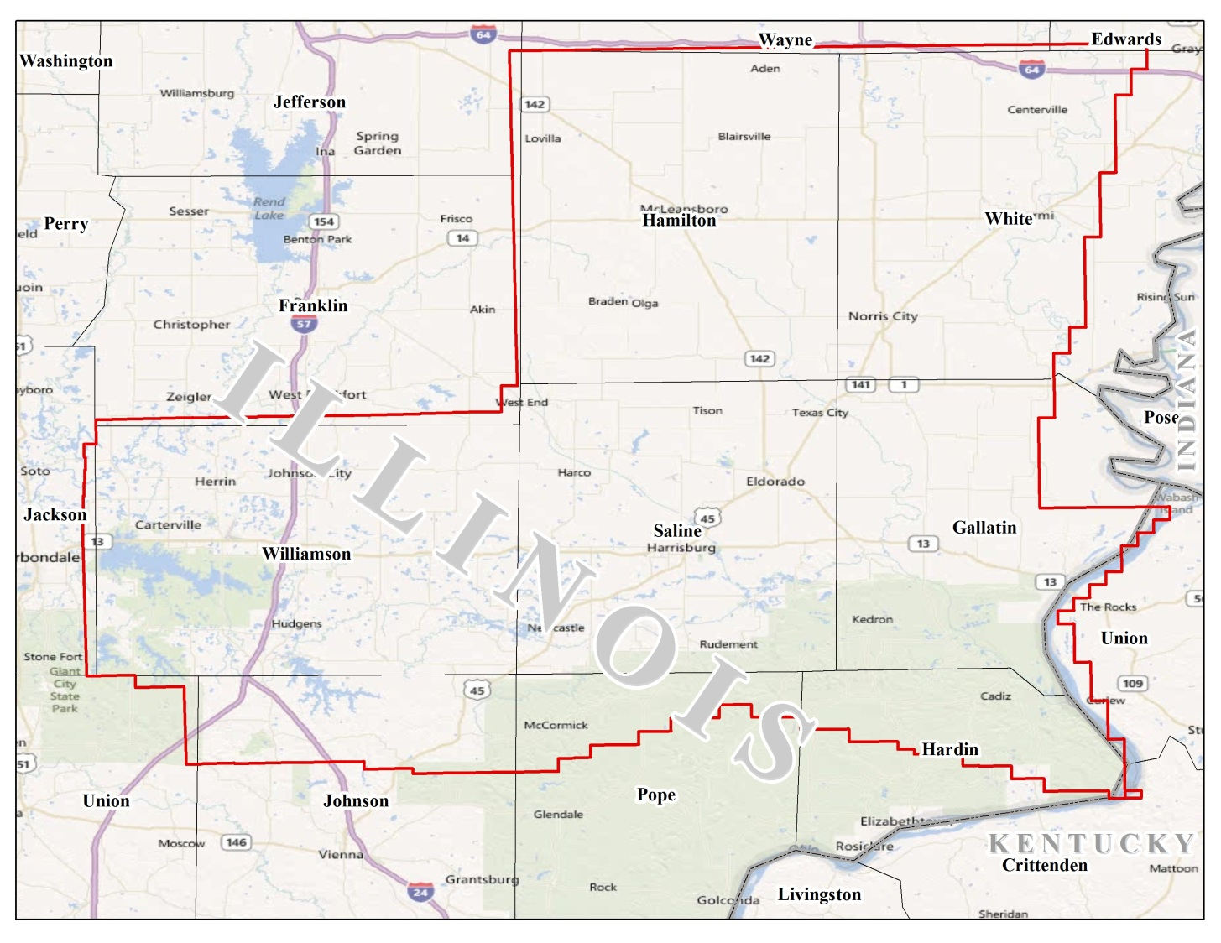

The objectives for the Saline Illinois post processing are as follows:

Table 1 Project Parameters
Collection Area | Processed Area | FEMA Specification Level | Contour Accuracy | NPS | RMSE_{z} | FVA | CVA
2179 mi² | 2179 mi² | Highest | 2ft | 1m | 18.5cm | 24.5cm | 36.3cm

This project included bare earth post processing only. All LiDAR points classified as class 2 are considered to be Bare Earth and points classified as class 8 are Model Key. All data for this project has been collected using the following spatial reference information:

Projection: Universal Transverse Mercator
UTM Zone: 16 North
Linear units: Meter
Horizontal Datum: North American Datum 1983
Vertical Datum: North American Vertical Datum of 1988 - Geoid 09
Vertical units: Meter

Consolidated Vertical Accuracy Test Results

The vertical accuracy requirements based on flood risk and terrain slope are met with 18.4 cm for consolidated vertical accuracy (CVA) testing. The mandatory requirement for the highest specification for vertical accuracy, 95%confidence level is for CVA < 36.3.

Tested 18.4 cm CVA at 95 % confidence level in: brush, forest, and urban terrain against bare earth generated surface. The Root Mean Square Error for the elevation differences between GPS control points and LiDAR points is 9.4 cm calculated with 51 supplemental vertical accuracy points (SVA).

2. Scope of Work
Statement of Priorities
PTS Elevation Data Acquisition
STARR – Contract # HSFEHQ-09-D-0370 Task Order # HSFE05-11-J-0090

LiDAR Processing

This project is to take elevation data collected under the HQFY10 Task Order, processed only to the Point Cloud deliverable, and via manual editing (post-processing) develop the Fully Classified LAS files. These areas include Traverse MI, Ironwood 1 MI, Ironwood 2 MI, Wabash IN/IL, and Saline IL. The resultant data will also be tested for the Consolidated Vertical Accuracy at the 95% Confidence Level. Traverse and Ironwood 1 will be tested at the ‘High” FEMA Specification Level (or 72.6 cm) and Ironwood 2, Wabash and Saline will be tested at the ‘Highest’ FEMA Specification Level (or 36.3 cm). Deliverables will include the following: CVA points, diagrams and pictures of point locations, survey report, Fully Classified LAS files, CVA testing report, QA testing report, TSDN and metadata.

LiDAR Collection and Processing

- Background

All data collected under this contract will adhere to the FEMA Procedure Memorandum No. 61 - Standards for LiDAR and Other High Quality Digital Topography.

- Technical Discussion

- Scope of Work

STARR understands that the Region requires three (3) areas to be collected and processed to the Point Cloud deliverable, one (1) area to be collected and processed to bare earth under this task order. These areas are to be collected to the "Highest" FEMA specification level. This means that the vertical accuracy requirements must meet FVA/CVA requirements of 24.5cm./36.3cm. The nominal pulse spacing requirement is less than or equal to 1-meter. These vertical accuracy requirements are equivalent to a 2-foot contour accuracy.

We understand that FEMA does not require the data to be hydro-flattened, as specified in USGS v.13. FEMA is also not requiring the capture of breaklines for this task.

STARR also understands that the Region requires five (5) areas collected under the HQ FY10 task order to be processed from the Point Cloud deliverable to the Bare Earth deliverable.

- Work Assignments
- Survey
CompassData will support STARR with obtaining the ground control required by the LiDAR firms to support their collection efforts, as well as obtaining the independent QC points needed to support the Fundamental Vertical Accuracy (FVA) and Consolidated Vertical Accuracy (CVA) Assessment requirements for STARR. The use of Compass Data to support all the control allows for one field crew mobilization, an independent source of data collection for the accuracy assessment, and a process whereby the base reference point for all control is the same, thereby eliminating one possible source of error as data is assessed. Additionally, CompassData is a small business and assists STARR in meeting Small Business Subcontracting Goals.

STARR proposes the following methodology to meet the requirements of FEMA PM61 and the associated Appendix A. We note that Appendix A was written in 2003, and the associated NOAA TM NOS NGS -58 Guidelines for Establishing GPS-Derived Ellipsoid Heights V4.3 were written in 1997 with no revision. The NOAA approach is not entirely compliant with the procedures, technologies and methodologies detailed in PM61 and Appendix A, but provides for a very effective method of collecting high accuracy points that allows FVA testing and modified CVA testing for bare-earth evaluation at reduced costs.

Given the recent advances in GPS technology and associated updates to survey methodologies, we propose the following, using PM61 and associated documents as guidelines exercised through careful GPS survey practice in conjunction with reasoned professional judgment to arrive at statistically and numerically relevant Control and Testing results for the project areas as currently described. This methodology will allow FVA testing to specification, as 20 FVA and at minimum 20 Supplemental Vertical Accuracy (SVA) points will be collected for each project area.
CompassData will collect all points with a combination of RTK and Static Post Processing with Base lines no longer than 80km to meet the specifications for the project. All points will be collected with Survey Grade GPS equipment, which typically achieves a high precision in the range of sub 3cm on a point-by-point basis. As a common practice we will also be collecting a surveyed control monument on a daily basis, when available, to check the collection methodology and accuracy. This allows for minimal duplication of point occupation, greatly reducing time in the field.

NMAS/NSSDA Vertical Accuracy Table 1 contained in the ASPRS Guidelines requires accuracy test data to be 3 times more accurate than the NSSDA accuracy requirement of the finished product. Section 2.3.3 of the ASPRS Guidelines states “QC surveys should be such that the checkpoint accuracy is at least three times more accurate than the dataset being evaluated." Based on the 95th percentile confidence level of 24.5cm, all survey points will be at < 8cm precision.

Ground control points will be located only in open terrain, where there is a high probability that the sensor will have detected the ground surface without influence from surrounding vegetation or buildings. Points will be located on flat or uniformly sloping terrain and will be at least five (5) meters away from any break line whether there is a change in slope. This criterion applies for all FVA QC points as well. Distribution of the Control points will also be evaluated and approved by the LiDAR vendor. FVA points will remain confidential and only revealed to the LiDAR vendor at the time of the FVA assessment.

The blind vertical SVA QC points will be collected randomly across different land use types using the ASPRS NSSDA land cover types. The points will be located in flat areas with no substantial elevation breaks within a 3-5 meter radius. All SVA points in the Urban and Brush land use categories, and the Forest land use category if practical, will be collected at <8cm precision to ensure a valid statistical test capability. this methodology has been exercised and accepted in current FY10 areas in both Highest and High accuracy categories.
The CVA Assessment will incorporate a representative sample of the FVA points into the dataset to save on the total number of points collected. A CVA point will not be collected for any land class comprising less than 10% of the total project area, which could result in less than 4 land classes being collected in some areas.

All points will be documented with an overhead image chip showing site and situation, at least 2 ground-based photos in the cardinal directions where practical, and a sketch will be provided of all Control and FVA points. An Accuracy Report for each day of collection will be provided based on daily observation of (a high-order NGS-Point) 1 or more high-order points (when available) to demonstrate system collection precision against an independent known point. Shape files as well as KML files will be provided for the block.
All coordinate data will be provided in Decimal Degrees, NAD83/NAVD88(Geoid09) and in UTM Feet otherwise specified.

CompassData will collect the required SVA/CVA points for Sawyer even though the areas are not being processed to Bare Earth at this time. These points will be provided as part of the deliverable package such that when processing does occur they will be available for testing purposes. These points collected at the time of the acquisition flights will accurately reflect the ground cover and surface conditions at the time of the LiDAR acquisition.

For testing, CompassData will follow the USGS LiDAR Guidelines and Base Specification v13 from 2010. The USGS guidelines reference both the National Digital Elevation Program (NDEP) and American Society of Photogrammetry and Remote Sensing guidelines (ASPRS), both from 2004, for accuracy testing. Both guidelines state: “…. recommends following the current industry standard of utilizing a minimum of 20 checkpoints (30 is preferred) in each of the major land cover categories representative of the area for which digital elevation modeling is to be performed; this helps to identify potential systematic errors in an elevation dataset.” Furthermore, PM61Section 4.1.3 Assessment of Bare Earth Vertical Accuracy states “Reporting of positional accuracy shall be in accordance with ASPRS/NDEP standards for FVA and CVA. Testing should be performed on the bare earth deliverable as specified in the mapping activity statement, along with the following guidance: For smaller projects less than 1,000 square miles, fewer check points for SVA testing is acceptable.” CompassData’s professional judgment is to follow this guidance and only reduce the check point count when appropriate.

Survey Assumptions:
While each project is unique and actual time spent can greatly vary for each item; there is a typical requirement for each of these steps:

Once the initial request has been received, we will spend between 8-40 hours preparing the proposal. This includes time speaking to the client and team members to gain a better understanding of their requirements, researching local network availability, reviewing land classifications in the region, determining if additional equipment is needed to reach collection locations, preparing graphics, revising proposals when required, explaining collection methodologies to client, etc.

Prior to deployment into the field; approximately 16 hours of office time are required for every 40 hours of field data collection. This time is needed to ensure equipment is operational, locate NGS monuments near project locations, identify / purchase VRS network availability, identify GCP collection locations with optional collection sites for each point, work out any potential site access issues, etc.

Once on site; 20-30 minutes are required to properly set up and start GPS equipment. While the equipment is starting up, our field data collector will draw a sketch of the site and also take multiple photographs of the set up and surrounding area.

Once equipment is set up; survey data collection will take 2-5 minutes if collecting within a VRS network. If data collection is outside of a VRS network; data collection can take 30-60 minutes for a high accuracy static collection. Please note that cell phone coverage is also needed when in a VRS network. There are many times where we are within the coverage of a VRS network but are unable to utilize it due to lack of cell coverage. Typically multiple points will be contained in a single file when collecting in a VRS network. Static collections create one file per point.

Once GCP data has been collected; 10-15 minutes are needed to break down and repack the GPS equipment.

Once equipment has been packed; 20-120 minutes are needed to travel to next survey location (or back to their hotel, base camp, etc). This estimate varies greatly by project area. Small areas, or projects with a high density of points, require less travel. Large projects or project with a sparse distribution of points will require longer drive times. Remote areas and infrequently used forest roads have been particularly problematic and are very time consuming in our experience. Please note there are many instances where the field data collector must find a different feature to collect because the original feature located in the office is not ideal. They will then travel to the secondary or tertiary feature that was located in the office and collect there. Our surveyors typically perform some initial field post processing of data to validate that our collection methodology is correct. This ensures the overall data collection is valid for the area, reducing our need to return for recollection.

Once GCP data has been collected, the surveyor will upload raw collection data to the CompassData FTP site. Data upload requires 1-2 hours per day, in addition to field collection times.

We typically average between 3-10 points per day depending on the variables noted above.

Once GCP data has been uploaded and received at CompassData HQ; every day of field work requires approximately 4-8 hours of office processing time. Points collected in a VRS network are typically in bundles, requiring less time to process per point. Static collections become necessary in areas without VRS and cell phone coverage, requiring a point by point file creation procedure.

Testing for each project area requires 2-4 hours to certify the accuracy and draft a report. Many times we identify anomalies in the LiDAR data which then requires retesting. Testing must be certified by a Professional Licensed Surveyor.

Mobilization Costs: Varies from project. Includes airfare, equipment shipping fees, local per diem rates for food and lodging, vehicle rental (if necessary) and fuel costs.

CompassData pricing also includes the cost of professional survey equipment, computers and software for processing of raw data. These costs are distributed throughout every project.

Specific Region 5 Notes:
We have determined that VRS coverage is limited or unavailable in most of the Region 5 project areas. The project areas are typically quite large, and the points are well distributed in forested areas only accessible by forest roads. We feel these collections will take more time at each step for the reasons noted above.

Wabash and Saline are contiguous areas and were originally treated as a single project area. Per PM 61 guidelines, these areas must be treated separately for testing due to their size.. CompassData has previously collected 20 Supplemental Vertical Accuracy. We are proposing accuracy testing with 60 SVA points per area, 120 in total. Because we will utilize the 20 previously collected points, 100 new points are required in the three predominant land classifications found in the project area: Brush, Urban and Forest, approximately 33 points in each classification.

- Acquisition
Not Applicable for Wabash and Saline Project Areas.

- Processing
Automated Processing
The following is a brief explanation of the LiDAR processing, remembering that each vendor will use a slightly different process based on their internal requirements and the type of sensor utilized to collect the data.

Raw airborne GPS and IMU data will be extracted and differentially processed, to derive a smoothed best estimate of trajectory (SBET).The SBET is used to reduce the LiDAR slant range measurements to derive the return measurement for each LiDAR pulse within each flight line.

The LiDAR points will be imported into the processing software and tiled into 1500m x 1500m tiles. An initial accuracy assessment using the ground control survey data will be calculated to ensure the data is accurately 'tied' to the ground.. The data will then be classified using automated processes to extract a bare earth digital elevation model (DEM). Once all project data is imported and classified, the survey ground control data will be calculated against the LAS Class 2 (Ground) data for an accuracy assessment. As a QC measure, a routine will be used to generate accuracy statistical reports by comparison among LiDAR points, ground control, and triangulated irregular networks (TIN). Any systematic bias in the data is removed to meet or exceed the vertical accuracy requirements. At this point the FVA test will be conducted.

Manual Processing
The calibrated and filtered LiDAR point cloud will be hand checked for accuracy. All points will be placed in one of the following categories: 1 Unclassified, 2 Ground, 7 Noise, and 12 Overlap Points. Model Key points will then be generated from the Ground points and placed in Category 8. CVA testing will be conducted and final reports generated.

Of the areas to be collected under this task order, only the Sangamon River Watershed data will be processed to Fully Classified (Bare Earth) data.

Several areas collected under the STARR HQ FY10 Task Order will also be processed to the Fully Classified (Bare Earth) data. These areas will be processed by the vendor responsible for their acquisition with the exception of the Traverse area.

Traverse, MI will be manually processed by Continental Mapping Consultants, Inc.. Ironwood 1 and 2, MI will be manually processed by Tuck Mapping, Inc. Wabash and Saline will be manually processed by Woolpert, Inc.

Assumptions by area:

Wabash - the following are considerations in the manual edit of point cloud data to bare earth
- Area is relatively flat
- Area is primarily agriculture with scattered forest/brush
- Area is primarily rural with scattered small urban centers

Saline - the following are considerations in the manual edit of point cloud data to bare earth
- Area is relatively flat
- Area is primarily agriculture with scattered forest/brush
- Area is primarily rural with scattered small urban centers

- Quality Control Testing
Survey
To ensure valid in-field collections, an NGS monument with suitable vertical reporting was measured using the same equipment and procedures used for control, FVA and CVA points on a daily basis. The measurement was compared to the NGS published values to ensure that the GPS collection schema was producing valid data and as a physical proof point of quality of collections. Those monument measurements are summarized in the accuracy report included in the Survey data deliverables.

LiDAR Acquisition

Blind RMSE Testing. The LAS data will be tested at the conclusion of the automated processing step. At this point the LAS points have been calibrated and open area points should accurately reflect the bare earth surface. The processing contractor will call for the FVA test points from the survey contractor, and using the x, y coordinates determine the elevation at that location. These elevations are returned to the survey contractor who will determine the vertical offsets at each point location. Calculation of the RMSE and the 95% Confidence Level will be done via a spreadsheet. The values are returned to the Project Manager and to the LiDAR contractor. If the value is within the acceptable range, manual processing can continue. If the value is not within range, the LiDAR contractor must analyze the data further to get within acceptable range. If the test points are compromised during that analysis, the LiDAR vendor will be responsible for the cost of obtaining further blind check points such that the data can be confidently checked and approved. All remedial activity must be included in the PostFlight Report. Likewise, at the conclusion of the manual bare earth processing the CVA test points will be checked against the produced bare earth surface following the same methodology.

- Quality Assurance
Greenhorne & O'Mara will conduct the Quality Assurance activities on behalf of STARR. These activities are guided by our Quality Assurance checklist which was developed to include all of the suggested information found in PM61. In addition a statistical sampling of LAS data tiles are reviewed, checking for spikes in the data, incomplete coverage, and cleanliness of the data. This review is done using the LP360 software (commercially available software). The software allows for review of the data via a rolling cross section approach whereby a tile of data can easily be reviewed ensuring there are no artifacts remaining in the bare earth data. The final step in the quality assurance process is the construct of the TSDN documentation and the final assembly of the metadata for the terrain products.

- Management
Project management of the contract and oversight of the subcontractors will be performed for STARR by Greenhorne & O'Mara. Standard project management activities will include progress reporting, MIP update, approval of subcontractor invoicing, etc.

All subcontractors will be required to submit informal progress statements on a weekly basis, such that the Manager can answer questions from the FEMA Region, STARR management, and STARR study teams, quickly and efficiently.

Staying abreast of the progress, issues raised, weather conditions and the like will also afford the manager the opportunity to develop mitigation strategies should any risk develop.
- Deliverables
- Survey
The following will be delivered from the Survey subcontractor:
For FVA and CVA Point Survey -
- Accuracy reports based on known monuments;
- Image chips - aerial image of the position of each point;
- Pictures - four pictures in the cardinal directions showing the point from the ground perspective;
- Shape file of the points;
- Station diagrams for each point;
- Final report - includes methodologies and general project information;
- Spreadsheet of all points; and
- Any obsolete records.

For QC Testing -
- Final report;
- Excel spreadsheet with calculations;
- Metadata process steps; and
- Compliance certificate.

- LiDAR
The following will be delivered from the LiDAR subcontractor:
- Pre-flight Operations Plan (PreFlight Report);
- Post-flight Aerial Acquisition and Calibration Report (PostFlight Report);
- Point cloud LAS points (partially classified);
- Fully classified LAS points (includes 1. Unclassified, 2 Bare-earth ground, 7. Noise, 8. Model Key Points, 9. Water - if breaklines are collected, 10 Ignored ground, 11. Withheld, 12 Overlap);
- Metadata process steps; and
- Compliance certificate.

- Quality Assurance
- Quality Assurance Checklist;
- TSDN; and
- Final compiled metadata record.

- Schedule

Processing of the data acquired under the HQ FY10 task order will begin as soon as the Task Order, and subsequent STARR task orders for the subcontractors have been executed. STARR anticipates all data to be processed to the Fully Classified LAS files by summer of 2012.

3. Issues
- Special Problem Reports
None
- Project Modifications
None

4. Information for the next Mapping Partner
In order to make use of the fully classified LiDAR for floodplain mapping activities the elevations may need to be converted from meters to feet. This can be accomplished by providing a z factor of 3.280899 when converting the LAS files into points.

One (1) area within the southeast portion of the project area was intermittently affected by flooding in the low lying agricultural fields adjacent to the Ohio River. The fields, located in Gallatin County, have a history flooding due to their geological makeup and proximity to the river. These areas are former meanders of the nearby river that contain existing water bodies or wetlands year around. As requested, we are including approximate easting and northing coordinates of the issue. The provided coordinates represent the corners of an approximate boundary of the area. This boundary follows the bend of the river in the flood-affected area. We are also including a screen capture of the boundary area as well as a representative screen capture of the flood-affected areas. The approximate coordinates of the flood-affected area are as follows: Top Left: X: 402939.6 Y: 418185.3, Top Right: X: 409656.3 Y: 4181932.9, Bottom Left: 398209.6 Y: 4158042.5, Bottom Right: X: 403635.1 Y: 4157990.7

5. Conclusion
STARR has completed the processing of the Saline, Illinois area of interest as described in Task Order # HSFE05-11-J-0090. The post processing for Saline, Illinois meets the requirements set forth by FEMA Procedure Memorandum– Standards for LiDAR and Other High Quality Digital Topography, USGS LiDAR Guidelines and Base Specifications v13, and ASPRS LAS v1.2 specifications.

Final deliverables have been shipped to the FEMA Engineering Library, via external hard drive, and the appropriate documentation has been uploaded to the MIP.

J:\FEMA\R05\ILLINOIS_17\SALINE_17165\SALINE_165C\12-05-0810S\SubmissionUpload\Terrain\2149983

