
Horizon’s, Inc.

LiDAR Acquisition/Processing/Quality Control

07-1121-01 Red River Basin Block C

LiDAR Acquisition

LiDAR Acquisition. LiDAR acquisition for this project was collected with Leica ALS50 #64 LiDAR systems including an inertial measuring unit (IMU) and a dual frequency GPS receiver. Acquisition was accomplished on 4/21/08 - 5/16/08. Maps identifying the flight lines and LiDAR collection log sheets containing information regarding flights, times, conditions, etc are included in the Appendix. The LiDAR flight specifications follow:

Field of View | 45 Degrees
Altitude | 8000 feet AMT
Scan Rate | 33.1 Hz
Pulse Rate | 94000 kHz
Airspeed | 160 knots
Average Post Spacing | 1.7 meters
Average Swath Width | 2050 feet
Intensity Mode | 4+3
Total Flight Lines: | 64
Number of Lifts | 7

GPS Data Collection

GPS Data Collection. A GPS receiver was in constant operation over a temporary control point during flight acquisition. The base station identification and location are listed in the following table. Base station information is also included in the Appendix.

Station | Location
KFAR | 46 55 48.16929 -96 48 40.85835 246.9450

GPS base station

GPS Data Processing

GPS Data Processing. All GPS phase data was post processed with continuous kinematic survey techniques using “On the Fly” (OTF) integer ambiguity resolution. The GPS data was processed with forward and reverse processing algorithms. The results from each process, using the data collected at the airport, were combined to yield a single fixed integer phase differential solution of the aircraft trajectory. Plots of altitude and the forward and reverse GPS solution residuals are included in the Appendix. The differences between the forward to reverse solution within the project area were within project specifications (<10cm) in both the horizontal and vertical components, indicating a valid and accurate solution.

IMU Data Processing

IMU Data Processing. An IMU was used to record precise changes in position and orientation of the LIDAR scanner at a rate of 200 Hz. All IMU data was processed post flight with a filter to integrate inertial measurements and precise phase differential GPS positions. The resulting solution contains geodetic position, omega, phi, kappa, and time for subsequent merging with the laser ranging information.

LiDAR Data Processing

LIDAR Data Preprocess.
Flight Line Data Acquisition/Quality Control Check. LiDAR data and the IMU files were processed together using LIDAR processing software. The data set for each flight line was checked for project area coverage, data gaps between overlapping flight lines, and tension/compression areas (areas where data points are more or less dense than the average project specified post spacing). Based on this check it appears the entire project area is covered without gaps. LiDAR Coverage Check and Line Overlap Check Diagrams are included in Appendix.
Boresighting Process. Pre-processing of LiDAR corrects for rotational, atmospheric, and elevation differences that are inherent to LiDAR data sets. This process is called boresighting. LiDAR data was collected for bi- and cross-directional flight lines over the airport prior to and after acquisition of the project area. Using an iterative process that involves analyzing raster difference calculations the Omega, Phi, Kappa angle corrections of the LiDAR instrument were determined. The corrections were applied to the LiDAR data set for the project area.
Vertical Accuracy Check. Extensive comparisons were made of vertical and horizontal positional differences between points common to two or more LiDAR flight lines. This was done for the airport bore-sight testing area and the project area. All flight lines (airport and project) were within project specifications for vertical accuracy.
LiDAR Intensity Check. An intensity raster for each flight line was generated. The raster was checked and verified that intensity was recorded for each LiDAR point.
Project Coordinate System. LiDAR preprocessing software outputs data to its corresponding UTM zone in meters and a GRS80 ellipsoidal height.
Vertical Bias Correction. LiDAR has a consistent vertical offset. LiDAR ground points were compared to independently surveyed and positioned ground control points at both the airport bore-sight area and the project area. Based on the results of these comparisons, the LiDAR data was vertically biased down to the ground.
Project Ground Control Check. Comparisons between on-site ground survey control points and LiDAR data yielded the following results:

Vertical Accuracy (RMSE) | .044
Standard Deviation | .045
Mean Difference | .008
Number of Points | 17

LiDAR Data Surfacing Process.
Raw LiDAR Data Set. LiDAR data in overlap areas of project flight lines was removed and data from all swaths was merged into a single data set. The data set was trimmed to the digital project boundary including an additional buffer zone (buffer zone assures adequate contour generation from the DEM). Resulting data set is the Raw LiDAR data. The Raw LiDAR data set was processed through a minimum block mean algorithm and points were classified as either bare earth or non-bare earth. User developed “macros” that factor mean terrain angle and height from the ground, were used to determine bare earth point classification.
LiDAR Surfacing Process. The surfacing process is a 2D-edit procedure that ensures the accuracy of the automated feature classification. Editors used a combination of imagery, intensity of the LiDAR reflection and tin-editing software to assess points. The resulting data set is 2D Surfaced Bare Earth. The LiDAR data is filtered using a quadric error metric to remove redundant points. This method leaves points where there is a change in the slope of surfaces (road ditches) and eliminates points from evenly sloped terrain (flat field) where the points do not affect the TIN LiDAR data. The resulting data set is 2D Surfaced/Filtered Bare Earth

LiDAR Data 3D Edit Process.
LiDAR 3D Edit Process. The 2D surfaced/filtered bare-earth LiDAR data and stereo imagery are edited in softcopy photogrammetric workstations with 3D viewing and compilation capabilities. Contours generated from the LiDAR data were compared to the imagery. Breakline features (as necessary to generate accurate contours), water features and planimetric data were collected. Data points still present on structures and/or vegetation were removed. LiDAR data erroneously removed during the surfacing process was replaced. LiDAR points required as spot elevations are classified. Resulting data set is 3D Bare Earth LiDAR.
LIDAR Graphic Edit Process. Contours were generated from the 3D linework and bare-earth LiDAR data and reviewed by experienced graphics edit technicians. LiDAR points that create small “tops and depressions” are removed from the data set. Anomalies in the data set were corrected in the TIN at the softcopy photogrammetric workstations. 3D linework was reviewed for uniformity and completeness. Water bodies (i.e. streams and lakes) were analyzed for proper elevations and flow characteristics. LiDAR points located within the water feature boundaries are removed (LiDAR does not accurately measure water surface elevations). The resulting data set is the Digital Terrain Model data used to generate the final contours – DTM data includes 3D breaklines and filtered LiDAR data.

Appendix Items.
Flight Map

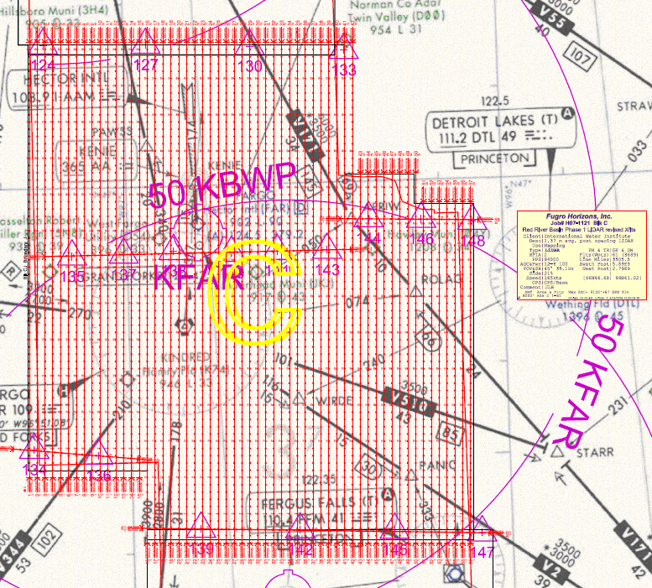

LiDAR Collection Logsheet

See Block_C/processing_report/flight_logs folder for all lifts

Diagram – GPS Solution Residuals

See Block_C/processing_report/gps_graphs folder for all lifts

Diagram – Aircraft Trajectory Plot

See Block_C/processing_report/gps_graphs folder for all lifts

Diagram – LiDAR Coverage Check for Project Lines



