Elevation QA Report

Project: Contractor:

Data Delivery Date: Date Data Reviewed:

Reviewer: Total Square Miles Reviewed:

Elevation Type: Format: Grid Spacing: Tile size:
Projection: Zone: Datum: Units:

Licensing: Metadata:

Materials Received:

Vertical Accuracy Test Performed: Test Point Source: RMSE:
Vertical Accuracy Test Notes:

QA Review Summary:

07-08-2010
LiDAR Quality Control (QA) Review Process

Preparation:
-Metadata reviewed to determine data projection, datum, format, etc.
-If ARRA contract, check for raw .LAS files, classified .LAS files, breaklines, blind control points,
and DEM in Image or Grid format
-Open data in Global Mapper

Vertical accuracy testing:
-If ARRA contract, use Vertical Accuracy Test Worksheet to perform RMSE on 20 blind point
positions provided by contractor

Inspection and Correction of data:
-Minimum and maximum elevations in dataset; correct if in error
-Appropriate hydro flattening as specified in V12 Lidar Specification (For ARRA/GPSC Data)
-Data void areas
-Data spikes
-Tile edge seam lines
-Non-bare earth surface artifacts (structures, bridges, vegetation, etc.)
-Elevation errors - raised/lowered areas/tiles
-Other surface treatment anomalies
-Check DRGs for correct elevations and horizontal positioning (if test points not available)
-Create footprint (project boundary) shape file and establish square miles
During Inspection, identify data errors and create “error” file folder:
-Capture geo-referenced JPG or TIFF image(s) of identified errors
-Copy to Error file
During Inspection, level elevations and remove artifacts (these two steps not done for ARRA data):
-Level smoothing to remove non-bare earth surface artifacts (structures, bridges, vegetation, etc.)
-Level data spikes where possible

Export image files and create project Elevation QA Review Report:
-Export ERDAS Imagine image files in native projection and resolution
-If ARRA, Copy Vertical Accuracy Test Worksheet into QA Report
-Place QA Review Process and Project Area Extent into QA Report
-If rejected, attach sample geo-referenced JPG or TIFF error images with an explanation of reason
-If rejected, restart QA process when replacement data is received
-Provide completed Elevation QA Review Report to Elevation Supervisor for final viewing
-Add QA Report, footprint, Imagine image(s), and Error file to original data file for final shipment to EROS

Area Extent

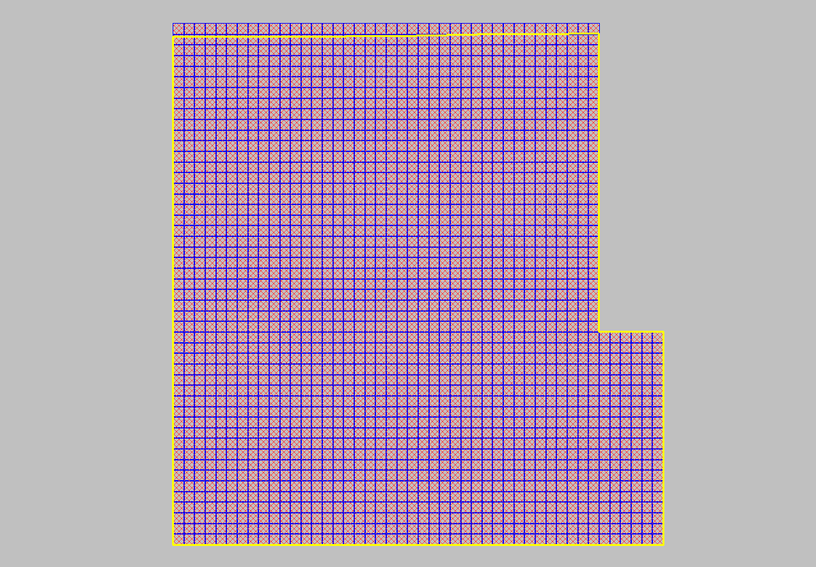

Errors

Breaklines do not represent ground conditions at 48° 52' 22.8161" N, 98° 17' 31.5439" W
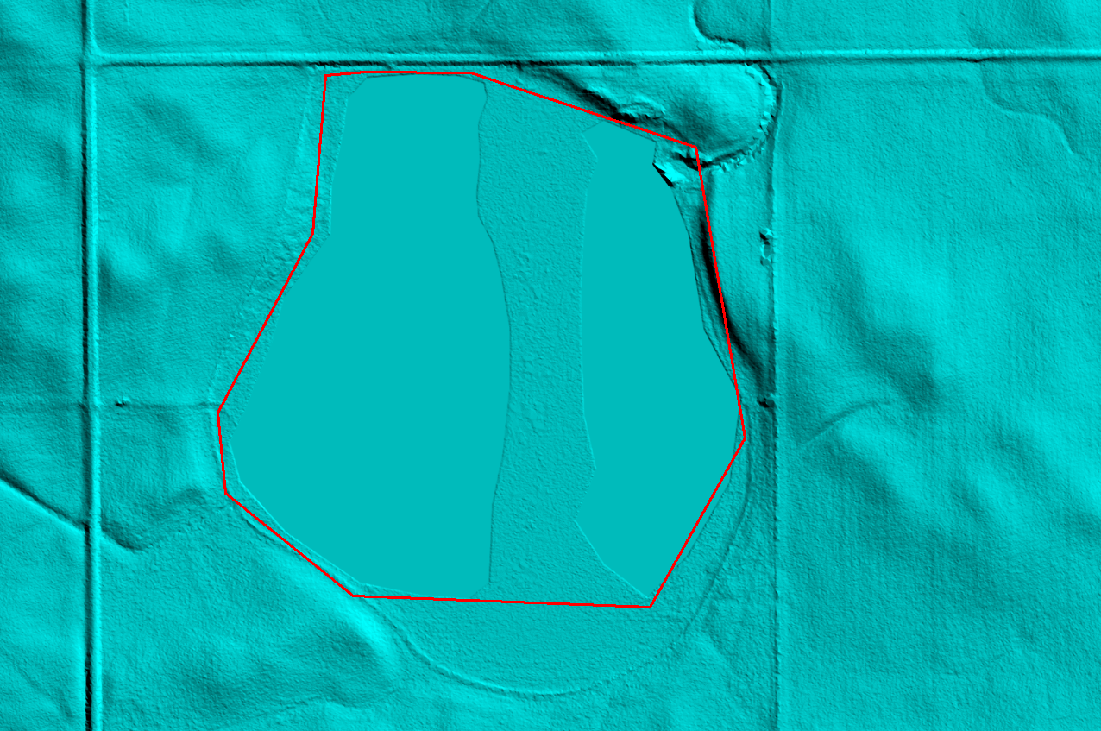
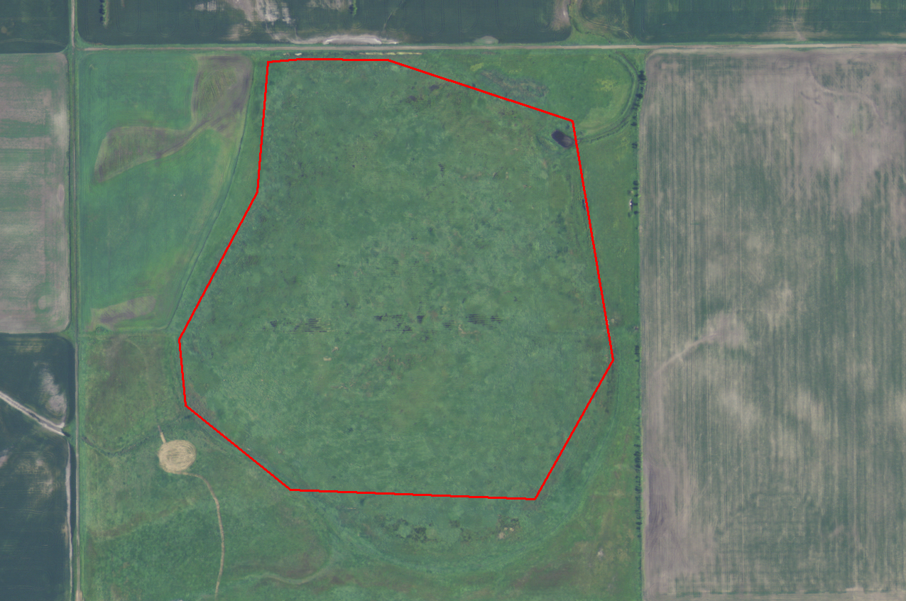

Breaklines do not represent ground conditions at 48° 51' 29.2645" N, 98° 47' 46.5490" W
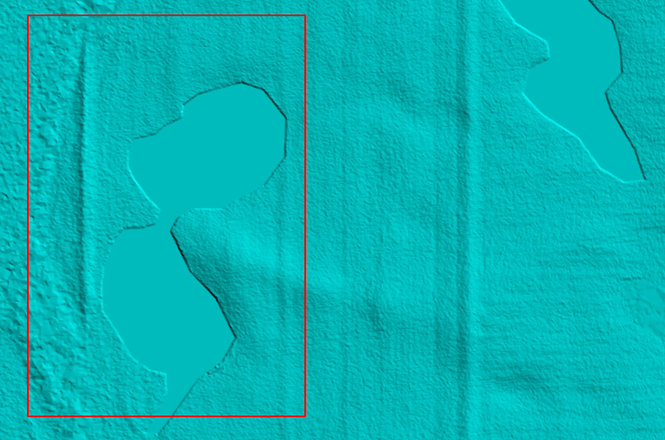
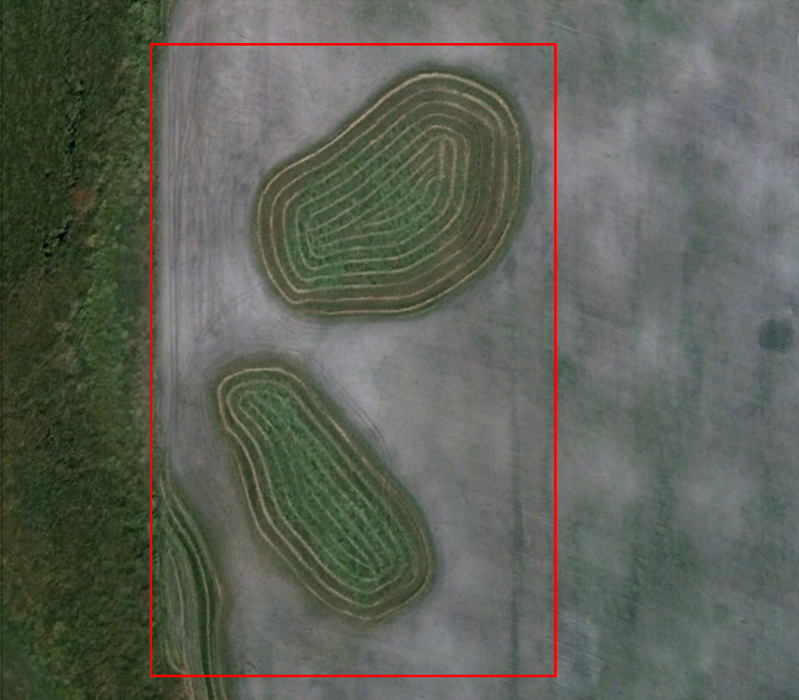

Breaklines do not represent ground conditions at 48° 44' 5.7538" N, 98° 23' 8.9180" W
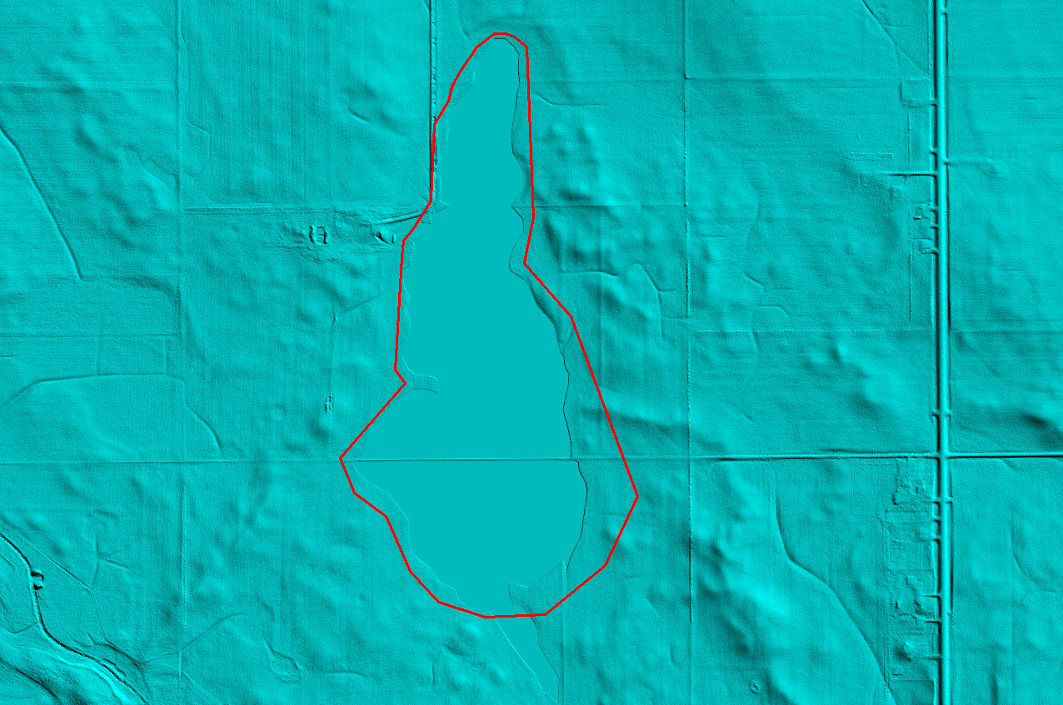
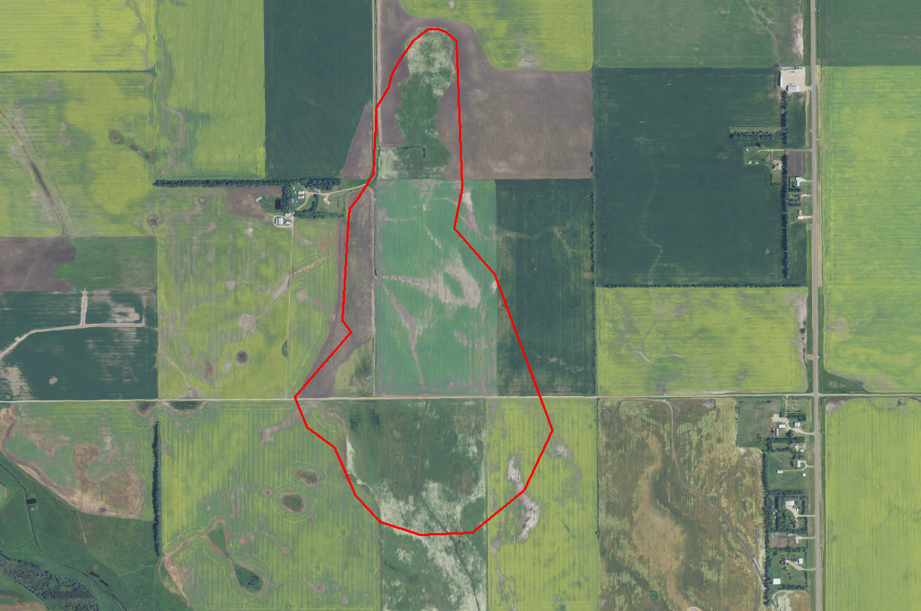

Breaklines do not represent ground conditions at 48° 39' 54.4377" N, 98° 18' 22.4086" W
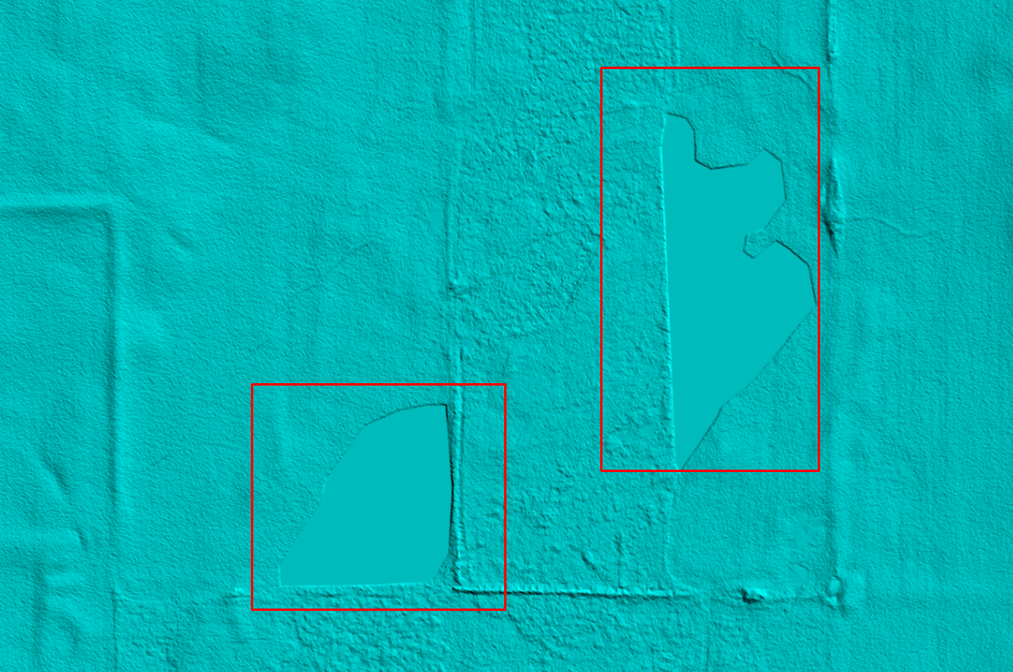
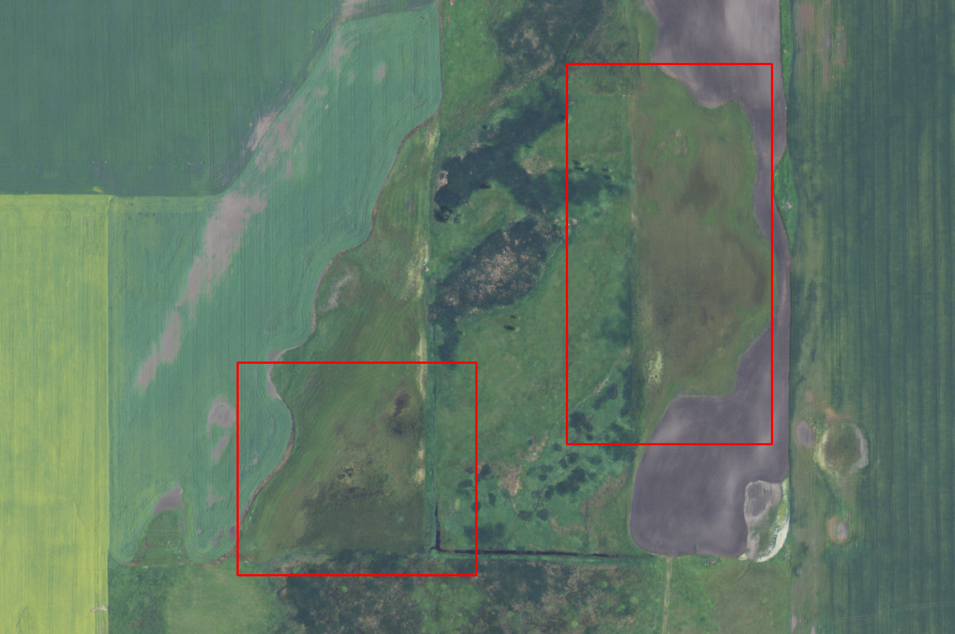

Breaklines do not represent ground conditions at 48° 22' 16.7509" N, 98° 47' 48.3174" W
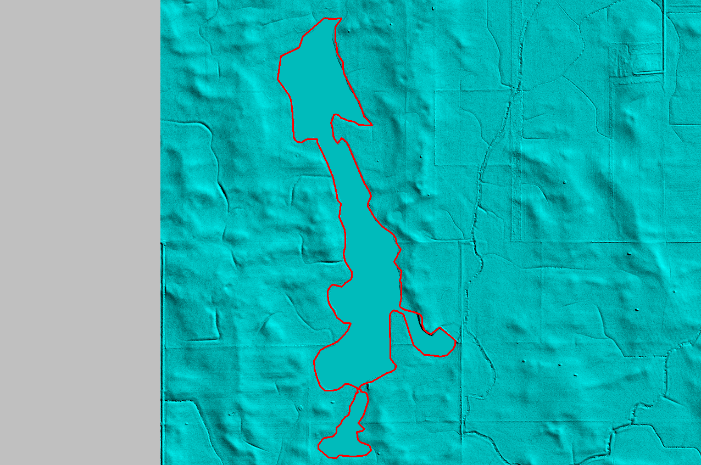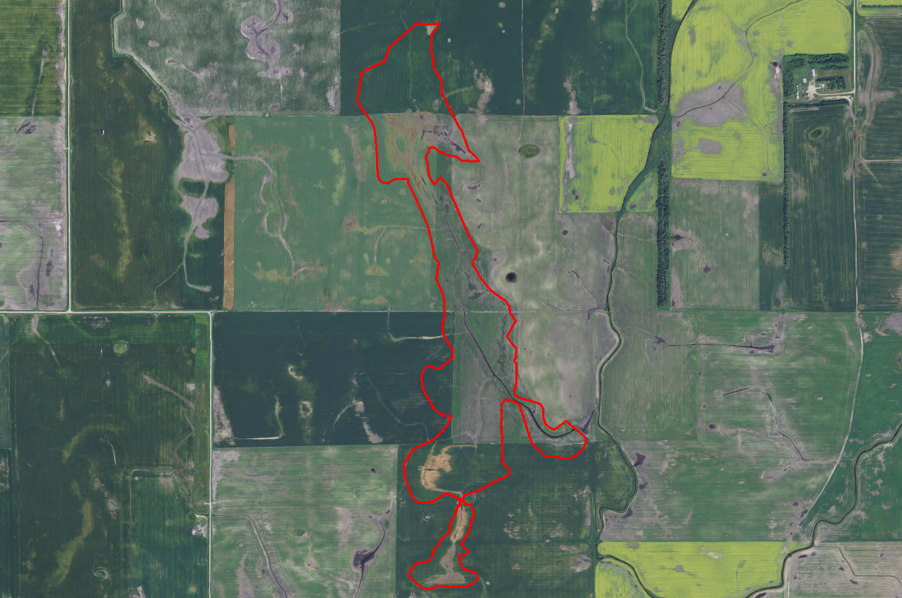

Culvert removal at 48° 56' 6.0760" N, 98° 30' 53.9138" W
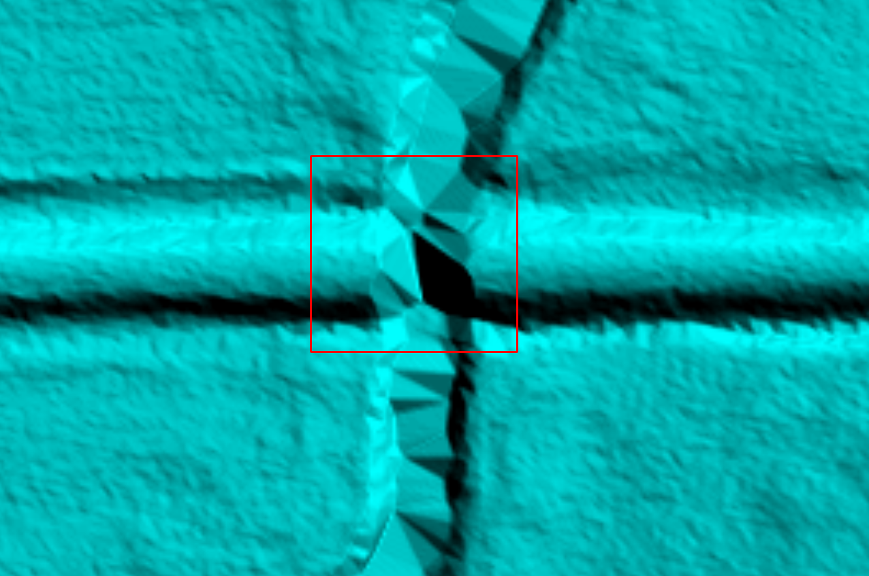

Culvert removal at 48° 29' 32.6894" N, 97° 54' 43.0760" W
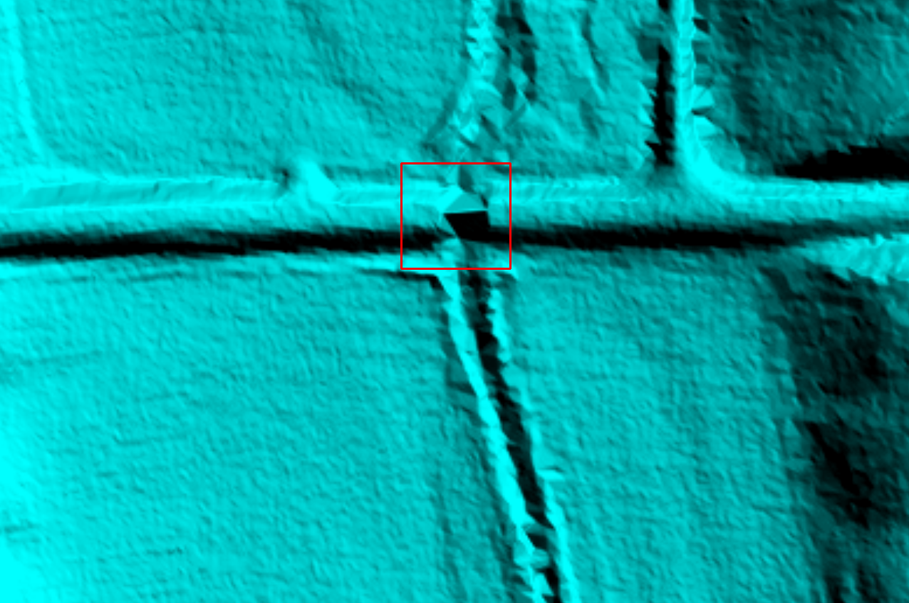

Differing water elevations, no dam or spillway at 48° 56' 14.0451" N, 98° 21' 54.1269" W
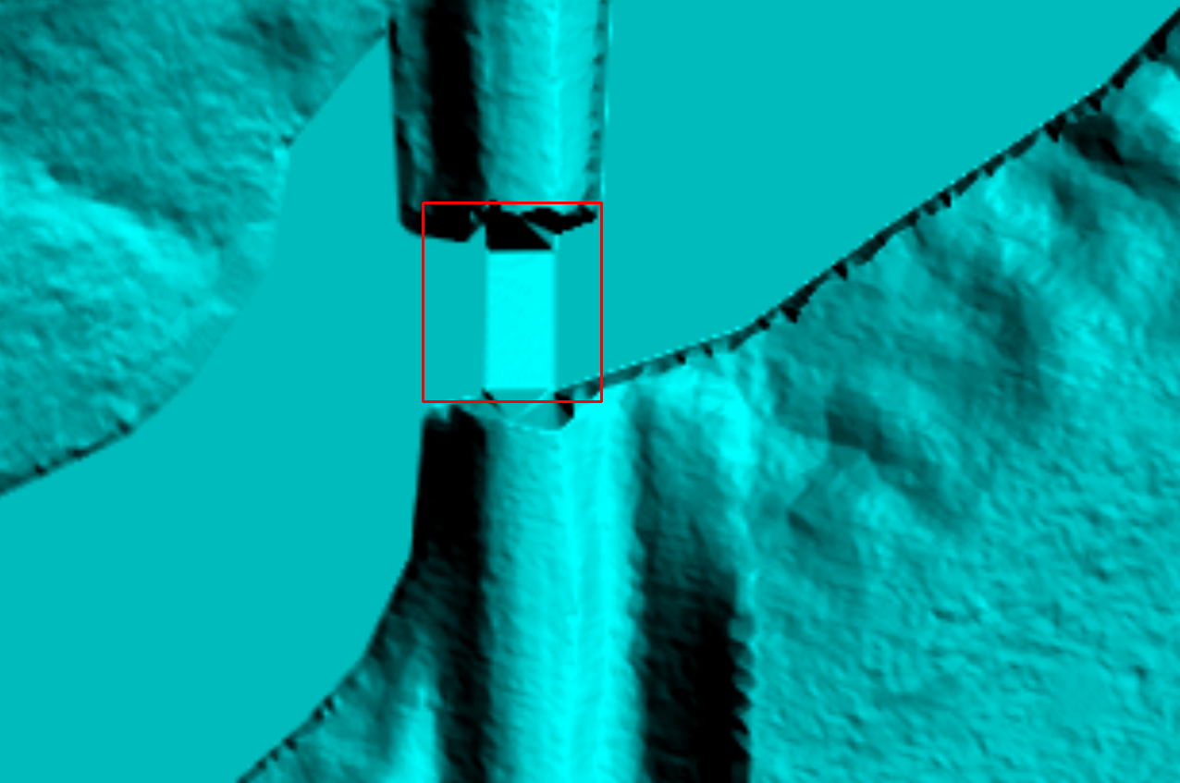

Hydro-flattening needed at 48° 58' 26.4505" N, 98° 41' 48.2665" W
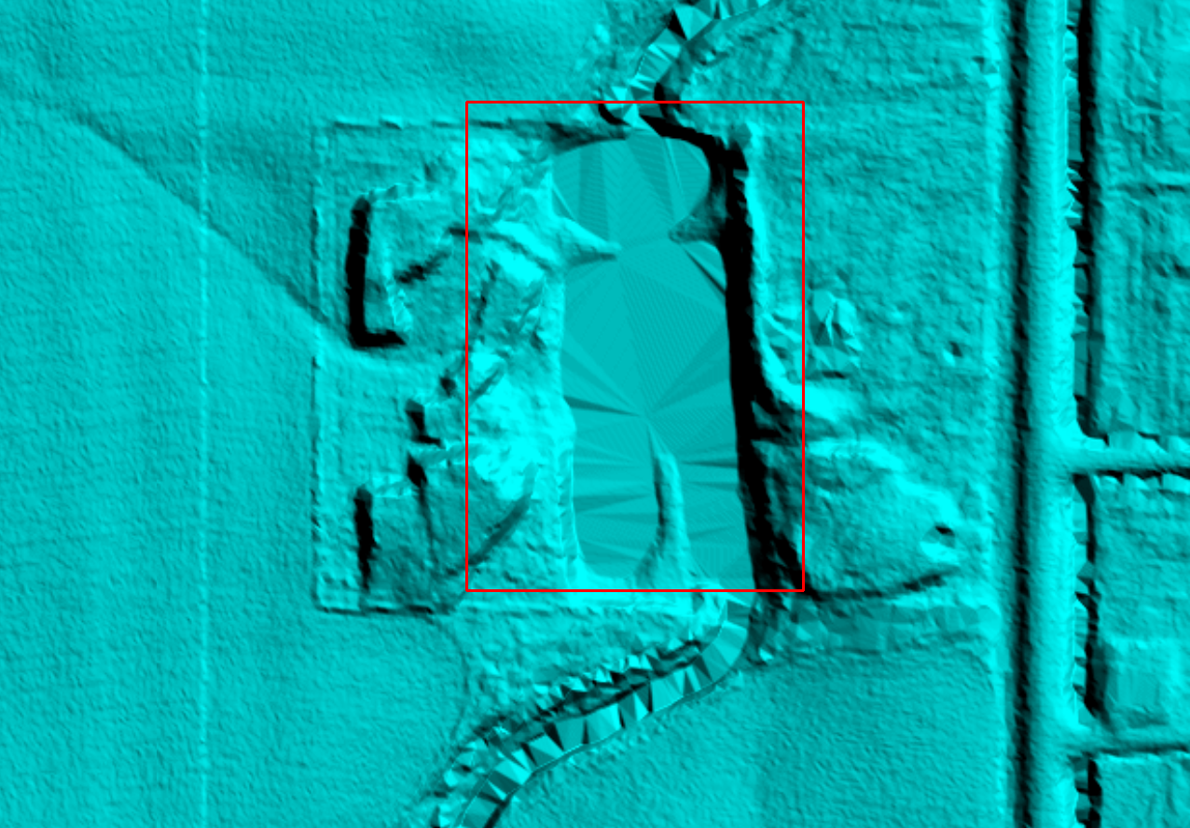
Hydro-flattening needed at 48° 54' 26.1742" N, 97° 53' 8.8311" W
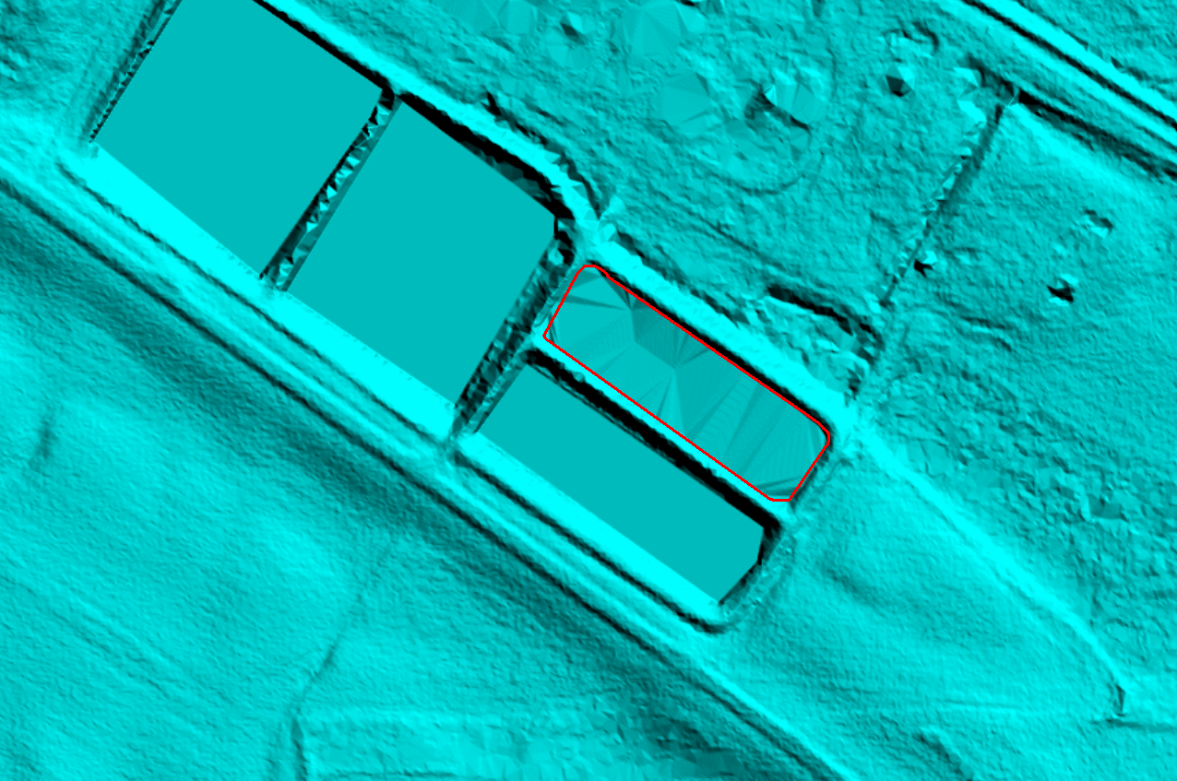

Hydro-flattening needed at 48° 51' 36.1497" N, 98° 48' 1.7707" W
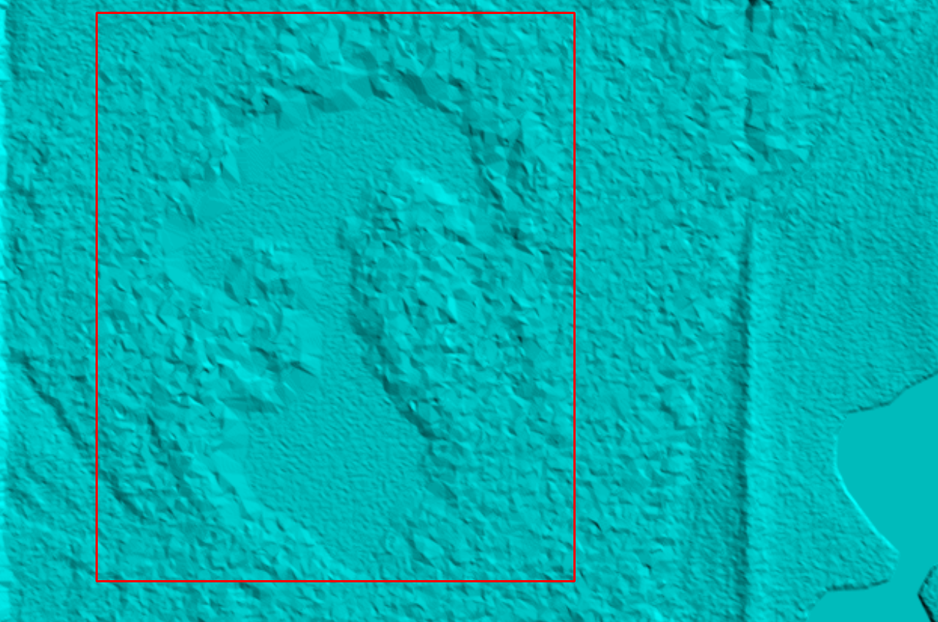

Pits in road at 48° 59' 32.3995" N, 97° 46' 13.8956" W


