LiDAR ACCURACY REPORT
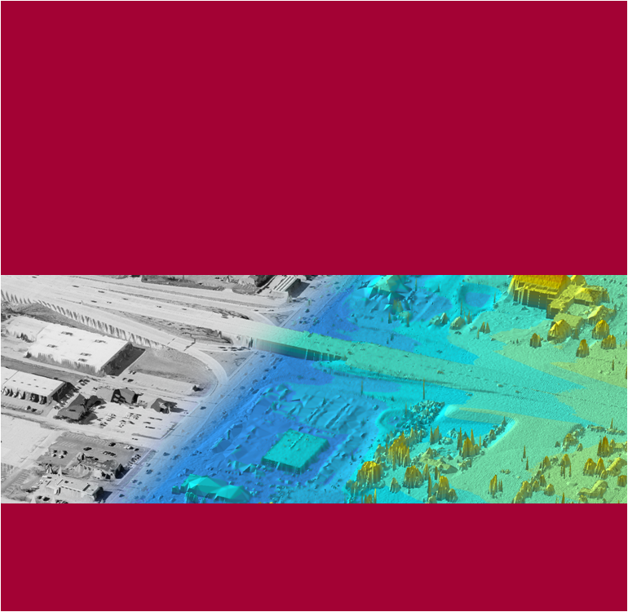
US Army Corps of Engineers, St. Louis District
Project: | Pottawatomie County, KS
Delivery Order No. | 0021
Contract No.: | W912P9-07-0518
Date: | 7-February-2011
Submitted by: | Wade Williams, Project Manager

Project Overview
The St. Louis District of the United States Army Corps of Engineers (USACE) contracted with Surdex Corporation in February of 2010 to collect LiDAR elevation data over Pottawatomie County in Kansas. The post processed elevation data was to meet National Digital Elevation Program (NDEP) standards of a vertical accuracy of 15 centimeters RMSE.

Project Area
This report covers the collection of LiDAR elevation data over Pottawatomie County. The project limits are presented in the graphics below. The project area consisted of approximately 350 square miles of elevation data.

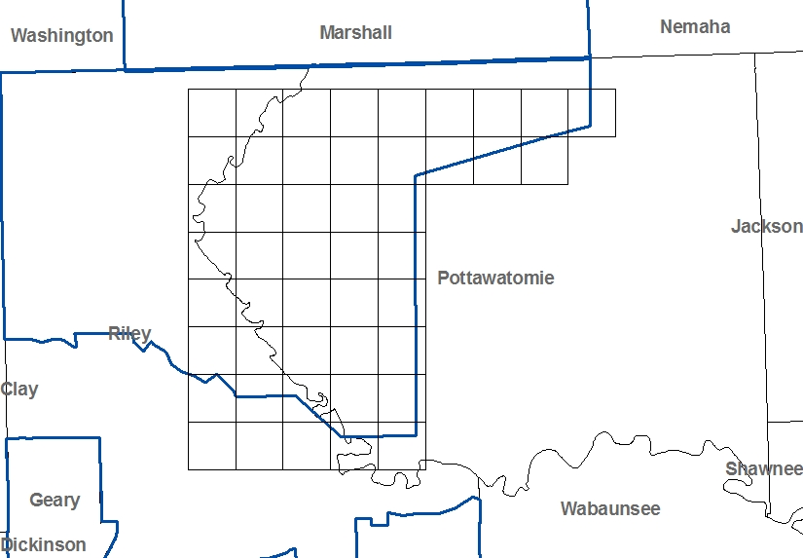

Figure 1 Pottawatomie County Project Area

LiDAR Data Collection Scenario
The LiDAR elevation data for this project was collected with a Leica ALS-50II MPIA aerial LiDAR sensor system. The project design called for acquisition of LiDAR data with flight lines aligned with the length of the project area. The nominal collection scenario called for the acquisition of nominal point spacing of 1.4m on the ground.

Pottawatomie County LiDAR Evaluation
The field survey for this project consisted of a combination of primary control (11) and LiDAR check points (9). The graphic below presents these points on the project area map.
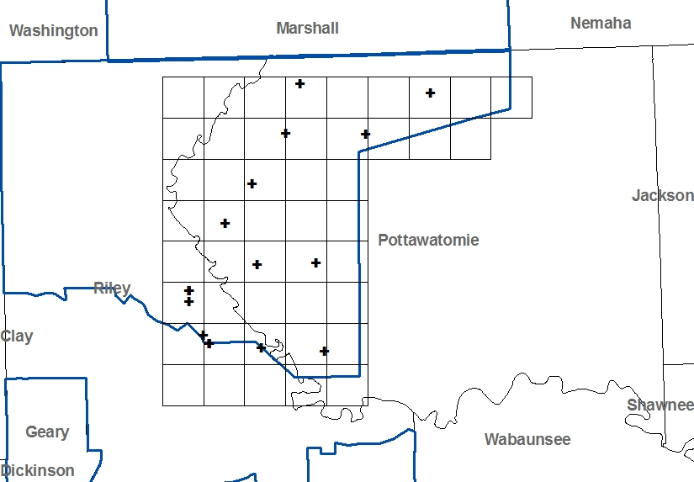

Figure 2 Pottawatomie County Control

These points consisted of various types of ground cover including asphalt, gravel, short grass, tall grass and trees. Examples to the types of points surveyed are included below.
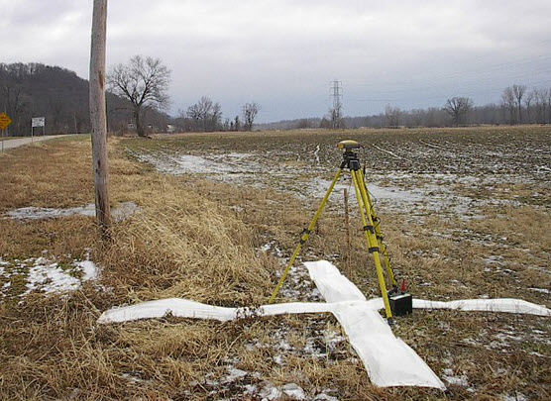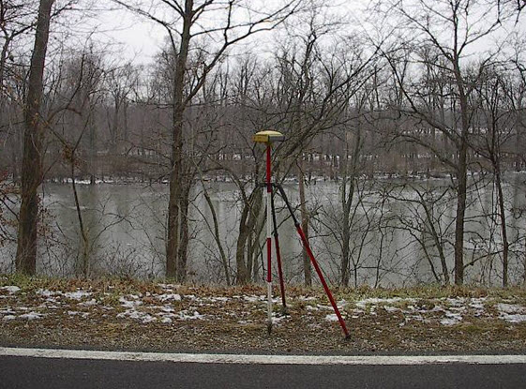

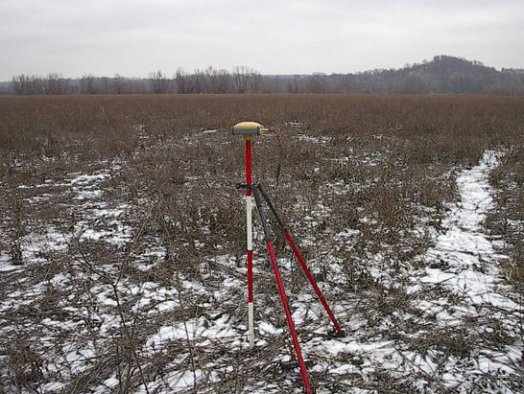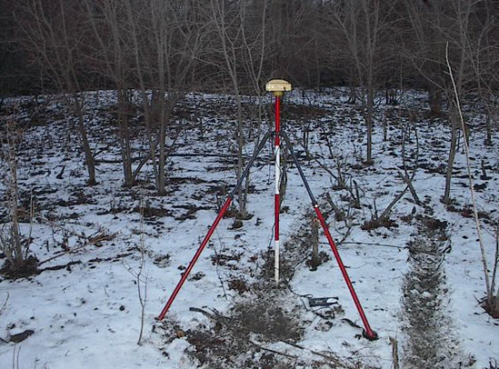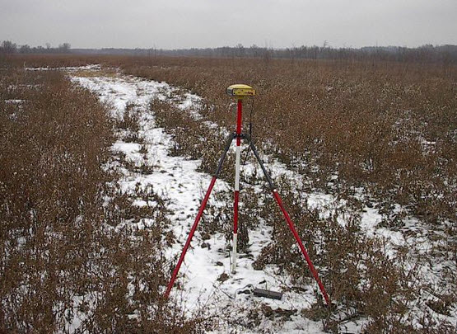

The required LiDAR elevation data values were derived within ArcGIS from the bare earth .las files. For each control point location a LiDAR elevation value was derived and exported and the surface value subtracted from the survey elevation. These derived values were imported into Excel and comparisons were performed to generate statistics by ground cover type and for the overall dataset.

Results
The table below presents the results of the accuracy analysis for Pottawatomie County. All values are in meters.
Stat | Primary Control | Hard Surface | Grass | Trees | Overall
Count | 11 | 4 | 2 | 3 | 20
Average | -0.03 | -0.03 | 0.00 | 0.21 | -0.02
RMSE | 0.11 | 0.06 | 0.06 | 0.22 | 0.13
95% Confidence Level | 0.25 | 0.22 | 0.11 | 0.44 | 0.25

As indicated above the LiDAR surface meets project specifications of RMSE less than or equal to 15cm, with an overall RMSE of 13 cm.

