PROJECT REPORT

For the

Worcester Acquisition and Classification for FEMA VA LiDAR

USGS Contract:
G10PC00013

Prepared for:
United States Geological Survey & Federal Emergency Management Agency

Prepared by:
Dewberry
8401 Arlington Blvd.
Fairfax, VA 22031-4666

Report Date: July 28, 2011

Table of Contents
1 Executive Summary 3
2 Project Tiling Footprint and Coordinate System 3
3 LiDAR Acquisition, Calibration and Control Survey Report 4
4 Vertical Accuracy Assessment 4
5 LiDAR Processing & Qualitative Assessment 6
5.1 LiDAR Classification Methodology 6
5.2 LiDAR Processing Conclusion 8
5.3 Classified LiDAR QA\QC Checklist 8
6 Breakline Production 9
6.1 Breakline Production Methodology 9
6.2 Breakline Qualitative Assessment 10
6.3 Breakline Topology Rules 10
6.4 Breakline QA/QC Checklist 11
7 DEM Production & Qualitative Assessment 13
7.1 DEM Production Methodology 13
7.2 DEM Qualitative Assessment 14
7.3 DEM QA/QC Checklist 14
8 Conclusion 15

Executive Summary
The primary purpose of this project was to develop a consistent and accurate surface elevation dataset derived from high-accuracy Light Detection and Ranging (LiDAR) technology for the Worcester County Virginia FEMA project area. The Virginia FEMA project area encompasses 5 areas: Hooper’s Island, Worcester County, Northern VA Counties, Middle VA Counties, and the Southern Cities. The deliverables as required in the task order are classified point cloud data (LAS), raw swath cloud data, hydro-flattened bare-earth DEMs, breaklines, metadata, and reports. This report documents the development of the deliverable products including the planning, acquisition, and processing of the LiDAR data as well as the derivation of LiDAR products.

Dewberry served as the primary contractor for the project. In addition to project management, Dewberry was responsible for LiDAR classification, breakline production, DEM development and quality assurance. Dewberry’s staff performed the final post-processing of the LAS files for the project, produced the breaklines used to enhance the LiDAR-derived surface, generated the 2 foot DEMs, and performed quality assurance inspections on all subcontractor generated data and reports. Geodigital/Terrapoint (Terrapoint) performed the LiDAR data acquisition including data calibration. Their reports can be found in the Appendices.
This report covers the Worcester County deliverable.

Project Tiling Footprint and Coordinate System
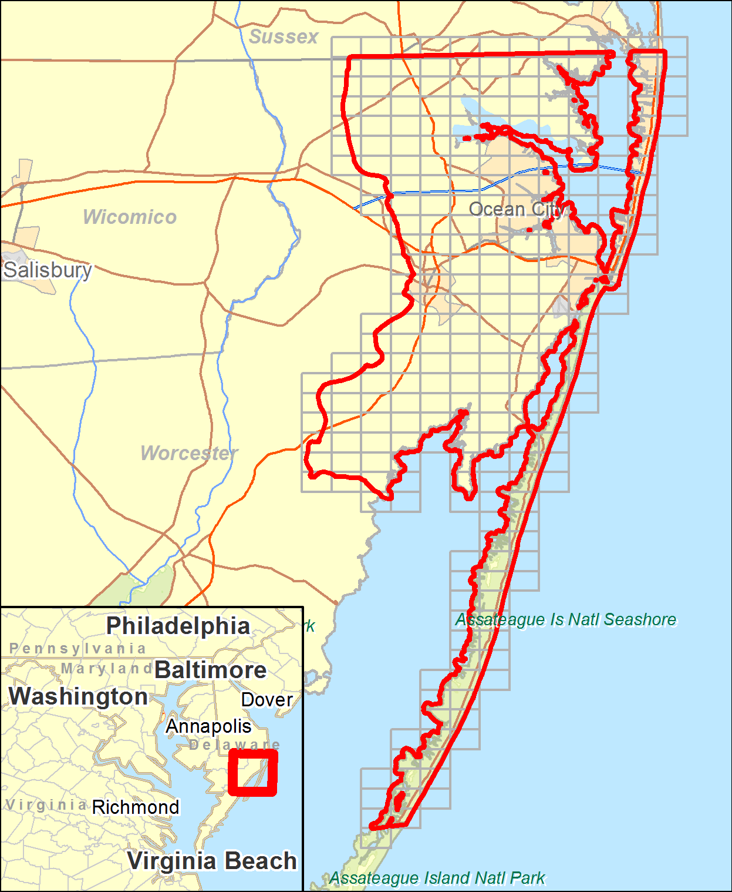
The LiDAR delivery consists of two hundred sixty three (263) tiles (Figure 1). Each tile’s extent is 6000 feet by 4000 feet. This conforms to the Orthophotography and high-resolution elevation tile grid developed by the state of Maryland.
The projection information is:
Horizontal Datum: NAD83 (2007)
Vertical Datum: NAVD88
Projection: State Plane
Zone: Maryland (1900)
Units (Horizontal & Vertical): Feet
Geoid: Geoid09

Figure 1 - Tile grid and project boundary of the Worcester County project area.

LiDAR Acquisition, Calibration and Control Survey Report
The LiDAR acquisition was completed in one flight mission on April 18th, 2011. Terrrapoint provided a separate report documenting all of the steps in their acquisition process. That document can be found in Appendix A. Their report includes the LiDAR collection parameters, planned flight path maps, flight line trajectories, forward/reverse or combined separation plots, estimated position accuracy reports, and the flight log. Terrapoint’s Geodetic Control Survey Report (Appendix B) contains a thorough review of control used including the final coordinates of the control, a map of the fully constrained control network, details of the constrained GPS network, new control station descriptions, and published control station descriptions. Terrapoint’s LiDAR Data Calibration Report (Appendix C) contains details of the LiDAR data processing and calibration as well as their vertical accuracy assessment (discussed below).

Vertical Accuracy Assessment
Terrapoint verified internally prior to delivery to Dewberry that the LiDAR data met fundamental accuracy requirements (vertical accuracy NSSDA RMSE_{Z} = 9.25cm (NSSDA Accuracy_{Z} 95% = 18 cm) or better; in open, non-vegetated terrain) when compared to kinematic and static GPS checkpoints. Below is a summary for both tests:
- The LiDAR dataset was tested to 0.074m vertical accuracy at 95% confidence level based on consolidated RMSEz (0.038m x 1.960) when compared to 2735 GPS kinematic check points.
- The LiDAR dataset was tested to 0.059m vertical accuracy at 95% confidence level based on consolidated RMSEz (0.03m x 1.960) when compared to 13 GPS static check points.

Dewberry further collected additional survey checkpoints and used those checkpoints to verify the accuracy of the LiDAR. Figure 2 shows the distribution of these check points throughout the dataset.
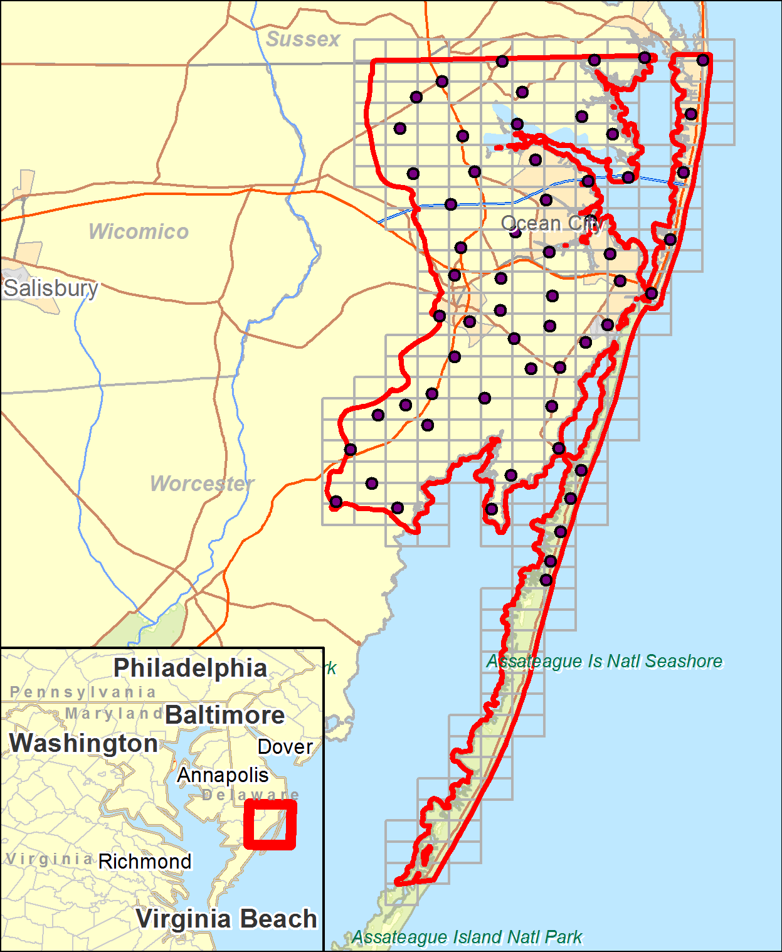
Figure 2 – Checkpoint Map shows that checkpoints are well distributed throughout project area.
The tables below show the vertical accuracy statistics and results. FVA (Fundamental Vertical Accuracy) is determined with check points located only in land cover category, open terrain (grass, dirt, sand, and/or rocks), where there is a very high probability that the LiDAR sensor will have detected the bare-earth ground surface and where random errors are expected to follow a normal error distribution. The FVA determines how well the calibrated LiDAR sensor performed. With a normal error distribution, the vertical accuracy at the 95% confidence level is computed as the vertical root mean square error (RMSEz) of the checkpoints x 1.9600.
For Worcester County, the scope of work required the vertical accuracy to be NSSDA RMSE_{Z} = 0.31 ft (9.25 cm) (NSSDA Accuracy_{Z} 95% = 0.60 ft, or 18 cm) or better; in open, non-vegetated terrain. The NSSDA RMSE_{Z} is 0.22 feet (6.7cm) and the NSSDA Accuracy_{Z} 95% is 0.43 ft (13.1 cm).
Table 1 – Overall Descriptive Statistics for Checkpoints
100 % of Totals | RMSE_{Z} (ft)  Spec=0.30 ft¹ | Mean (ft) | Median (ft) | Skew | Std Dev (ft) | # of Points | Min (ft) | Max (ft)
Open Terrain | 0.22 | 0.14 | 0.12 | 0.77 | 0.17 | 21.00 | -0.16 | 0.51
Consolidated | 0.41 | 0.29 | 0.23 | 0.88 | 0.30 | 60.00 | -0.35 | 1.24
¹Specification for Open Terrain points only.
Table 2 – Fundamental Vertical Accuracy at the 95% confidence level
Land Cover Category | # of Points | FVA ― Fundamental Vertical Accuracy (RMSEZ x 1.9600) Spec=.60 ft | CVA ― Consolidated Vertical Accuracy (95th Percentile) Spec=1.19 ft
Open Terrain | 21 | 0.43
Consolidated | 60 |  | 0.90

Based on the vertical accuracy testing conducted by Terrapoint and Dewberry, the LiDAR dataset for the Worcester County project area satisfies the project’s pre-defined vertical accuracy criteria. The LiDAR data tested at 0.43 ft (13.1 cm) vertical accuracy at 95% confidence level.

LiDAR Processing & Qualitative Assessment

5.1 LiDAR Classification Methodology
The LiDAR is tiled into the 6000ft x 4000ft tiles named using the Maryland Orthophotography and high-resolution elevation tiling scheme. The data were processed using GeoCue and TerraScan software. The initial step is the setup of the GeoCue project, which is done by importing the project defined tile boundary index. The acquired 3D laser point clouds, in LAS binary format, were imported into the GeoCue project and divided into tiles. Once tiled, the laser points were tested to ensure accuracy from flightline to flightline. This is check is done by creating a set of deltaZ ortho images. This process measures the relative accuracy between flight lines (how well one flight line fits an overlapping flight line vertically). No issues were found with during this step.
After these checks, the data is classified using a proprietary routine in TerraScan. This routine classifies out any obvious outliers from the dataset following which the ground layer is extracted from the point cloud. The ground extraction process encompassed in this routine takes place by building an iterative surface model. This surface model is generated using three main parameters: building size, iteration angle and iteration distance. The initial model is based on low points being selected by a "roaming window" with the assumption is that these are the ground points. The size of this roaming window is determined by the building size parameter. The low points are triangulated and the remaining points are evaluated and subsequently added to the model if they meet the iteration angle and distance constraints. This process is repeated until no additional points are added within iterations. A second critical parameter is the maximum terrain angle constraint, which determines the maximum terrain angle allowed within the classification model.
Once the automated classification has finished each tile is imported into TerraScan and a surface model is created to examine the ground classification. Often times, low lying buildings, porches, bridges, and small vegetation artifacts which are not caught during the automated classification are edited during this step. Dewberry analysts visually review the ground surface model and corrected errors in the ground classification such as vegetation and buildings that are present following the initial processing. Dewberry analysts employ 3D visualization techniques to view the point cloud at multiple angles and in profile to ensure that non-ground points are removed from the ground classification.
After the ground classification corrections are complete, the dataset is processed through a water classification routine that utilizes breaklines compiled by Dewberry to automatically classify hydro features. The water classification routine selects points within the breakline polygon and automatically classifies them as class 9, water. The water classification routine also buffers the breakline polygon by 2 feet and classifies points with that buffered polygon to class 10, ignored ground for DEM production. The ground class for this data set is comprised of Class 2 . Once the data classification is finalized, the LAS format 1.0 format points are converted to LAS 1.2 Point Data Record Format 1 and converted to the required ASPRS classification scheme.
- Class 1 = Unclassified, and used for all other features that do not fit into the Classes 2, 7, 9, or 10, including vegetation, buildings, etc.
- Class 2 = Ground
- Class 7 = Noise
- Class 9 = Water
- Class 10 = Ignored Ground due to breakline proximity.
- Class 11 = Withheld

The following fields within the LAS files are populated to the following precision: GPS Time (0.000001 second precision), Easting (0.01 foot precision), Northing (0.01 foot precision), Elevation (0.01 foot precision), Intensity (integer value - 12 bit dynamic range), Number of Returns (integer - range of 1-4), Return number (integer range of 1-4), Scan Direction Flag (integer - range 0-1), Classification (integer), Scan Angle Rank (integer), Edge of flight line (integer, range 0-1), User bit field (integer - flight line information encoded). The LAS file also contains a Variable length record in the file header.
Following the completion of LiDAR point classification, the Dewberry qualitative assessment process flow for the project incorporated the following reviews:
- Format: Using TerraScan, Dewberry verified that all points were classified into valid classes according to project specifications.
  - LAS format 1.2, point data record format 1
  - All points contain populated intensity values.
  - All LAS files contain Variable Length Records with georeferencing information.
  - All LiDAR points in the LAS files are classified in accordance with project specifications.

- Spatial Reference Checks: The LAS files were imported into the GeoCue processing environment. As part of the Dewberry process workflow, the GeoCue import produced a minimum bounding polygon for each data file. This minimum bounding polygon was one of the tools used in conjunction with the statistical analysis to verify spatial reference integrity.
  - No issues were identified with the spatial referencing of this dataset.

- Data density, data voids: The LAS files are used to produce Digital Elevation Models using the commercial software package “QT Modeler” which creates a 3-dimensional data model derived from ground points in the LAS files. Grid spacing is based on the project density deliverable requirement for un-obscured areas.
  - Acceptable voids (areas with no LiDAR returns in the LAS files) that are present in the majority of LiDAR projects include voids caused by bodies of water. These are considered to be acceptable voids.
  - Dewberry identified no data voids within the dataset.
- Bare earth quality: Dewberry assured the cleanliness of the bare earth during classification by removing all artifacts, including vegetation, buildings, bridges, and other features not valid for inclusion in the ground surface model.

5.2 LiDAR Processing Conclusion
Based on the procedures and quality assurance checks, the classification conforms to project specifications set by the scope of work. All issues found during the qualitative QC were fixed. The dataset conforms to project specifications for format and header values. The quality control steps taken by Dewberry to assure the classified LAS meet project specifications are detailed below.

5.3 Classified LiDAR QA\QC Checklist
Overview
Correct number of files delivered and all files adhere to project format specifications
LAS statistics are run to check for inconsistencies
Dewberry quantitative review process is completed
Dewberry qualitative review process is completed
Create LAS extent geometry
Data Inventory and Coverage
All tiles present and labeled according to the project tile grid
Dewberry Quantitative Review Process
LAS statistics review:
LAS format 1.2
Point data record format 1
Georeference information is populated and accurate
- NAD_1983_NSRS2007_StatePlane_Maryland_FIPS_1900_Ft_US
- NAVD88 - Geoid09 (Feet)

GPS time recorded as Adjusted GPS Time, with 0.01 precision
Points have intensity values
Files contain multiple returns (minimum First, Last, and one Intermediate)
Scan angle < 40°
Data meets Nominal Pulse Spacing requirement: <=0.5 meters
Tested on single swath, first return data only;
Tested on geometrically usable portion (90%) of swath
Data passes Geometric Grid Data Density Test
Tested on 1 meter grid
Tested on first return data only
At least 90% of grid cells contain at least 1 point
Data tested for vertical accuracy
Checkpoint inventory
Vertical accuracy assessment. LiDAR compiled to meet requirements.
Completion Comments: Complete – Approved

Breakline Production

6.1 Breakline Production Methodology
Dewberry used GeoCue software to develop LiDAR stereo models of the project area so the LiDAR derived data could be viewed in 3-D stereo using Socet Set softcopy photogrammetric software. Using LiDARgrammetry procedures with LiDAR intensity imagery, Dewberry stereo-compiled the five types of hard breaklines in accordance with the project’s Data Dictionary. All drainage breaklines are monotonically enforced to show downhill flow. Water bodies are reviewed in stereo and the lowest elevation is applied to the entire waterbody.

6.2 Breakline Qualitative Assessment
Dewberry completed breakline qualitative assessments according to a defined workflow. The following workflow diagram represents the steps taken by Dewberry to provide a thorough qualitative assessment of the breakline data (Figure 3).

Figure 3 – Breakline Workflow

6.3 Breakline Topology Rules
Automated checks are applied on hydro features to validate the 3D connectivity of the feature and the monotonicity of the hydrographic breaklines. Dewberry’s major concern was that the hydrographic breaklines have a continuous flow downhill and that breaklines do not undulate. Error points are generated at each vertex not complying with the tested rules and these potential edit calls are then visually validated during the visual evaluation of the data. This step also helped validate that breakline vertices did not have excessive minimum or maximum elevations and that elevations are consistent with adjacent vertex elevations.
The next step is to compare the elevation of the breakline vertices against the elevation extracted from the ESRI Terrain built from the LiDAR ground points, keeping in mind that a discrepancy is expected because of the hydro-enforcement applied to the breaklines and because of the interpolated imagery used to acquire the breaklines. A given tolerance is used to validate if the elevations do not differ too much from the LiDAR.
Dewberry’s final check for the breaklines was to perform a full qualitative analysis. Dewberry compared the breaklines against LiDAR intensity images to ensure breaklines were captured in the required locations. The quality control steps taken by Dewberry are outlined in the QA Checklist below.

6.4 Breakline QA/QC Checklist
Overview
All Feature Classes are present in GDB
All features have been loaded into the geodatabase correctly. Ensure feature classes with subtypes are domained correctly.
The breakline topology inside of the geodatabase has been validated. See Data Dictionary for specific rules
Projection/coordinate system of GDB is accurate with project specifications
Perform Completeness check on breaklines using either intensity or ortho imagery
Check entire dataset for missing features that were not captured, but should be to meet baseline specifications or for consistency (See Data Dictionary for specific collection rules). NHD data will be used to help evaluate completeness of collected hydrographic features. Features should be collected consistently across tile bounds within a dataset as well as be collected consistently between datasets.
Check to make sure breaklines are compiled to correct tile grid boundary and there is full coverage without overlap
Check to make sure breaklines are correctly edge-matched to adjoining datasets if applicable. Ensure breaklines from one dataset join breaklines from another dataset that are coded the same and all connecting vertices between the two datasets match in X,Y, and Z (elevation). There should be no breaklines abruptly ending at dataset boundaries and no discrepancies of Z-elevation in overlapping vertices between datasets.
Compare Breakline Z elevations to LiDAR elevations
Using a terrain created from LiDAR ground points and water points and GeoFIRM tools, drape breaklines on terrain to compare Z values. Breakline elevations should be at or below the elevations of the immediately surrounding terrain. Z value differences should generally be limited to within 1 FT. This should be performed before other breakline checks are completed.
Perform automated data checks using PLTS
The following data checks are performed utilizing ESRI’s PLTS extension. These checks allow automated validation of 100% of the data. Error records can either be written to a table for future correction, or browsed for immediate correction. PLTS checks should always be performed on the full dataset.

Perform “adjacent vertex elevation change check” on the Inland Ponds feature class (Elevation Difference Tolerance=.001 feet). This check will return Waterbodies whose vertices are not all identical. This tool is found under “Z Value Checks.”
Perform “unnecessary polygon boundaries check” on waterbodies and Streams feature classes. This tool is found under “Topology Checks.”
Perform “duplicate geometry check”. Attributes do not need to be checked during this tool. This tool is found under “Duplicate Geometry Checks.”
Perform “geometry on geometry check”. Spatial relationship is contains, attributes do not need to be checked. This tool is found under “Feature on Feature Checks.”
Perform “polygon overlap/gap is sliver check”. Maximum Polygon Area is not required. This tool is found under “Feature on Feature Checks.”
Perform Dewberry Proprietary Tool Checks
Perform monotonicity check on inland streams features using “A3_checkMonotonicityStreamLines.” This tool looks at line direction as well as elevation. Features in the output shapefile attributed with a “d” are correct monotonically, but were compiled from low elevation to high elevation. These errors can be ignored. Features in the output shapefile attributed with an “m” are not correct monotonically and need elevations to be corrected. Input features for this tool need to be in a geodatabase. Z tolerance is .01 feet. Polygons need to be exported as lines for the monotonicity tool.
Perform connectivity check between (tidal waters to inland streams), (tidal waters to inland ponds), (inland ponds to inland streams) using the tool “07_CheckConnectivityForHydro.” The input for this tool needs to be in a geodatabase. The output is a shapefile showing the location of overlapping vertices from the polygon features and polyline features that are at different Z-elevation. The unnecessary polygon boundary check must be run and all errors fixed prior to performing connectivity check. If there are exceptions to the polygon boundary rule then that feature class must be checked against itself, i.e. inland streams to inland streams.
Metadata
Each XML file (1 per feature class) is error free as determined by the USGS MP tool
Metadata content contains sufficient detail and all pertinent information regarding source materials, projections, datums, processing steps, etc. Content should be consistent across all feature classes.

Completion Comments: Complete – Approved

DEM Production & Qualitative Assessment

7.1 DEM Production Methodology
Dewberry’s utilizes ESRI software and Global Mapper for the DEM production and QC process. ArcGIS software is used to generate the products and the QC is performed in both ArcGIS and Global Mapper. The DEM workflow is described in Figure 4.
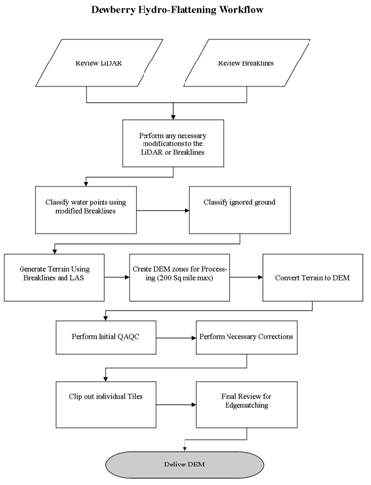
Figure 4 – Dewberry’s DEM Workflow
- Classify Water Points: LAS point falling within hydrographic breaklines shall be classified to ASPRS class 9 using TerraScan. Breaklines must be prepared correctly prior to performing this task.
- Classify Ignored Ground Points: Classify points in close proximity to the breaklines from Ground to class 10 (Ignored Ground). Close proximity will be defined as equal to the nominal point spacing on either side of the breakline. Breaklines will be buffered using this specification and the subsequent file will need to be prepared in the same manner as the water breaklines for classification. This process will be performed after the water points have been classified and only run on remaining ground points.
- Terrain Processing: A Terrain will be generated using the Breaklines and LAS data that has been imported into ArcGIS as a Multipoint File. If the final DEMs are to be clipped to a project boundary that boundary will be used during the generation of the Terrain.
- Create DEM Zones for Processing: Create DEM Zones that are buffered by 14m around the edges. Zones should be created in a logical manner to minimize the number of zones without creating zones to large for processing. Dewberry will make zones no larger than 200 square miles (taking into account that a DEM will fill in the entire extent not just where LiDAR is present). Once the first zone is created it must be verified against the tile grid to ensure that the cells line up perfectly with the tile grid edge.
- Convert Terrain to Raster: Convert Terrain to raster using the DEM Zones created in step 4. Utilizing the natural neighbors interpolation method. In the environmental properties set the extents of the raster to the buffered Zone. For each subsequent zone, the first DEM will be utilized as the snap raster to ensure that zones consistently snap to one another.
- Perform Initial QAQC on Zones: During the initial QA process anomalies will be identified and corrective polygons will be created.
- Correct Issues on Zones: Corrections on zones will be performed following Dewberry’s in-house correction process.
- Extract Individual Tiles: Individual Tiles will be extracted from the zones utilizing the Dewberry created tool.
- Final QA: Final QA will be performed on the dataset to ensure that tile boundaries are seamless.

7.2 DEM Qualitative Assessment
Dewberry performed a comprehensive qualitative assessment of the DEM deliverables to ensure that all tiled DEM products were delivered with the proper extents, were free of processing artifacts, and contained the proper referencing information. This process was performed in ArcGIS software with the use of a tool set Dewberry has developed to verify that the raster extents match those of the tile grid and contain the correct projection information. The DEM data was reviewed at a scale of 1:5000 to review for artifacts caused by the DEM generation process and to review the hydro-flattened features. To perform this review Dewberry creates HillShade models and overlays a partially transparent colorized elevation model to review for these issues. Upon completion of this review the DEM data is loaded into Global Mapper to ensure that all files are readable and that no artifacts exist between tiles.
The quality control steps taken by Dewberry are outlined in the QA Checklist below.

7.3 DEM QA/QC Checklist
Overview
Correct number of files is delivered and all files are in IMG Format
All files are visually inspected to be free of artifacts and processing anomalies.
DEM extent geometry shapefile is created
Review
All files are tiled with a 2 foot cell size
Georeference information is populated and accurate
- NAD_1983_NSRS2007_StatePlane_Maryland_FIPS_1900_Ft_US

Vertical accuracy is verified by comparing the LAS to the DEM.
Water Bodies, wide streams and rivers and other non-tidal water bodies as defined in Section III are hydro-flattened within the DEM.
Manually review bare-earth DEMs with a hillshade to check for processing issues or any general anomalies enforcement process or any general anomalies that may be present.
Completion Comments: Complete – Approved

Conclusion
Dewberry was tasked by the client to collect LiDAR data and create derived LiDAR products for Worcester County, MD. Terrapoint was subcontracted to perform the LiDAR acquisition and calibration. Once Dewberry received the LiDAR data, initial QA/QC checks on the raw LAS swaths were performed. The LiDAR data were compiled to meet a vertical accuracy of 9.25 cm and based on Terrapoint’s vertical accuracy tests and Dewberry’s independently collected checkpoints the data meets that criterion. The LiDAR data tested at 0.43 ft (13.1 cm) meters vertical accuracy at 95% confidence level. Dewberry then classified the data according to project specifications and the classification was checked to ensure its accuracy. 3D breaklines were collected for the area. These breaklines and the LiDAR ground points were used to generate a DEM with hydro-flattened water bodies. Finally metadata were created for all deliverables. Based on the scope of work, all delivered products for the Worcester County, MD project conform to project specifications.

