Elevation QA Report

Project: Contractor:
Data Delivery Date: Date Data Reviewed:

Reviewer: Total Square Miles Reviewed:

Elevation Type: Format: Grid Spacing: Tile size:
Projection: Zone: Datum: Units:

Licensing: Metadata:
Materials Received:

Vertical Accuracy Test Performed: Test Point Source: RMSE:
Vertical Accuracy Test Notes:
QC Review Summary:

11-2-2010
LiDAR Quality Control (QC) Review Process

Preparation:
-Metadata reviewed to determine data projection, datum, format, etc.
-If ARRA contract, check for raw .LAS files, classified .LAS files, breaklines, blind control points,
and DEM in Image or Grid format
-Open data in Global Mapper

Vertical accuracy testing:
-If ARRA contract, use Vertical Accuracy Test Worksheet to perform RMSE on 20 blind point
positions provided by contractor

Inspection and Correction of data:
-Minimum and maximum elevations in dataset; correct if in error
-Appropriate hydro flattening as specified in V12 Lidar Specification (For ARRA/GPSC Data)
-Data void areas
-Data spikes
-Tile edge seam lines
-Non-bare earth surface artifacts (structures, bridges, vegetation, etc.)
-Elevation errors - raised/lowered areas/tiles
-Other surface treatment anomalies
-Check DRGs for correct elevations and horizontal positioning (if test points not available)
-Create footprint (project boundary) shape file and establish square miles
During Inspection, identify data errors and create “error” file folder:
-Capture geo-referenced JPG or TIFF image(s) of identified errors
-Copy to Error file
During Inspection, level elevations and remove artifacts (these two steps not done for ARRA data):
-Level smoothing to remove non-bare earth surface artifacts (structures, bridges, vegetation, etc.)
-Level data spikes where possible

Export image files and create project Elevation QC Review Report:
-Export ERDAS Imagine image files in native projection and resolution
-If ARRA, Copy Vertical Accuracy Test Worksheet into QC Report
-Place QC Review Process and Project Area Extent into QC Report
-If rejected, attach sample geo-referenced JPG or TIFF error images with an explanation of reason
-If rejected, restart QC process when replacement data is received
-Provide completed Elevation QC Review Report to Elevation Supervisor for final viewing
-Add QC Report, footprint, Imagine image(s), and Error file to original data file for final shipment to EROS

Boone Co. MO Area Extent
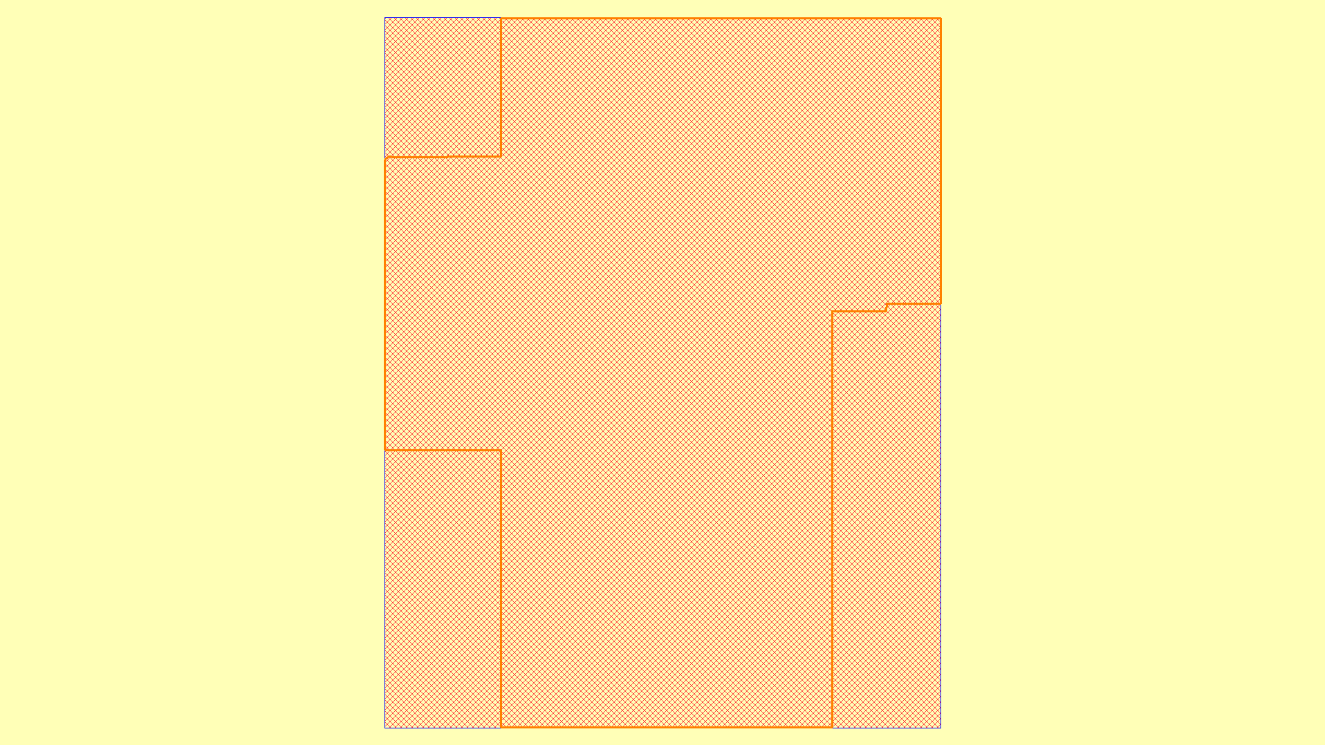
200 ft. hole @ 38° 55' 41.8620" N, 92° 20' 34.3993" W
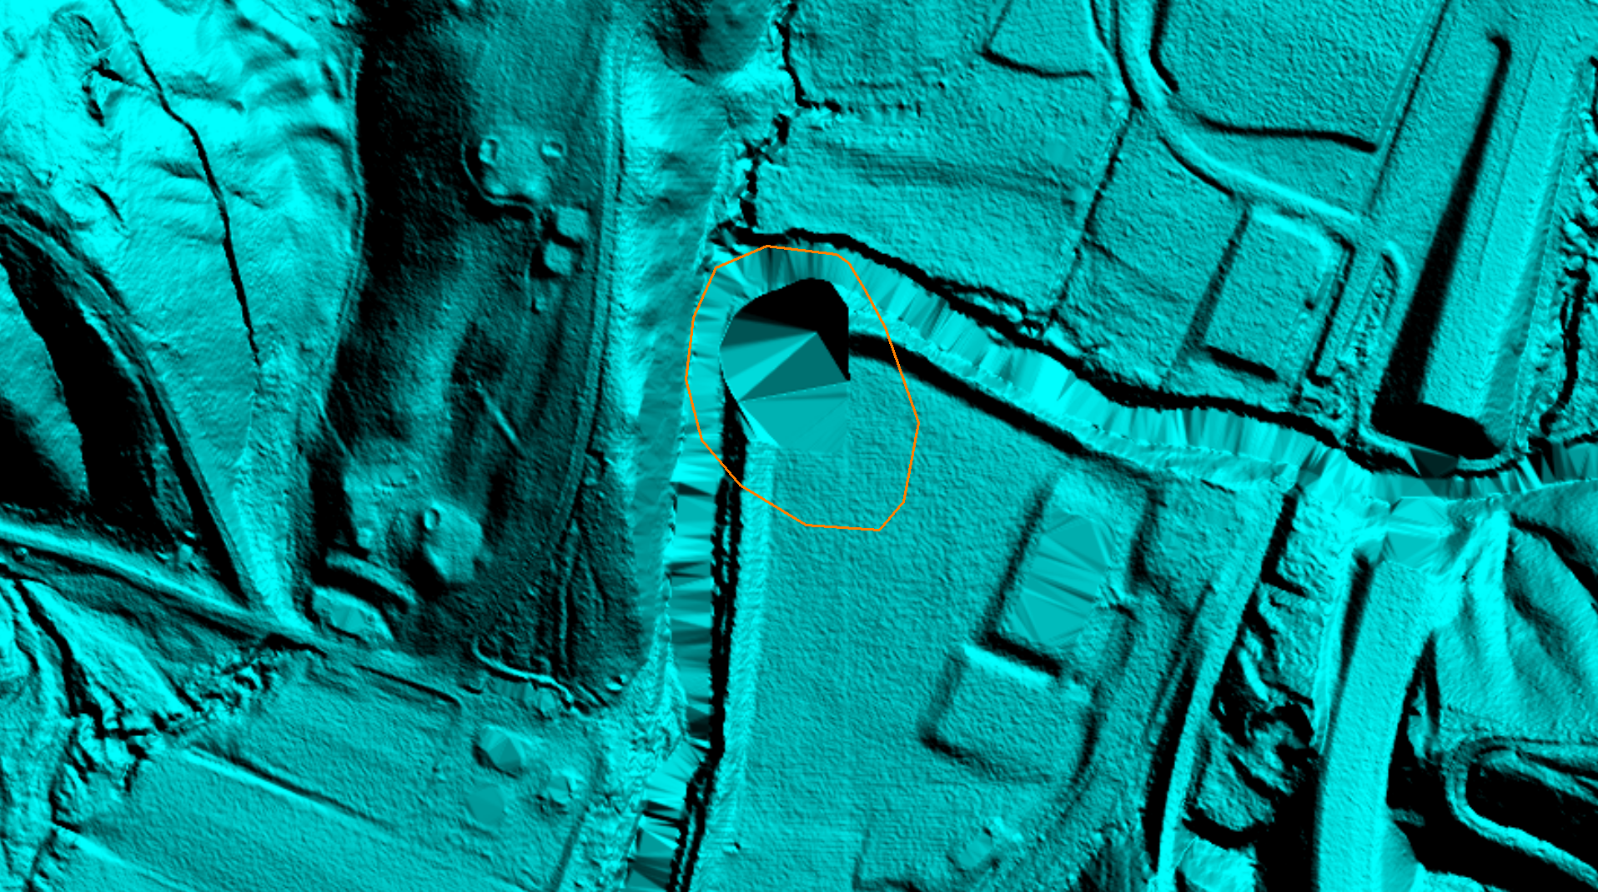

705 ft. hole @ 38° 56' 45.6534" N, 92° 37' 39.2939" W
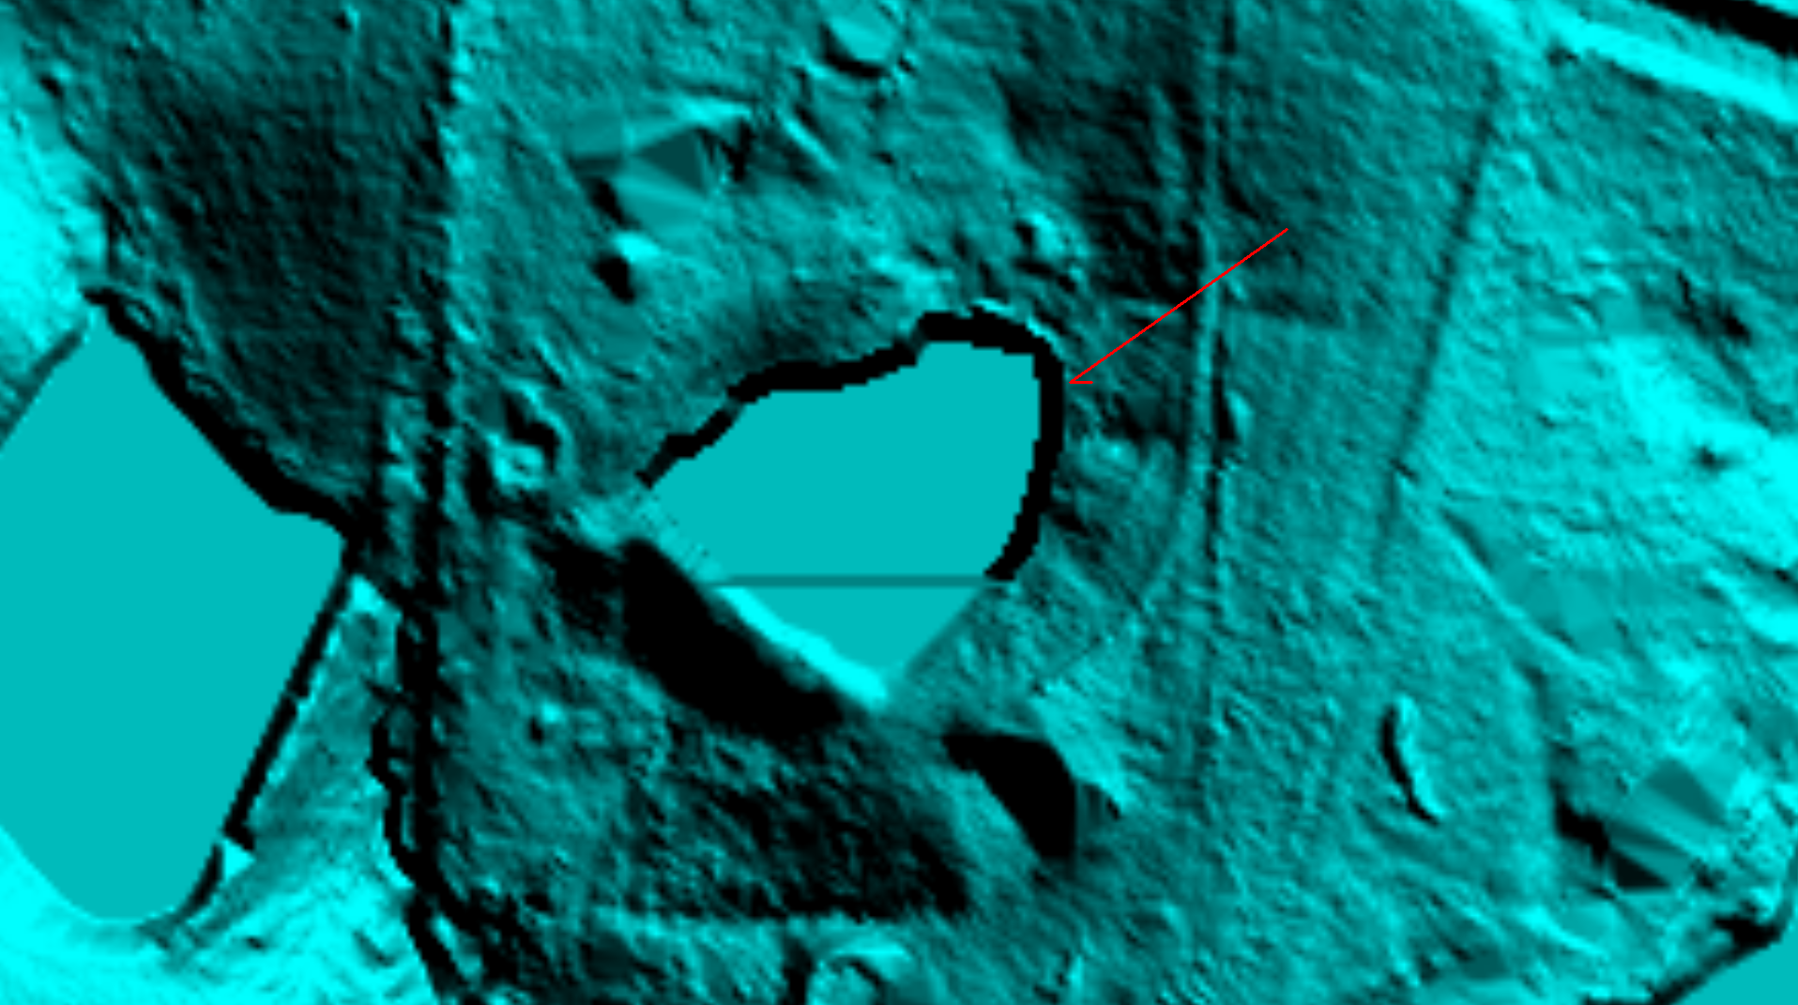
705 ft. hole 3-D
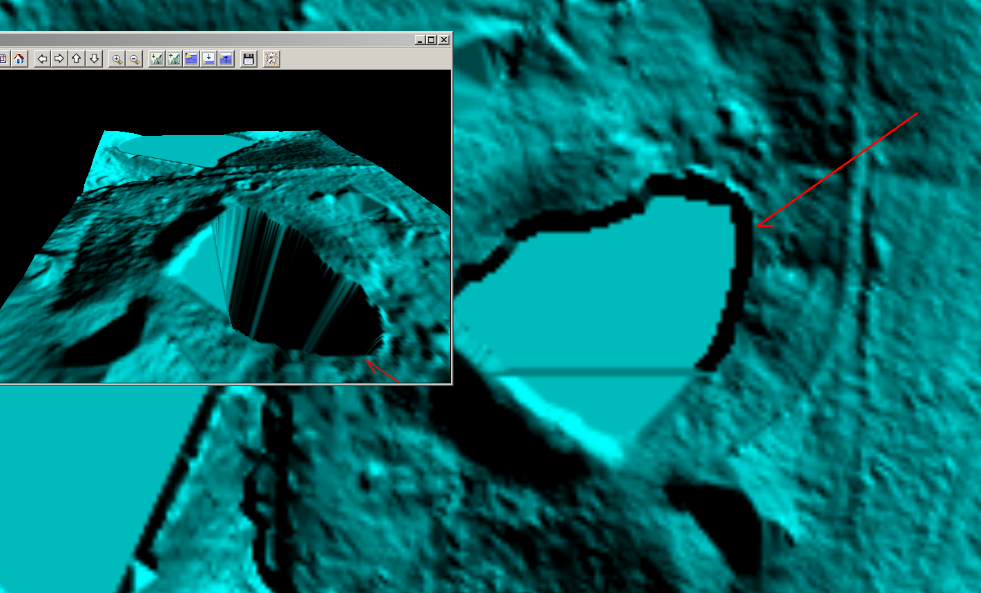

Drop off at tile edge in stream @ 38° 55' 19.1281" N, 92° 37' 56.9093" W
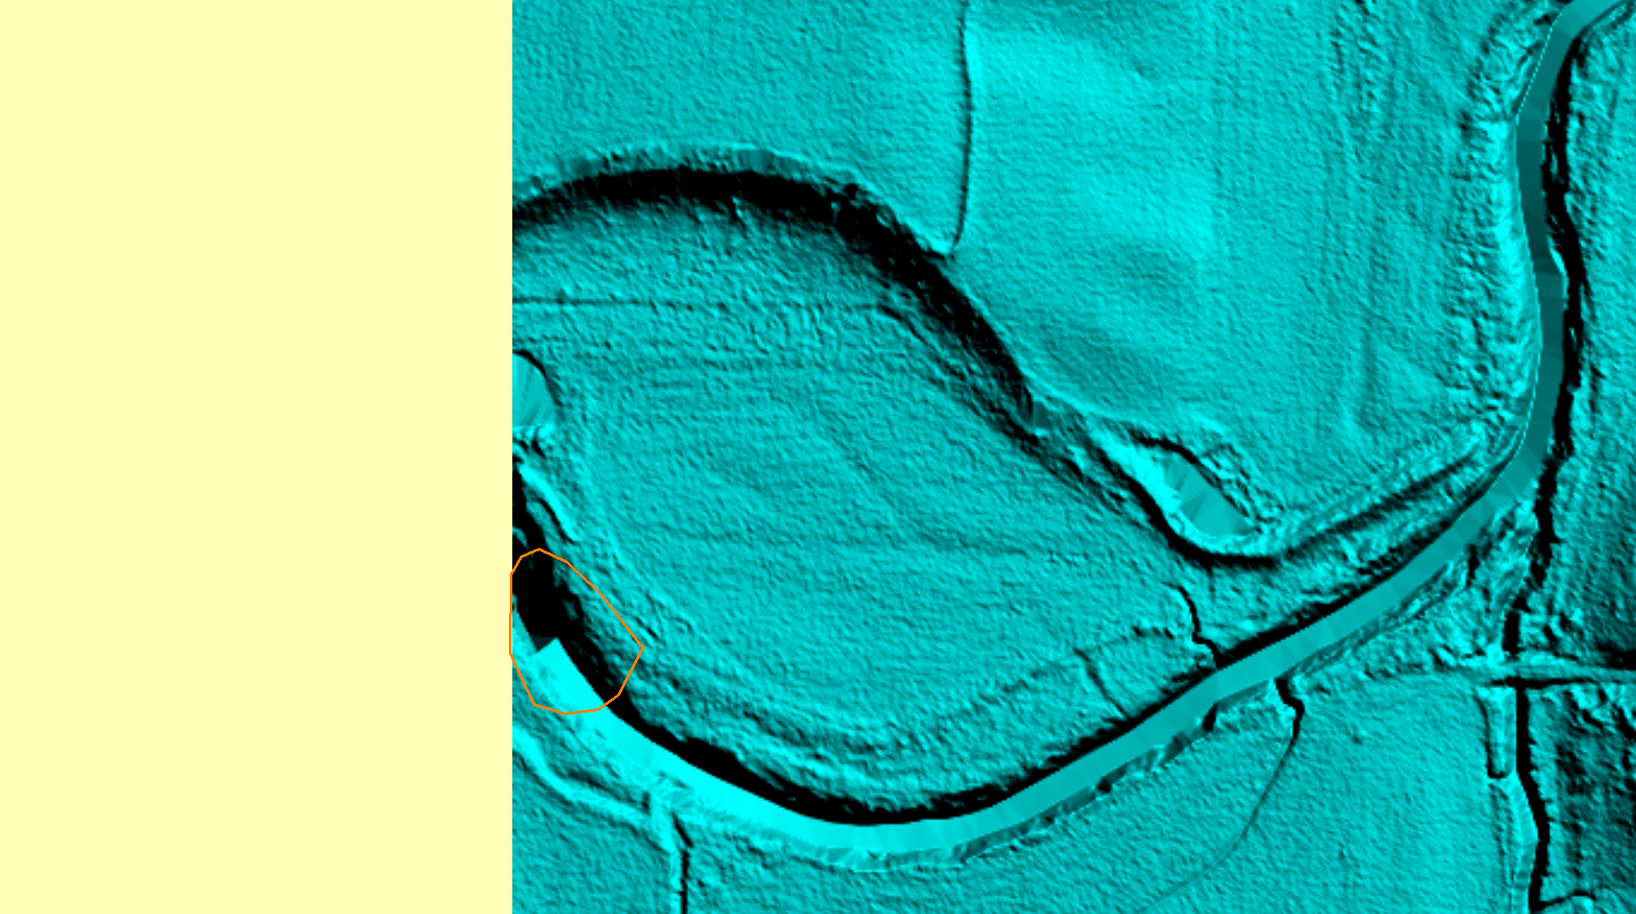
Drop off in 3-D
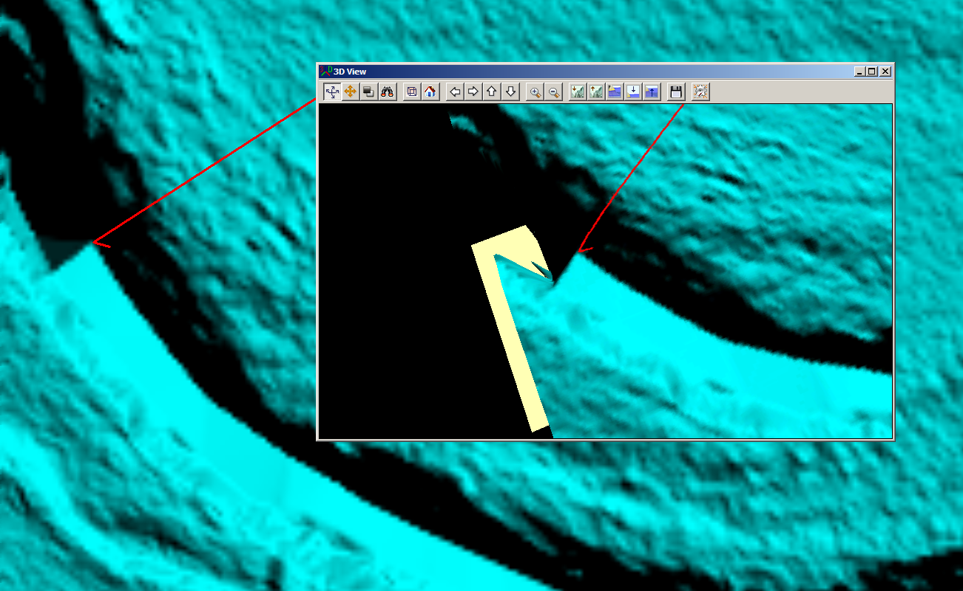

Bridge @ 38° 58' 30.8441" N, 92° 19' 35.2795" W
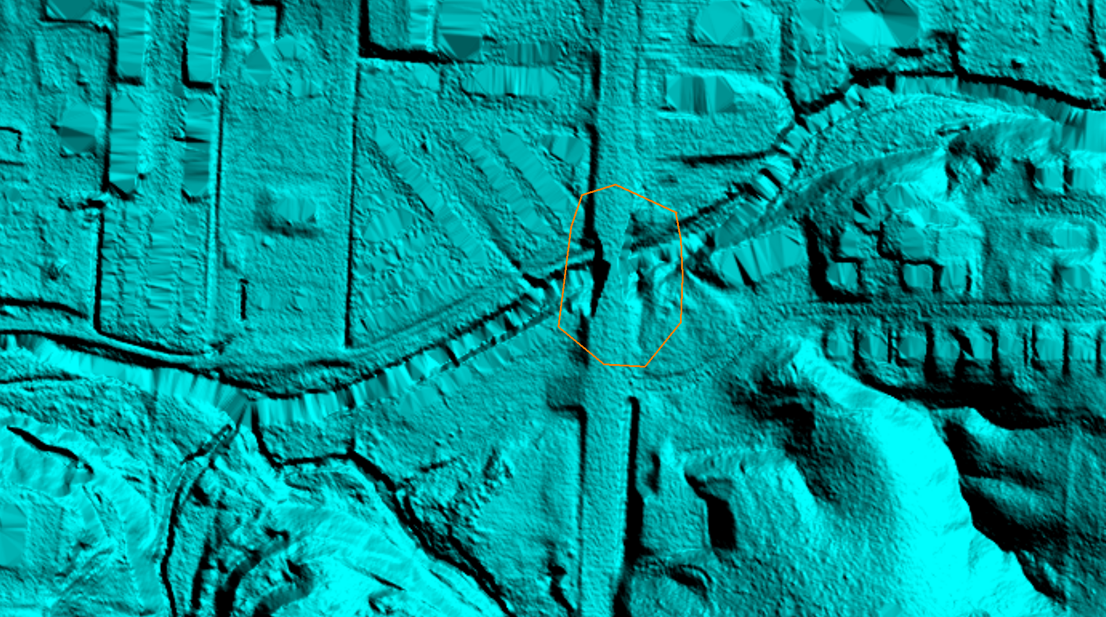
Building @ 38° 57' 2.8114" N, 92° 12' 11.0389" W
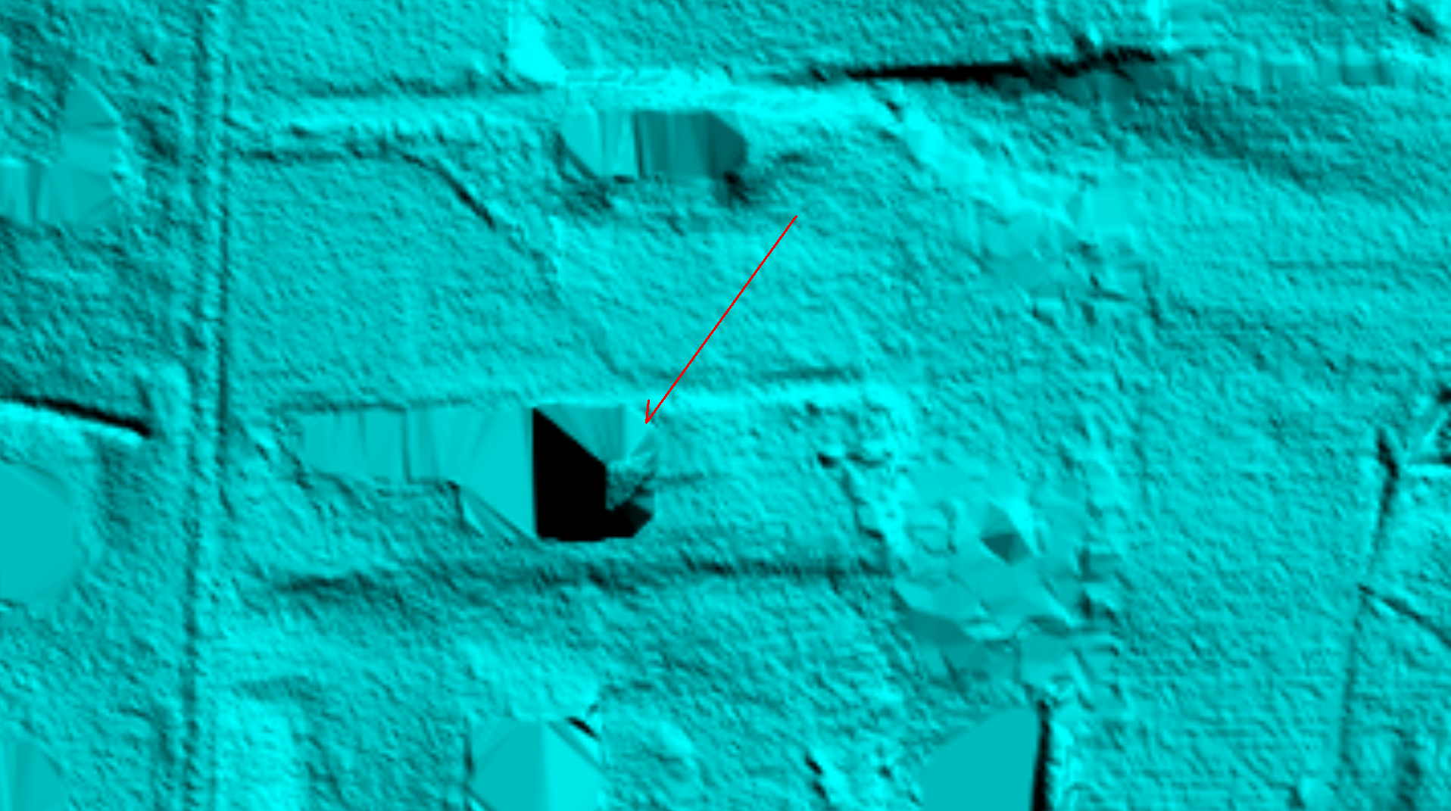

Breakline errors @ 38° 59' 5.5838" N, 92° 32' 43.8104" W
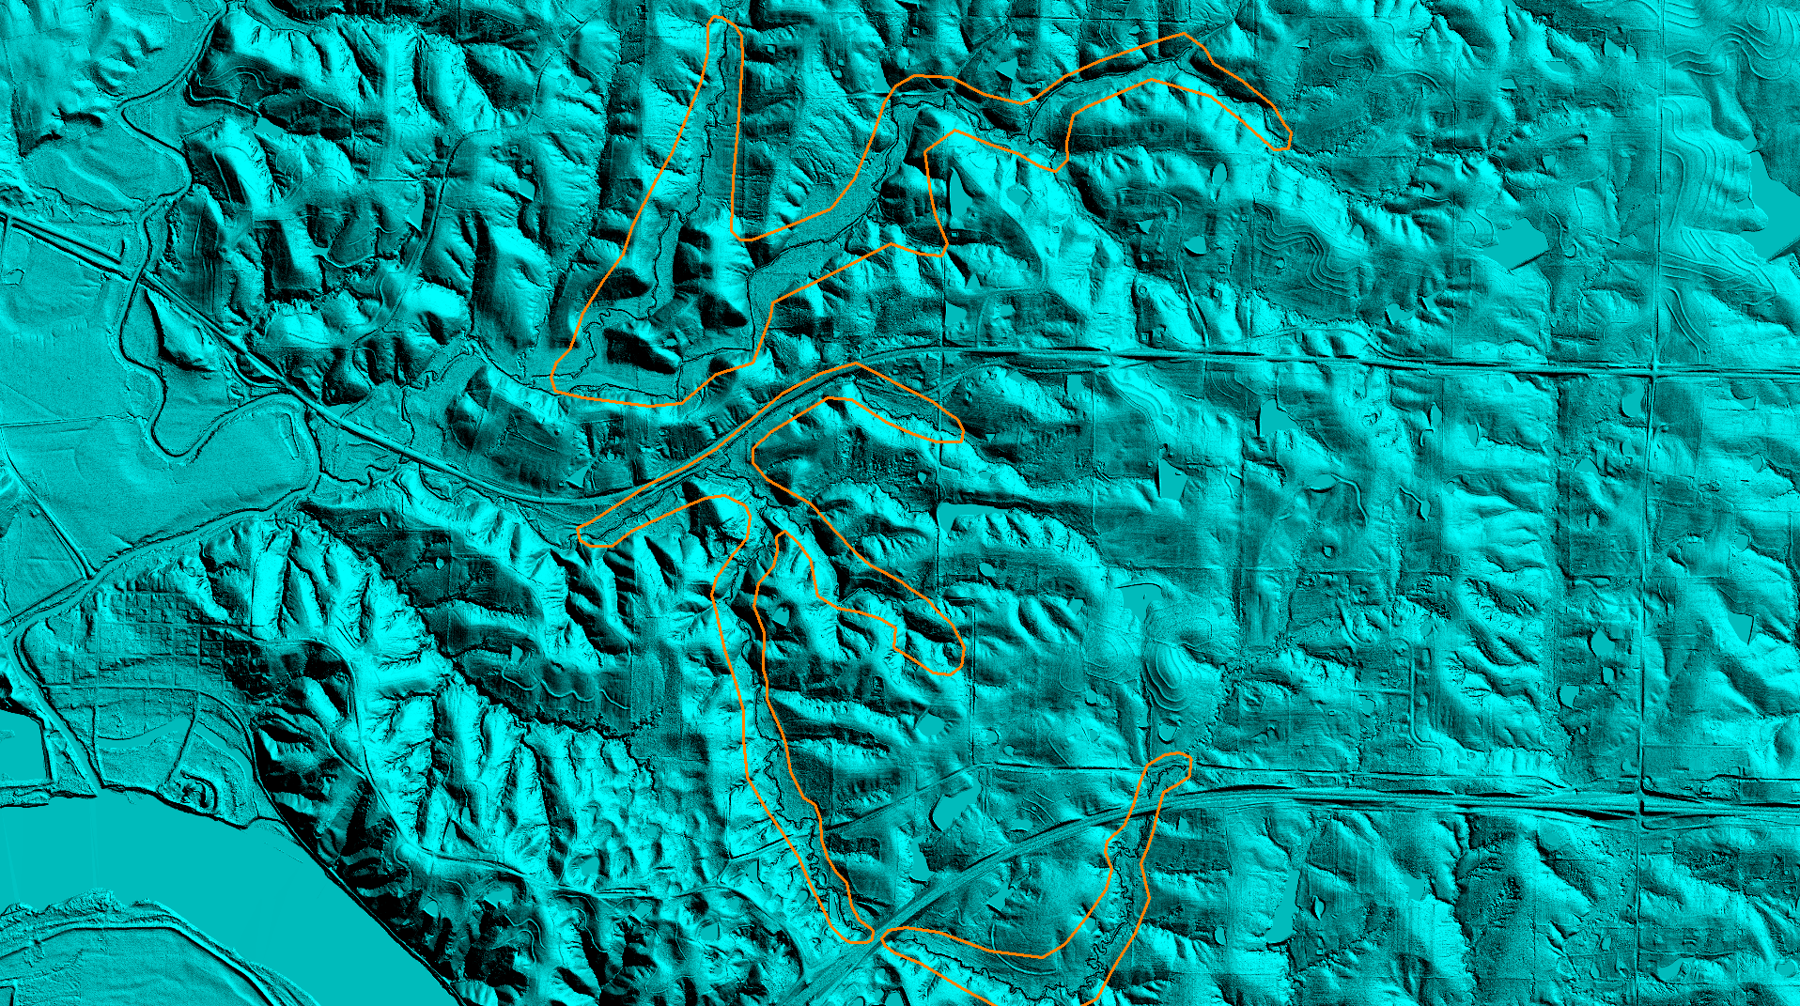
Breakline errors 3 – D
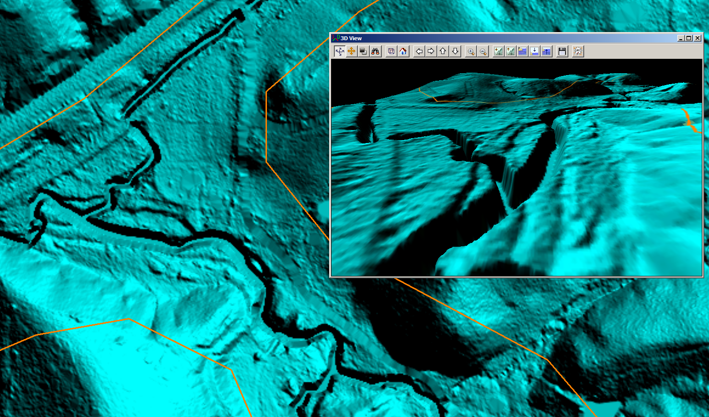

Breakline errors @ 38° 57' 23.8030" N, 92° 29' 43.7801" W
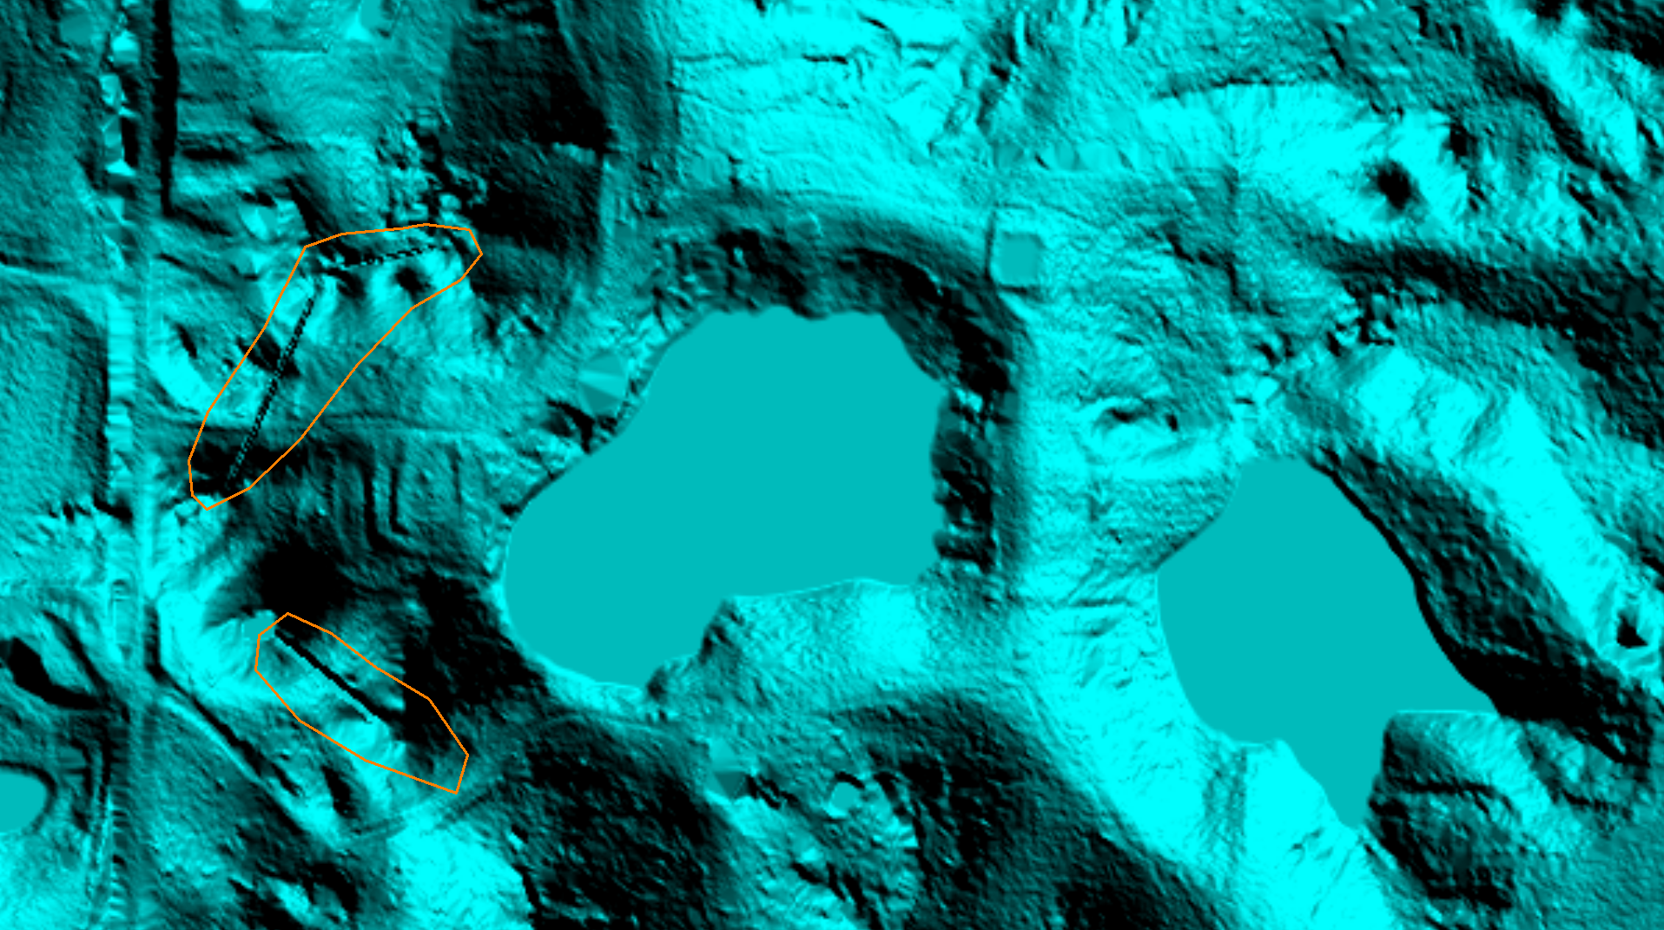
Breakline errors 3-D
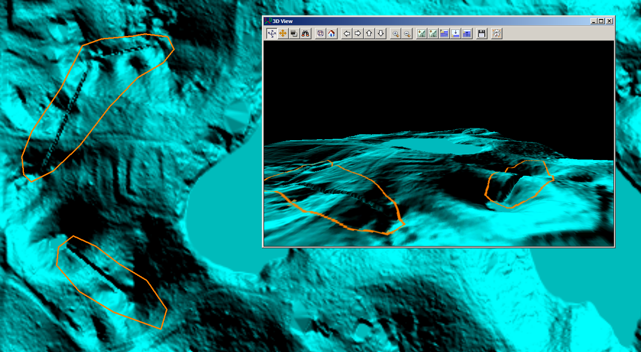

False shoreline created @ tile edge @ 38° 40' 3.8520" N, 92° 07' 27.4354" W
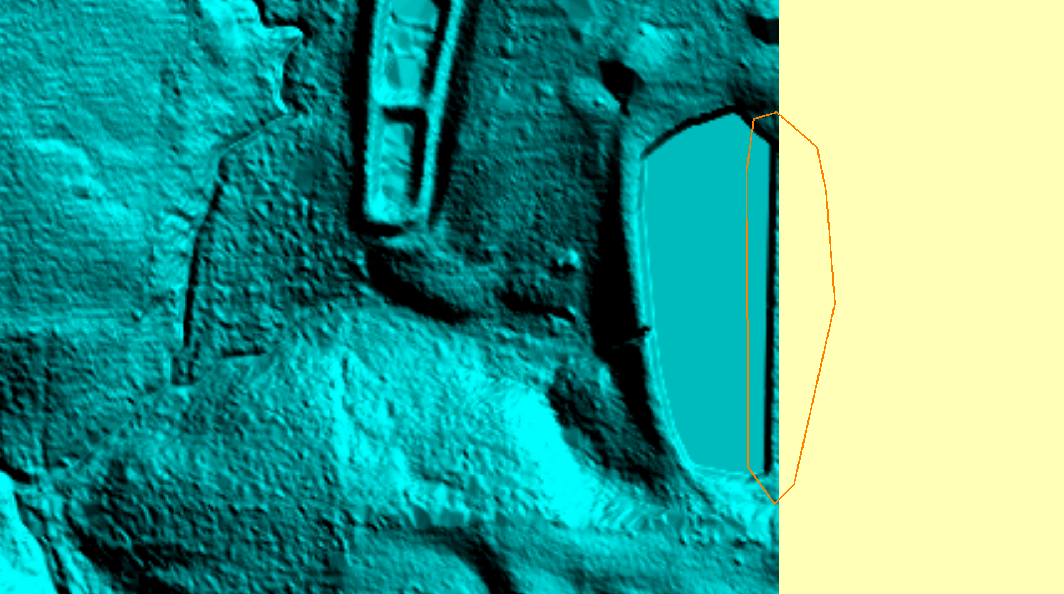
Hole in road bank @ 38° 53' 54.8568" N, 92° 16' 44.9389" W
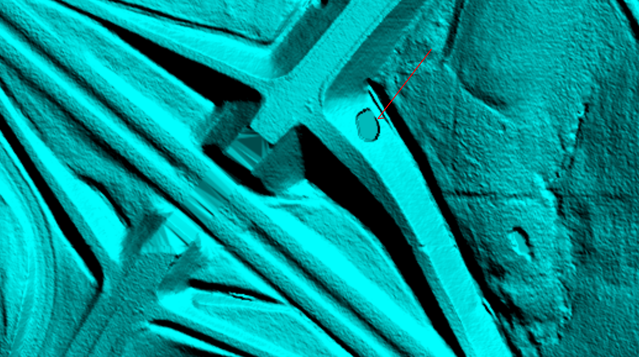

Pond with deep shoreline @ 39° 11' 54.8156" N, 92° 14' 16.7647" W
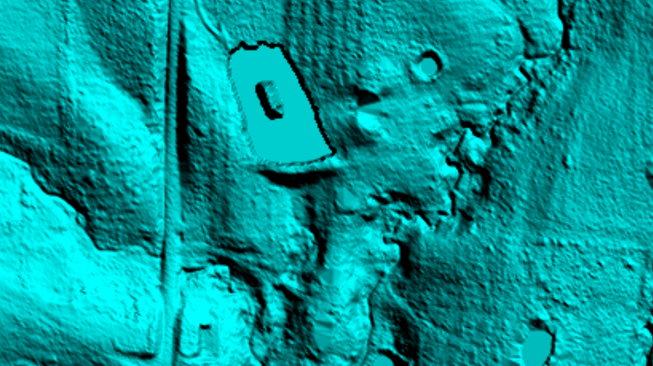
Deep shoreline 3 – D
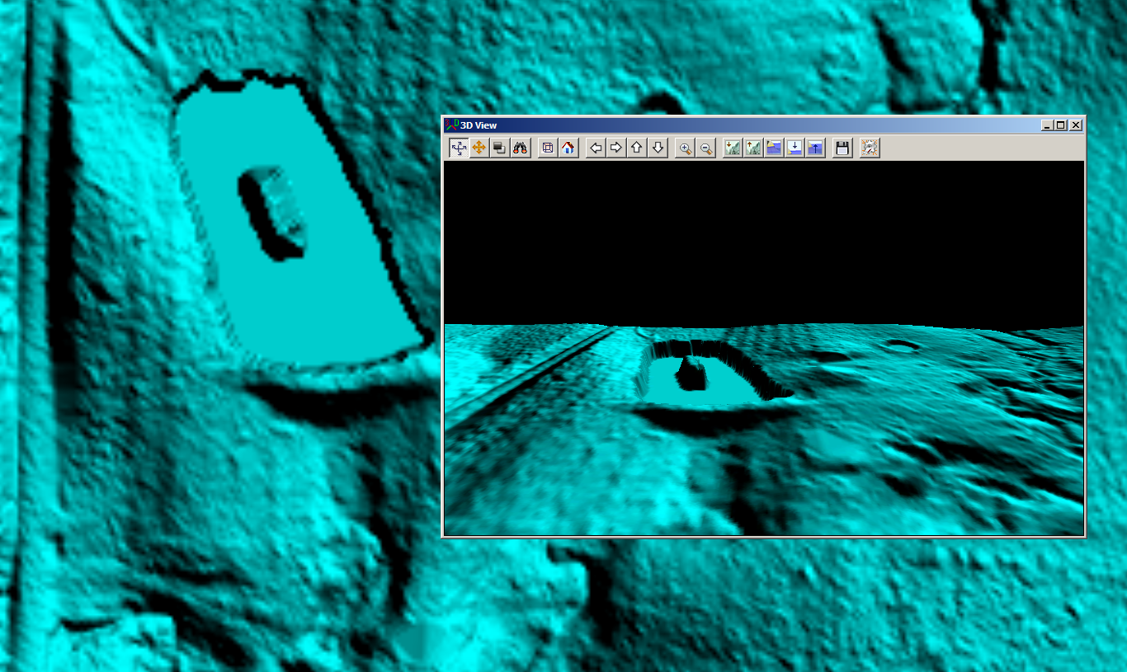

Water elevation in stream higher than ground @ 38° 40' 5.8744" N, 92° 28' 10.9432" W
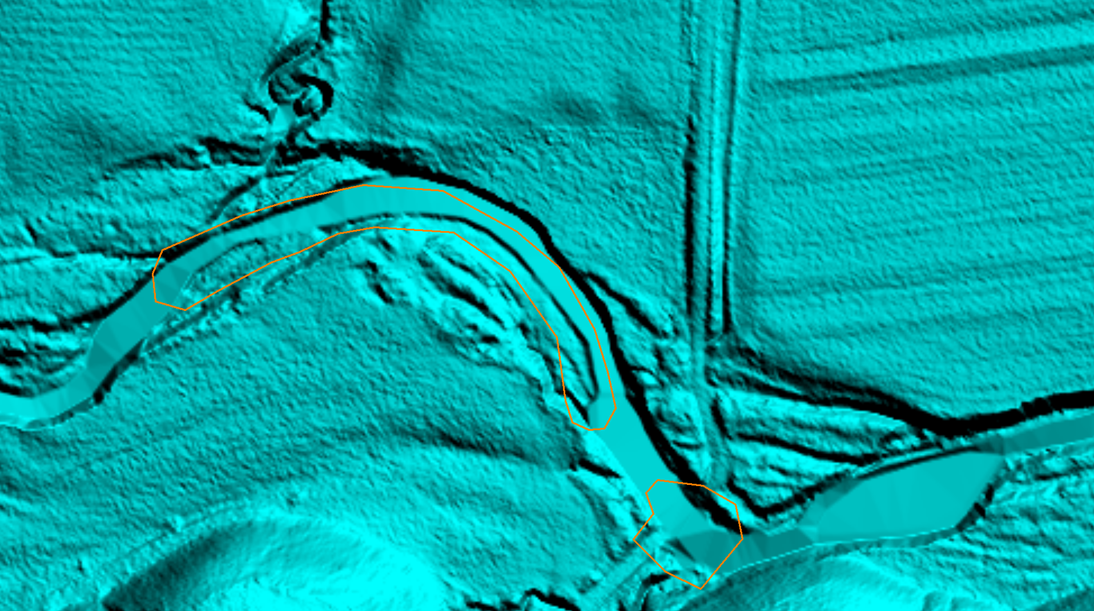
Water elevation in pond higher than ground @ 38° 52' 17.2494" N, 92° 22' 19.0527" W
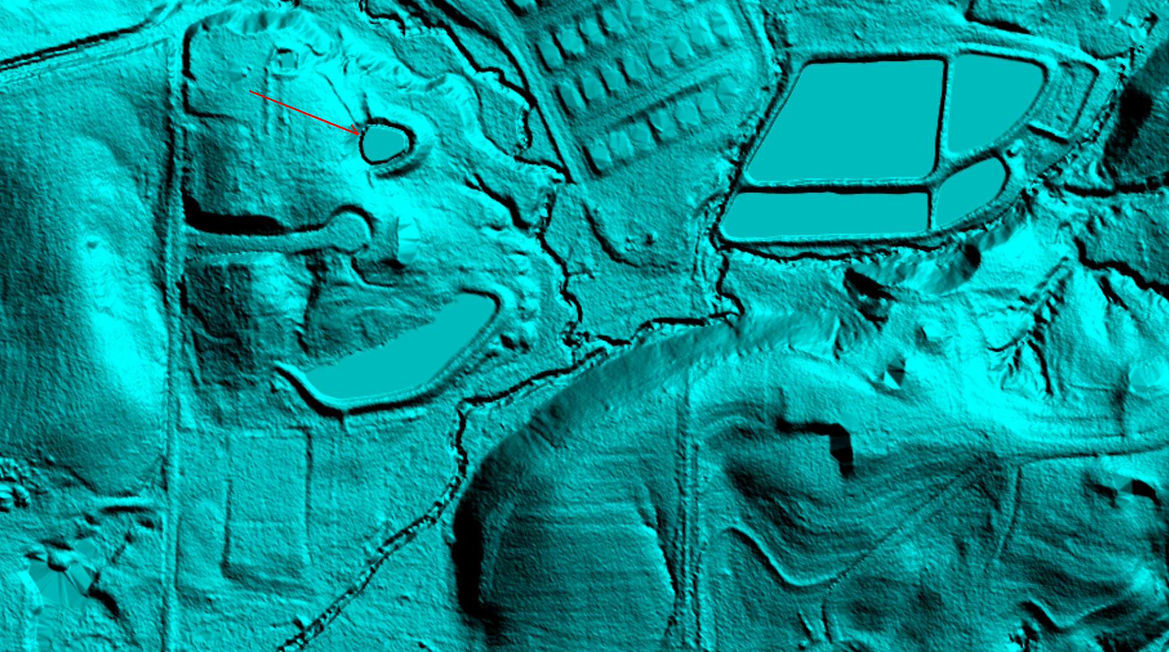Note: This stream and pond example do not meet the size requirements to flatten.

