

Greene County, Missouri
2011 Digital Mapping Project

LiDAR & Survey Report

2011

EXECUTIVE SUMMARY
USACE contracted with Sanborn to provide LiDAR mapping services for Greene Co. Missouri. Utilizing a multi-return LiDAR system, data in the form of 3-dimensional positions of a dense set of mass points was collected for approximately 678 square miles. The system includes geodetic GPS positioning, orientation derived from high-end inertial sensors and high-accuracy lasers. The sensor is attached to the aircraft’s underside and emits rapid pulses of light that are used to determine distances between the plane and near-ground surface features.
For Green Co., the Leica ALS-60 LiDAR system was used to collect data for the survey. The LiDAR system is calibrated by conducting flight passes over a known ground surface before and after each LiDAR mission. During final data processing, the calibration parameters are inserted into post-processing software.
A GPS control network survey was designed to provide ground control for high-accuracy LiDAR data collection of Greene Co MO project. AGPS stations were strategically situated to ensure LiDAR collection occurred within 40km of any base station. Multiple receivers were used to achieve this requirement. The GPS control network consisted of four (4) control stations. The network included NGS monuments: AC7221, AI4215, AC7184 and HD1507. Springfield Regional Airport (SGF) was used as base for all LiDAR operations.
The checkpoint survey was designed to provide quality control points throughout project area. Seventeen (17) evenly distributed checkpoints were collected throughout project area. Checkpoints were chosen in bare earth class areas.
The acquired LiDAR data was processed to obtain first and last return point data. The last return data was further filtered to yield a LiDAR surface representing the bare earth.
The contents of this report summarize the methods used to establish the base station coordinate check, perform the LiDAR data collection and post-processing as well as the results of these methods.

Contents

EXECUTIVE SUMMARY 2
1.0 INTRODUCTION 4
1.1 Contact Information 4
1.2 Purpose of the LiDAR Acquisition 4
1.3 Project Location 4
1.4 Standard Specifications for LiDAR 5
2.0 Final LiDAR Processing 6
3.0 GEODETIC BASE NETWORK 8
3.1 Network Scope 8
3.2 Data Processing and Network Adjustment 8
3.3 Final LiDAR Verification 9
4.0 Coordinates and Datum 12
4.1 Introduction 12
4.2 Horizontal Datum 12
4.3 Vertical Datum 12

List of Tables & Figures
Figure 1: Area of Collection ………………….………………………………………………………………………………………………….. 4
Table 2: Project Specifications...........................…………………………………………………………………………………………. 5
Table 3: Processing Accuracies and Requirements………………………………………………………………………………………… 7
Figure 4: Survey Network Diagram…………………………………………………………………………………………………………….. 8
Table 5: NGS Control Constraints…………………………………………………………………………………………………………….. 9
Table 6: Survey Loop Closure Summary………………………………………………………………………………………………………. 9
Figure 7: Greene CO. Survey Checkpoint Diagram ...……………………………………………........................................ 10
Table 8: LiDAR Accuracy Assessment based on the Checkpoint Survey (US feet) ....……….……………………………….. 11

1.0 INTRODUCTION

This document contains the technical write-up of the LiDAR campaign, including grounds control and checkpoint surveys, the collection and post-processing of the LiDAR data.

1.1 Contact Information
Questions regarding the technical aspects of this report should be addressed to:

Alistair Strachan
Project Manager
Sanborn Map Co., Inc.
1935 Jamboree Dr. Suite 100
Colorado Springs, CO 80920
719-502-1296 (Desk) 719-264-5584 (Fax)
AStrachan@sanborn.com

1.2 Purpose of the LiDAR Acquisition
As stated in the statement of work for acquisition and production of the standard FEMA data for Greene Co. This LiDAR operation was designed to create data sets that will establish an authoritative source for elevation information for Greene Co.

1.3 Project Location
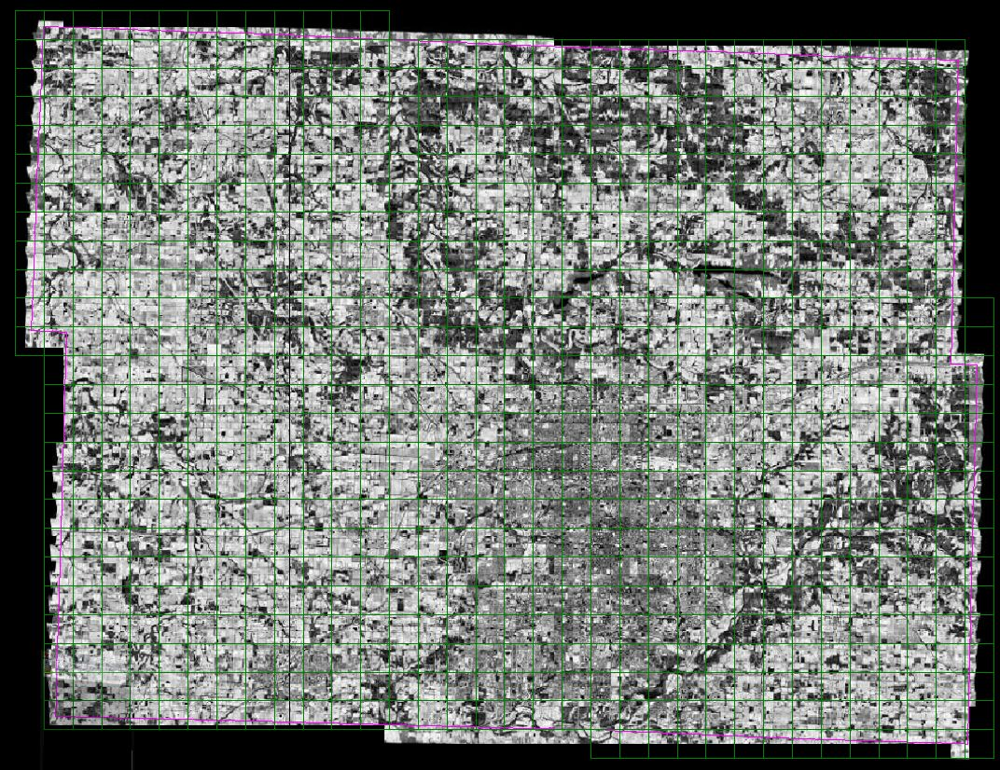

Figure 1: Area of Collection

Standard Specifications for LiDAR

Table 2: Project Specifications
Area  (sq. mi) | 678 | Product  type | FEMA | Projection | Missouri State Central Zone  State Plane  Survey Feet
Vertical  Accuracy (CM) | Bare Earth  15 cm | Check  Points  required | Yes | Horizontal Datum /  Vertical Datum | NAD 83/NAVD 88
Horizontal  accuracy (M) | 0.5 meter | Number  Collected | 17 | Units | US Survey Feet

Final Product DELIVERIES in both:
- UTM Zone 15 (meters) &
- MO SPCS Central Zone (US Svy Feet)

2.0 Final LiDAR Processing
The post-processing of LiDAR data involves several steps. The airborne GPS data was post-processed using Waypoint’s GravNAVTM software (version 7.5). A fixed-bias carrier phase solution was computed in both the forward and reverse chronological directions. The data was processed for both base stations and combined. In the event that the solution degraded as a result of the combination of both solutions, the best of either solution was used to yield more accurate data. LiDAR acquisition was limited to periods when the PDOP was less than 3.2.

The GPS trajectory was combined with the raw IMU data and post-processed using Applanix Inc.’s POSPROC (version 4.3) Kalman Filtering software. This results in a two-fold improvement in the attitude accuracies over the real-time INS data. The best-estimated trajectory (BET) and refined attitude data are then re-introduced into the LEICA ALS post processor for the Leica system to compute the laser point-positions. The trajectory is then combined with the attitude data and laser range measurements to produce the 3-dimensional coordinates of the mass points.

All return values are produced within ALS Post processing software for the Leica system. The multi-return information is processed to obtain the “Bare Earth Dataset” as a deliverable. All LiDAR data is processed using the binary LAS format 1.2 file format.

LiDAR filtering was accomplished using TerraSolid, TerraScan LiDAR processing and modeling software. The filtering process reclassifies all the data into classes with in the LAS formatted file based scheme set using the LAS format 1.2 specifications or by the client. Once the data is classified, the entire data set is reviewed and manually edited for anomalies that are outside the required guidelines of the product specification or contract guidelines, whichever apply. Table 3 indicates the required product specifications.

The coordinate and datum transformations are then applied to the data set to reflect the required deliverable projection, coordinate and datum systems as provided in the contract.

The Greene Co. deliverables are then generated. At this time, a final QC process is undertaken to validate all deliverables for the project. Prior to release of data for delivery, Sanborn’s quality control/quality assurance department reviews the data and then releases it for delivery.

Table 3: Processing Accuracies and Requirements

Accuracy of LiDAR Data (H) | 0.5 m RMSE
Accuracy of LiDAR data in bare areas | 15 cm RMSE
Accuracy of LiDAR data in vegetated areas | 27 cm RMSE
Percent of artifacts removed (terrain and vegetation dependent) | 95%
Percent of all outliers removed | 98%
Percent of all vegetation removed | 97%
Percent of all buildings removed | 99%

3.0 GEODETIC BASE NETWORK

3.1 Network Scope
During the LiDAR campaign, the Sanborn field crew conducted a GPS field survey to establish final coordinates of the ground base stations for final processing of the base-remote GPS solutions. NGS points AI4215, AC7184, AC7221 and HD1507 were used for the LiDAR missions. See table 5 for station names, orders and constraints.

3.2 Data Processing and Network Adjustment
The static baselines created between points AI4215, AC7184, AC7221 and HD1507 were processed using Trimble Geomatics Office ™ (Ver. 1.62) software. Fixed bias solution was obtained for the baselines. The broadcast ephemeris was used, since the accuracy and extent of the network does not warrant the use of the precise ephemeris. The results were satisfactory; therefore, fulfilling project specifications for first order control network. See Table 6 for loop closure summary.
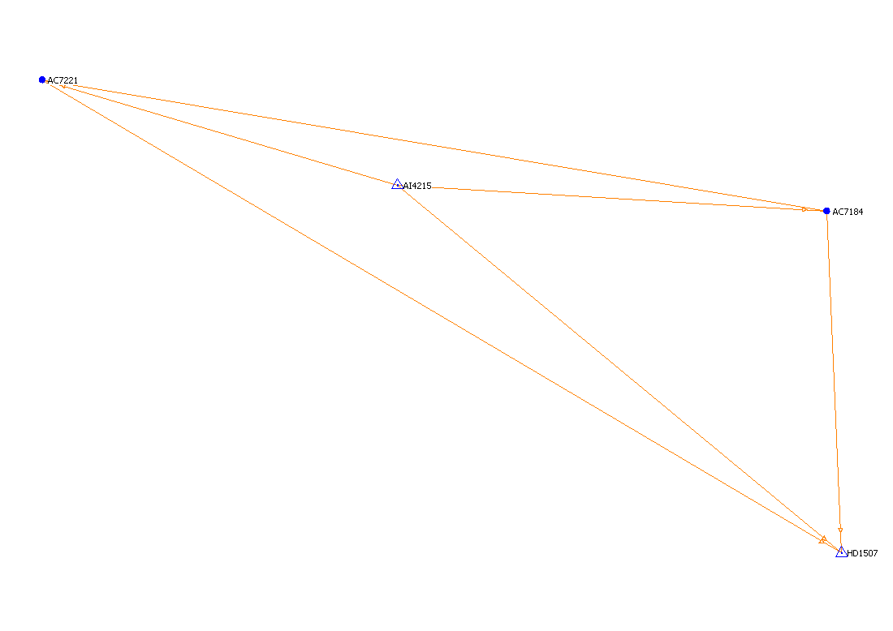
Figure 4: Survey Network Diagram
Table 5: NGS Control Constraints

Horizontal

Code | NGS Station Name | PID | Constrain
AI4215 | SGF D | AI4215 | Constrained
AC7184 | GR 38 | AC7184 | Checkpoint
AC7221 | GR 82 | AC7221 | Checkpoint
HD1507 | WILLIS RESET | HD1507 | Constrained
Vertical
Code | NGS Station Name | PID | Constrain
AI4215 | SGF D | AI4215 | Checkpoint
AC7184 | GR 38 | AC7184 | Checkpoint
AC7221 | GR 82 | AC7221 | Checkpoint
HD1507 | WILLIS RESET | HD1507 | Constrained

Table 6: Survey Loop Closure Summary

Loop | Δ Horiz (ft.) | Δ Vert (ft.) | Dist. (ft.) | ppm
AI4215: AC7184: AC7221: AI4215  AI4215: AC7184: HD1507: AI4215  AI4215: AC7221: HD1507: AI4215  AC7184: AC7221: HD1507: AC7184 | 0.001  0.005  0.002  0.002 | 0.019  -0.016  -0.013  0.022 | 195197.382  165031.907  229551.255  252840.830 | 0.099  0.101  0.058  0.088

3.3 Final LiDAR Verification
The LiDAR data was evaluated using a collection of 17 GPS surveyed checkpoints. See Figure 7 for diagram. For Greene Co., Missouri the standard deviation is 0.110 feet and the root mean squared is 0.106 feet. The LiDAR data was compared to each of these classes yielding a much better result than was required for the project. Table 8 indicates the results for Greene Co., Missouri and each point including the overall results as it compares to the LiDAR data set.
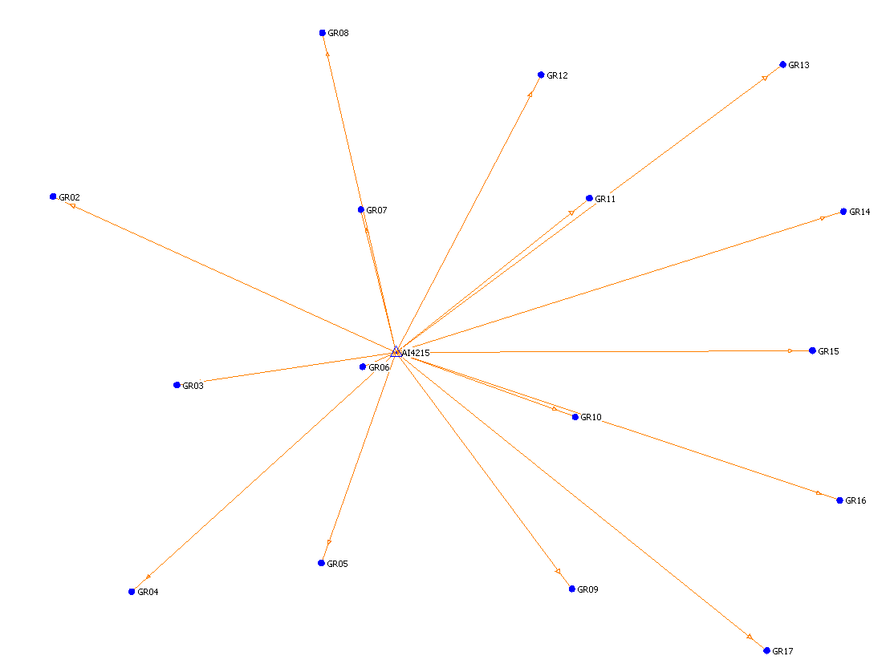
Figure 7: Greene Co. Survey Checkpoint Diagram
Table 8: LiDAR Accuracy Assessment based on the Checkpoint Survey (US feet)
Number | Easting | Northing | Known Z | Laser Z | Dz
1 | 1460872.233 | 539788.261 | 1454.403 | 1454.430 | +0.027
2 | 1455501.597 | 515665.163 | 1412.092 | 1412.050 | -0.042
3 | 1460264.395 | 489726.930 | 1393.725 | 1393.520 | -0.205
4 | 1447627.812 | 463680.892 | 1386.539 | 1386.590 | +0.051
5 | 1413877.341 | 474364.311 | 1295.880 | 1295.890 | +0.010
6 | 1414434.588 | 504172.881 | 1292.456 | 1292.580 | +0.124
7 | 1416861.384 | 542094.196 | 1197.894 | 1197.790 | -0.104
8 | 1408511.025 | 563469.358 | 1068.462 | 1068.460 | -0.002
9 | 1450402.299 | 565264.642 | 1207.435 | 1207.180 | -0.255
10 | 1337586.440 | 473889.727 | 1283.194 | 1283.290 | +0.096
11 | 1345419.498 | 509696.884 | 1199.340 | 1199.310 | -0.030
12 | 1323954.336 | 542388.318 | 1019.917 | 1020.020 | +0.103
13 | 1370644.201 | 570779.621 | 1142.120 | 1142.080 | -0.040
14 | 1377297.902 | 540113.799 | 1218.212 | 1218.320 | +0.108
15 | 1377605.842 | 512883.497 | 1274.515 | 1274.640 | +0.125
16 | 1370443.675 | 478863.496 | 1244.958 | 1245.020 | +0.062
17 | 1383426.672 | 515332.163 | 1259.748 | 1259.720 | -0.028

Average dz -0.000
Minimum dz -0.255
Maximum dz +0.125
Average Magnitude 0.083
Root Mean Square 0.106
Standard Deviation 0.110

4.0 Coordinates and Datum

4.1 Introduction
The final adjustment was constrained to the published NAD83 geodetic coordinates (φ, λ) and NAVD88 elevations. The adjustment was cross-referenced to the GEOID03 model to enable the estimation of orthometric heights.

4.2 Horizontal Datum
The final horizontal coordinates are provided in the North American Datum of 1983/1997 (NAD83/97) adjustment as referenced to the Missouri State Plane Coordinates System, Central Zone, in United States Survey Feet.

4.3 Vertical Datum
The final orthometric elevations were determined for all points in the network using GEOID03 model and are provided on the North American Vertical Datum of 1988 (NAVD88) latest adjustment, in United States Survey Feet.

