Elevation QC Report

Project: Contractor:
Data Delivery Date: Date Data Reviewed:

Reviewer: Total Square Miles Reviewed:

Elevation Type: Format: Grid Spacing: Tile size:
Projection: Zone: Datum: Units:

Licensing: Metadata:
Materials Received:

Vertical Accuracy Test Performed: Test Point Source: RMSE:
Vertical Accuracy Test Notes:

QC Review Summary:

LiDAR Quality Control (QC) Review Process

Preparation:
-Metadata reviewed to determine data projection, datum, format, etc.
-If ARRA contract, check for raw .LAS files, classified .LAS files, breaklines, blind control points,
and DEM in Image or Grid format
-Open data in Global Mapper

Vertical accuracy testing:
-If ARRA contract, use Vertical Accuracy Test Worksheet to perform RMSE on 20 blind point
positions provided by contractor

Inspection and Correction of data:
-Minimum and maximum elevations in dataset; correct if in error
-Appropriate hydro flattening as specified in V12 Lidar Specification (For ARRA/GPSC Data)
-Data void areas
-Data spikes
-Tile edge seam lines
-Non-bare earth surface artifacts (structures, bridges, vegetation, etc.)
-Elevation errors - raised/lowered areas/tiles
-Other surface treatment anomalies
-Check DRGs for correct elevations and horizontal positioning (if test points not available)
-Create footprint (project boundary) shape file and establish square miles
During Inspection, identify data errors and create “error” file folder:
-Capture geo-referenced JPG or TIFF image(s) of identified errors
-Copy to Error file
During Inspection, level elevations and remove artifacts (these two steps not done for ARRA data):
-Level smoothing to remove non-bare earth surface artifacts (structures, bridges, vegetation, etc.)
-Level data spikes where possible

Export image files and create project Elevation QC Review Report:
-Export ERDAS Imagine image files in native projection and resolution
-If ARRA, Copy Vertical Accuracy Test Worksheet into QC Report
-Place QC Review Process and Project Area Extent into QC Report
-If rejected, attach sample geo-referenced JPG or TIFF error images with an explanation of reason
-If rejected, restart QC process when replacement data is received
-Provide completed Elevation QC Review Report to Elevation Supervisor for final viewing
-Add QC Report, footprint, Imagine image(s), and Error file to original data file for final shipment to EROS
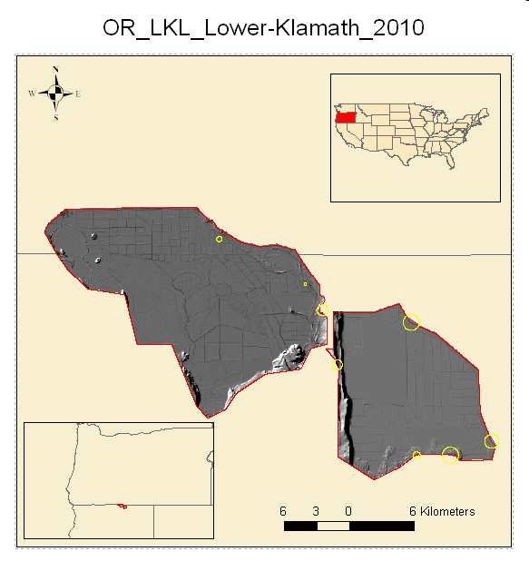
Figure 1: Project Location with Bounding Box
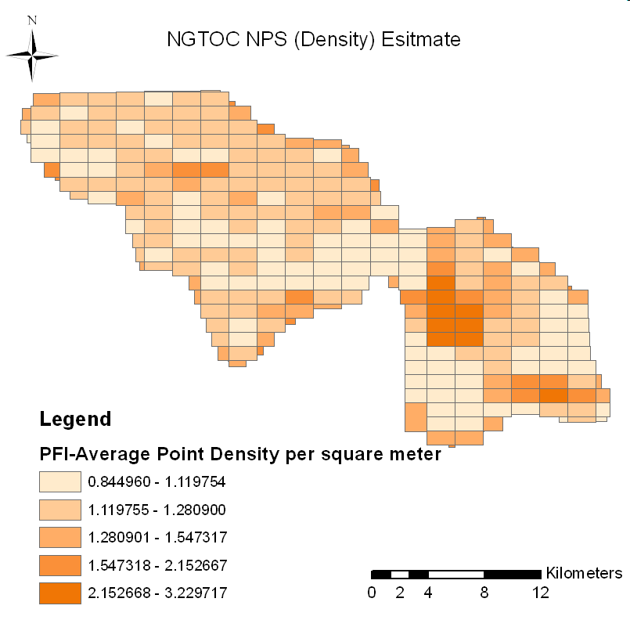
Figure 2: Density Test Graphic
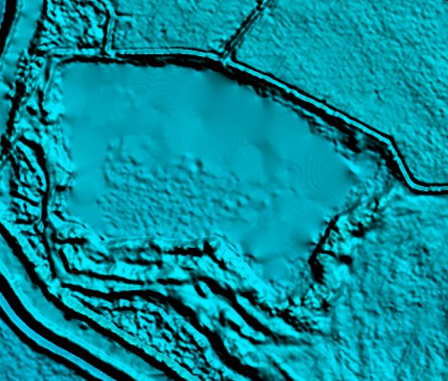
Figure 3: Water-body Pre-flattening

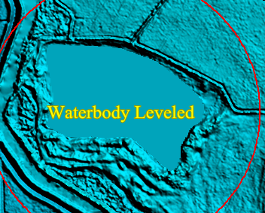
Figure 4: Flattened Water-Body
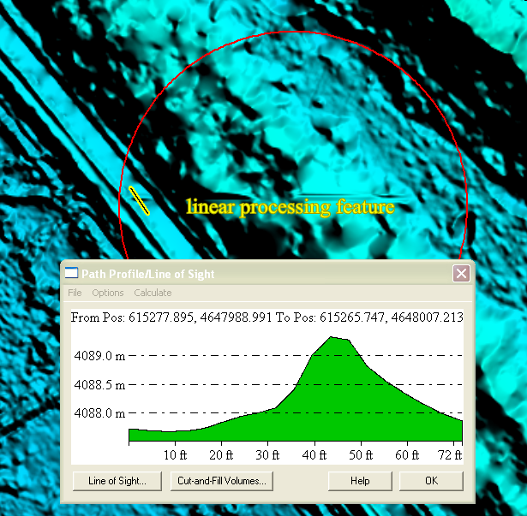
Figure 5: Apparent Systematic Error

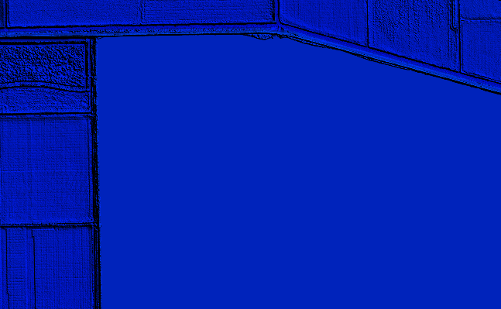
Figure 6: Major Water-Bodies already Flattened
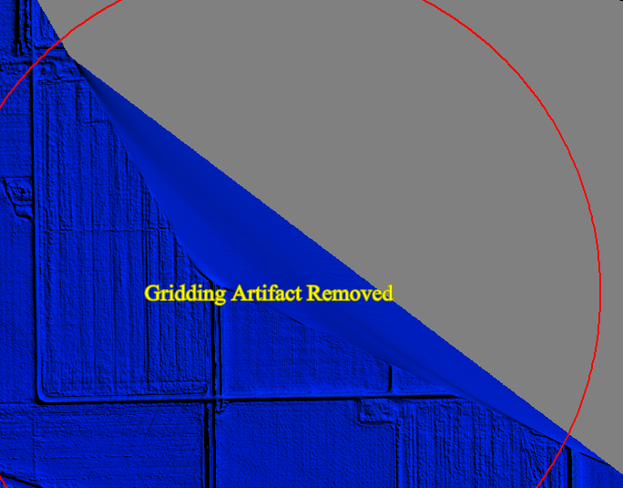
Figure 7: Gridding artifact that was removed
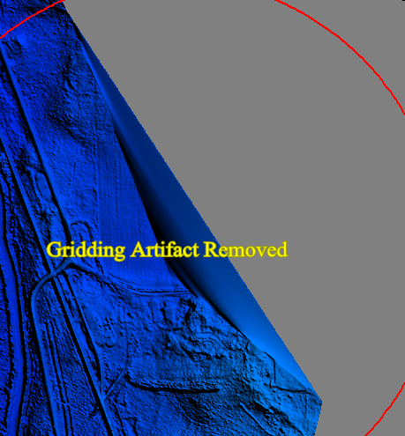
Figure 8: Another example of a Gridding Artifact that was removed

