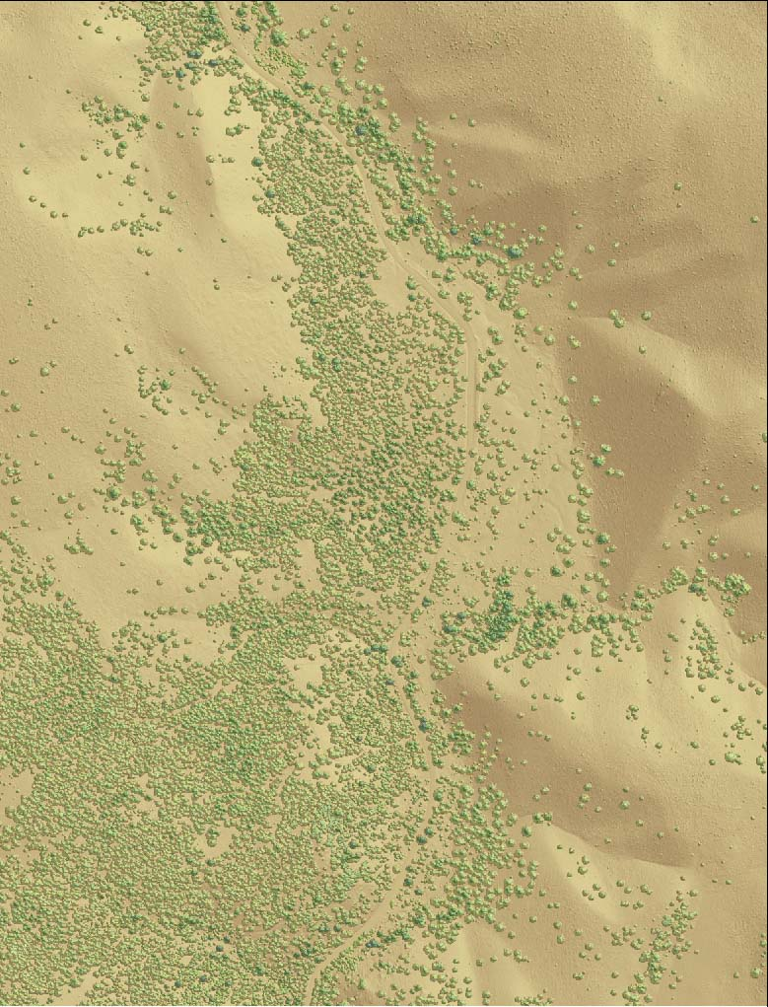

LiDAR Remote Sensing Data Collection
DEPARTMENT OF GEOLOGY AND MINERAL INDUSTRIES
Malheur, oregon

nOVEMBER 13, 2009

Submitted to:

Department of Geology and Mineral Industries
800 NE Oregon Street, Suite 965
Portland, OR 97232


Submitted by:
Watershed Sciences
529 SW 3rd Avenue, Suite 300
Portland, OR 97204


LiDAR Remote Sensing Data Collection:
DOGAMI, Malheur study area

TABLE OF CONTENTS

1. Overview 1
1.1 Study Area (Malheur) 1
2. Accuracy 6
2.1 Relative Accuracy Calibration Results 6
2.2 Absolute Accuracy 8
3. Data Density/Resolution 10
4. Selected Imagery 14

1. Overview

1.1 Study Area (Malheur)
Watershed Sciences, Inc. is currently collecting Light Detection and Ranging (LiDAR) data of the Malheur study area for the Oregon Department of Geology and Mineral Industries (DOGAMI). The area of interest (AOI) totals 399 square miles (255,271 acres) and the total area to fly (TAF) covers 409 square miles (261,732 acres). The TAF acreage is greater than the original AOI acreage due to buffering and flight planning optimization (Figure 1.1 below). This report has been amended to reflect new data and cumulative statistics for the overall LiDAR survey. DOGAMI data are delivered in OGIC(HARN): Projection: Oregon Statewide Lambert Conformal Conic; horizontal and vertical datums: NAD83 (HARN)/NAVD88(Geoid03); Units: International Feet.

Figure 1.1. DOGAMI Malheur study area.
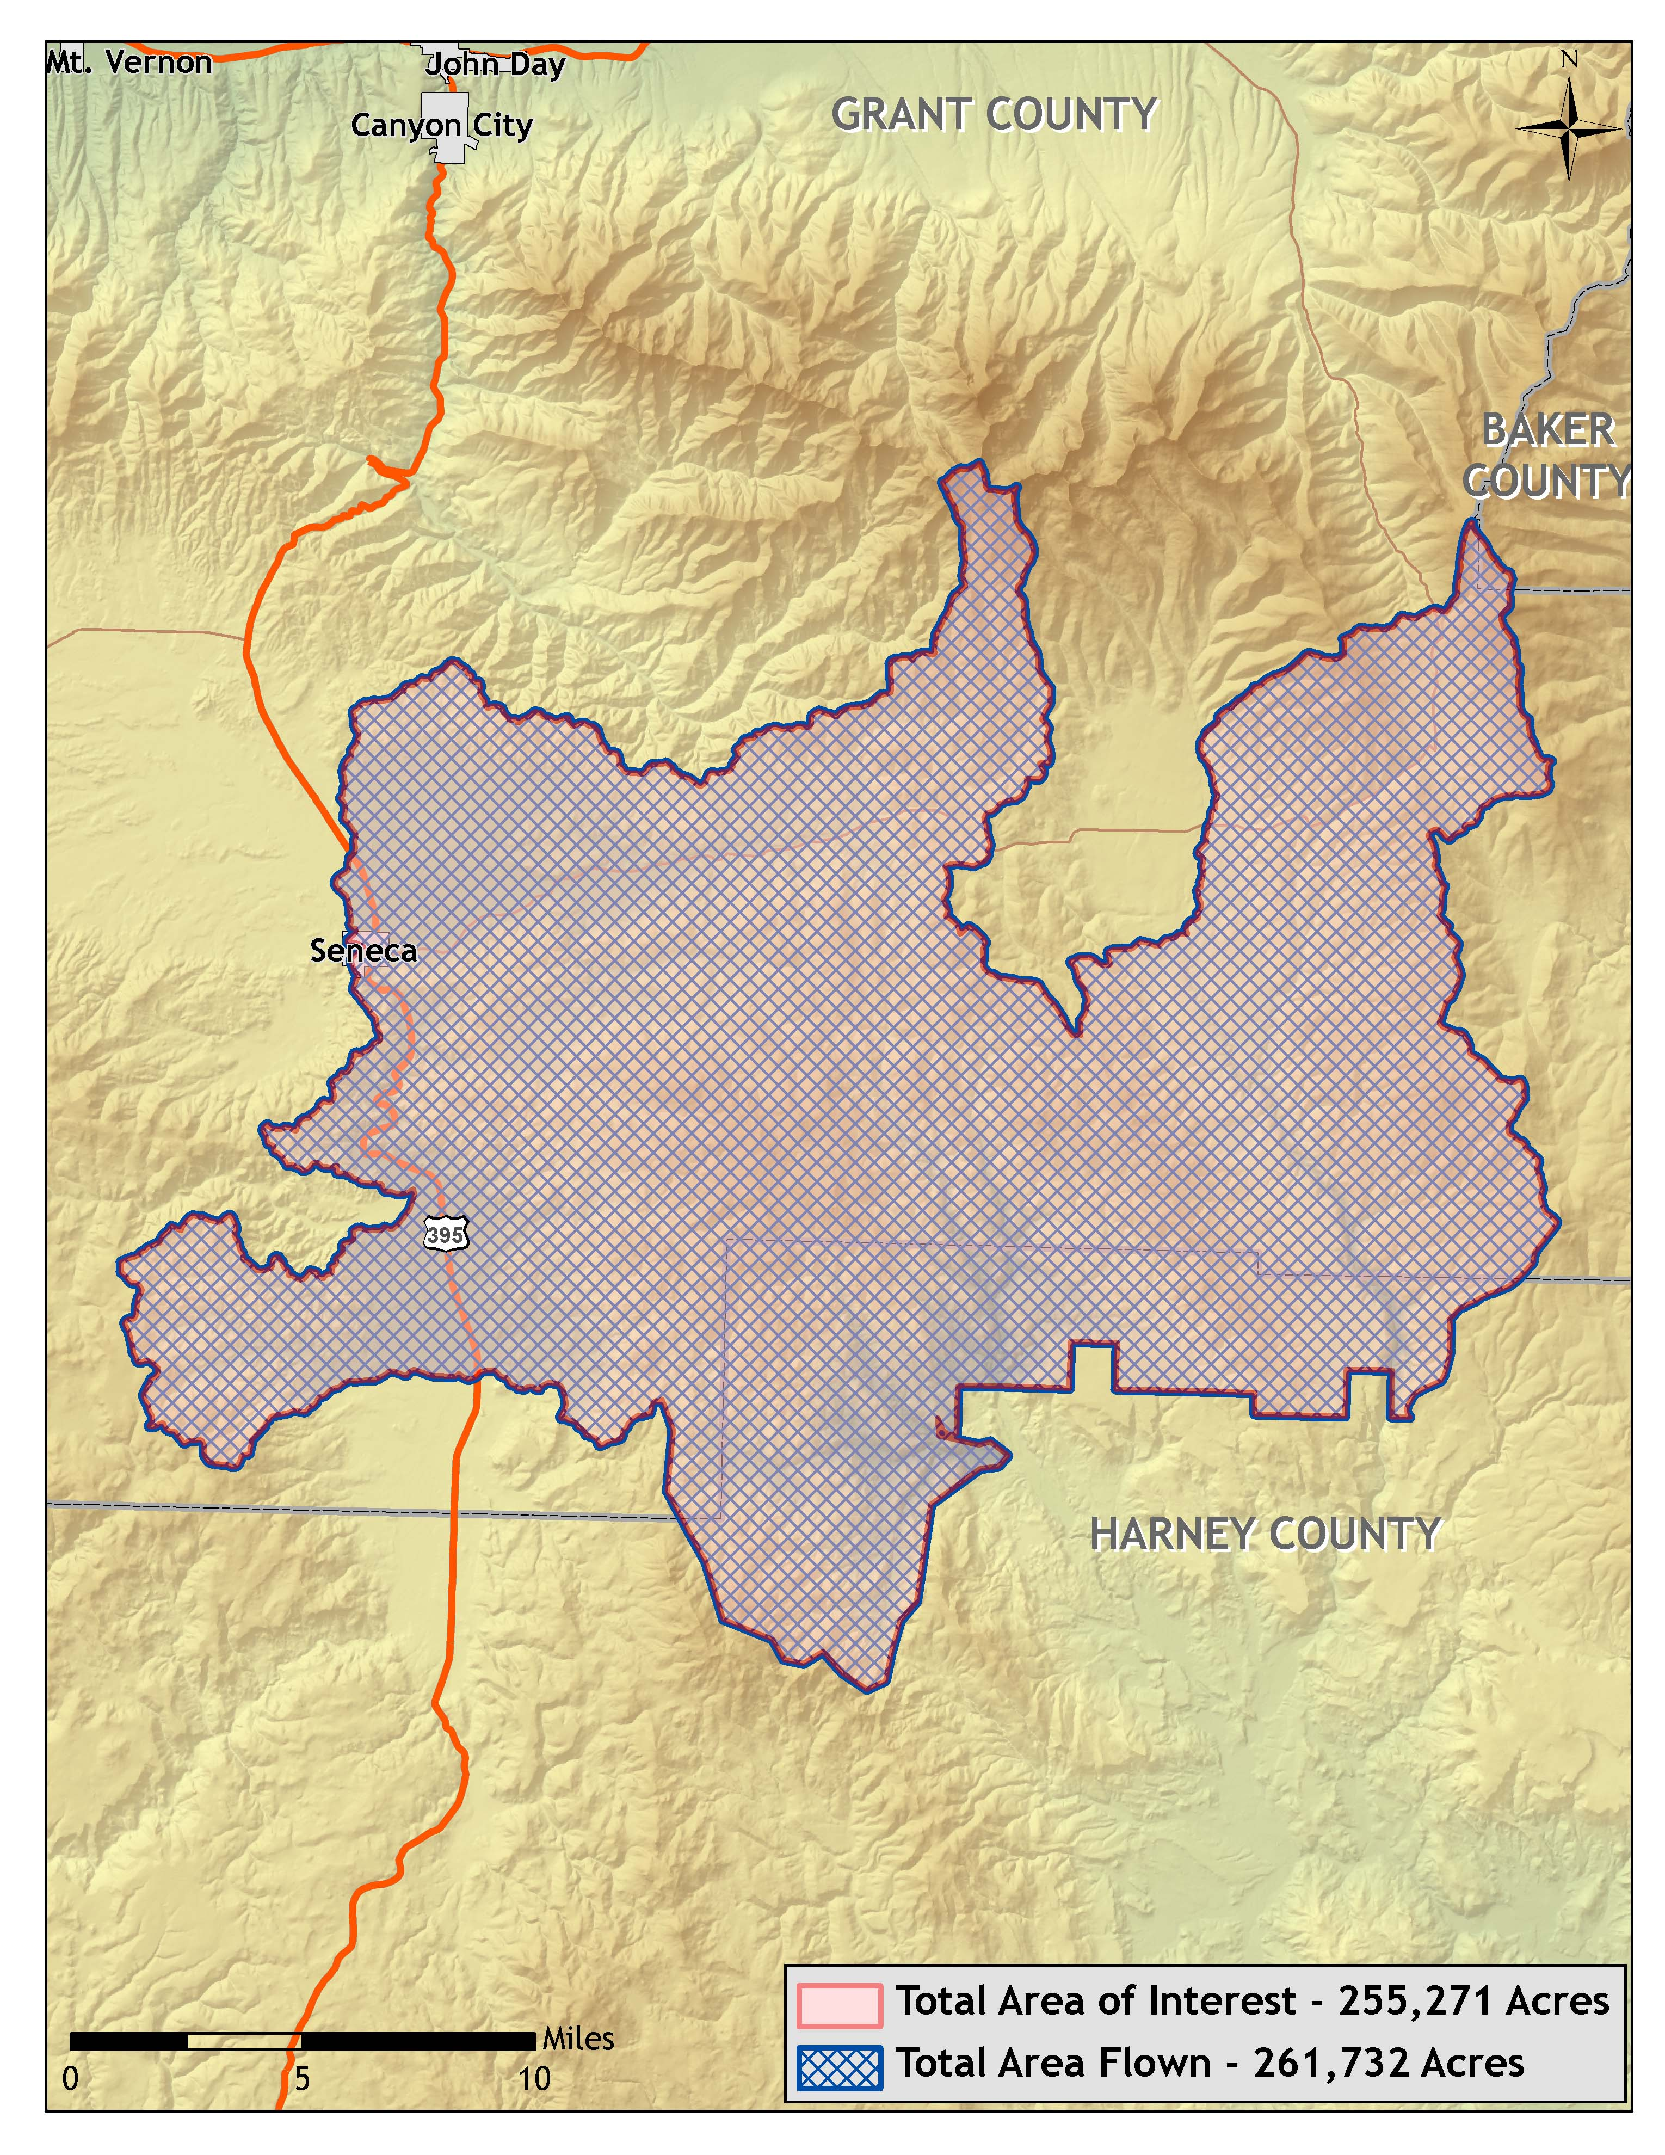
For Delivery 1 of the Malheur study area, the AOI totals 132,104 acres (206 square miles) and the TAF totals 134,922 acres (211 square miles). The AOI for delivery 2 is 123,167 acres (192 square miles) and the TAF totals 126,810 acres (198 square miles). Figure 1.2 below displays the TAF and AOI for the complete Malheur study area.

Figure 1.2. Malheur study area, illustrating the portion delivered to date.
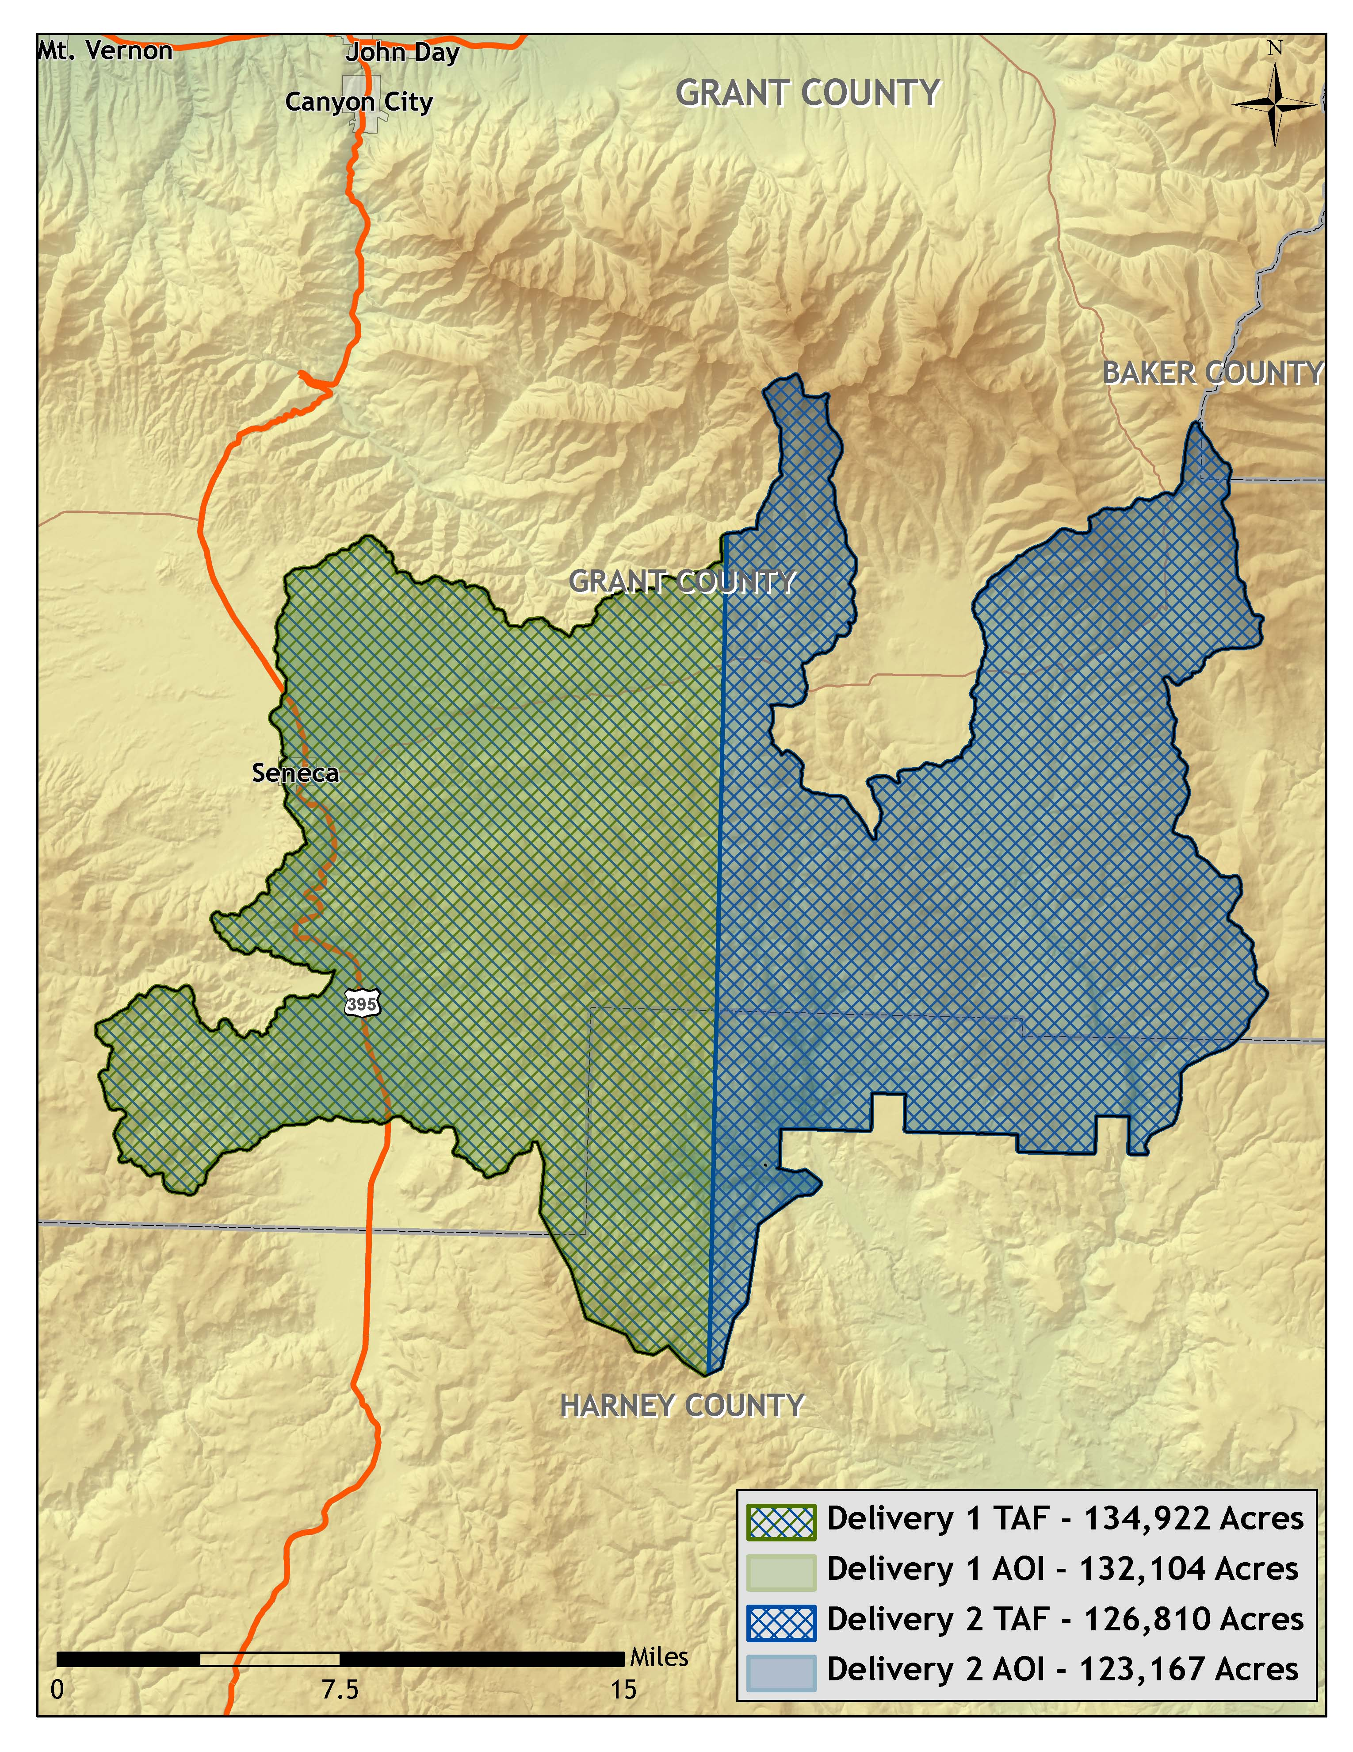

Figure 1.3. Malheur study area, illustrating the TAF in USGS Quad delineation.
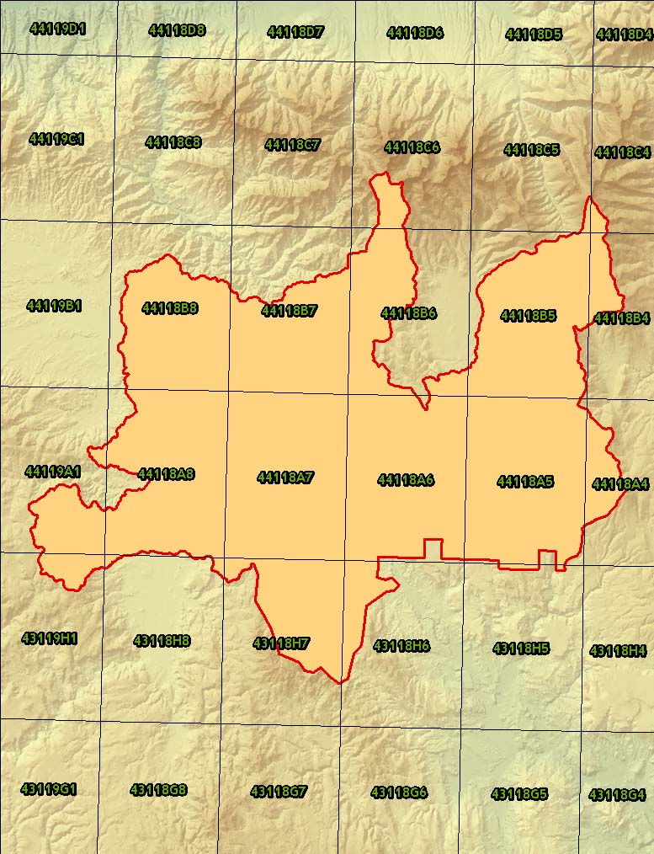

Figure 1.4. Flightlines flown for the Malheur study area (n = 456). 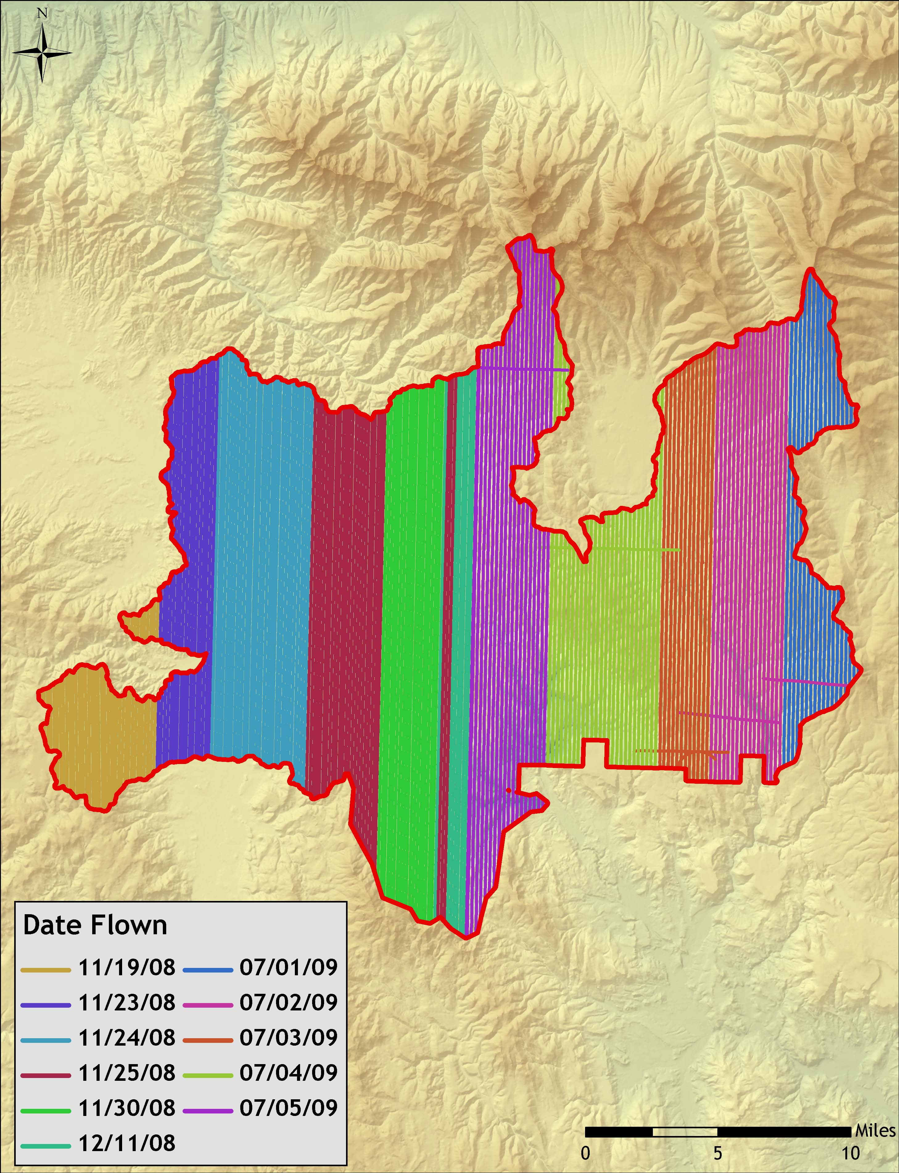
Figure 1.5. Base station and real time kinematic locations for the Malheur study area.
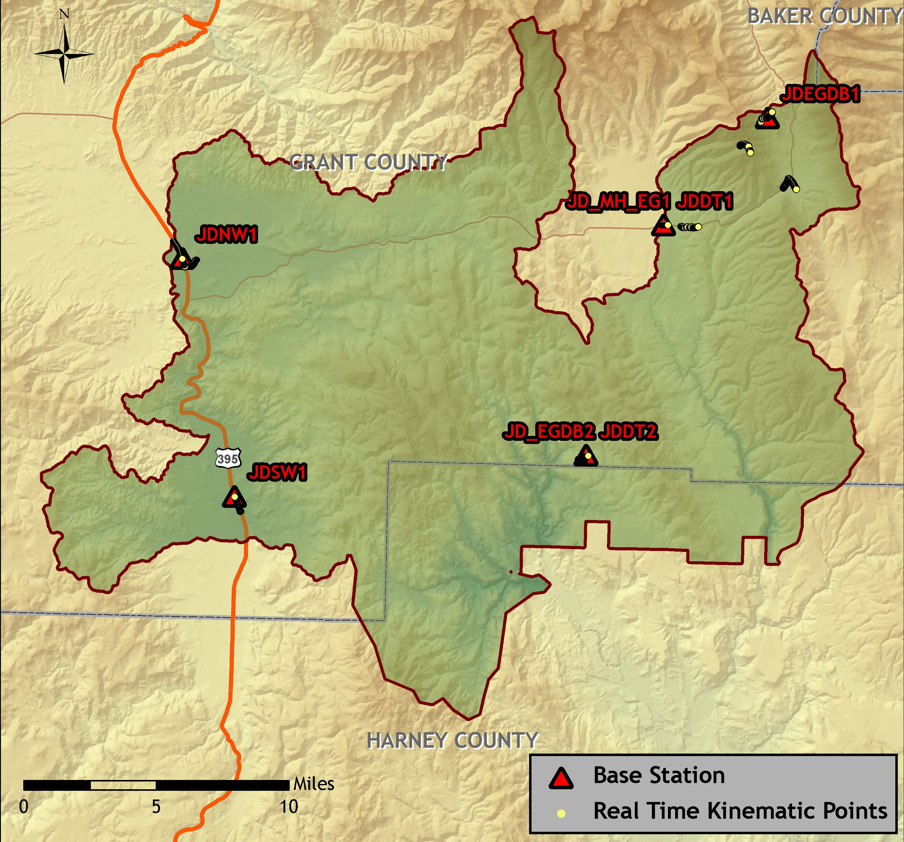

Table 1.1. Base Station Surveyed Coordinates, (NAD83/NAVD88, OPUS corrected) used for kinematic post-processing of the aircraft GPS data for the Malheur study area.

 | Datum NAD83(HARN) |  | GRS80
Base  Station ID | Latitude  (North) | Longitude  (West) | Ellipsoid  Height (m)
JDSW1 | 44 01 35.70835 | 118 55 58.47038 | 1379.296
JDNW1 | 44 09 21.26537 | 118 58 36.18625 | 1407.882
JDDT1 | 44 10 47.76576 | 118 36 42.60703 | 1534.795
JDDT2 | 44 03 11.70242 | 118 40 01.41587 | 1544.344
JD_MH_EG1 | 44 10 47.75578 | 118 36 42.34455 | 1534.697
JDEGDB1 | 44 14 22.57915 | 118 32 3.45395 | 1820.398
JD_EGDB2 | 44 3 11.70203 | 118 40 1.26426 | 1544.306

2. Accuracy

2.1 Relative Accuracy Calibration Results

Relative accuracy statistics are based on the comparison of 456 flightlines and over 11 billion points for data acquired to date.

- Project Average = 0.14ft (0.04m)
- Median Relative Accuracy = 0.14ft (0.04m)
- 1σ Relative Accuracy = 0.15ft (0.05m)
- 2σ Relative Accuracy = 0.20ft (0.06m)

Figure 2.1. Statistical relative accuracies, non slope-adjusted.
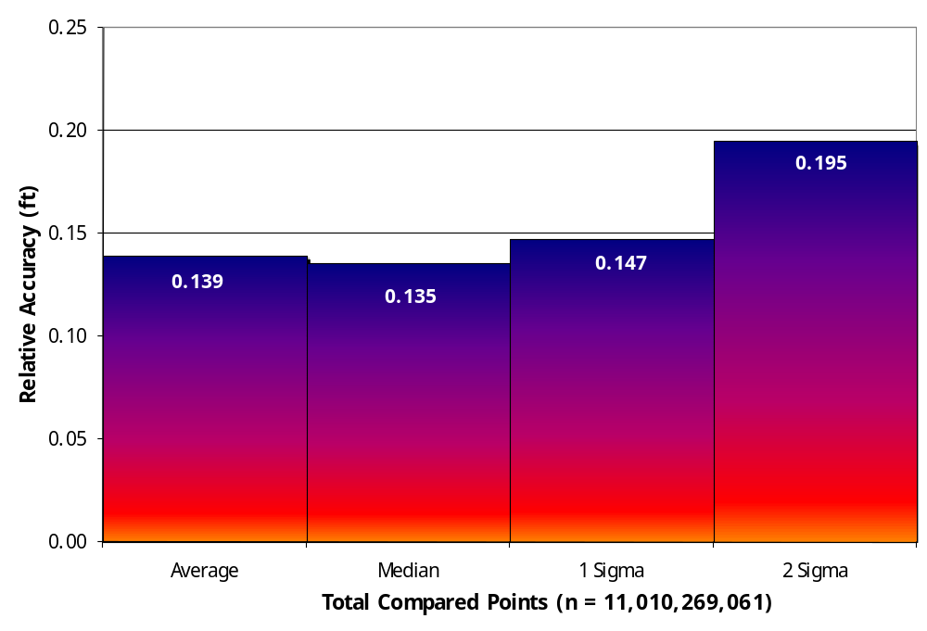

Figure 2.2. Percentage distribution of relative accuracies, non slope-adjusted.
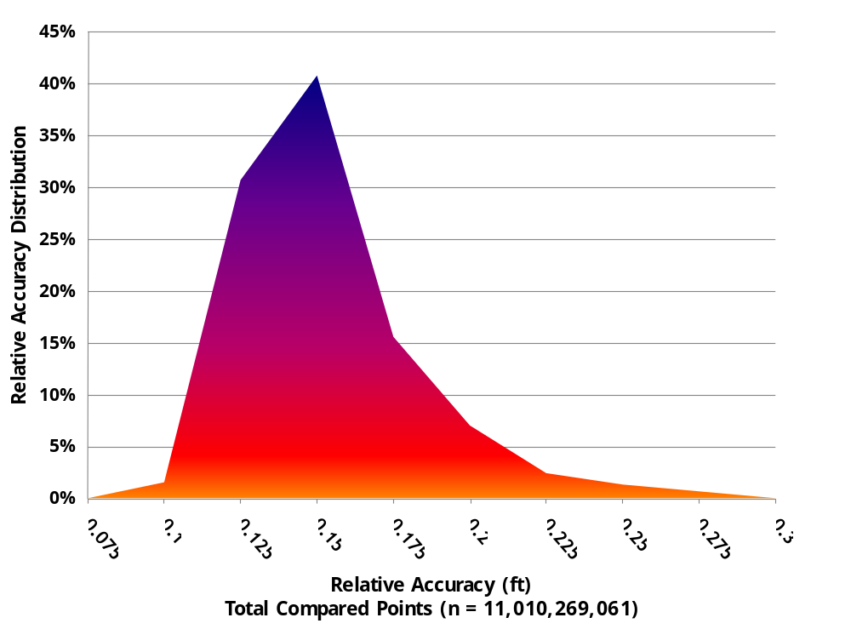

2.2 Absolute Accuracy

Absolute accuracy compares known Real Time Kinematic (RTK) ground survey points to the closest laser point. For the Malheur study area, 3,126 RTK points were collected. Accuracy statistics are reported in Table 2.1 and shown in Figures 2.3-2.4.

Table 2.1. Absolute Accuracy – Deviation between laser points and RTK survey points.

Sample Size (n): 3,126
Root Mean Square Error (RMSE): 0.11 feet
Standard Deviations | Deviations
1 sigma (σ): 0.10 feet | Minimum ∆z: -0.39 feet
2 sigma (σ): 0.21 feet | Maximum ∆z: 0.39 feet
 | Average ∆z: 0.08 feet

Figure 2.3. Malheur Study area histogram statistics
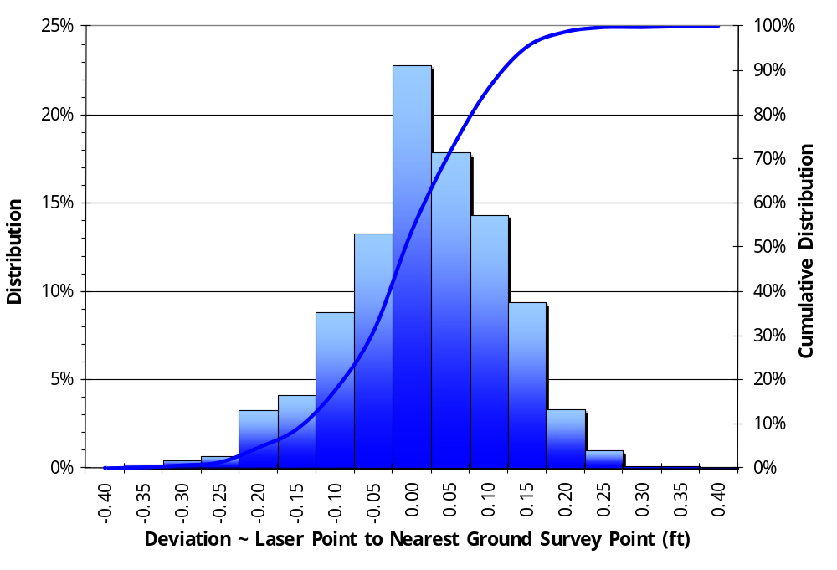

Figure 2.4. Malheur study area point absolute deviation statistics.

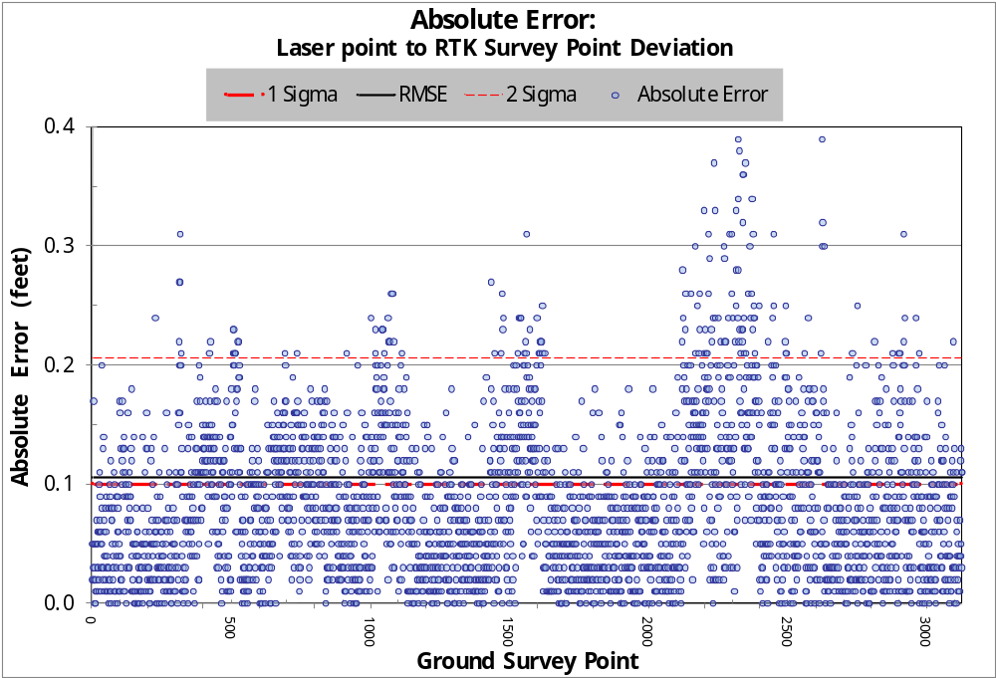

3. Data Density/Resolution

Some types of surfaces (i.e., dense vegetation or water) may return fewer pulses than the laser originally emitted. Therefore, the delivered density can be less than the native density and vary according to distributions of terrain, land cover and water bodies. Increased data density on the eastern portion of the Malheur study site is the result of a dual laser configuration. A single laser configuration was used on the western portion of the study area, or “Delivery 1”. Density histograms and maps (Figures 3.1 – 3.4) have been calculated based on first return laser point density and ground-classified laser point density.

Table 3.1. Average density statistics for Malheur data delivered to date.

Average Pulse Density  (per square ft) | Average Pulse Density  (per square m) | Average Ground Density  (per square ft) | Average Ground Density  (per square m)
0.78 | 8.42 | 0.18 | 1.99

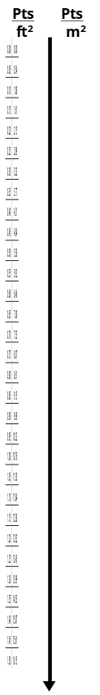
Figure 3.1. Histogram of first return laser point density for data delivered to date.
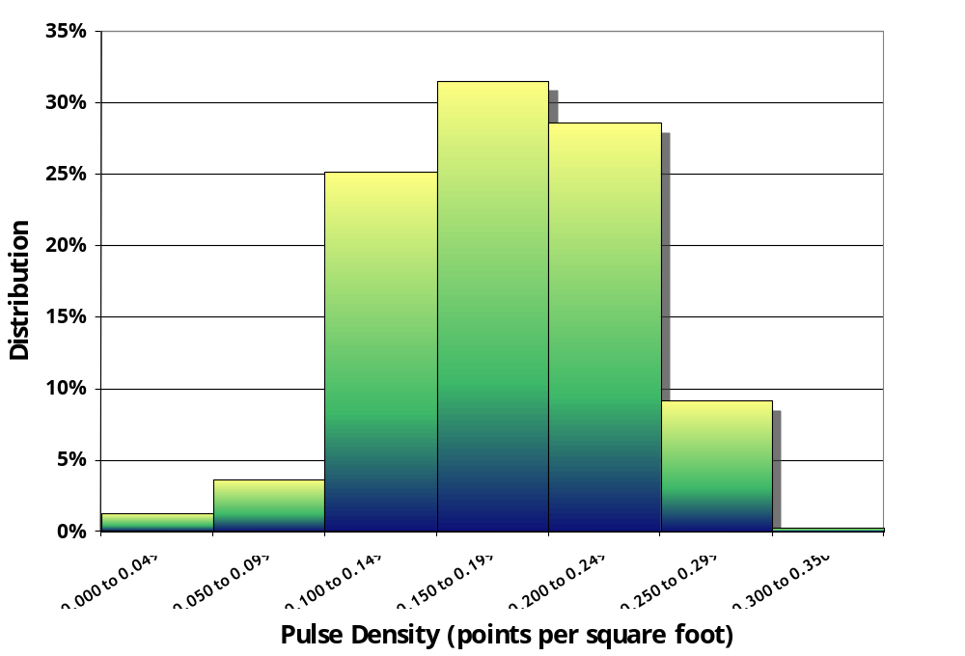
Figure 3.2. Image shows first return laser point per 0.75’ USGS Quad for data delivered to date.

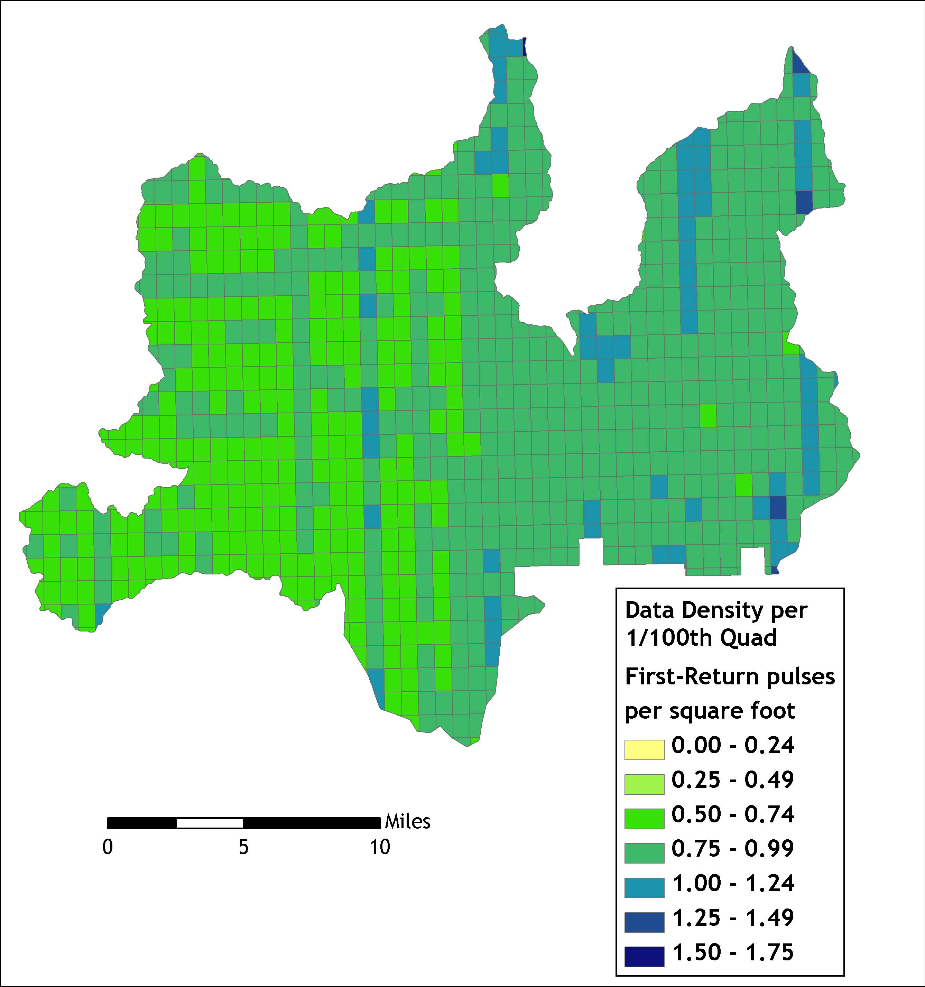

Ground classifications were derived from ground surface modeling. Supervised classifications were performed by reseeding of the ground model where it was determined that the ground model failed, usually under dense vegetation and/or at breaks in terrain, steep slopes and at bin boundaries.
Figure 3.3. Histogram of ground-classified laser point density for data delivered to date.
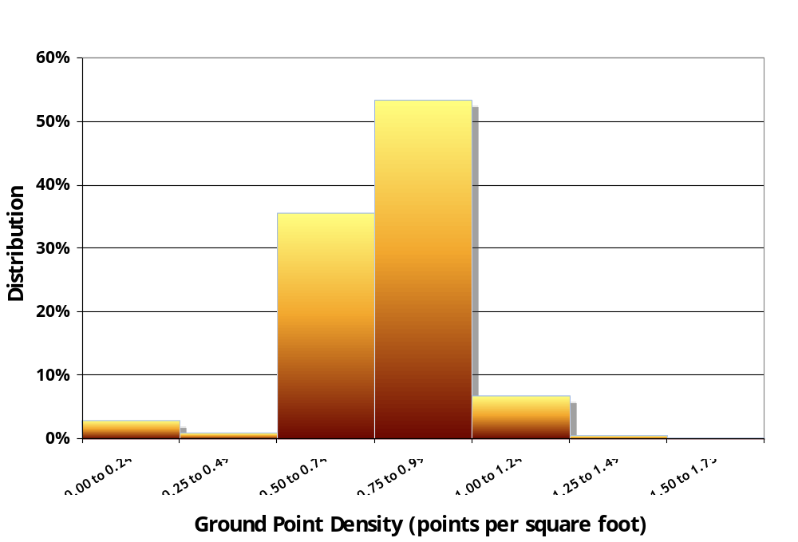

Figure 3.4. Ground-classified laser point density per 0.75’ USGS Quad for data delivered to date.

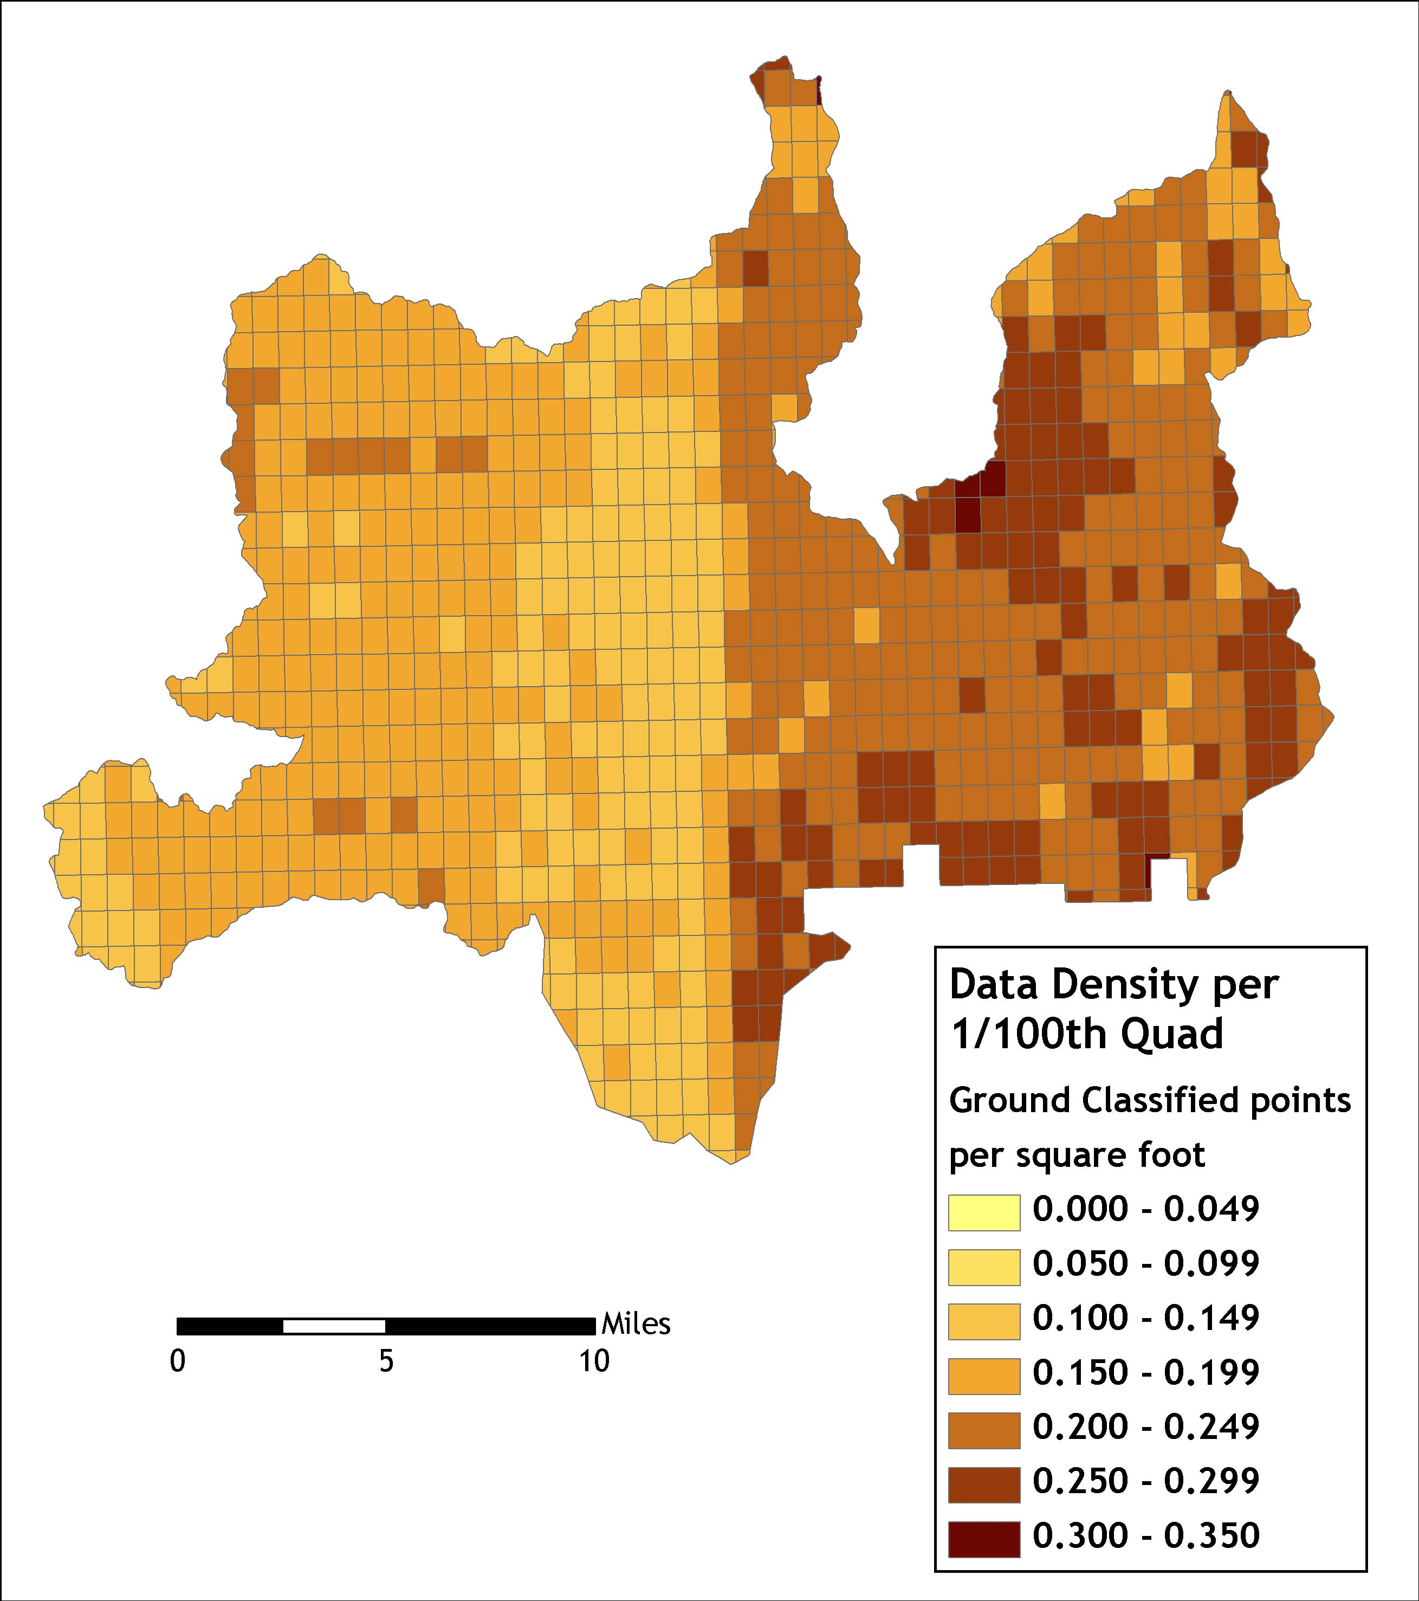

4. Selected Imagery
Figure 4.1. Image of the Malheur River alongside National Forest Development Road 1651. Top image derived from LiDAR highest hits, bottom from bare earth LiDAR.
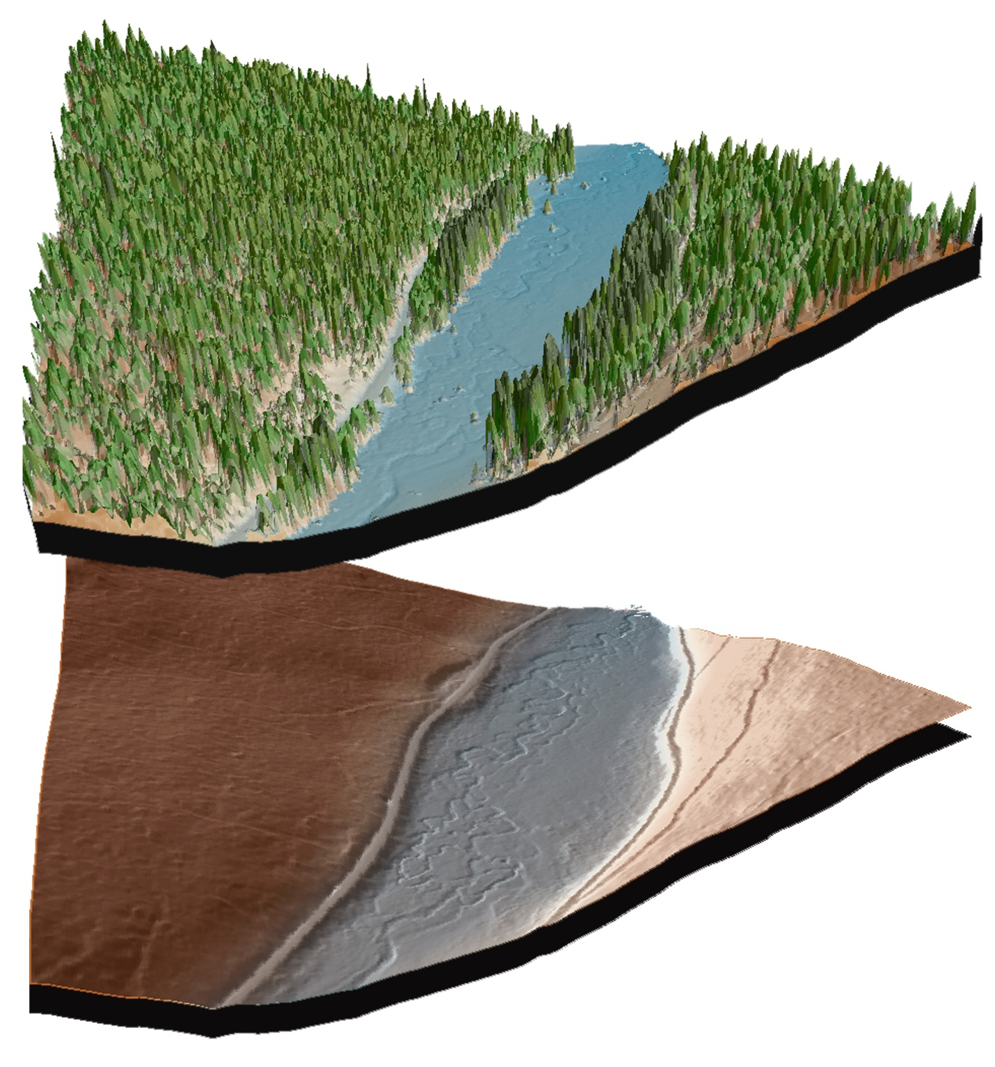
Figure 4.2. Agricultural area North East of Seneca. Upper image derived from bare earth LiDAR, center image derived from highest hit LiDAR, lower image derived from NAIP orthophoto.


