
Department of Geology & Mineral Industries
800 NE Oregon St, Suite 965
Portland, OR 97232

Malheur LIDAR Project, 2009 – Delivery 1 QC Analysis
LIDAR QC Report – April 13th, 2009
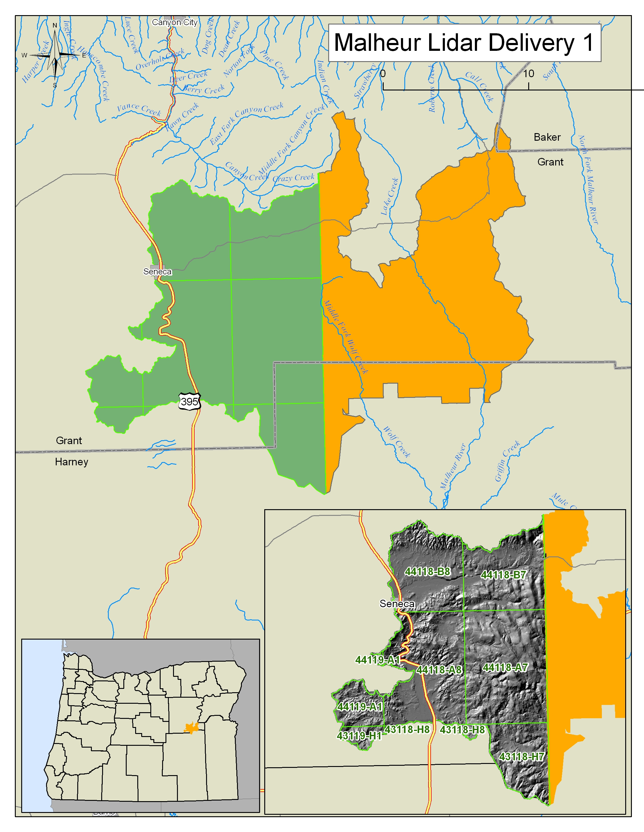
Map featuring Malheur Delivery 1 data extent.

The Oregon Department of Geology & Mineral Industries has contracted with Watershed Sciences to collect high resolution lidar topographic data for multiple areas within the State of Oregon. Areas for lidar data collection have been designed as part of a collaborative effort of State, Federal, and Local agencies in order to meet a wide range of project goals. The vendor has agreed to certain conditions of data quality and standards for all lidar data deliverables listed in sections A through C (OPA #8865) of the 2007-2009 Lidar Data Acquisition Price Agreement (pgs 14-23). Data submitted under this price agreement is to be collected at a resolution of at least 8 points per square meter and processed to meet or exceed the agreed upon data quality standards. This document itemizes and reports upon Malheur Lidar Project – Delivery 1 products furnished by the lidar vendor as documentation that all data meets project specific standards.

Upon receipt from vendor (Watershed Sciences), all lidar data for Delivery 1 was independently reviewed by staff from the Oregon Department of Geology and Mineral Industries (DOGAMI) to ensure project specifications were met. All data were inventoried for completeness and data were checked for quality, which included examining lidar data for errors associated with internal data consistency, model quality, and accuracy.

- Consistency Analysis involves examining flight line offsets to quantify the accuracy of data calibration. Calibration influences elevation data quality with poor calibration leading to small but systematic errors within lidar elevation points, which then create inaccuracies within derived lidar elevation models.
- Visual checks are carried out in order to identify potential data artifacts and misclassifications of lidar point data. Lidar point data is classified as either ground, above ground, or error points. Sophisticated processing scripts are used to classify point data and remove error points. The data vendor performs quality control analysis to fix misclassifications of point data. The delivered bare earth DEM is then reviewed by DOGAMI to ensure that the data classification is correct and there are no topographic processing artifacts. If errors are found, data must be resubmitted.
- Accuracy of the data is examined by comparing lidar elevation data with independent survey control to quantify vertical and horizontal accuracy. For each lidar collection project DOGAMI collected independent GPS ground elevations, which were then compared against delivered lidar elevation models.

Data Completeness

Data for Malheur Delivery 1 area were collected between November 19th – December 11, 2008. Total area of delivered data totals 206.37 square miles. Delivery 1 (Figure 1) includes data in the format of grids, trajectory files, intensity images, Lidar ASCII Standard (LAS) point files, ground point density rasters, RTK survey data, a shapefile of the delivery area, and the lidar delivery report (Table 1). Bare earth and highest hit grids were delivered in ArcInfo Grid format with 3ft cell size. Lidar point data is delivered in LAS binary format for ground classified returns as well as the entire lidar point cloud. Georeferenced intensity images are supplied in TIF format. Supplementary data includes ground density rasters displaying locations where ground returns are low. Real time kinematic ground survey data (used for absolute vertical adjustment) is supplied in shapefile format. This delivery contains data for the following USGS 7.5 minute quads (listed by Ohio Code #) within the boundary of the Malheur Survey collection area: 43118h7, 43118h8, 43119h1, 44118a7, 44118a8, 44118b7, 44118b8, 44119a1 (Figure 1).

FINAL Delivery | Resolution | Format | Tiling
Bare Earth DEMs | 3ft | grid | quad |  | x
Highest Hit DEMs | 3ft | grid | quad |  | x
Trajectory files | 1 sec | ascii (TXYZRPH) | flight |  | x
Intensity Images | 1.5ft | tif | 100th quad |  | x
LAS | 8pts/m^2 | las | 100th quad |  | x
Ground Returns | N/A | las | 100th quad |  | x
Ground Density Raster | 3ft | grid | quad |  | x
RTK point data |  | shape |  |  | x
Delivery Area shapefile |  | shape | quad |  | x
Report |  | pdf |  |  | x
Miscellaneous |  | Format | Tiling
Processing bins |  | dxf or dgn | project |  | x
Table 1. Deliverable Checklist

All data associated with this delivery has been loaded and viewed to ensure completeness. Raster imagery such as elevation grids and intensity geotifs have been viewed in ArcMap, cross referenced with the delivery area. Las files have been loaded into Terrasolid software to ensure completeness and readability.

Deliverable Descriptions: (All data projected in Oregon Lambert, NAD83 (HARN), Intl Feet with exception of trajectory files).

- Bare Earth Grids: Tin interpolated grids created from lidar ground returns.
- Highest Hit Grids: Tin interpolated grids created from the highest lidar elevation for a given 3ft cell.
- Intensity TIF: TIF raster built using returned lidar pulse intensity values gathered from highest hit returns.
- Trajectory File: File contains point location measurement of the aircraft used to collect lidar data. Data is collected using an Inertial Measurement Unit (IMU), and collects measurements of: Easting(meters), Northing (meters), Ellipsoid Height (meters) of aircraft, aircraft roll (degrees), aircraft pitch (degrees), aircraft heading (degrees). Measurements are collected at one second intervals. Data is projected in UTM zone 10, NAD83 (HARN).
- LAS: Binary file of all lidar points collected in survey (Class, flight line #, GPS Time, Echo, Easting, Northing, Elevation, Intensity, Scan Angle, Echo Number, and Scanner).
- Ground LAS: Binary file of lidar points classified as ground (Class, flight line #, GPS Time, Echo, Easting, Northing, Elevation, Intensity, Scan Angle, Echo Number, and Scanner).
- RTK Point Data: Ground GPS Survey data used to correct raw lidar point cloud for vertical offsets.
- Delivery Area Shapefile: Geometry file depicting the geospatial area associated with deliverables.
- Report: Report provides detailed description of data collection methods and processing. The vendor also reports accuracies associated with calibration, consistency, absolute error, and point classifications.

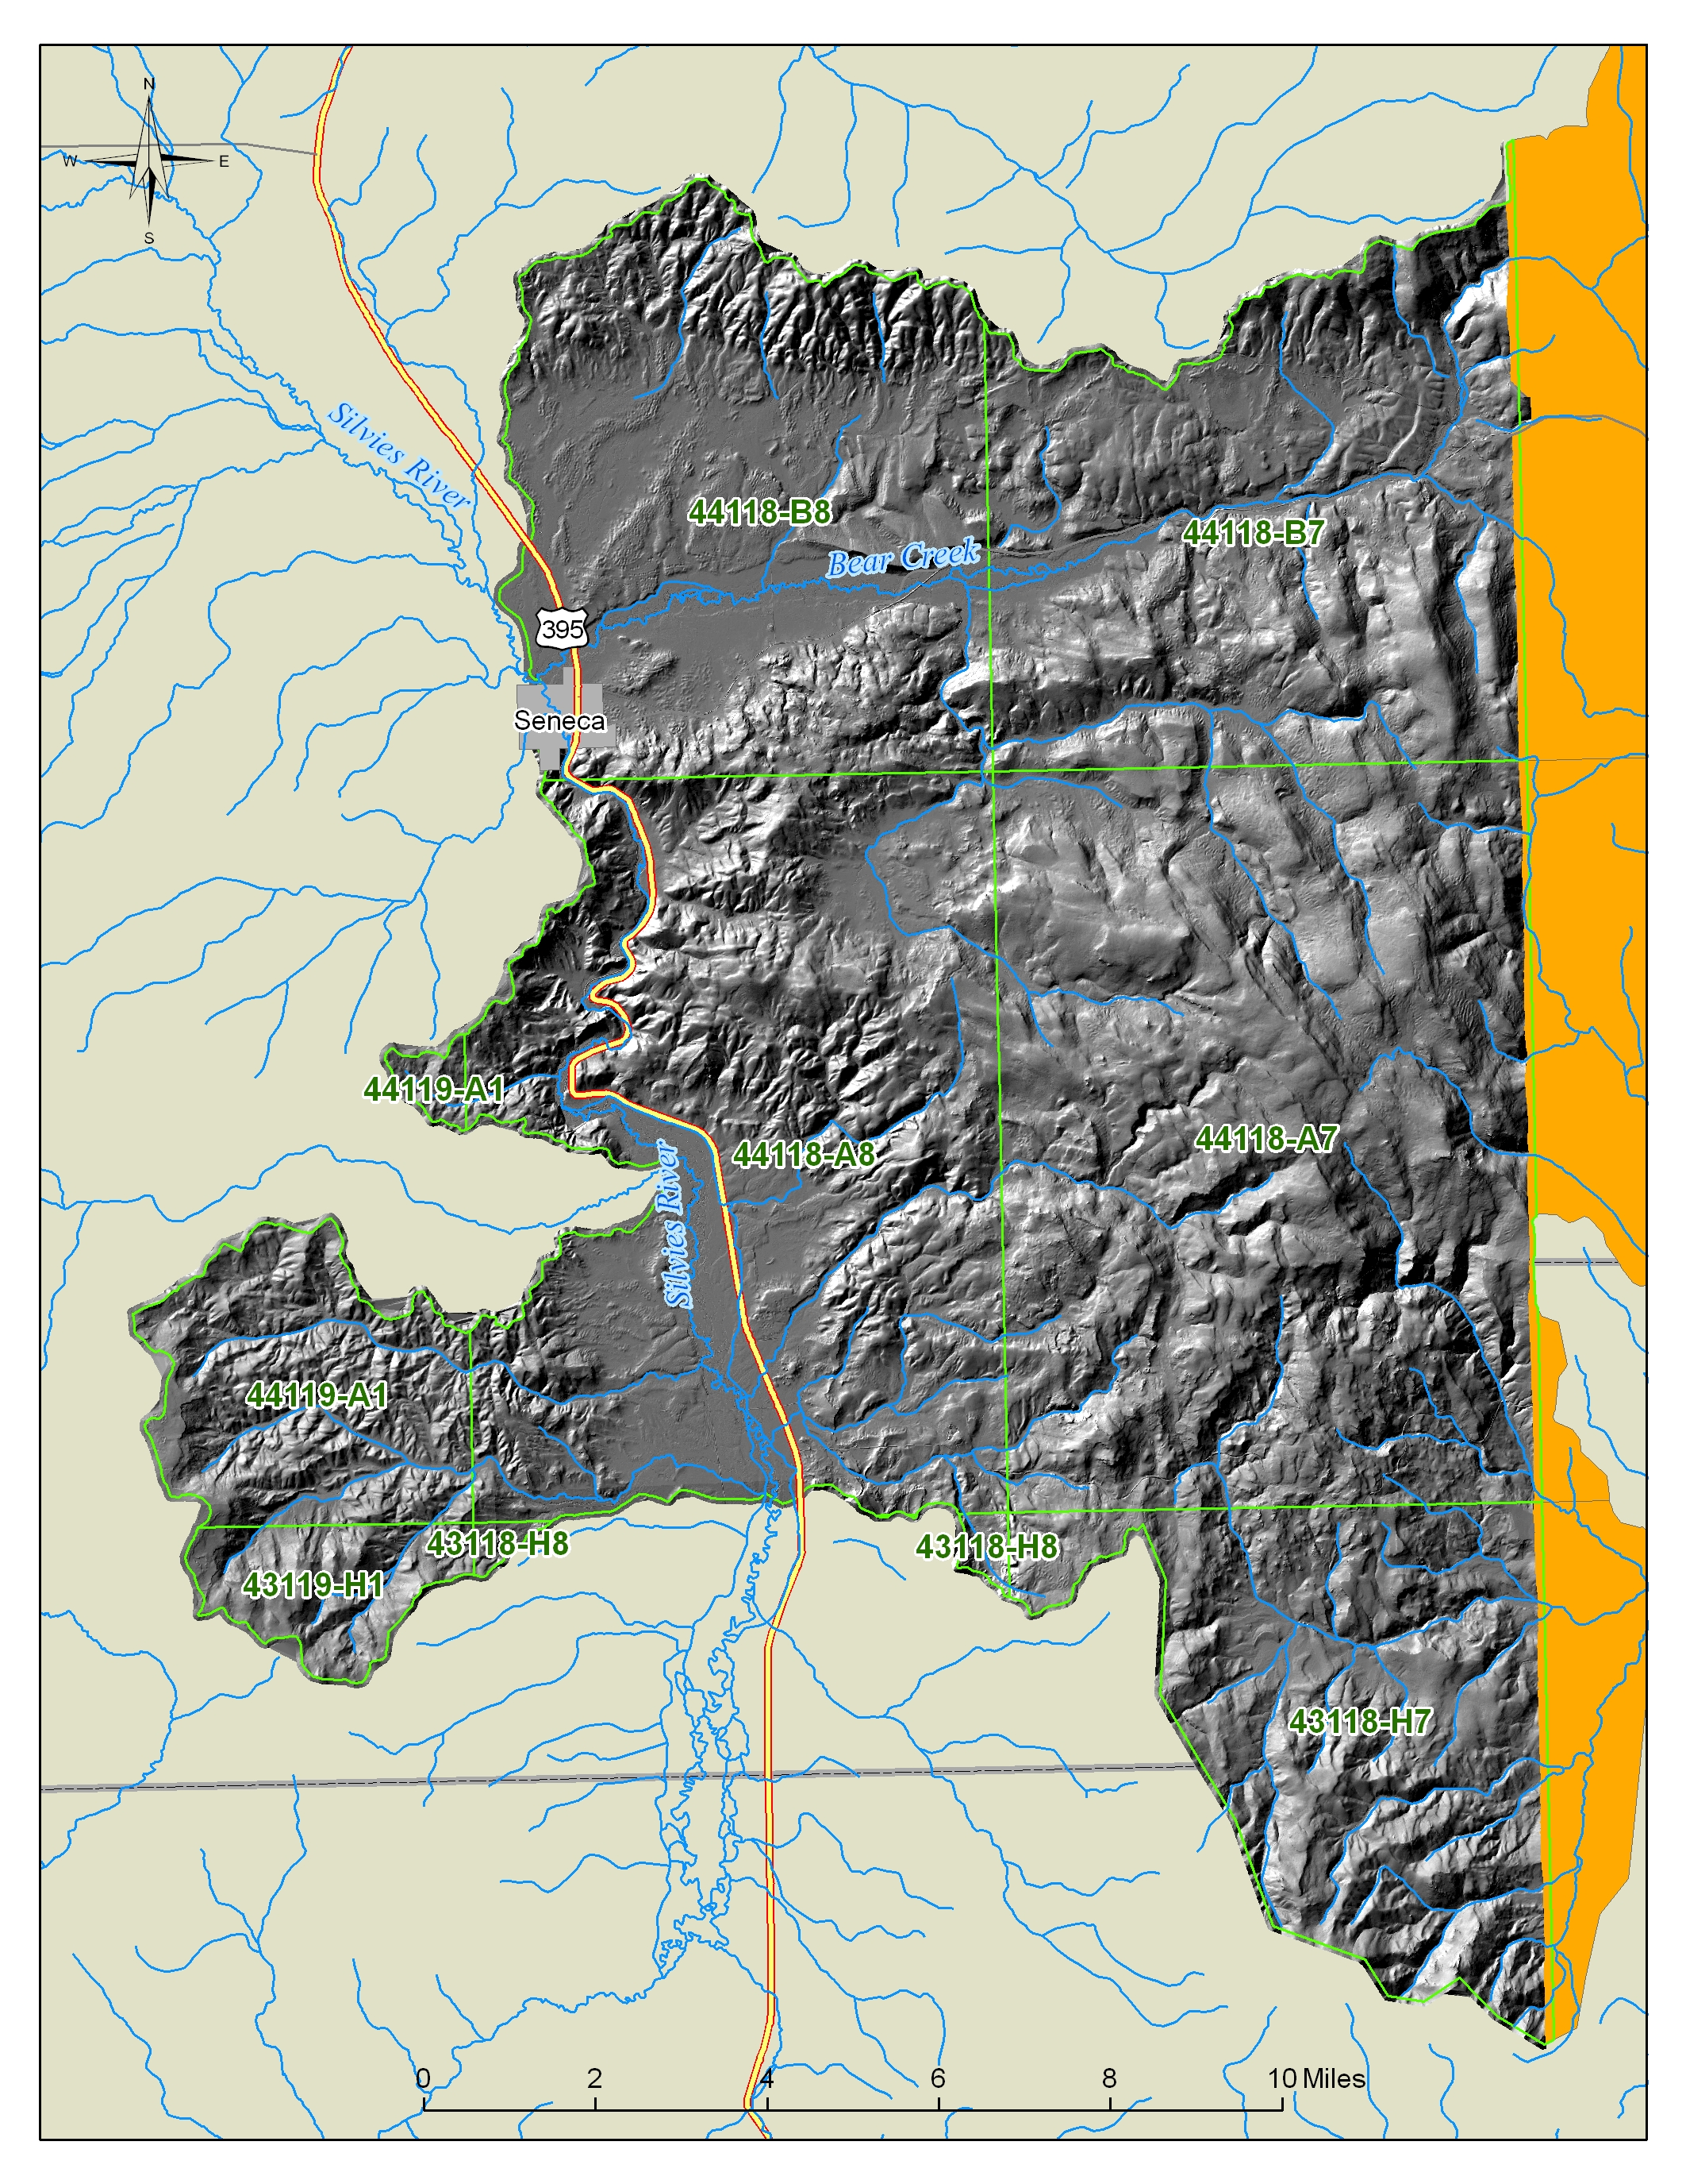
Figure 1. Delivery 1 location area. Data is referenced to USGS 7.5 minute quadrangles within the extents of the Malheur Survey collection area.

Consistency Analysis:
The Oregon LIDAR Consortium has specified that lidar consistency must average less than 0.15m (0.49 feet) in vertical offsets between flight lines. DOGAMI measures consistency offsets throughout delivered datasets to ensure that project specifications are met.
Consistency refers to lidar elevation differences between overlapping flight lines. Consistency errors are created by poor lidar system calibration settings associated with sensor platform mounting. Errors in consistency manifest as vertical offsets between individual flight lines. Consistency offsets were measured using the “find match” tool within the TerraMatch© software toolset. This tool uses aircraft trajectory information linked to the lidar point cloud to quantify flight line-to-flight line offsets.
To quantify the magnitude of this error 1036 delivered data tiles were examined for vertical offset between flight lines. Data tiles with less than 1000 points were not used in analysis. Selection of tiles aimed to evenly sample the delivered spatial extent of data. Each tile measured 750 x 750 meters in size. The average number of points used for flight line comparison was 965,542 per tile (Table 2a). Error measurements were calculated by differencing the nearest point from an adjacent flight line within 1 meters in the horizontal plane and 0.2 meters in the vertical plane. Each flight line was compared to adjacent flight lines, and the average magnitude of vertical error was calculated. A total of 156 flight lines were sampled and compared for consistency.

Summary Statistics
# of Tiles | 1036
# of Flight Line Sections | 156
Avg # of Points | 4,809,606
Avg. Magnitude Z error (m) | 0.040
Table 2a. Summary Results of Consistency Analysis

 | meters | feet
Mean | 0.040 | 0.132
Standard Error | 0.001 | 0.002
Standard Deviation | 0.009 | 0.031
Sample Variance | 0.000 | 0.000
Range | 0.044 | 0.146
Minimum | 0.023 | 0.076
Maximum | 0.068 | 0.221
Table 2b. Descriptive Statistics for Magnitude Z Error.

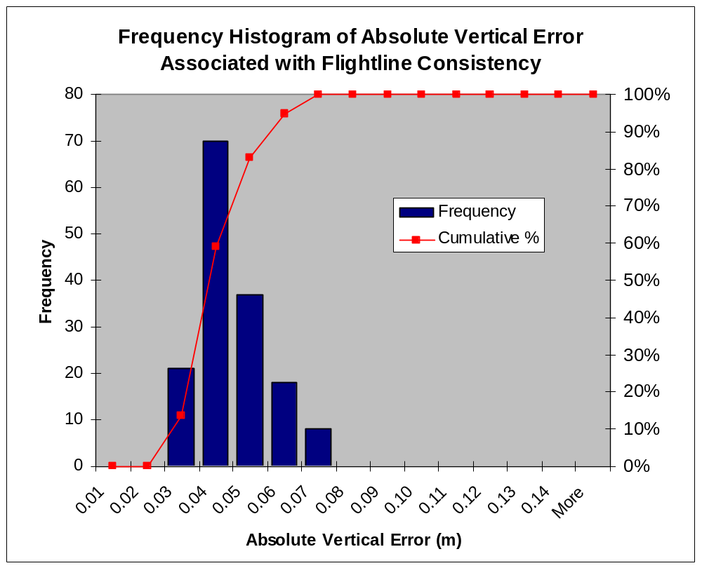
Figure 2.

Results of the consistency analysis found the average flight line offset to be 0.049 meters with a maximum error of 0.099m (Table 2b). Distribution of error showed over 96% of all error was less than 0.07m and 98% was less than 0.09m (Figure 2). These results show that all data fell well within tolerances of data consistency according to contract agreement.

Visual Analysis

Lidar 3ft grids were loaded into ArcGIS software for visual analysis. Data were examined through slope and hillshade models of bare earth returns. Hillshades of the highest hit models were used to identify areas of missing ground (Figure 3). Both bare earth and highest hit models were examined for calibration offsets, tiling artifacts (Figure 4), seam line offsets, pits (Figure 5), and birds.
Calibration offsets typically are visualized as a corduroy-like patterning within a hillshaded lidar model. These offsets present themselves along steep slopes and typically stand out more in highest hit models than bare earth. Tiling artifacts are a result of missing or misclassified data along the edge of lidar processing tiles. These artifacts present themselves as linear features typically 1-2 grid cells in width, and are present in both the highest hit and bare earth models (e.g. Figure 3). Seam line offsets occur where two distinct days of lidar data overlap. Errors occur as a result of improper absolute vertical error adjustments. These errors are typically visualized as a linear stair step running along the edge of connecting flight lines. Pits and birds refer to uncommonly high or low points that are the result of atmospheric and sensor noise. Pits (low points) typically occur where the laser comes in contact with water on the ground (Figure 5). Birds (high points) typically occur where the laser comes into contact with atmospherics¹.
Errors located during visual analysis were digitized for spatial reference and stored in ESRI shapefile format. Each feature was assigned an ID value and commented to describe the nature of the observed error. The shapefile was delivered to the vendor for locating and fixing errors. Upon receiving the observed error locations, the vendor performed an analysis to conclude whether the error was valid. For all valid errors found, the vendor has reprocessed the data to accommodate fixes. For all observed errors that are found to be false, the vendor has produced an image documenting the nature of the feature in grid and point data format. A readme file was created explaining all edits performed. Corrected data was delivered to DOGAMI. This data were examined to ensure edits were made, and visually inspected for completeness, then combined into the original delivery.

¹ Atmospherics include clouds, rain, fog, or virga.
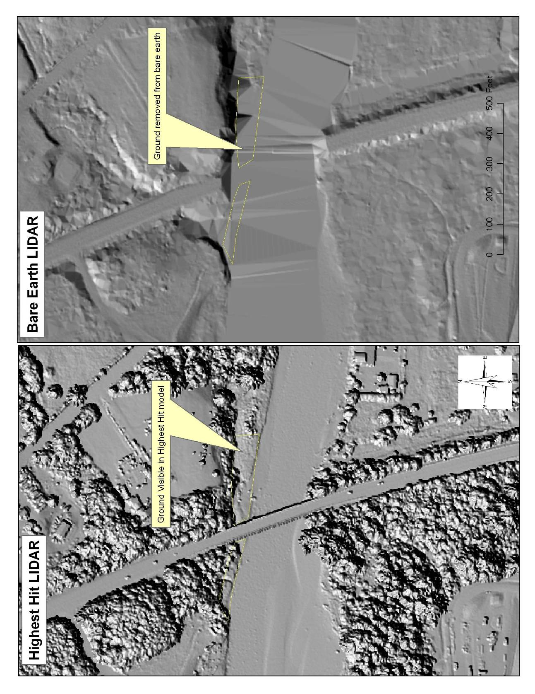
Figure 3. Example of missing ground in lidar bare earth data. Ground is clearly visible in highest hit model, but has been removed from the bare earth model. This type of classification error is common near water body features.
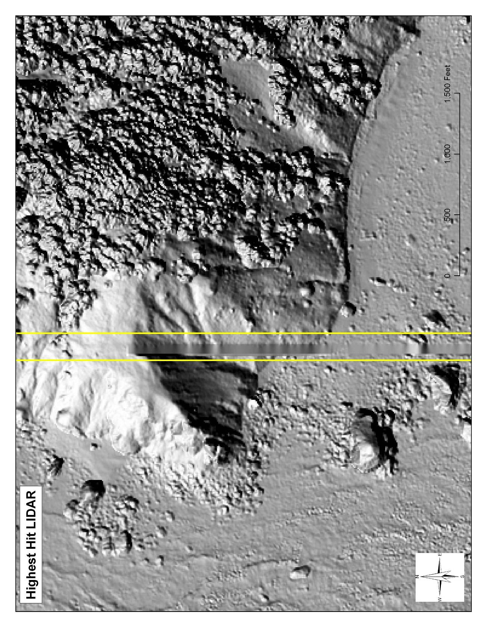
Figure 4. Example of tile artifact found in highest hit lidar data. Artifact is a seam line error created due to misclassification of ground at edge of lidar processing tiles.

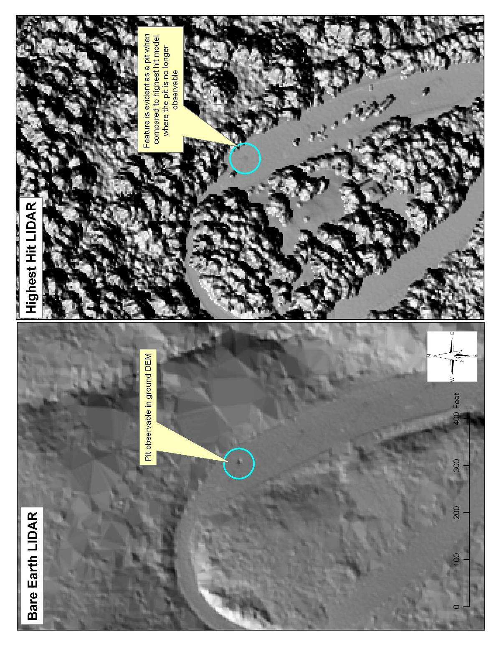
Figure 5. Example of “Pit” observable when comparing bare earth to highest hit models. Pits are caused when standing water absorbs the lidar pulse. Pits are evident in ground model as the lowest point elevation is assigned to the grid cell value. Inversely the pit is not observable in the highest hit model as the highest point elevation is assigned to the grid value
Absolute Accuracy Analysis:

Absolute accuracy refers to the mean vertical offset of lidar data relative to measured ground-control points (GCP) obtained throughout the lidar sampling area. DOGAMI used a TrimbleTM 5700/5800 Total Station GPS surveying system (Figure 5) to measure GCP’s. This system consisted of a GPS base station (5700 unit), Zephyr Geodetic antenna, Trimmark 3 radio, and 5800 “rover”. The 5700 base station was mounted on a fixed height (typically 2.0 m) tripod and located over a known geodetic survey monument followed by a site calibration on several adjacent benchmarks to precisely establish a local coordinate system. This step is critical in order to eliminate various survey errors. For example, Trimble reports that the 5700/5800 GPS system have horizontal errors of approximately ±1-cm + 1ppm (parts per million * the baseline length) and ±2-cm in the vertical (TrimbleNavigationSystem, 2005). These errors may be compounded by other factors such as poor satellite geometry, multipath, and poor atmospheric conditions, combining to increase the total error to several centimeters. Thus, the site calibration process is critical in order to minimize these uncertainties.

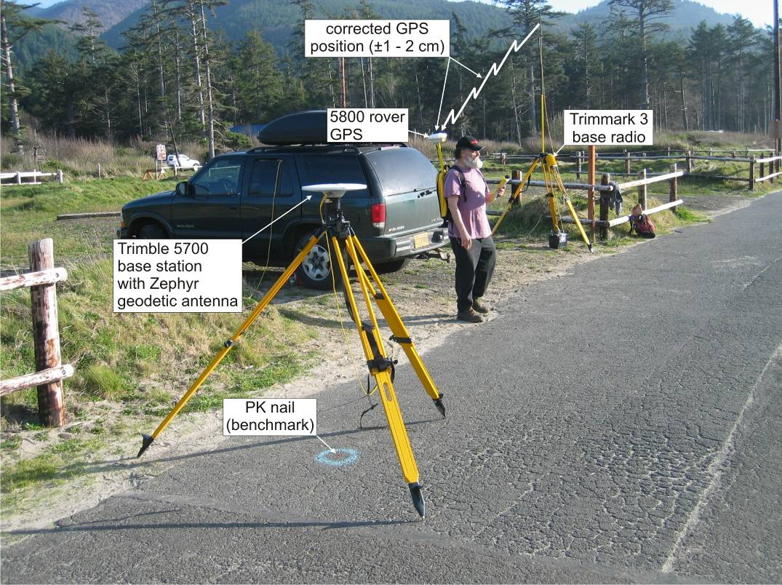
Figure 5. The Trimble 5700 base station antenna located over a known reference point at Cape Lookout State Park. Corrected GPS position and elevation information is then transmitted by a Trimmark III base radio to the 5800 GPS rover unit.

The approach adopted for the Southern Oregon coast lidar survey was comprised of two components:
- Verify the horizontal and vertical coordinates established by Watershed Sciences for a select number of survey monuments used to calibrate the lidar survey. These surveys typically involved a minimum of two hours of GPS occupation over a known point. The collected data were then submitted to the National Geodetic Survey (NGS) Online Positioning User Service (OPUS) for post-processing against several Continuously Operating Reference Stations (CORS) operated by the NGS.
- Collect GCP’s along relatively flat surfaces (roads, paths, parking lots etc.). This step involved the collection of both continuous measurements (from a vehicle as well as from a backpack) as well as static measurements (typically 5 epics).

Having collected the GCP data, the GPS data was post-processed using Trimble’s Geomatic Office software. Data post-processing typically involved calibrations against at least three CORS stations as well as from local site calibrations performed in the field using those benchmarks that had been independently verified. Data is post processed to refine measurements so that horizontal and vertical errors are less than 0.02 meters (0.065 feet). Horizontal accuracy of data is tested by reoccupying a sample subset of survey monuments used for processing of lidar data. Each occupation,s x and y coordinates are compared with the vendor coordinates for offsets.
Vertical accuracy analysis consisted of differencing control data and the delivered lidar Digital Elevation Models (DEM) to expose offsets. These offsets were used to produce a mean vertical error and vertical RMSE value for the entire delivered data set. Project specifications list the maximum acceptable mean vertical offset to be 0.20 meters (0.65 feet).
A total of 98 measured GCP’s obtained in the Delivery 1 region, 109 were eventually compared with the lidar elevation grids. The data delivered to DOGAMI was found to have a mean vertical offset of +/-0.091 meters (0.298 feet) and an RMSE value of 0.094 meters (0.310 ft). Offset values ranged from 0 to 0.153 meters (Table 3 and Figure 7). Offsets between lidar and GPS RTK data were greater than contractor reported offsets. It was found this was a function of DOGAMI’s sample size. This is apparent in Figure 7 where data is positively skewed. Typically data is positively skewed 0.02-0.03m due to point averaging within cells.
Horizontal accuracies were not specified in agreement since true horizontal accuracy is regarded as a product of the lidar ground foot print. Lidar is referenced to co-acquired GPS base station data that has accuracies far greater than the value of the lidar foot print. The ground footprint is equal to 1/3333rd of above ground flying height. Survey altitude for this acquisition was targeted at 900 meters yielding a ground foot print of 0.27 meters. This value exceeds the typical accuracy value of ground control used to reference the lidar data (<0.01m). Project specifications require the lidar foot print to fall within 0.15 and 0.40 meters.
DOGAMI was able to test the horizontal accuracy of survey monuments used to reference the lidar data while conducting vertical control measurements. For internal purposes only, the XY coordinates of survey monuments surveyed by DOGAMI were compared to the survey monuments provided by the vender and in almost every case, the reported results were consistent with those obtained by DOGAMI staff.

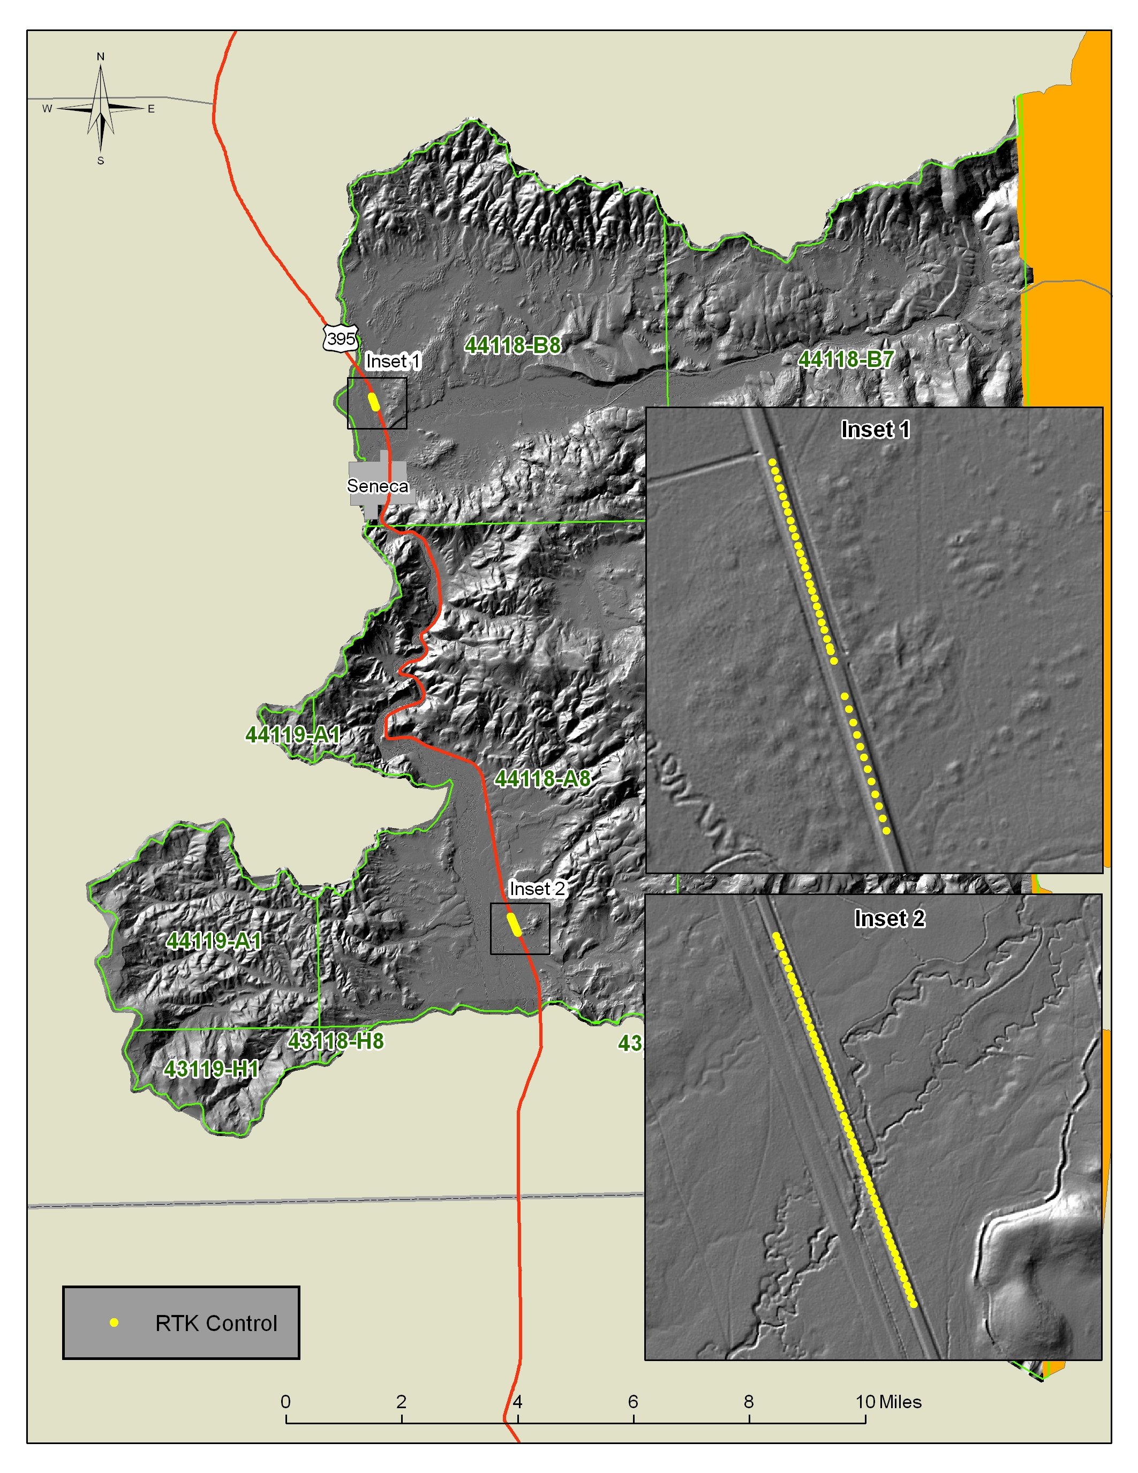
Figure 6. Locations of RTK control surveyed by DOGAMI. Data was used to test absolute accuracy for the Malheur lidar survey within the Delivery 1 extent.

 | Meters | Feet
Mean | 0.091 | 0.298
Standard Error | 0.003 | 0.009
Standard Deviation | 0.027 | 0.089
Range | 0.116 | 0.380
Minimum | 0.037 | 0.121
Maximum | 0.153 | 0.502

Table 3. Descriptive Statistics for absolute value vertical offsets.

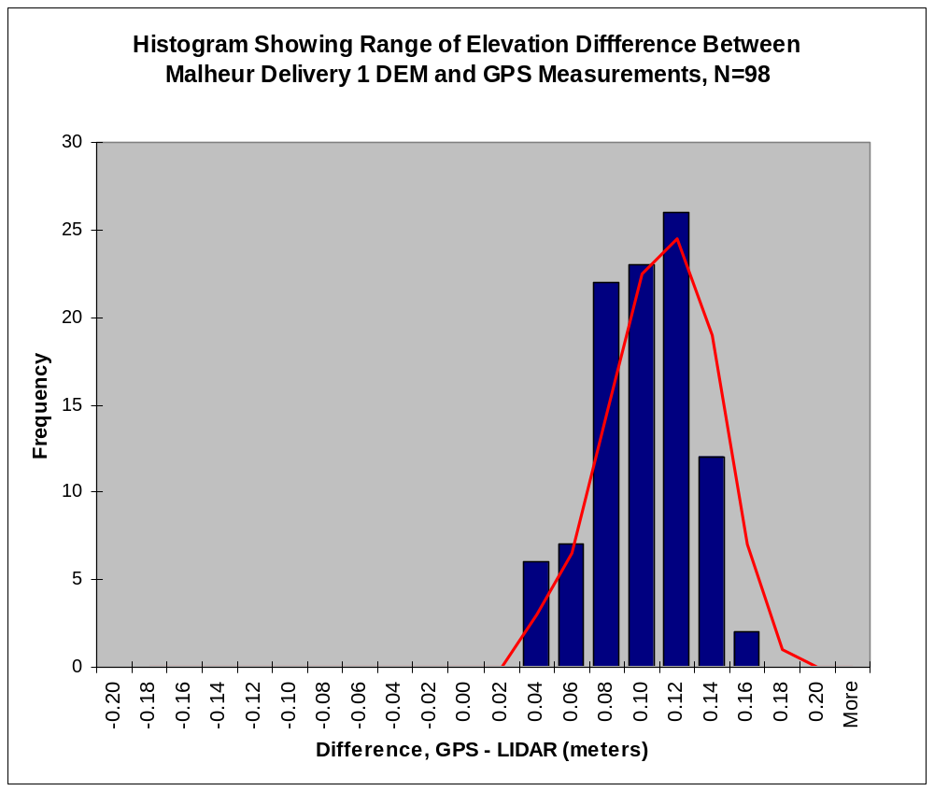
Figure 7.

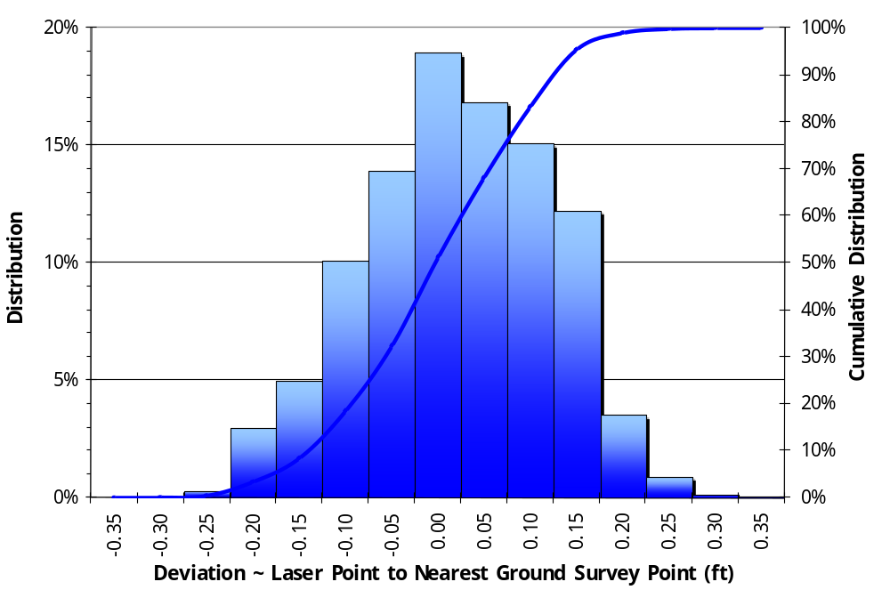

Figure 8. Absolute accuracy histogram reported by Watershed Sciences. Data analysis compared GPS data to LiDAR point data, N=1619.

Acceptance

The data described in this report meets and exceeds project specifications laid out in the contracted data standards agreement. All components of data to be delivered have been received as of April 6th, 2009. Consistency analysis has concluded that all data contains flight line to flight line vertical offset less than the threshold of 0.15 meters as specified in agreement. The vendor has adequately responded to all fixable errors identified as part of the visual analysis. Perceived grid errors identified by DOGAMI that were found to be false have been documented by the vendor and explained to the satisfaction of DOGAMI reviewers. Absolute accuracy analysis of the data has concluded that absolute vertical error of lidar data is less than the specified tolerance of 0.20 meters as specified in the data standards agreement.

Approval Signatures

________________________________________________ Date: __________________

Ian Madin
Chief Scientist

________________________________________________ Date: __________________

John English
Lidar Database Coordinator

